**Painkiller**

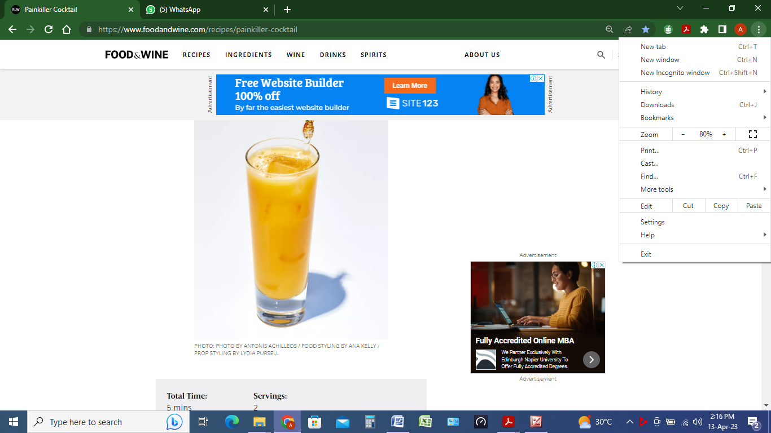

**INGREDIENTS**

½ cup bottled fresh pineapple juice

¼ to 1/2 cup (2 to 4 ounces) rum (such as Pusser's Rum), to taste

2 tablespoons cream of coconut (from 1 [15-ounce] can)

2 tablespoons fresh orange juice (from 1 orange)

Freshly grated nutmeg

**METHOD**

1. Pour pineapple juice, rum, cream of coconut, and orange juice into a cocktail shaker filled with ice. Place lid on shaker, and shake until well combined, 10 to 15 seconds. Strain evenly into 2 Collins glasses filled with ice, and garnish with nutmeg.

Note:

To prepare fresh pineapple juice: Using a juicer, juice 4 cups chopped pineapple (about 1 pound). Pour fresh juice through a fine wire-mesh strainer into a vessel; discard solids.