Pelau

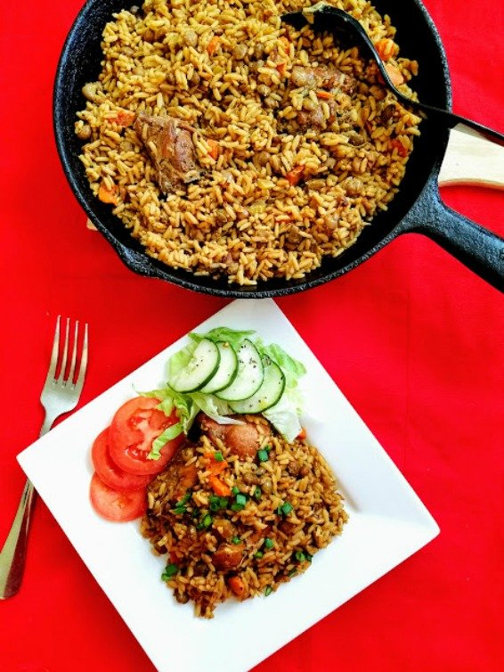

**INGREDIENTS**

2 – 2 ½ lbs. mixed chicken pieces or legs and thigh, cut up and rinse with lime juice

2 limes, juiced

¼ cup green seasoning

1 teaspoon salt

1 teaspoon black pepper

1 medium onion, chopped

1 plum tomato, chopped

1 medium size carrot, diced

1 small red bell pepper, diced/chopped

1 small green bell pepper, diced/chopped

1 stalk celery, chopped

6 sprigs fresh thyme, DE-stemmed or leave whole

4 pimento flavouring peppers, chopped, optional

2 cups frozen pigeon peas, boiled for 15 minutes

2 cups parboiled long grain rice

2 tablespoon canola or vegetable oil

3 tablespoon brown or white sugar

1 cup coconut milk

2 cups hot water

4 sprigs parsley, chopped

1 teaspoon ketchup

2 packs chicken or vegetable bouillon

1 tablespoon cooking margarine (golden ray) optional

1 scotch bonnet pepper, optional

**METHOD**

**[Marinating Chicken]**

1. Marinade chicken with green seasoning salt and black pepper for a minimum of 2 hours or overnight.
2. Add onion, tomato, carrot, bell peppers, pimento peppers, celery and thyme to marinated chicken, set aside.
3. **[.Caramelizing or Browning the Sugar and making the Pelau]**
4. Heat a large pot on high heat, add oil and heat for about 2 minutes .Add the sugar, DO NOT STIR! At least not yet.
5. Allow the sugar to melt until it starts to get brown around some of the edges. Using your pot spoon, stir the sugar around, about 3 - 4 times until it starts to melt and become like liquid.
6. It should start getting light brown in colour, and going from liquid too almost frothy and bubbly in less than a minute.
7. Stir the sugar again with your spoon, it should be darker in colour at this point. The entire browning process, should take at least 2 - 3 minutes or so.
8. Start adding the seasoned chicken a few pieces at a time, stir constantly to ensure all the pieces get coated evenly with the caramelized/burnt sugar.
9. DO NOT ADD THE SEASONINGS FROM THE BOWL, AT LEAST NOT YET. **Save the seasonings,**YOU WILL BE USING IT SHORTLY.
10. After adding all the chicken pieces cover the pot and allow to cook on medium heat for about 10 minutes
11. Open pot lid, turn up the heat for about 3 – 5 minutes so as to allow the chicken to get A NICE AND FINAL brown colour, STIR!
12. Add any seasonings that were left over from the marinated chicken bowl, Stir.
13. Add the drained cooked pigeon peas, Stir. Cover Pot with lid for 5 more minutes
14. While chicken is cooking, rinse rice in warm water about 3 - 4 times and drain.
15. Add rice to pot and stir. Add golden ray butter if using, bouillon seasoning, ketchup, coconut milk, STIR!
16. Add water and mix together. Cook on high uncovered for 2-3 minutes.
17. Add the whole scotch bonnet pepper, **ONLY IF YOU LIKE AND IS USING HOT PEPPER**
18. Turn heat to very low, cover pot and simmer for about 30 – 35 minutes, checking periodically to ensure it's not sticking to the bottom of the pot, Taste and adjust seasoning if you need too.
19. After you turn the heat off, add the parsley and mix in with your pelau.
20. (ENJOY:)

**NOTES**

The chicken will release a lot of its own juices at the first simmer, so you will have some liquid in the pot after this, so be very careful in adding liquids to the pot,  
  
Just keep in mind your liquid should be about an inch or so above your rice, the trick here is to allow your pelau to simmer on very low! You can also use canned pigeon peas, if you use the can; there is no need to boil before use. If you can get the fresh peas, even better, just follow the same directions as for the frozen.  
  
Can be served with a cucumber salad, coleslaw, avocado and pepper sauce.  
  
If you do not like coconut milk, you can just leave it out and substitute with additional water.