Information Analysis of Catchment Hydrological Observation and Simulation across Temporal Scales
Baoxiang Pan, Zhentao Cong
（Institute of Hydrology and Water Resources, Tsinghua University, Beijing, China.）
Abstract：Catchment hydrological cycle takes on different patterns across temporal scales. The interim between daily runoff generation event and long range water-energy correlation pattern requires further examination to justify a self-consistent understanding. In this research, we use quantized entropy of runoff observations to represent the prior uncertainty in determining the catchment's hydrological patterns. Mutual information between runoff observation and the catchment's water energy provisions, as represented by precipitation and potential evapotranspiration, is employed to denote the uncertainty decrease given the existed observations. Mutual information between runoff observation and simulation is employed to denote the uncertainty decrease given the models. The differences of these items, as constrained by the functional transformation of the Bayes' theorem, construct the framework of epistemic and aleatory uncertainty in evaluating the observation and simulation systems. We implement this information analysis with daily hydrometeorological data clustered at temporal scales from 10 days to 1 year in 24 catchments from MOPEX data set to detect the catchments' hydrological patterns revealed by data and two existed models. An improved approach combining K-nearest-neighbor method and support-vector-regression is employed to tackle with high dimensional information item estimation. The estimations of information contents and flows of hydrological items across temporal scales are related with the catchments' seasonality type. It also shows that information distilled by the monthly and annual water balance models applied here does not correspond to that provided by observations around temporal scale from two months to half a year. This calls for a better understanding of seasonal hydrological mechanism.
keywords：information theory; temporal scale; hydrological model; Budyko
1 Introduction
Given the pros and cons of the bottom-up and top-down hydrological simulation paradigms^{[1]}, we are faced with the following problems in reaching a temporal scale consistent hydrological simulation system:
- How catchment hydrological patterns evolve as temporal scale expands;
- To what accuracy the data support the patterns;
- To what extent the existing models capture these patterns.
This research tries to give primary responses to these questions with a comprehensive observation model evaluation framework based on entropy and mutual information^{[2]}.In this framework, the uncertainty caused by the insufficiency and inaccuracy of data is attributed to Aleatory Uncertainty, while that caused by imperfect data processing is attributed to Epistemic Uncertainty:
_
作者简介： 潘宝祥（1991-），男，汉族，山东临沂人；Email：panbaoxiang@hotmail.com
导师：丛振涛
The definition provides a crystalline framework to evaluate the observation and simulation systems. However, it must blend into the existed uncertainty estimation knowledge systems before its wide acceptance. Besides, the hydrological context in which these items make sense and the specific calculating techniques should be strictly examined.
In this research, we provide both intuitive and formal explanations of the Aleatory Epistemic Uncertainty Evaluation Framework. We will see that this framework is no more and no less than a functional transformation of the classical Bayes' theorem. In order to make senses of the bits estimated in this framework, we restrict the context to hydrological series (precipitation, potential evapotranspiration and runoff observations) laid at time domain sampling points. The original daily series are re-clustered into series with temporal scales from ten days to a year (no moving cluster). The information contents of these items at various temporal scales are represented with quantized entropy. The accuracy of the quantization scheme is determined by practical needs as is clarified in the following sections. We employ mutual information between different temporal scale hydrological items to quantify the information flows within the hydrological cycle at that scale. Given the drawbacks of the existed high dimensional information estimators, we adapt a k-nearest neighbor distance method^{[3]}, which uses the distances between samples to estimate high dimensional mutual information directly. Since the variable space is composed of different hydrological items, we could not take it as a Euclidean Space and measure the sample points' distances with the popular norms. Considering the mathematical significance and strong information extraction ability of the support vector regression^{[4]}, we apply it to depict the distances. The theoretical clarification and algorithm are in the second section. Information items to be estimated are followed. At last, we discuss the interpretations of these terms and respond the questions we put forward above.
2 Methodology
It is intuitively believed that an infrequent sample of a random variable provides more surprisal, or information. The mathematical expression of this common sense is that information provided by an observation should be a decreasing function of its probability. If we further require the additive property of information between independent events, the form of information content attributed to a sample with probability p should be -logp. Thus, the average information content of random variable X should be^{[5]}:
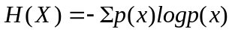
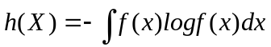
The other term we apply here is mutual information. Its discrete and continuous forms are as follows:

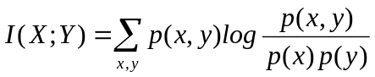
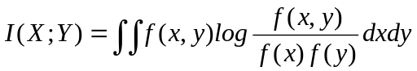
The definitions above are closed related with Bayesian Statistics. Bayes' theorem is stated mathematically as the following equation:
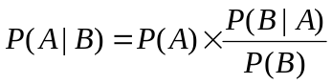
A and B are random vairables. 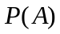 denotes prior distribution, 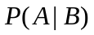 denotes posteriori distribution. 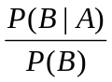 is called standardized likelihood.
Equation (8) quantizes how a subjective degree of belief should rationally change to account of evidence.

As have been declared, each probability distribution corresponds to its uncertainty or information content as is defined in Equation (4) or (5). We implement the function on both sides of Equation (8). The specific steps are as follows:
Make logarithmic transformation of Equation (8):
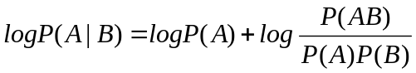
Multiply each item by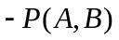:
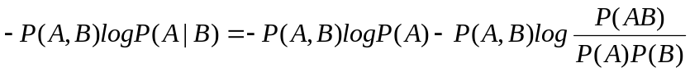
Sum or integrate each item in the sample space:
or
which simplifies to
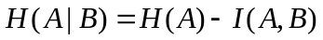
Given the correspondence of Equation (8)} and (13), H(A|B) represents posterior uncertainty, H(A) represents prior uncertainty, I(A,B) represents information connection between the two random variables.
In hydrological simulation, a general goal is to produce accurate runoff simulation with inputs from hydrometeorological series, underlying surface observations or other information sources. This is not only for the practical objective of efficient water resources utilization, but also for the scientific value that once the runoff process were characterized, each component into which the precipitation is partitioned gets determined.
The information theoretical paraphrase of this notion is that the information content of runoff observation depicts information required to figure out the catchment hydrological compositions, which could be decreased due to the information contribution of the input observations.
There are two steps in quantizing this information contribution. The first step is observation and the second is simulation. Noise introduced in observation is called Aleatory Uncertainty. The simulator serves as an information distiller or decoder that transfers the mass input observation data into simple simulations. The information loss during decoding is called Epistemic Uncertainty. Both the two terms are measured in bits.
We apply the introduced items to quantify the information contents and connections of catchment hydrological variables across temporal scales. The specific values to be estimated are listed in table 1. All these estimations are implemented at temporal scales from 10 days to a year. This range bypasses the difficulty of estimating discrete-continuous hybrid distributed daily precipitations^{[6]} while incorporating significant temporal scales in detecting long term catchment hydrological behaviors.
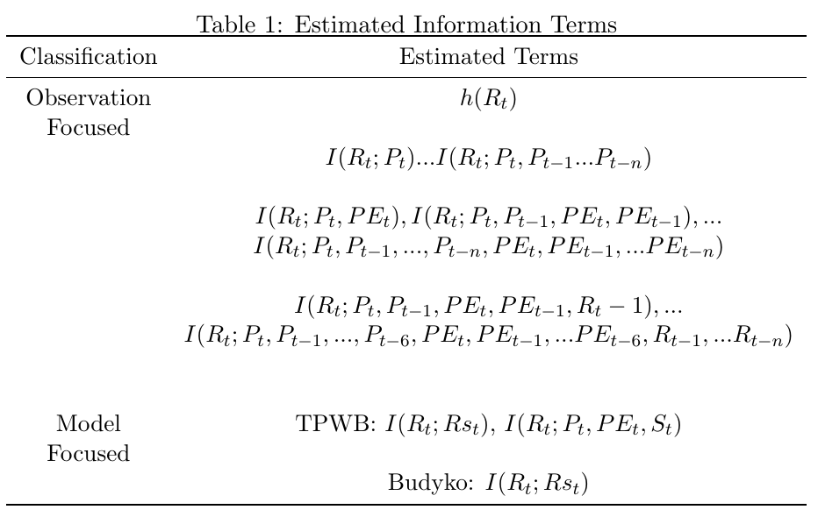
P_{t} and PE_{t} denotes precipitation and potential evapotranspiration random variables at time step t. R_{t} and Rs_{t} denotes observed and simulated runoff^{[7]}.
3 Data
We implement our simulation and estimation with clustered daily hydrologic records (including precipitation, potential evapotranspiration and runoff) from the MOPEX data set^{[8]}. Given their annual water-energy distribution patterns, the selected 24 catchments are classified into 4 groups, explicitly, weak seasonality with synchronous rainfall energy distribution (WS), weak seasonality with asynchronous rainfall energy distribution (WA), strong seasonality with synchronous rainfall energy distribution(SS) and strong seasonality with asynchronous rainfall energy climate (SA).
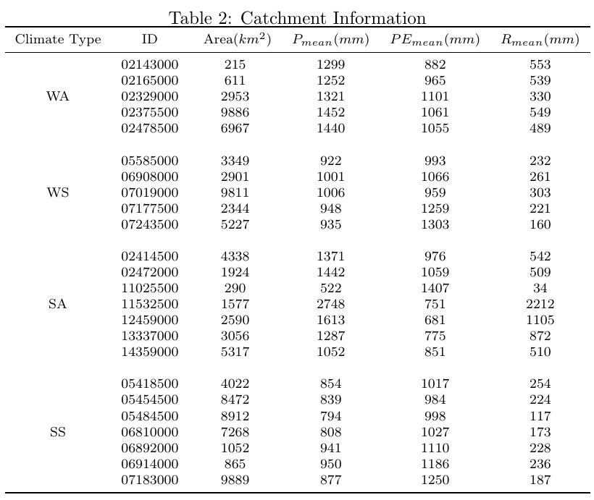
4 Results
In each 3 dimensional graph from the tables below, the abscissa represents the input steps, while the ordinate represents the estimating temporal scales; in each 2 dimensional graph, the abscissa represents temporal scales while the ordinate represents entropy (either conditional or unconditional).
4.1 Aleatory Uncertainty
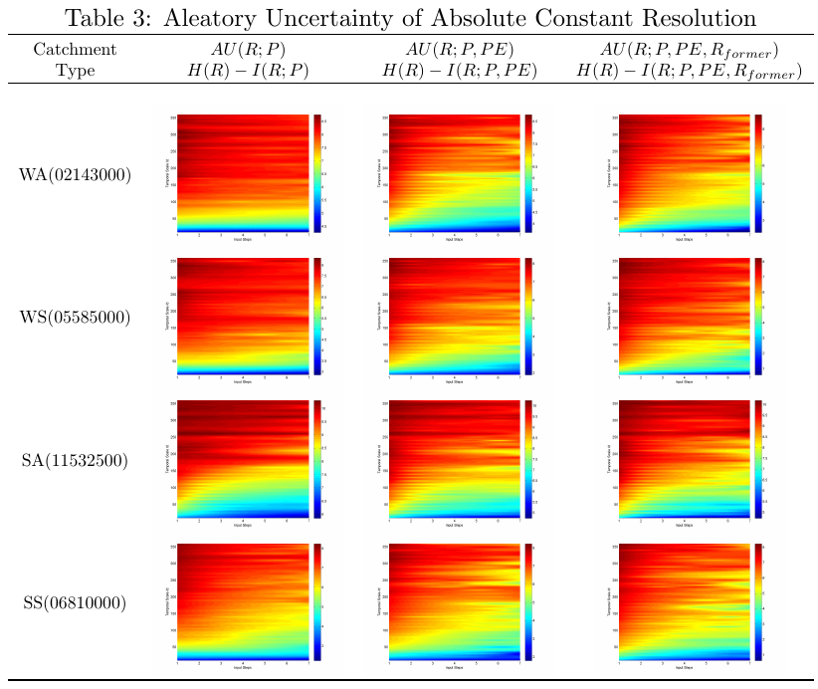

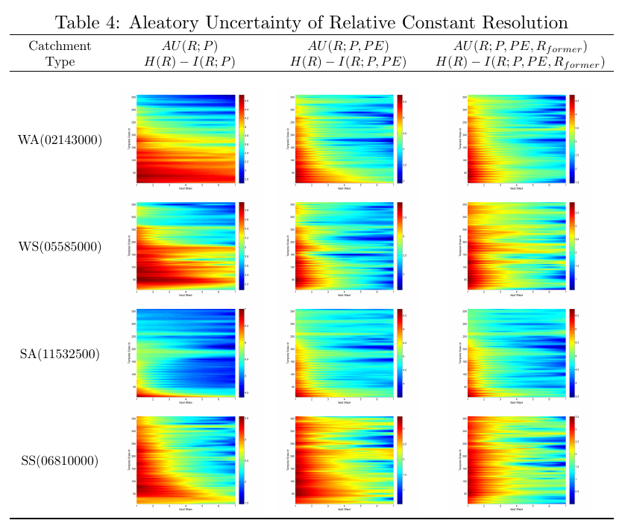
4.2 Epistemic Uncertainty
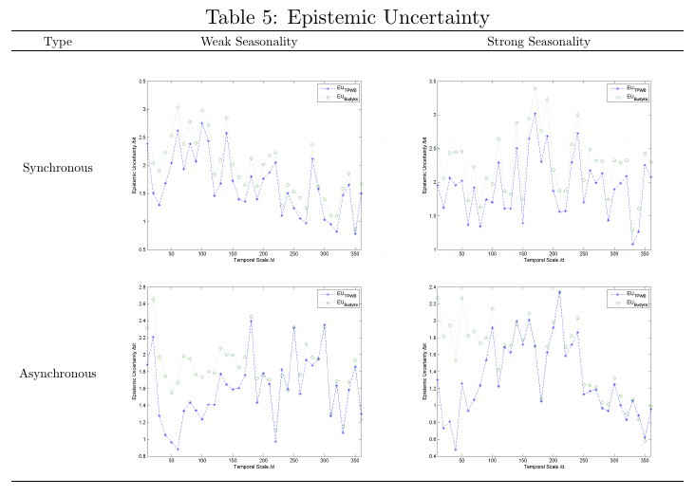

5 Discussion
5.1 Prior Uncertainty——Runoff Entropy
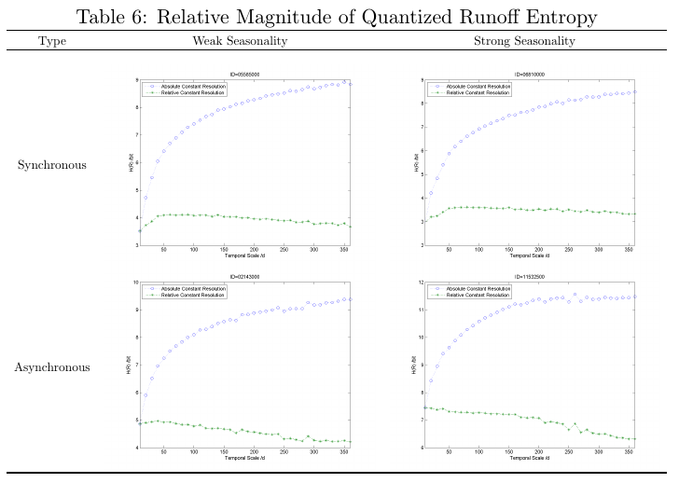

5.2 Mutual Information Between Runoff Observation and Input Data
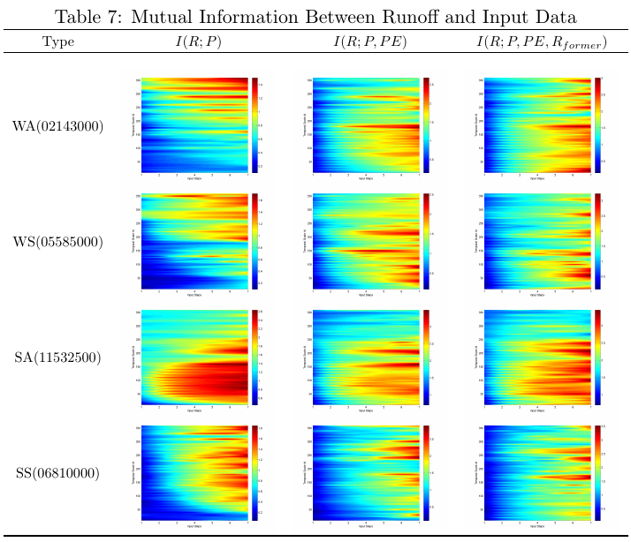

- Information Contribution of PE and 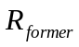
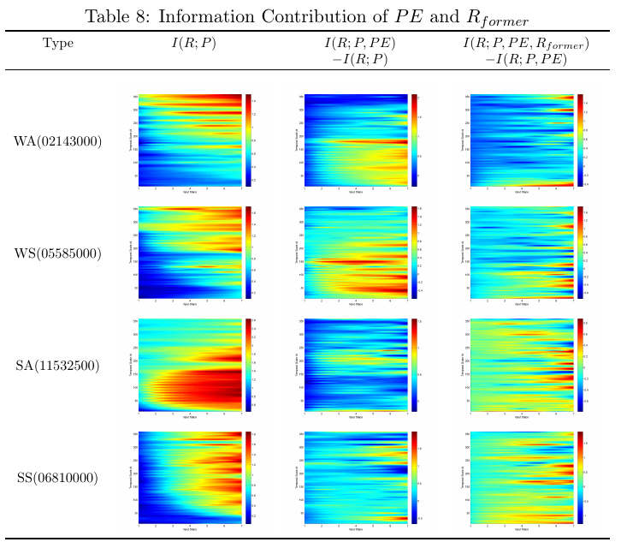

- Mutual Information with Different Lagged Input Steps
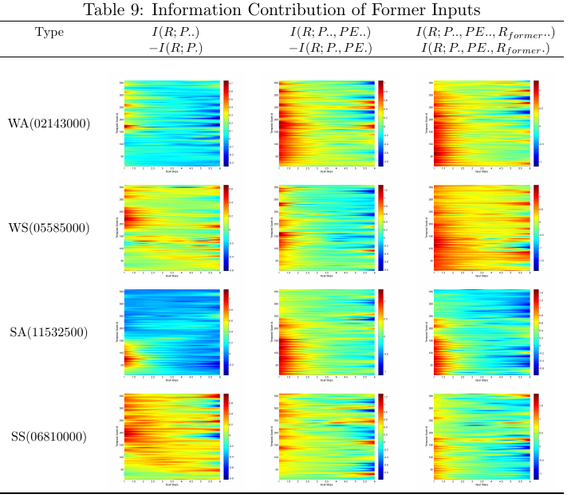

5.3 Mutual Information Between Runoff Observation and Simulation
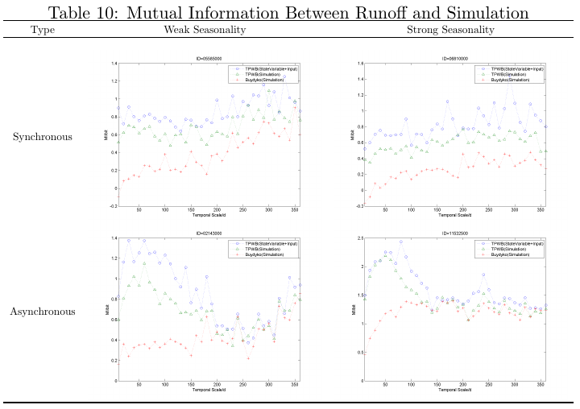
The specific items in equation (1) and (2) are listed in Table 6 to Table 10 . It is helpful to distinct the uncertainties introduced by observation and simulation in order to make corresponding improvements ^{[2]}.
The origin of observation uncertainty, defined as Aleatory Uncertainty, can be attributed to two sources. The first one is observation bias. For consistent observations with no system error, this uncertainty source weakens as temporal scale expands due to the large number law. The daily observation errors tend to set off when clustering them together.
The other origin is the inherent uncertainty caused by the coarse temporal scale. A simple clustering of water quantity of different hydrological terms cannot exert a strong control of the system. The variability of their temporal distribution takes effect in increasing the uncertainty.
Given the reliability of the MOPEX dataset, the latter uncertainty source is viewed as the dominant factor. In other words, the Aleatory Uncertainty is mainly caused by data insufficiency rather than inaccuracy for large temporal scales.
There are more than one models processing same observations. These models seek balance between structure complexity and accuracy. The structure complexities of the two models applied here are different. The TWPB model uses a state variable to represent former hydrological conditions. The Budyko model assumes a closed hydrological cycle in its calculating temporal scales. The ignorance of soil moisture profit and loss crippled its efficiency in monthly hydrological simulation. Graphics in Table 10 show their capacities in distilling information from the input observations. In models with iterative structures, this capacity is divided into two parts, the first stresses the ability to extract lagged inputs' influences, while the second stresses the ability to digest the distilled variable.
6 Conclusion
This research explores the hydrological patterns revealed by observations and models at temporal scales from 10 days to a year with an information theoretical approach. We apply the quantized differential entropy of runoff observations to represent the prior uncertainty in figuring out the catchment’s hydrological compositions. Mutual information between hydrometeorological observations and runoff is applied to denote the best performance we could potentially reach given the existed observation system. The non-linear support vector regression processed data is taken as sufficient statistic in depicting high dimensional mutual information. The performances of two existed water balance models are represented by mutual information between runoff observations and their simulations. All the estimations are constrained by the data-processing inequality.
The estimations revealed the existence and flows of information in catchment across temporal scales, which could be used to explain hydrological patterns in the framework of aleatory and epistemic uncertainty. Results showed that these patterns are related to the seasonality type of the catchments, which calls for more case studies to figure out the mechanism under the phenomenon. It also shows that information distilled by the monthly and annual water balance models applied here does not correspond to the information provided by input observations around temporal scale from two months to half a year. This calls for a better understanding of seasonal hydrological mechanism.

References
[1] | Beven K J. A discussion of distributed hydrological modelling. Springer, 1996
[2] | Gong W, Gupta H V, Yang D, et al. Estimating epistemic and aleatory uncertainties during hydrologic modeling: An information theoretic approach. Water Resources Research, 2013, 49(4):2253–2273.
[3] | Kraskov A, Stogbauer H, Grassberger P. Estimating mutual information. Physical review E, 2004, 69(6):066138.
[4] | Cortes C, Vapnik V. Support-vector networks. Machine learning, 1995, 20(3):273–297.
[5] | Shannon C E. A mathematical theory of communication. ACM SIGMOBILE Mobile Computing and Communications Review, 1948, 5(1):3–55.
[6] Gong W, Yang D, Gupta H V, et al. Estimating information entropy for hydrological data: One-dimensional case. Water Resources Research, 2014, 50(6):5003–5018.
[7] Xiong L, Guo S. A two-parameter monthly water balance model and its application. Journal of Hydrology, 1999, 216(1):111–123.
[8] Duan Q, Schaake J, Andreassian V, et al. Model Parameter Estimation Experiment (MOPEX): An overview of science strategy. and major results from the second and third workshops. Journal of Hydrology, 2006, 320(1):3–17.

