Workshop - Nov 2022

2022-11-30

data <- read.csv('https://raw.githubusercontent.com/ahurford/biol-4605-data/main/data/corn.csv', fill=TRUE)

plot <- plot(data,   
 main="Figure 1.")

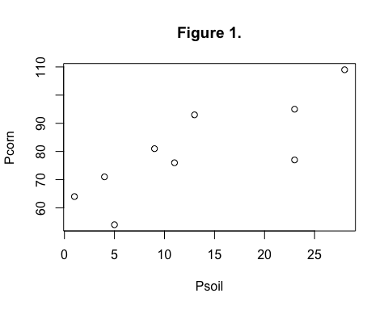

Figure 1.