DIGI02 / WEB SYSTEM
Web Design
Foundation
BLACK / WHITE / GOLD
A practical foundation for a premium engineering-led Digi02 website, combining cinematic product storytelling with architecture-first technical communication.

Version 1.0 • 14 August 2026
Reference DNA: Mobile Hacking Lab + Intent HQ Deep Privacy | Adapted for Digi02, not copied

00 / NORTH STAR

The design goal
Digi02 should not look like a generic agency, a luxury brand, a crypto company, or a template-driven SaaS site. The website should feel like a precision instrument: technically credible, visually controlled, and confident enough to let real systems, diagrams, hardware, interfaces, and evidence do the talking.
DESIGN NORTH STAR
A visitor should leave thinking: “These people engineer serious technology.” Beauty is a consequence of precision, not decoration.

What we are borrowing — and what we are not
Reference | Borrow the principle | Do not copy
Mobile Hacking Lab | Cinematic hardware scale, scroll-driven chapters, technical micro-labels, layered product storytelling, aggressive visual hierarchy. | Their exact imagery, course structure, green accent, copy, component geometry, certification language, or animations.
Intent HQ / Deep Privacy | Architecture-first storytelling, working demonstrations, evidence-led sections, calm editorial rhythm, diagrams that explain the product. | Their brown palette, privacy terminology, card compositions, diagrams, typography, or branded interaction patterns.
Digi02 | Real products, real capabilities, real evidence, black/white/gold identity, Africa-rooted engineering confidence. | Stock “innovation” imagery, fake metrics, decorative sci-fi HUDs, generic service cards, or unsupported claims.

Core design principles
- Show systems, not slogans. Every major claim should be demonstrated with a product view, diagram, real interface, hardware image, process, metric, or case evidence.
- One capability, one visual grammar. UAV, payments, ERP, payroll, POS, and custom software should feel related but not be the same page with different words.
- Gold signals importance. It is an accent for focus, state, and hierarchy — never wallpaper.
- Motion explains. Animation should reveal relationships, progression, state, or system behavior; it should not exist only to look expensive.
- Dark space is structural. Large black areas should create focus and pacing, not simply make the site “dark mode.”
- Reduce before adding. If a section works without a card, glow, gradient, badge, or icon, do not add one.

01 / QUICK REFERENCE

One-page foundation
Area | Decision
Visual concept | Precision Systems — black canvas, monumental white typography, controlled gold, real engineering subject matter.
Display font | Space Grotesk 600–700 (fallback: Inter Display).
Body / UI font | Inter 400–600.
Technical labels | IBM Plex Mono 500 or JetBrains Mono 500; uppercase; 0.12–0.18em tracking.
Base spacing | 8px system, with 4px only for micro-adjustments.
Desktop grid | 12 columns; max content 1440px; 64–80px side margins; 24px gutters.
Mobile grid | 4 columns; 20px margins; 16px gutters.
Section spacing | Desktop 120–160px; tablet 88–120px; mobile 64–88px.
Primary background | #050505.
Primary text | #F7F6F2.
Gold accent | #C9A34A; use roughly 3–7% of a screen.
Radii | 4px controls; 8px cards; 12px large media. Avoid over-rounding.
Motion | Fast 160ms; UI 240ms; section 420ms; cinematic 800–1200ms.
Motion easing | Primary: cubic-bezier(0.22, 1, 0.36, 1).
Image rule | Real product/hardware/UI first. Avoid generic “people using laptops” stock.
Cards | Use only when content is genuinely a bounded object. Prefer open editorial layouts for storytelling.
Accessibility | WCAG AA contrast, visible focus, keyboard support, reduced motion, semantic structure, alt text.

02 / VISUAL REFERENCES

Reference DNA
The following screenshots were supplied as visual references. The useful lesson is not their surface styling; it is how each site makes the subject matter itself become the interface.

Mobile Hacking Lab — cinematic product storytelling
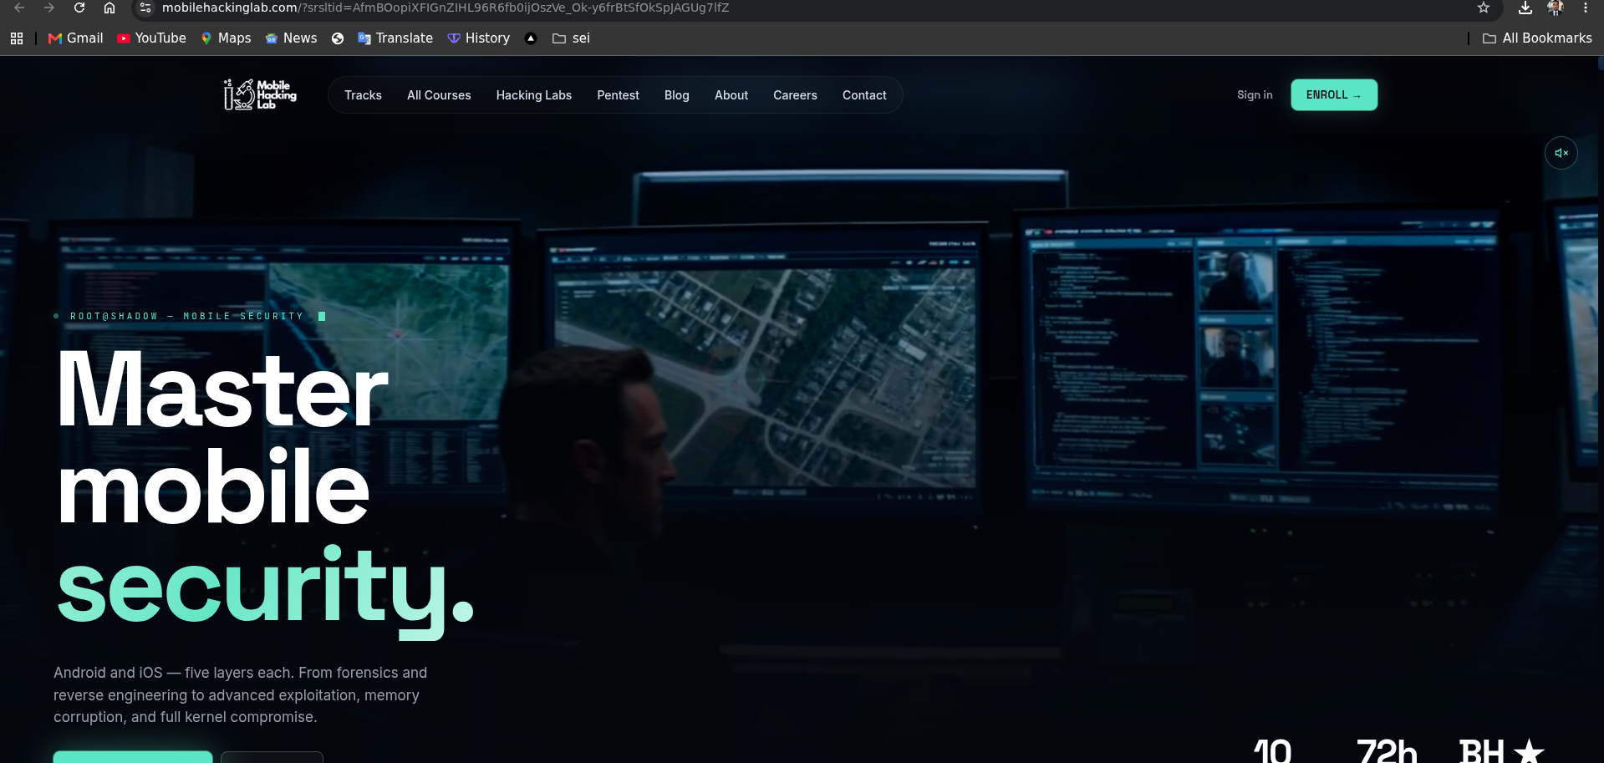
Reference: a cinematic hero where the environment and subject establish credibility before the interface explains details.
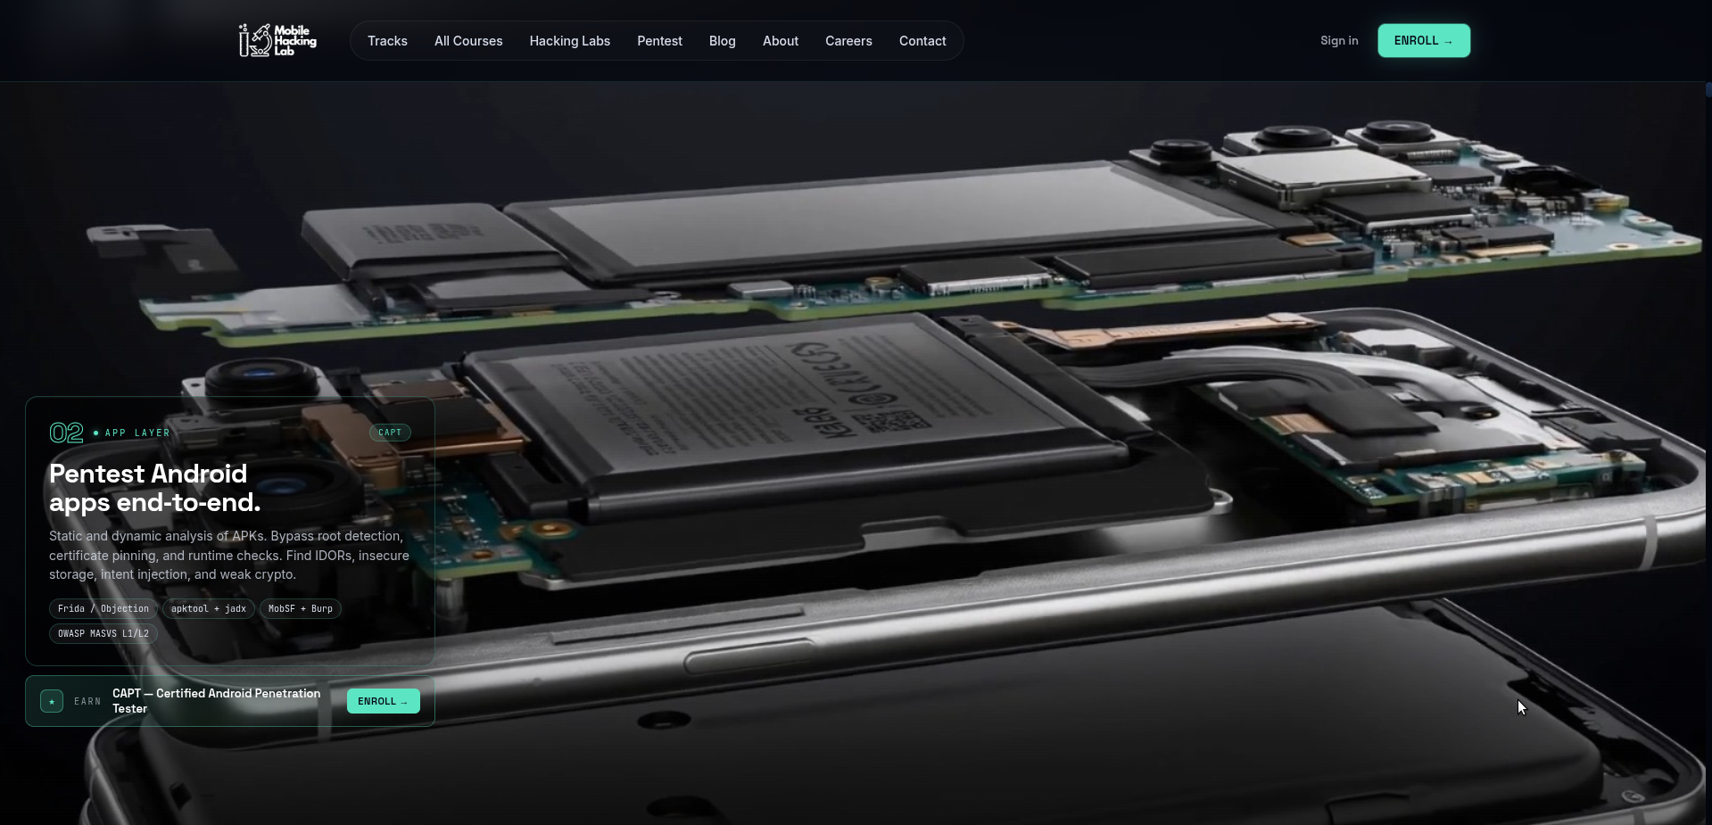
Reference: the device internals become the page background; information is layered over real subject matter rather than placed into generic cards.
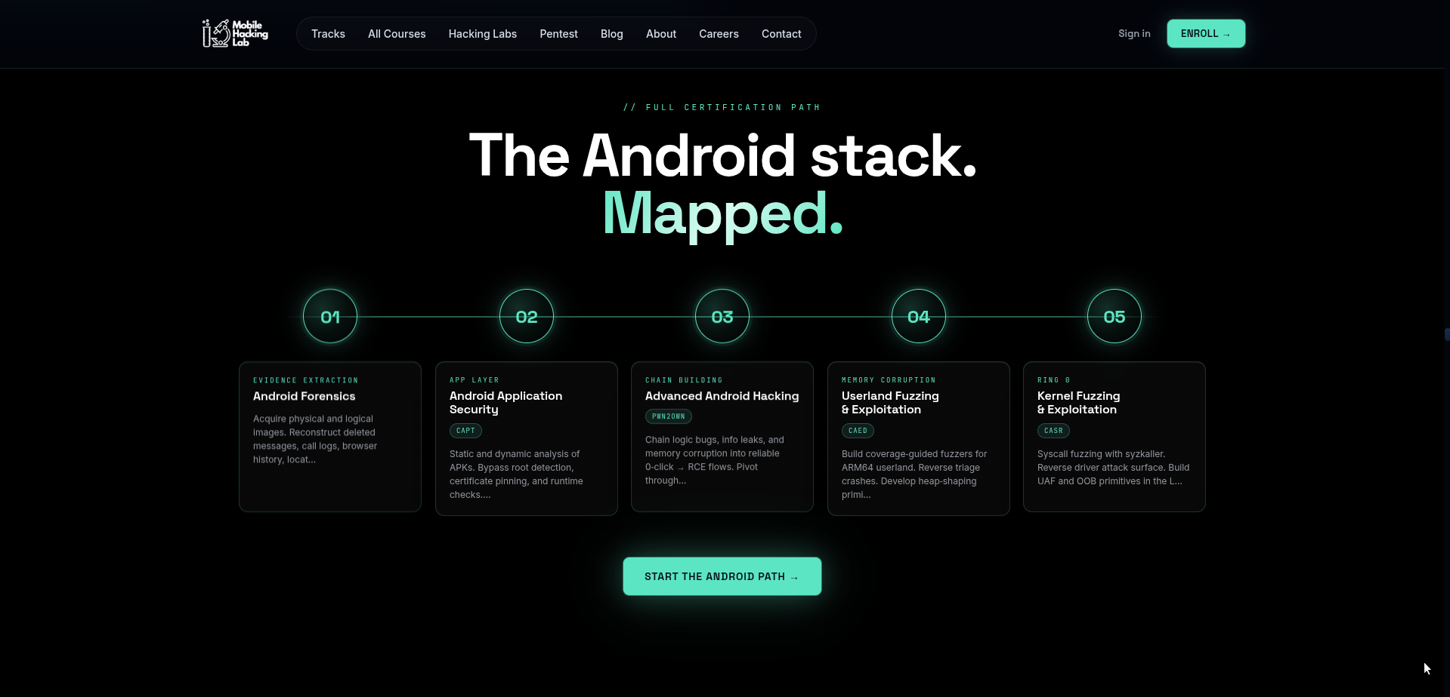
Reference: a certification/path map uses a clear progression line, numbered nodes, compact metadata, and a single strong CTA.

Intent HQ — architecture-first storytelling
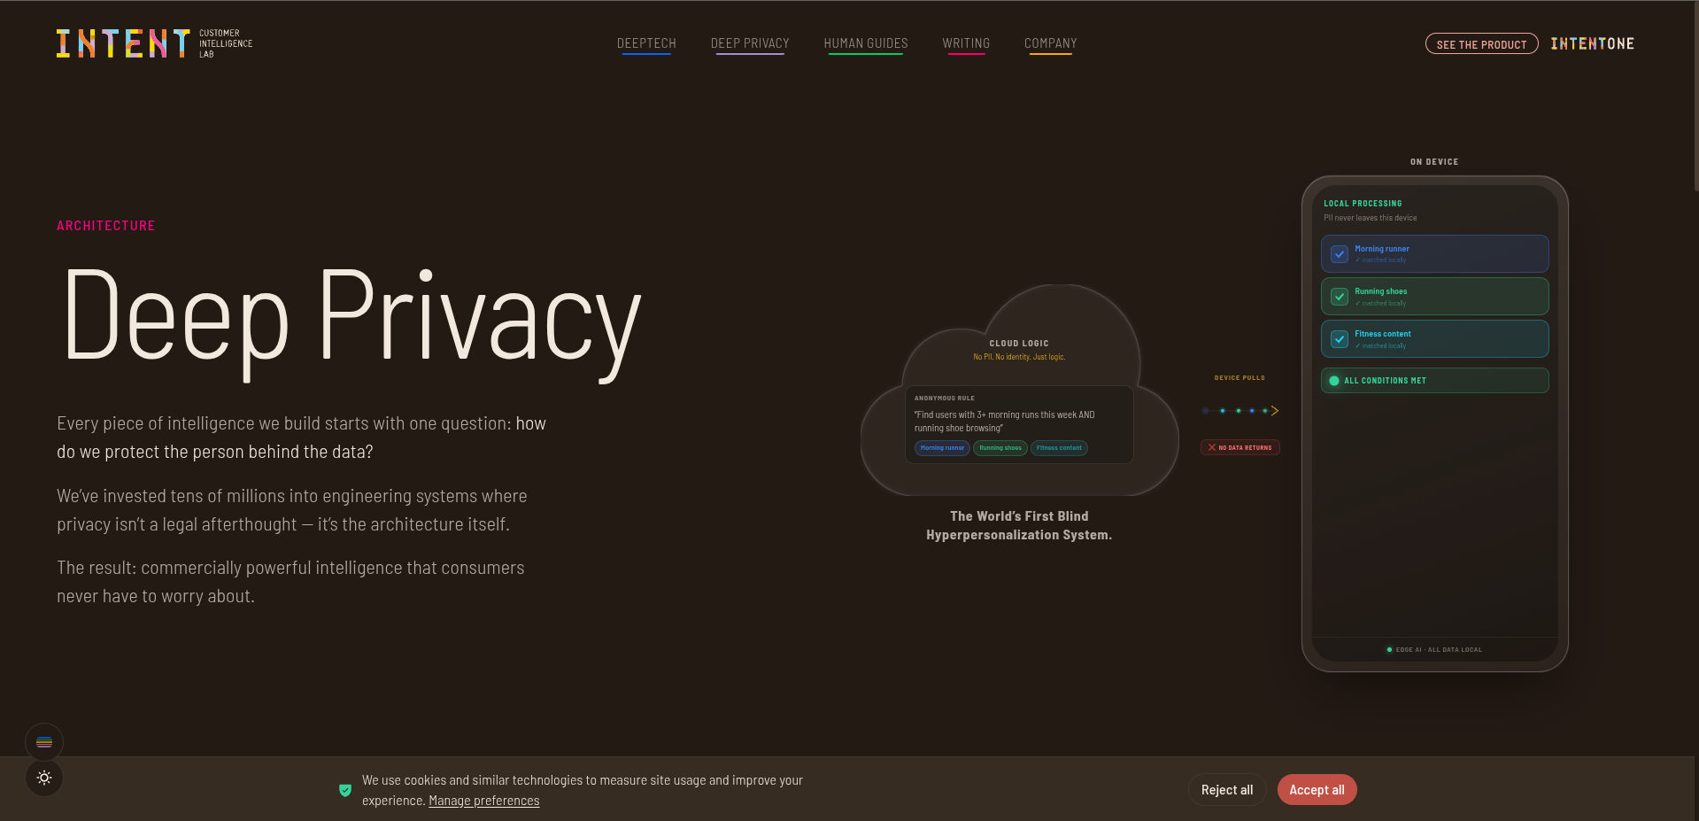
Reference: a technical architecture is explained visually beside concise editorial copy.
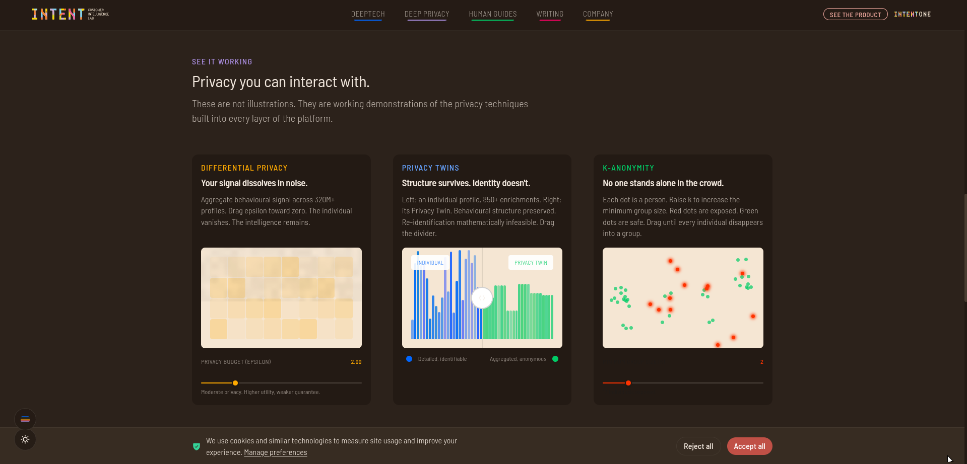
Reference: working demonstrations turn abstract technical claims into interactive proof.
THE DIGI02 ADAPTATION
Use Mobile Hacking Lab for scale, chapters, product drama, and scroll choreography. Use Intent for diagrams, demonstrations, evidence, and editorial restraint. Bind both with Digi02’s black / white / gold identity.

03 / COLOR

Color system
The palette must read as engineering, not “luxury gold.” The gold is a precision accent. Black carries the atmosphere; white carries information; gold carries priority.
Token | Hex | Use
Black 950 | #050505 | Primary page background; cinematic sections.
Black 900 | #0B0B0C | Navigation, overlays, deep cards.
Black 800 | #111112 | Elevated surfaces.
Black 700 | #181818 | Hover surfaces and secondary panels.
White 50 | #F7F6F2 | Primary text on dark.
White 100 | #E7E5DF | Secondary high-contrast text.
Neutral 400 | #AAA8A2 | Body secondary text / metadata.
Neutral 600 | #73716C | Disabled / tertiary copy.
Gold 500 | #C9A34A | Brand accent; active states; key lines; selected metadata.
Gold 400 | #E0BC67 | Small highlights; focus emphasis; dark-background icons.
Gold 700 | #86672B | Gold text on light surfaces; subtle borders.
Gold 100 | #F1E2BD | Soft gold surface tint; rare editorial callout.

Color usage ratio
- 80–85% black / dark neutrals: atmosphere, canvas, continuity.
- 10–15% white / near-white: typography, diagrams, primary UI information.
- 3–7% gold: CTA, active state, key line, selected node, metric emphasis, focus ring, or one focal word.
- Semantic red/green/amber may appear only for real system states. They are functional, never part of the decorative brand palette.

Gold rules
- Never use gold as a large page background.
- Do not put gold on every icon, border, title, and button simultaneously.
- Prefer one active gold element per visual group.
- Avoid metallic gradients for normal UI. If a metallic treatment appears, reserve it for a hero render, physical product, or rare 1–2px accent line.
- Never pair black + gold with excessive serif typography, marble textures, crowns, sparkles, or “luxury” motifs.
04 / TYPE

Typography system
The typographic contrast should echo the references: very large, confident display type paired with restrained body copy and tiny technical metadata. This creates authority without clutter.
Role | Font | Desktop | Mobile | Weight / tracking
Hero Display | Space Grotesk | 72–104px | 48–64px | 600–700 / -0.035em
H1 | Space Grotesk | 56–72px | 40–48px | 600–700 / -0.03em
H2 | Space Grotesk | 40–52px | 32–40px | 600–700 / -0.02em
H3 | Space Grotesk | 28–36px | 24–30px | 600 / -0.015em
Lead | Inter | 20–24px | 18–20px | 400 / -0.01em
Body | Inter | 16–18px | 16–17px | 400 / normal
UI / Button | Inter | 14–16px | 14–16px | 600 / 0 to +0.01em
Technical label | IBM Plex Mono | 10–12px | 10–11px | 500 / +0.12–0.18em
Caption | Inter | 12–13px | 12px | 400–500 / +0.01em

Typography rules
- Hero headlines should usually fit in 2–4 lines, not a full paragraph.
- Use sentence case for human-facing headings; reserve uppercase for technical labels and navigation microcopy.
- Keep body copy measure around 55–75 characters per line.
- Use mono labels to identify systems, modes, coordinates, stages, and metadata — not for long reading.
- One accent word in gold can work in a hero, but never color every second word.
- Avoid centered body copy except for very short statements. Default to left alignment for authority and readability.
FONT FALLBACK
If loading three families is too heavy: use Inter Display + Inter for all human-facing type, and a single mono family only where technical metadata materially adds meaning.

05 / LAYOUT

Grid, spacing & composition
Token | Value | Rule
space-0.5 | 4px | Micro alignment only.
space-1 | 8px | Base unit.
space-2 | 16px | Inline / compact stack.
space-3 | 24px | Card padding / grid gutter.
space-4 | 32px | Component separation.
space-5 | 40px | Large component spacing.
space-6 | 48px | Subsection spacing.
space-8 | 64px | Major internal spacing.
space-10 | 80px | Large section rhythm.
space-12 | 96px | Editorial breathing room.
space-15 | 120px | Standard section gap desktop.
space-20 | 160px | Cinematic section gap desktop.

Desktop grid
- 12 columns, 24px gutters.
- Max content width: 1440px. Hero media may exceed the content container when composition requires it.
- Standard side margin: 64px at 1440px and above; expand toward 80–96px on very wide screens.
- Do not center every section. Alternate 4/8, 5/7, 6/6, and full-bleed compositions to create editorial pacing.

Responsive grid
Viewport | Columns | Margins | Gutters | Section gap
≥ 1440px | 12 | 64–96px | 24px | 120–160px
1024–1439px | 12 | 40–56px | 20–24px | 96–128px
768–1023px | 8 | 32px | 20px | 80–104px
480–767px | 4 | 20–24px | 16px | 64–88px
< 480px | 4 | 20px | 16px | 56–72px

Composition rule
Every page should alternate density: cinematic / explanatory / evidence / interactive / breathing space. Do not stack six equally-sized sections with identical card grids. Rhythm is part of the brand.

06 / SURFACE

Surfaces, borders, radii & depth
Element | Radius | Border | Depth
Buttons / inputs | 4px | 1px neutral or gold focus | No default shadow.
Cards / data panels | 8px | 1px rgba(255,255,255,.10) | Tonal lift only.
Large media / hero modules | 12px | Usually none | Image itself creates depth.
Pills / tags | 999px | 1px subtle | Use sparingly for metadata.
Floating nav | 12–16px | 1px white/10% | Optional backdrop blur 12–18px.

- Prefer tonal layers over heavy shadows.
- Use gold glow only for focused/active states, never as ambient decoration behind every card.
- One-pixel lines are part of the visual language: architecture lines, progress tracks, dividers, and active borders.
- Avoid consumer-app roundness. Large 24–32px radii will make the site feel soft and generic.

07 / IMAGERY

Imagery & visual asset language

Priority order
- Real Digi02 product / hardware / interface imagery.
- High-quality 3D or technical render based on a real Digi02 system.
- Architecture diagram or system visualization derived from the product.
- Documentary photography of real people working with the product.
- Abstract visuals only when they communicate a system concept. Generic stock imagery is the last resort.

Cinematic product treatment
- Allow a device, UAV, interface, or technical assembly to occupy 50–80% of a hero viewport.
- Crop intentionally. The whole object does not need to fit; close-ups create scale and confidence.
- Use lighting that separates the object from black without making it look like a luxury ad.
- Overlay information only where the image has negative space. Never cover the important product area with text.
- Use gold as a locator: a line, active node, highlighted subsystem, or small label — not a giant glow.

Photography
- Prefer real engineering environments, field deployment, hardware interaction, control rooms, laboratories, offices, or client operations.
- Avoid handshake photos, generic coders looking at screens, fake holograms, random server racks, and “innovation team” stock scenes.
- Grade images toward neutral blacks, controlled warm highlights, and natural skin tones. Do not wash every image in gold.

08 / SYSTEM VISUALS

Architecture diagrams & technical visual language
Intent HQ demonstrates a critical idea: technical complexity can be a visual asset when it is made understandable. Digi02 should use diagrams as product communication, not decoration.

Diagram grammar
Element | Default treatment
Node | Dark surface, 1px white/10% border; active node uses gold border or dot.
Connector | 1px neutral line; gold only for the current/active path.
Stage number | Mono 10–12px; 01, 02, 03...
Stage title | Inter/Space Grotesk 18–28px depending scale.
Metadata | Mono uppercase, muted white; 0.12em tracking.
Status | Small dot + concise word: ACTIVE, VERIFIED, LOCAL, SECURE.
Annotation | Short, specific, placed close to the object it explains.

Recommended interactive diagram patterns
- Scroll-to-activate pipeline: one stage becomes gold while the rest remain muted.
- Hover-to-inspect subsystem: reveal specs or explanatory layer without navigating away.
- Before/after or split-state slider for transformation workflows.
- Sticky architecture canvas with narrative text advancing beside it.
- Clickable node map for complex systems, with keyboard-equivalent controls.

09 / UI LANGUAGE

Iconography, metadata & micro-labels
- Use a consistent outline icon family at 1.5–1.75px stroke. Avoid mixed filled/outline icon packs.
- Use icons for recognition, not decoration. If text is clearer, use text.
- Technical micro-label format: DIGI02 / AUTONOMOUS SYSTEMS, SYSTEM 04, LINK / ACTIVE, NAV / AUTONOMOUS.
- Do not fabricate telemetry. Any value that looks like a real metric must be real, explicitly illustrative, or clearly labeled DEMO.
- Use numerals for progression and hierarchy: 01 / 02 / 03. This works especially well for process, architecture, or product layers.

10 / MOTION

Motion & interaction system
Motion should have a job: orient, reveal, connect, demonstrate, or acknowledge. The best reference moments feel cinematic because they use scale and sequencing, not because everything moves.
Token | Duration | Use
motion-instant | 100–120ms | Press feedback, icon response.
motion-fast | 160ms | Hover color, border, opacity.
motion-ui | 240ms | Menus, tooltips, small overlays.
motion-component | 360–420ms | Cards, drawers, section content reveal.
motion-scene | 600–800ms | Large visual transition or diagram state.
motion-cinematic | 800–1200ms | Hero object rotation, scene shift, product dissection.

Easing
--ease-standard: cubic-bezier(0.22, 1, 0.36, 1);
--ease-emphasized: cubic-bezier(0.16, 1, 0.3, 1);
--ease-exit: cubic-bezier(0.4, 0, 1, 1);

Scroll behavior
- Use sticky sections for chapter-based storytelling; do not pin the entire site.
- Translate elements modestly: 16–40px is usually enough. Avoid objects flying 300px into view.
- Use opacity + transform, not blur-heavy reveals on every section.
- For product rotation/disassembly, scrub motion to scroll progress only when the visual meaning remains understandable at any point.
- Use progress indicators for long chapter sequences. A thin gold line or numbered chapter state is enough.
- Never hide critical information behind hover-only interactions.

Hover & focus
Interaction | Behavior
Primary button | Gold surface brightens slightly; arrow moves 3–4px; 160ms.
Secondary button | Border shifts from white/18% to gold/70%; text stays stable.
Text link | Gold underline draws from left to right; arrow moves 2px.
Card | 1–2px lift or subtle tonal change; do not scale aggressively.
Diagram node | Gold ring + connected path activates; details appear in adjacent panel.
Keyboard focus | 2px gold focus ring with 2px offset; must remain clearly visible.

Reduced motion
When prefers-reduced-motion is enabled, remove parallax, 3D rotation, autoplay scene changes, and scrubbed transforms. Preserve hierarchy with instant or short opacity transitions and static diagrams.

11 / NAVIGATION

Navigation & information architecture

Recommended top-level structure
Primary | Purpose
Capabilities | Software, ERP, payroll, transaction systems, autonomous systems.
Systems | Named Digi02 products/platforms or grouped system families.
Industries | Where the systems operate and who they serve.
Company | About, leadership, careers, partnerships.
Insights | Case studies, engineering notes, research, news.
Talk to Engineering | Primary CTA; opens contact or project enquiry path.

- Keep top navigation to 5–6 primary items.
- Use a dark mega-menu with grouped capability families, short descriptions, and one featured case or system visual.
- Floating navigation may use a subtle translucent black surface, 1px white/10% border, and 12–18px blur.
- Do not overfill the nav with every service. The page should feel curated, not like a sitemap.

12 / COMPONENTS

Core component rules

Buttons
Variant | Treatment | Use
Primary | Gold background, black text, 4px radius, concise label + arrow. | One dominant CTA per section.
Secondary | Transparent, white/18% border, white text. | Alternative action.
Ghost | Text only, optional arrow, gold on interaction. | Navigation and low-priority actions.
Dark-on-light | Black background, white text. | Rare light/editorial sections.

Cards
Cards are not the default layout. Use them when the content is a bounded object: a case study, product module, dataset, article, comparison item, or interactive demo. For service storytelling, prefer open compositions, diagrams, or full-width media.

Tags and chips
- Use for metadata such as AUTONOMOUS, SECURE PAYMENTS, ERP, DEPLOYED, CASE STUDY.
- Small height (24–28px), subtle border, minimal radius, mono or small UI text.
- Avoid clouds of 10–15 decorative tags.

Forms
- Labels above inputs; never rely on placeholder as label.
- Dark input surface #111112; 1px border white/12%; gold focus state.
- Error messaging must be specific and adjacent to the field.
- Project enquiry form should feel consultative, not like a generic “Contact us” form.

13 / CONTENT

Content, voice & evidence

Voice
- Technical, calm, specific, confident.
- Short claims followed by proof.
- Use verbs: engineer, integrate, automate, secure, deploy, control, monitor, reconcile, optimize.
- Avoid empty phrases: cutting-edge, revolutionary, world-class, seamless, innovative solutions, next-generation — unless the claim is immediately substantiated.
- Write like engineers explaining capability to serious buyers, not like an agency trying to impress everyone.

Evidence hierarchy
- Case outcome: measurable result, named context when permission allows.
- System proof: architecture, product screenshot, live demo, deployment view, spec, integration map.
- Operational proof: uptime, throughput, transactions, deployments, users, regions — only if verified.
- Trust proof: certifications, partners, audits, patents, standards, security controls — only if current and accurate.
- Human proof: client quote or expert endorsement with clear identity and permission.
NO FAKE TELEMETRY
A premium technical website loses trust instantly when decorative metrics look real but are invented. Use verified data, clearly labeled demo data, or purely qualitative diagrams.

14 / HOME

Homepage choreography
The homepage should behave like a controlled introduction to a systems company, not a catalogue of services.
Chapter | Purpose | Recommended visual
01 / Hero | Define the company in one sentence. | Large real system/product visual; subtle chapter label; one primary CTA.
02 / Proof | Establish scale and credibility fast. | 3–5 verified metrics, clients, deployments, standards, or outcomes.
03 / Systems | Reveal the capability families. | Scroll-driven system chapters; each with its own subject matter.
04 / Architecture | Explain how Digi02 thinks. | Interactive system map connecting software, transactions, enterprise, and autonomous systems.
05 / Case evidence | Show what has worked. | Editorial case stories; outcome first, then architecture.
06 / Engineering approach | Show how Digi02 builds. | Process, stack, security, quality, deployment model.
07 / Insights | Show ongoing expertise. | Engineering notes, research, product updates.
08 / CTA | Invite a serious conversation. | Minimal black/gold contact section: “Talk to Engineering.”

15 / CAPABILITY PAGES

Capability-specific visual grammar

UAV / Autonomous systems
- Most cinematic page in the system.
- Large aircraft imagery or 3D render; subsystem callouts; mission-control views; flight path or autonomy architecture.
- Use stages such as FLIGHT CONTROL / NAVIGATION / TELEMETRY / PAYLOAD / GROUND CONTROL / MISSION DATA.
- Motion can include controlled rotation, exploded view, map route draw, and subsystem activation.

Secure payments
- Use transaction-flow storytelling rather than generic card grids.
- Visual path: DEVICE → AUTHENTICATION → TRANSACTION ENGINE → SECURITY → SETTLEMENT → REPORTING.
- Gold = current transaction stage; white = verified; muted = inactive.

Enterprise ERP
- Present the organization as a connected operating system.
- Modules can orbit or connect to a central operating layer: Finance, HR, Inventory, Procurement, Operations, Analytics.
- Use interaction to show data crossing departments and becoming a unified view.

Payroll automation
- Use a pipeline metaphor: Employee data → Attendance → Allowances → Tax/PAYE → Approval → Payroll → Reporting.
- Use before/after or throughput visualization to show reduction of manual work when evidence is available.

POS systems
- Borrow the “hardware as interface” philosophy from Mobile Hacking Lab.
- Use device close-ups, exploded layers, or retail context; explain hardware → payment → inventory → analytics → branch management.
- Do not make the page look like an e-commerce product listing.

Custom software
- Show architecture constructing itself: Frontend → API → Services → Data → Cloud → Security → Monitoring → Integrations.
- Show real screenshots or anonymized product views where possible.
- Use case studies to demonstrate range instead of listing every framework or language in a logo cloud.

16 / RESPONSIVE

Responsive behavior
- Mobile is not desktop stacked vertically. Recompose the story around a narrower viewport.
- Cinematic hero objects should crop more aggressively on mobile rather than shrink into tiny full-object images.
- Sticky scrollytelling should become shorter, simpler sequences; if the interaction is fragile on touch, replace it with a controlled carousel or stepped story.
- Horizontal architecture maps should become vertical progressions or swipeable panels with clear position indicators.
- Keep touch targets at least 44×44px.
- Maintain 16px minimum body text.
- Do not use hover as the only way to reveal important content.
Pattern | Desktop | Mobile adaptation
Hero split | Text 4–5 cols / media 7–8 cols | Text first; media full bleed or cropped beneath.
System map | Horizontal or layered canvas | Vertical stages with active connector.
Mega-menu | Multi-column grouped panel | Full-height navigation sheet.
Large data grid | 3–4 columns | 1 column, prioritised content.
Sticky product scene | 60–100vh pin | Short pin or static keyframes.

17 / ACCESSIBILITY

Accessibility & inclusive interaction

Non-negotiables
- Meet WCAG 2.2 AA contrast for text and meaningful controls.
- Visible keyboard focus for every interactive element; gold focus ring recommended.
- Logical heading order; one H1 per page.
- Meaningful alt text for product and diagram imagery; decorative imagery should be ignored by assistive technology.
- Architecture diagrams need a text equivalent or structured explanation.
- Interactive demos must work with keyboard and touch, not mouse only.
- Respect prefers-reduced-motion.
- Never communicate status by color alone; pair color with text, icon, or pattern.

Gold contrast warning
Gold text on white often fails contrast when the gold is too light. Use Gold 700 (#86672B) for small text on light backgrounds. Gold 500 (#C9A34A) is best used as an accent, border, icon, large display accent, or on very dark surfaces — not as default small body text.

18 / PERFORMANCE

Performance rules for a cinematic site
- Do not trade credibility for a 12-second hero load. The first useful visual should appear quickly.
- Use modern image formats (AVIF/WebP), responsive srcsets, and intentional crop variants.
- Lazy-load non-critical media below the fold.
- Use video only when it communicates more than an image sequence; provide a poster and avoid mandatory audio.
- Prefer transform/opacity animations; avoid animating layout properties that cause reflow.
- For 3D, load a lightweight static hero first, then progressively enhance when the model is ready.
- Reserve GPU-heavy WebGL scenes for moments that materially improve understanding.
- Budget motion libraries and fonts. Do not load three animation frameworks for one page.
PERFORMANCE IS PART OF THE BRAND
A company selling serious technology cannot have a website that feels technically careless. Smoothness, loading, responsive behavior, and accessibility are part of the product impression.

19 / TOKENS

Implementation tokens
Use these as a starting point. The developer may map them into CSS variables, Tailwind tokens, a design-token file, or the chosen component system.
:root {
--bg-950: #050505;
--bg-900: #0B0B0C;
--surface-800: #111112;
--surface-700: #181818;
--text-primary: #F7F6F2;
--text-secondary: #AAA8A2;
--text-muted: #73716C;
--gold-500: #C9A34A;
--gold-400: #E0BC67;
--gold-700: #86672B;
--line-subtle: rgba(255,255,255,.10);
--line-gold: rgba(201,163,74,.35);

--radius-control: 4px;
--radius-card: 8px;
--radius-media: 12px;

--space-1: 8px;
--space-2: 16px;
--space-3: 24px;
--space-4: 32px;
--space-6: 48px;
--space-8: 64px;
--space-12: 96px;
--space-15: 120px;
--space-20: 160px;

--motion-fast: 160ms;
--motion-ui: 240ms;
--motion-component: 420ms;
--motion-scene: 800ms;
--ease-standard: cubic-bezier(.22,1,.36,1);
}

20 / ANTI-PATTERNS

What must never happen
- Black + gold turned into a luxury/watch/casino aesthetic.
- Every service represented by the same 3-card grid.
- Glowing hexagons, fake terminals, random world maps, Matrix code, gold particles, or generic circuit-board backgrounds.
- Invented telemetry, fake client logos, fake certifications, or unsupported performance claims.
- Huge gradients and blur effects reducing text clarity.
- Every element rounded into a pill or 24px card.
- Scroll hijacking that makes the page difficult to control.
- Autoplay audio.
- Motion that breaks on mobile or becomes unusable with reduced motion.
- Stock images of handshakes, fake coders, or generic “business innovation” scenes.
- A 30-item navigation bar because Digi02 has many capabilities.
- A homepage that reads like six unrelated companies under one logo.

21 / QA

Design QA & handoff checklist
□ The page has one clear visual idea, not just a collection of components.
□ The primary CTA is obvious within 5 seconds.
□ Gold appears intentionally and sparingly.
□ Every major claim has proof, system detail, or evidence nearby.
□ The layout does not repeat the same card grid more than necessary.
□ Hero type scale is strong without obscuring meaning.
□ Body copy is readable and line lengths are controlled.
□ All hover interactions have keyboard/touch equivalents.
□ Focus states are visible.
□ Reduced-motion mode has been checked.
□ Mobile composition has been intentionally redesigned, not simply stacked.
□ No critical text is embedded only in an image.
□ Images are optimized and responsive.
□ Animations use transform/opacity where practical.
□ Real data/metrics are verified or clearly marked as demo.
□ No component looks copied from Mobile Hacking Lab or Intent HQ.
□ The page feels recognizably Digi02 when viewed without the logo.

22 / EXECUTION ORDER

Build priority
Priority | Build first | Why
P0 | Color, type, spacing, grid, buttons, navigation, accessibility basics | Prevents visual drift before any page gets complicated.
P0 | Homepage hero + one capability chapter | Defines the actual Digi02 visual language.
P1 | Reusable architecture / system-diagram component | Creates the engineering identity across multiple products.
P1 | UAV page and POS page | Best opportunities for cinematic product storytelling.
P1 | Payments / ERP / Payroll pipeline patterns | Creates meaningful interaction without copying reference sites.
P2 | Case-study / evidence system | Turns design quality into buyer confidence.
P2 | Motion polish and progressive 3D | Add only after layout, responsiveness, and performance are strong.

BEST FIRST PROTOTYPE
Before building every page, prove the system with three screens: (1) homepage hero + systems chapter, (2) UAV capability scene, and (3) architecture/evidence section. If those three feel unmistakably Digi02, the rest of the site will have a strong foundation.

23 / SOURCES

Reference sources
These references are used for design-principle study only. The Digi02 implementation should not copy protected imagery, copywriting, branding, proprietary diagrams, or distinctive component compositions.
Source | Reference use
Mobile Hacking Lab — https://www.mobilehackinglab.com/ | Cinematic device/hardware presentation, chapter-based storytelling, technical metadata, certification path hierarchy.
Intent HQ Deep Privacy — https://intenthq.com/deep-privacy | Architecture-first storytelling, interactive demonstrations, evidence-led technical communication.
Intent HQ Deeptech — https://intenthq.com/deeptech | Layered architecture and connected-system framing.
Intent HQ Evidence — https://intenthq.com/evidence | Proof / evidence presentation principles.
User-provided screenshots — 14 Aug 2026 | Visual reference captures used throughout this guide.
Digi02 Stitch design package — user-provided ZIP | Existing baseline to be upgraded from muted-green “Kinetic Enterprise” styling into black/white/gold Precision Systems.

Final design statement
DIGI02 / PRECISION SYSTEMS
Black canvas. Monumental white type. Controlled gold. Real technology. System diagrams. Technical micro-typography. Cinematic product presentation. Evidence over hype. Motion that explains. Every page should feel engineered.

