**Higher School of Digital Economy**

MANOUBA UNIVERSITY



**Academic Year: 2023/2024**

4evergreen web application

Field of Study : Business Information System

**REPORT OF THE YEAR'S END PROJECT**

By:

**Ben Rajab Assil -- Ksouri Emna**

Table of Contents

**Chapter I : Project Presentation3-4**

1.Introduction 3

2.Platform Overview3

**Chapter II :** **.NET(c#)** **5-14**

1. Data Base connexion5-6

2. Login Interface 7

2.1 Password and User Name verification7

3. Dashboard Interface8-9

3.1 Search Functionality8

4. Admins 10

4.1 Super Admin 10

4.2 Communities Admin 10

4.3 Green Space Admin 10

5. CRUD Operations 11-12

6. Error: Reference ID Not Found 13

**Chapter III : Conclusion** **14**

**CHAPTER I :** **Project Presentation**

1. Introduction :

In this era, where technology is an essential component of our lives, the importance of embracing green living and sustainable practices has become increasingly evident. Recognizing the intersection of technology and environmental consciousness, we have developed a solution that uses the power of technology to promote plant care, community engagement, and environmental awareness.

1. Platform Overview :

Our project aims to create a website that helps people to care about green life . The website will feature a homepage where users can log in or sign up. Upon signing in, users have the option to join existing green space communities or create their own. A green space community serves as a platform where members can collaborate on plant care tasks, such as creating and sharing tasks. Additionally, users can share posts of their plants with other members, fostering a sense of community among plant enthusiasts.

platform 4evergreen represents 4 essential goals :

* Share: Encourage users to share their love for plants, experiences, and knowledge with others in the community. This includes sharing photos, stories, tips, and advice on plant care and cultivation.
* Care: Foster a culture of responsibility and stewardship towards plants by facilitating collaborative care within the community. Users can assign and complete tasks related to plant care.
* Learn: Provide users with opportunities to expand their knowledge and understanding of plants, gardening techniques, and environmental stewardship.
* Discover: Facilitate exploration and discovery by enabling users to explore new plant species, gardening trends, and green initiatives. Users can discover new plants, gardens, and green spaces within their community.

**CHAPTER II: .NET**

1. Data Base connexion:

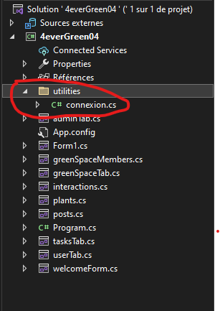Organized project files with a dedicated utilities directory housing the Connection class.

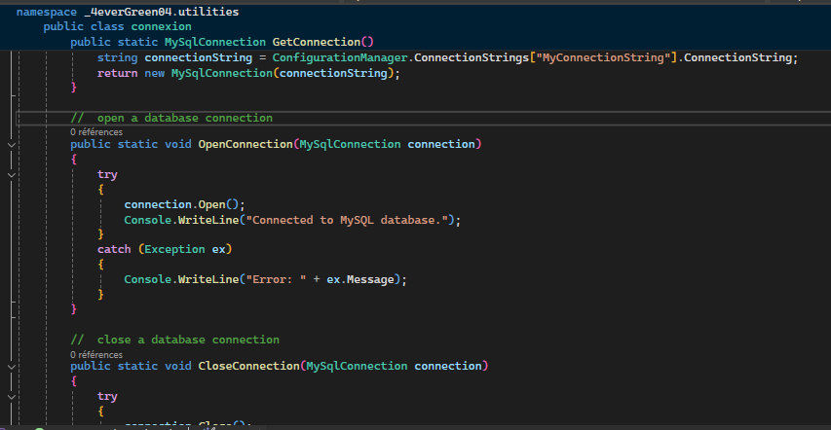Connection Class Code

Configuration settings, including the database connection string, stored in the app.config file.

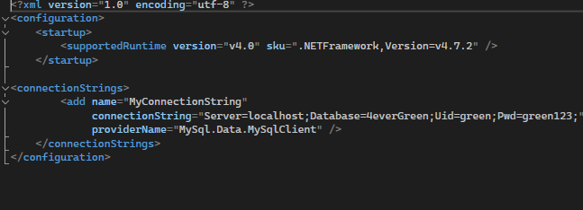

1. 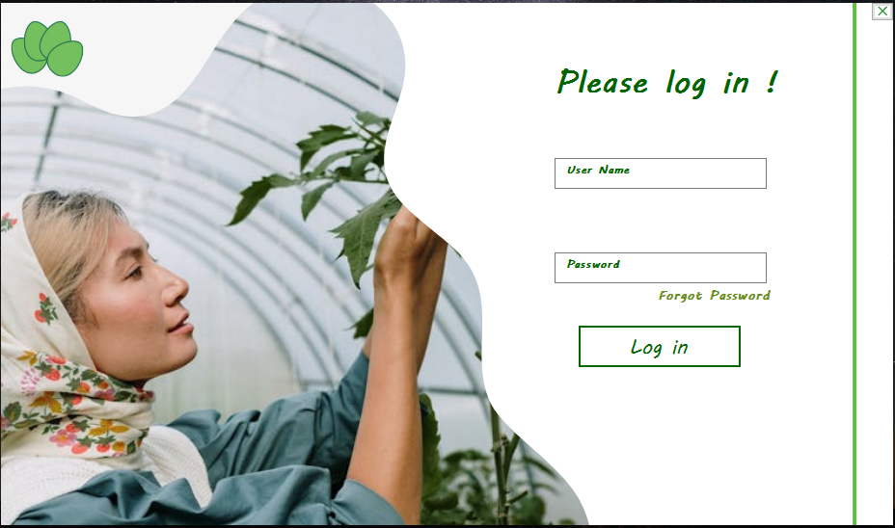Login I*nterface*:

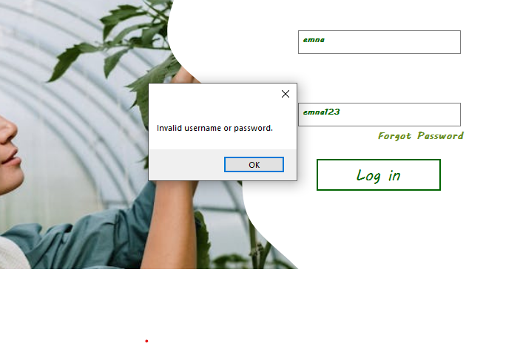2.1 Password and User Name verification

1. Dashboard Interface

Central interface providing access to including table search and logout options.

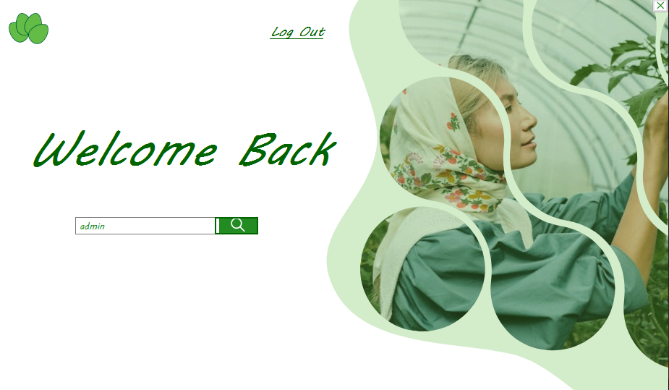

* 1. Search Functionality:

enables users to quickly find and access specific tables by entering their names. It ensures secure access control by verifying the user's role before granting access to the requested table. Error messages are displayed if invalid table names are entered or if the user lacks appropriate permissions.

No access granted:

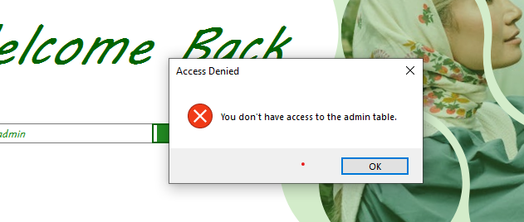

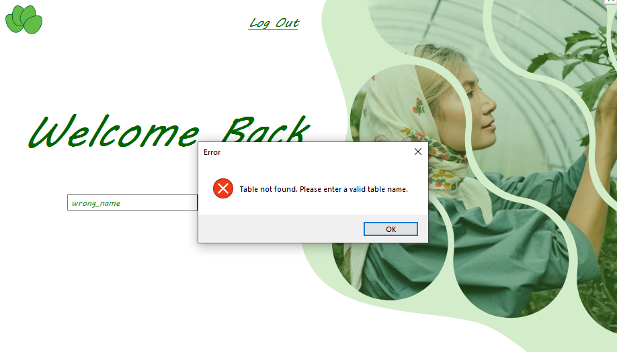Table not found erreur:

1. Admins:

The application features three types of administrators:

Super admin, have access to all tables,

Community admin, access to user-related tables (users, post, interactions),

Green space admin, exclusively access green space-related tables (green space members, plant tasks, plants).

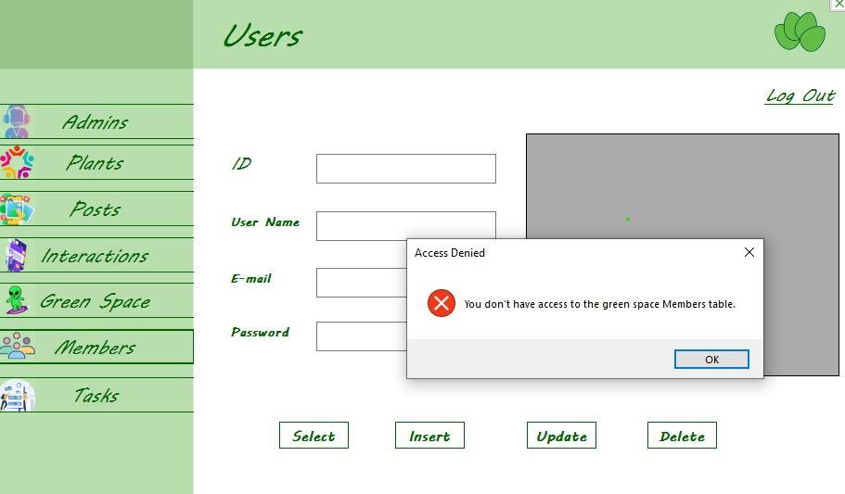Access was denied to a community admin who wanted to access the green space members.

1. CRUD Operations:
   1. 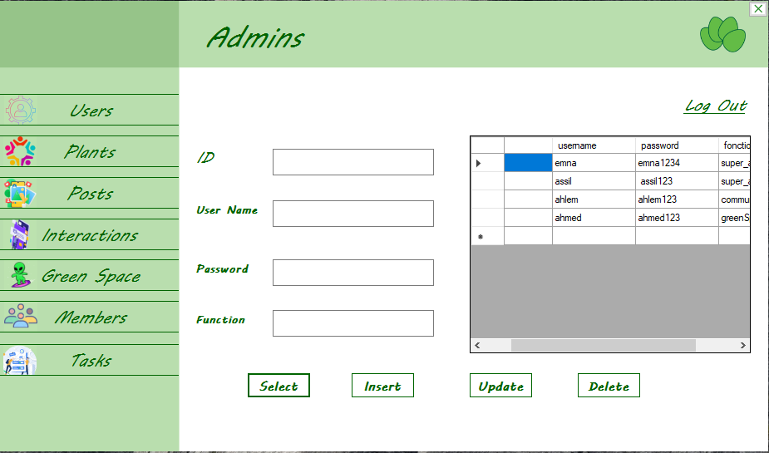Select Operation:
   2. Insert Operation:

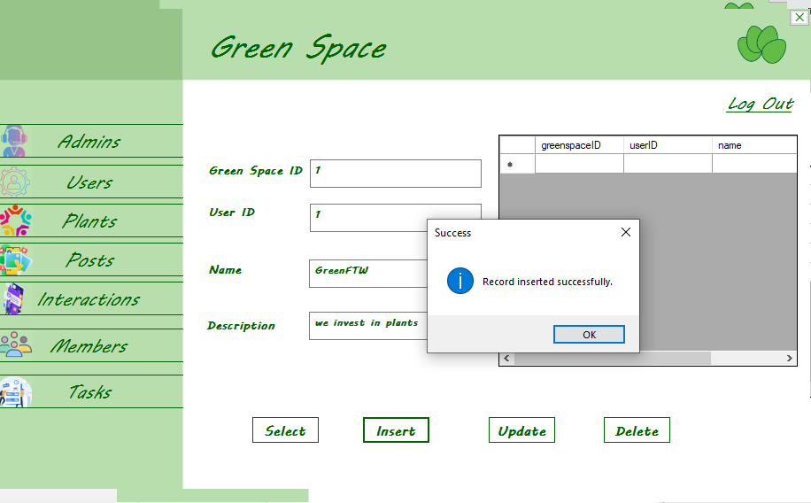

* 1. 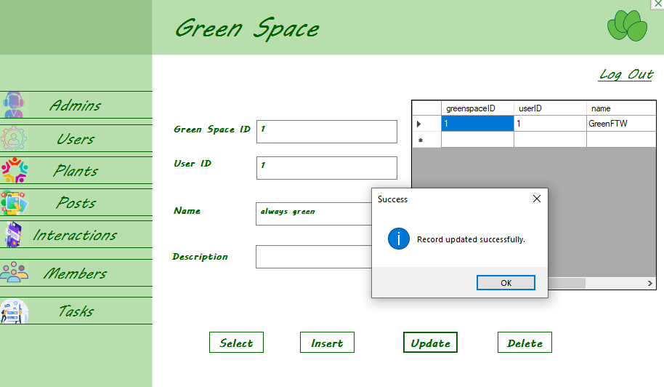Update Operation:
  2. Delete Operation:

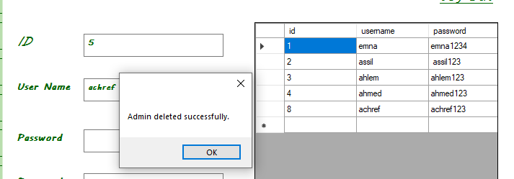

1. 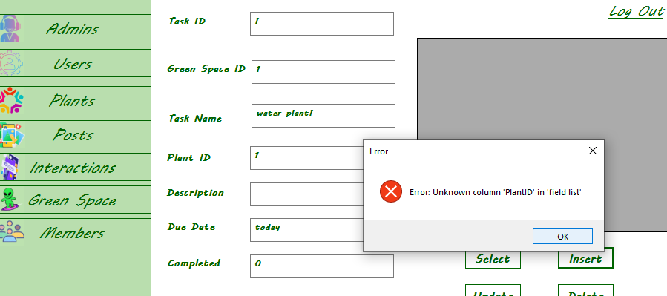Error: Reference ID Not Found

**CHAPTER III: Conclusion**

The 4everGreen project embodies more than just a technological initiative, we have merged our passion for technology with our desire to raise awareness about nature preservation.

We are grateful for the opportunity to channel our knowledge and skills into this end-of-year project. We extend our heartfelt thanks to our teachers for their support and invaluable guidance throughout this journey.