


PROJECT REPORT
Smart Supply Chains
Unlocking Performance Insights with Power BI

Student: Warteni Emna
Class: G6B
Academic Year: 2025/2026

Table of Contents
Supply Chain Performance Analysis
1. Objective of the project 3
2. Introduction 3
3. Business problem statement 3
4. Data used 3
5. KEY Performance indicators 4
6. Methodology (Data Flow) 4
7. Power BI dashboard structure 4
A. Overview page : 5
B. Delivery performance : 5
C. Supplier performance: 6
D. Inventory Management: 6
- Cost Analysis: 7
8. Analysis &Insights 8
9. Recommandations 8
10. Conclusion 8

Objective of the project:
The objective of this project is to analyze supply chain performance using Power BI it aims to:
- Monitor key indicators such as delivery time, cost, and fulfillment rate
- Identify the main causes of delivery delays
- Evaluate and compare supplier performance
- Analyze transportation cost trends
The goal is to improve efficiency, reduce delays, and support better decision-making.

Introduction:
This project aims to analyze supply chain performance using Power BI. It helps identify delays, evaluate suppliers, and monitor costs. The use of dashboards allows better understanding of operations.

Business poblem Statement:
The company is experiencing several operational challenges that affect its performance:
- A high number of delayed deliveries
- Increasing transportation costs
- Limited visibility into supplier performance
The on-time delivery rate is only 43%, which means that more than half of the orders are delayed. This situation requires a data-driven solution to monitor performance and support decision-making.

Data used:
The data used in this project comes from an Excel dataset that contains information about supply chain operations.
The dataset includes details such as:
- Order ID and product type
- Supplier and delivery region
- Order and delivery dates
- Lead time and transportation cost
- Fulfillment rate
- Delay status and delay causes
This data represents 100 orders and is used to analyze delivery performance, supplier efficiency, and cost behavior.

Key Performance Indicators:
The following KPIs are used to evaluate supply chain performance:
• On-Time Delivery Rate (43%): Measures the percentage of orders delivered on time. A low value indicates delivery issues.
• Average Lead Time (6.8 days): Represents the average time required to deliver orders. Lower lead time means better efficiency.
• Total Transportation Cost (~11K): Shows the total cost of transportation during the period.
• Average Fulfillment Rate (0.91): Indicates how well orders are completed and delivered successfully.

Methodology:
The project was carried out through the following steps:
- Data collection: The dataset was imported from an Excel file containing supply chain information.
- Data Cleaning: Power Query was used to clean and prepare the data (handling missing values and formatting).
- Data Modeling: Relationships and calculated measures (KPIs) were created using DAX.
- Data Visualization: Interactive charts and KPI cards were built in Power BI to represent the data clearly.
- Analysis: The dashboard was used to analyze performance, identify delays, and extract insights.
This methodology helps transform raw data into meaningful information for decision-making.

Power BI Dashboard Structure
The dashboard is organized into several sections to provide a clear and complete analysis of supply chain performance.

Overview Page
This section provides a global view of the data. It includes:
- Total number of orders, regions, and suppliers.
- Key performance indicators (KPIs) such as On-Time Delivery Rate, Average Lead Time, Total Cost, and Fulfillment Rate.
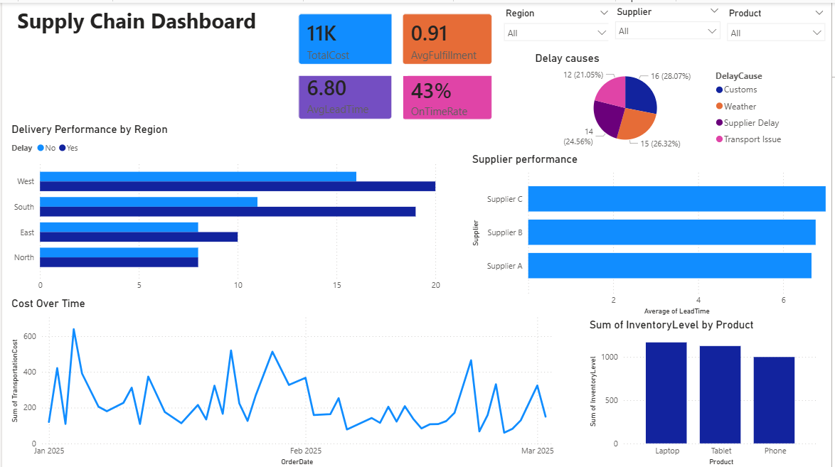

Delivery Performance:
This section focuses on delivery efficiency:
- A bar chart showing on-time vs delayed deliveries by region.
- A pie chart illustrating the main causes of delays (transport, customs, weather, supplier).
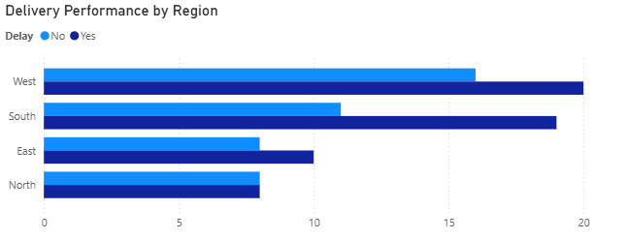

Supplier Performance:
This section evaluates supplier efficiency:
- A bar chart comparing suppliers based on average lead time.
- A table or visual showing supplier performance.
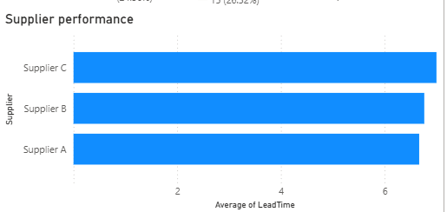

Inventory Management :
This section analyzes inventory behavior:
- Inventory levels over time.
- Stock availability by product.
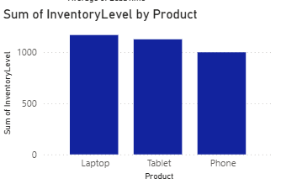

Cost Analysis:
This section analyzes transportation costs:
. A line chart showing cost trends over time.
. A comparison of costs by region or product.

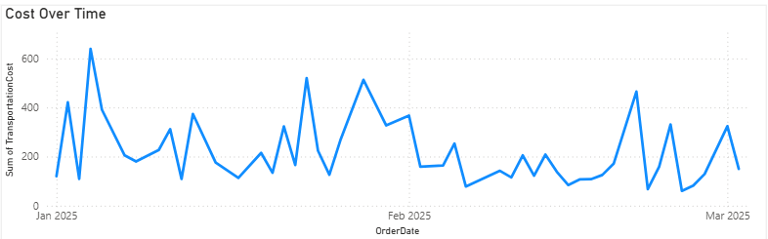

Analysis & Insights:
The dashboard reveals several important insights:
- The West region has the highest number of delayed deliveries.
- The On-Time Delivery Rate (43%) indicates poor delivery performance.
- Supplier A performs better compared to others due to lower lead time.
- Transportation and customs issues are the main causes of delays.
- Costs vary over time, indicating possible inefficiencies in logistics.
These findings highlight key areas that require improvement.

Recommendations:
- Improve logistics planning in high-delay regions.
- Optimize supplier selection based on performance.
- Reduce transportation delays and costs.
- Use dashboards for continuous monitoring and decision-making.

Conclusion:
This project demonstrates how Power BI can be used to analyze supply chain performance effectively.
The dashboard helps identify hidden patterns, such as regions with high delays and suppliers with lower efficiency. It also provides a clear visualization of costs and delivery performance.

