**ITE325 IT ELECTIVE 4 – TECHNOPRENEURSHIP (LAB)**

**MIDTERM EXAMINATION**

**2ND SEMESTER, ACADEMIC YEAR 2024 – 2025**

Name: **HANIBA, JOHN MEL C**  Date:

Program/Year/Block: **BSIT3D**  Score:

**IT Elective 4 – Technopreneurship**

**Start Up Business Booth Opening and Ribbon Cutting**

**Objectives:**

**I. Booth Design:** Visual appeal and functionality are critical. Ensure that the design aligns with your brand identity and draws attention.

The **DigiPin** booth will be designed for **visual appeal, functionality, and interactive engagement**. It will serve as a welcoming space where visitors can explore **DigiPin’s** products, participate in activities, and make purchases.

**1. Layout and Theme**

The booth will have a **modern and organized** setup with clearly defined sections to ensure smooth interaction between staff and visitors. Branding elements will be prominently displayed to enhance brand recognition.

**2. Key Booth Elements**

**Backdrop and Branding**

* A large banner displaying the **DigiPin logo, tagline, and key products** to establish strong brand identity.
* QR codes linking to DigiPin’s **official store and social media pages** for easy access.

**Product Display and Demonstration**

* **Laptops for Product Display:** Laptops will showcase **digital planners, templates, and available button pin designs** to allow customers to browse easily.
* **Live Pin Customization Booth:** Visitors can request personalized designs for button pins.
* **Digital Planner Demonstration:** A dedicated area where staff will guide visitors on using digital planners effectively.

**Interactive Code-Solving Engagement**

* **Coding Challenge Activity:** A small section where visitors can participate in a short **code-solving challenge**.
* **Reward System:** Visitors who successfully solve the challenge will receive **exclusive DigiPin products** as rewards, encouraging engagement.

**Sales and Transaction Counter**

* A designated **sales counter** for processing purchases, with **printed receipts and order forms** readily available.
* Business cards and flyers will be distributed to potential customers.

**Marketing and Customer Engagement**

* **Photo Spot:** A small branded section where customers can take pictures with their purchased items.
* **Freebies and Giveaways:** Stickers or keychains as incentives for visitors who interact with the booth

**II. Target Audience:** Understand the demographic attending the event to tailor the booth layout, design, and promotional materials.

DigiPin’s target audience at the event includes:

* Students & Young Professionals – Looking for creative and functional digital planners for organization.
* Artists & Creatives – Interested in unique button pins to express their style.
* Small Business Owners & Entrepreneurs – Seeking custom branding solutions through personalized pins and digital prints.
* Collectors & Hobbyists – Enthusiasts who enjoy pop culture and themed collectibles.

**III. Product/Service:** Identify key products or services to showcase that will attract attention and spark curiosity.

To attract attention and engage visitors, DigiPin will highlight:



* Custom Button Pins – Featuring trendy designs, pop culture references, and motivational quotes.
* Digital Planners & Templates – Ready-to-download planners, journals, and printable organizers.
* Exclusive Event-Only Bundles – Limited-edition pin and printable packs at special discounts.
* Live Demonstration Booth – Showcasing how digital planners work and how customers can personalize button pins.

# Booth Materials and Equipment

List all the materials and equipment needed for setting up the booth.

**Setup & Display:**

* Table, chairs, table cover **Promotional Materials:**
* Flyers, business cards, posters, and a QR code for digital access. **Product & Sales Materials:**
* Button pins, tablet/laptop for digital products, demo screens, POS system, receipts, and order forms.

**Miscellaneous:**

* Extension cords, notebook, and cleaning supplies.

# Marketing Materials

1. Brochure Design
2. Poster

1. Business Card

1. QR Code for Facebook Page
2. Flyers A qr code with blue circles

   AI-generated content may be incorrect.

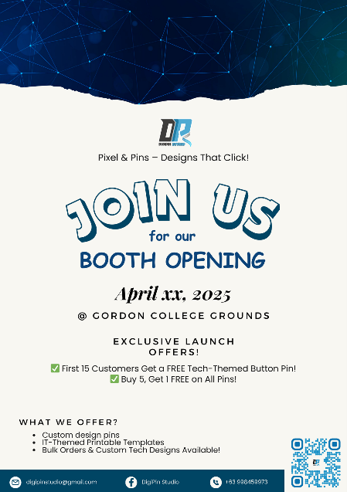

1. Promotional Items

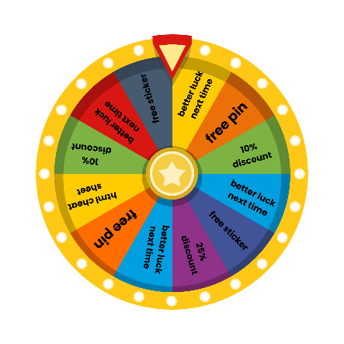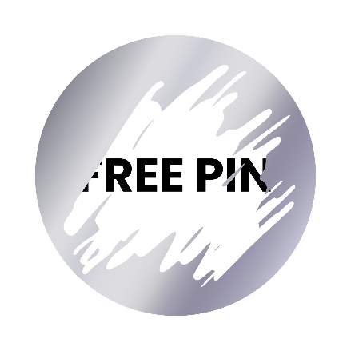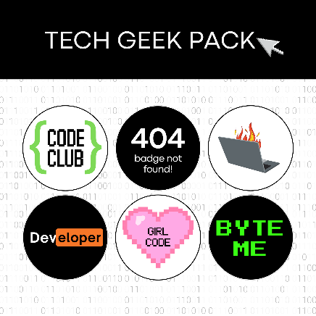

1. Others: _________________________________________

# Product or Service

**Products to Sell:**

* Custom Button Pins – Featuring trendy designs, pop culture references, and motivational quotes.
* Digital Planners & Templates – Ready-to-download planners, journals, and printable organizers.
* Exclusive Event-Only Bundles – Limited-edition pin and printable packs at special discounts.

**Services Offered to the Public:**

* **Live Customization** – Customers can personalize button pins on the spot.
* **Digital Planner Demonstration** – Showcasing how digital planners work and how customers can maximize their use.
* **Branding Consultation** – Assisting small business owners in selecting designs for personalized pins and prints.
* **On-the-Spot Printing** – Printing services for event-exclusive designs and custom orders.

# Startup Business Founder Coordination

* **Team Members & Responsibilities:**
  + **Leader: Knowell Lucky Versoza** – Oversees the overall booth operations and ensures smooth coordination.
  + **Ainjell Manuel** – Manages product sales and handles customer transactions.
  + **John Mel Haniba** – Responsible for live customization and product demonstrations.
  + **Allen Jake Lavina** – Handles marketing and promotional activities, including distributing flyers and engaging visitors.
  + **Ynnyannah Cruz** – Assists in customer interactions, organizing booth materials, and documentation.
* **Shift Management:** Organize staff shifts to ensure efficient booth operation.
* **Role Assignment:** Clearly define responsibilities to streamline workflow.
* **Logistics Coordination:** Ensure materials and equipment are prepared.
* **Customer Engagement:** Create an interactive and welcoming environment for visitors.

# Others

* Bring orange ribbon for ribbon cutting.
* Print attendance form or sheet using your letterhead for listing audience/visitors’ information.
* All booth activity should be properly documented.

# Accomplishment Report

Submit an accomplishment report day after booth opening schedule.