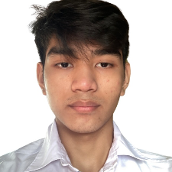**JOB OBJECTIVES:**



Emnmtv29@gmail.com

|

Purok 4 new cab, olongapo city,PH

|

09272391660

I am a highly dedicated and motivated individual, capable of working under pressure in various environments. I am eager to apply for the position of Web Developer with your company, where I can utilize my skills to enhance and elevate the user experience.

**PERSONAL INFORMATION:**

* Age : 21 years’ old
* Gender : Male
* Civil Status : Single
* Nationality : Filipino
* Religion : Roman Catholic
* Date of Birth : April 11, 2003
* Place of Birth : Olongapo City, Zambales
* Language : Filipino, English

**JOB EXPERIENCE:**

As a third-year college student, I may not have formal work experience yet, but I have developed several web application projects as part of my coursework. I would be excited to gain my first professional experience with your company and contribute my skills to your team.

**EDUCATION:**

* **College** : **Gordon College, 2022 - Present**

Bachelor of Science in Information Technology

* **Senior High**

**School** : **New Cabalan Senior High School, 2019-2021**

Science Technology Engineering and Mathematics With Honor

* **Junior High**

**School** : **New Cabalan National High School, 2015-2019**

Academic Achiever

**Skills:**

* **Web Development:** Backend API development (PHP, Python, Node.js, Express), Frontend (Angular, Vue.js, React.js)
* **Databases:** MySQL, Prisma
* **Technical Skills:** Strong understanding of RESTful APIs, database design, and JavaScript frameworks
* **Soft Skills:**
  + Communication: Effective in discussing technical concepts and collaborating with teams
  + Time Management: Capable of meeting deadlines and managing multiple projects efficiently
  + Flexibility: Adaptable to new technologies and fast-paced work environments
  + Problem-Solving: Strong analytical skills to identify and solve complex challenges