I want to create a minimalist site that does not utilize a lot of page heavy, intense, blaring design but is thoughtful and clean and user friendly. So, the wireframe is more focused on the look. I may find this concept will change once I get into bootstrap because if the point of the project is to get more familiar with bootstrap and this design doesn’t facilitate that – I’ll adapt it and use this for a rainy day.

Landing page

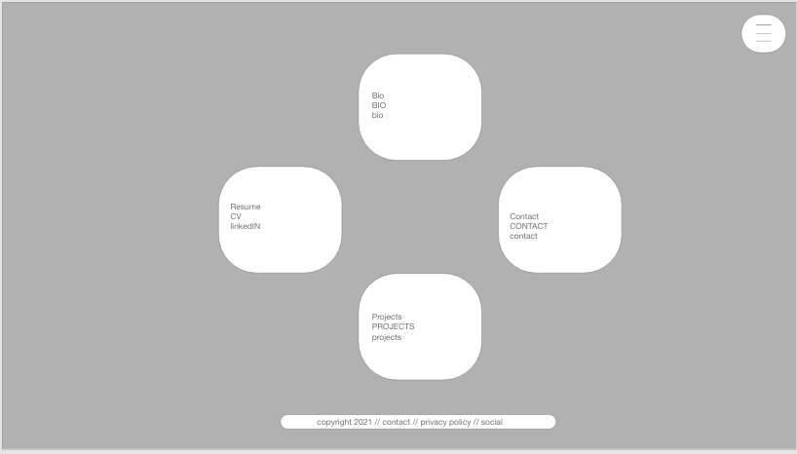

Projects 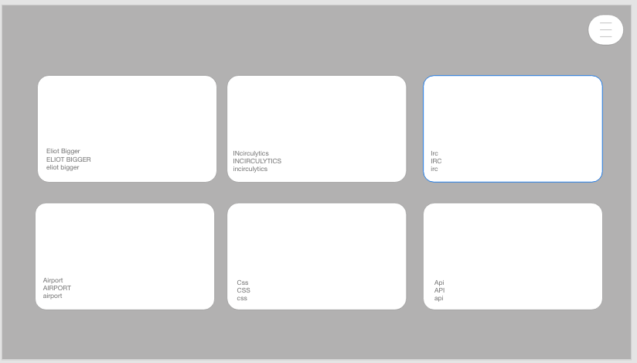

Bio

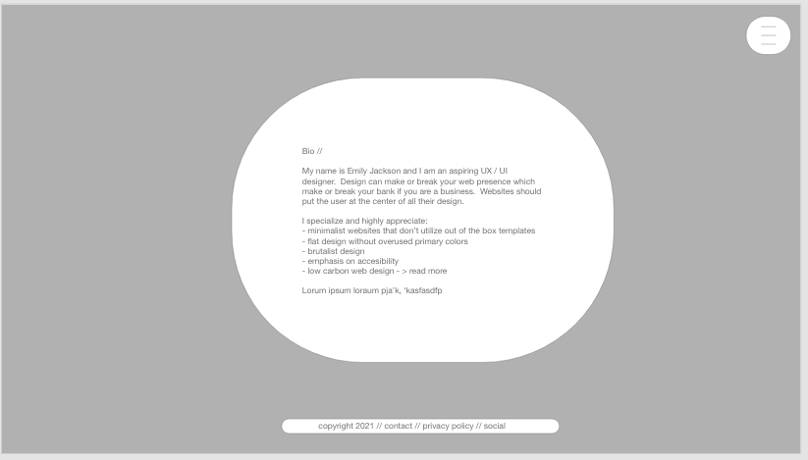

Links

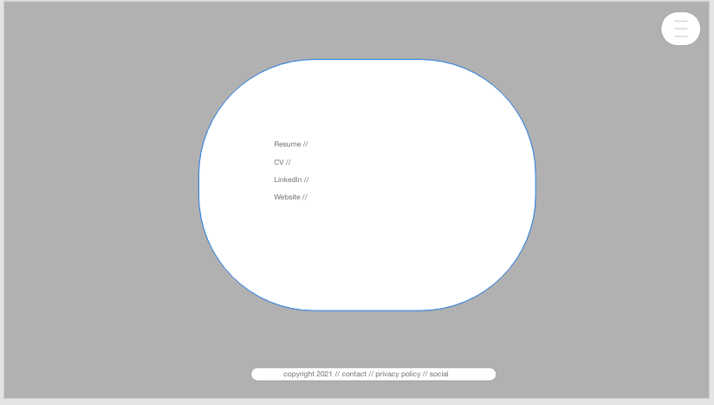

Form

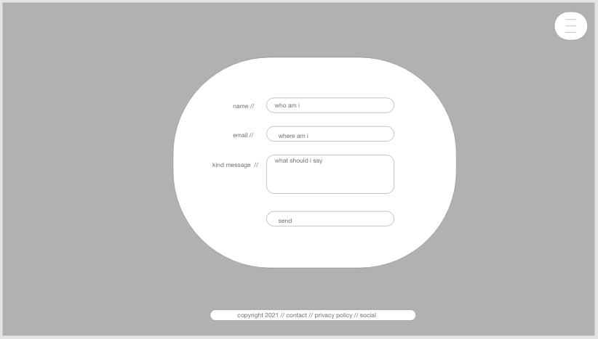

Content Page

