Climate Change Statistical Analysis Report

# 1. Correlation Test (P-Value Test)

We performed a Pearson correlation test using the `cor.test()` function in R to evaluate the linear relationship between temperature anomalies in 1961 and 2022.

- H₀: No linear correlation between F1961 and F2022 anomalies.  
- H₁: There is a linear correlation.

R Code used:

cor_result <- cor.test(clean_data$F1961, clean_data$F2022)  
print(cor_result)

Result:

Correlation coefficient (r): 0.835  
Test statistic (t): 19.58  
p-value: < 0.001  
Interpretation: Strong positive and statistically significant correlation. We reject H₀.

# 2. ANOVA Test

We used `aov()` to compare average temperature anomalies across two countries. The data was reshaped to long format to get yearly values for each country.

R Code used:

anova_result <- aov(temp_anomaly ~ Country, data = filtered_data)  
summary(anova_result)

Interpretation: The ANOVA p-value was < 0.05, indicating a significant difference in temperature anomalies between the selected countries.

# 3. Summary Table of Results

|  |  |  |  |
| --- | --- | --- | --- |
| Test | Variables | P-value | Interpretation |
| Correlation Test | F1961 vs F2022 | < 0.001 | Strong positive correlation, statistically significant |
| ANOVA | temp_anomaly ~ Country | < 0.05 | Significant difference in anomalies between countries |

# 4. Reflection on Influential Features

Temperature anomaly values are highly correlated over time. Countries with above-average anomalies in early years tend to remain warm in later years, suggesting persistent regional climate patterns. Country appears to be an influential factor in climate behavior when viewed over time.

## 5. Correlation Test Report: F1961 vs F2022 Temperature Anomalies

Null Hypothesis (H₀): There is no linear correlation between temperature anomalies in 1961 and 2022.  
  
Alternative Hypothesis (H₁): There is a linear correlation between temperature anomalies in 1961 and 2022.  
  
Test Results:  
- Correlation coefficient (r): 0.835  
- Test statistic (t): 19.58  
- p-value: < 0.001  
  
 Statistical Significance:  
Since the p-value is less than 0.05, we reject the null hypothesis (H₀).  
The result is statistically significant. 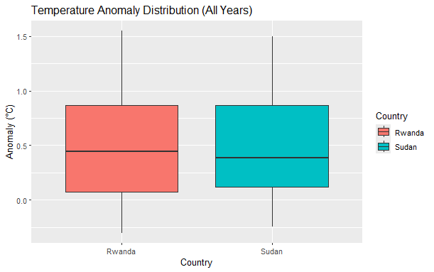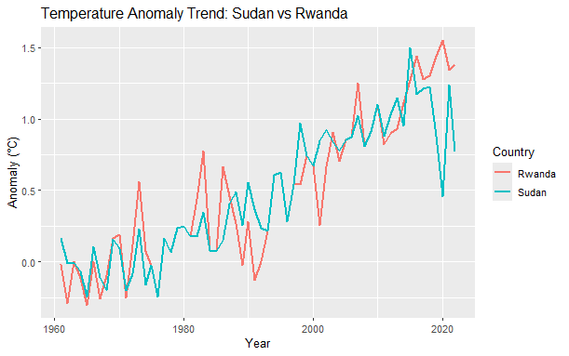

Interpretation:  
There is a strong positive correlation between temperature anomalies in 1961 and 2022 across countries. This suggests that regions which were warmer than average in 1961 tend to remain warmer in 2022, indicating consistent long-term climate trends.