CSN-261

**ASSIGNMENT REPORT**

By - Mayank Meena(19114055)

horizontal line

# 

### [Website](http://mayankmeena.netlify.app)

Problem 1:

Write a C++ program to implement a graph using adjacency list (linked list) without using STL.

Perform following operations on the graph after creating the graph based on the edges given in input.

1. BFS traversal

2. DFS traversal

3. Cycle finding in the graph

4. Calculate diameter of the graph

Soln:

For all we used graph data structure made from Linked list.

for BFS, i used queue data structure and LinkedList, and bfs algorithm to do BFS traversal.

For DFS, i used Linked List as data structure and recursive function on linked list to use it as stack to do dfs traversal as we go node then dfs traverse that one.

For Cycle, i used Linked List as data structure and recursive function on linked list to perform cycle detection by algorithm:if we find adjacent vertex visited if it is not parent one then cycle is there.

For diameter, i performed bfs to find end node then performed bfs through that node and founded distance using dist = dist of parent +. And max distance was diameter.I used queue and LinkedList to find Diameter.

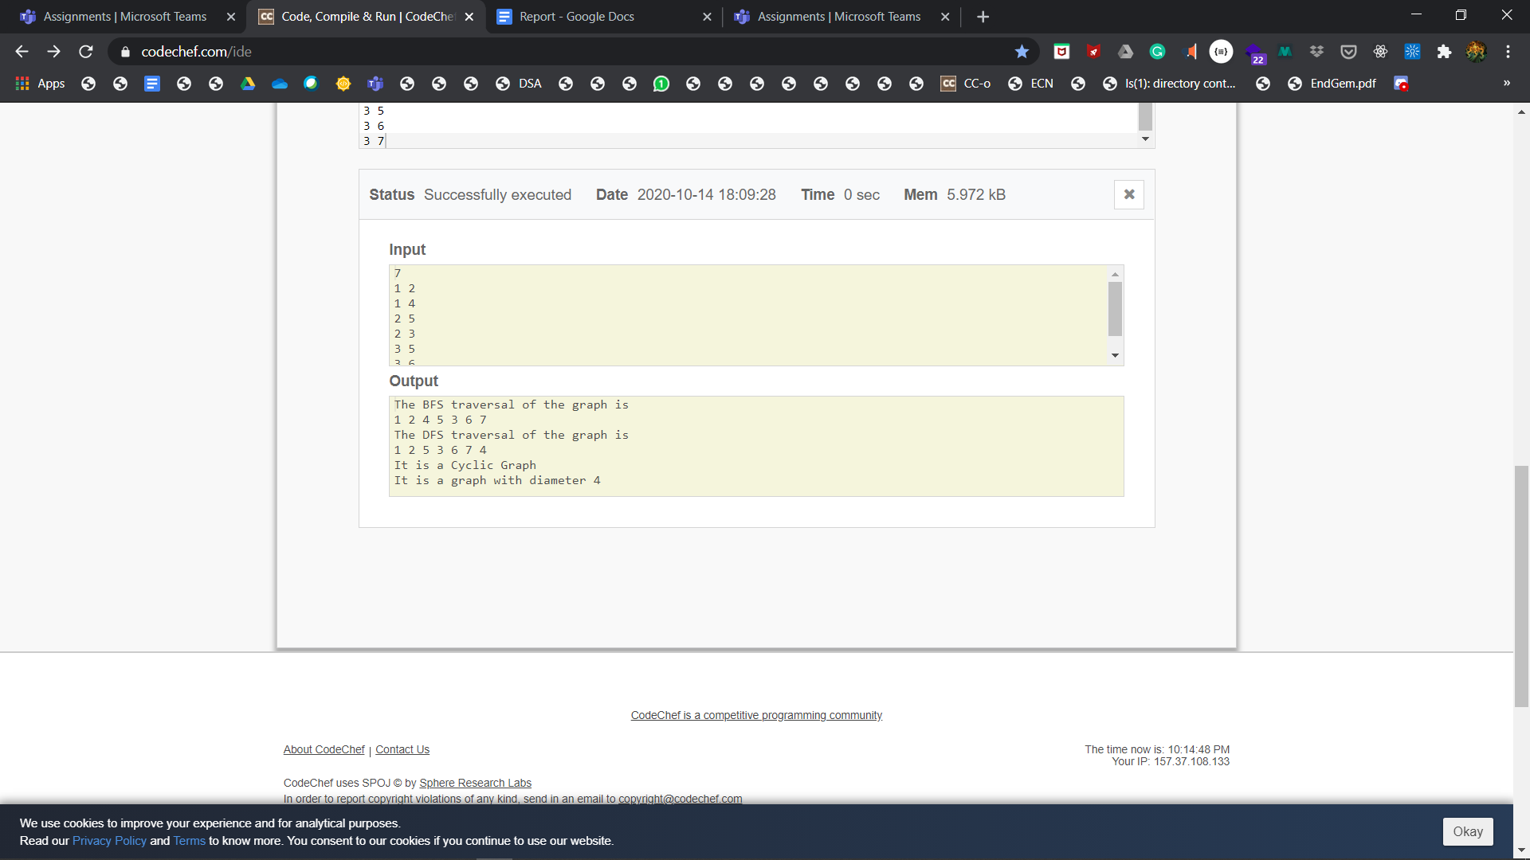

Problem2:Given a set of nodes connected to each other in

the form of a weighted undirected graph G, find the minimum spanning tree (MST).A spanning tree T

of an undirected graph G is a subgraph that is a

Tree which includes all of the vertices of G

, with minimum possible number of edges. G may

have more than one spanning trees.The weight of a spanning tree is the sum of weights given to

each edge of the spanning tree. A minimum spanning tree (MST)is a spanning tree whose weight is less than or equal to that of every other spanning tree. For given input graph (given as a text file having the format as shown in the example below), implement Kruskal’s algorithm in C++ program using UNION-FIND

data structures (without using STL) and show all the edges of the MST

as output in both the command line and in the “dot file”.

Soln: I used Graph data structure made by array of struct edges.Then i used Union-Find algorithm to check if edge added to tree will make it cyclic or not then i sorted edges according to weight then used Krushkal’s algorithm using union find spanning tree.

