1.Develop a phonebook management application

**Code:**

file_name = "phonebook.txt"  
file1 = open(file_name, "a+")  
file1.close  
  
  
def show_main_menu():  
 *#main menu for PhoneBook Program* print("|_______________________________________________________|")  
 print("| Phone Book Menu |\n" +  
 "| ******************* |\n" +  
 "|Enter 1,2,3,4,5 or 6 :- |\n" +  
 "|Enter 1 To Display Your Contacts Records |\n" +  
 "|Enter 2 To Add a New Contact Record |\n" +  
 "|Enter 3 To update or Edit Existing Record |\n" +  
 "|Enter 4 To Delete a Contact |\n" +  
 "|Enter 5 To Search your contacts |\n" +  
 "|Enter 6 To Quit |\n" +  
 "| ******************* |\n" +  
 "|_______________________________________________________|")  
  
 choice = input("\n User choice: ")  
 if choice == "1":  
 file1 = open(file_name, "r+")  
 file_contents = file1.read()  
 if len(file_contents) == 0:  
 print("Phone Book is empty")  
 else:  
 print(file_contents)  
 file1.close  
 fn = input("Press Enter to continue ...")  
 show_main_menu()  
 elif choice == "2":  
 enter_contact_record()  
 fn = input("Press Enter to continue ...")  
 show_main_menu()  
  
 elif choice == "3":  
 update_record()  
 fn = input("Press Enter to continue ...")  
 show_main_menu()  
  
 elif choice == "4":  
 delete_record()  
 fn = input("Press Enter to continue ...")  
 show_main_menu()  
  
 elif choice == "5":  
 search_contact_record()  
 fn = input("Press Enter to continue ...")  
 show_main_menu()  
 elif choice == "6":  
 print("Thanks for using Our Phone Book. ")  
  
 else:  
 print("Wrong choice, Please Enter [1 to 6]\n")  
 fn = input("Press Enter to continue ...")  
 show_main_menu()  
  
  
def update_record():  
 *#This function is use for updateing record* update_name = input("Enter First name to find contact to update: ")  
 update_name = update_name.title()  
 file1 = open(file_name, "r+")  
 file_contents = file1.readlines()  
 file2 = open(file_name, "w")  
  
 found = False  
 for line in file_contents:  
 if update_name in line:  
 print("Your updating contact record is:", end=" ")  
 print(line)  
 found = True  
 '''updated_name = input("Enter First name for updating contact record: ")  
 'new_line = line.replace(update_name,updated_name)'''  
 first = input('Enter First Name: ')  
 first = first.title()  
 last = input('Enter Last Name: ')  
 last = last.title()  
 phone = input('Enter Phone number: ')  
 address = input('Enter Address: ')  
 email = input('Enter E-mail: ')  
 contact = ("[" + first + " " + last + ", " + phone + ", " + address + ", " + email + "]\n")  
  
 file1.write(contact)  
 print(contact)  
 break  
 elif found == False:  
 print("ENTRY NOT FOUND = " + update_name)  
  
 for line in file_contents:  
 if line.find(update_name) != -1:  
 pass  
 else:  
 file2.write(line)  
  
  
def delete_record():  
 *# This function is use for deleting record* delete_name = input("Enter First name for Deleting contact record: ")  
 delete_name = delete_name.title()  
 with open(file_name, 'r') as file:  
 lines = file.readlines()  
  
 file1 = open(file_name, "w")  
 *# file_contents = file1.readlines()* print("record is deleted")  
 for line in lines:  
 if line.find(delete_name) != -1:  
 pass  
  
 else:  
 file1.write(line)  
  
  
  
def search_contact_record():  
 *# This function is used to searches a specific contact record* search_name = input("Enter First name for Searching contact record: ")  
  
 search_name = search_name.title()  
 file1 = open(file_name, "r+")  
 file_contents = file1.readlines()  
  
 found = False  
 for line in file_contents:  
  
 if search_name in line:  
 print("Your Required Contact Record is:", end=" ")  
 print(line)  
 found = True  
 break  
 if found == False:  
 print("There's no contact Record in Phone Book with name = " + search_name)  
  
  
def enter_contact_record():  
 *#It collects contact info firstname, last name, email, address and phone* first = input('Enter First Name: ')  
 first = first.title()  
  
 last = input('Enter Last Name: ')  
 last = last.title()  
 phone = (input('Enter Phone number: '))  
 address = input('Enter Address: ')  
 email = input('Enter E-mail: ')  
 contact = ("[" + first + " " + last + ", " + phone + ", " + address + ", " + email + "]\n")  
 file1 = open(file_name, "a")  
 file1.write(contact)  
 print("This contact :\n " + contact + "has been added successfully!")  
  
  
show_main_menu()

**Output:**

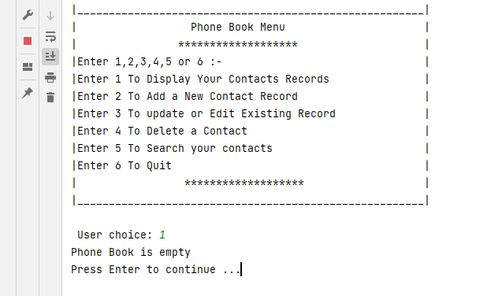

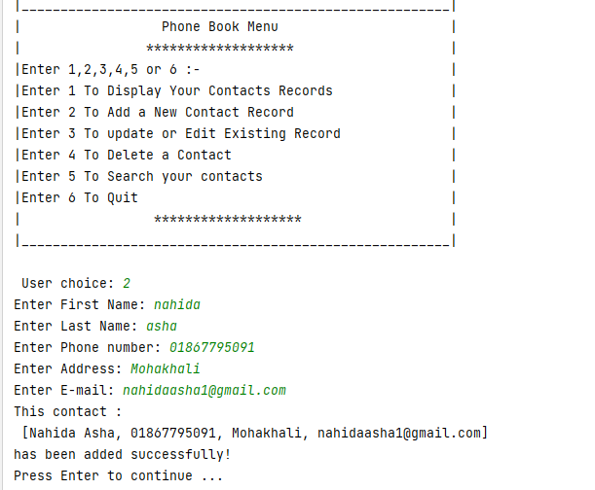

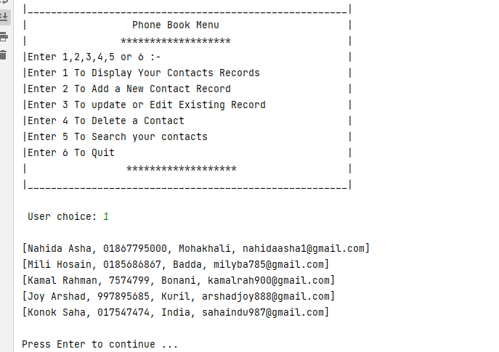

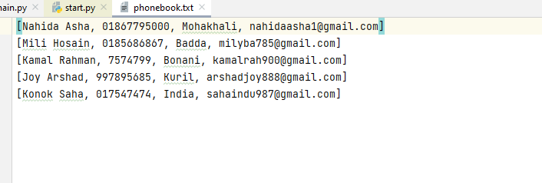

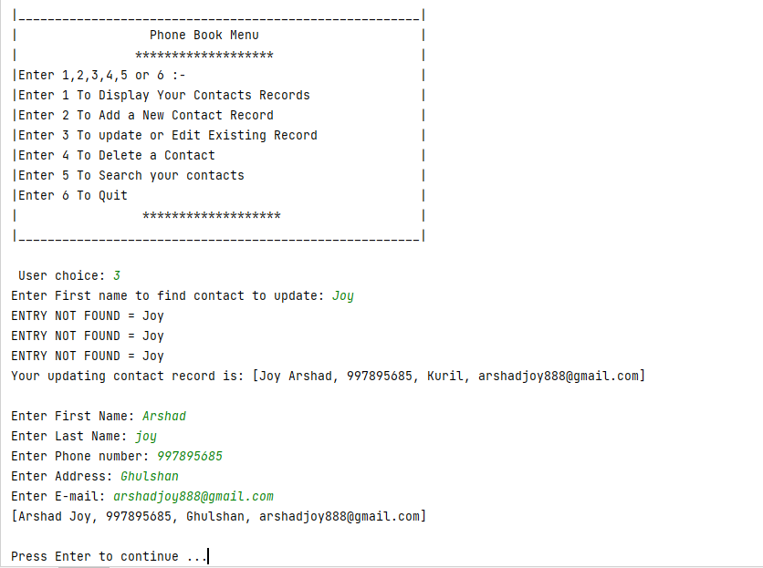

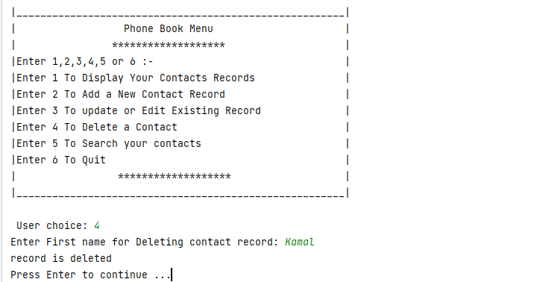

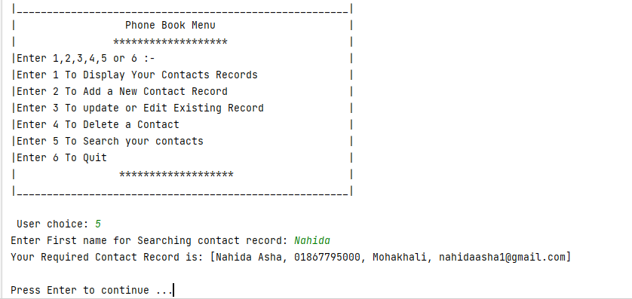

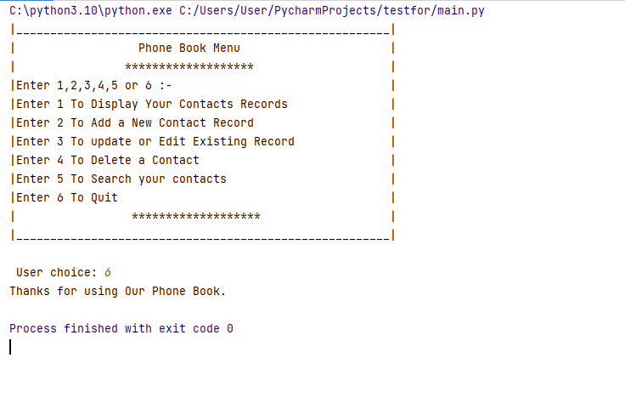

Develop a dictionary application for Python reserved keyword

**Code:**

from printing_functions import main_menu  
from operation_functions import user_input  
  
  
def start():  
 main_menu()  
 user_input()  
  
  
start()

def main_menu():  
 *# main menu for keyword program* print("""   
 ++++++++++++++++++++++++++++++++++++++++++++++++++++++  
 + 1.Add a new keyword +  
 + 2.Update a keyword +   
 + 3.Delete a keyword +  
 + 4.Print all keywords +  
 + 5.Search for a keyword +  
 + 6.Export to a file +  
 + 8.quit +  
 ++++++++++++++++++++++++++++++++++++++++++++++++++++++  
 """)  
  
  
def update_menu():  
 *# update keyword or sample code* print("""  
 1.Update the name of a keyword  
 2.Update the description of a keyword  
 3.Update the sample code of a keyword  
 4.Return to the main menu  
 """)  
  
  
def add_keyword_menu():  
 *# add keywords in the directory* print("""  
 1.Add a new keyword  
 2.Return to the main menu  
 """)  
  
  
def quit():  
 print("++++++++++++++++++++++++++++++++++++++++++++++++++++++++++++++++++++")  
 print("BYE BYE!")

keywords = {  
  
}

from printing_functions import main_menu, quit, update_menu  
from dictionary import keywords  
  
  
def user_input():  
 menu = input("Please enter your choice: ")  
 while menu != "8":  
 if menu == "1":  
 add_keyword()  
 elif menu == "2":  
 update_keyword()  
 elif menu == "3":  
 remove_keyword()  
 elif menu == "4":  
 show_all_keywords()  
 elif menu == "5":  
 search_keyword()  
 elif menu == "6":  
 export()  
 elif menu == "7":  
 remove_all_keywords()  
 else:  
 print("Invalid choice!!!")  
 quit()  
  
  
def update_keyword():  
 *# for updating keyword* print("go back? Press 'b'")  
 input_keyword = input("Enter the keyword: ")  
 while input_keyword.lower() != "b":  
 for key, value in keywords.items():  
 if input_keyword.lower() == key.lower():  
 print("Name:", value["name"])  
 print("Description:", value["des"])  
 print("sample Code:", value["sc"])  
 update_menu()  
 user_input_update(value["name"])  
 break  
 else:  
 print("Not found")  
 break  
 else:  
 main_menu()  
 user_input()  
  
  
def add_keyword():  
 print("go back? Press 'b'")  
 input_keyword = input("Please enter the keyword: ")  
  
 while input_keyword.lower() != "b":  
 for key, value in keywords.items():  
 if input_keyword.lower() == key.lower():  
 print("Keyword already exists")  
 break  
 else:  
 input_description = input("Please enter the description: ")  
 input_sample_code = input("Please enter the sample code: ")  
 keywords[input_keyword] = {  
 "name": input_keyword,  
 "des": input_description,  
 "sc": input_sample_code  
 }  
 print("Keyword added successfully")  
 break  
 break  
 else:  
 main_menu()  
 user_input()  
  
  
def search_keyword():  
 *# used for searching keyword* print("go back? Press 'b'")  
 input_keyword = input("Enter the keyword: ")  
 while input_keyword.lower() != "b":  
 for key, value in keywords.items():  
 if input_keyword.lower() == key.lower():  
 print("Name:", value["name"])  
 print("Description:", value["des"])  
 print("Sample Code:", value["sc"])  
 break  
 else:  
 print("Not found")  
 break  
 else:  
 main_menu()  
 user_input()  
  
  
def user_input_update(input_keyword):  
 menu = input("Enter your choice: ")  
 while menu != "4":  
 if menu == "1":  
 input_name = input("Enter the new keyword: ")  
 keywords[input_keyword]["name"] = input_name  
 print("Keyword name updated")  
 break  
 elif menu == "2":  
 input_description = input("Enter the new description: ")  
 keywords[input_keyword]["des"] = input_description  
 print("Keyword description updated")  
 break  
 elif menu == "3":  
 input_sample_code = input("Enter the new sample code: ")  
 keywords[input_keyword]["sc"] = input_sample_code  
 print("Keyword sample code updated")  
 break  
 else:  
 print("Invalid choice")  
 break  
 main_menu()  
 user_input()  
  
  
def remove_keyword():  
 print("Press 'a' for previous option")  
 input_keyword = input("Please enter the keyword: ")  
 while input_keyword.lower() != "a":  
 for key, value in keywords.items():  
 if input_keyword.lower() == key.lower():  
 del keywords[key]  
 print("Keyword removed successfully")  
 break  
 else:  
 print("Not found")  
 break  
 else:  
 main_menu()  
 user_input()  
  
  
def show_all_keywords():  
 count = 0  
 for key, value in keywords.items():  
 print("Keyword", count, ":", key)  
 count += 1  
 for key, value in value.items():  
 print(key + ": ", value)  
 print("+++++++++++++++++++++++++++++++++++++++++++++++++++++++")  
 print("+++++++++++++++++++++++++++++++++++++++++++++++++++++++")  
 main_menu()  
 user_input()  
  
  
def remove_all_keywords():  
 keywords.clear()  
 print("All keywords removed successfully")  
  
  
def export():  
 with open("keywords.txt", "w") as f:  
 count = 0  
 for key, value in keywords.items():  
 count += 1  
 print(str(count) + ".", file=f)  
 for key, value in value.items():  
 f.write(key + ": " + value + "\n")  
 f.write(  
 "+++++++++++++++++++++++++++++++++++++++++++++++++++++++\n")  
 print("File exported")  
  
 main_menu()  
 user_input()

**Output:**

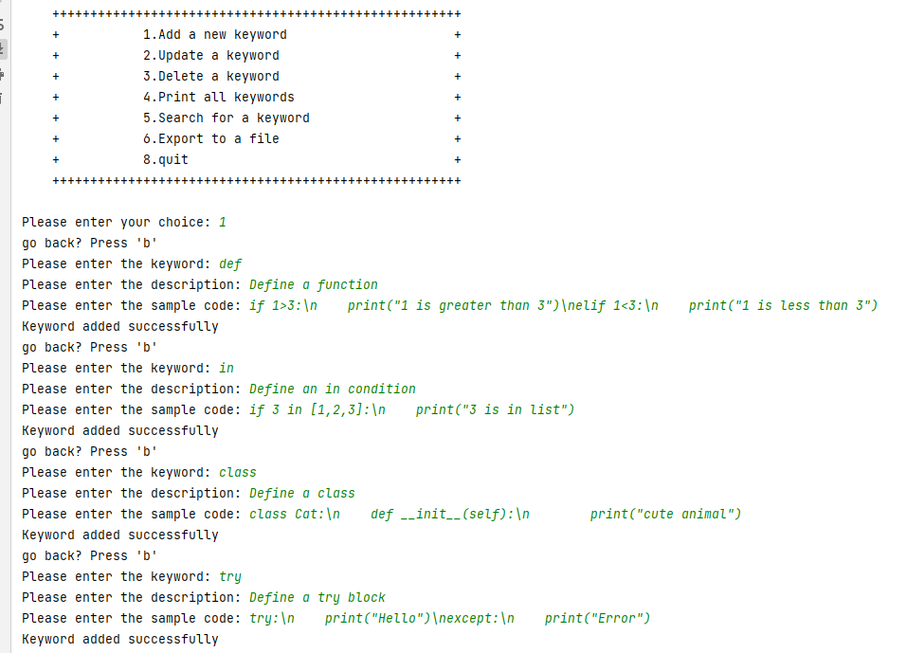

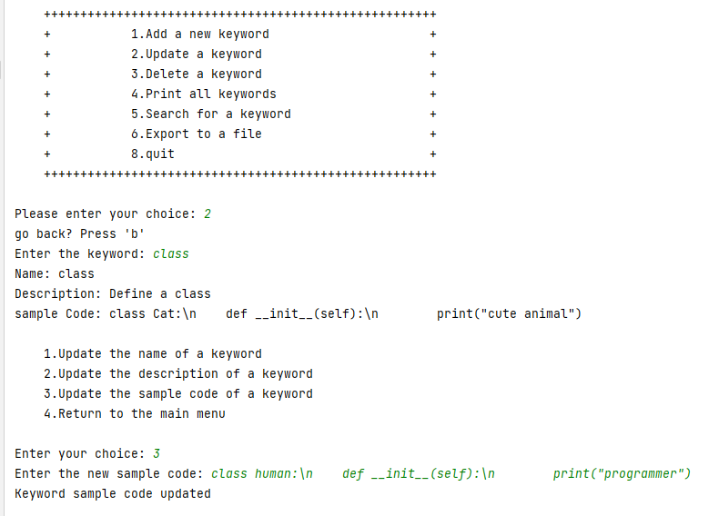

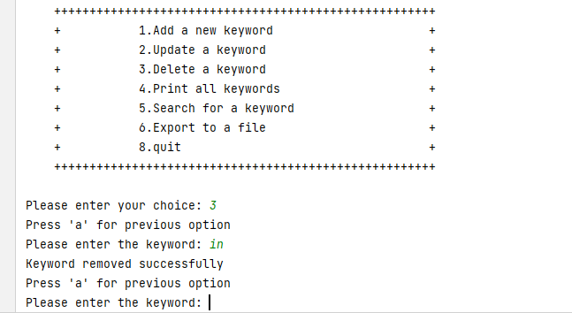

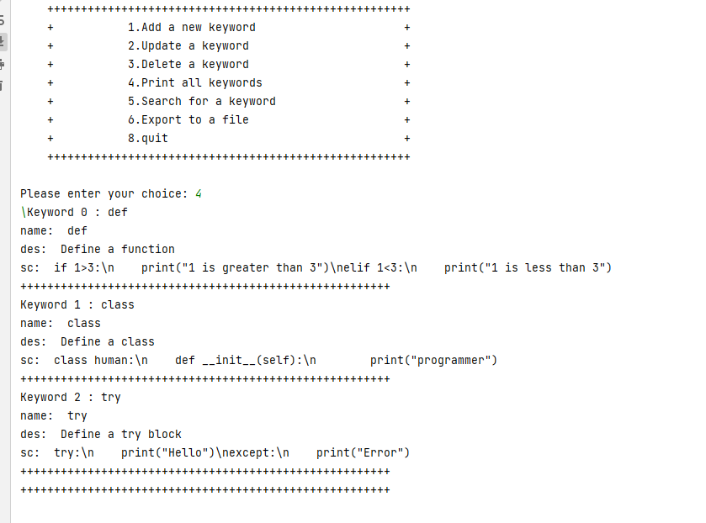

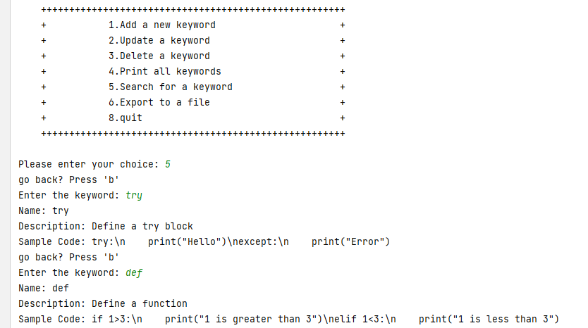

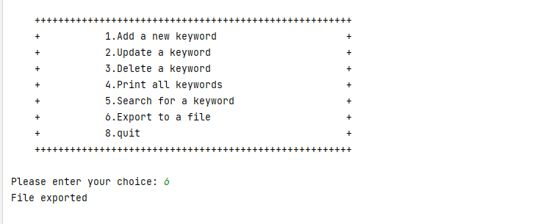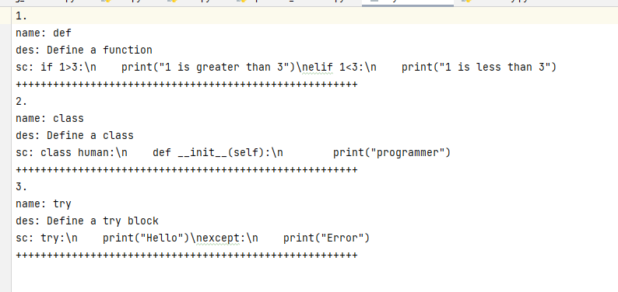

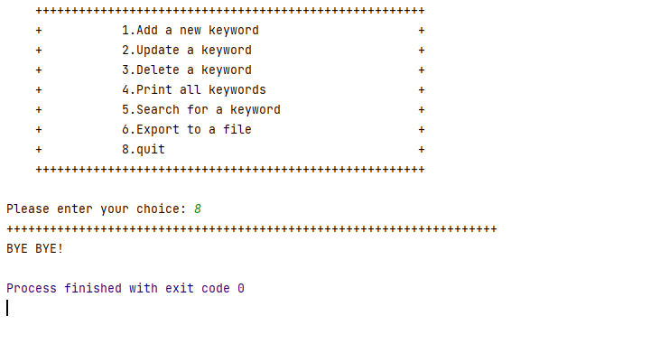

Develop a to-do list application.

Code:

from printing_functions import main_menu  
from operation_functions import user_input  
  
  
def main():  
 main_menu()  
 user_input()  
  
  
main()

def main_menu():  
  
*#main function for TO*DO list* print(""" ^^^^^^^^^^^^^^^^^^^^^^^^^^^^^^^^  
 TODO LIST  
 ---------------------  
 1. Add Task  
 2. Update Task  
 3. Delete Task  
 4. Show All Tasks  
 5. Save Tasks In File  
 6. Search Task  
 7. Exit The List  
 ^^^^^^^^^^^^^^^^^^^^^^^^^^^^^^^^^^^   
 """)  
  
  
def quit():  
 *#when user want to exit this application* print("Please visit again!")  
 print("^^^^^^^^^^^^^^^^^^^^^^^^^^^^^^^^")

from printing_functions import quit, main_menu  
  
todo_list = []  
  
def add_task():  
 *# adding task to list* task = input("Enter a new task: ")  
 todo_list.append(["", "", "", "", ""])  
 todo_list[-1][0] = task  
 todo_list[-1][1] = input("Enter a date : ")  
 todo_list[-1][2] = input("Enter Start time : ")  
 todo_list[-1][3] = input("Enter End time : ")  
 todo_list[-1][4] = input("Enter the description: ")  
 print("\nTask Added....!")  
 main_menu()  
 user_input()  
  
  
def update_task():  
 *# Updating task in list* task_or_date = input("Enter a task : ")  
 for index, task in enumerate(todo_list):  
 if task[0] == task_or_date or task[1] == task_or_date:  
 todo_list[index][0] = input("Enter the Updated task : ")  
 todo_list[index][1] = input("Enter the Updated date : ")  
 todo_list[index][2] = input("Enter the Updated Start time : ")  
 todo_list[index][3] = input("Enter the Updated End time : ")  
 todo_list[-1][4] = input("Enter the description: ")  
 print("\nTask Updated successfully!")  
 main_menu()  
 user_input()  
  
  
def delete_task():  
 task_to_delete = input("Enter a task : ")  
 for index, task in enumerate(todo_list):  
 if task[0] == task_to_delete or task[1] == task_to_delete:  
 todo_list.pop(index)  
 print("Task deleted successfully...!")  
 main_menu()  
 user_input()  
  
  
def view_all():  
 for item in todo_list:  
 task, date, start_time, end_time, des = item  
 print("Task", task)  
 print("Date:", date)  
 print("Start Time:", start_time)  
 print("End Time:", end_time)  
 print("Description :", des)  
  
 main_menu()  
 user_input()  
  
  
def operation(operation_type, operation_value, operation_list):  
 if operation_type == "delete":  
 *# delete task* operation_list.pop(operation_value)  
 elif operation_type == "view":  
 print(operation_list)  
 elif operation_type == "save":  
 with open("todo.txt", "w") as file:  
 for item in operation_list:  
 file.write(item + "\n")  
 elif operation_type == "search":  
 for item in operation_list:  
 if operation_value in item:  
 print(item)  
 elif operation_type == "exit":  
 print("Goodbye...!")  
 else:  
 print("Invalid operation")  
  
  
def user_input():  
 menu = input("Enter your choice: ")  
 while menu != "7":  
 if menu == "1":  
 add_task()  
 elif menu == "2":  
 update_task()  
 elif menu == "3":  
 delete_task()  
 elif menu == "4":  
 view_all()  
 elif menu == "5":  
 operation("save", None, todo_list)  
 elif menu == "6":  
 task = input("Enter the task you want to search: ")  
 operation("search", task, todo_list)  
 else:  
 print("Invalid choice")  
 menu = input("Enter your choice: ")  
  
 quit()

**Output:**

