Median Home Valuations and Growth Rates Comparison of PDX & DFW
Elijah V Moos
Western Governors University

Table of Contents
A. Project Highlights 4
B. Project Execution 5
C. Data Collection Process 7
C.1 Advantages and Limitations of Data Set 8
D. Data Extraction and Preparation 9
E. Data Analysis Process 10
E.1 Data Analysis Methods 10
E.2 Advantages and Limitations of Tools and Techniques 11
E.3 Application of Analytical Methods 12
F Data Analysis Results 13
F.1 Statistical Significance 13
F.2 Practical Significance 15
F.3 Overall Success 16
G. Conclusion 17
G.1 Summary of Conclusions 17
G.2 Effective Storytelling 17
G.3 Recommended Courses of Action 18
H Panopto Presentation 19
Appendix 20

A. Project Highlights
The Research Question this proposal answered was which region, PDX or DFW, presented a better value proposition for the average homebuyer by offering the “safest” investment potential based on each respective region’s most significant cities?
This project’s scope was to ingest, clean, analyze, visualize, test, and validate Zillow’s historical median-value data for two metropolitan regions, PDX and DFW, to determine which region is the safer investment. The data included historical tracking of home values and were measured accordingly. Each region was limited to its largest cities to create an inclusive, informative dataset that remains manageable and digestible.
This project used the ADDIE methodology because it naturally aligned with the project’s structure. This seemingly linear methodology not only fits intuitively with project planning and execution but also allows for the necessary flexibility throughout the individual stages. Having a robust, accurate dataset, along with making good use of the items generated at each stage, resulted in an impressively efficient flow throughout the research and development process.
This project used multiple Python libraries, including Pandas for general data analysis, NumPy and SciPy for mathematical and statistical computations, and Matplotlib, PyPlot, and Seaborn for visualizations. All Python code was written within Jupyter Notebooks, which served as our environment for performing data analysis.

B. Project Execution
B.1 Project Planning
The goal of this project was to use Zillow’s historical median housing price data tables to generate an analysis that would help determine whether PDX or DFW is the safer investment for an upcoming house purchase. The first objective of this goal was to clean the data. Data cleaning was the necessary first step of the analytical process, as using accurate data is crucial for drawing realistic conclusions. Data cleaning comprised two deliverables: first, removing null rows from the dataset to eliminate invalid data from the very beginning; and second, trimming excess locations and focusing the dataset on the relevant regions used to answer the research question.
The second objective of the project was to visualize the cleaned data to facilitate a holistic understanding. This objective was comprised of three deliverables: A regional line graph that simply and concisely displayed the delta of median home prices over time, a regional growth analysis that provided a second way to understand the rate of change, and a comparison graph that plotted the two sets of regional data together, generating a dynamic view of the relationship between the two areas.
The third and final objective of the goal was to test and validate the data. This objective comprised two deliverables: a Median Price T-Test that described the relationship between median home prices in the two regions and their significance, and a Growth Rate T-Test that described the growth rates in each region and indicated the significance of the difference between them.

B.2 Planning Methodology
As mentioned in Section A, this project utilized the ADDIE methodology because, from the initial stages, integrating it felt so natural to the way the project was planned. This meant the project followed a five-step process, beginning with the Analysis of Zillow median housing price data, which fueled the following steps. Next was Design, which used items like the proposal document, along with setting up dataframes and assessing how best to store data. After Design, Development focused on developing code to better understand and format the Zillow data, making it more usable. The developed data was then implemented into visualizations and tests to ensure its functionality and to assess its ability to answer the research question. Finally, the visualizations and tests were evaluated for decisiveness, and a conclusion was distilled.

B.3 Project Timeline
Milestone or deliverable | Duration  (hours or days) | Projected start date | Anticipated end date
Data Collection | 8 hours | January 12, 2025 | January 12, 2025
Data Cleaning | 8 hours | January 13, 2025 | January 13, 2025
Data Structuring | 16 hours | January 14, 2025 | January 15, 2025
Visualizations | 32 hours | January 16, 2025 | January 21, 2025
T-Testing | 8 hours | January 22, 2025 | January 22, 2025
Reviewing Results | 8 hours | January 23, 2025 | January 23, 2025

Roughly half of the Project Timeline remained identical to the proposal’s timeline, but there were minor shifts between the estimated and actual times. The data structuring step took one fewer day than expected, while generating the visualizations took one additional day. T-Testing took twice as much time as expected, but still fell within the same estimated calendar day.

C. Data Collection Process
The data source provided a direct link to a table containing the exact dataset for our search, which was downloaded as a .csv file from Zillow. Once the data was downloaded, the .csv file was loaded into the Jupyter Notebook for further reading and analysis.
The overall quality of the data provided by Zillow was remarkably high, with the only exceptions being for smaller regions outside the research scope. For the intent of this project, both the quality and completeness of data were very high, and extensive cleaning was not necessary. The data were trimmed to exclude cities with missing data, and the analysis focused on the most popular cities that did not require additional accommodations.
Given that the dataset is free, publicly available, and maintained by an authoritative source, there were no concerns regarding data governance, privacy, security, or ethical compliance. Each of these items was easily resolved using the freely available Zillow dataset. The nature of median housing prices being assessed by a primary source, such as Zillow, led to insufficient precautions. The data itself is masked and amortized, and is also calculated by a company that would be a primary source on housing purchases outside the research question this report answers.
The elements in this section did not differ from those in Task 2, and there were no unplanned issues, as the dataset was obtained prior to the creation of the proposal. Given the timing of the proposal, data governance issues were anticipated because the data was proprietary to Zillow.

C.1 Advantages and Limitations of the Data Set
The main advantage of the selected dataset, provided by Zillow, was that it was proprietary, largely complete, and covered a significant period. The data being properly resolved, any potential issues with sourcing or accuracy, as Zillow would be considered a primary source for median house valuation. The overall completion of the data meant that both the quantity and quality of the data cleaning were less extensive than they could have been. Although cleaning was still necessary, the estimated timeframe was maintained. Finally, the time period covered by the data allowed for an acceptable and significant amount of research to be completed. Without this timeframe, the conclusions drawn to answer the research question would not have been as robust or complete.
The main disadvantage of the Zillow dataset would likely be the “one-note” nature of home valuations over time. Although the research was ultimately conclusive, it would have been interesting to see some of the out-of-scope variables balanced against the home valuations to see if there was a correlation between them. Items such as local bond elections or tax rates may have improved the overall quality of the completed research.

D. Data Extraction and Preparation
The extraction process for this project was pretty straightforward, given that the primary data source had the dataset available via direct download. Once the dataset was downloaded as a .csv file, it was loaded into the project’s Jupyter Notebook and investigated using multiple Python methods. Once a general view of the file was generated in the Jupyter Notebook, any missing values were dropped, and unnecessary locations were trimmed. This resulted in two usable dataframes, which were then transposed where needed so that the remaining analysis and visualizations could be performed. The only remaining preparation step was to simplify the Date fields from a YYYY-MM-DD format to a strictly time-based format, which resulted in a significantly more workable time-based field. Python was the primary tool used for all preparation techniques.

E. Data Analysis Process

E.1 Data Analysis Methods
This report used T-Testing as the primary statistical test to support the hypothesis that the DFW housing market would offer a “safer” investment opportunity than the PDX housing market for prospective and current home buyers. T-tests were used to evaluate both the literal value of each regional market’s median home value and the determined growth rate of value over time. Using T-Testing to assess these values and their relevance statistically enabled us to determine whether one region has a significantly better valuation based on historical data.
The null hypothesis for this report was that PDX was, in fact, the more valuable or “safer” investment between the two regions, based on its higher median home value and/or growth rate. Both the T-stat and P-values from this testing process, using the SciPy library, served as the analysis metrics. An alpha value of 0.05 (5%) was used to determine statistical significance between regions. To reject the null hypothesis, the P-value would have to be below the specified alpha value, and a median home purchase in the DFW metropolitan area would be confirmed as the “safer” investment.
T-testing was selected as the preferred statistical test for this comparison, specifically because the resulting P-value could accurately assess the tendencies in the two regions. Given the nature of this report, which involved positioning two regions’ worth of categorically identical median home equity pricing data, T-statistics and P-values served as a simple and effective way to compare prospective financial value.

E.2 Advantages and Limitations of Tools and Techniques
This project used multiple Python libraries, including Pandas for general data analysis, NumPy and SciPy for mathematical and statistical computations, and Matplotlib, PyPlot, and Seaborn for visualizations. All Python code was written within Jupyter Notebooks, which served as our environment for performing data analysis. The main advantage of the tools used, such as Python, is the availability of powerful libraries and the accessibility of Jupyter Notebooks. These two tools, in conjunction, allowed for a flexible, lightweight environment that could be set up quickly and had enough power to compute and visualize the data well enough to answer the research question.
While the limitations are hard to pin down, the relatively simple computations did take a noticeable amount of time to complete. It is worth noting that if a more complex analysis were performed or the scale were increased, the project’s timeframe would have scaled accordingly. Additionally, Matplotlib’s visualization capabilities were somewhat challenging to use intuitively and required additional research. An alternative program may have reduced the overall commitment.

E.3 Application of Analytical Methods
This analysis will utilize statistical T-tests to support the provided hypothesis. T-Tests will also be used to evaluate both the literal value and the determined growth rate of the value over time, as they enable us to measure the correlation between variables across the two regions and determine whether one region is, in fact, a strictly “better” option.

The steps used to enact these statistical tests are as follows:
- Importing the necessary libraries and data via pandas read_csv()
- Digging into the data to obtain a brief overview of the shape
  - .head() .info() .isnull() and .shape() all provided the initial exploration
- Cleaning the data by dropping rows with null values and grouping into relevant regions
- Transposing the data to make it easier to process and visualize
- Processing the data
  - The “Date” field specifically proved to be an opportunity for improvement
- Creating visualizations for individual regions and eventually a comparative graph
- Calculating the regional growth rate
- Calculating the median home value and growth T-tests

By following the listed steps, we were able to load, clean, analyze, evaluate, and review the median house valuation data provided by Zillow, and ultimately create usable conclusions and visualizations to interpret the data more effectively. Each step in this process was both necessary and efficient in achieving a result that could be used to address the research question and to interact with both the hypothesis and the null hypothesis.

F Data Analysis Results

F.1 Statistical Significance
To test for statistical significance, this project used T-Testing because the two regions were measured using similar methods: median home value or growth rate over a period of time. Given that the hypothesis for this report was that the DFW median home valuations and/or growth rates would be superior to PDX and ultimately prove the region to be a better investment, the null hypothesis would state the opposite; that PDX would be the safer option given a higher median home price and/or growth rate.
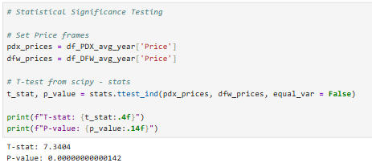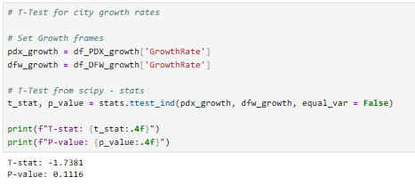
This project used stats from the SciPy library to perform a T-test, yielding a T-stat and P-value, which were used to conclude the data. All T-tests were conducted at a significance level of 0.05 (5%). On the subject of Median Home Valuation, with a T-stat of 7.34 and a P-value of 0.00, we were unable to reject the null hypothesis that the median home valuation was higher in PDX than in DFW, as there is a consistent record amongst the cities within the region of being higher priced, despite a small number of residences in Frisco specifically coming close. Regarding Growth Rate, the result T-stat of -1.74 indicates that DFW has a higher growth rate than PDX, but the P-value of 0.11 falls outside the alpha’s acceptable range for rejecting the null hypothesis. The conclusion is that although DFW has a higher growth rate than PDX, the difference is not statistically significant enough to definitively determine DFW as the better investment in terms of median house valuation or growth rate.
The following visualizations have been included to support the evidence found in the statistical test listed above:

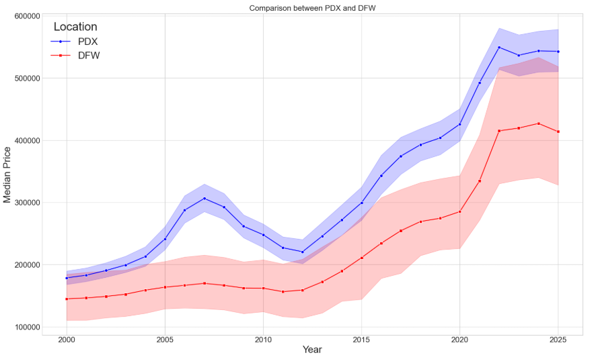

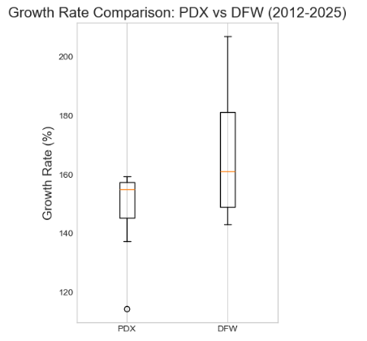

F.2 Practical Significance
This project was intended to determine which region, DFW or PDX, would serve as a better or safer investment option for some personal relatives to investigate as their next home purchase. The effectiveness of each specific reason would primarily influence this decision, and monetary quality in particular would be a significant factor in selecting where to move. With this in mind, the practical significance of the research conducted in this project is to define which, if any, region is the definitively better option for monetary investment based on median home value or the growth rate of that median home value over time.
With this definition in place, it is safe to say that, although unanticipated, the report’s results are indeed helpful. The report hypothesized that DFW would be the superior option of the two, given the spectacular growth in the North Dallas area over the past two decades, but, as the research concluded, this growth largely brought DFW into line with the value presented in PDX. It should be noted that DFW’s growth rate is noticeably higher than PDX’s, but not to a degree that would discount the growth rate of the PDX region itself.
The practical significance of this conclusion is substantial, in that both options are satisfactory and, although there is not strictly a “right” answer, there is also not a “wrong” answer. The nature of the two largely competitive regions allows for a decision-making framework that considers factors beyond strict home valuation when determining which region to move to.

F.3 Overall Success
The primary criterion for considering this project a success was to develop and obtain a tool that simplifies the decision to move to either PDX or DFW. However, this requirement did not necessitate a straightforward answer; instead, it required that the resulting T-test and P-values provide a conclusion that was insightful to the subjects of the research question. This meant that the primary initiative would be to thoroughly ingest, clean, analyze, and interpret the data source, resulting in both understandable visualizations and accurate final testing.
Overall, this project should be viewed as a success. Even though the decision based on the T-stat and P-values did not support the original hypothesis, knowing that both regions are similarly viable is valuable to the research subjects. Gaining the ability to look beyond strict home valuations allows the subjects to consider other, potentially more interesting factors on a human level, such as business opportunities, commute times, local amenities, and more. The conclusion drawn from the research will absolutely help the subjects decide on either region based on median home value, give a slight edge to the DFW region based on growth rate, or appreciate the freedom to make their decision based on other factors, given that the two regions are comfortably comparable.

G. Conclusion

G.1 Summary of Conclusions
The goal of this project was to use Zillow’s historical median housing price data tables to generate an analysis that would help determine whether PDX or DFW is the safer investment for an upcoming house purchase. To do this, we used a comprehensive dataset generated and hosted by the well-known real estate listing site Zillow. Once our environment was set up using Python and Jupyter Notebook, the data was ingested, cleaned, analyzed, visualized, tested, and validated to determine which of the two metropolitan regions was the better investment option. The visualizations and testing performed provided a conclusive result: the median home valuation and growth rate statistics between the regions were too similar to firmly call one region the superior option. This conclusion was helpful to the research subjects, as now that there is no pressure to select an obviously superior option in terms of finances, they are free to select the preferred region for any number of personal or miscellaneous reasons.

G.2 Effective Storytelling
The visualizations for this project were selected due to their immediate and apparent ability to present a series of information, such as median home values, over time. All visualizations for the effort were generated in Jupyter Notebooks using Python and the Matplotlib and Seaborn libraries. The Line Graphs created were intended to describe the relationship between value over time and, very obviously, showed exactly that. We can see throughout the line graphs the nature of PDX region home values: what started proportionally low rose until the 2008 housing crisis, when the value tanked and then stabilized. Some time around 2010, the PDX region saw its growth rate steadily increase until roughly 2022, when there was an initial pullback in raw value, followed by a plateau that has held to the present day.
The DFW portion of the line graph follows a similar overall trend, but it certainly has unique points that set it apart from the PDX values. The most obvious is that there is no dip around 2008 in the PDX metro values. Additionally, there has been nearly no pullback post-2020, and home values have only decreased at all as of 2025. That being said, there was undoubtedly a plateauing of value in the same time period as the PDX region after COVID.
The final graphic in this project was a box plot that visually summarized the differences in growth rates between the two regions. This specific charting technique is effective in this case because it succinctly shows both the relative positions of the regions and where differences can be found. The PDX region has a much tighter range of growth rates, which are consistently lower, by a small margin on average, than those in the DFW region. If the project scope were limited to comparing one city instead of a metroplex, this box plot would very helpfully distinguish growth rate potential between metros.

G.3 Recommended Courses of Action
Based on the analysis provided in this report, the first recommendation has already been made: that the conclusion drawn by and for the research subjects be that the decision on which region to move to should not be based exclusively on median home value or historical growth rates. Both regions have experienced significant growth, and both have a respectable median home value when accounting for that growth. The second recommendation from this report would be, if a numerically based conclusion must be drawn, to narrow the field of variables from median home value across a region to more specific and relevant attributes. This may include specific cities within a region, which could be decided before or after taking personal, qualitative factors into account, or specifying a range of home values to base the comparison on, such as low, medium, or high base-value homes. Continuing the analysis provided in this report, based on the conclusion of relatively similar values between regions, would likely yield interesting discoveries while also providing a comforting basis for believing there is no notably less financially beneficial region.

H Panopto Presentation
https://wgu.hosted.panopto.com/Panopto/Pages/Viewer.aspx?id=8e26dd39-966c-44b3-adb4-b3dc0020a46c

Appendix
Zillow Dataset: https://files.zillowstatic.com/research/public_csvs/zhvi/City_zhvi_uc_sfr_tier_0.33_0.67_sm_sa_month.csv?t=1764473966

