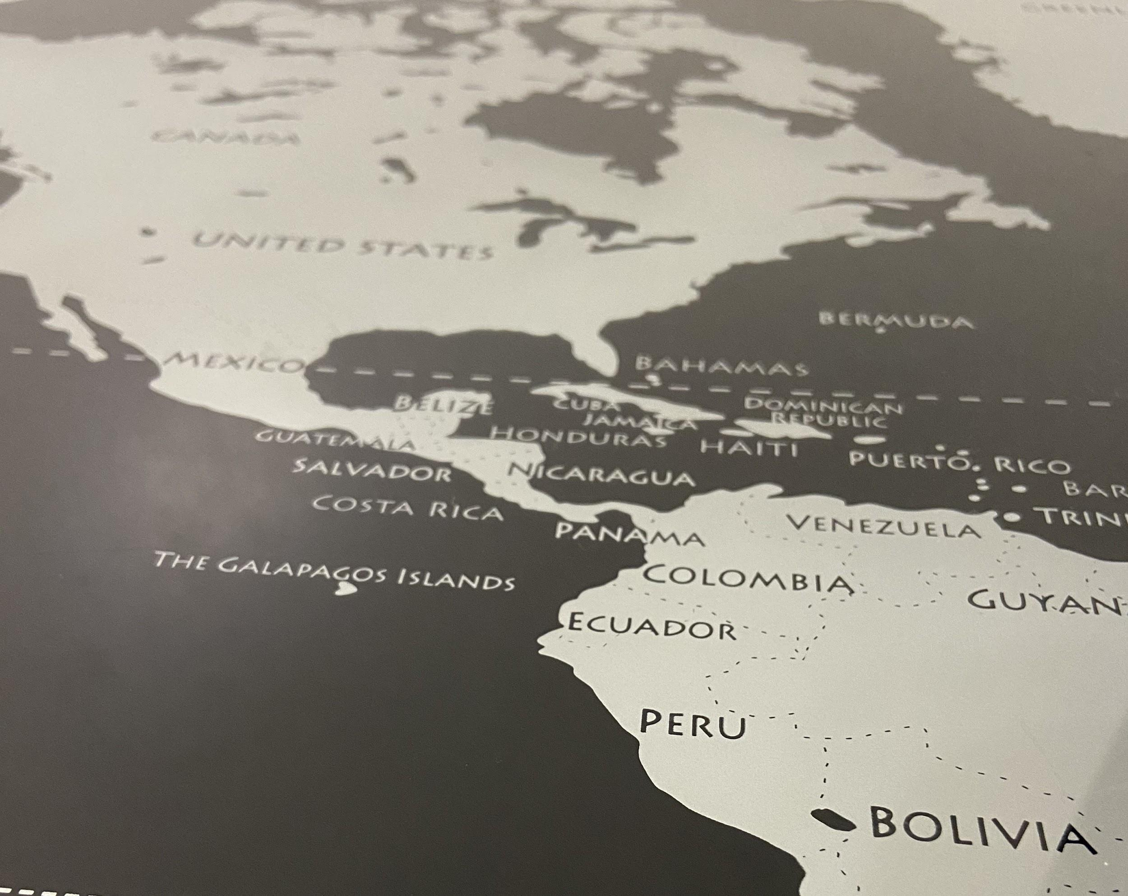

**Acknowledging the history of the location of this DH work**

As a land-grant university, it is important to recognize the Native peoples who are stewards on the land where I completed this project. For this reason, I will write about the Native peoples who historically lived in Lincoln, Nebraska, where this project has been completed. In particular, I will discuss the Pawnee, who lived on the Great Plains near the Loupe, Republican, and Platte River in Nebraska.

The Pawnee tribe was one of the largest and most powerful tribes in what is now Nebraska.[1] Unfortunately today, there are over 3,200 Pawnees in the U.S., in the early 18th in comparison to the 60,000 Pawnees that lived on the area in the early 18th century.[2] As one of the oldest in the Great Plains, they have managed to evolve and adapt into new environments to survive. Despite the constant move from one area to another due to the change of climates, they mostly survived from farming crops and hunting buffalo.[3]

The decrease in population was a result of two epidemics and the constant fight against colonizers and other tribes.[4] In 1830-1831, the Pawnees lost at least half of their population due to smallpox.[5] In 1833, they agreed to give up their weapons and to live as agrarians while being protected by the federal government.[6] During this same year, the tribe “ceded to the United States all lands they claimed lying south of the Platte River.”[7] Without weapons and the constant battle between other tribes and expanding settlers, the Pawnees were most likely forced to give up their weapons and their land and decided to move to protect their families.

Even though the Pawnees, along with other tribes, tried to stay in Nebraska, they received new reservations by the Omnibus Treaty in 1867.[8] On March 1867, President Johnson officially declared Nebraska a state.[9] Five years before this treaty and Nebraska’s statehood, the Morrill Act was signed and passed into law. Signed by Abraham Lincoln, this act was originally titled: “An Act Donating Public Lands to the Several State and Territories, “provided each state with 30,0000 acres of Federal land for each member in their Congressional delegation.”[10] The Pawnee tribe began a three-year period to move to Oklahoma beginning in 1874.[11] UNL was chartered in 1869 on Pawnee Territory.[12]

However, it is not enough to acknowledge Native Americans, we need to listen to Native peoples and we need to act on those needs. Generations have benefitted from this land, and there are still people supporting the exploitation of these lands while ignoring Native Americans.

Bibliography

Douglas R. Parks, “Pawnee (tribe),” *The Encyclopedia of Oklahoma History and Culture*, <https://www.okhistory.org/publications/enc/entry.php?entry=PA022>.

“Historical Overview,” *An Architectural Tour of Historic UNL*, 2005, <https://historicbuildings.unl.edu/index.html>.

“Morrill Act,” *Primary Documents in American History,* The Library of Congress, 2017, <https://www.loc.gov/rr/program/bib/ourdocs/morrill.html>.

“Nebraska Statehood Launched in Troubled Times,” *History Nebraska*, <https://history.nebraska.gov/blog/nebraska-statehood-launched-troubled-times>.

“Pawnee History,” *Pawnee Nation of Oklahoma*, 2020, <https://www.pawneenation.org/page/home/pawnee-history>.

“Removal of Tribes to Oklahoma,” Oklahoma Historical Society, <https://www.okhistory.org/research/airemoval>.

Wedel, Waldo R. and Douglas R. Parks, “Pawnee Geography Historical and Sacred,” Great Plains Quarterly, 1985, <https://digitalcommons.unl.edu/cgi/viewcontent.cgi?referer=https://www.google.com/&httpsredir=1&article=2852&context=greatplainsquarterly>.

Wedel, Waldo R. and Jade Robison, “The Direct-Historical Approach in Pawnee Archeology (with six plates)” Transactions and Reports, Nebraska State Historical Society, 1938, <https://digitalcommons.unl.edu/cgi/viewcontent.cgi?article=1068&context=nebhisttrans>.

Wishart, David J. editor, “Pawnees,” *Encyclopedia of the Great Plains*, 2011,<http://plainshumanities.unl.edu/encyclopedia/doc/egp.na.082>.

[1] Waldo R. Wedel and Jade Robison, “The Direct-Historical Approach in Pawnee Archeology (with six plates)” Transactions and Reports, Nebraska State Historical Society, 1938, <https://digitalcommons.unl.edu/cgi/viewcontent.cgi?article=1068&context=nebhisttrans>.

[2] “Pawnee History,” Pawnee Nation of Oklahoma, 2020, <https://www.pawneenation.org/page/home/pawnee-history>

[3]David J. Wishart, editor, “Pawnees,” *Encyclopedia of the Great Plains*, 2011, <http://plainshumanities.unl.edu/encyclopedia/doc/egp.na.082>

[4] Wishart, paragraph 5.

[5] Wishart, paragraph 5.

[6] Douglas R. Parks, “Pawnee (tribe),” *The Encyclopedia of Oklahoma History and Culture*, <https://www.okhistory.org/publications/enc/entry.php?entry=PA022>.

[7] Waldo R. Wedel and Douglas R. Parks, “Pawnee Geography Historical and Sacred,” Great Plains Quarterly, 1985, <https://digitalcommons.unl.edu/cgi/viewcontent.cgi?referer=https://www.google.com/&httpsredir=1&article=2852&context=greatplainsquarterly>

[8] “Removal of Tribes to Oklahoma,” Oklahoma Historical Society, <https://www.okhistory.org/research/airemoval>.

[9] “Nebraska Statehood Launched in Troubled Times,” *History Nebraska*, <https://history.nebraska.gov/blog/nebraska-statehood-launched-troubled-times>.

[10] “Morrill Act,” Primary Documents in American History, The Library of Congress, 2017, <https://www.loc.gov/rr/program/bib/ourdocs/morrill.html>.

[11] Parks, paragraph 12.

[12] “Historical Overview,” *An Architectural Tour of Historic UNL*, 2005, <https://historicbuildings.unl.edu/index.html>.