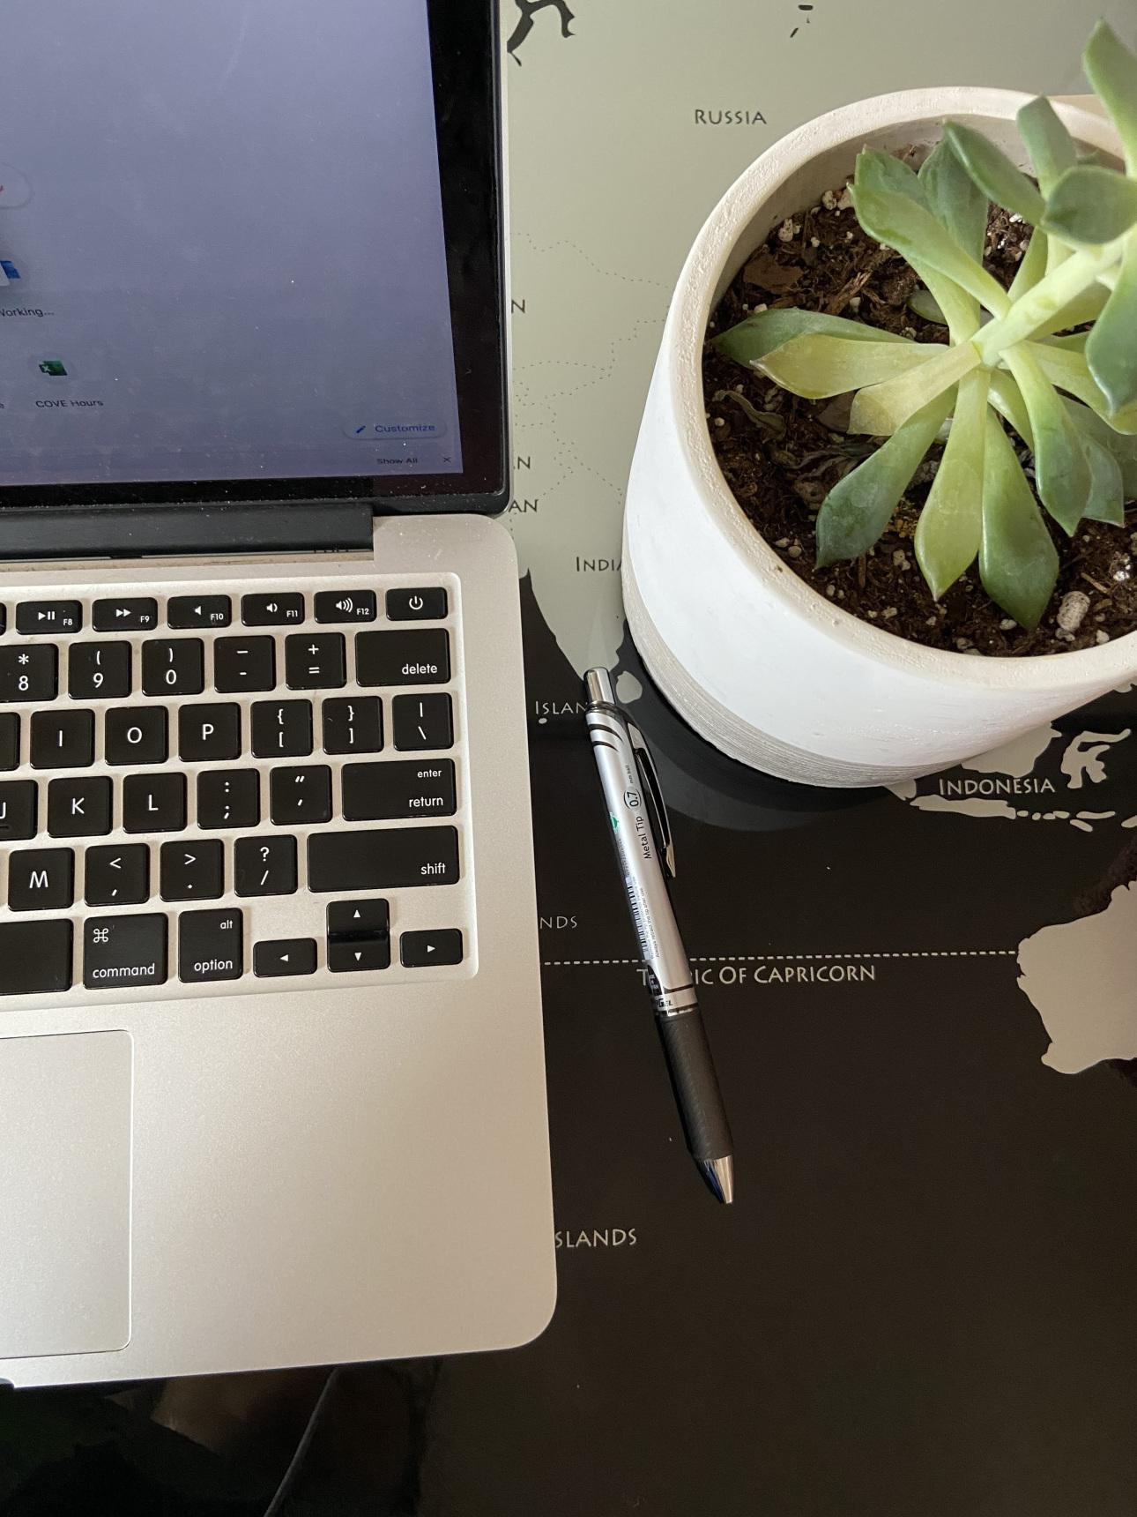

Thinking about the resources and tools that I use every day allowed me to reflect on the resources that we used for Module 3. While comparing between WordPress, Blogger, Flickr, and Omeka, I realized that it is important to learn how to categorize data to be able to use these tools.

First, I will compare WordPress and Blogger. Before learning about blogging websites in this class, I noticed that many people used WordPress to blog. Creating a post and working on the post is not difficult to understand. I was able to include a picture and include different spaces. I liked how every paragraph had its own “block,” so in every paragraph you could include a poll, a chart, or another picture. On the home page there are a couple tutorials on how to “master the block editor.” This made me realize that there are so many features that I may not use on the first time around (especially since I am not very creative). After learning more about metadata and realizing the importance of categories, I wondered if I would write about more than one category. I noticed that one can create different categories on WordPress but not on Blogger. I personally liked this feature because I can keep track of how many posts I have made under “food,” instead of having to go back to my site. For some people that take this seriously, categories are not just important to keep track of your posts, but they are also important to keep track of marketing and earnings. I think that Blogger is much easier to understand, however, it does not have the section to categorize each post.

If I were to be a blogger, I would use Flickr to edit videos and pictures. Under albums, it includes the feature to include a new album and a new collection. Earlier this week, I noticed that my professor used Flickr to upload his lecture videos on Canvas. He did mention that he wanted to upload his lectures on YouTube, but he was not sure how to do that. Many of my professors have used this method to teach their lectures during the coronavirus. I don’t just think that this is important for lecture, but it is also important for vlogs. This website is very easy to navigate (and to make your albums private). I personally see myself uploading needed lectures and dividing them up by each course. The only problem that I may have is finding a specific picture or video, but I believe that the descriptions under each item will be very useful.

Another website where I found the “description” feature useful was on Omeka.net. I personally really like this to summarize any articles that I read for my research in the future. One can also create collections, so I may use this to keep track of the research that I have done for Latinx literature or 19th century American literature. If I am not sure where I included a specific article, I can also “refine my search” (under Quick Filter) so I can also search for keywords. To further extend the metadata, I can set up a feature where I can include a “lesson plan” if I were to use this website for teaching. This is important because I can specifically point out the most important arguments of the article. I can even upload an image or a file on the item! This is very easy if I need to pull up a PDF of an article.

Overall, I personally liked learning about different resources. However, I found the use of metadata both useful and difficult. I believed that it was useful because it makes it easier for a user to find data in a sea of information. It is also difficult because one must standardize the metadata so that we can easily go back and find the needed information. Additionally, I have also thought about the ethical considerations of metadata, as I want to be thoughtful of how I store this information.