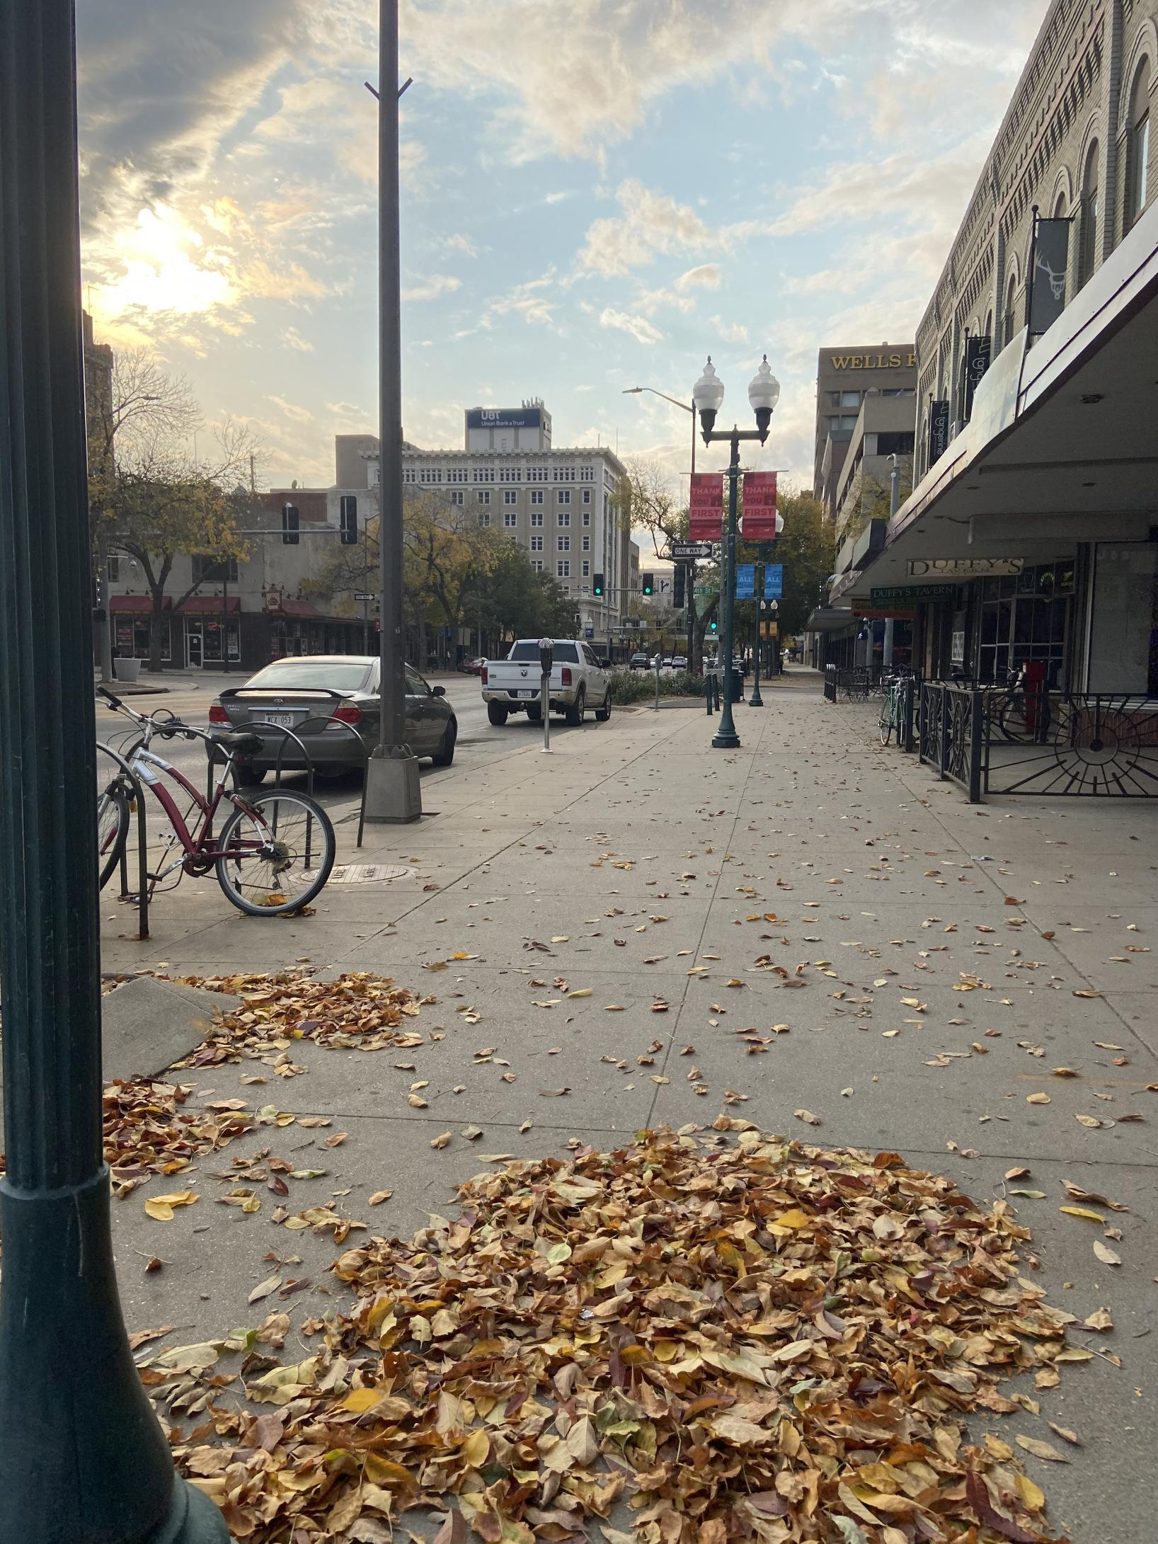

In this reflection, I will describe my observation of Downtown Lincoln during COVID. Before writing my reflection, I make a connection between society during COVID and the professionals in [Chapter 16 of *Making Things and Drawing Boundaries*](https://dhdebates.gc.cuny.edu/projects/making-things-and-drawing-boundaries).

COVID in Lincoln reminds me of a section stated in Chapter 16: “Thinking as Handwork: Critical Making with Humanistic Concerns.” The authors, Resch et al., discuss the importance of theory in critical making. They talk about how digital humanists and science and technology studies professionals work together to discuss different methods to complete the final product. Resch et al. state that “theory can be taken for granted” (paragraph 7). This phrase in the chapter reminded me of what we, as a society, are experiencing today.

As it is known, many businesses in Downtown Lincoln have reinforced the policies encouraged by the CDC. The CDC professionals have worked to encourage policies to decrease the number of people with COVID. The CDC reminded me of the DH and STS professionals who work hard to set methods and theories to assist the professionals. These methods and theories are similar to the policies during COVID, because we are also encouraged to follow them. Unfortunately, similar to DH and STS professionals that do not follow the theories, there are many people in our community that do now follow the policies.

During the pandemic, we are supposed to social distance and wear a mask (especially if we are around other people). However, during my observation, I noticed a pedaling party-cycle tour full of young people (I noticed five or six different groups of people during the day). They were definitely not following the policies. Thankfully I did see people that tried to keep social distance and their mask on while they walked. There were times where other people and I would awkwardly look at each other to not walk too close to each other or to choose another sidewalk. I also noticed that in the stores, many people kept their distance, especially during checkout.

Due to these observations, I found it difficult to write down my reflection for this module. While reading [Chapter 16](https://dhdebates.gc.cuny.edu/projects/making-things-and-drawing-boundaries), I wondered why people take the theories for granted, and during my observation, I also wondered why people take the policies for granted. On the street I live on, I noticed a sign outside *La Panaderia* selling shirts that state “No Human is Illegal,” I also noticed many homeless people, and I noticed the young students on the party-cycle tour blasting hip-hop music. It was heartbreaking to notice that there are people who are trying to survive and demonstrate their humanity, while there are others who do not care about noticing others. This reflection was very hard for me to write this week (especially after learning about RBG’s death and Breonna Taylor’s case). Since I know that this is one of the many assignments that will be used for DH Publication #2, I wanted to write a strong reflection.