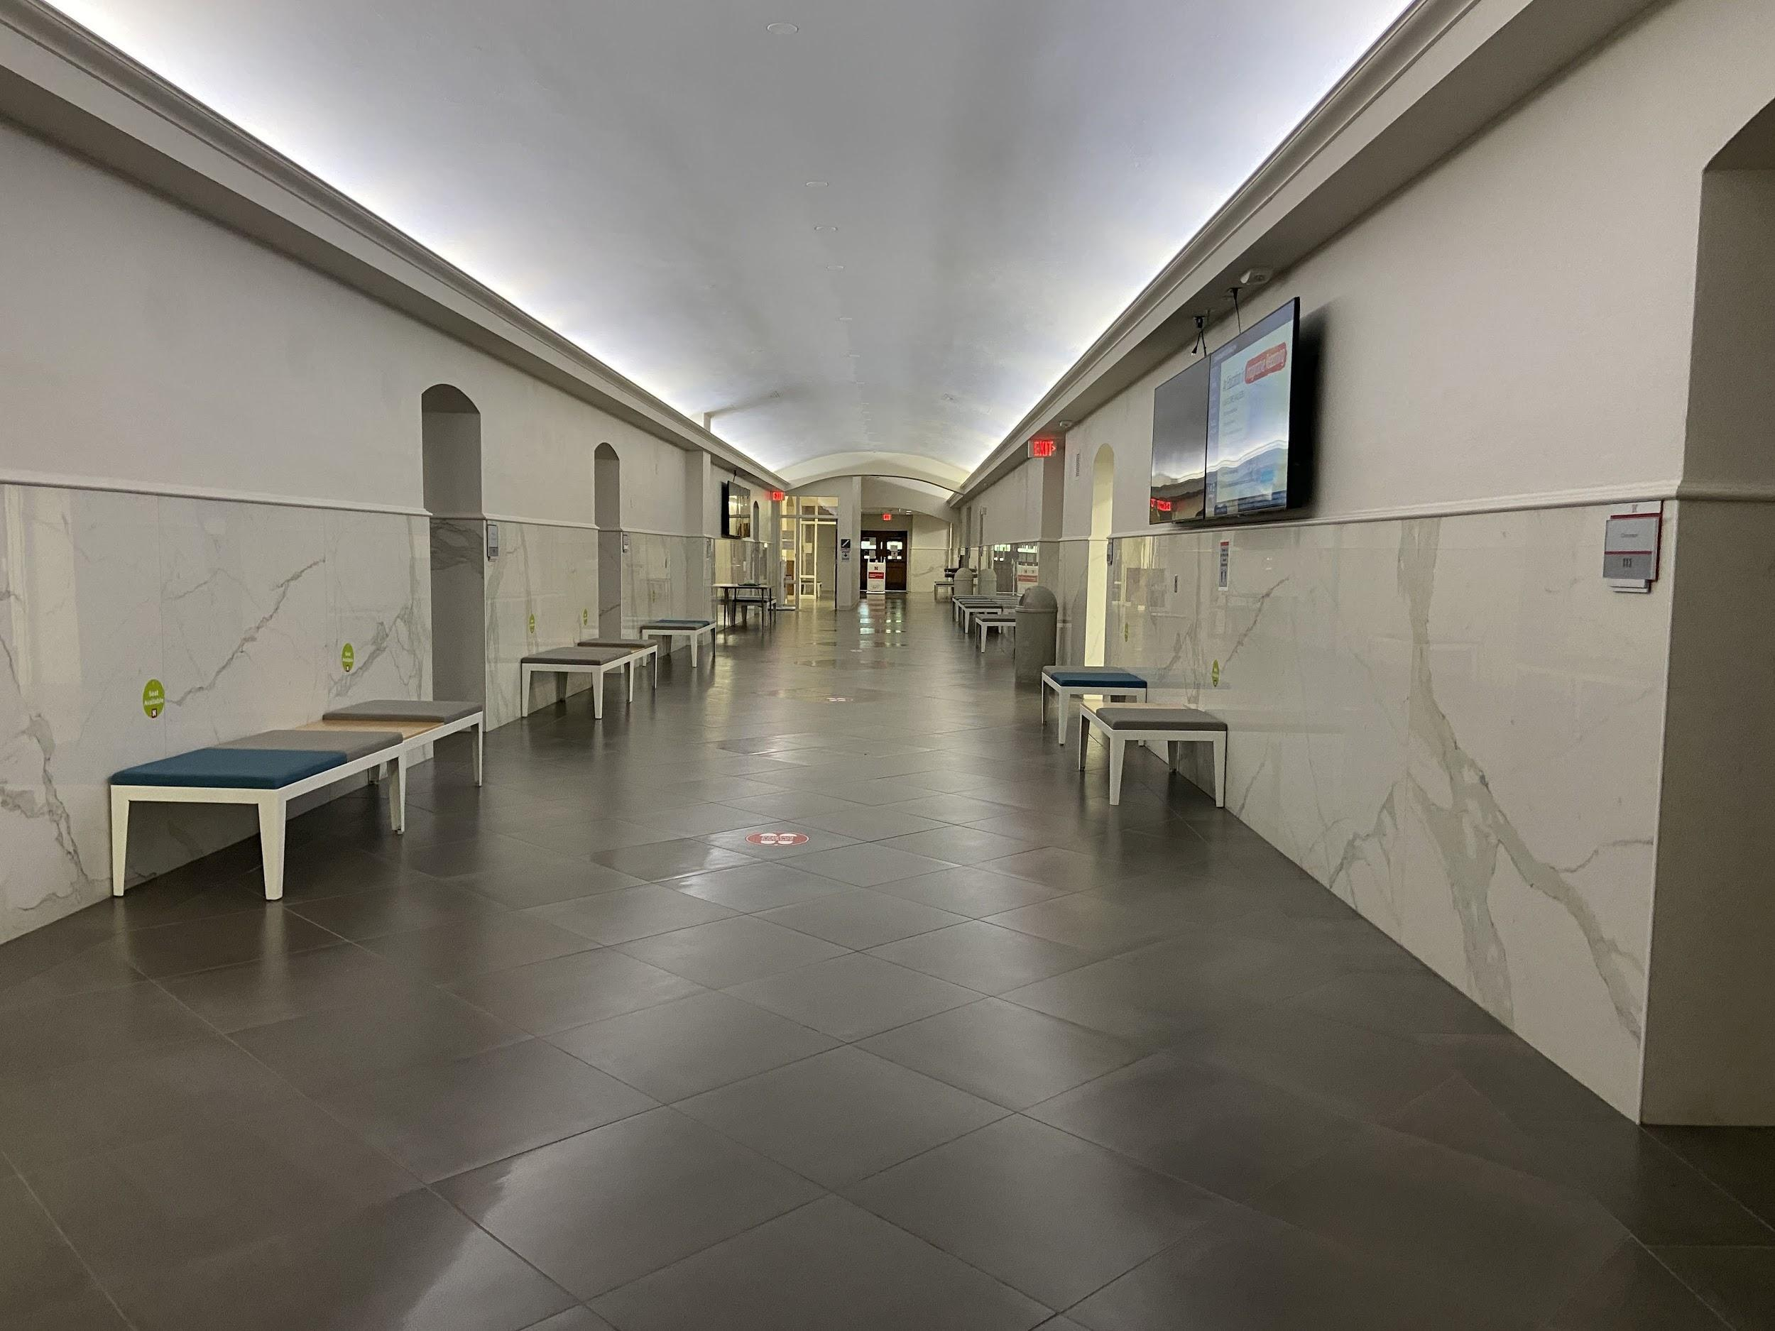

The first time that I came to Lincoln to visit campus was in the chilly month of February. Most of the students were in the classrooms, in The Union, or in the library close to the Dunkin’ Donuts. At the time, I was really excited to attend UNL in the fall and continue to meet new grad students and start my classes. As I am sitting here in my kitchen, completely alone, I feel like my first visit to Nebraska was YEARS ago! COVID-19 messed up our time frame and, unfortunately, it has also changed our community drastically. There are many new policies due to COVID but there are also questions that have been raised due to these restrictions.

Most of the people are wearing a mask outside. I definitely noticed that people are not walking around in clusters. In Andrew’s Hall, I noticed the one can only enter through one set of the doors and exit through the other side. As I walked around the building, I felt that I was completely alone. I knew that many of the professors were in their office with the door closed and others were probably working from home. The Little Library and the writing center were closed. It seemed like everything was closed. I know that faculty working in the English department asked the students to avoid entering the office.

As I was walking back, I passed by the library and I noticed that there weren’t many students working in the library or by the coffee shop. It is clear that the library and The Union rearranged their furniture to restrict capacity and to reinforce social distancing among students. This made me think of the students that may not have fast-speed internet (like myself). We are so dependent on the internet and other online programs that we never thought that Zoom was going to crash on the first day of school. In [Chapter 14: “Reifying the Make as Humanist](https://www.blogger.com/blog/post/edit/6460124631916029892/6723529444311681294#),” the author states that the one of the aspect of Digital Humanities that are particular concern to all humanists and that present the biggest challenge to making in the humanities is access to technology (paragraph 9). “Without student access to computer hardware, software, and collaborative experimental spaces, our expectations for a digitally enriched humanities curriculum replicate expectations of privilege” (paragraph 9). Education during COVID emphasizes the major challenges that public institutions face during a “normal” year.

Many students on social media have called their institution “Zoom University.” However, they do not realize the long hours of research that professors (and GTAs) spend on their course. As was expressed in *Making Things and Drawing Boundaries*: it takes more than one person to create an object ([Chapter 2](https://dhdebates.gc.cuny.edu/projects/making-things-and-drawing-boundaries)). And it will definitely take more than one person to get us back to “normal.” But before we go back to “normal” many students have asked themselves whether they should be paying the same amount of tuition and fees even though they may not have access to the library, the recreational center, or other resources on campus. However, is this fair for the departments with limited funding? Or for their professors, who had to work twice as much to create an entire course online?

Works Cited

Hunter, John, et al. “Making Things and Drawing Boundaries: Chapter 14.” *“Chapter 14” in “Making Things and Drawing Boundaries” on Manifold*, University of Minnesota Press, 2017, dhdebates.gc.cuny.edu/read/0bf2487d-ccb2-4388-bffd-275ee90a3c65/section/6ea34bdc-68a3-4b3b-bdd3-d383f4b6ff4a.

Staley, David. “On the ‘Maker Turn’ in the Humanities: Chapter 2.” *“Chapter 2” in “Making Things and Drawing Boundaries” on Manifold*, University of Minnesota Press, 2017, https://dhdebates.gc.cuny.edu/read/untitled-aa1769f2-6c55-485a-81af-ea82cce86966/section/be0ac4f2-f18b-476e-9199-463df64aa8d9.