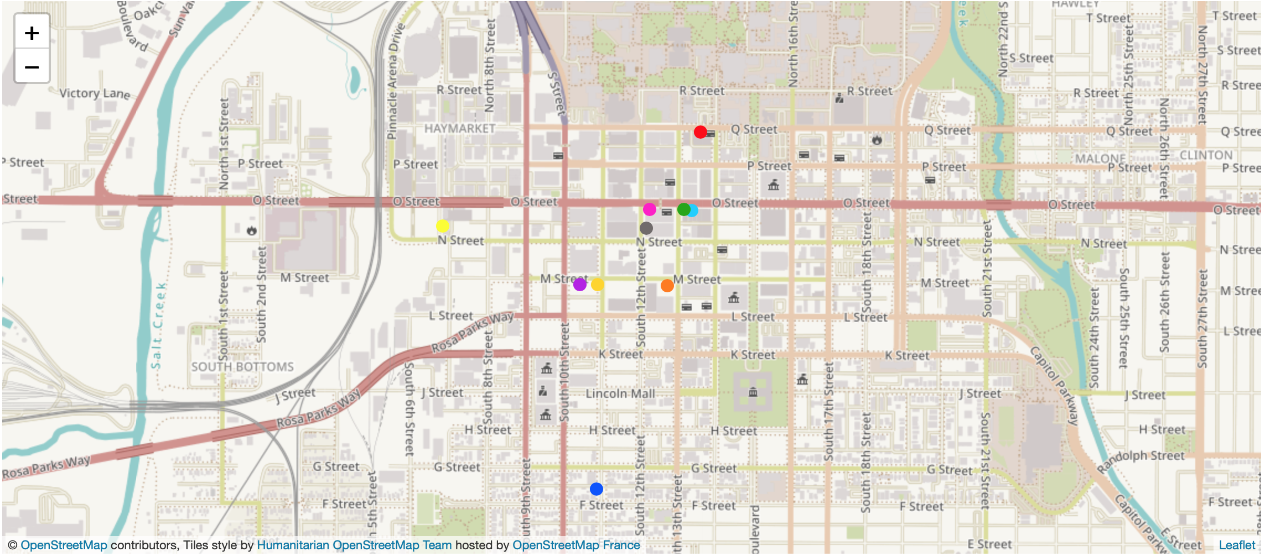

I believe that GitHub is a great tool to use for visualization. I did use GeoJson for the coding needed in GitHub. Although this project is similar to StoryMap, GeoJson is a simple map with the markers on the location of my images. GeoJson is a zoomed in map, in comparison to StoryMap, so this allows the viewer to understand the geography of the location that I focused on for this project. For GeoJSON, I personally liked including the description for each marker (including the title and the date). However, I found it a bit confusing having to open up Flickr to include an image to GeoJSON. The viewer may find GeoJson more interesting since they will be the one taking control on the images that they click on. Additionally, they are also able to zoom in and out of the image to have a better understanding of the distance between Downtown Lincoln and the University of Nebraska-Lincoln. Based on the Flickr Album on my Home page, the viewer will also be able to compare the guidelines at UNL to those of Downtown. I hope that the viewer takes advantage of these tools to get a better understanding of the information that I am presenting. **Click on the image above to visit my GitHub Map of Downtown Lincoln.**

[**https://emoreno14.github.io/geojson_demo/**](https://emoreno14.github.io/geojson_demo/)