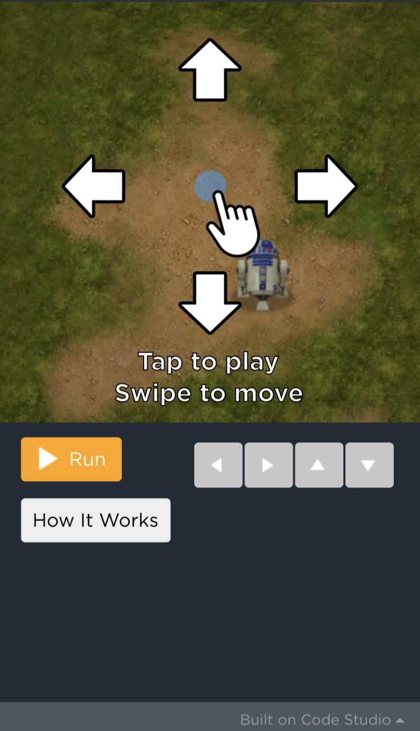

While I was creating *Hour of Code*, I was thinking of how I can also use the tools given to me to try to portray to the player the feelings experienced through COVID-19. In my game, I decided to set the droid, R2-D2, as the virus. Every time the droid encountered a Rebel Pilot (someone without a face mask), the virus would get 300 points for infecting a Rebel Pilot. After the first is infected two other Rebel Pilots will pop up and walk around. I also decided to include Stormtroopers as an example of people who do have their masks on. Every time the droid (the virus) encounters people without a mask, it loses 100 points. A few seconds into the game, there are so many Rebel Pilots that the player may feel overwhelmed. This is how many people feel during this pandemic. Overwhelmed by the number of people who have been infected and by the number of people who still don’t care. The player may also feel trapped, since they will not know when everything will end. **Click on the image to start the game.** You may have to reset the game multiple times before playing it.

<https://studio.code.org/c/1205836803>