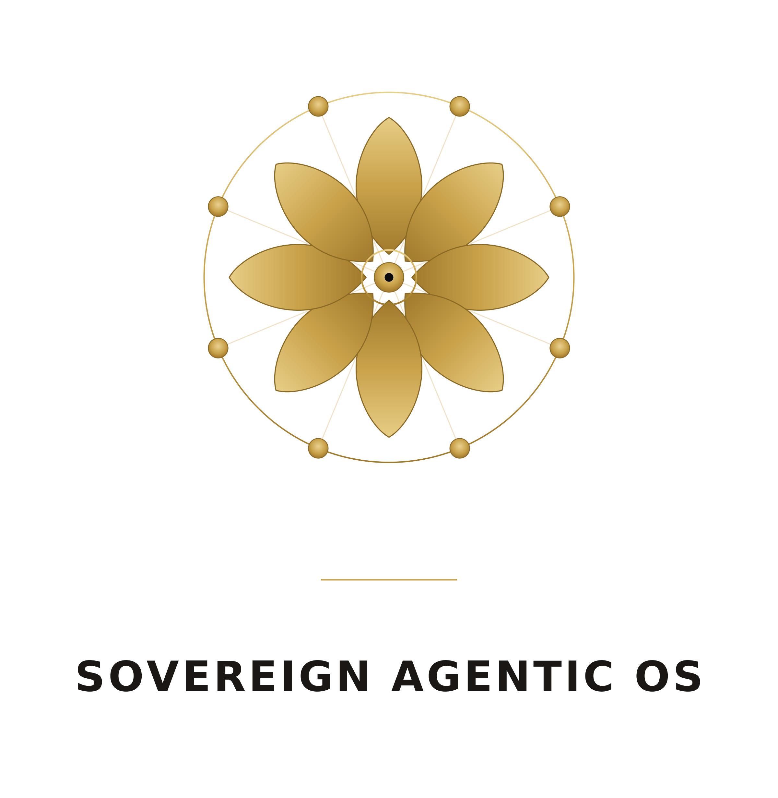

The Sovereign Agentic OS
  - One governed operating system for data, knowledge, and agents.
Data Masterclass · datamasterclass.com
An introduction · July 2026
Table of Contents

Why the Sovereign Agentic OS exists
Artificial intelligence has learned to reason, write, and act. What it has not been given, in most organizations, is a safe place to do real work — a place where an agent can touch your data, your documents, and your systems without becoming a liability. Today that access is usually improvised: a script here, an API key there, a copied spreadsheet, a model with no idea who is asking or what they are allowed to see. That is not a foundation you can build a company on.
The Sovereign Agentic OS is the foundation. It is an EU-sovereign, open-source operating system that unifies data, knowledge, connections, files, metrics, dashboards, software, agents, science, and strategy into one governed platform — one you run on your own infrastructure (deployed on STACKIT), under your own control, subject to your own policy. It is not another dashboard bolted onto your stack. It is the operating layer beneath all of it.

Governance by default
Its defining idea is simple to state and hard to fake: governance is not a feature, it is the default. Every action in the OS — whether a person clicks a button or an agent calls a tool — runs as the signed-in user. It is checked against OPA policy, filtered by row-level and document-level security so you only ever see the rows and documents you are entitled to, and written to an immutable audit trail. Nothing runs as a nameless service account with god-mode access.
Crucially, the agent interface is the same governed path as the UI. When you connect Claude or another agent to the OS over the Model Context Protocol, it does not get a privileged back door. It travels the identical policy-checked, security-filtered, audited road that a human does — under your identity and your permissions. This is what makes it safe to hand an agent real work: it can only ever do what you could do, and every step is on the record.
Two cross-cutting models run through the entire OS. Learn these two ideas and the rest of the platform becomes legible.

The two ideas you must know

Roles — four ranks, lowest to highest
Authority in the OS is a simple ladder of four roles. Each rank contains the one below it and adds a well-defined power.
- creator — creates and runs their own work, and consumes what has been shared with them. The default rank for everyone doing the work.
- builder — a creator who can also approve Personal → Shared promotions within their domain. Builders are approvers of work, not administrators of people.
- domain_admin — a builder who can also administer users within their own domain: invite, assign roles up to builder, deactivate.
- admin — runs the whole tenant and certifies assets company-wide. The only role that can appoint a domain_admin.
The ladder is the same everywhere, so a permission you understand in one tab means the same thing in every other tab.

Tiers — from My to Domain to Company
Every asset in the OS lives at one of three levels of visibility, and it always starts at the most private.
- My (Personal) — visible only to you. Everything begins here.
- Domain (Shared) — visible to your domain, reached by promotion with builder approval.
- Company (Certified) — trusted across the whole organization, reached by admin certification.
Promotion is never a silent flip of a switch. Moving an asset up a tier always requires documentation first — you describe what it is and why it can be trusted before anyone else comes to rely on it. That discipline is how trust scales from one person to a whole company without losing the thread of accountability.

How the OS is organised
The OS is arranged into five areas that mirror how work actually flows — from intent, to the context that governs it, to what you build, to how you keep it all accountable.
- Plan — set direction: strategy, initiatives, your operating model, and the workflows that run the business.
- Context — govern the knowledge and data your agents and people are allowed to use.
- Build — create agents, apps, models, and dashboards on top of that governed context.
- Govern — oversee and administer: approvals, monitoring, components, models, and platform administration.
- Entry — the front doors: orientation, your personal cockpit, tutorials, and the MCP connection.
The sections below walk every tab in order: a one-line reason it exists, and a short, practical note on how to use it.

Entry — the front doors

Home
Why it exists: an orientation landing that lets you jump straight into any area of the OS. How to use it: start here when you are not sure where something lives. Home surfaces the five areas and the fastest route into each, so a new user can find their footing and an experienced one can move fast.

Cockpit
Why it exists: your personal, at-a-glance operational overview. How to use it: open the Cockpit each morning to see pending work waiting on you — approvals, requests, runs — alongside recent activity. It is the single screen that answers "what needs me today?"

Tutorials
Why it exists: guided, in-product walkthroughs of the golden paths. How to use it: when you want to learn a workflow — building an agent, promoting a dataset — run the matching tutorial. It teaches by doing, inside the real product, rather than in a separate manual.

MCP
Why it exists: connects the OS to Claude and other agents over the Model Context Protocol, governed identically to the UI. How to use it: generate your per-user token and point your agent client at the OS. The agent then acts as you, bound by your permissions and fully audited. Configuring the connection surface is a builder-and-above task, but any user can connect and use their own token.

About / Licenses
Why it exists: transparency about what you are running. How to use it: check here for the current version and the full set of open-source licenses behind the platform. Because the OS is open source, nothing about its composition is hidden from you.

Plan — set direction

Strategy
Why it exists: to hold your Strategic Pillars — long-horizon goals with a value metric, a target, a horizon, and progress so far. How to use it: define the handful of pillars that matter, each with a measurable outcome, and let everything downstream point back to them. Pillars are tiered My/Domain/Company and versioned, so direction is explicit, shared, and traceable over time.

Big Bets
Why it exists: to plan the major initiatives that move a pillar. How to use it: tie each Big Bet to a pillar, then use the solution-design workspace to lay out the workflow → the components that deliver it → their interplay → the context they use, with value tracked against the goal. A Big Bet is where a strategic intention becomes a concrete, buildable plan.

Operating Model
Why it exists: the durable business context your agents build on. How to use it: maintain your operating model across General · Strategy · Business · Organization · Architecture · Data · Glossary, at My/Domain/Company scope. This is the stable, shared understanding of how the business works — the ground truth agents draw on so their output fits your reality, not a generic one.

Workflows
Why it exists: to capture business processes as living, governed artifacts. How to use it: model a process as a swimlane diagram with steps, actors, rules, and the know-how each step needs. Track readiness and gaps to see where a process is ready to automate, and export to PDF to share it. Workflows turn tacit process knowledge into something the OS — and its agents — can reason about.

Marketplace
Why it exists: to discover and reuse company-certified assets. How to use it: browse Company-tier, certified assets — datasets, agents, dashboards — and adopt them instead of rebuilding. The Marketplace is how good, trusted work spreads across the organization. Available to builders and above.

Context — govern what agents may use

Knowledge
Why it exists: curated reference knowledge, written for both people and retrieval. How to use it: author reference material in markdown; the OS embeds it so it is RAG-retrievable by agents. Knowledge is foldered, versioned, and tiered My/Domain/Company — the deliberate, human-curated layer of what your agents know.

Files
Why it exists: your unstructured documents, governed and retrievable. How to use it: upload documents and files into folders; the OS embeds them for retrieval so agents can ground answers in your real source material. Every file stays under the same governance and tiering as everything else.

Data
Why it exists: structured data, refined through a disciplined pipeline. How to use it: bring data through a guided Bronze → Silver → Gold pipeline on the Trino lakehouse — raw, cleaned, then trusted. A catalog makes it discoverable, "Talk to Data" lets you query in natural language, and promotion moves gold data up the tiers for wider use.

Connections
Why it exists: governed links to the external systems where your data already lives. How to use it: set up connectors to databases, warehouses, and SaaS tools — Slack, Gmail, GitHub, Snowflake, and more — grouped and searchable by category. Every connection is governed, so external reach never bypasses your policy.

Metrics
Why it exists: one agreed definition for each business metric. How to use it: define metrics on the Cube semantic layer so "revenue" or "active users" means exactly one thing everywhere. Query them, attach alerts, and promote the trusted ones. Metrics give agents and dashboards a single, governed source of numerical truth.

Build — create value on the context

Agents
Why it exists: to build multi-agent systems that do real work on your governed context. How to use it: move through five phases — Define · Design · Build · Run · Evaluate. Grant context to agents as capabilities, so an agent can only ever use what you have explicitly allowed. Then run it and evaluate the result, with downloadable reports for evidence. Governance is built into the build, not added after.

Software
Why it exists: to build and deploy real applications on the platform. How to use it: create software that runs on the OS itself, with the same identity, policy, and audit guarantees as everything else. Your apps inherit governance rather than reinventing it.

Science
Why it exists: the full machine-learning lifecycle in one governed place. How to use it: create → train → deploy → monitor models without leaving the platform. Training runs, deployments, and monitoring all sit under the same policy and audit trail as your data and agents.

Dashboards
Why it exists: business intelligence on your trusted data and metrics. How to use it: build BI dashboards embedded from the analytics engine on your gold data and defined metrics — with per-viewer row-level security, so each person sees only their entitled slice of the same dashboard. One dashboard, correctly filtered for everyone.

Console
Why it exists: a governed operator surface for direct queries. How to use it: run SQL over Trino and Cube in the Query console — every query policy- and RLS-checked per caller and audited, available to builders. A raw admin shell also lives here, but stays strictly admin-only. Power without a bypass.

Govern — keep it all accountable

Policies & Approvals
Why it exists: the governance inbox for the whole tenant. How to use it: review and approve promotions and requests, and see the policies currently in force. This is where Personal → Shared → Certified actually happens, with a person accountable at each gate. Available to builders and above.

Monitoring
Why it exists: observability across agents and the platform. How to use it: inspect agent runs, traces, cost, and logs to understand what happened and why. When an agent behaves unexpectedly, this is where you follow the thread. Available to builders and above.

Components
Why it exists: the health of the platform's underlying services. How to use it: check the status of the OS's component services at a glance. An admin view for keeping the platform itself healthy.

LLM Gateway
Why it exists: self-service management of the models behind the OS. How to use it: manage models and providers through LiteLLM — add a provider, map it to a tier — so model choice stays configurable and never hardcoded. Available to builders and above.

Admin
Why it exists: platform administration for the tenant. How to use it: manage Users & Access, security, backups, and tenant settings. Full administration is an admin task; a builder who visits sees only their own Settings, never the levers of the tenant.

Where it all connects
The five areas are not silos — they are a single loop. Plan sets the direction and names the outcomes that matter. Context governs exactly what data and knowledge may be used in pursuit of them. Build creates the agents, apps, models, and dashboards that turn that context into value. And Govern keeps every step of it accountable — who approved what, what ran, what it cost, and who could see it.
The thread running through all of it is the same one you met at the start: every action runs as you, checked, filtered, and recorded — whether a person or an agent takes it. That is what lets you give AI real hands on your work without giving up control of it.
To get started, open the Cockpit to see what is waiting on you, and run a Tutorial to walk a golden path end to end. Everything else is the same operating model, applied one tab at a time.

