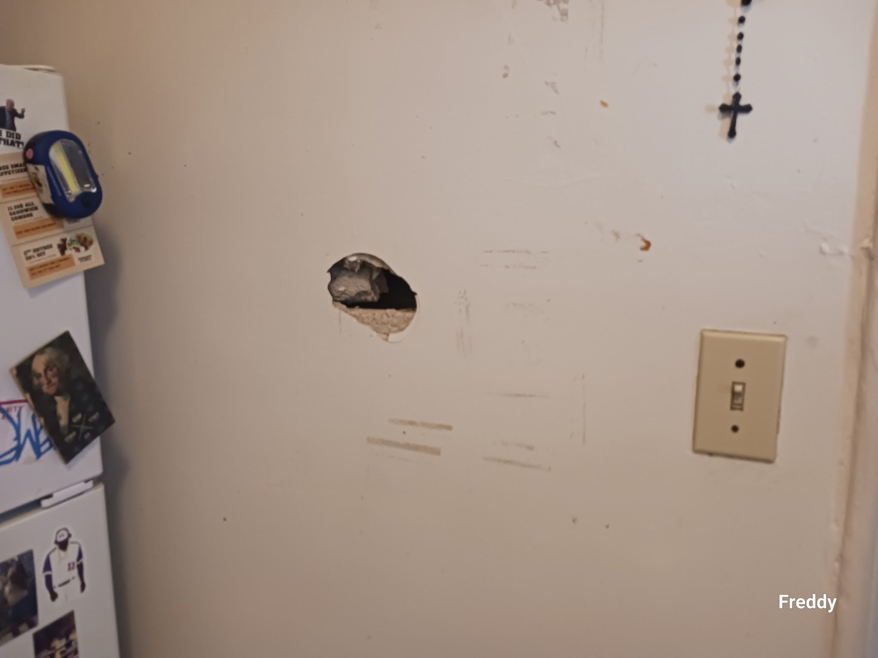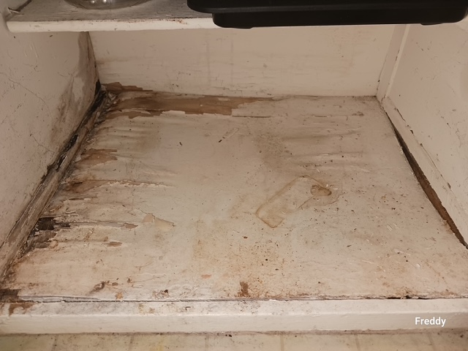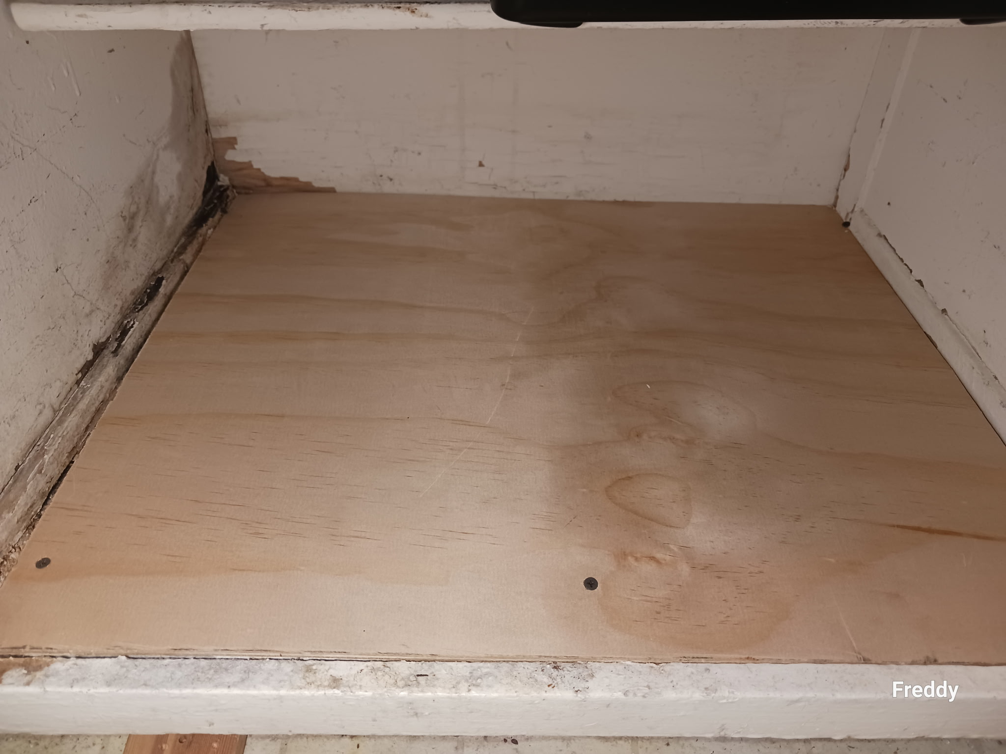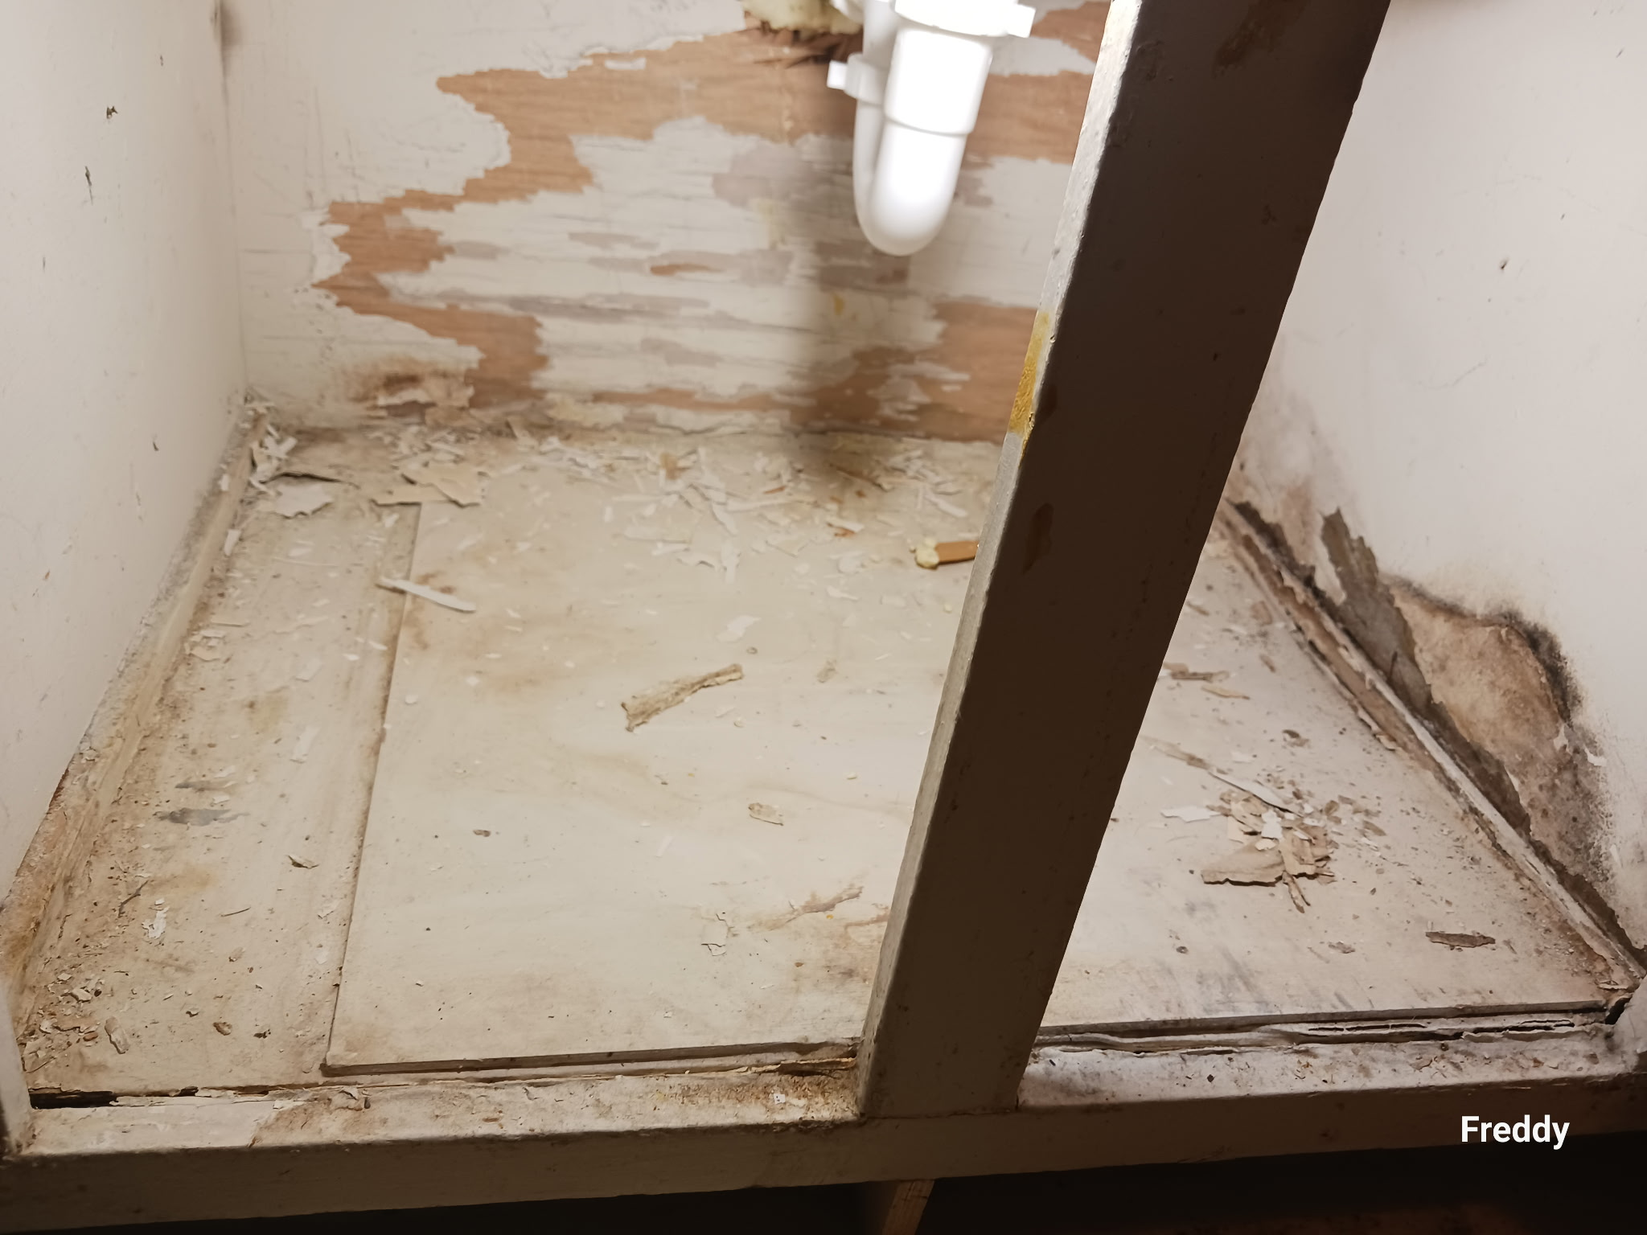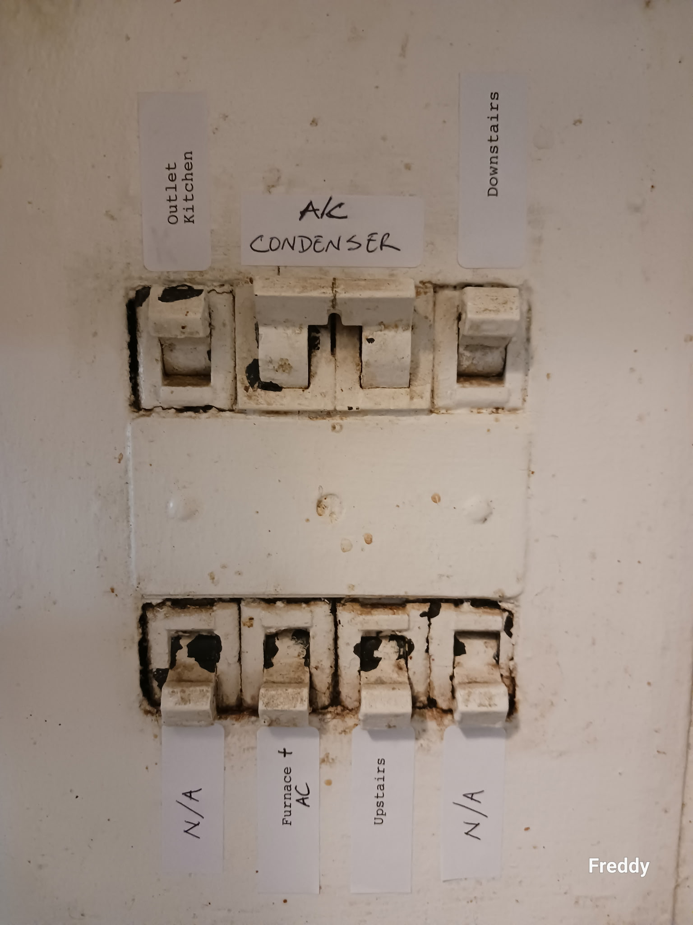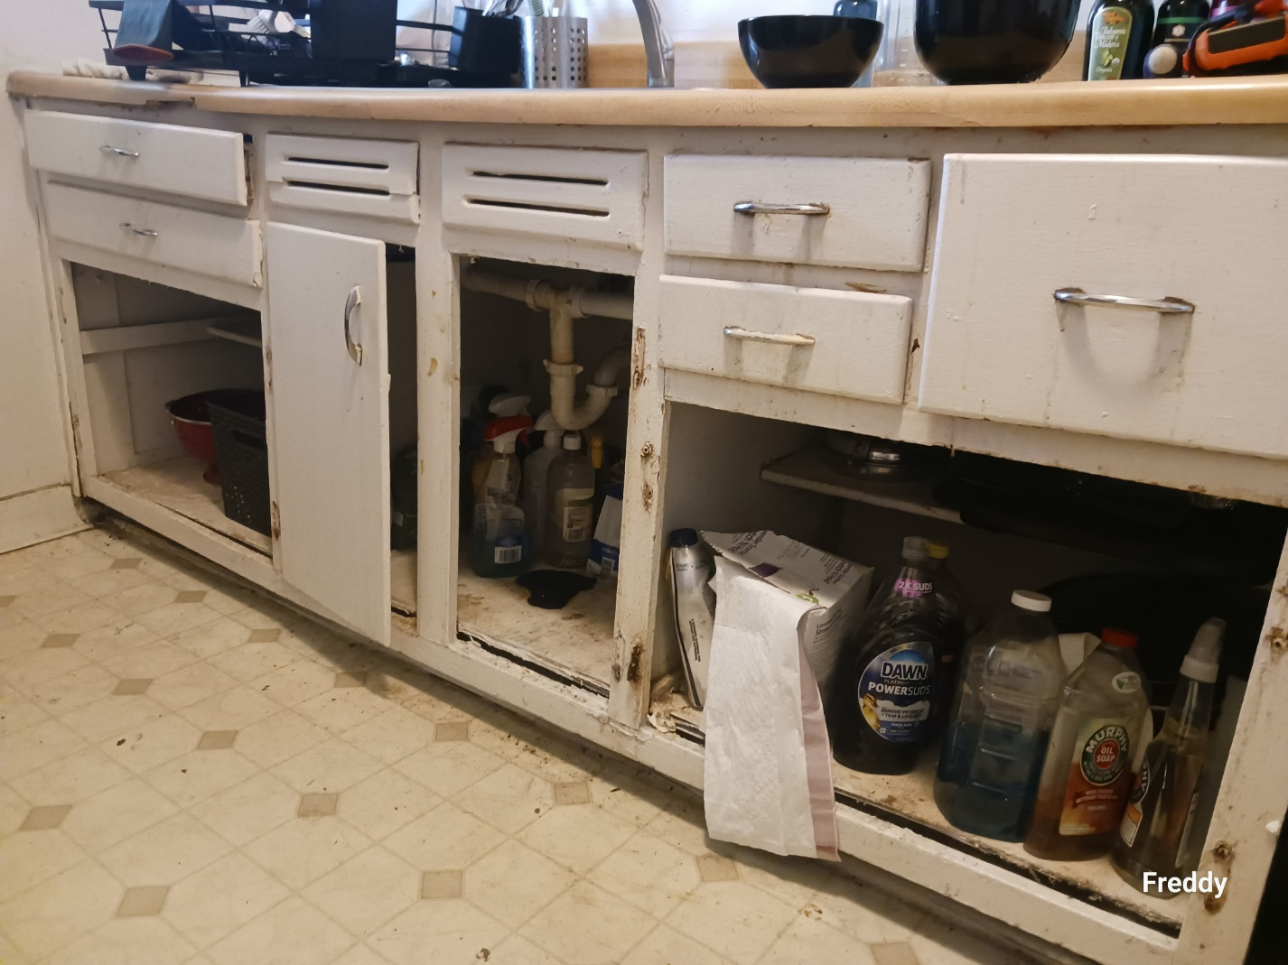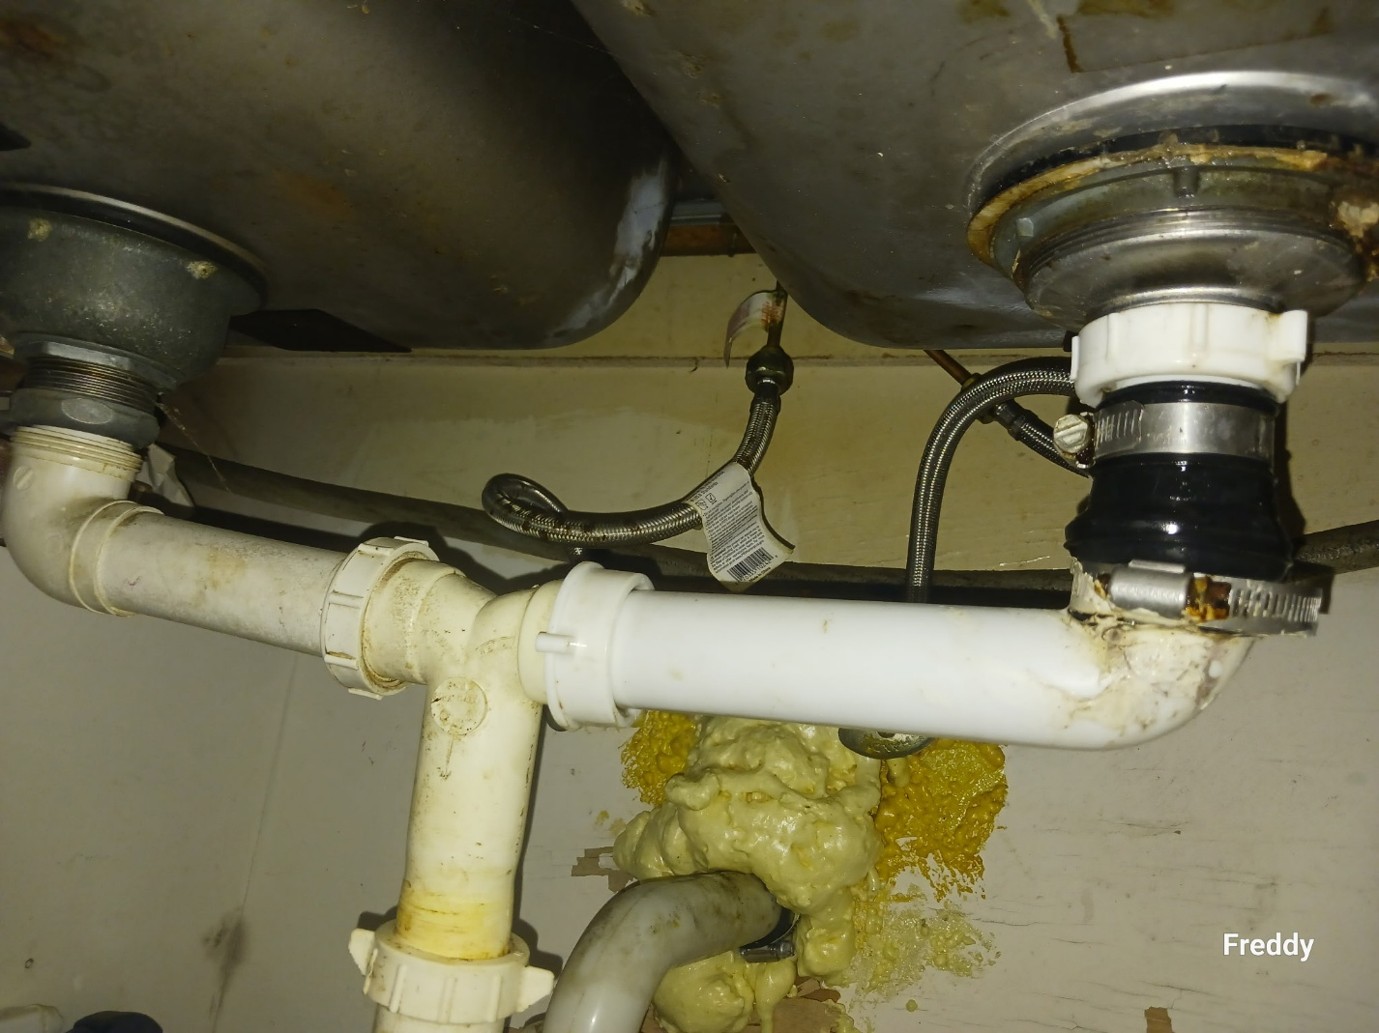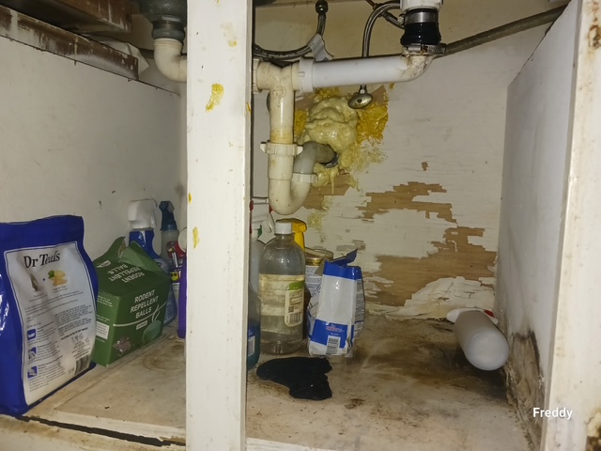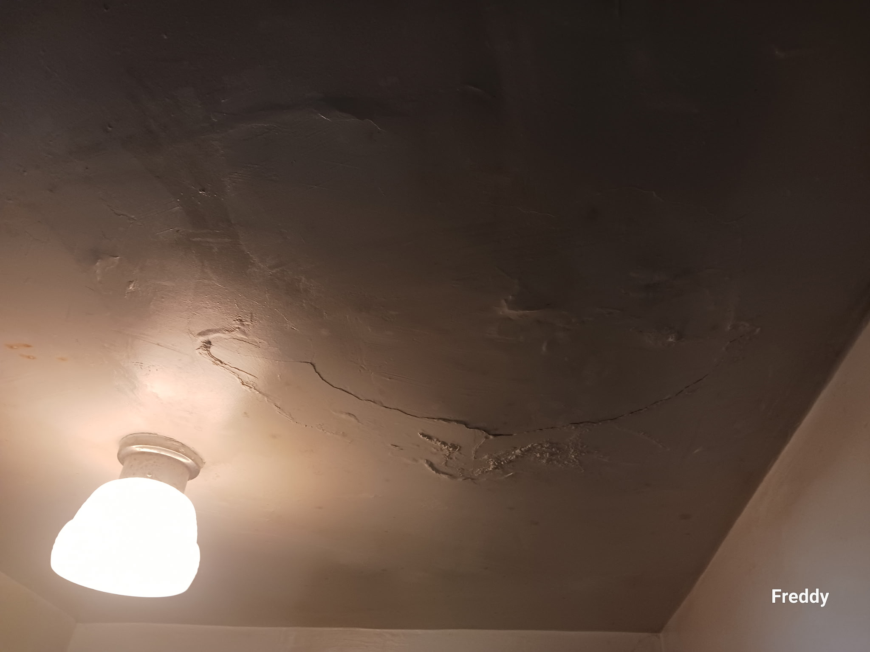

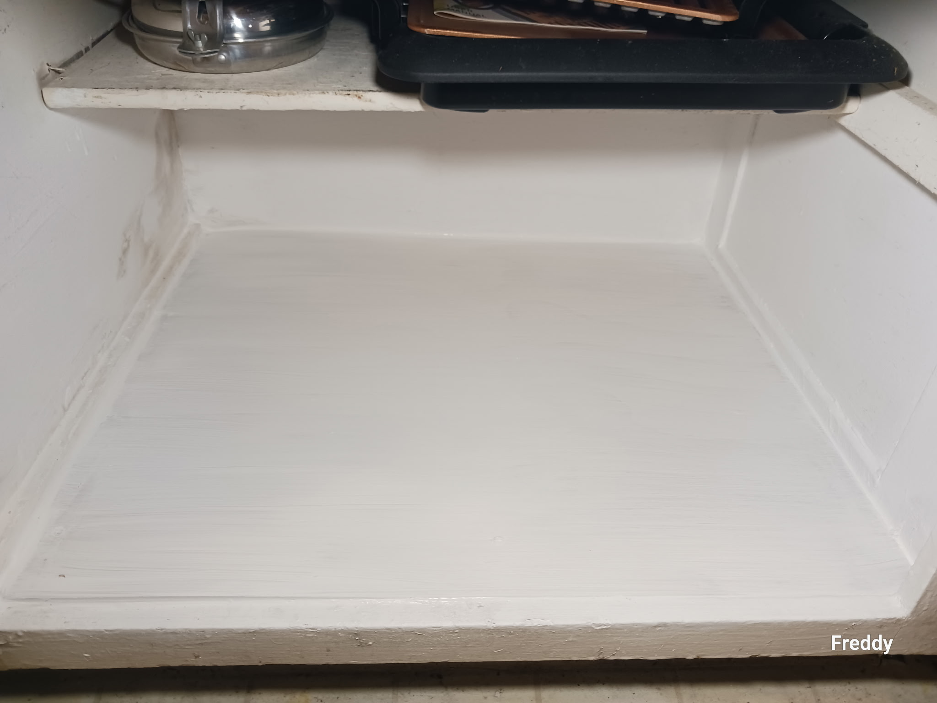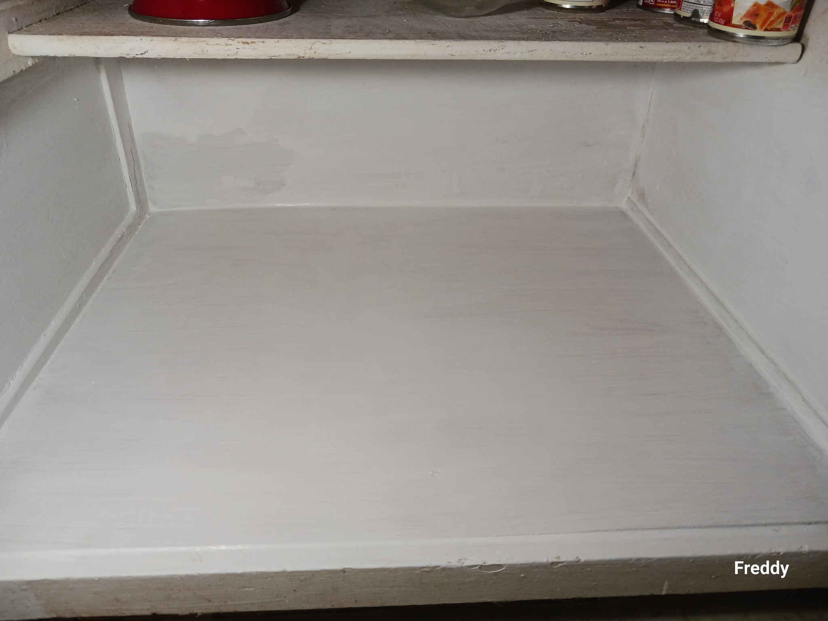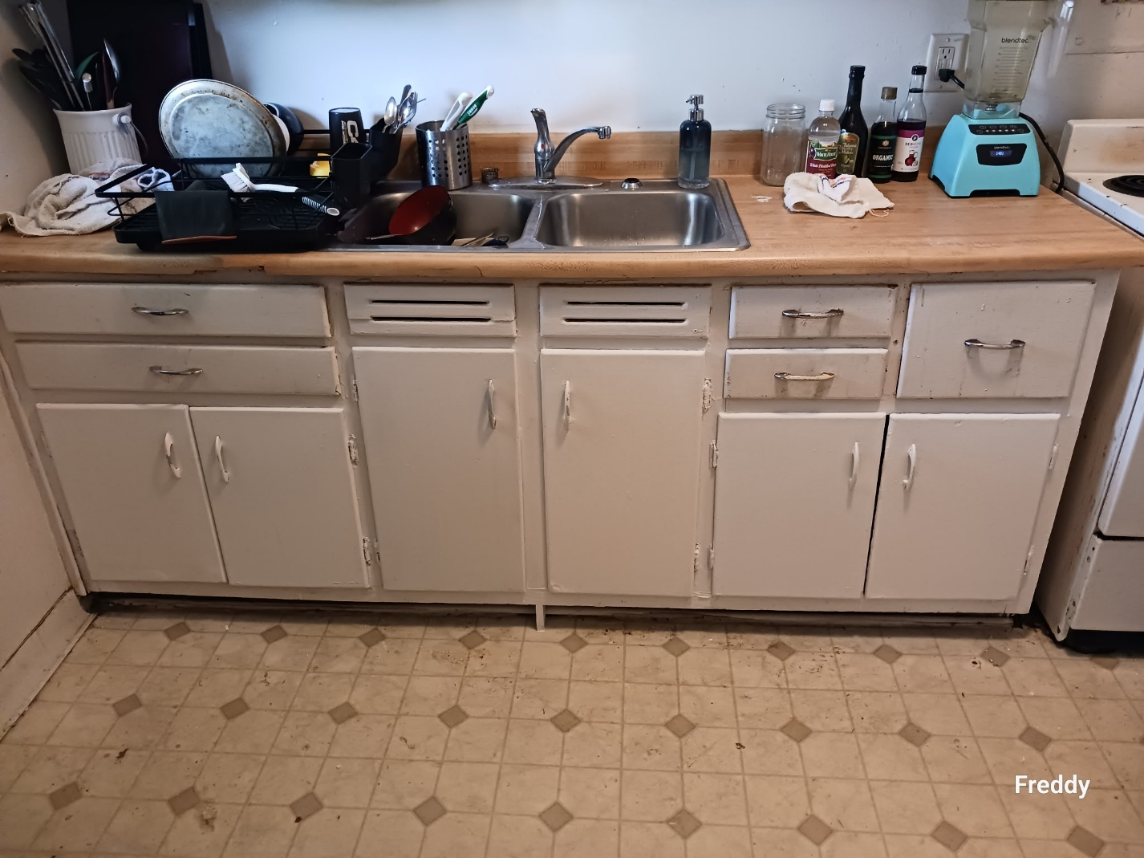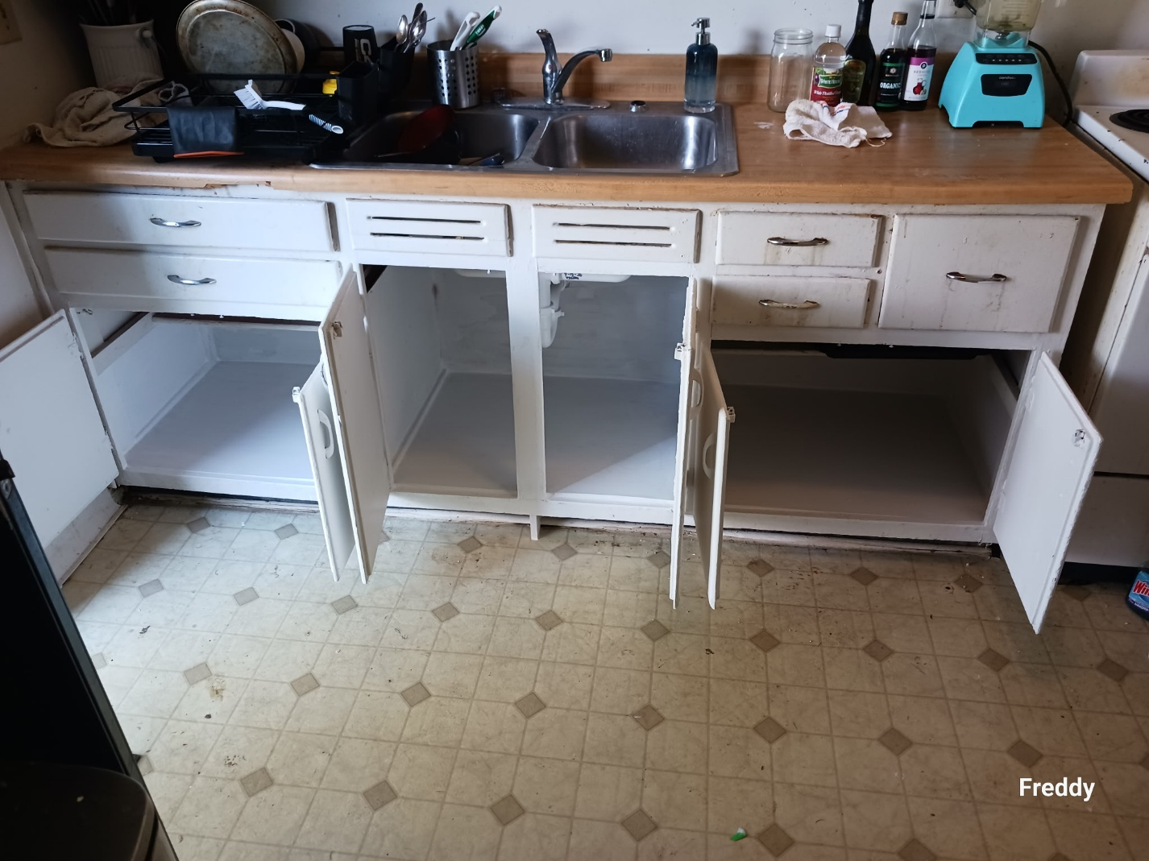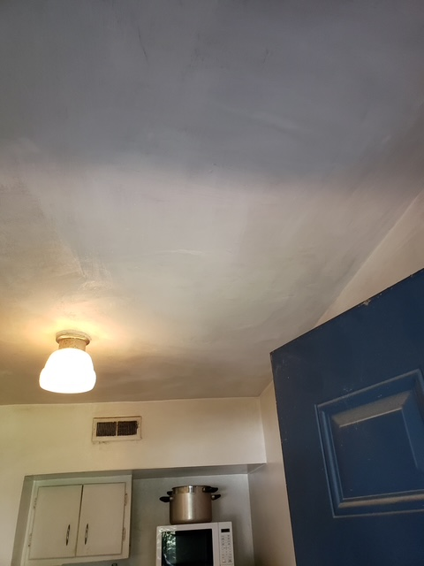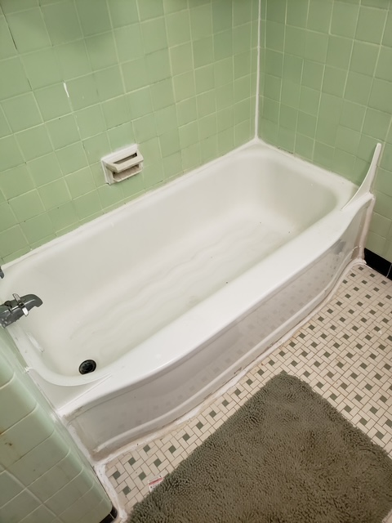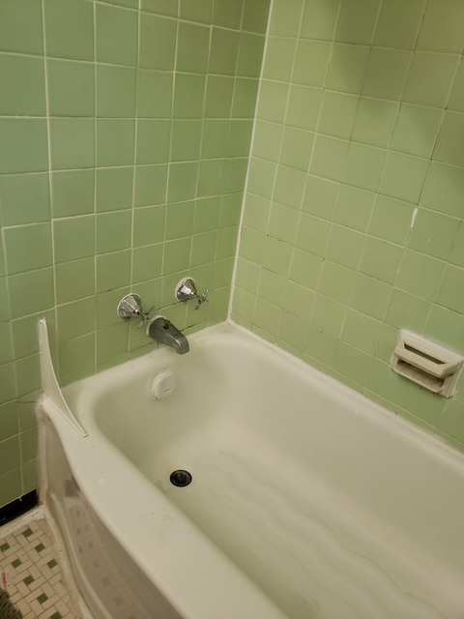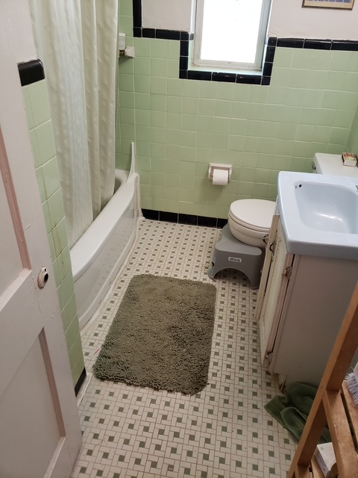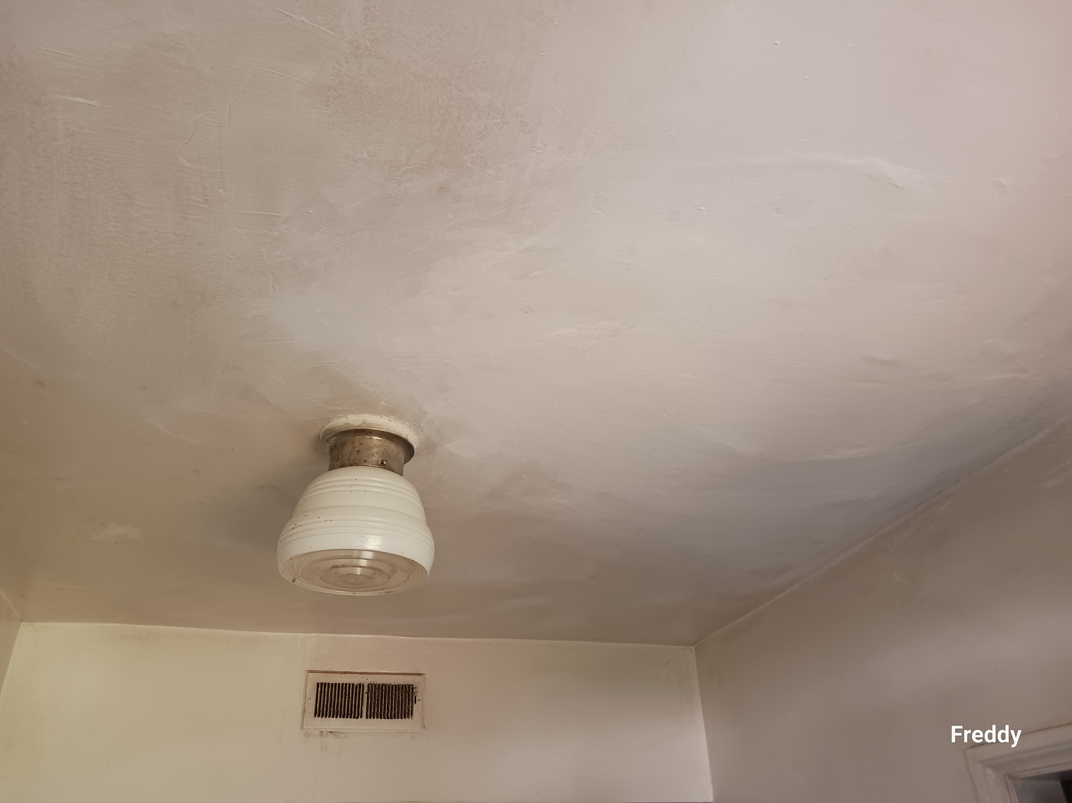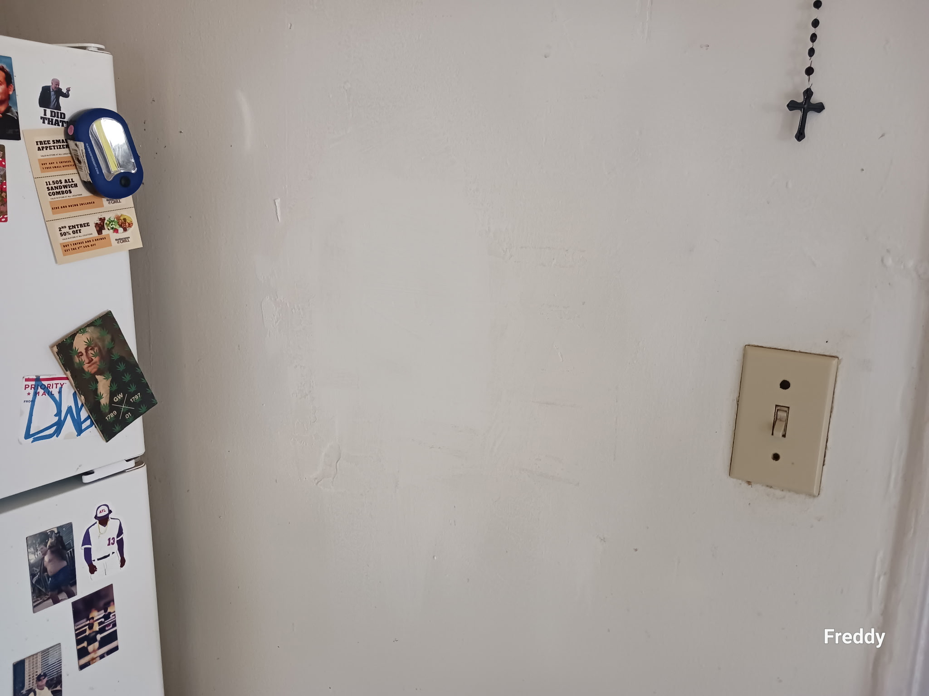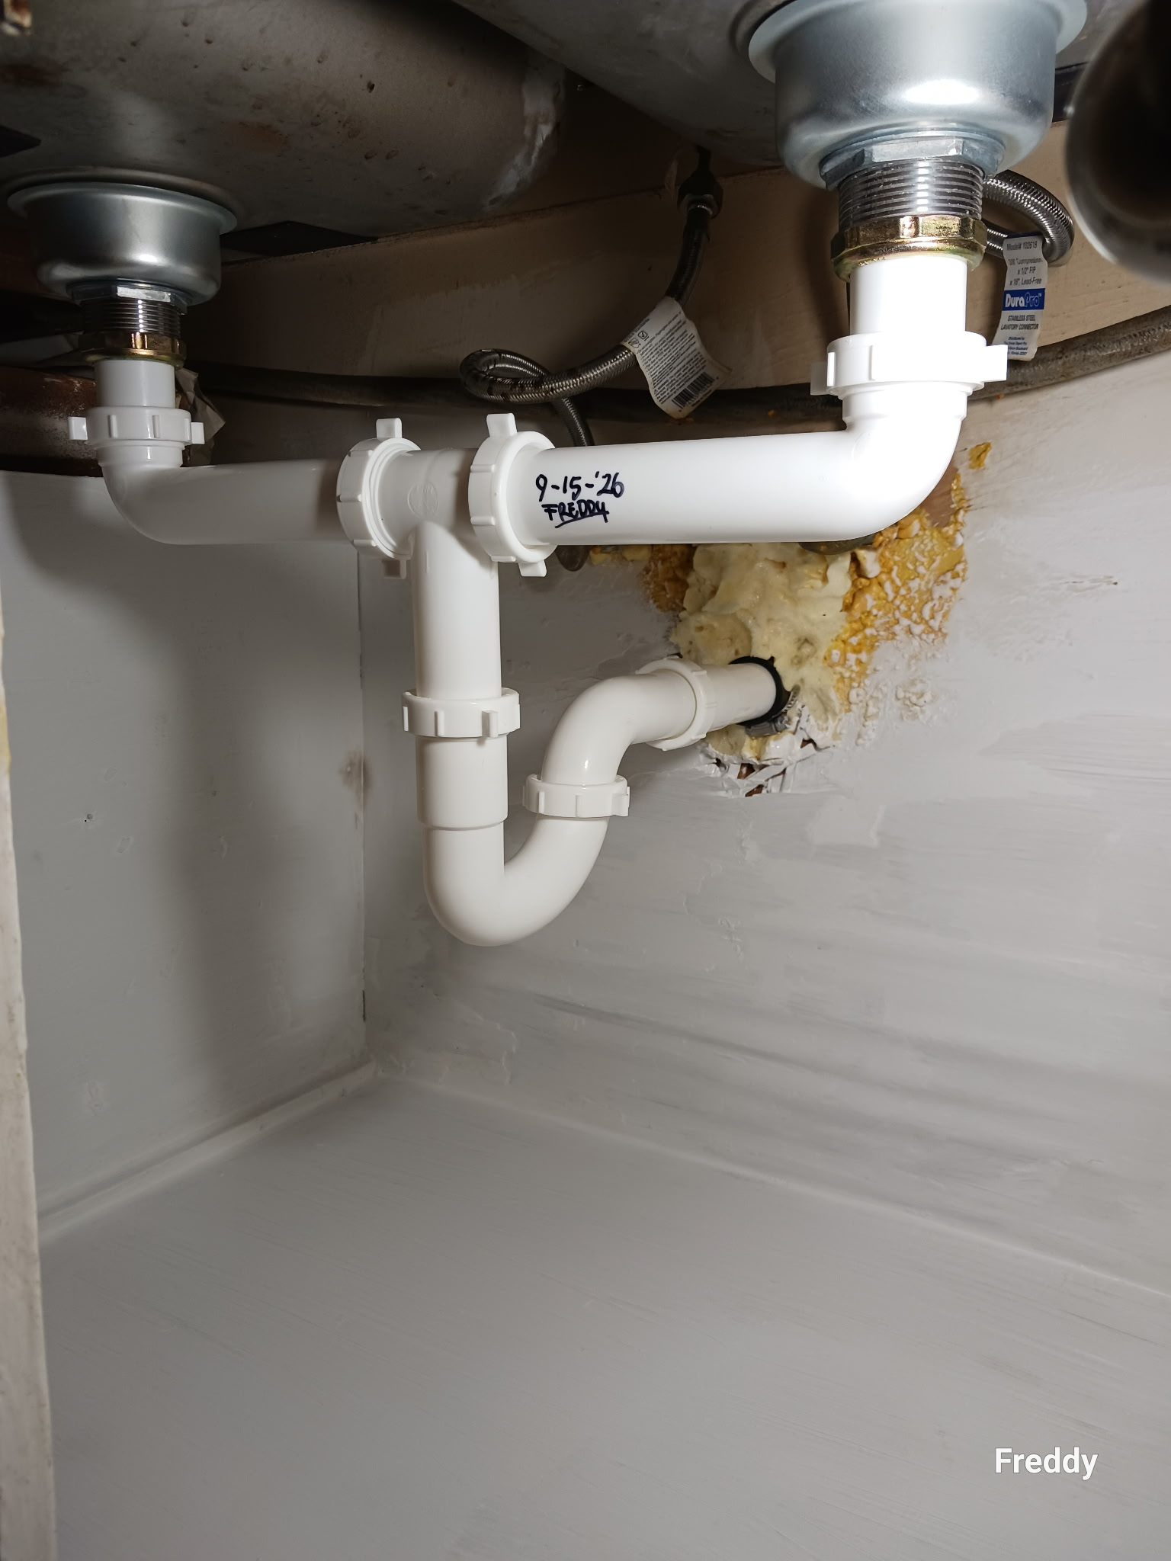
Dear Officer Milam,

I am writing to provide an update regarding Case #1321007, Citation #00025364CC. Our maintenance team has addressed all of the cited items as follows:

1. Water Leak Underneath the Kitchen Sink
Our maintenance team replaced the entire plumbing assembly underneath the kitchen sink, which resolved the plumbing leak.
2. Failure to Maintain Kitchen Cabinets
Our maintenance team replaced all damaged lower shelves, re-supported the base cabinets, replaced the missing cabinet doors, and repainted the interior of the base cabinets.
3. Rodent Issue
We inspected all potential access points, and they had previously been sealed. The range was pulled out, and the area was cleaned. The exterior perimeter was also inspected, and a bait station was found to be in place. No evidence of current rodent activity was observed.
4. Kitchen Ceiling Water Damage/Plumbing Leak
Our maintenance team repaired two leaking bathtub faucet stems, re-caulked the tub surround, and installed two new splash guards. The damaged portion of the kitchen ceiling was subsequently repaired.
5. A/C Not Working
Our maintenance team determined that the circuit breaker for the A/C condenser unit was in the off position. The A/C is currently operating normally. A temperature reading at the pipe indicated 47.2 degrees Fahrenheit, while the interior thermostat showed a temperature of 70 degrees Fahrenheit.

I’ve attached before and after pictures for your review. Please let me know whether the above repairs and corrective actions have addressed all of the concerns identified in the citation and if there are any additional steps we need to take.

Additionally, if all of the cited items have been satisfactorily addressed, please clarify whether I am still required to appear at Magistrate Court on December 8, 2025, or whether my appearance can be waived.

Thank you for your assistance.
Sincerely,

J. R. Gibson
Emory Woods Apartments
2085 Powell Lane
Decatur, GA 30033
jrgibson@emorywoods.com

From: JR Gibson <communications@montagne.mailer.appfolio.us>
Subject: Stairway Tread Replacement & Apartment Occupancy Update
Date: October 7, 2026 at 11:18:25 AM EDT
To: toddster1979@gmail.com

Dear Todd,
We have your apartment scheduled for the replacement of two stairway treads this Friday, October 9, 2026. The contractor is expected to arrive between 8:00 and 9:00 a.m.
Please let me know if you will be home to provide access to the apartment. If you will not be available, please let me know, so that I can make other arrangements to access the apartment.
Additionally, I would appreciate an update regarding the status of the unauthorized occupant in your apartment.
Thank you for your cooperation. I look forward to hearing from you.
Sincerely,
J. R. Gibson
2085 Powell Lane
Decatur, GA 30033
404-634-3777
jrgibson@emorywoods.com

