Performing a Super iCybie (SiC) upgrade
Abstract
A document which contains the steps taken to upgrade two iCybie robotic dogs to make them compatible to interfacing directly with a computer.
Introduction
The iCybie with Revision ‘D’ motherboard, manufacture date 24 May 2001, is a canine-style anima containing code on an internal ROM which manifests its behaviors. This robot also contains an external connection where a 40-pin (flash memory) card can be utilized to expand the internal memory. Although the original robot comes with a dummy card, an aftermarket accessory, the walk-up charger contains a chipped memory card containing *.h and *.bin files loaded by a bootstrap program.
If the robot is prepared by a hardware modification where the internal ROM can be accessed, it is possible to connect it to a computer using a 9-pin serial port.
Preparing the Robot
The robot can be modified with the introduction of the MAX233CPP integrated circuit in line between the modem of the robot and a three-terminal external I/O port. At the external port, a stereo jack is installed to the top right of the battery compartment. A cable can now be connected, built to adapt the stereo jack to three pins—pin 2, 3, and 5—while pins 1, 4, and 6, 7 and 8 are connected together on the 9-pin serial.
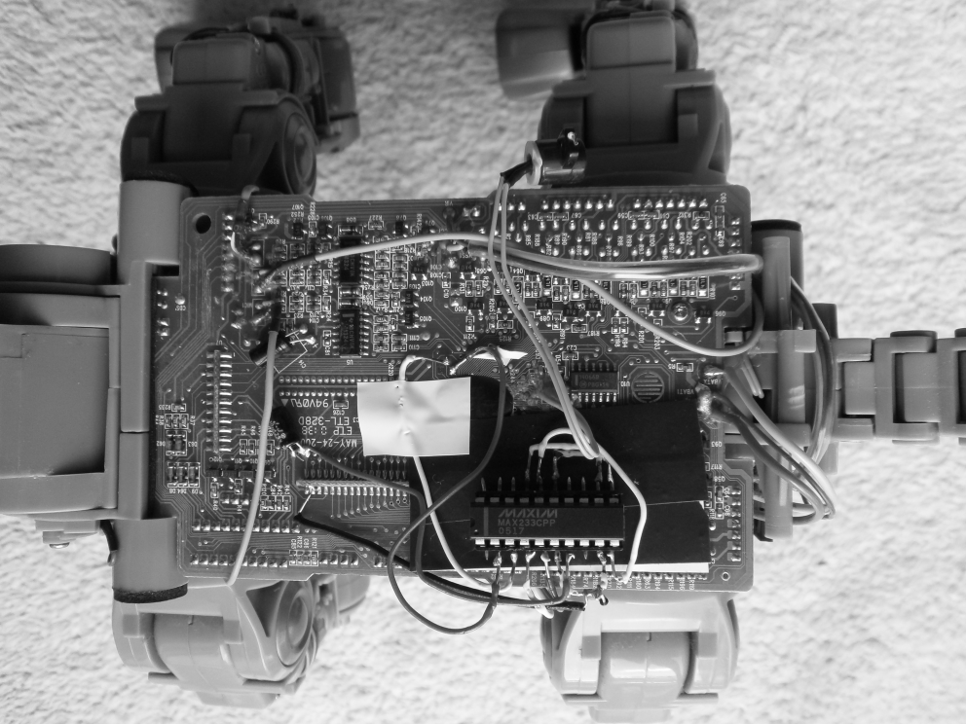
Fig.1. The addition of MAX233 to upgrade to RS-232.
The modification consists of soldering a wire harness to a DIP socket, as well as connecting to the power supply, ground, and TxD-RxD of the serial port. The MAX233 is connected to the robot according to the schematic, shown in Fig.2.
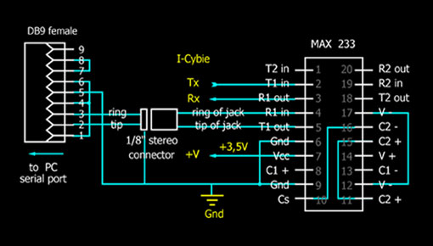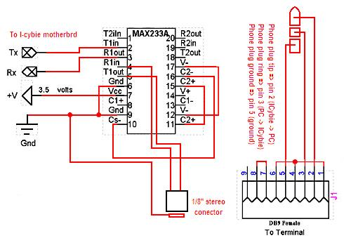
Figure 2. IC in circuit. MAKE YOUR OWN
Words.
Preparing the Memory Card
The memory card contains two 128K x8 CMOS multi-purpose flash, for a total of 2 x 1 Mbit / 256kB addressable memory, numbered SST39VF010. When the card is acquired with the walk-up charger, the card contains *.bin files which load to the iCybie internal memory upon boot.
In order to configure the robot’s internal memory to use the hardware modification, two files—cromnist-h.bin and cromnist-l.bin—need to be uploaded to the memory card. With the memory card installed in the robot, on boot the files are used to add an 8kB program, C-ROM, to the bootstrapper, interrupting the process to include the hardware connection.
To use the Downloader.exe program original supplied, a second program AllowIo.exe which opens the parallel port at 0x378. To run the program Downloader.exe, a *.bat file is required with the following contents:
allowio.exe downloader.exe 0x378
The program then will run, shown in Fig.3.
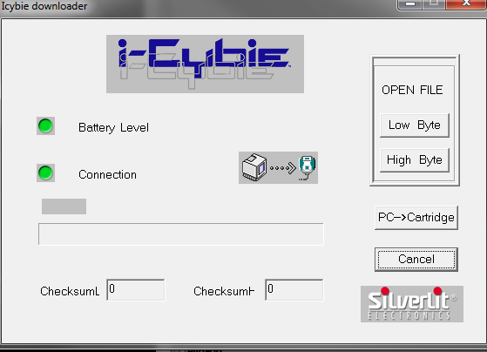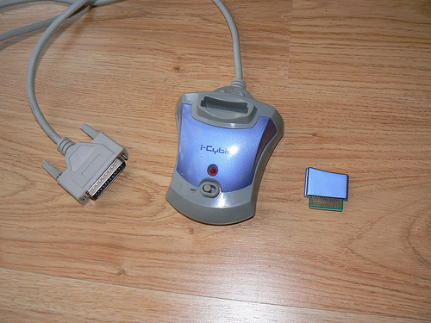
Fig.3. Downloader program showing connection to the hardware unit.
Selection of the two files: cromnist-l.bin by opening the file from the folder containing the downloader program using “Low Byte”, cromnist-h.bin using “High Byte”, then using “PC → Cartridge” will save the files onto the memory card.
Applying the CROM program
Having everything ready, it is now possible to upgrade the robot’s system ROM to include the CROM bootstrap. THIS STEP DOES NOT WORK. How about ICBURN?
Using ICBURN
This returns the message: “FATAL: can't determine file type 'crominst-l.bin'”.
Have contacted the author of the software. I was given the advice:
For “icburn” the usage is:
usage: icburn [flags] base_filename
(version 0.01
Sends image file to cartridge via Downloader
Downloader with cartridge must be attached to parallel port
input files:
base_filename-l.bin = lower half
base_filename-h.bin = upper half
(or) filename.ic3 = all in one file
flags:
-t trust-me mode (don't verify)
So use “icburn crominst” where the two BIN files are in the current folder.
ICBURN is more reliable than the SilverLit downloader, but it depends on your parallel port hardware.
Getting the error:
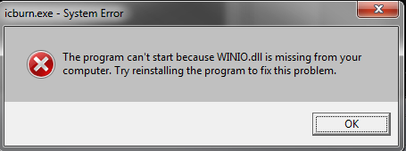
Which I can remedy with a library I acquired from the parallel-port debugger project.
This does not work either, I now get:
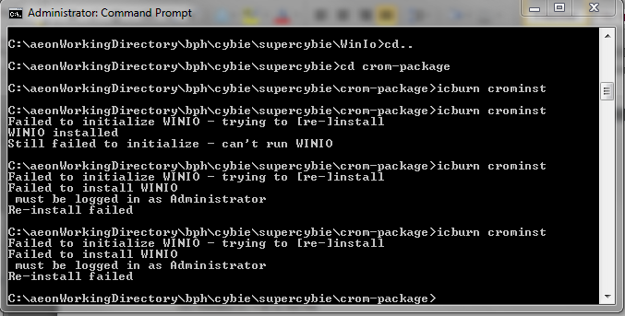
But it is clearly noted the command prompt is in Administrator mode.
Project on hold again.
Am resuming with connecting via Serial Port the CPU of Cybie.

Trying again on the advice of the AiboPet guy: EMAILS TALKING ABOUT STRATEGY
In general the serial interface to a Super-iCybie is more reliable than the
parallel port Downloader.
It lets you read the contents of a cartridge (using "SICGRAB.EXE") as well
as program it (using "SICBURN.EXE")
It is also more universal since it doesn't require a true parallel port on
the computer (which are getting hard to find)
USB->Parallel port adapters do not work well in this scenario.
--
However if you have your heart set on the parallel port approach, the source
code to "ICBURN" is included.
The source to SICBURN is in the SDK http://www.aibohack.com/icybie/icsdk.htm
("ICBURN" for parallel port, "SICBURN" for serial port).
ICBURN is derived from source code SilverLit gave me a long time ago.
It uses the "WinIO" library to get raw access to the parallel port bits.
The one included here is pretty old. Check the Web for something more
uptodate.
NOTE: This is from 10 years ago. Direct bit-banging on the parallel port was
old even back then.
From Yahoo is masquerade:
For “icburn” the usage is:
usage: icburn [flags] base_filename
(version 0.01
Sends image file to cartridge via Downloader
Downloader with cartridge must be attached to parallel port
input files:
base_filename-l.bin = lower half
base_filename-h.bin = upper half
(or) filename.ic3 = all in one file
flags:
-t trust-me mode (don't verify)

So use “icburn crominst” where the two BIN files are in the current folder.
ICBURN is more reliable than the SilverLit downloader, but it depends on your parallel port hardware.
Do you have an official downloader (with parallel port) from SilverLit?
If yes, then you need to install the CROMINST program on the working cartridge. This will replace the walkup charger personality for a short period of time.
You can do this with the official SilverLit downloader software or my “icburn” program. You need a computer with a real parallel port (not one with a USB adapter)
You use the CROMINST program *ONCE* to patch the system ROM. Then you put the Walkup personality back on the cartridge (or even better use the ZCybie personality)

