test

John Doe

<2023-04-18 Tue>

Table of Contents
1. Simple Slide
1.1. A slide using Emacs
1.2. Additional bullet point 1
1.3. Additional bullet point 2
1.4. Additional bullet point 3
1.5. Additional bullet point 4
2. A More Complex Slide
2.1. 1st point
2.1.1. Sub level
2.1.2. Another level
2.2. 2nd point
2.2.1. Sub level
2.2.2. Another level
2.3. 3nd point
2.3.1. org mode means not having to remember\LaTeX commands.
2.3.2. Emacs is superb!
3. Slide with Image
3.1. The beauty of nature
3.2. A walk in the jungle
4. Slide with Code Block

Simple Slide

A slide using Emacs

Additional bullet point 1

Additional bullet point 2

Additional bullet point 3

Additional bullet point 4

A More Complex Slide

1st point

Sub level

Another level

2nd point

Sub level

Another level

3nd point

org mode means not having to remember\LaTeX commands.

Emacs is superb!

Slide with Image

The beauty of nature

A walk in the jungle
[[ 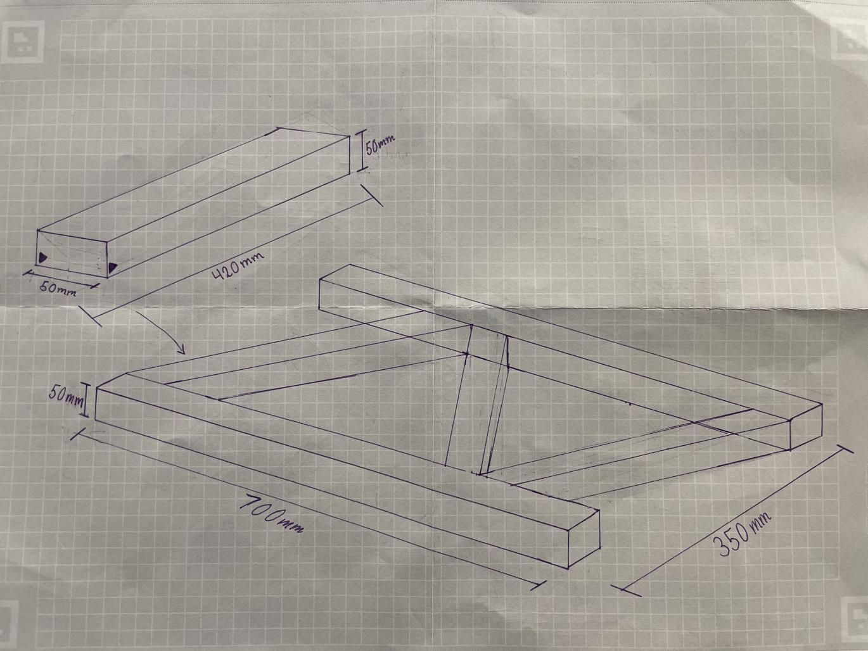

Slide with Code Block
print("Hello from alpha2phi")

