Trendupp Africa

Trendupp App Internal Testing
August 7, 2026 / 10:30 AM / DottsMediaHouse Office

ATTENDEES
Trendupp Africa Team: Bright Esagbodje, Kingsley Abiodun, Judith Onwuka (Gechy), Faith Akintola, Olusegun Oyetunji
Prod Cycle Limited Team: Ajiri Glory, Victor Ikeh, Promise Tembe

AGENDA

Internal Trendupp Website/App Testing

NOTES
The meeting was held with both teams to internally review the Trendupp App and Website, spot errors and streamline processes.

Introduction
Kicking off the meeting, Bright Esagbodje explained the purpose of the team meeting and the essence of the Trendupp platform. He further gave a rundown of how the platform works, from advertisers publishing their campaign brief and budget, reviewing creators, and selecting the right fit, to creators responding to advertisers' briefs and pitching.
Mr Olusegun further explained that the meeting is an internal review of the Trendupp App from a user's standpoint, and the team should review flexibly from different angles.

Web Testing
The team first reviewed the latest Web version of Trendupp using Chrome, Safari and Microsoft Edge browsers.

Creators Interface
- Sign Up and Log In:
Everyone signed up to access and drop feedback on the Creators Interface.
- At the sign-up phase, manual and social app sign-up seemed to work seamlessly. Kingsley Abiodun recommended that it would have been better to have two apps focused on creators and Advertisers, in case registered creators want to access the app as Advertisers, and he used Uber for passengers and Uber for drivers as a reference.
The Prod Cycle team clarified that registered Creators will need to use a different email address to sign up as an Advertiser, and vice versa.
- Also, while registered, the team spotted the need to open access to adding links to other social media profiles, aside from YouTube and Facebook.
- My Profile - Portfolio:
- The Dotts Team raised concerns about the need to update the portfolio description by adding an option to include “VIDEO.” Also, the need to expand portfolio images up to 5, instead of just 2.
- Video and Images should open in the app and not take Creators outside the Trendupp platform.
- The Prod Cycle explained reasons for not adding video and limiting image size: High images and videos will slow down the website/app.

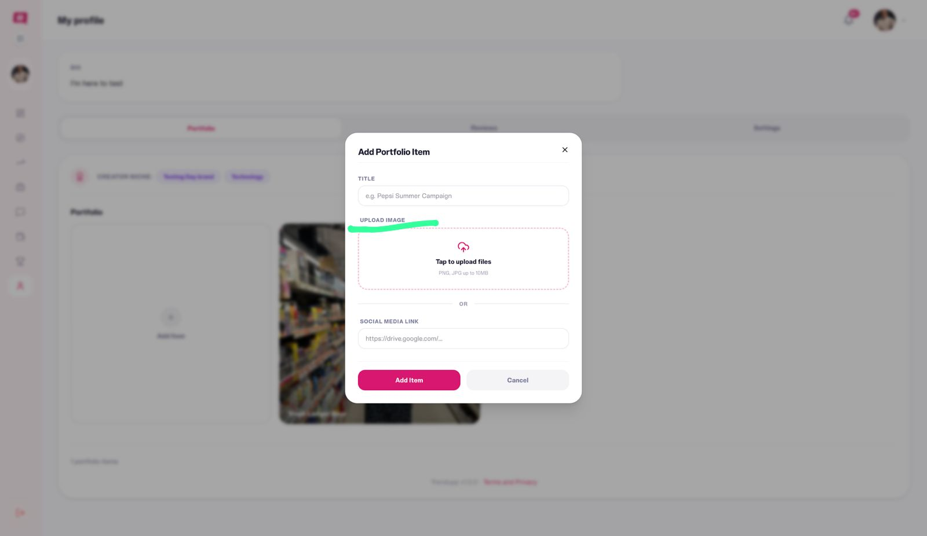
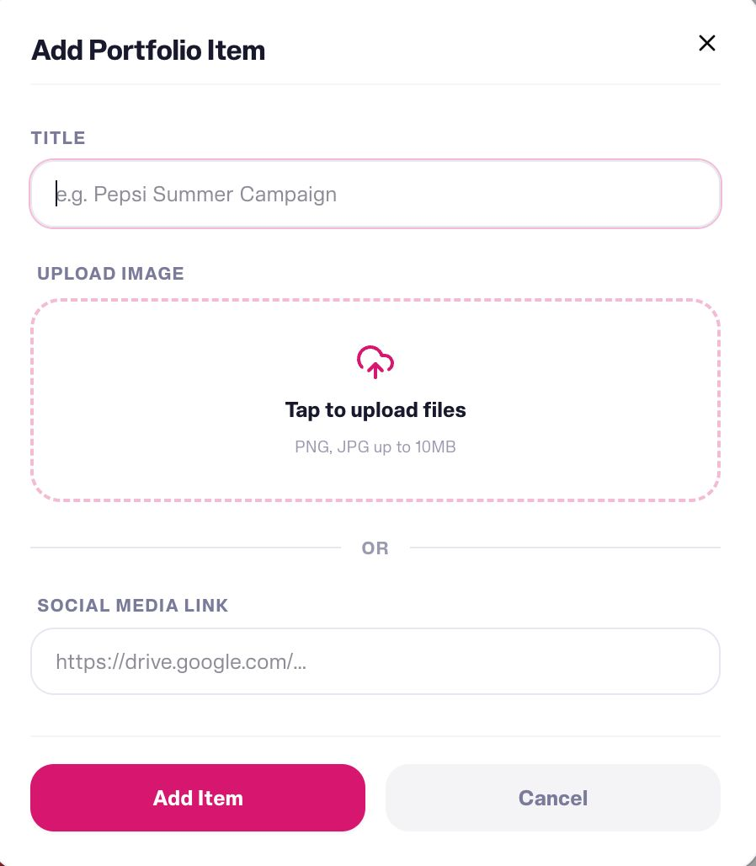
- The need to add an edit button to already uploaded portfolio.
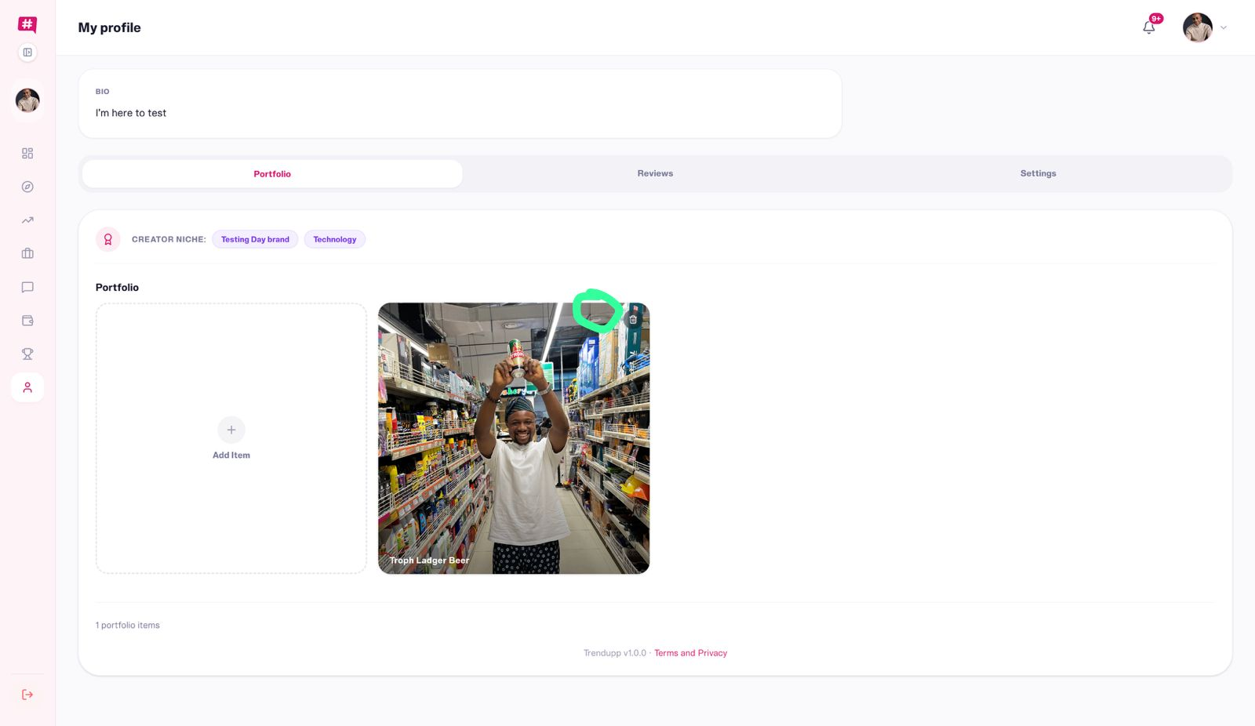
- The Trendupp Team also stated that since Creators would input their social media profile link upon registration, Real-time data and bio/profile should be shown at first glance to help Advertisers make an easy selection.
Mr Olusegun responded to the feedback, explaining that the bio/profile and portfolio can be generic, but creators will need to add specific links to visuals relating to the Advertiser’s campaign brief. He further mentioned that the Prod Cycle Tech team should add restrictions on the type of links to be added on the portfolio or campaign for security purposes.
- A consensus was reached to remove “UPLOAD IMAGE,” remove “OR,” then make links embedded, so the thumbnail appears automatically as well. Also, for the portfolio link, ⁠change the URL from “https://drive.google.com” to “https://” to eliminate limitations for Creators that don’t have Drive links.
- The Trendupp team re-emphasised ensuring in-app watch visuals and the maximum image upload size was agreed to be reduced to 5MB, instead of the initial 10MB.
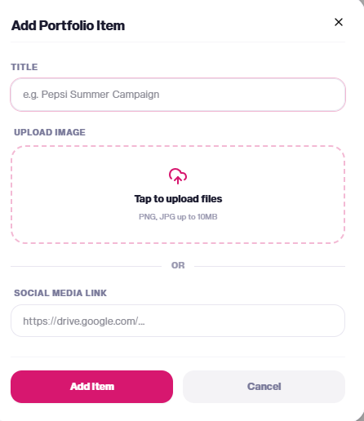
- For easy Navigation, Kingsley Abiodun suggested that the “Settings Tab”, currently in the “MY PROFILE” page, should be moved to “Main Menu.”
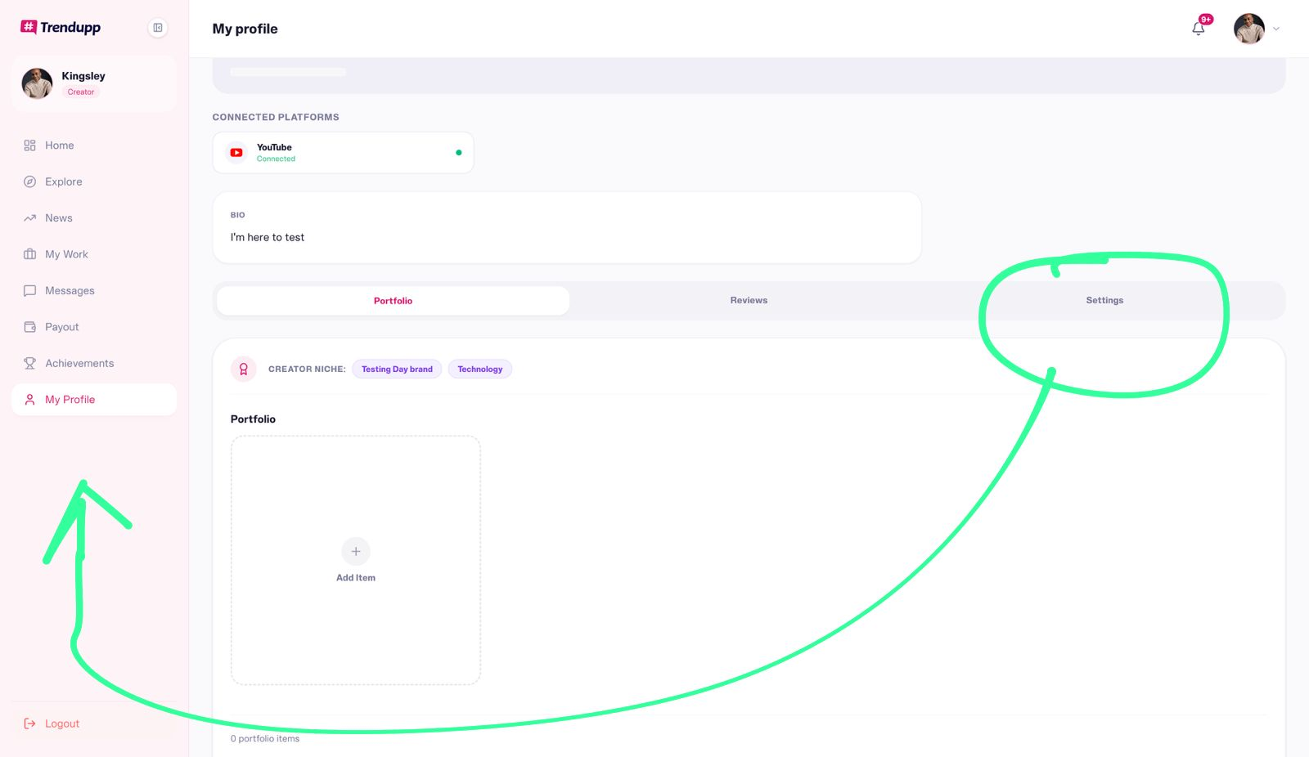
- Campaign:
- When in a specific Advertiser Campaign Brief, the “Next” button should replace the current “Apply Now” button to ensure the user reads through the Overview, Requirements and Timeline before finally applying.

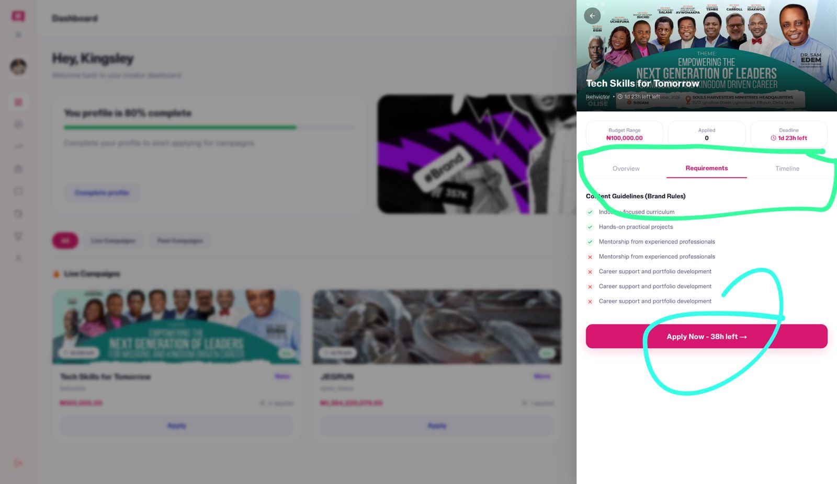
- In the Application form, “Facebook” should be added to the Primary Platform section.
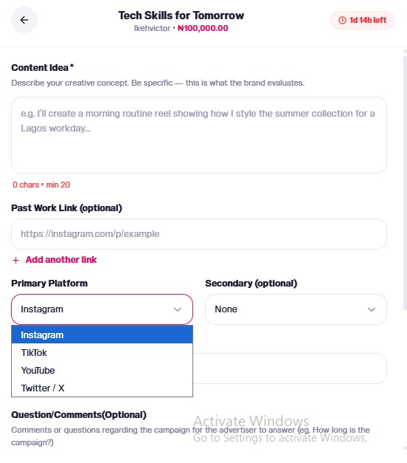
- Suggestion to add an option/dropdown for Creators to select an already-uploaded campaign/porfolio asides social media links. This means rather than having to scroll through the Instagram page to find a 4-month-related campaign link, such an option will create convenience.

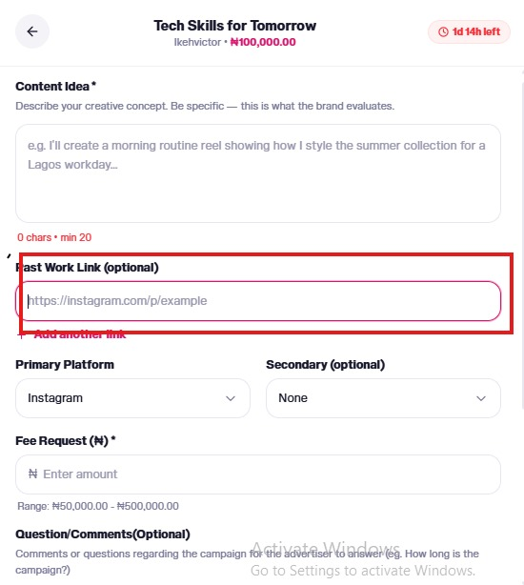
- News Content
- Written and Video Content, including News, How-to, Educational, and Navigational guides, will be added to this section. In addition, weekly newsletters will be sent out to our database of Creators.
- Mr Olusegun expressed the need to create a Content Marketing Strategy.
- My Work
- No issues were recorded from this page.
- Messages/Dispute
The Trendupp team stated the need to add a separate Chat Section, different from the dedicated Dispute Chat section. This is because certain clarification and alignment conversations that could help achieve successful campaign outcomes need to be discussed ahead.
The Prod Cycle team replied that, based on the alignment, the need to omit the chat was to prevent any communication between the Advertisers and Creators, unless there is a dispute or revision request, which will be monitored by an Admin.
In addition, the Trendupp Team expressed the need to make the approvals/rejections of disputes automated to prevent any delays with the manual process. Both teams resulted in thinking through the Dispute chat process.
- Payout
- Proof of Payment: A copy/content should be reviewed. Payment can’t be held for 3 months after posting. Instead, payment should be released from escrow after the Advertiser has confirmed a post’s deployment.
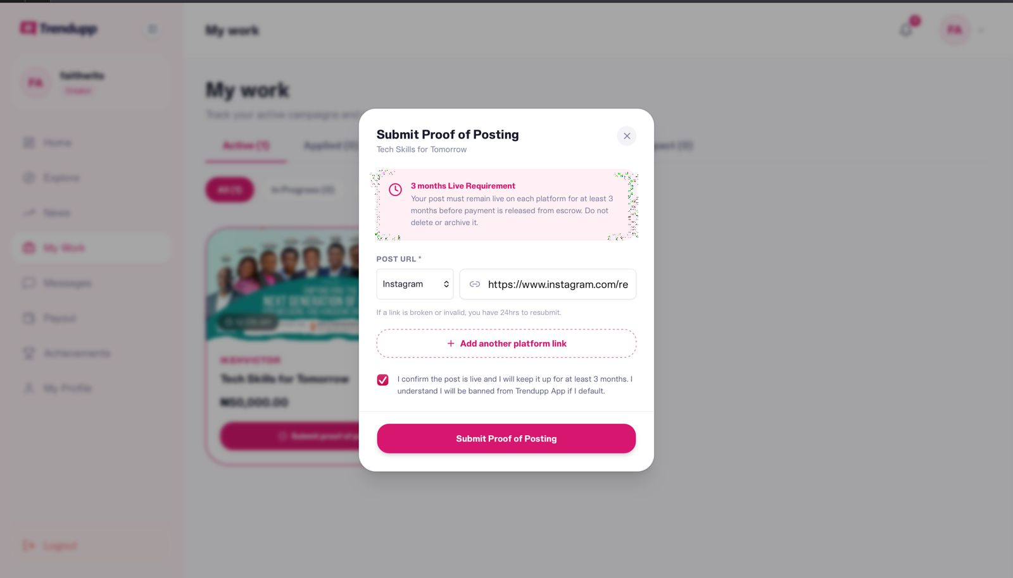

Advertisers Interface
- Sign Up and Log In:
Everyone signed up to access and drop feedback on the Advertisers Interface. At the sign-up phase, manual and social app sign-up seemed to work seamlessly across different browsers.
- A pop-up message signalling an issue with a “Missing OR Authentication Header.
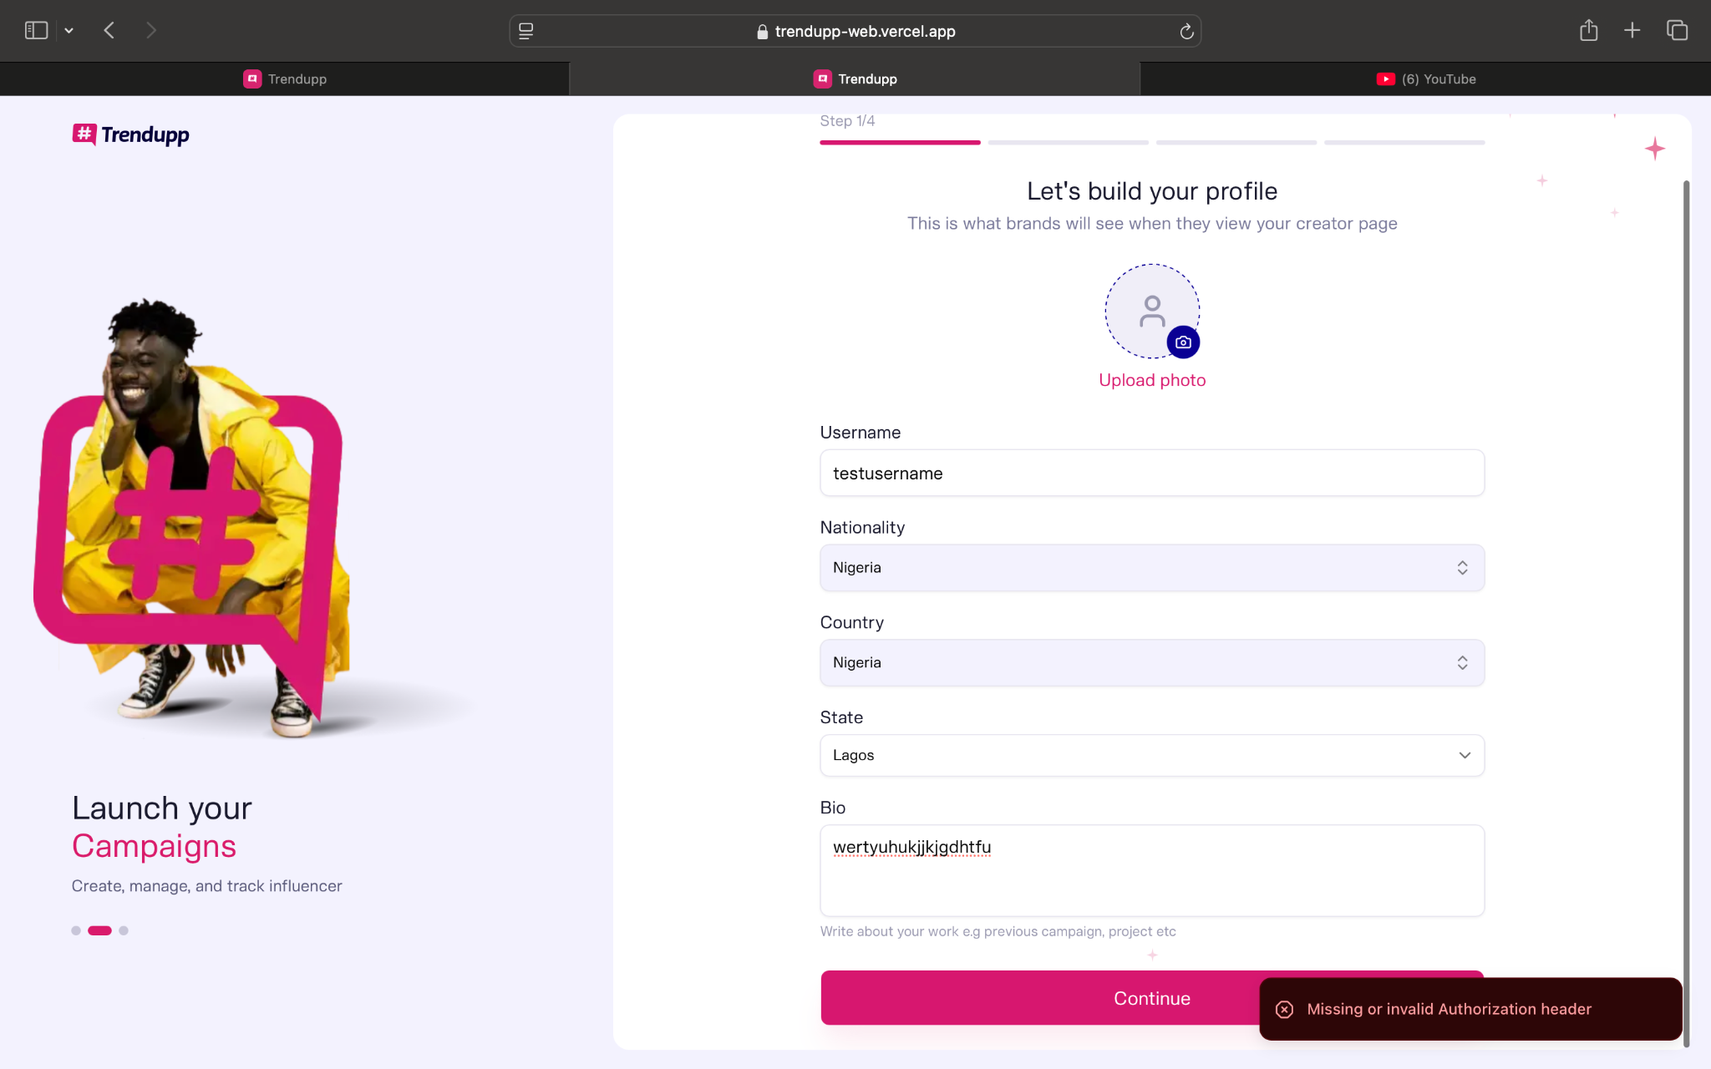
- A pop-up message after registration as an Advertiser showed “You are now a Nano Creator.”
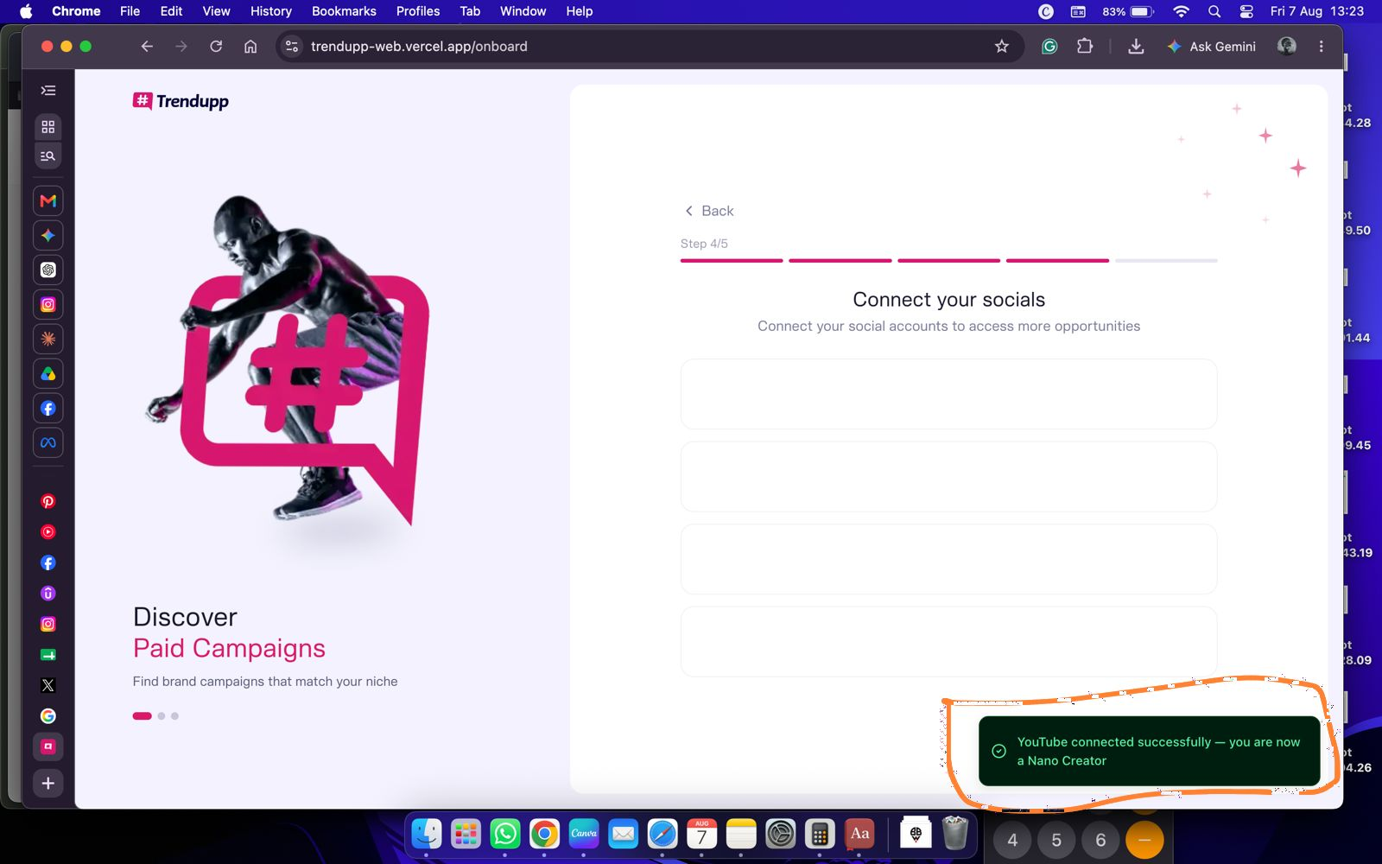
- Bright experienced a password error message after using a matching password to sign up to the Advertiser’s dashboard.
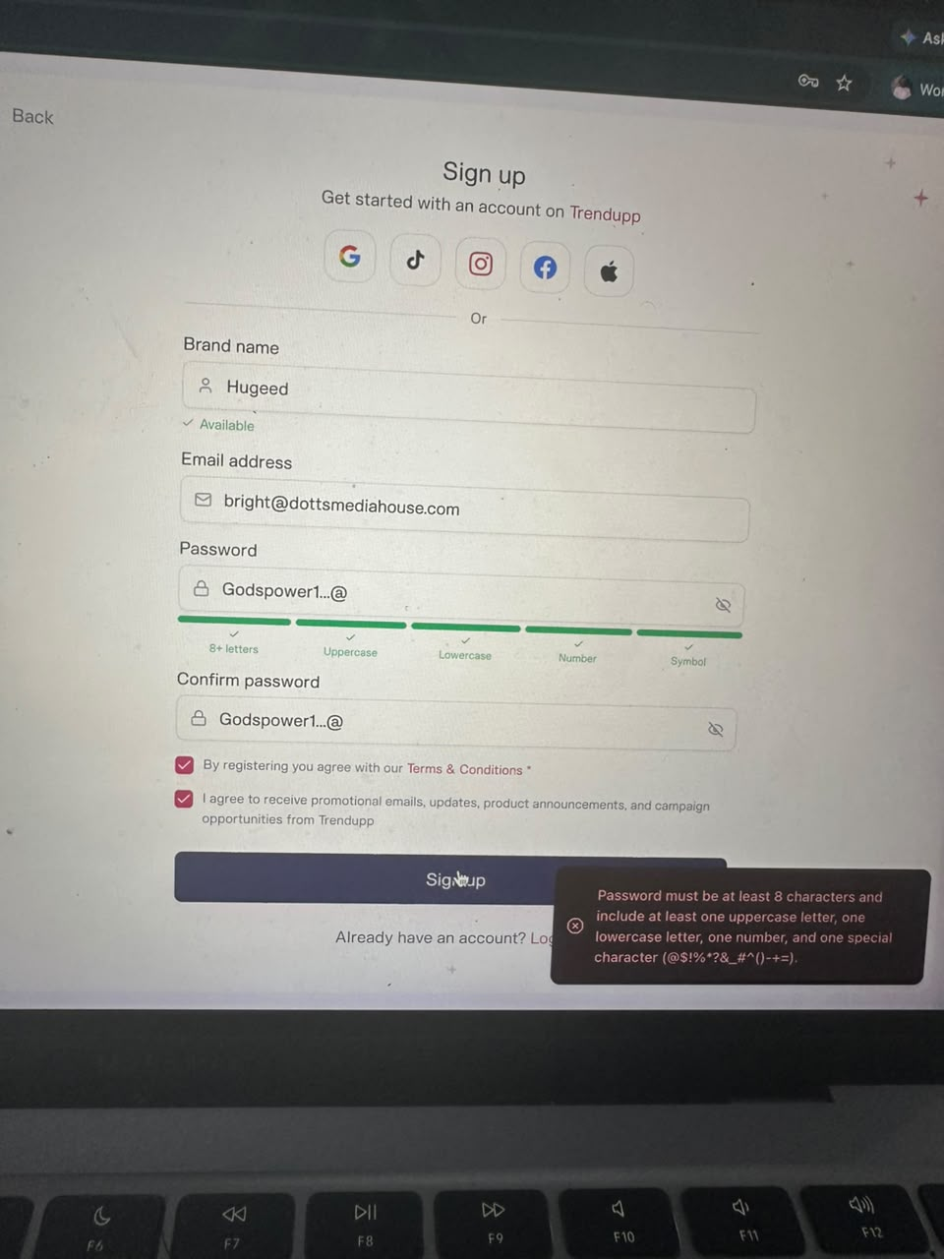

- Homepage:
- Top Performing Creators should not be moved manually. Also, after opening “Sell all,” we should see a full page of creators. This is currently not opening.
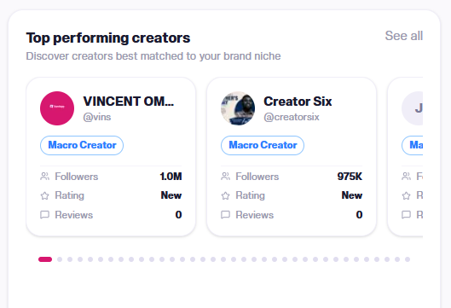
- Opening the “See all” News page leads to a 404 Error page.
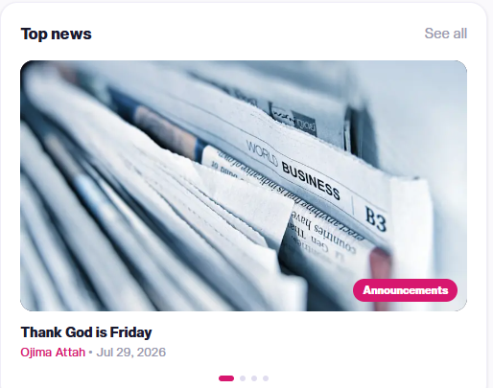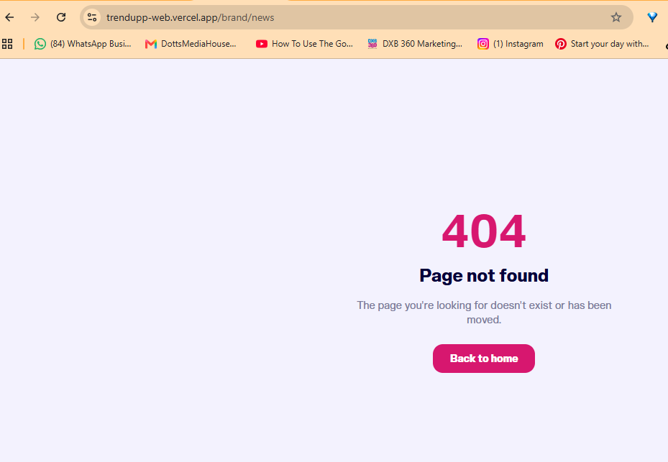

- Campaign:
- Add Crop feature for Advertiser’s Banner.
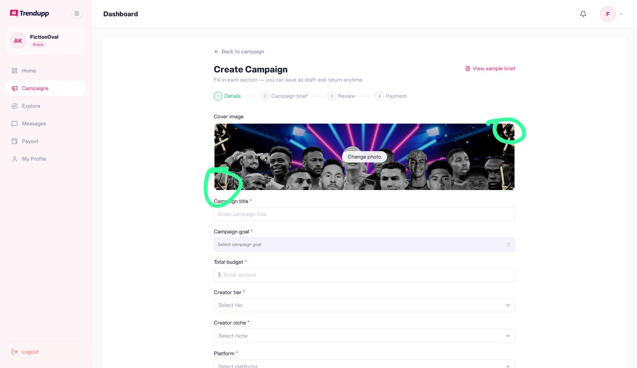
- Link to Campaign section video feedback: https://drive.google.com/file/d/1hIsC_8GI7dOIWNVnbHtMCRVoVuAL3yD5/view?usp=sharing
- Currency should be NAIRA based on the country selected during registration (Nigeria).
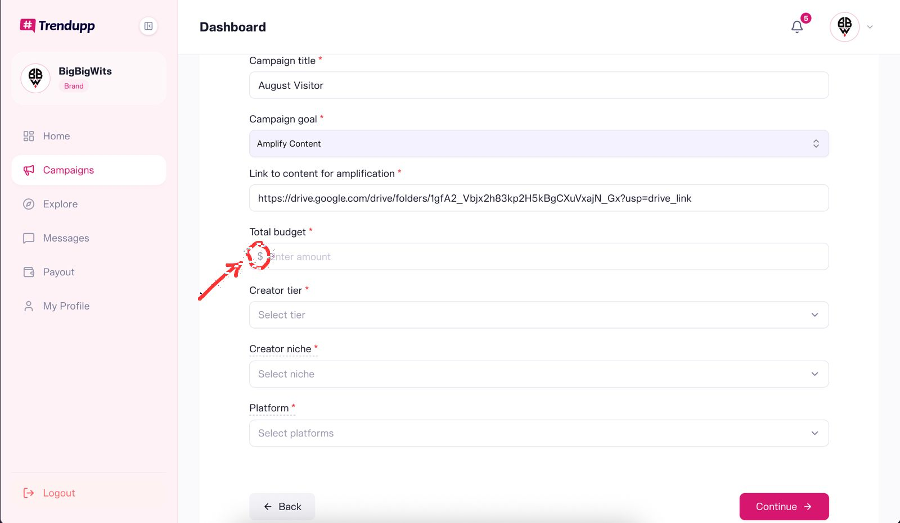
- APPLICATION REVIEW INTERFACE - The past work link should be embedded so it shows as a pop up instead of the advertiser clicking and it opening on another tab.
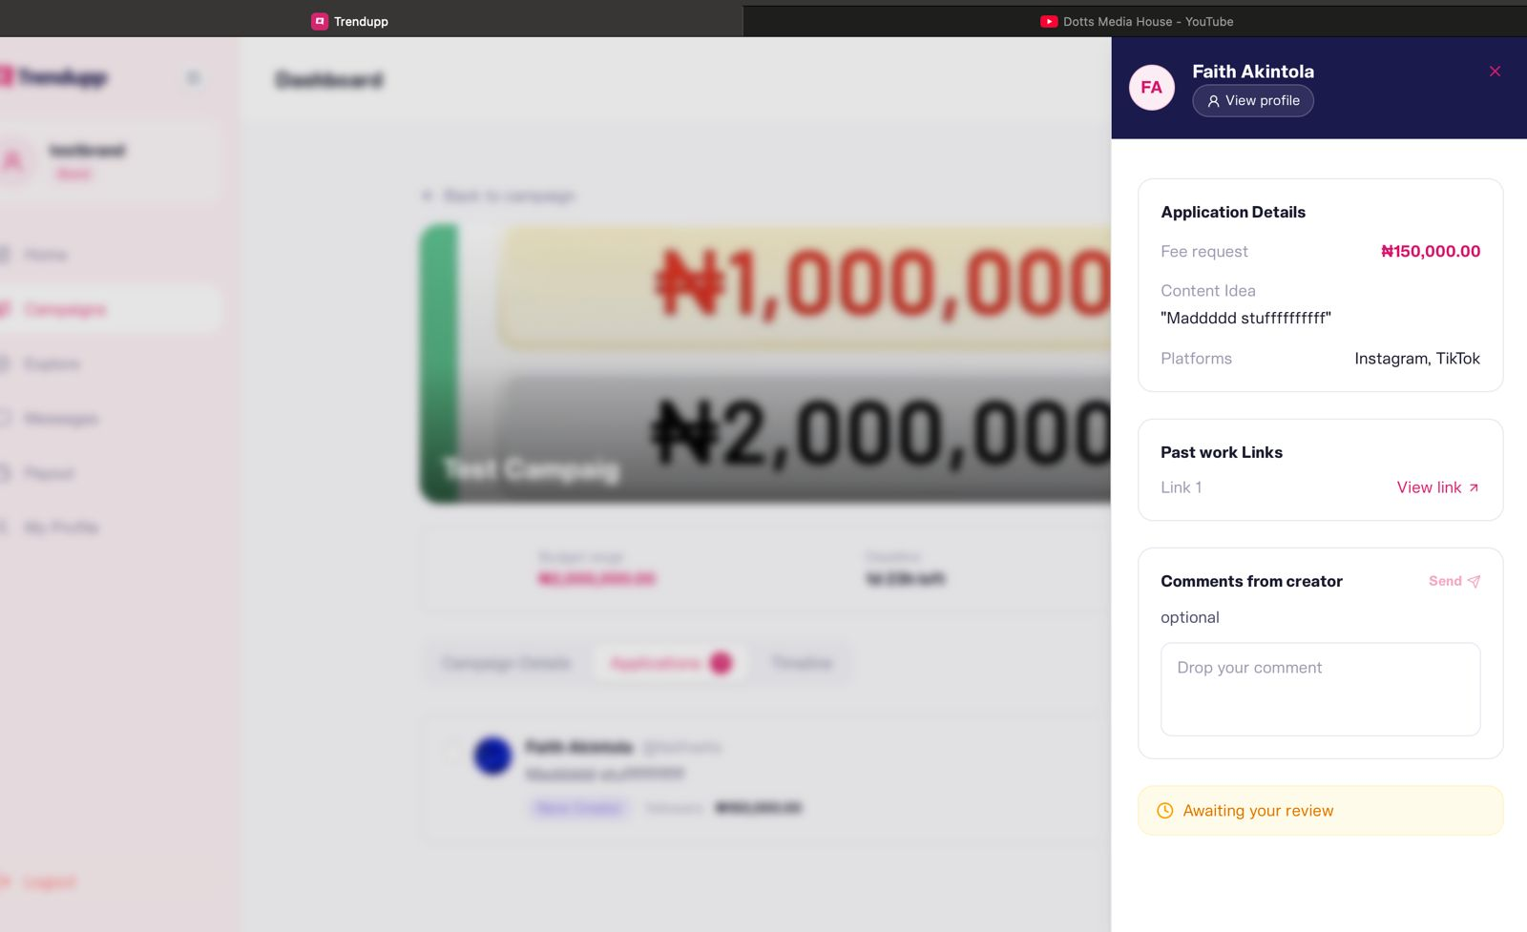

Mobile Testing
The team also reviewed the latest Mobile version of the Trendupp App using Android and iPhone.

Creators Interface
- Sign Up and Log In:
- Android users signed up successfully using manual and Google options. However, glitches were experienced when signing up/logging in through social apps. While logging in through Facebook granted access to the dashboard, it was not a straightforward process.
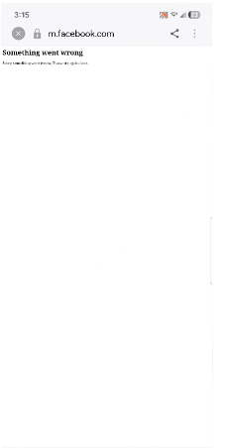
- Link to Facebook sign-in video feedback: https://drive.google.com/file/d/1fg3PUQjaoAY9UciqbXop3upjY9gWL4Tt/view?usp=sharing
- Logging in through Instagram and TikTok was not successful.
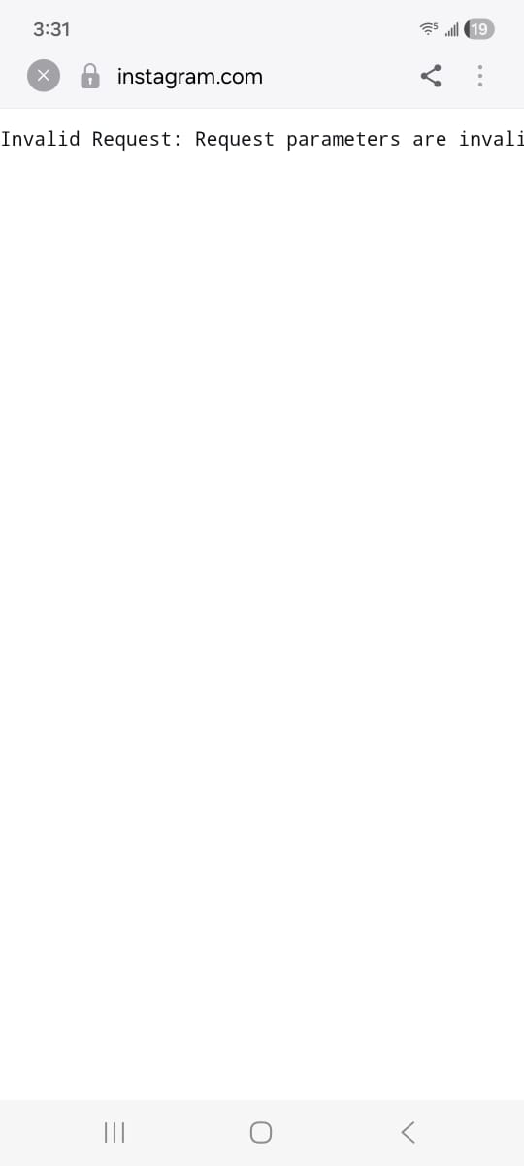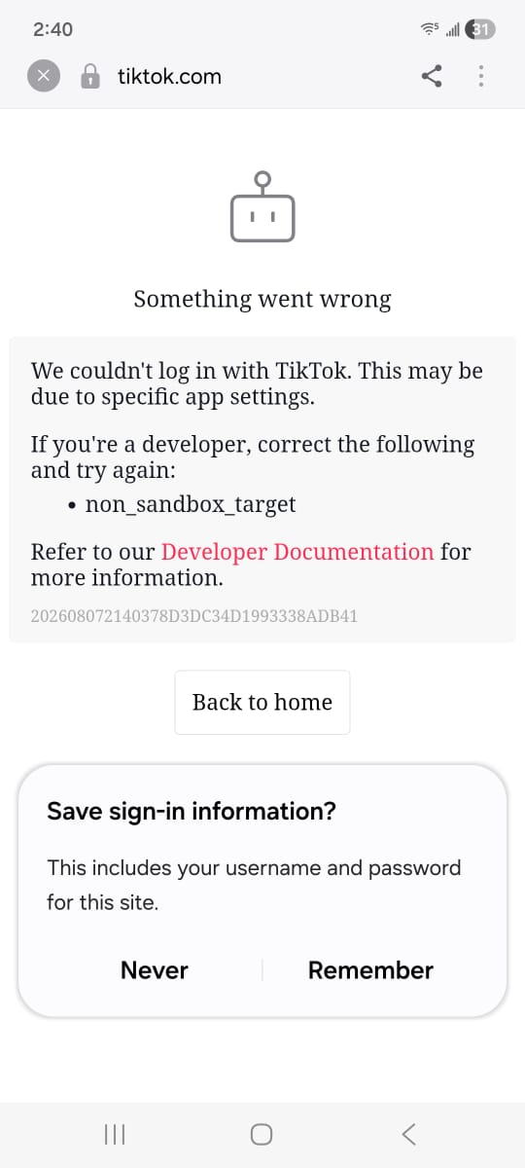

- iPhone users experienced Error message upon sign-up and so could not sign up.
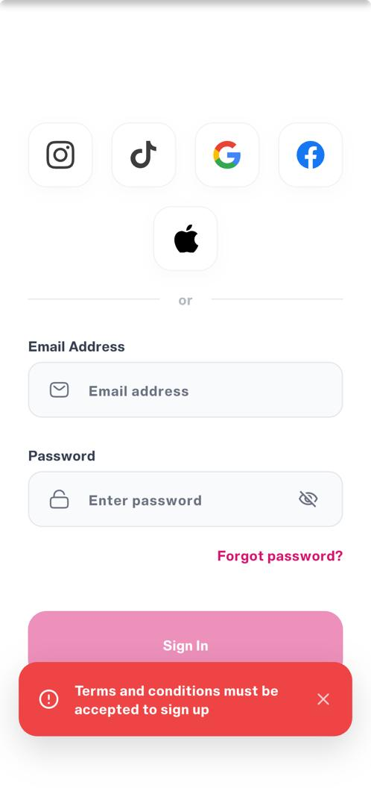

- Logo Appearance
- The logo looks distorted, and the images of focus on this page are blurry
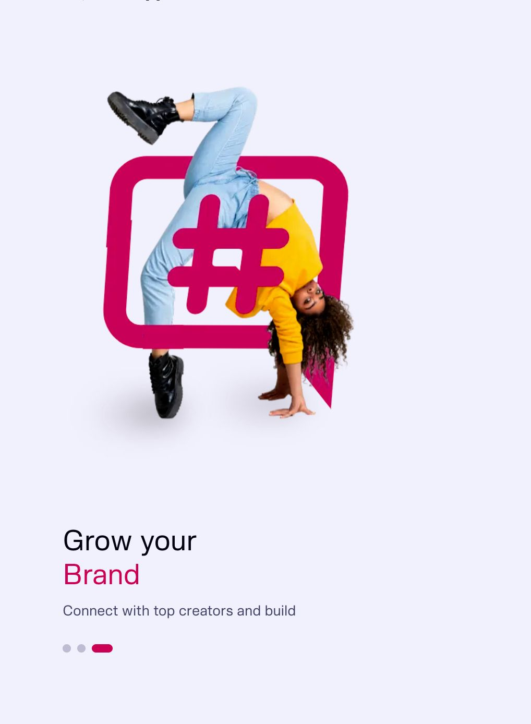

- Profile (Android)
- The logic on the web app seems to be different from the one on the mobile app. Android phone users were unable to save the change made to “Profile” because the bio has to be a minimum of 160 characters. This is not the same on the web app.
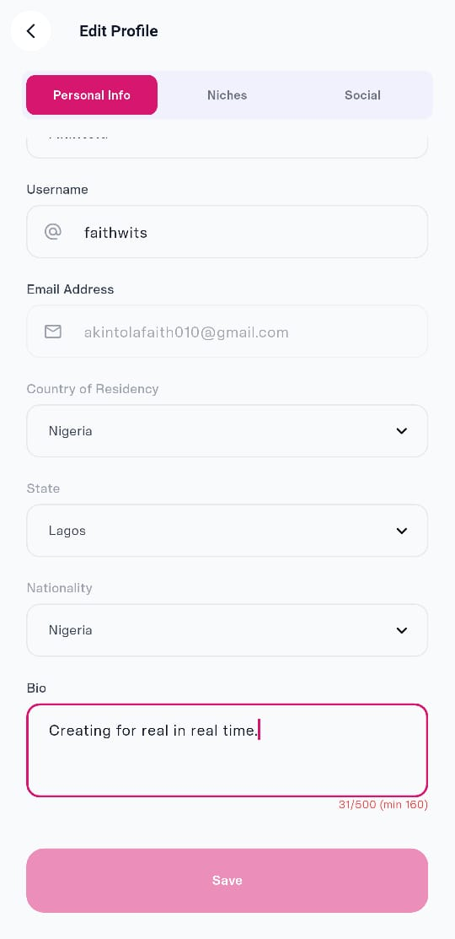

- Like the web, there should be an option to access the general portfolio, if need be. Instead of adding only links to past video/image. Also use “portfolio link” instead of “Social media link.”
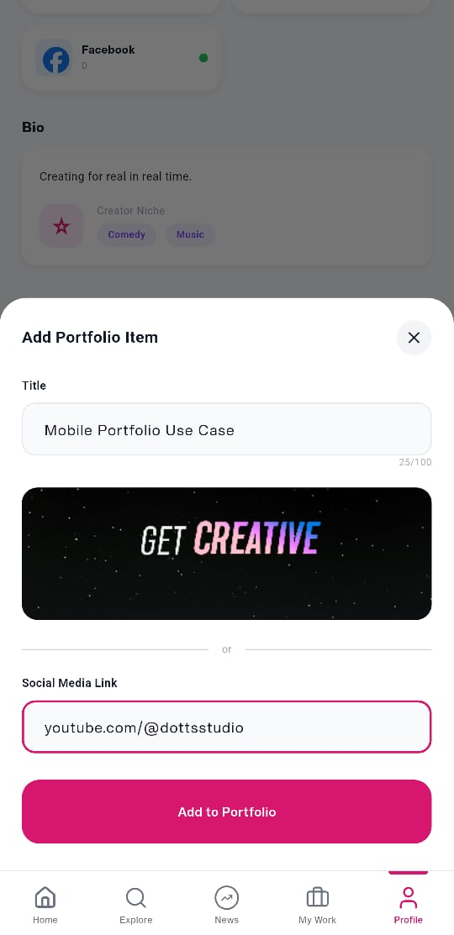

- Portfolio items added are clickable on mobile app, but not on web app
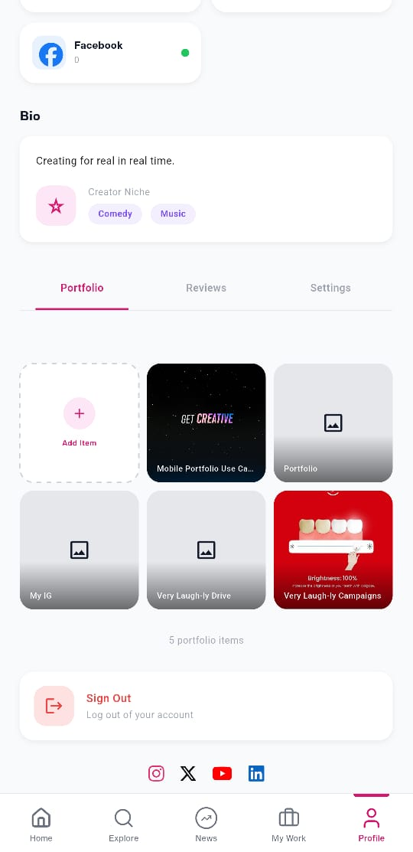

- Campaign (Android)
- The “All” tab under Campaigns is showing only Live Campaigns.
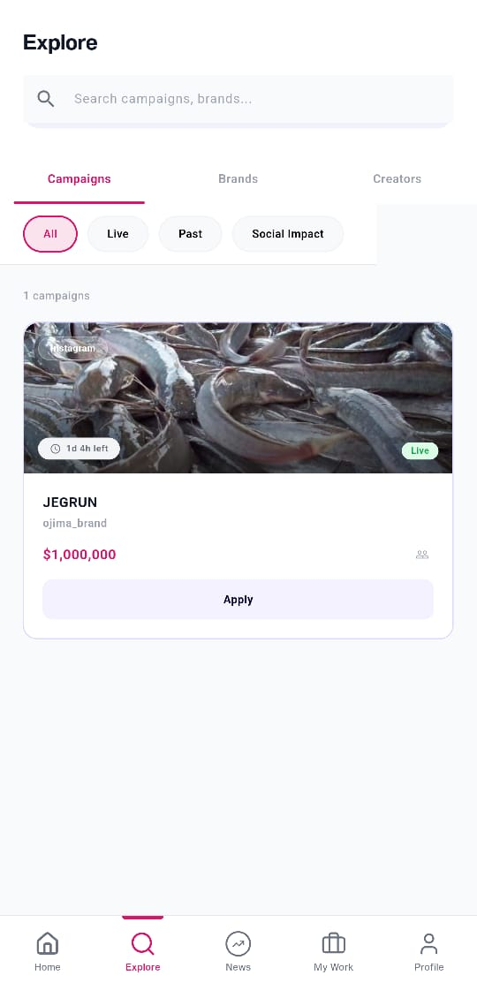

- User is unable to submit content link for a Pending Application
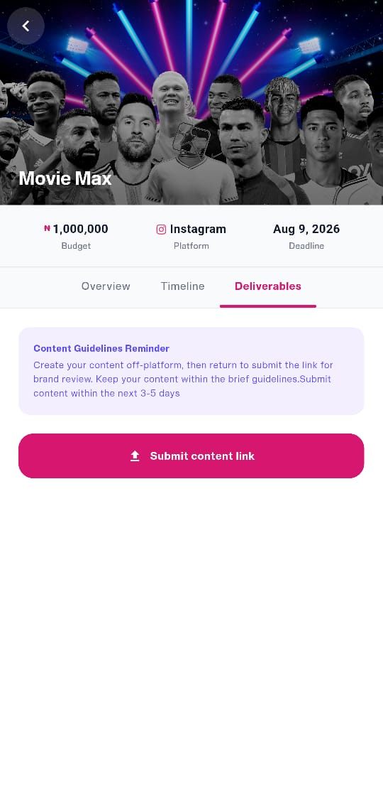
- Accessibility Improvements - Request to add the Chat Button to the Menus at the bottom of the Homepage. This placement ensures users can quickly access all active chats at any time.
Link to video feedback: https://drive.google.com/file/d/1-WAiipehUZFuRMDC9lvk1gbSlSVAEm1g/view?usp=sharing

Advertisers Interface
- Sign Up and Log In:
- Android users sign up successfully using manual and Google options. However, glitches were experienced when signing up/logging in through social apps.
- iPhone users also experienced an error message upon sign-up and so could not sign up.
- Profile (Android)
- The logic on the web app seems to be different from the one on the mobile app. The mobile version should carry the same details and flow as that of the web version.
- Campaign:
- The currencies of the Campaigns available should be in the Advertiser's native currency. Currently, it is showing all NAIRA on the web and all DOLLARS on the mobile app.
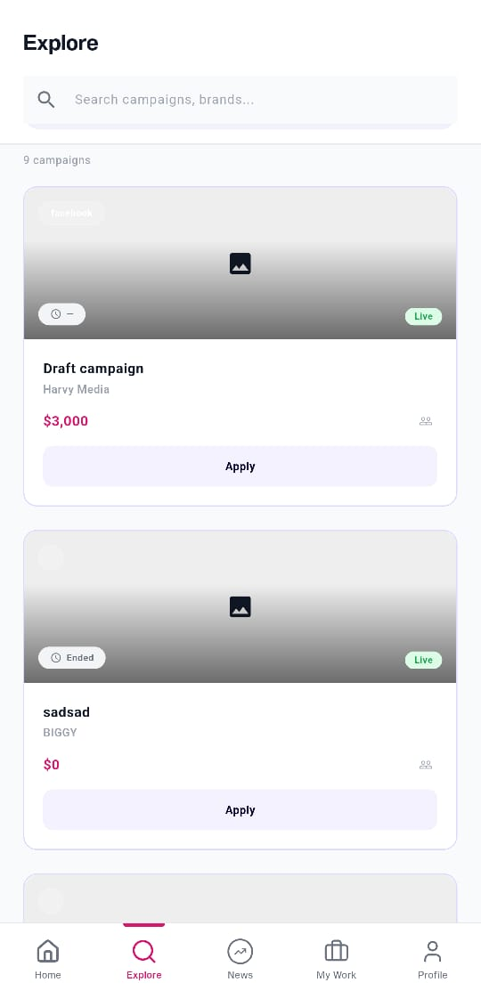

Admin Dashboard Testing

Website Version
- Super-Admin Role
- Owner role should be Owner only, not Owner/Administrator because Owner obviously has admin access
- Campaigns
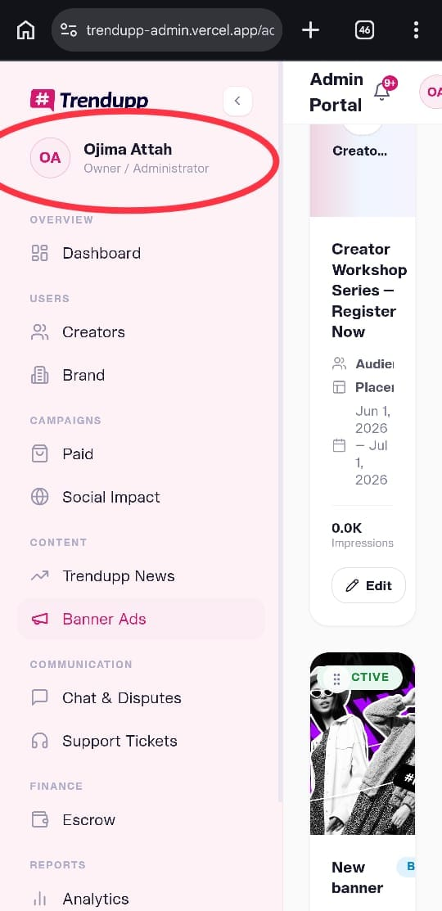
- Error message when Admins extend deadline.
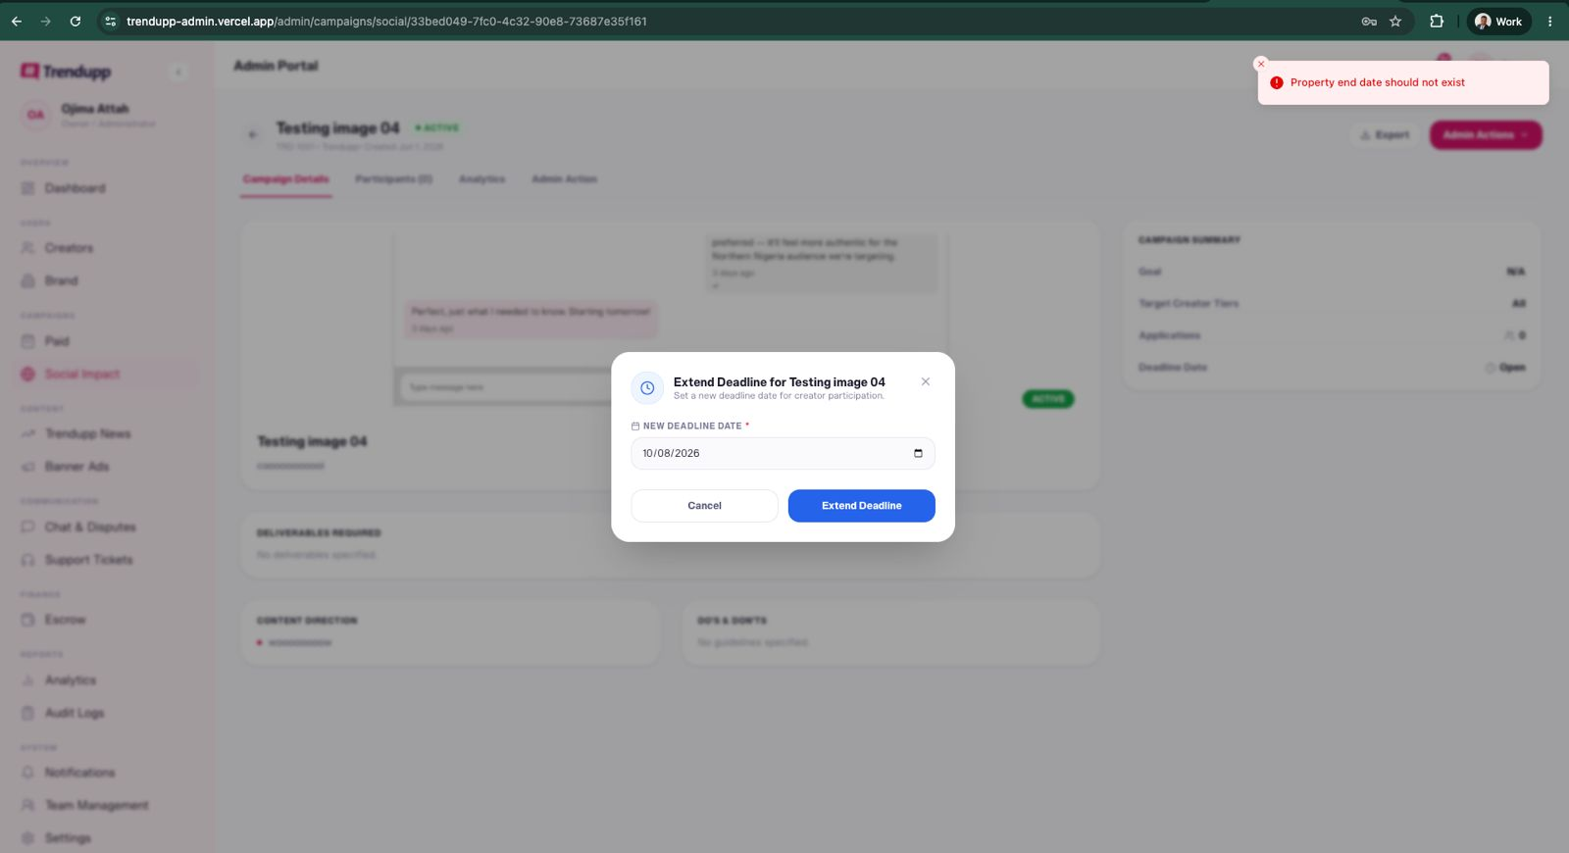
- Error message and inability to pause Campaigns.
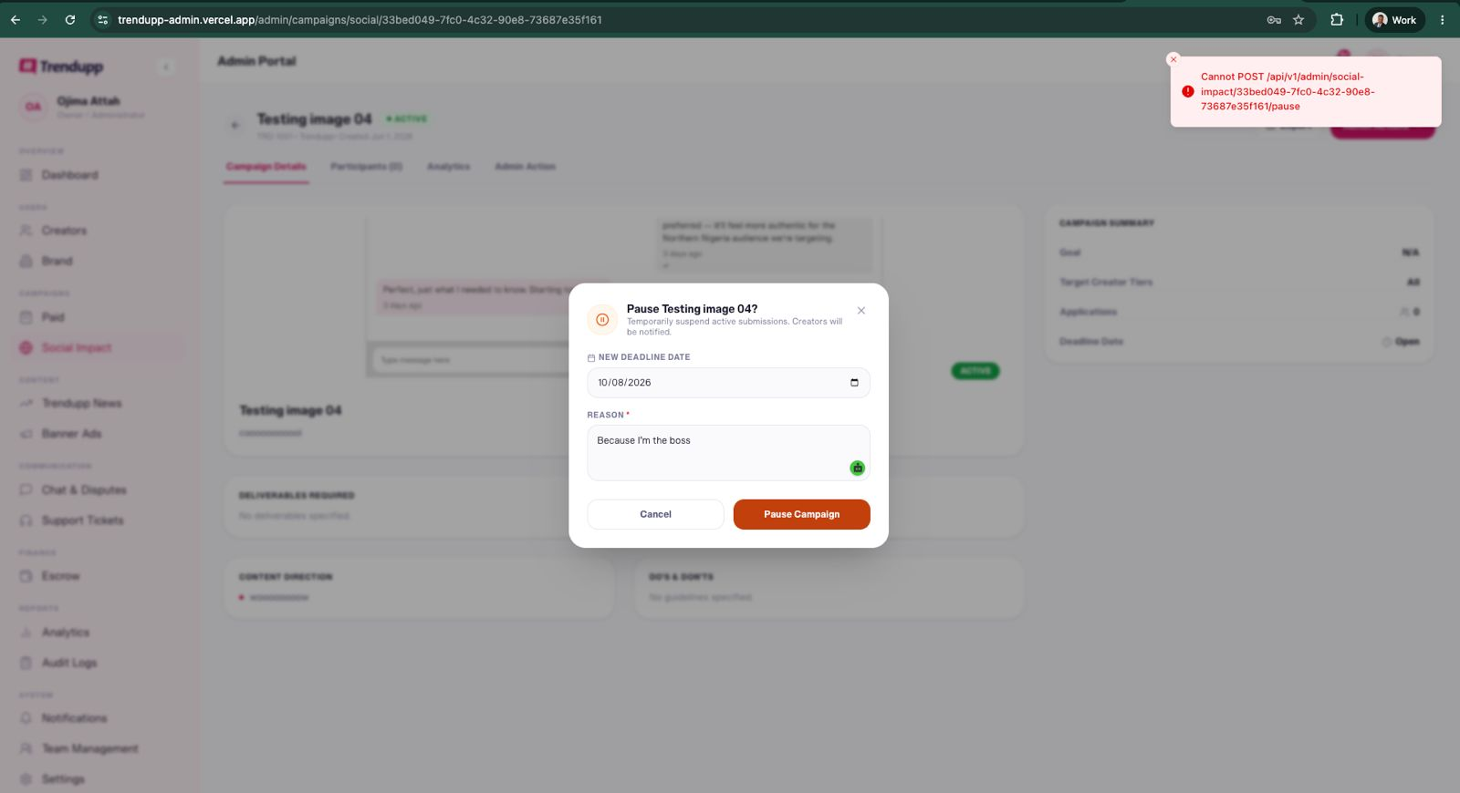
- Categories/Niche
- While adding Brand Industries, the same word in full-caps, title cases, and small letters is treated as different entities. E.g COMEDY, Comedy, and comedy are co-existing independently when entered. They should be treated as the same.
- Communication (Chat and Disputes)
- Both Teams agreed that the Chat Dispute scenarios and Mediator/Admin role would be reviewed, especially with initial decisions and communication between advertisers and creators.
- Analytics
- No issues were encountered. It is detailed enough. The Trendupp team recommended a simple analytics page for Advertisers to track past campaigns, number of partnered creators, etc.

Mobile Version
- Super-Admin Role
- Owner role should be Owner only, not Owner/Administrator because Owner obviously has admin access.
- Admin Dashboard for Trendupp Mobile App should be responsive and whole like the web version for an On-The-Go experience.

Others (Generic)
- Advertisers (Special)
Mr Olusegun recommended creating a custom package for high-paying advertisers, with each assigned to a relationship manager. This would be ideal for our Next-level upgrade.
- Tool Tip Box
There is a need to rework the Tip Boxes content across the web and mobile platform. They should be simple and added where applicable.
- Notifications
There is a need to have a list of notifications (in-app, OTP, approval/rejection, etc.) for different pages. Notifications should brief acceptance or rejection on the creator side (email and in-app).
- FAQs
FAQs Content should be based on the errors observed via Trendupp web and app platforms. Also, tooltips and other possible questions should be used to create the FAQs.
Testing Questionnaires
The need to develop questionnaires before Friday which apply to different mobile (iPhone, Samsung, Redmi, Tecno, Google Pixel, etc) and web devices.
- Violations in Communication
The need to review the T&C to ensure that guidelines on the Dispute/Communication chat are well-stated. A disclaimer should show in the dispute chat at the point of communication between Advertisers and Creators.
- Logo Update
The App's current logo should be changed and updated to the appropriate one with immediate effect.
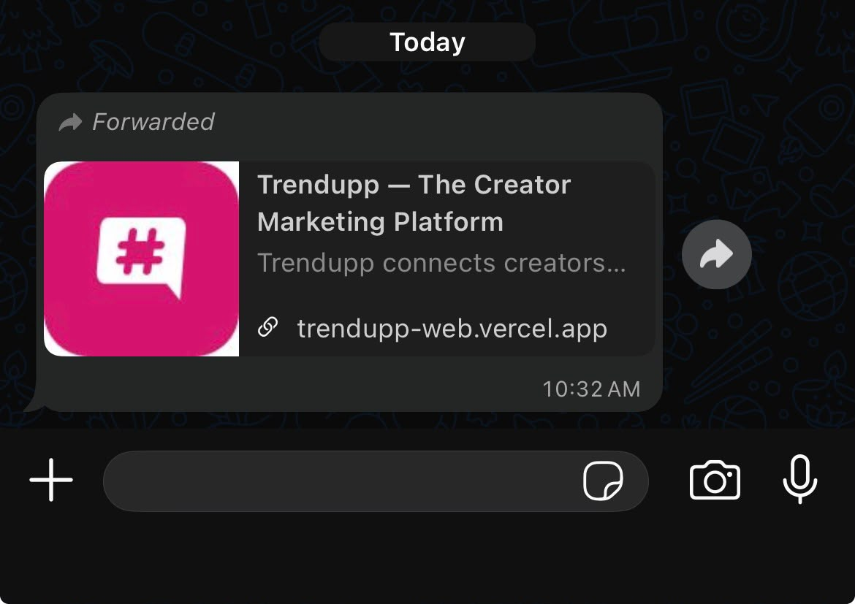
- Influencers Tiers
Concerns were raised about the Influencer Tiers. They include whether nano, micro, macro, or mega influencers can see all briefs in their dashboard and apply, even when the advertiser specified the influencer’s tier he or she wants.
Furthermore, should the advertiser’s brief notifications be streamlined to only the influencers of focus?
While these concerns/processes were suggested to be reviewed again, both teams agreed to have all briefs show in the campaign page; however, only the influencer tiers needed by the influencers would be allowed to apply.
- News/Blog
There is also a need to create a Content Marketing Strategy, including creating navigational content around the app, advertisers and creators-focused content. These content types would be in written and video form, including News, How-to, Educational, and Navigational guides. In addition, weekly newsletters will be sent out to the email addresses of our users’ database.
- Future Feature Addition
App User Experience improvements - Mr Olusegun mentioned the need to add accessibility features, especially to the mobile app, to accommodate options for the Text-to-Audio feature and Text font size adjustment.

ACTION ITEMS
Prod Cycle Team
- Change and Update App Logo
- To fix all stated errors and feedback on Trendupp web and app.
- Align with Trendupp Team on updates.
Trendupp Team
- The need to develop questionnaires before Friday which apply to different mobile (iPhone, Samsung, Redmi, Tecno, Google Pixel, etc) and web devices.
- Content Marketing Strategy
- Special Advertisers package set up

CLOSING
The App testing meeting closed by 5 PM.

