Table of Contents

Database schema reference
Every database, table and column of the client-hosted data plane (MySQL 8), generated from the code. For the design and its reasons see schema.md and the decision log in architecture.md; for the conversion and validation rules see the rulebook.
52 tables, 559 columns.
Conventions. Amounts are DECIMAL(20,4) in the base currency with the canonical sign: debit positive, credit negative (schema.md 1, 7.1). Every accounting table carries its source tracking columns (connection_id, source_key, source_alter_id, origin, import_batch_id, raw_record_id). Rows deleted in the source are kept with is_deleted (soft delete). PK primary key, FK foreign key, UK part of a unique key.

1. The four databases
Database | What it holds | Tables
ledgerbridge_source | Raw layer: every record exactly as the source sent it (ADR-005). Written only by connectors through the sync; the transform reads it. | 1
ledgerbridge_accounting | Canonical model: companies, chart of accounts, masters and transactions in one shape for every source. Written by the transform; read by validation, reports and (later) the reporting layer. | 26
ledgerbridge_reporting | Semantic layer for reports and AI (M6): views and aggregate tables. Empty until M6; the only database the AI user can read (AI-003). | 0
ledgerbridge_system | Running the platform: connections, sync runs and progress, validation, alerts, users, roles, audit and AI logs, configuration. | 25
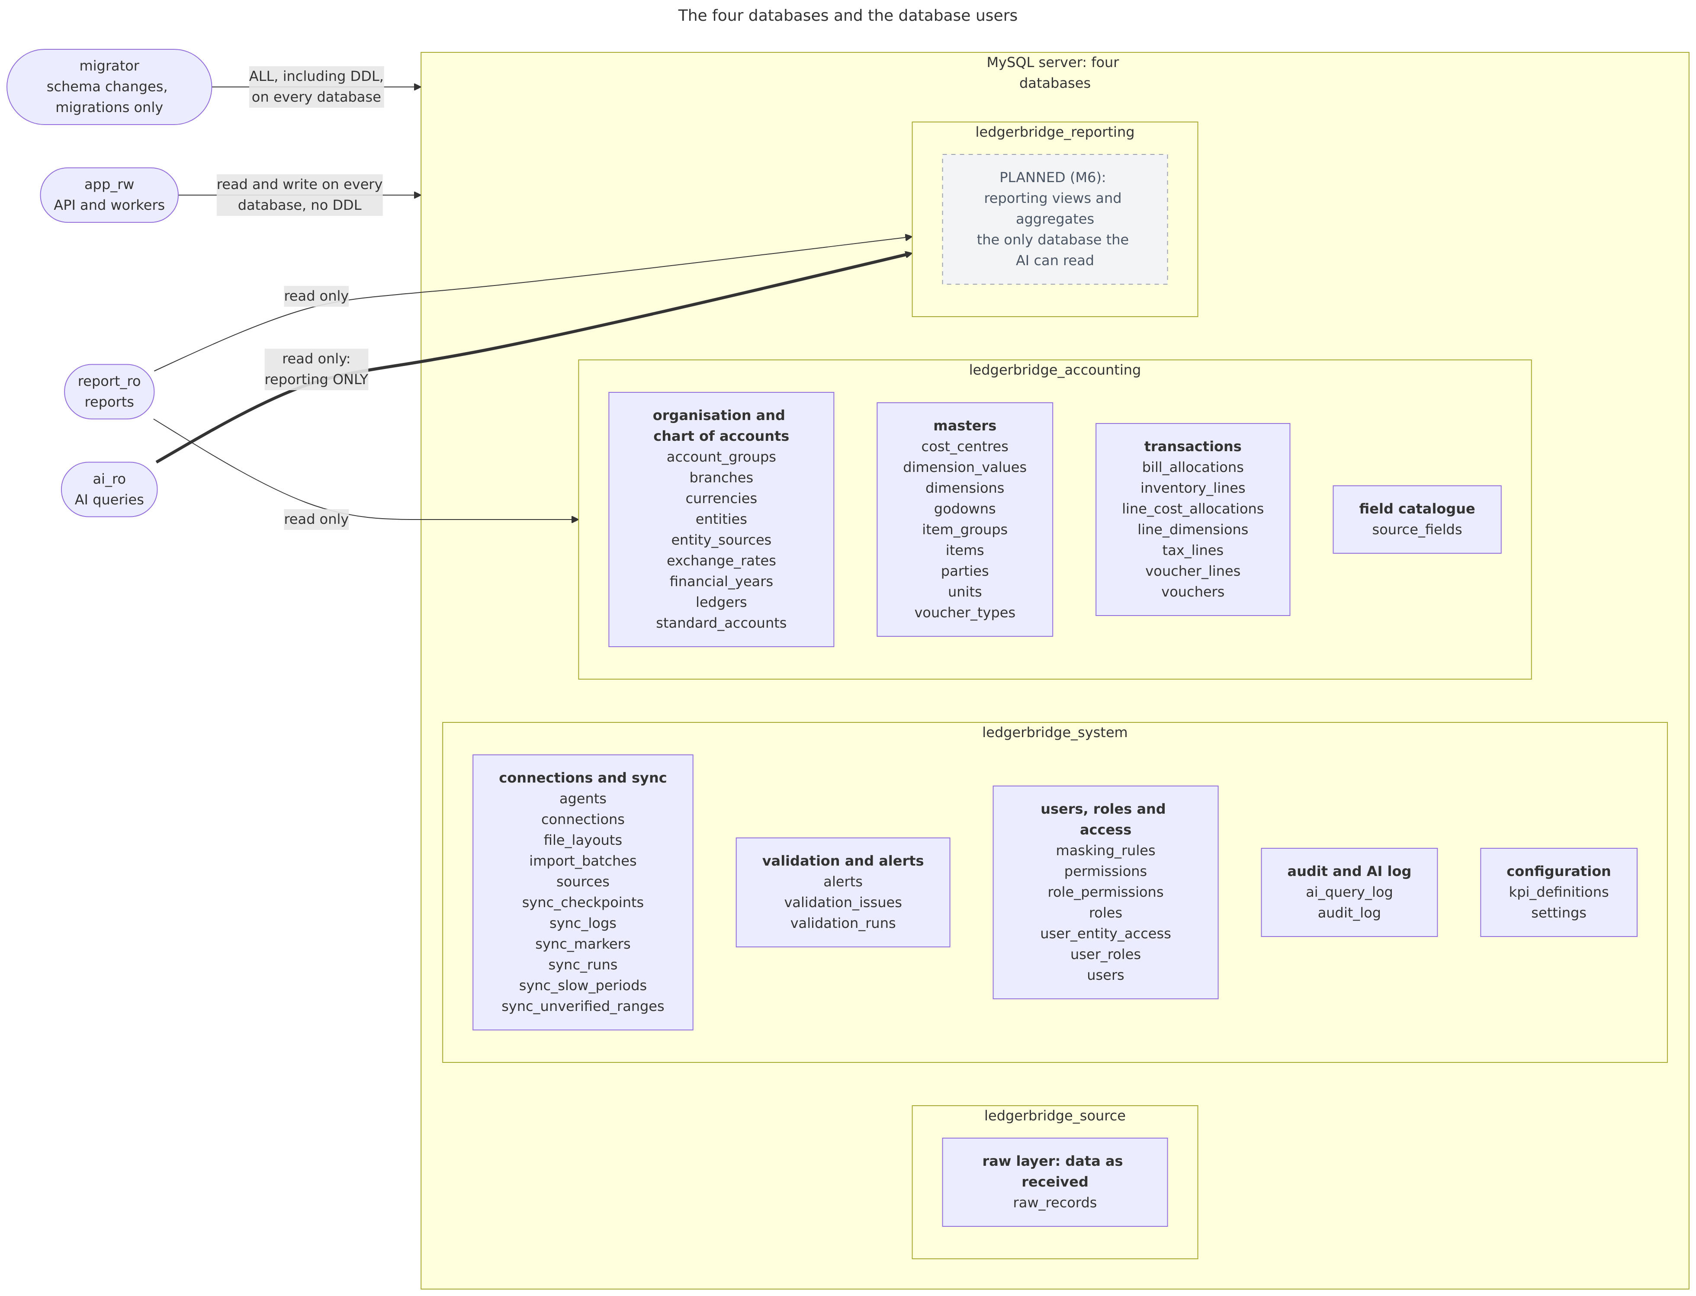

2. Database users and their rights
Created by deploy/mysql/init/01-schemas.sh (schema.md 2.1). Each user has only the rights it needs; the AI can read the reporting layer and nothing else.
User | Used by | Rights | Databases
migrator | schema changes, migrations only | ALL, including DDL, on every database | ledgerbridge_source, ledgerbridge_system, ledgerbridge_accounting, ledgerbridge_reporting
app_rw | API and workers | read and write on every database, no DDL | ledgerbridge_source, ledgerbridge_system, ledgerbridge_accounting, ledgerbridge_reporting
report_ro | reports | read only | ledgerbridge_accounting, ledgerbridge_reporting
ai_ro | AI queries | read only: reporting ONLY | ledgerbridge_reporting

3. Diagrams
How to read them: docs/diagrams/README.md.
Overview (keys only)
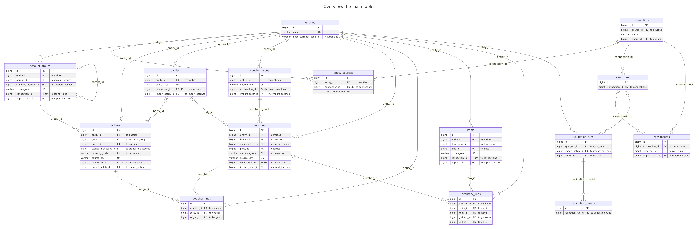
Organisation and chart of accounts (ledgerbridge_accounting)
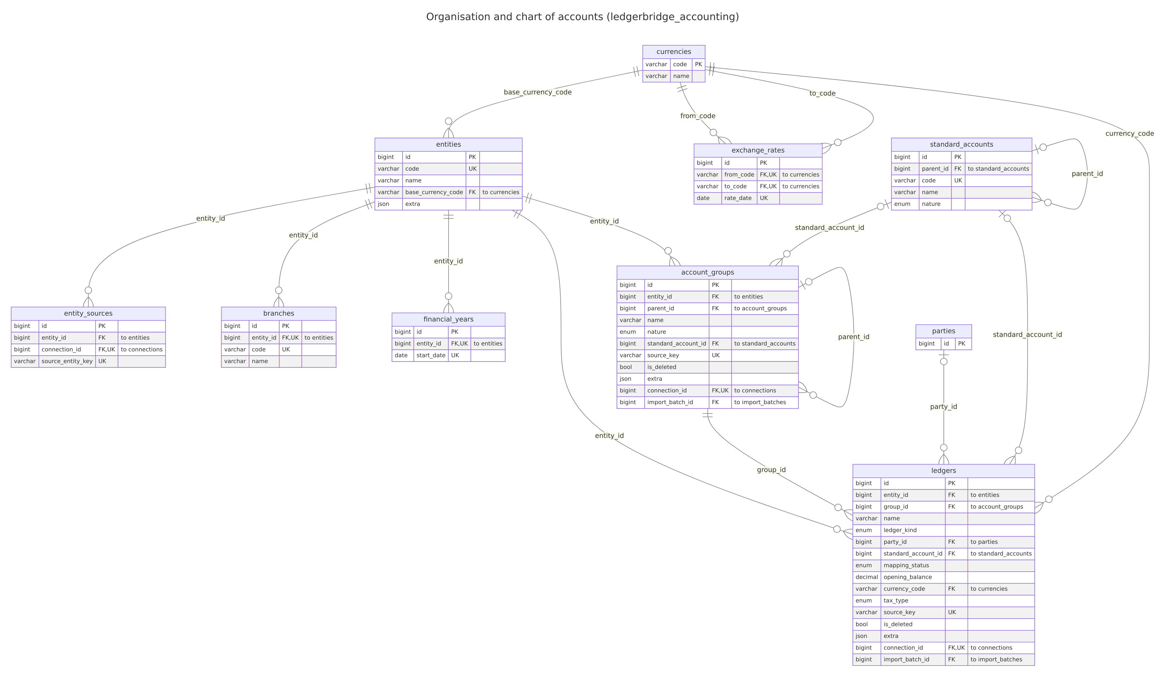
Masters: parties, items, units, godowns, cost centres, voucher types, dimensions (ledgerbridge_accounting)
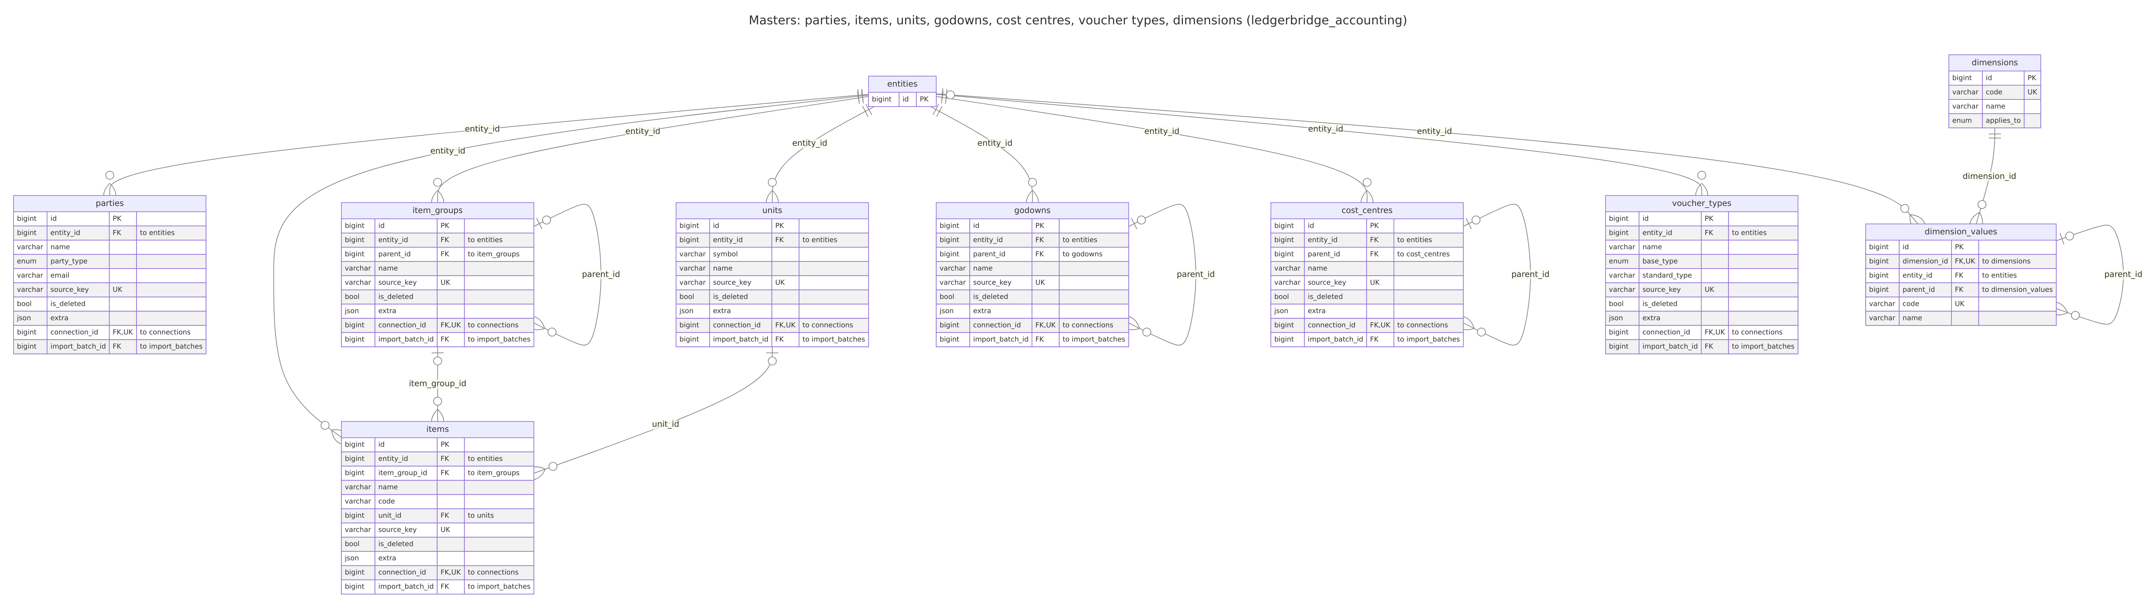
Transactions: vouchers and their child tables (ledgerbridge_accounting)
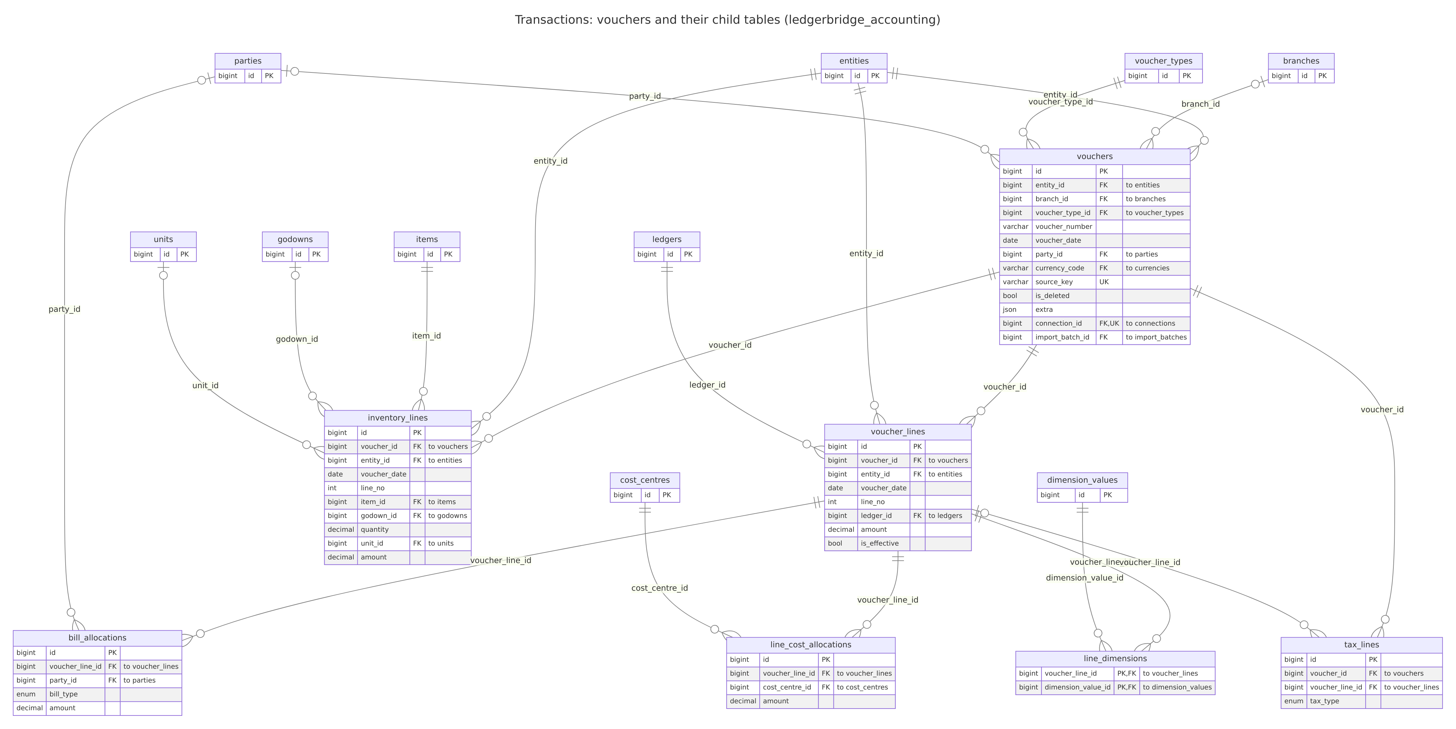
System, part 1: connections, sync, raw records, validation, alerts, field catalogue
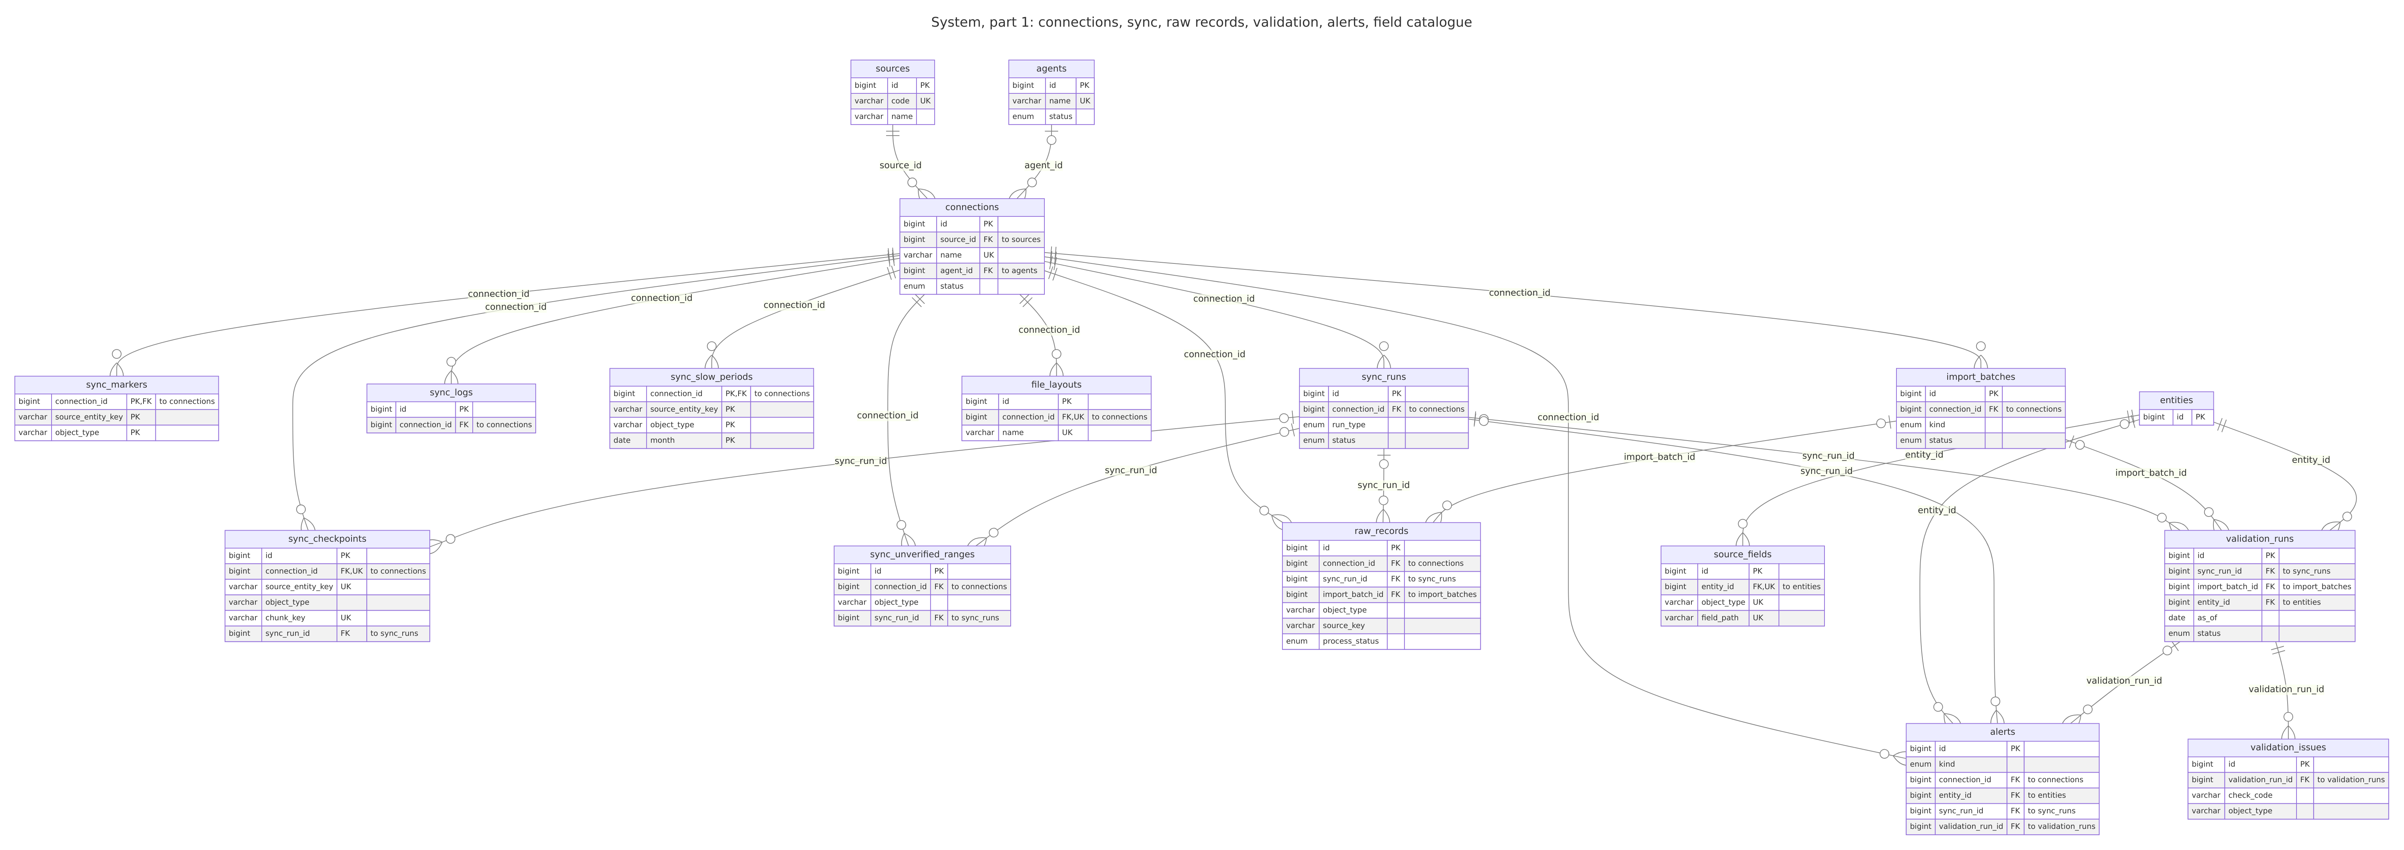
System, part 2: users, roles and access, audit and AI log, configuration (ledgerbridge_system)
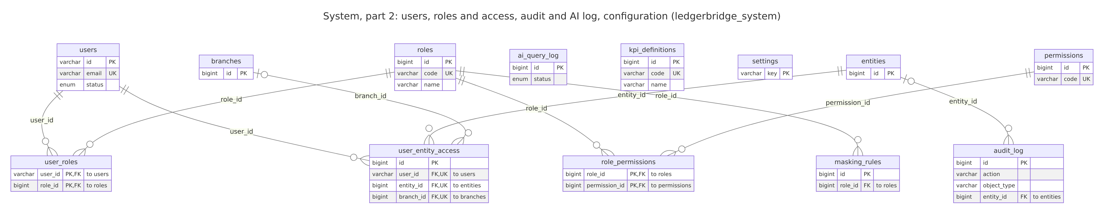
Data flow, level 0 (the platform and what it talks to)
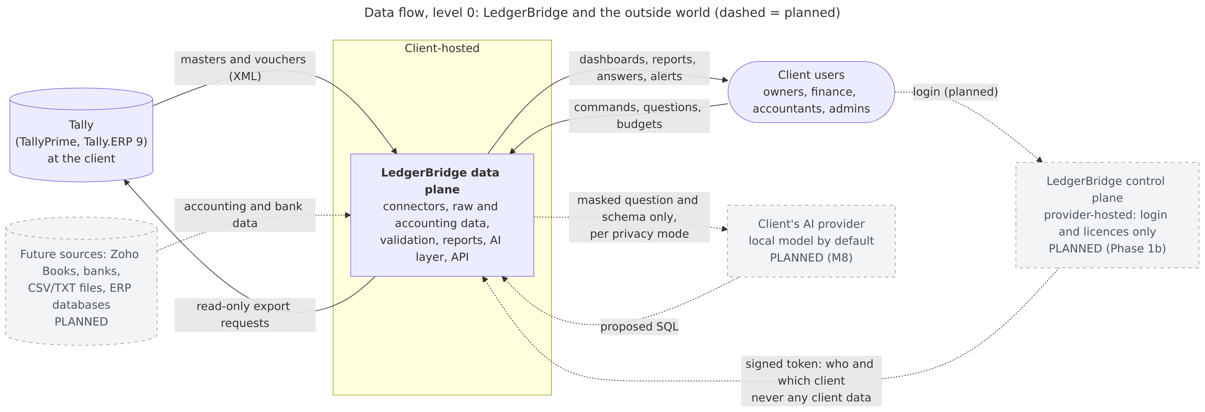
Data flow, level 1 (inside the data plane)
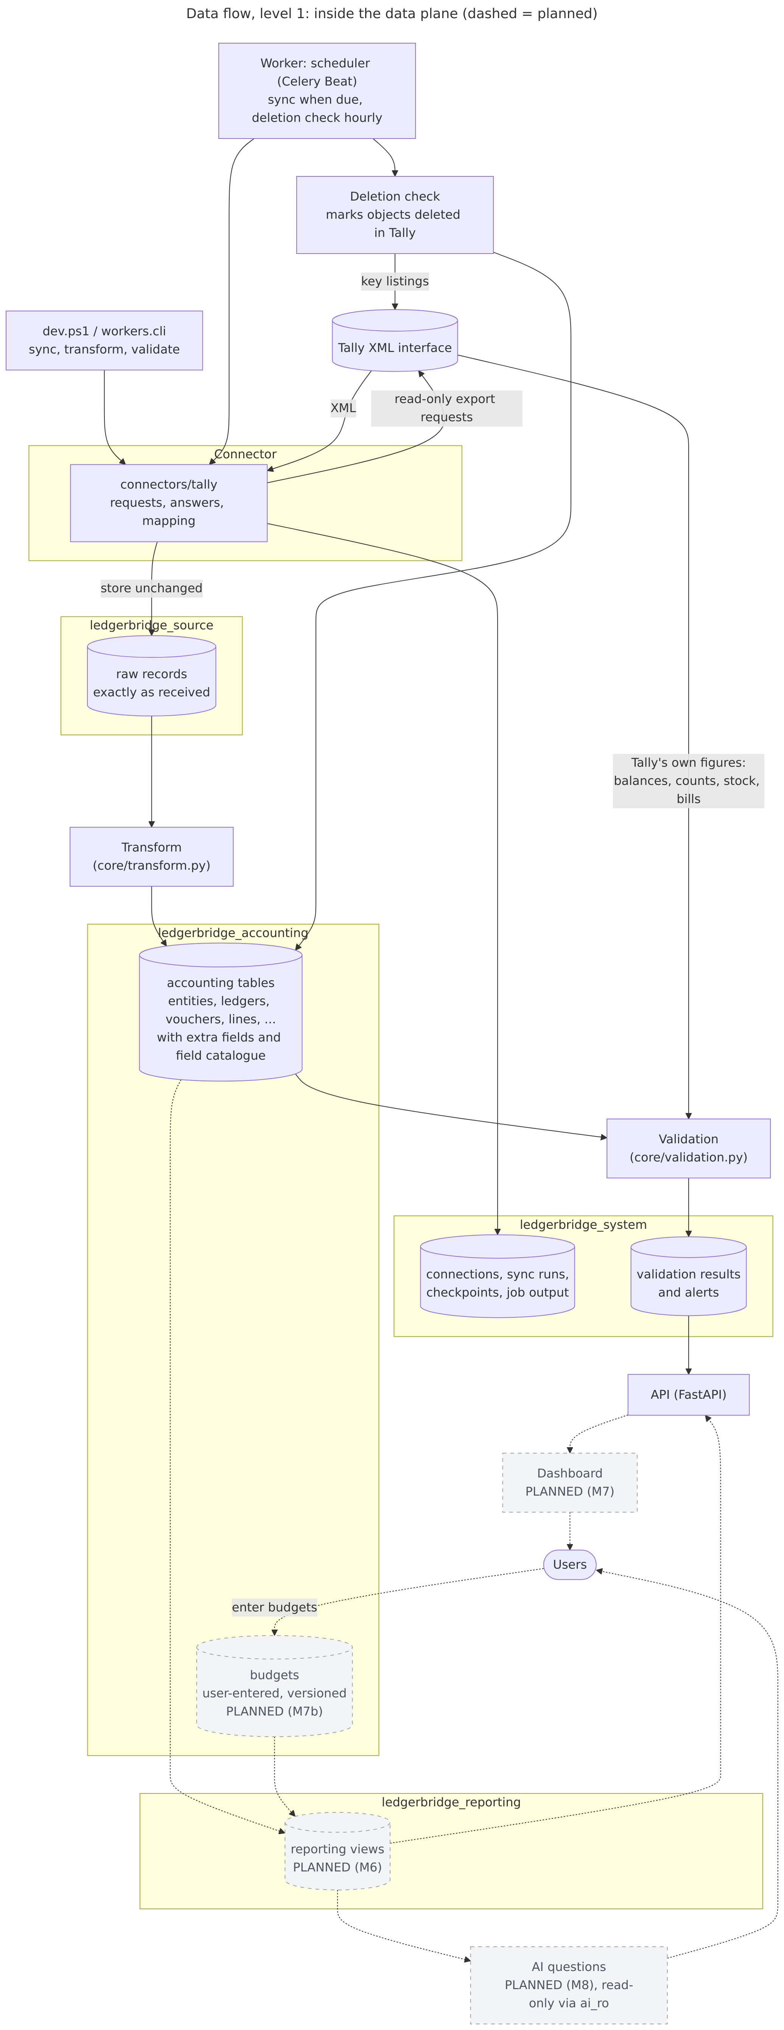

4. Tables

ledgerbridge_source: raw layer: data as received

ledgerbridge_source.raw_records
Purpose: Every object fetched from a source, exactly as received (XML for Tally), one row per version.
Filled by: Sync (connector -> RawStore): a new row only when the payload changed (hash); process_status tracks the transform.
Column | Type | Null | Key | Meaning
id | BIGINT UNSIGNED | no | PK | Row id.
connection_id | BIGINT UNSIGNED | no | FK | The connection the row came from.
sync_run_id | BIGINT UNSIGNED | yes | FK | The sync run it belongs to.
import_batch_id | BIGINT UNSIGNED | yes | FK | The import it came from, for imported data.
source_entity_key | VARCHAR(191) | no |  | The source company’s key (Tally: company GUID).
object_type | VARCHAR(64) | no |  | group, ledger, voucher_type, voucher, stock_item, …
source_key | VARCHAR(191) | no |  | The source’s own key (Tally: GUID); unique per connection.
source_alter_id | BIGINT | yes |  | The source’s change counter (Tally: AlterID) when last stored.
payload_format | ENUM(‘xml’,‘json’,‘csv’,‘txt’) | no |  | Payload format.
payload | LONGTEXT | no |  | The record exactly as received (re-serialised XML).
payload_hash | CHAR(64) | no |  | SHA-256 of the payload: an unchanged record isn’t stored again.
received_at | DATETIME(6) | no |  | When: received.
process_status | ENUM(‘pending’,‘processed’,‘failed’,‘skipped’) | no |  | pending / processed / failed / skipped (superseded).
process_error | TEXT | yes |  | Why the transform failed: error type and a short message, never SQL.
process_warning | TEXT | yes |  | Process warning.
created_at | DATETIME(6) | no |  | When the row was created (UTC).
updated_at | DATETIME(6) | no |  | When the row was last changed (UTC).
Keys and indexes: index ix_raw_records_conn_type_key (connection_id, object_type, source_key); index ix_raw_records_status_received (process_status, received_at).
Refers to: connection_id → connections.id; sync_run_id → sync_runs.id; import_batch_id → import_batches.id.

ledgerbridge_accounting: organisation and chart of accounts

ledgerbridge_accounting.entities
Purpose: A company in the platform (one per source company).
Filled by: Transform, from the source’s company record, on the first sync.
Column | Type | Null | Key | Meaning
id | BIGINT UNSIGNED | no | PK | Row id.
code | VARCHAR(32) | no | UK | Short code used in reports.
name | VARCHAR(255) | no |  | Name as the source keeps it.
legal_name | VARCHAR(255) | yes |  | Legal name.
country_code | CHAR(2) | no |  | Default IN.
state_code | VARCHAR(8) | yes |  | GST state code.
gstin | VARCHAR(32) | yes |  | 15 characters when valid; wider so source data that isn’t fits (migration 0010).
pan | VARCHAR(32) | yes |  | Pan.
base_currency_code | CHAR(3) | no | FK | Default INR.
fy_start_month | TINYINT | no |  | Default 4 (April) (DAT-006).
books_from | DATE | yes |  | Company inception / books start (IMP-001).
is_active | BOOL | no |  | Whether it is in use.
extra | JSON | yes |  | ADR-025
created_at | DATETIME(6) | no |  | When the row was created (UTC).
updated_at | DATETIME(6) | no |  | When the row was last changed (UTC).
Keys and indexes: unique (code).
Refers to: base_currency_code → currencies.code.
Referred to by: account_groups, alerts, audit_log, branches, cost_centres, dimension_values, entity_sources, financial_years, godowns, inventory_lines, item_groups, items, ledgers, parties, source_fields, units, user_entity_access, validation_runs, voucher_lines, voucher_types, vouchers.

ledgerbridge_accounting.entity_sources
Purpose: Which source company (by its key, Tally’s GUID) belongs to which entity, on which connection.
Filled by: Transform, with the entity.
Column | Type | Null | Key | Meaning
id | BIGINT UNSIGNED | no | PK | Row id.
entity_id | BIGINT UNSIGNED | no | FK | The entity (company) the row belongs to.
connection_id | BIGINT UNSIGNED | no | FK, UK | The connection the row came from.
source_entity_key | VARCHAR(191) | no | UK | Tally company GUID or name, Zoho organization ID.
source_entity_name | VARCHAR(255) | no |  | Source entity name.
precedence | SMALLINT | no |  | Higher wins on overlap (IMP-005).
active_from | DATE | yes |  | Active from.
active_to | DATE | yes |  | Active to.
created_at | DATETIME(6) | no |  | When the row was created (UTC).
updated_at | DATETIME(6) | no |  | When the row was last changed (UTC).
Keys and indexes: unique (connection_id, source_entity_key).
Refers to: entity_id → entities.id; connection_id → connections.id.

ledgerbridge_accounting.branches
Purpose: Branches of an entity (planned).
Filled by: Not filled yet.
Column | Type | Null | Key | Meaning
id | BIGINT UNSIGNED | no | PK | Row id.
entity_id | BIGINT UNSIGNED | no | FK, UK | The entity (company) the row belongs to.
code | VARCHAR(64) | no | UK | Short stable code.
name | VARCHAR(255) | no |  | Name as the source keeps it.
state_code | VARCHAR(8) | yes |  | GST state code.
gstin | VARCHAR(32) | yes |  | GST registration number.
is_active | BOOL | no |  | Whether it is in use.
created_at | DATETIME(6) | no |  | When the row was created (UTC).
updated_at | DATETIME(6) | no |  | When the row was last changed (UTC).
Keys and indexes: unique (entity_id, code).
Refers to: entity_id → entities.id.
Referred to by: user_entity_access, vouchers.

ledgerbridge_accounting.financial_years
Purpose: Financial years of an entity (planned).
Filled by: Not filled yet.
Column | Type | Null | Key | Meaning
id | BIGINT UNSIGNED | no | PK | Row id.
entity_id | BIGINT UNSIGNED | no | FK, UK | The entity (company) the row belongs to.
label | VARCHAR(64) | no |  | Label.
start_date | DATE | no | UK | Start date.
end_date | DATE | no |  | End date.
is_closed | BOOL | no |  | Whether closed.
created_at | DATETIME(6) | no |  | When the row was created (UTC).
updated_at | DATETIME(6) | no |  | When the row was last changed (UTC).
Keys and indexes: unique (entity_id, start_date).
Refers to: entity_id → entities.id.

ledgerbridge_accounting.currencies
Purpose: Currencies by ISO code.
Filled by: Seeded (INR); foreign currencies in M4b (FX-001).
Column | Type | Null | Key | Meaning
code | CHAR(3) | no | PK | Short stable code.
name | VARCHAR(255) | no |  | Name as the source keeps it.
decimal_places | TINYINT | no |  | Decimals shown.
created_at | DATETIME(6) | no |  | When the row was created (UTC).
updated_at | DATETIME(6) | no |  | When the row was last changed (UTC).
Referred to by: entities, exchange_rates, ledgers, vouchers.

ledgerbridge_accounting.exchange_rates
Purpose: Exchange rates by date (outline; redesigned for FX-003).
Filled by: Not filled yet.
Column | Type | Null | Key | Meaning
id | BIGINT UNSIGNED | no | PK | Row id.
from_code | CHAR(3) | no | FK, UK | Refers to currencies.
to_code | CHAR(3) | no | FK, UK | Refers to currencies.
rate_date | DATE | no | UK | Rate date.
rate | NUMERIC(20, 8) | no |  | Rate.
source | VARCHAR(64) | yes |  | Source.
created_at | DATETIME(6) | no |  | When the row was created (UTC).
updated_at | DATETIME(6) | no |  | When the row was last changed (UTC).
Keys and indexes: unique (from_code, to_code, rate_date).
Refers to: from_code → currencies.code; to_code → currencies.code.

ledgerbridge_accounting.standard_accounts
Purpose: The standard chart of accounts used to compare and combine companies (RPT-006).
Filled by: Seeded by a migration.
Column | Type | Null | Key | Meaning
id | BIGINT UNSIGNED | no | PK | Row id.
parent_id | BIGINT UNSIGNED | yes | FK | Hierarchy.
code | VARCHAR(32) | no | UK | Short stable code.
name | VARCHAR(255) | no |  | Name as the source keeps it.
nature | ENUM(‘asset’,‘liability’,‘equity’,‘income’,‘expense’) | no |  | Nature.
statement | ENUM(‘balance_sheet’,‘profit_loss’) | no |  | Statement.
statement_line | VARCHAR(64) | no |  | e.g. revenue, cogs, current_assets.
cash_flow_class | ENUM(‘operating’,‘investing’,‘financing’,‘cash’,‘none’) | no |  | For cash flow statement.
sort_order | INTEGER | no |  | Sort order.
created_at | DATETIME(6) | no |  | When the row was created (UTC).
updated_at | DATETIME(6) | no |  | When the row was last changed (UTC).
Keys and indexes: unique (code).
Refers to: parent_id → standard_accounts.id.
Referred to by: account_groups, ledgers, standard_accounts.

ledgerbridge_accounting.account_groups
Purpose: The source’s group tree (Tally groups), per entity, as kept there.
Filled by: Transform, from group masters; renamed reserved groups keep their reserved name as an alias.
Column | Type | Null | Key | Meaning
id | BIGINT UNSIGNED | no | PK | Row id.
entity_id | BIGINT UNSIGNED | no | FK | The entity (company) the row belongs to.
parent_id | BIGINT UNSIGNED | yes | FK | The parent row in the same table (a tree).
name | VARCHAR(255) | no |  | Name as the source keeps it.
nature | ENUM(‘asset’,‘liability’,‘equity’,‘income’,‘expense’) | yes |  | Derived from primary group.
is_primary | BOOL | no |  | Tally’s 28 predefined primary groups.
affects_gross_profit | BOOL | no |  | Tally flag for P&L layout.
standard_account_id | BIGINT UNSIGNED | yes | FK | Default mapping for ledgers under this group.
source_key | VARCHAR(191) | no | UK | The source’s own key (Tally: GUID); unique per connection.
source_alter_id | BIGINT | yes |  | The source’s change counter (Tally: AlterID) when last stored.
origin | ENUM(‘live’,‘backup’,‘file’,‘manual’) | no |  | live or backup (IMP-004).
raw_record_id | BIGINT UNSIGNED | yes |  | The raw record it was transformed from.
is_deleted | BOOL | no |  | Deleted in the source (soft delete; kept for history).
extra | JSON | yes |  | Source fields with no column, as JSON (ADR-025).
connection_id | BIGINT UNSIGNED | no | FK, UK | The connection the row came from.
import_batch_id | BIGINT UNSIGNED | yes | FK | The import it came from, for imported data.
created_at | DATETIME(6) | no |  | When the row was created (UTC).
updated_at | DATETIME(6) | no |  | When the row was last changed (UTC).
Keys and indexes: unique (connection_id, source_key); index ix_account_groups_raw_record (raw_record_id).
Refers to: entity_id → entities.id; parent_id → account_groups.id; standard_account_id → standard_accounts.id; connection_id → connections.id; import_batch_id → import_batches.id.
Referred to by: account_groups, ledgers.

ledgerbridge_accounting.ledgers
Purpose: The source’s ledgers, per entity, with their group, kind, standard account, opening balance as at the books’ beginning and tax type.
Filled by: Transform, from ledger masters fetched for a period starting on the books’ beginning.
Column | Type | Null | Key | Meaning
id | BIGINT UNSIGNED | no | PK | Row id.
entity_id | BIGINT UNSIGNED | no | FK | The entity (company) the row belongs to.
group_id | BIGINT UNSIGNED | no | FK | Refers to account_groups.
name | VARCHAR(255) | no |  | Name as the source keeps it.
alias | VARCHAR(255) | yes |  | Alias.
ledger_kind | ENUM(‘party’,‘bank’,‘cash’,‘tax’,‘stock’,‘income’,‘expense’,‘asset’,‘liability’,‘equity’,‘other’) | no |  | party, bank, cash, tax, stock, … (from the reserved group).
party_id | BIGINT UNSIGNED | yes | FK | Set for customer/vendor ledgers.
standard_account_id | BIGINT UNSIGNED | yes | FK | Overrides group mapping.
mapping_status | ENUM(‘auto’,‘suggested’,‘confirmed’,‘unmapped’) | no |  | auto (a standard account was found) or unmapped.
opening_balance | NUMERIC(20, 4) | no |  | Signed; as at opening_balance_date.
opening_balance_date | DATE | yes |  | Opening balance date.
currency_code | CHAR(3) | no | FK | Currency (ISO code).
is_bill_wise | BOOL | no |  | Whether bill wise.
is_cost_centre_applicable | BOOL | no |  | Whether cost centre applicable.
gstin | VARCHAR(32) | yes |  | GST registration number.
tax_type | ENUM(‘cgst’,‘sgst’,‘igst’,‘cess’,‘tds’,‘tcs’,‘vat’,‘other’) | yes |  | cgst, sgst, igst, cess, tds, tcs, vat for tax ledgers.
source_key | VARCHAR(191) | no | UK | The source’s own key (Tally: GUID); unique per connection.
source_alter_id | BIGINT | yes |  | The source’s change counter (Tally: AlterID) when last stored.
origin | ENUM(‘live’,‘backup’,‘file’,‘manual’) | no |  | live or backup (IMP-004).
raw_record_id | BIGINT UNSIGNED | yes |  | The raw record it was transformed from.
is_deleted | BOOL | no |  | Deleted in the source (soft delete; kept for history).
extra | JSON | yes |  | Source fields with no column, as JSON (ADR-025).
connection_id | BIGINT UNSIGNED | no | FK, UK | The connection the row came from.
import_batch_id | BIGINT UNSIGNED | yes | FK | The import it came from, for imported data.
created_at | DATETIME(6) | no |  | When the row was created (UTC).
updated_at | DATETIME(6) | no |  | When the row was last changed (UTC).
Keys and indexes: unique (connection_id, source_key); index ix_ledgers_entity_group (entity_id, group_id); index ix_ledgers_entity_name (entity_id, name); index ix_ledgers_raw_record (raw_record_id).
Refers to: entity_id → entities.id; group_id → account_groups.id; party_id → parties.id; standard_account_id → standard_accounts.id; currency_code → currencies.code; connection_id → connections.id; import_batch_id → import_batches.id.
Referred to by: voucher_lines.

ledgerbridge_accounting: masters

ledgerbridge_accounting.parties
Purpose: Customers and vendors (the ledgers under Sundry Debtors / Creditors), with GST, PAN and contact details (sensitive: AI-015).
Filled by: Transform, with their ledgers.
Column | Type | Null | Key | Meaning
id | BIGINT UNSIGNED | no | PK | Row id.
entity_id | BIGINT UNSIGNED | no | FK | The entity (company) the row belongs to.
name | VARCHAR(255) | no |  | Sensitive (masking candidate).
party_type | ENUM(‘customer’,‘vendor’,‘both’,‘other’) | no |  | Tally: Sundry Debtors → customer, Sundry Creditors → vendor.
gstin | VARCHAR(32) | yes |  | GST registration number.
pan | VARCHAR(32) | yes |  | Sensitive.
state_code | VARCHAR(8) | yes |  | GST state code.
country_code | CHAR(2) | yes |  | Country code.
credit_days | INTEGER | yes |  | Used for ageing and overdue flags.
credit_limit | NUMERIC(20, 4) | yes |  | Credit limit.
email | VARCHAR(255) | yes |  | E-mail address.
phone | VARCHAR(255) | yes |  | Phone.
source_key | VARCHAR(191) | no | UK | The source’s own key (Tally: GUID); unique per connection.
source_alter_id | BIGINT | yes |  | The source’s change counter (Tally: AlterID) when last stored.
origin | ENUM(‘live’,‘backup’,‘file’,‘manual’) | no |  | live or backup (IMP-004).
raw_record_id | BIGINT UNSIGNED | yes |  | The raw record it was transformed from.
is_deleted | BOOL | no |  | Deleted in the source (soft delete; kept for history).
extra | JSON | yes |  | Source fields with no column, as JSON (ADR-025).
connection_id | BIGINT UNSIGNED | no | FK, UK | The connection the row came from.
import_batch_id | BIGINT UNSIGNED | yes | FK | The import it came from, for imported data.
created_at | DATETIME(6) | no |  | When the row was created (UTC).
updated_at | DATETIME(6) | no |  | When the row was last changed (UTC).
Keys and indexes: unique (connection_id, source_key); index ix_parties_raw_record (raw_record_id).
Refers to: entity_id → entities.id; connection_id → connections.id; import_batch_id → import_batches.id.
Referred to by: bill_allocations, ledgers, vouchers.

ledgerbridge_accounting.items
Purpose: Stock items with their opening quantity and value.
Filled by: Transform, from stock item masters (as at the books’ beginning).
Column | Type | Null | Key | Meaning
id | BIGINT UNSIGNED | no | PK | Row id.
entity_id | BIGINT UNSIGNED | no | FK | The entity (company) the row belongs to.
item_group_id | BIGINT UNSIGNED | yes | FK | Refers to item_groups.
name | VARCHAR(255) | no |  | Name as the source keeps it.
code | VARCHAR(255) | yes |  | Short stable code.
unit_id | BIGINT UNSIGNED | yes | FK | Refers to units.
hsn_code | VARCHAR(32) | yes |  | Hsn code.
gst_rate | NUMERIC(20, 6) | yes |  | Gst rate.
opening_qty | NUMERIC(20, 6) | no |  | Opening qty.
opening_value | NUMERIC(20, 4) | no |  | Opening value.
source_key | VARCHAR(191) | no | UK | The source’s own key (Tally: GUID); unique per connection.
source_alter_id | BIGINT | yes |  | The source’s change counter (Tally: AlterID) when last stored.
origin | ENUM(‘live’,‘backup’,‘file’,‘manual’) | no |  | live or backup (IMP-004).
raw_record_id | BIGINT UNSIGNED | yes |  | The raw record it was transformed from.
is_deleted | BOOL | no |  | Deleted in the source (soft delete; kept for history).
extra | JSON | yes |  | Source fields with no column, as JSON (ADR-025).
connection_id | BIGINT UNSIGNED | no | FK, UK | The connection the row came from.
import_batch_id | BIGINT UNSIGNED | yes | FK | The import it came from, for imported data.
created_at | DATETIME(6) | no |  | When the row was created (UTC).
updated_at | DATETIME(6) | no |  | When the row was last changed (UTC).
Keys and indexes: unique (connection_id, source_key); index ix_items_raw_record (raw_record_id).
Refers to: entity_id → entities.id; item_group_id → item_groups.id; unit_id → units.id; connection_id → connections.id; import_batch_id → import_batches.id.
Referred to by: inventory_lines.

ledgerbridge_accounting.item_groups
Purpose: Stock groups.
Filled by: Transform, from stock group masters.
Column | Type | Null | Key | Meaning
id | BIGINT UNSIGNED | no | PK | Row id.
entity_id | BIGINT UNSIGNED | no | FK | The entity (company) the row belongs to.
parent_id | BIGINT UNSIGNED | yes | FK | The parent row in the same table (a tree).
name | VARCHAR(255) | no |  | Name as the source keeps it.
source_key | VARCHAR(191) | no | UK | The source’s own key (Tally: GUID); unique per connection.
source_alter_id | BIGINT | yes |  | The source’s change counter (Tally: AlterID) when last stored.
origin | ENUM(‘live’,‘backup’,‘file’,‘manual’) | no |  | live or backup (IMP-004).
raw_record_id | BIGINT UNSIGNED | yes |  | The raw record it was transformed from.
is_deleted | BOOL | no |  | Deleted in the source (soft delete; kept for history).
extra | JSON | yes |  | Source fields with no column, as JSON (ADR-025).
connection_id | BIGINT UNSIGNED | no | FK, UK | The connection the row came from.
import_batch_id | BIGINT UNSIGNED | yes | FK | The import it came from, for imported data.
created_at | DATETIME(6) | no |  | When the row was created (UTC).
updated_at | DATETIME(6) | no |  | When the row was last changed (UTC).
Keys and indexes: unique (connection_id, source_key); index ix_item_groups_raw_record (raw_record_id).
Refers to: entity_id → entities.id; parent_id → item_groups.id; connection_id → connections.id; import_batch_id → import_batches.id.
Referred to by: item_groups, items.

ledgerbridge_accounting.units
Purpose: Units of measure.
Filled by: Transform, from unit masters.
Column | Type | Null | Key | Meaning
id | BIGINT UNSIGNED | no | PK | Row id.
entity_id | BIGINT UNSIGNED | no | FK | The entity (company) the row belongs to.
symbol | VARCHAR(255) | no |  | Symbol.
name | VARCHAR(255) | no |  | Name as the source keeps it.
decimal_places | TINYINT | no |  | Decimals shown.
source_key | VARCHAR(191) | no | UK | The source’s own key (Tally: GUID); unique per connection.
source_alter_id | BIGINT | yes |  | The source’s change counter (Tally: AlterID) when last stored.
origin | ENUM(‘live’,‘backup’,‘file’,‘manual’) | no |  | live or backup (IMP-004).
raw_record_id | BIGINT UNSIGNED | yes |  | The raw record it was transformed from.
is_deleted | BOOL | no |  | Deleted in the source (soft delete; kept for history).
extra | JSON | yes |  | Source fields with no column, as JSON (ADR-025).
connection_id | BIGINT UNSIGNED | no | FK, UK | The connection the row came from.
import_batch_id | BIGINT UNSIGNED | yes | FK | The import it came from, for imported data.
created_at | DATETIME(6) | no |  | When the row was created (UTC).
updated_at | DATETIME(6) | no |  | When the row was last changed (UTC).
Keys and indexes: unique (connection_id, source_key); index ix_units_raw_record (raw_record_id).
Refers to: entity_id → entities.id; connection_id → connections.id; import_batch_id → import_batches.id.
Referred to by: inventory_lines, items.

ledgerbridge_accounting.godowns
Purpose: Godowns (locations) and whose stock they hold (holding, ADR-031).
Filled by: Transform, from godown masters.
Column | Type | Null | Key | Meaning
id | BIGINT UNSIGNED | no | PK | Row id.
entity_id | BIGINT UNSIGNED | no | FK | The entity (company) the row belongs to.
parent_id | BIGINT UNSIGNED | yes | FK | The parent row in the same table (a tree).
name | VARCHAR(255) | no |  | Name as the source keeps it.
holding | ENUM(‘own’,‘ours_with_third_party’,‘third_party_with_us’) | no |  | own / ours_with_third_party (a job worker’s) / third_party_with_us.
source_key | VARCHAR(191) | no | UK | The source’s own key (Tally: GUID); unique per connection.
source_alter_id | BIGINT | yes |  | The source’s change counter (Tally: AlterID) when last stored.
origin | ENUM(‘live’,‘backup’,‘file’,‘manual’) | no |  | live or backup (IMP-004).
raw_record_id | BIGINT UNSIGNED | yes |  | The raw record it was transformed from.
is_deleted | BOOL | no |  | Deleted in the source (soft delete; kept for history).
extra | JSON | yes |  | Source fields with no column, as JSON (ADR-025).
connection_id | BIGINT UNSIGNED | no | FK, UK | The connection the row came from.
import_batch_id | BIGINT UNSIGNED | yes | FK | The import it came from, for imported data.
created_at | DATETIME(6) | no |  | When the row was created (UTC).
updated_at | DATETIME(6) | no |  | When the row was last changed (UTC).
Keys and indexes: unique (connection_id, source_key); index ix_godowns_raw_record (raw_record_id).
Refers to: entity_id → entities.id; parent_id → godowns.id; connection_id → connections.id; import_batch_id → import_batches.id.
Referred to by: godowns, inventory_lines.

ledgerbridge_accounting.cost_centres
Purpose: Cost centres and their categories.
Filled by: Transform, from cost centre masters.
Column | Type | Null | Key | Meaning
id | BIGINT UNSIGNED | no | PK | Row id.
entity_id | BIGINT UNSIGNED | no | FK | The entity (company) the row belongs to.
parent_id | BIGINT UNSIGNED | yes | FK | The parent row in the same table (a tree).
category | VARCHAR(255) | yes |  | Category.
name | VARCHAR(255) | no |  | Name as the source keeps it.
source_key | VARCHAR(191) | no | UK | The source’s own key (Tally: GUID); unique per connection.
source_alter_id | BIGINT | yes |  | The source’s change counter (Tally: AlterID) when last stored.
origin | ENUM(‘live’,‘backup’,‘file’,‘manual’) | no |  | live or backup (IMP-004).
raw_record_id | BIGINT UNSIGNED | yes |  | The raw record it was transformed from.
is_deleted | BOOL | no |  | Deleted in the source (soft delete; kept for history).
extra | JSON | yes |  | Source fields with no column, as JSON (ADR-025).
connection_id | BIGINT UNSIGNED | no | FK, UK | The connection the row came from.
import_batch_id | BIGINT UNSIGNED | yes | FK | The import it came from, for imported data.
created_at | DATETIME(6) | no |  | When the row was created (UTC).
updated_at | DATETIME(6) | no |  | When the row was last changed (UTC).
Keys and indexes: unique (connection_id, source_key); index ix_cost_centres_raw_record (raw_record_id).
Refers to: entity_id → entities.id; parent_id → cost_centres.id; connection_id → connections.id; import_batch_id → import_batches.id.
Referred to by: cost_centres, line_cost_allocations.

ledgerbridge_accounting.voucher_types
Purpose: The source’s voucher types and the standard type each derives from; whether its vouchers post to the books and move stock.
Filled by: Transform, from voucher type masters (type tree resolved, ADR-027).
Column | Type | Null | Key | Meaning
id | BIGINT UNSIGNED | no | PK | Row id.
entity_id | BIGINT UNSIGNED | no | FK | The entity (company) the row belongs to.
name | VARCHAR(255) | no |  | Name as the source keeps it.
base_type | ENUM(‘sales’,‘purchase’,‘payment’,‘receipt’,‘journal’,‘contra’,‘debit_note’,‘credit_note’,‘stock_journal’,‘delivery_note’,‘receipt_note’,‘other’) | no |  | Base type.
is_accounting | BOOL | no |  | Whether accounting.
is_inventory | BOOL | no |  | Whether inventory.
standard_type | VARCHAR(64) | yes |  | Standard type.
moves_stock | BOOL | no |  | Moves stock.
source_key | VARCHAR(191) | no | UK | The source’s own key (Tally: GUID); unique per connection.
source_alter_id | BIGINT | yes |  | The source’s change counter (Tally: AlterID) when last stored.
origin | ENUM(‘live’,‘backup’,‘file’,‘manual’) | no |  | live or backup (IMP-004).
raw_record_id | BIGINT UNSIGNED | yes |  | The raw record it was transformed from.
is_deleted | BOOL | no |  | Deleted in the source (soft delete; kept for history).
extra | JSON | yes |  | Source fields with no column, as JSON (ADR-025).
connection_id | BIGINT UNSIGNED | no | FK, UK | The connection the row came from.
import_batch_id | BIGINT UNSIGNED | yes | FK | The import it came from, for imported data.
created_at | DATETIME(6) | no |  | When the row was created (UTC).
updated_at | DATETIME(6) | no |  | When the row was last changed (UTC).
Keys and indexes: unique (connection_id, source_key); index ix_voucher_types_raw_record (raw_record_id).
Refers to: entity_id → entities.id; connection_id → connections.id; import_batch_id → import_batches.id.
Referred to by: vouchers.

ledgerbridge_accounting.dimensions
Purpose: User-defined reporting dimensions (DAT-005), e.g. a promoted UDF.
Filled by: promote-field, from the field catalogue.
Column | Type | Null | Key | Meaning
id | BIGINT UNSIGNED | no | PK | Row id.
code | VARCHAR(64) | no | UK | Short stable code.
name | VARCHAR(255) | no |  | Name as the source keeps it.
applies_to | ENUM(‘voucher’,‘line’) | no |  | Applies to.
is_active | BOOL | no |  | Whether it is in use.
source_object_type | VARCHAR(64) | yes |  | Source object type.
source_field | VARCHAR(255) | yes |  | Source field.
created_at | DATETIME(6) | no |  | When the row was created (UTC).
updated_at | DATETIME(6) | no |  | When the row was last changed (UTC).
Keys and indexes: unique (code).
Referred to by: dimension_values.

ledgerbridge_accounting.dimension_values
Purpose: The values of a dimension.
Filled by: Transform, for promoted fields.
Column | Type | Null | Key | Meaning
id | BIGINT UNSIGNED | no | PK | Row id.
dimension_id | BIGINT UNSIGNED | no | FK, UK | Refers to dimensions.
entity_id | BIGINT UNSIGNED | yes | FK | The entity (company) the row belongs to.
parent_id | BIGINT UNSIGNED | yes | FK | The parent row in the same table (a tree).
code | VARCHAR(64) | no | UK | Short stable code.
name | VARCHAR(255) | no |  | Name as the source keeps it.
created_at | DATETIME(6) | no |  | When the row was created (UTC).
updated_at | DATETIME(6) | no |  | When the row was last changed (UTC).
Keys and indexes: unique (dimension_id, code).
Refers to: dimension_id → dimensions.id; entity_id → entities.id; parent_id → dimension_values.id.
Referred to by: dimension_values, line_dimensions.

ledgerbridge_accounting: transactions

ledgerbridge_accounting.vouchers
Purpose: Vouchers (transactions) with their type, number, date, party and flags.
Filled by: Transform, from voucher records; replaced as a whole with their child rows (schema.md 8 rule 7).
Column | Type | Null | Key | Meaning
id | BIGINT UNSIGNED | no | PK | Row id.
entity_id | BIGINT UNSIGNED | no | FK | The entity (company) the row belongs to.
branch_id | BIGINT UNSIGNED | yes | FK | Refers to branches.
voucher_type_id | BIGINT UNSIGNED | no | FK | Refers to voucher_types.
voucher_number | VARCHAR(255) | no |  | The source’s voucher number (up to 255 characters).
voucher_date | DATE | no |  | The voucher’s date (denormalised for fast period queries).
reference_number | VARCHAR(255) | yes |  | The source’s reference (e.g. the supplier’s invoice number).
reference_date | DATE | yes |  | Reference date.
effective_date | DATE | yes |  | The source’s effective date (Tally EFFECTIVEDATE); balances count by voucher_date, as Tally does. Migration 0016.
party_id | BIGINT UNSIGNED | yes | FK | Main party, if any.
narration | TEXT | yes |  | Searchable via RAG later (AI-010).
currency_code | CHAR(3) | no | FK | Currency (ISO code).
exchange_rate | NUMERIC(20, 8) | no |  | Exchange rate.
is_cancelled | BOOL | no |  | Whether cancelled.
is_optional | BOOL | no |  | Tally optional/memo vouchers, excluded from books.
is_post_dated | BOOL | no |  | The source marks it post-dated; it counts from its date.
source_key | VARCHAR(191) | no | UK | The source’s own key (Tally: GUID); unique per connection.
source_alter_id | BIGINT | yes |  | The source’s change counter (Tally: AlterID) when last stored.
origin | ENUM(‘live’,‘backup’,‘file’,‘manual’) | no |  | live or backup (IMP-004).
raw_record_id | BIGINT UNSIGNED | yes |  | The raw record it was transformed from.
is_deleted | BOOL | no |  | Deleted in the source (soft delete; kept for history).
extra | JSON | yes |  | Source fields with no column, as JSON (ADR-025).
connection_id | BIGINT UNSIGNED | no | FK, UK | The connection the row came from.
import_batch_id | BIGINT UNSIGNED | yes | FK | The import it came from, for imported data.
created_at | DATETIME(6) | no |  | When the row was created (UTC).
updated_at | DATETIME(6) | no |  | When the row was last changed (UTC).
Keys and indexes: unique (connection_id, source_key); index ix_vouchers_entity_date (entity_id, voucher_date); index ix_vouchers_entity_type_date (entity_id, voucher_type_id, voucher_date); index ix_vouchers_party_date (party_id, voucher_date); index ix_vouchers_raw_record (raw_record_id).
Refers to: entity_id → entities.id; branch_id → branches.id; voucher_type_id → voucher_types.id; party_id → parties.id; currency_code → currencies.code; connection_id → connections.id; import_batch_id → import_batches.id.
Referred to by: inventory_lines, tax_lines, voucher_lines.

ledgerbridge_accounting.voucher_lines
Purpose: The double-entry lines of each voucher (debit +, credit −); is_effective says whether a line counts in the books.
Filled by: Transform, with the voucher.
Column | Type | Null | Key | Meaning
id | BIGINT UNSIGNED | no | PK | Row id.
voucher_id | BIGINT UNSIGNED | no | FK | Refers to vouchers.
entity_id | BIGINT UNSIGNED | no | FK | Denormalized for fast filtering.
voucher_date | DATE | no |  | Denormalized for fast period queries.
line_no | INTEGER | no |  | Position of the line in its voucher.
ledger_id | BIGINT UNSIGNED | no | FK | Refers to ledgers.
amount | NUMERIC(20, 4) | no |  | Base currency, debit +, credit −.
amount_fc | NUMERIC(20, 4) | yes |  | Foreign-currency amount (Tally: the part before @ of -$100.00 @ Rs82.00/$ = -Rs8200.00); its rate is amount / amount_fc. NULL in the base currency.
is_party_line | BOOL | no |  | Whether party line.
is_effective | BOOL | no |  | Counts in the books: not cancelled, optional or deleted, and of a type that posts.
created_at | DATETIME(6) | no |  | When the row was created (UTC).
updated_at | DATETIME(6) | no |  | When the row was last changed (UTC).
Keys and indexes: index ix_voucher_lines_entity_ledger_date (entity_id, ledger_id, voucher_date); index ix_voucher_lines_voucher (voucher_id).
Refers to: voucher_id → vouchers.id, on delete cascade; entity_id → entities.id; ledger_id → ledgers.id.
Referred to by: bill_allocations, line_cost_allocations, line_dimensions, tax_lines.

ledgerbridge_accounting.bill_allocations
Purpose: Bill-wise allocations of a line (receivables and payables ageing).
Filled by: Transform, with the voucher.
Column | Type | Null | Key | Meaning
id | BIGINT UNSIGNED | no | PK | Row id.
voucher_line_id | BIGINT UNSIGNED | no | FK | Refers to voucher_lines.
party_id | BIGINT UNSIGNED | yes | FK | Refers to parties.
bill_type | ENUM(‘new_ref’,‘against_ref’,‘advance’,‘on_account’) | no |  | Bill type.
bill_name | VARCHAR(255) | yes |  | Bill name.
bill_date | DATE | yes |  | Bill date.
due_date | DATE | yes |  | Due date.
amount | NUMERIC(20, 4) | no |  | Amount in the base currency, canonical sign (debit +, credit −).
created_at | DATETIME(6) | no |  | When the row was created (UTC).
updated_at | DATETIME(6) | no |  | When the row was last changed (UTC).
Refers to: voucher_line_id → voucher_lines.id, on delete cascade; party_id → parties.id.

ledgerbridge_accounting.line_cost_allocations
Purpose: Cost centre allocations of a line.
Filled by: Transform, with the voucher.
Column | Type | Null | Key | Meaning
id | BIGINT UNSIGNED | no | PK | Row id.
voucher_line_id | BIGINT UNSIGNED | no | FK | Refers to voucher_lines.
cost_centre_id | BIGINT UNSIGNED | no | FK | Refers to cost_centres.
amount | NUMERIC(20, 4) | no |  | Amount in the base currency, canonical sign (debit +, credit −).
created_at | DATETIME(6) | no |  | When the row was created (UTC).
updated_at | DATETIME(6) | no |  | When the row was last changed (UTC).
Refers to: voucher_line_id → voucher_lines.id, on delete cascade; cost_centre_id → cost_centres.id.

ledgerbridge_accounting.line_dimensions
Purpose: A voucher line’s value for each dimension.
Filled by: Transform, with the voucher.
Column | Type | Null | Key | Meaning
voucher_line_id | BIGINT UNSIGNED | no | PK, FK | Refers to voucher_lines.
dimension_value_id | BIGINT UNSIGNED | no | PK, FK | Refers to dimension_values.
created_at | DATETIME(6) | no |  | When the row was created (UTC).
updated_at | DATETIME(6) | no |  | When the row was last changed (UTC).
Refers to: voucher_line_id → voucher_lines.id, on delete cascade; dimension_value_id → dimension_values.id.

ledgerbridge_accounting.inventory_lines
Purpose: Stock movements of a voucher (in +, out −) by item, godown and batch; stock_quantity is what moves stock (tracked lines move nothing).
Filled by: Transform, with the voucher.
Column | Type | Null | Key | Meaning
id | BIGINT UNSIGNED | no | PK | Row id.
voucher_id | BIGINT UNSIGNED | no | FK | Refers to vouchers.
entity_id | BIGINT UNSIGNED | no | FK | The entity (company) the row belongs to.
voucher_date | DATE | no |  | The voucher’s date (denormalised for fast period queries).
line_no | INTEGER | no |  | Position of the line in its voucher.
item_id | BIGINT UNSIGNED | no | FK | Refers to items.
godown_id | BIGINT UNSIGNED | yes | FK | Refers to godowns.
quantity | NUMERIC(20, 6) | no |  | Quantity.
stock_quantity | NUMERIC(20, 6) | no |  | What the line moves in stock: the quantity less the part tracked to a note.
unit_id | BIGINT UNSIGNED | yes | FK | Refers to units.
rate | NUMERIC(20, 6) | yes |  | Rate.
amount | NUMERIC(20, 4) | no |  | Amount in the base currency, canonical sign (debit +, credit −).
discount_pct | NUMERIC(20, 6) | yes |  | Discount pct.
batch_name | VARCHAR(255) | yes |  | Batch name.
created_at | DATETIME(6) | no |  | When the row was created (UTC).
updated_at | DATETIME(6) | no |  | When the row was last changed (UTC).
Refers to: voucher_id → vouchers.id, on delete cascade; entity_id → entities.id; item_id → items.id; godown_id → godowns.id; unit_id → units.id.

ledgerbridge_accounting.tax_lines
Purpose: Tax amounts of a voucher (GST, TDS, …) from lines posted to tax ledgers.
Filled by: Transform, with the voucher.
Column | Type | Null | Key | Meaning
id | BIGINT UNSIGNED | no | PK | Row id.
voucher_id | BIGINT UNSIGNED | no | FK | Refers to vouchers.
voucher_line_id | BIGINT UNSIGNED | yes | FK | Refers to voucher_lines.
tax_type | ENUM(‘cgst’,‘sgst’,‘igst’,‘cess’,‘tds’,‘tcs’,‘vat’,‘other’) | no |  | Tax type.
rate | NUMERIC(20, 6) | yes |  | Rate.
taxable_amount | NUMERIC(20, 4) | yes |  | Taxable amount.
tax_amount | NUMERIC(20, 4) | no |  | Tax amount.
hsn_code | VARCHAR(32) | yes |  | Hsn code.
created_at | DATETIME(6) | no |  | When the row was created (UTC).
updated_at | DATETIME(6) | no |  | When the row was last changed (UTC).
Refers to: voucher_id → vouchers.id, on delete cascade; voucher_line_id → voucher_lines.id, on delete cascade.

ledgerbridge_accounting: field catalogue

ledgerbridge_accounting.source_fields
Purpose: Field catalogue (ADR-025): every source field that has no column, kept in extra, with counts and an inferred type.
Filled by: Transform.
Column | Type | Null | Key | Meaning
id | BIGINT UNSIGNED | no | PK | Row id.
entity_id | BIGINT UNSIGNED | no | FK, UK | The entity (company) the row belongs to.
object_type | VARCHAR(64) | no | UK | Kind of source object.
field_path | VARCHAR(255) | no | UK | Field path.
prefix | VARCHAR(64) | yes |  | Prefix.
inferred_type | ENUM(‘text’,‘number’,‘date’,‘flag’,‘mixed’) | no |  | Inferred type.
record_count | BIGINT | no |  | Record count.
first_seen_at | DATETIME(6) | no |  | When: first seen.
last_seen_at | DATETIME(6) | no |  | When: last seen.
Keys and indexes: unique (entity_id, object_type, field_path).
Refers to: entity_id → entities.id.

ledgerbridge_system: connections and sync

ledgerbridge_system.sources
Purpose: Registered connector types (e.g. tally).
Filled by: Seeded on first use.
Column | Type | Null | Key | Meaning
id | BIGINT UNSIGNED | no | PK | Row id.
code | VARCHAR(32) | no | UK | Short stable code.
name | VARCHAR(255) | no |  | Name as the source keeps it.
connector_version | VARCHAR(32) | no |  | Connector version.
created_at | DATETIME(6) | no |  | When the row was created (UTC).
updated_at | DATETIME(6) | no |  | When the row was last changed (UTC).
Keys and indexes: unique (code).
Referred to by: connections.

ledgerbridge_system.agents
Purpose: Connector agents near on-premise sources (Phase 1b).
Filled by: Not filled yet.
Column | Type | Null | Key | Meaning
id | BIGINT UNSIGNED | no | PK | Row id.
name | VARCHAR(255) | no | UK | Name as the source keeps it.
cert_fingerprint | VARCHAR(128) | yes |  | Cert fingerprint.
version | VARCHAR(32) | yes |  | Version.
last_seen_at | DATETIME(6) | yes |  | When: last seen.
status | ENUM(‘active’,‘disabled’) | no |  | Current state.
created_at | DATETIME(6) | no |  | When the row was created (UTC).
updated_at | DATETIME(6) | no |  | When the row was last changed (UTC).
Keys and indexes: unique (name).
Referred to by: connections.

ledgerbridge_system.connections
Purpose: Each configured connection: source, origin, companies, settings, status.
Filled by: connect; status by connect -Activate / -Paused.
Column | Type | Null | Key | Meaning
id | BIGINT UNSIGNED | no | PK | Row id.
source_id | BIGINT UNSIGNED | no | FK | Refers to sources.
name | VARCHAR(255) | no | UK | Name as the source keeps it.
config | JSON | no |  | Config.
credentials_enc | VARBINARY(4096) | yes |  | Credentials enc.
agent_id | BIGINT UNSIGNED | yes | FK | Refers to agents.
sync_interval_sec | INTEGER | no |  | Sync interval sec.
status | ENUM(‘active’,‘paused’,‘error’) | no |  | Current state.
created_by | VARCHAR(36) | yes |  | Created by.
created_at | DATETIME(6) | no |  | When the row was created (UTC).
updated_at | DATETIME(6) | no |  | When the row was last changed (UTC).
Keys and indexes: unique (name).
Refers to: source_id → sources.id; agent_id → agents.id.
Referred to by: account_groups, alerts, cost_centres, entity_sources, file_layouts, godowns, import_batches, item_groups, items, ledgers, parties, raw_records, sync_checkpoints, sync_logs, sync_markers, sync_runs, sync_slow_periods, sync_unverified_ranges, units, voucher_types, vouchers.

ledgerbridge_system.sync_markers
Purpose: The last AlterID stored per connection, company and object type (incremental syncs).
Filled by: Sync.
Column | Type | Null | Key | Meaning
connection_id | BIGINT UNSIGNED | no | PK, FK | The connection the row came from.
source_entity_key | VARCHAR(191) | no | PK | The source company’s key (Tally: company GUID).
object_type | VARCHAR(64) | no | PK | Kind of source object.
marker_value | VARCHAR(191) | no |  | Marker value.
created_at | DATETIME(6) | no |  | When the row was created (UTC).
updated_at | DATETIME(6) | no |  | When the row was last changed (UTC).
Refers to: connection_id → connections.id.

ledgerbridge_system.sync_runs
Purpose: Every sync, deletion check and transform run with its status and counts (SYN-005).
Filled by: Sync, deletion check, transform.
Column | Type | Null | Key | Meaning
id | BIGINT UNSIGNED | no | PK | Row id.
connection_id | BIGINT UNSIGNED | no | FK | The connection the row came from.
run_type | ENUM(‘incremental’,‘full’,‘import’,‘deletion_check’,‘transform’) | no |  | Run type.
status | ENUM(‘running’,‘succeeded’,‘failed’,‘interrupted’) | no |  | Current state.
started_at | DATETIME(6) | no |  | When it started.
finished_at | DATETIME(6) | yes |  | When it finished.
records_received | INTEGER | no |  | Records received.
records_failed | INTEGER | no |  | Records failed.
error_summary | TEXT | yes |  | Error summary.
heartbeat_at | DATETIME(6) | yes |  | When: heartbeat.
pid | INTEGER | yes |  | Pid.
host | VARCHAR(64) | yes |  | Host.
created_at | DATETIME(6) | no |  | When the row was created (UTC).
updated_at | DATETIME(6) | no |  | When the row was last changed (UTC).
Refers to: connection_id → connections.id.
Referred to by: alerts, raw_records, sync_checkpoints, sync_unverified_ranges, validation_runs.

ledgerbridge_system.sync_logs
Purpose: Output lines of a background job, for sync watch (ADR-024).
Filled by: Background jobs.
Column | Type | Null | Key | Meaning
id | BIGINT UNSIGNED | no | PK | Row id.
connection_id | BIGINT UNSIGNED | no | FK | The connection the row came from.
job_id | CHAR(36) | no |  | Job id.
logged_at | DATETIME(6) | no |  | When: logged.
line | TEXT | no |  | Line.
Keys and indexes: index ix_sync_logs_job (job_id, id).
Refers to: connection_id → connections.id.

ledgerbridge_system.sync_checkpoints
Purpose: Chunks of a full sync fetched and stored, so an interrupted one resumes (ADR-022).
Filled by: Sync.
Column | Type | Null | Key | Meaning
id | BIGINT UNSIGNED | no | PK | Row id.
connection_id | BIGINT UNSIGNED | no | FK, UK | The connection the row came from.
source_entity_key | VARCHAR(191) | no | UK | The source company’s key (Tally: company GUID).
object_type | VARCHAR(64) | no |  | Kind of source object.
chunk_key | VARCHAR(128) | no | UK | e.g. voucher:2023-04-01..2023-04-30
records | INTEGER | no |  | Records.
sync_run_id | BIGINT UNSIGNED | yes | FK | The sync run it belongs to.
created_at | DATETIME(6) | no |  | When the row was created (UTC).
updated_at | DATETIME(6) | no |  | When the row was last changed (UTC).
Keys and indexes: unique (connection_id, source_entity_key, chunk_key).
Refers to: connection_id → connections.id; sync_run_id → sync_runs.id.

ledgerbridge_system.sync_slow_periods
Purpose: Months the source couldn’t deliver in one request; later runs split them directly.
Filled by: Sync.
Column | Type | Null | Key | Meaning
connection_id | BIGINT UNSIGNED | no | PK, FK | The connection the row came from.
source_entity_key | VARCHAR(191) | no | PK | The source company’s key (Tally: company GUID).
object_type | VARCHAR(64) | no | PK | Kind of source object.
month | DATE | no | PK | first day of the month
piece_days | INTEGER | no |  | Piece days.
created_at | DATETIME(6) | no |  | When the row was created (UTC).
updated_at | DATETIME(6) | no |  | When the row was last changed (UTC).
Refers to: connection_id → connections.id.

ledgerbridge_system.sync_unverified_ranges
Purpose: Date ranges whose records couldn’t be proven complete (ADR-023).
Filled by: Sync.
Column | Type | Null | Key | Meaning
id | BIGINT UNSIGNED | no | PK | Row id.
connection_id | BIGINT UNSIGNED | no | FK | The connection the row came from.
source_entity_key | VARCHAR(191) | no |  | The source company’s key (Tally: company GUID).
object_type | VARCHAR(64) | no |  | Kind of source object.
period_from | DATE | no |  | Period from.
period_to | DATE | no |  | Period to.
reason | VARCHAR(255) | no |  | counts and kinds only, never names
sync_run_id | BIGINT UNSIGNED | yes | FK | The sync run it belongs to.
resolved_at | DATETIME(6) | yes |  | When it was resolved (NULL while open).
created_at | DATETIME(6) | no |  | When the row was created (UTC).
updated_at | DATETIME(6) | no |  | When the row was last changed (UTC).
Keys and indexes: index ix_sync_unverified_open (connection_id, source_entity_key, resolved_at).
Refers to: connection_id → connections.id; sync_run_id → sync_runs.id.

ledgerbridge_system.import_batches
Purpose: Backup or file imports (IMP-003, IMP-004).
Filled by: Imports (later).
Column | Type | Null | Key | Meaning
id | BIGINT UNSIGNED | no | PK | Row id.
connection_id | BIGINT UNSIGNED | no | FK | The connection the row came from.
kind | ENUM(‘backup’,‘file’) | no |  | Kind.
file_name | VARCHAR(255) | yes |  | File name.
file_sha256 | CHAR(64) | yes |  | File sha256.
period_from | DATE | yes |  | Period from.
period_to | DATE | yes |  | Period to.
status | ENUM(‘pending’,‘running’,‘succeeded’,‘failed’) | no |  | Current state.
created_by | VARCHAR(36) | yes |  | Created by.
created_at | DATETIME(6) | no |  | When the row was created (UTC).
updated_at | DATETIME(6) | no |  | When the row was last changed (UTC).
Refers to: connection_id → connections.id.
Referred to by: account_groups, cost_centres, godowns, item_groups, items, ledgers, parties, raw_records, units, validation_runs, voucher_types, vouchers.

ledgerbridge_system.file_layouts
Purpose: Saved CSV/TXT column mappings (CON-003).
Filled by: Not filled yet.
Column | Type | Null | Key | Meaning
id | BIGINT UNSIGNED | no | PK | Row id.
connection_id | BIGINT UNSIGNED | no | FK, UK | The connection the row came from.
name | VARCHAR(255) | no | UK | Name as the source keeps it.
column_mapping | JSON | no |  | Column mapping.
created_at | DATETIME(6) | no |  | When the row was created (UTC).
updated_at | DATETIME(6) | no |  | When the row was last changed (UTC).
Keys and indexes: unique (connection_id, name).
Refers to: connection_id → connections.id.

ledgerbridge_system: validation and alerts

ledgerbridge_system.validation_runs
Purpose: Each validation of an entity as of a date, with counts (VAL-001).
Filled by: Validation after every sync and on validate.
Column | Type | Null | Key | Meaning
id | BIGINT UNSIGNED | no | PK | Row id.
sync_run_id | BIGINT UNSIGNED | yes | FK | The sync run it belongs to.
import_batch_id | BIGINT UNSIGNED | yes | FK | The import it came from, for imported data.
entity_id | BIGINT UNSIGNED | no | FK | The entity (company) the row belongs to.
as_of | DATE | no |  | As of.
started_at | DATETIME(6) | no |  | When it started.
status | ENUM(‘running’,‘passed’,‘failed’) | no |  | Current state.
checks_passed | INTEGER | no |  | Checks passed.
checks_failed | INTEGER | no |  | Checks failed.
thorough | BOOL | yes |  | Whether the source’s controls (counts, stock, bills, year ends) were compared.
created_at | DATETIME(6) | no |  | When the row was created (UTC).
updated_at | DATETIME(6) | no |  | When the row was last changed (UTC).
Refers to: sync_run_id → sync_runs.id; import_batch_id → import_batches.id; entity_id → entities.id.
Referred to by: alerts, validation_issues.

ledgerbridge_system.validation_issues
Purpose: Each failed check of a run, with its code and the two figures; resolved when a later run no longer finds it.
Filled by: Validation.
Column | Type | Null | Key | Meaning
id | BIGINT UNSIGNED | no | PK | Row id.
validation_run_id | BIGINT UNSIGNED | no | FK | Refers to validation_runs.
check_code | VARCHAR(64) | no |  | The check (see the error catalogue, LB-VAL-xxx).
severity | ENUM(‘error’,‘warning’,‘info’) | no |  | Severity.
object_type | VARCHAR(64) | yes |  | Kind of source object.
object_id | VARCHAR(64) | yes |  | Object id.
expected_value | NUMERIC(20, 4) | yes |  | Expected value.
actual_value | NUMERIC(20, 4) | yes |  | Actual value.
message | TEXT | no |  | Message.
resolved_at | DATETIME(6) | yes |  | When it was resolved (NULL while open).
created_at | DATETIME(6) | no |  | When the row was created (UTC).
updated_at | DATETIME(6) | no |  | When the row was last changed (UTC).
Refers to: validation_run_id → validation_runs.id.

ledgerbridge_system.alerts
Purpose: In-app alerts: one open per connection and kind (SYN-006, ADR-019).
Filled by: Sync and validation.
Column | Type | Null | Key | Meaning
id | BIGINT UNSIGNED | no | PK | Row id.
kind | ENUM(‘sync_failed’,‘deletion_check_failed’,‘validation_failed’) | no |  | Kind.
severity | ENUM(‘error’,‘warning’) | no |  | Severity.
connection_id | BIGINT UNSIGNED | no | FK | The connection the row came from.
entity_id | BIGINT UNSIGNED | yes | FK | The entity (company) the row belongs to.
sync_run_id | BIGINT UNSIGNED | yes | FK | The sync run it belongs to.
validation_run_id | BIGINT UNSIGNED | yes | FK | Refers to validation_runs.
message | TEXT | no |  | Message.
resolved_at | DATETIME(6) | yes |  | When it was resolved (NULL while open).
acknowledged_at | DATETIME(6) | yes |  | When: acknowledged.
acknowledged_by | VARCHAR(36) | yes |  | Acknowledged by.
created_at | DATETIME(6) | no |  | When the row was created (UTC).
updated_at | DATETIME(6) | no |  | When the row was last changed (UTC).
Keys and indexes: index ix_alerts_open (connection_id, kind, resolved_at).
Refers to: connection_id → connections.id; entity_id → entities.id; sync_run_id → sync_runs.id; validation_run_id → validation_runs.id.

ledgerbridge_system: users, roles and access

ledgerbridge_system.users
Purpose: Users (same id as the control plane); local password only with AUTH_MODE=local.
Filled by: M5.
Column | Type | Null | Key | Meaning
id | CHAR(36) | no | PK | same ID as the control plane
email | VARCHAR(255) | no | UK | E-mail address.
display_name | VARCHAR(255) | no |  | Display name.
status | ENUM(‘active’,‘disabled’,‘locked’) | no |  | Current state.
password_hash | VARCHAR(255) | yes |  | Password hash.
created_at | DATETIME(6) | no |  | When the row was created (UTC).
updated_at | DATETIME(6) | no |  | When the row was last changed (UTC).
Keys and indexes: unique (email).
Referred to by: user_entity_access, user_roles.

ledgerbridge_system.roles
Purpose: Roles.
Filled by: M5 (seeded defaults).
Column | Type | Null | Key | Meaning
id | BIGINT UNSIGNED | no | PK | Row id.
code | VARCHAR(64) | no | UK | Short stable code.
name | VARCHAR(255) | no |  | Name as the source keeps it.
is_system | BOOL | no |  | Whether system.
created_at | DATETIME(6) | no |  | When the row was created (UTC).
updated_at | DATETIME(6) | no |  | When the row was last changed (UTC).
Keys and indexes: unique (code).
Referred to by: masking_rules, role_permissions, user_roles.

ledgerbridge_system.permissions
Purpose: Permission codes, e.g. validation.view.
Filled by: M5 (seeded).
Column | Type | Null | Key | Meaning
id | BIGINT UNSIGNED | no | PK | Row id.
code | VARCHAR(64) | no | UK | Short stable code.
created_at | DATETIME(6) | no |  | When the row was created (UTC).
updated_at | DATETIME(6) | no |  | When the row was last changed (UTC).
Keys and indexes: unique (code).
Referred to by: role_permissions.

ledgerbridge_system.role_permissions
Purpose: Which role has which permission.
Filled by: M5.
Column | Type | Null | Key | Meaning
role_id | BIGINT UNSIGNED | no | PK, FK | Refers to roles.
permission_id | BIGINT UNSIGNED | no | PK, FK | Refers to permissions.
created_at | DATETIME(6) | no |  | When the row was created (UTC).
updated_at | DATETIME(6) | no |  | When the row was last changed (UTC).
Refers to: role_id → roles.id; permission_id → permissions.id.

ledgerbridge_system.user_roles
Purpose: Which user has which role.
Filled by: M5.
Column | Type | Null | Key | Meaning
user_id | CHAR(36) | no | PK, FK | Refers to users.
role_id | BIGINT UNSIGNED | no | PK, FK | Refers to roles.
created_at | DATETIME(6) | no |  | When the row was created (UTC).
updated_at | DATETIME(6) | no |  | When the row was last changed (UTC).
Refers to: user_id → users.id; role_id → roles.id.

ledgerbridge_system.user_entity_access
Purpose: Which entities (and branches) a user may see (ACC-002).
Filled by: M5.
Column | Type | Null | Key | Meaning
id | BIGINT UNSIGNED | no | PK | Row id.
user_id | CHAR(36) | no | FK, UK | Refers to users.
entity_id | BIGINT UNSIGNED | no | FK, UK | The entity (company) the row belongs to.
branch_id | BIGINT UNSIGNED | yes | FK, UK | Refers to branches.
created_at | DATETIME(6) | no |  | When the row was created (UTC).
updated_at | DATETIME(6) | no |  | When the row was last changed (UTC).
Keys and indexes: unique (user_id, entity_id, branch_id).
Refers to: user_id → users.id; entity_id → entities.id; branch_id → branches.id.

ledgerbridge_system.masking_rules
Purpose: Masking per role for sensitive fields (ACC-003, AI-015).
Filled by: M5 / M8.
Column | Type | Null | Key | Meaning
id | BIGINT UNSIGNED | no | PK | Row id.
role_id | BIGINT UNSIGNED | no | FK | Refers to roles.
target | VARCHAR(64) | no |  | e.g. party.name, party.pan
mask_type | ENUM(‘hide’,‘partial’,‘hash’) | no |  | Mask type.
created_at | DATETIME(6) | no |  | When the row was created (UTC).
updated_at | DATETIME(6) | no |  | When the row was last changed (UTC).
Refers to: role_id → roles.id.

ledgerbridge_system: audit and AI log

ledgerbridge_system.audit_log
Purpose: Append-only audit trail (AUD-001).
Filled by: API and workers (M5).
Column | Type | Null | Key | Meaning
id | BIGINT UNSIGNED | no | PK | Row id.
occurred_at | DATETIME(6) | no |  | When: occurred.
user_id | CHAR(36) | yes |  | User id.
action | VARCHAR(64) | no |  | Action.
object_type | VARCHAR(64) | yes |  | Kind of source object.
object_id | VARCHAR(64) | yes |  | Object id.
entity_id | BIGINT UNSIGNED | yes | FK | The entity (company) the row belongs to.
details | JSON | yes |  | Details.
ip_address | VARCHAR(45) | yes |  | Ip address.
created_at | DATETIME(6) | no |  | When the row was created (UTC).
updated_at | DATETIME(6) | no |  | When the row was last changed (UTC).
Keys and indexes: index ix_audit_log_occurred_at (occurred_at); index ix_audit_log_user_id (user_id).
Refers to: entity_id → entities.id.

ledgerbridge_system.ai_query_log
Purpose: One row per AI question (AI-007).
Filled by: M8.
Column | Type | Null | Key | Meaning
id | BIGINT UNSIGNED | no | PK | Row id.
user_id | CHAR(36) | yes |  | User id.
question | TEXT | no |  | Question.
generated_sql | TEXT | yes |  | Generated sql.
status | ENUM(‘succeeded’,‘failed’,‘refused’) | no |  | Current state.
row_count | INTEGER | yes |  | Row count.
duration_ms | INTEGER | yes |  | Duration ms.
provider | VARCHAR(64) | yes |  | Provider.
model | VARCHAR(128) | yes |  | Model.
created_at | DATETIME(6) | no |  | When the row was created (UTC).
updated_at | DATETIME(6) | no |  | When the row was last changed (UTC).
Keys and indexes: index ix_ai_query_log_user_created (user_id, created_at).

ledgerbridge_system: configuration

ledgerbridge_system.kpi_definitions
Purpose: Business health indicators and thresholds (RPT-002).
Filled by: M6.
Column | Type | Null | Key | Meaning
id | BIGINT UNSIGNED | no | PK | Row id.
code | VARCHAR(64) | no | UK | Short stable code.
name | VARCHAR(255) | no |  | Name as the source keeps it.
formula_view | VARCHAR(128) | no |  | Formula view.
good_threshold | NUMERIC(20, 4) | yes |  | Good threshold.
bad_threshold | NUMERIC(20, 4) | yes |  | Bad threshold.
direction | ENUM(‘higher_better’,‘lower_better’) | no |  | Direction.
created_at | DATETIME(6) | no |  | When the row was created (UTC).
updated_at | DATETIME(6) | no |  | When the row was last changed (UTC).
Keys and indexes: unique (code).

ledgerbridge_system.settings
Purpose: Key-value settings.
Filled by: Configuration.
Column | Type | Null | Key | Meaning
key | VARCHAR(128) | no | PK | Key.
value | JSON | no |  | Value.
created_at | DATETIME(6) | no |  | When the row was created (UTC).
updated_at | DATETIME(6) | no |  | When the row was last changed (UTC).

ledgerbridge_reporting
No tables yet: the reporting views and aggregate tables are built in M6 (designed in schema.md Section 6).

