Application – on Internet

Information for hosting administrator

"Employee Portal" - Development of a Cloud-Based Employee Management System

Avin Mohammed

Table of Contents
1 Hosting account registration 3
1.1 Create Account. 3
1.2 Project creation 7
2 Hosting server administrator data 9
3 Application installation 9
4 Running the application on Internet 14
4.1 Internet address 14
4.2 Application manual 14
4.2.1 Permissions 14
4.2.2 User manual 14

Hosting account registration

Create Account.
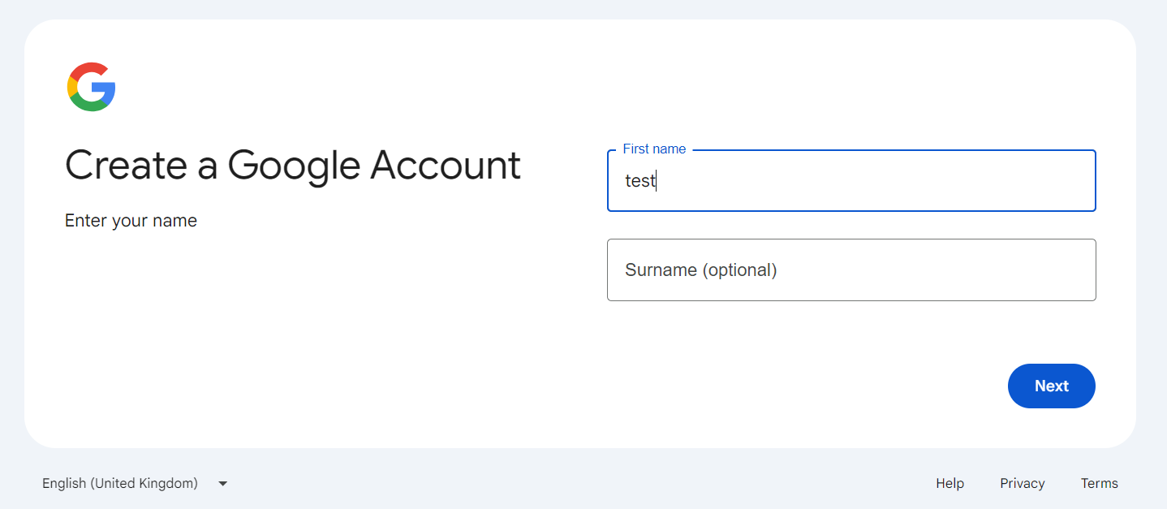
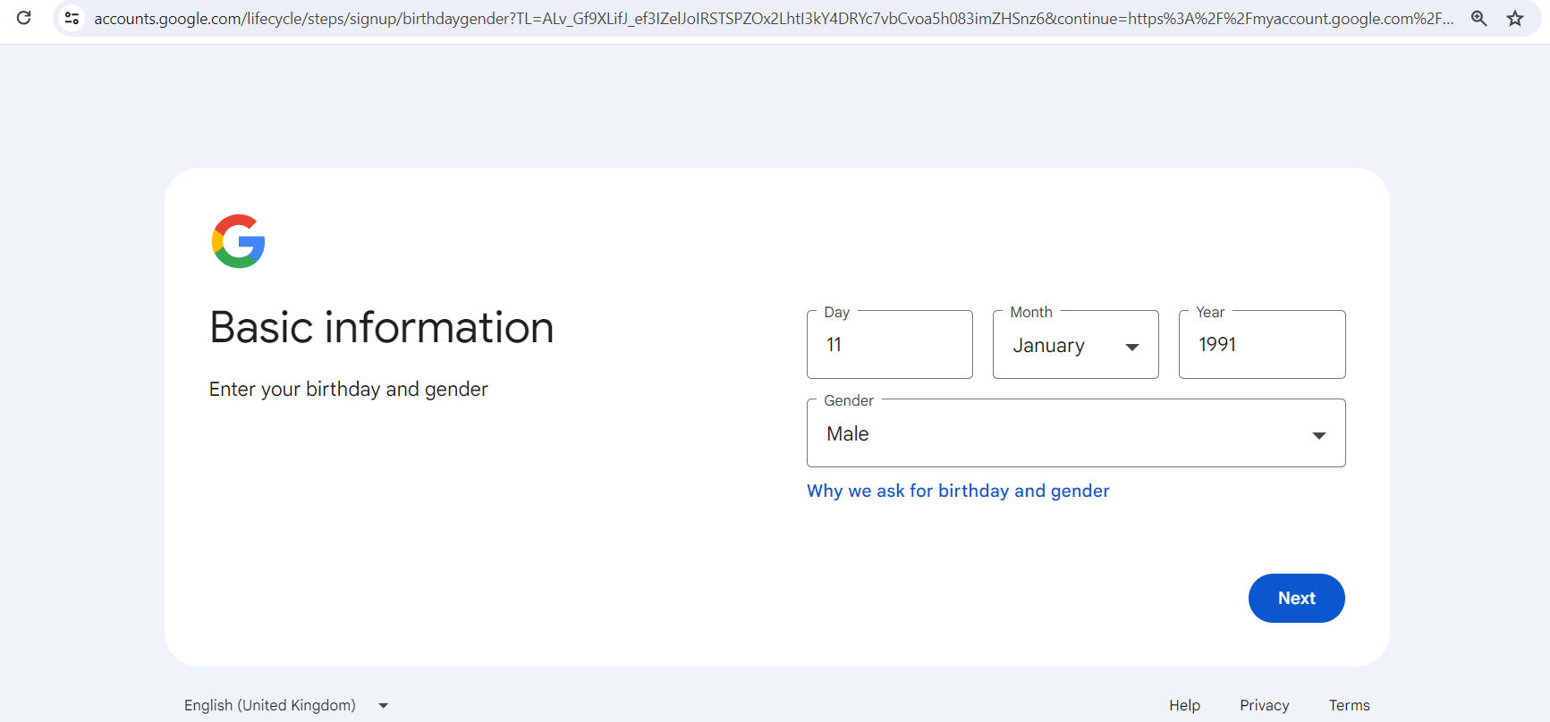

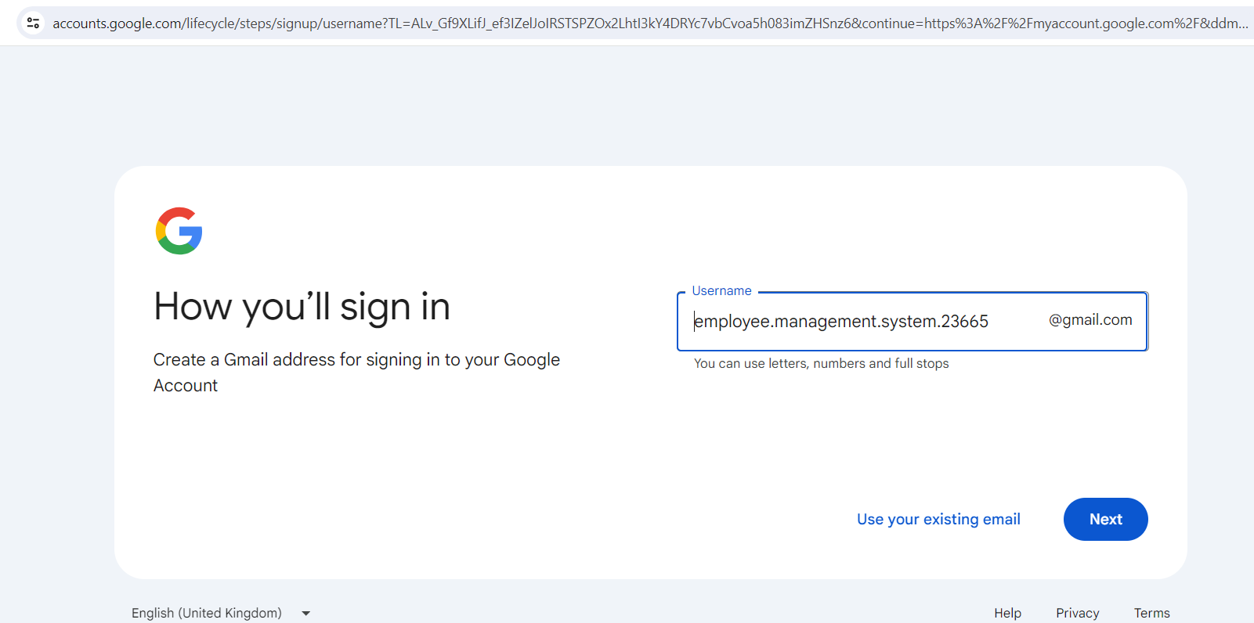
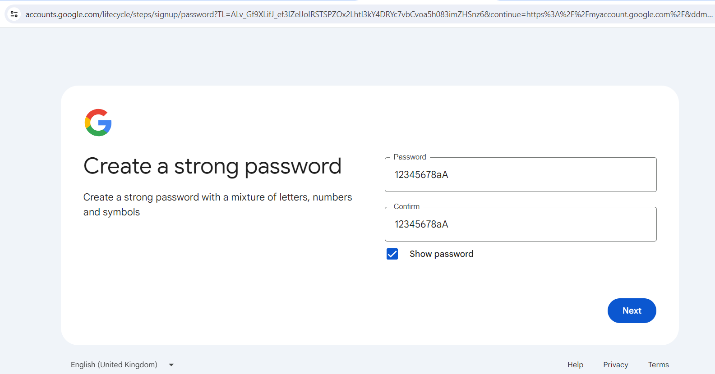
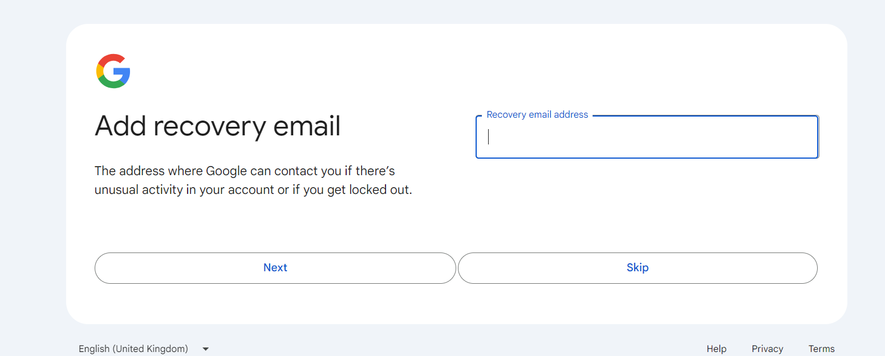

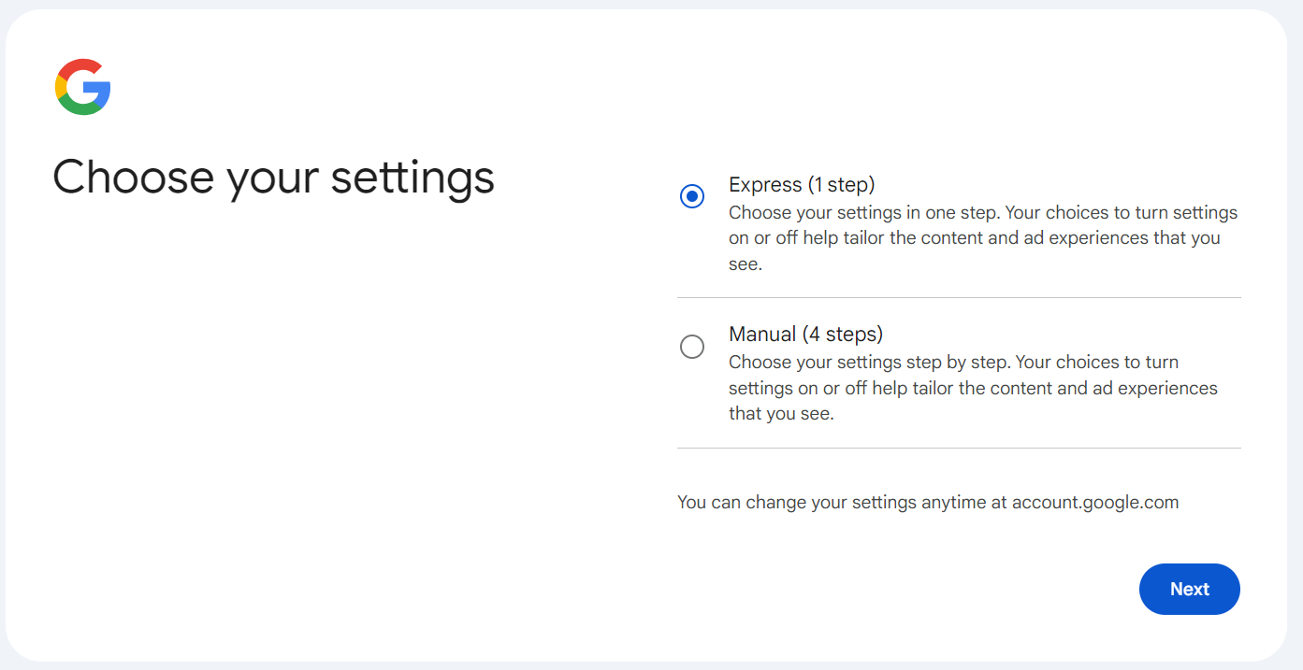
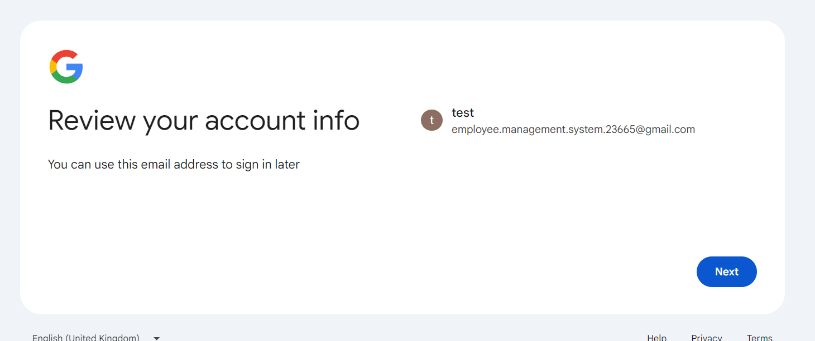

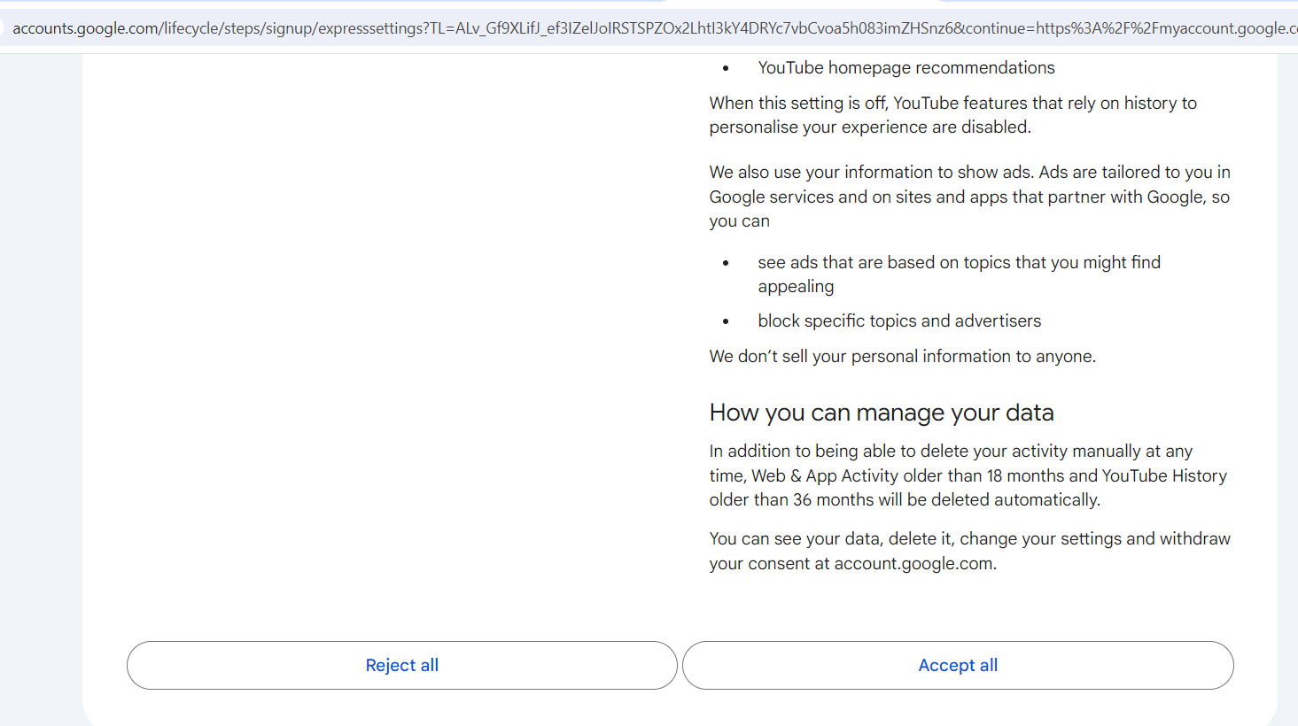
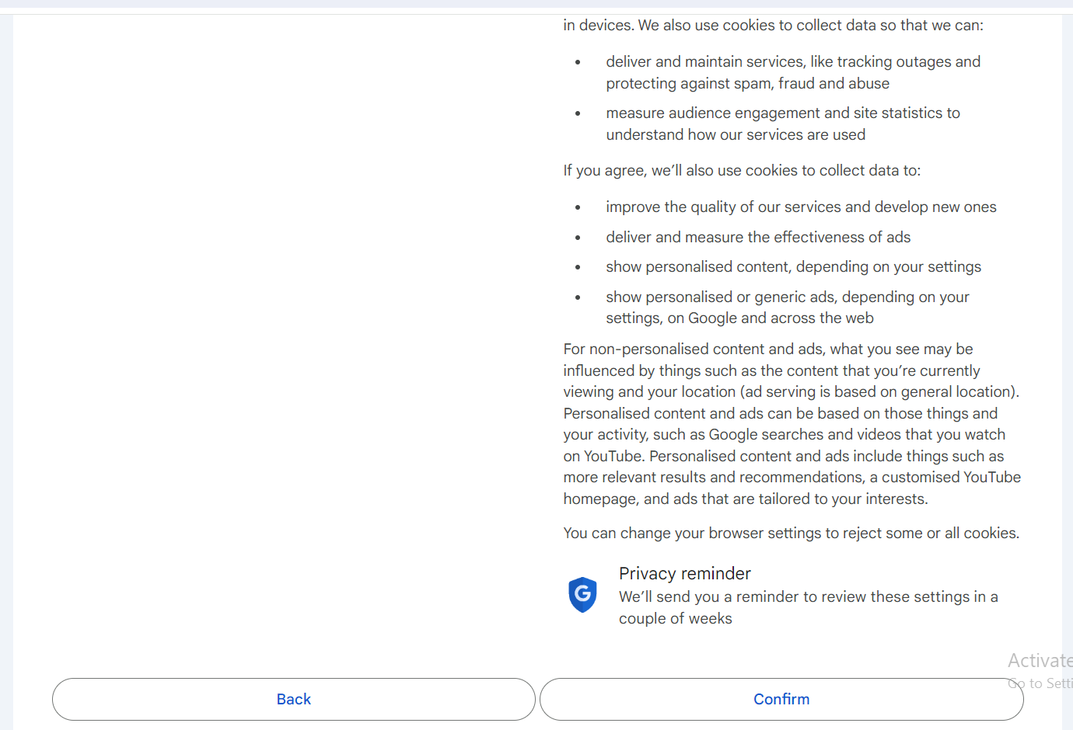
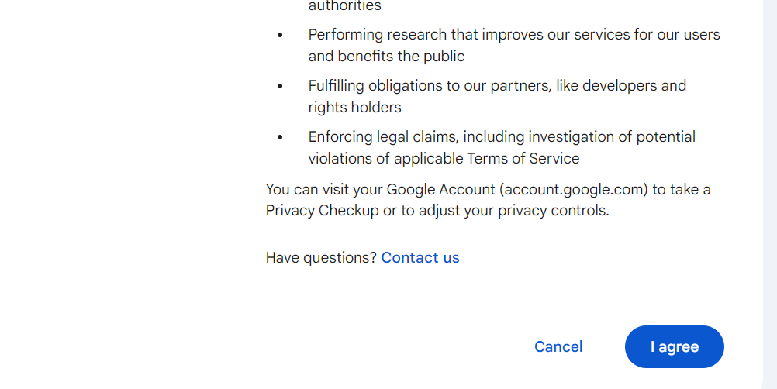
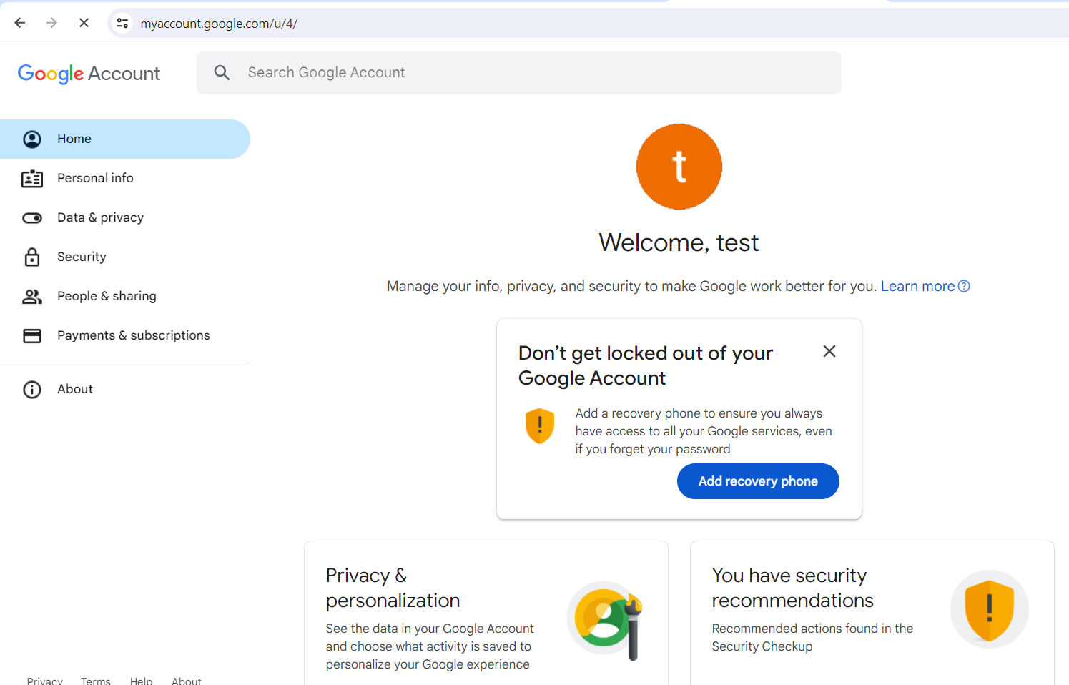

Project creation
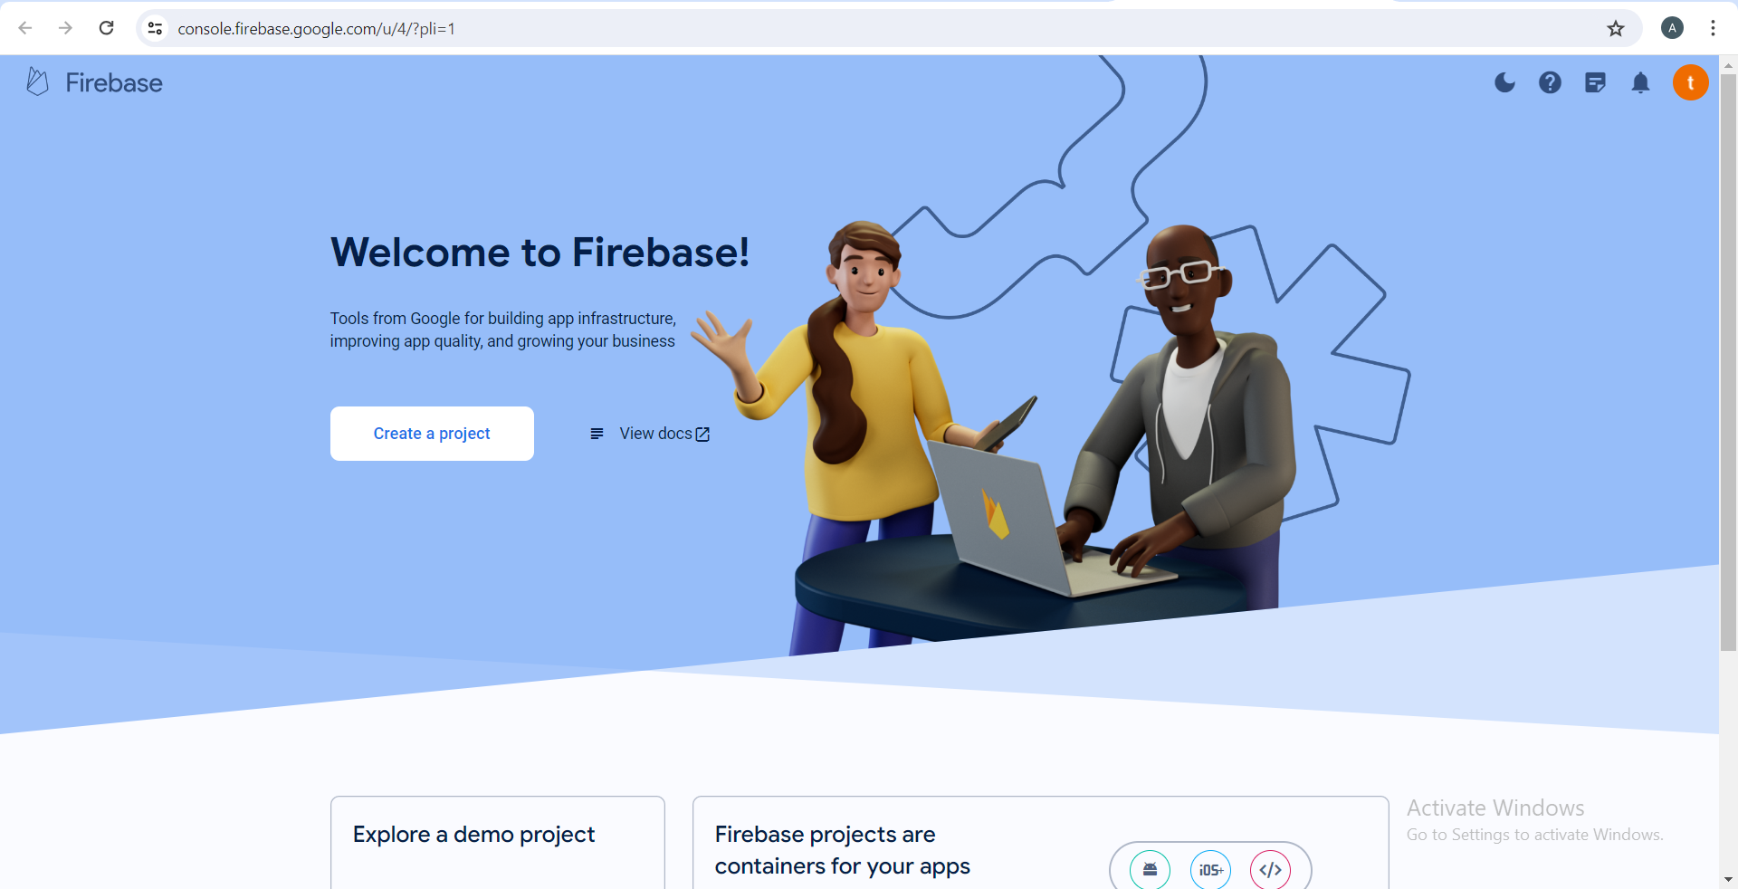



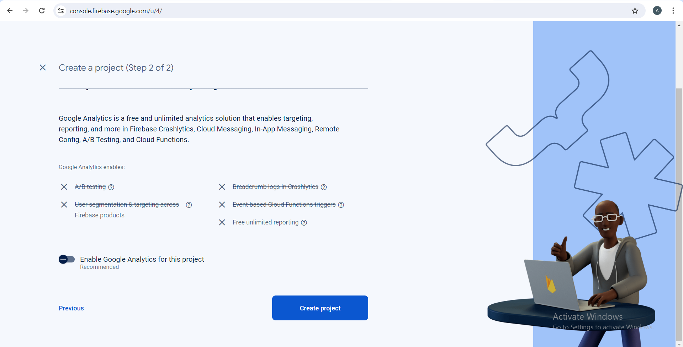
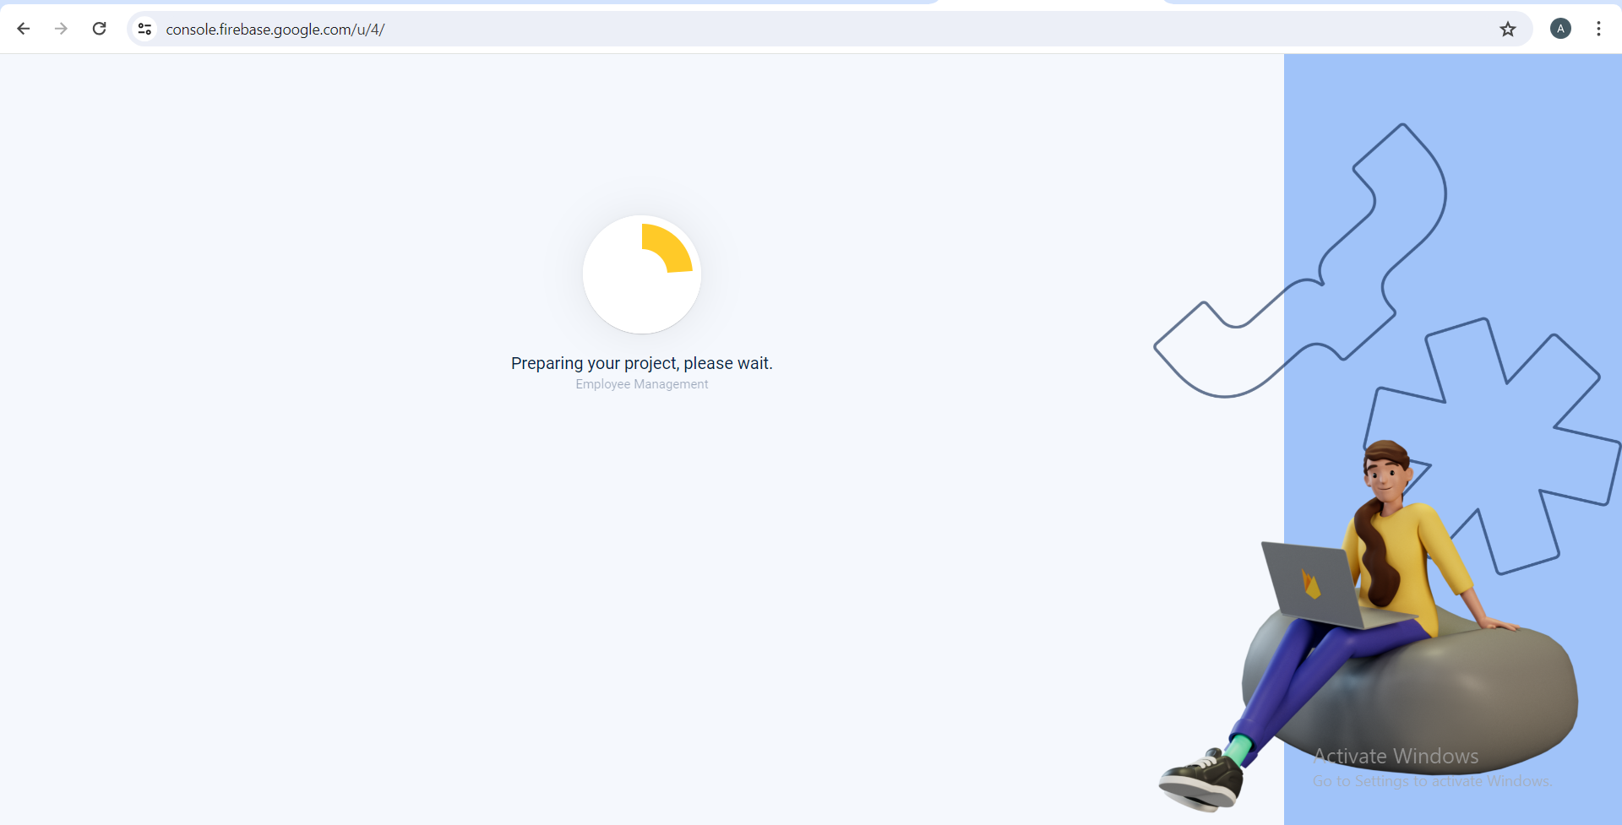

Hosting server administrator data
Login to Gmail account.
Admin id: | employee.management.system.23665 @gmail.com
Admin password: | 12345678aA
Hosting service url address: | https://console.firebase.google.com/

Application installation
- Save the hello world folder. For example in C:/
- Open Command Prompt.
- Run command cd(path of hello world folder you saved), for example cd c:/Mohammed_Web_960101/hello_database
- Run command firebase login
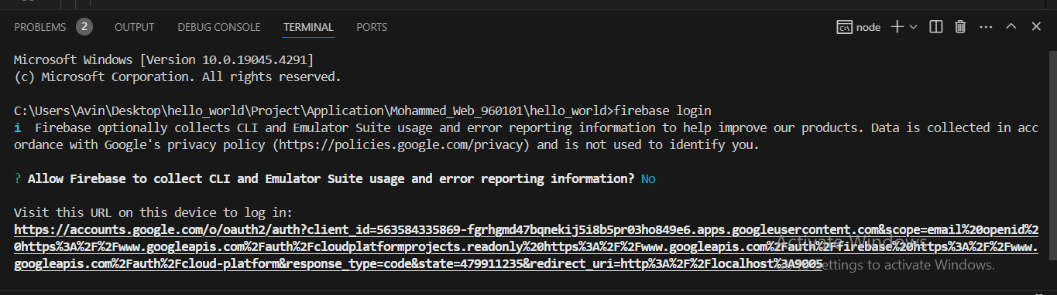
- enter above Firebase account credentials.
- choose create project or choose your project.
- We write the email then click next.
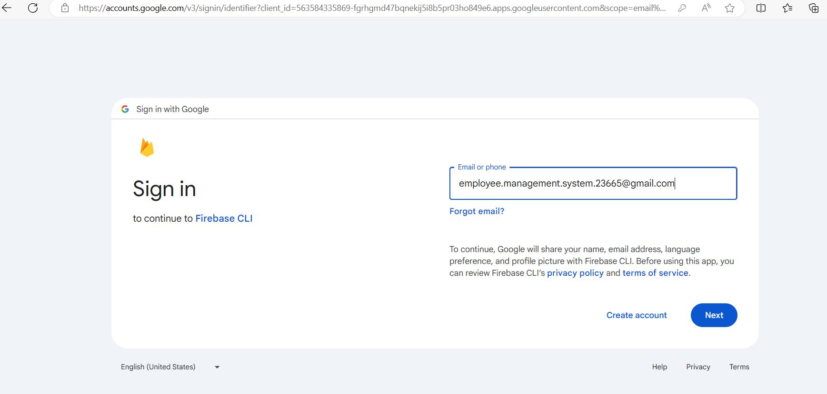
- We enter the password then click next.
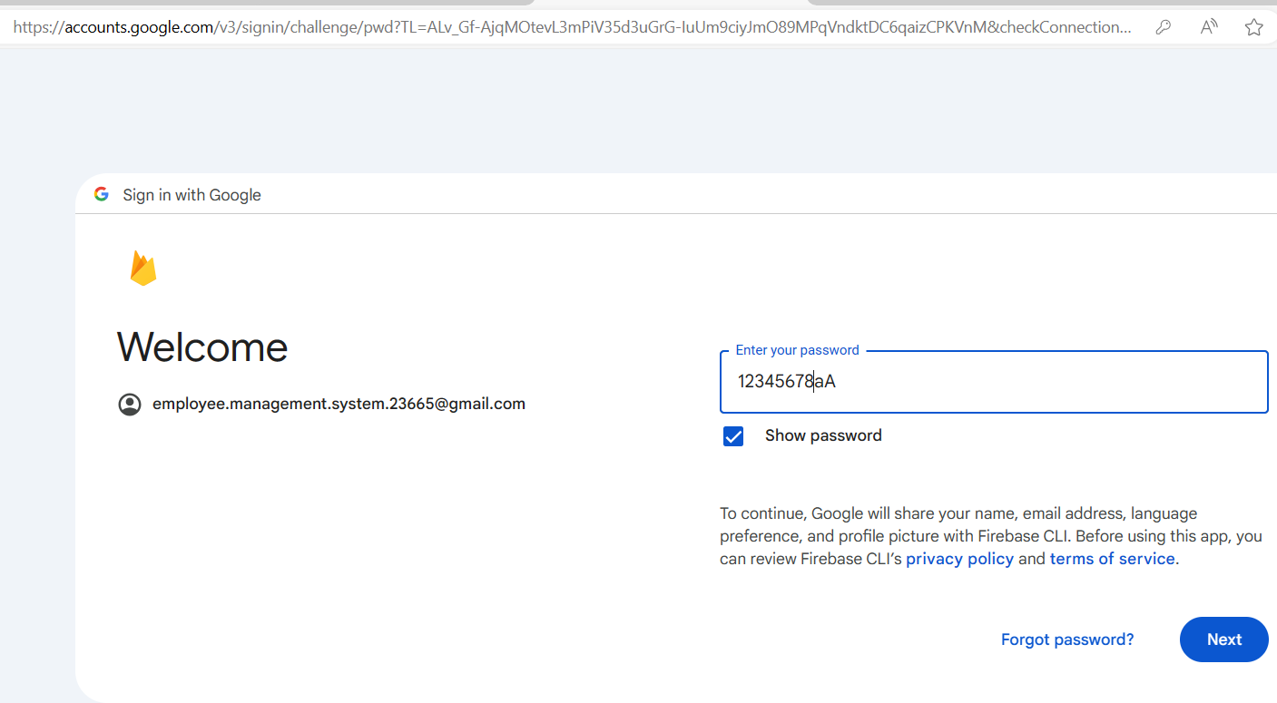

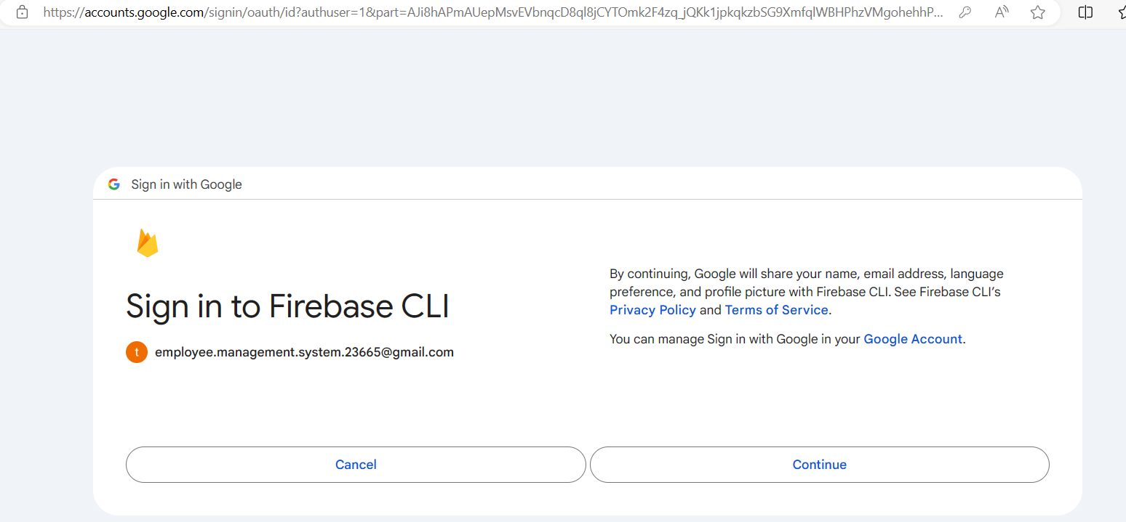
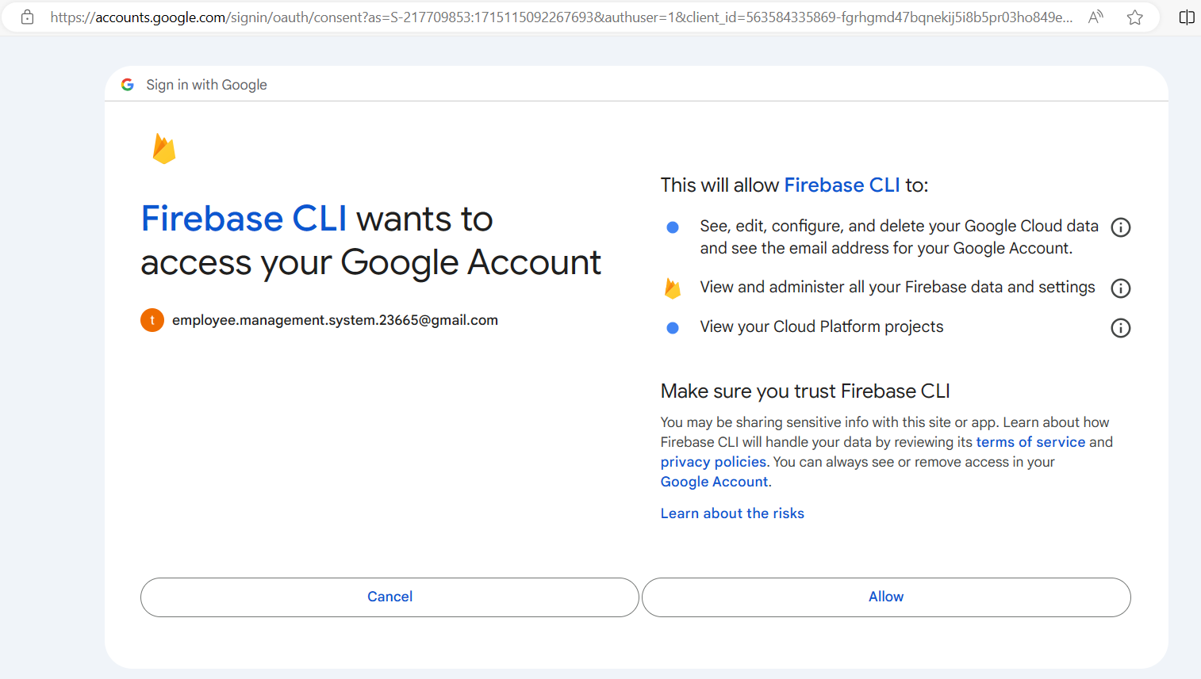
- Press allow.

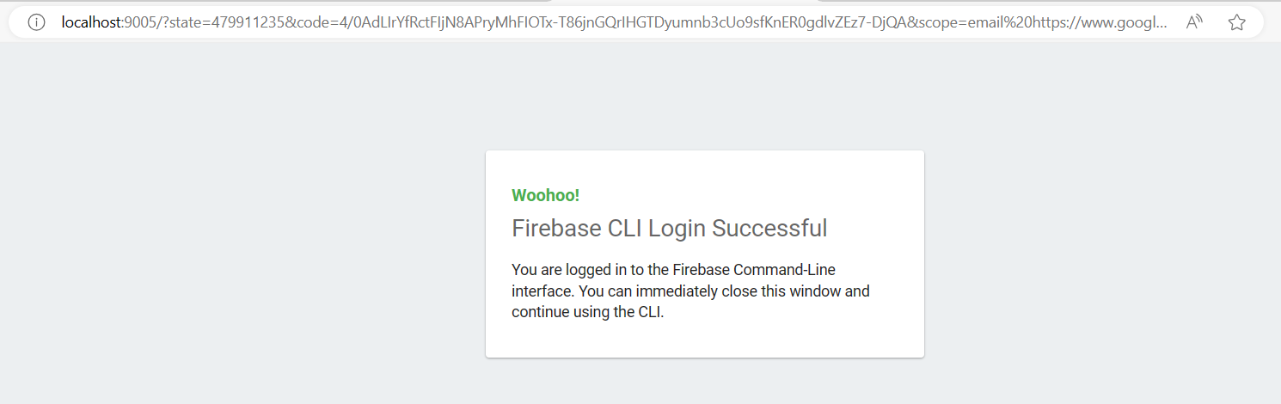

- Run command firebase init
- Select the features you want to use, in our case firestore and firebase hosting.
- Follow the steps inside the picture.
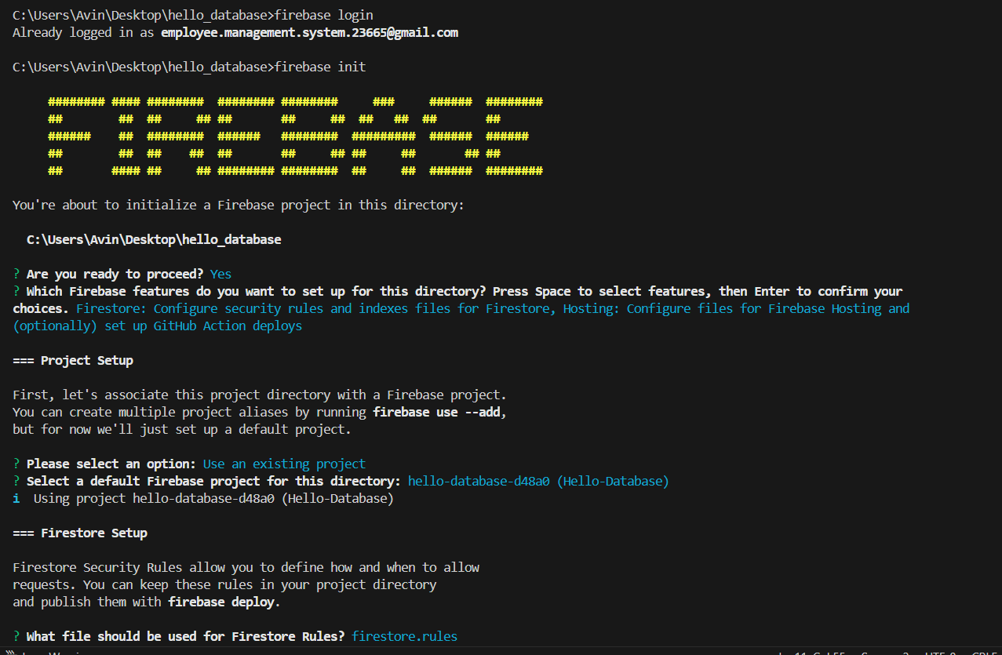
- Follow the steps inside the picture
- Run command flutter pub get
- Run command flutter build web
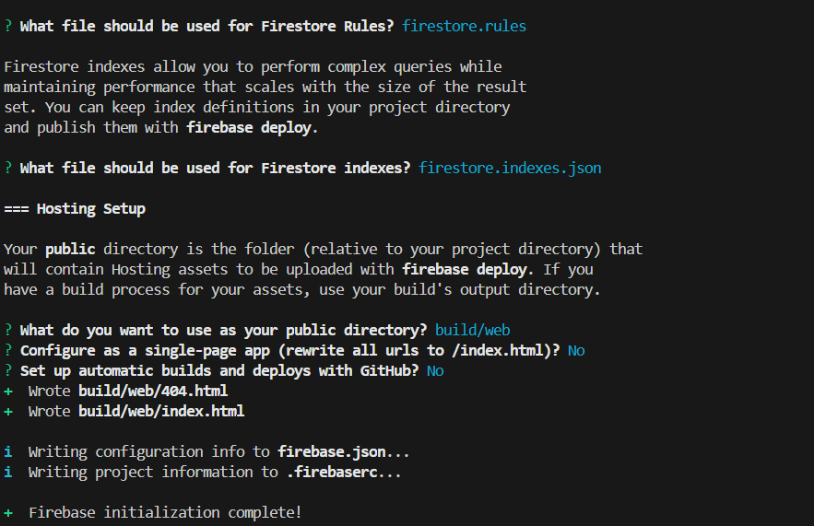
- Run command firebase deploy

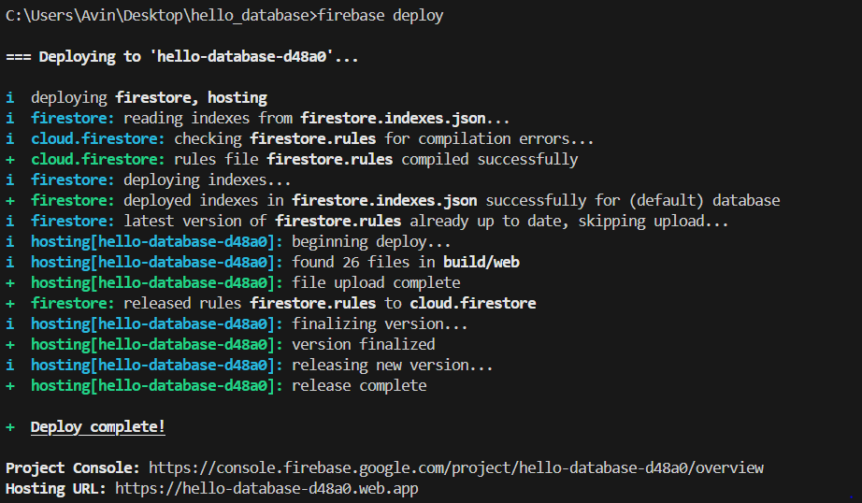

Running the application on Internet

Internet address

Internet address of the application: | https://hello-database-d48a0.web.app

Application manual

Permissions
Not Applicable

User manual
Not Applicable

