Title: Vertigo – Investigating the Dynamics of Theme Park Rides
Abstract: The safety of theme park rides were analysed and compared to existing studies on the human body using Vertigo, a data logger. For a ride Stealth, the experienced G-Force was found to be 2.8g for 0.2s, which in comparison to Robert V. Brulle’s work is 16.4% of the maximum human tolerance. We calculated jerk to be minimal throughout the ride, reaching a maximum of 0.28ms⁻³, reducing uneven forces and potential back problems. Without regard to structure, we therefore concluded that the rides were safe.
Introduction: Vertigo is an inertial data logger, which measures its acceleration in orthogonal IMUs (Inertial Measurement Units), its position in GPS, ie. polar coordinates and its rate of rotation in degrees per second. What makes Vertigo interesting is it constantly uses the Earth’s magnetic field to detect North, and gravity to detect downwards, which means that Vertigo converts what it experiences into a world frame. This is stored as a quaternion in the form (w,x,y,z) where w is the scalar rotational quantity and x, y and z represent a unit length vector of the quaternion that transforms the board frame into the world (NED) frame. It takes IMU, gyrometer and GPS measurements at a frequency of 100Hz.
Analysis
We were invited to Thorpe Park to present at the Angry Birds theatre as part for the Institute for Research in Schools. We found this to be a great opportunity to collect data on theme park rides because of their extreme yet controlled nature. After collecting data on multiple rides, we chose to do our analysis on the ride Stealth, as it could be easily understood but there was still room to analyse and explore.
Mapping:
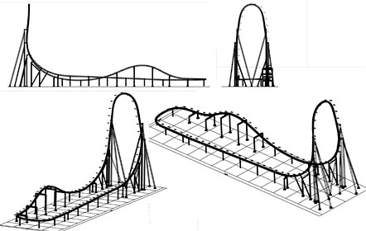
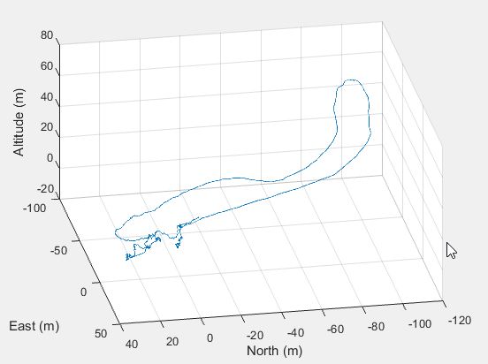
Vertigo measures its position by GPS but it also measures its acceleration, which can be integrated twice to work out the distance moved. Doing this, we now had two sets of values for position. As GPS was only accurate to a 2m by 2m by 2m cube, and at the time of measurement the iteration of Vertigo only recorded GPS every 0.1 seconds and acceleration was prone to drift as we were integrating twice without known constants.
Therefore, we decided to use a Kalman filter. This works by predicting the next position including associated uncertainty using the defined variables that account for noise. It then updates the position variable and the uncertainty variables with the predicted values and the cycle repeats. One problem that we encountered while running the Kalman filter is that high altitudes can lead to unreliable GPS data and high velocities can cause the filter to reset its position, leading to a zigzag.
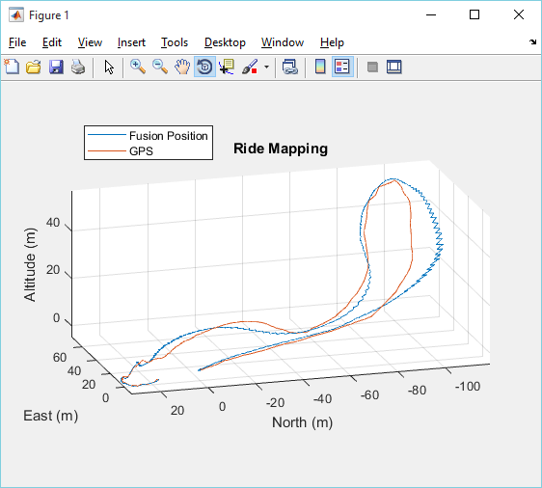
We then decided to adjust the weighting of the Kalman filter such that if the velocities were high, it would be weighted predominantly on the GPS data set, whereas if the GPS had anomalous data due to high altitude, it would be weighted heavily on the IMU data.
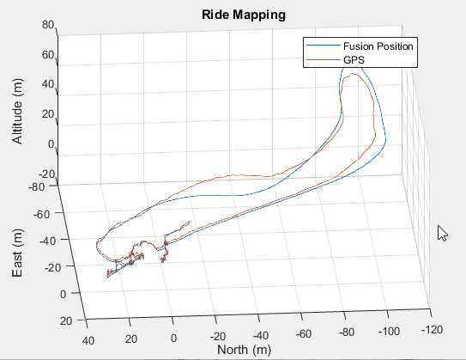

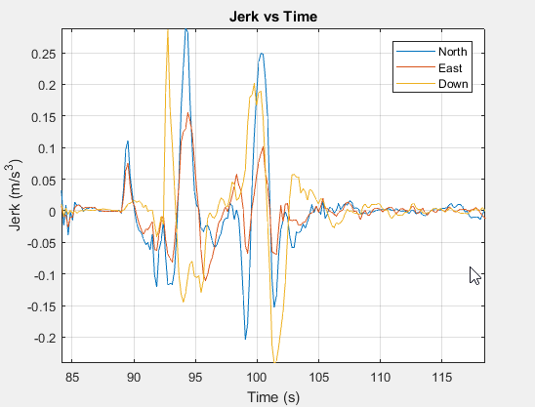

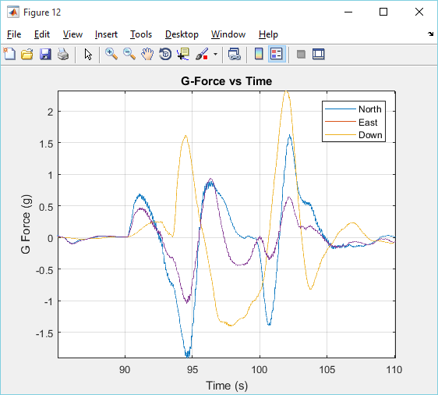
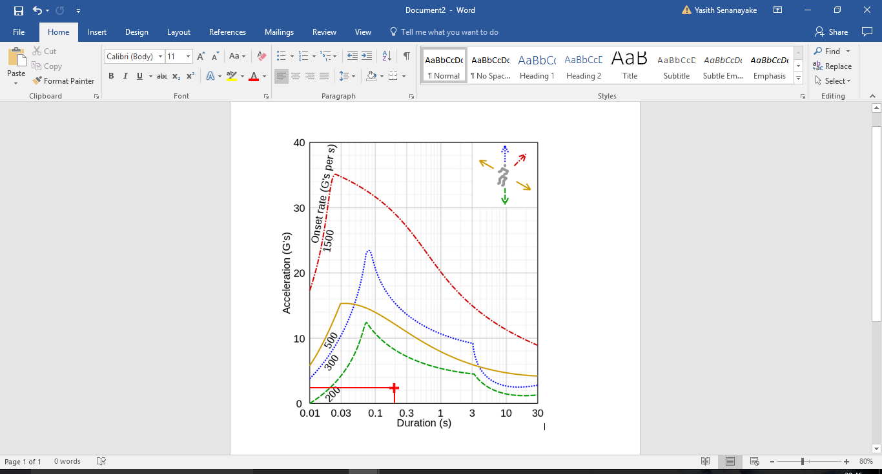
Safety Analysis
Robert V. Brulle (2008). Engineering the Space Age: A Rocket Scientist Remembers

To measure safety, we decided to compare the experienced G-Force with an existing study on the human body’s tolerance to linear acceleration.
We did this by looking at the acceleration in three orthogonal axes, North, East and Down on Stealth, a ride at Thorpe Park. There are two large spikes in down acceleration, with dips in north and east acceleration. This is as expected as the track starts of flat, then enters a steep climb with little movement in the North and East Directions, into a similarly steep drop. The maximum G-Force in any direction is 2.3G for 0.2 seconds. In comparison with a study by Robert V. Brulle, the experienced G-Force is 19.2% of the maximum tolerance in the same direction.
In addition, we also looked at jerk as it must be minimised to reduce uneven forces which can lead to back pains as well as cause the structural integrity of a ride to deteriorate more quickly. Some rides however, such as Rattlesnake at Chessington World of Adventures incorporate jerk into their rides to create a different experience. For most of the duration of the ride, the jerk remains at 0 but there are two spikes in all three vectors corresponding to the uphill and downhill sections of the ride reaching a maximum of 0.28ms⁻³ in the North and East Directions. This level of jerk is reasonable in a ride as a constant acceleration to a maximum velocity would result in an extremely high jerk which would be potentially unsafe.
The uncertainty in our measurements for safety that we needed to account for was any slight movement for Vertigo whilst strapped in, which could cause acceleration to show up on Vertigo. We could see this in our results as the results went slightly up and down. By looking at the amplitude of these oscillations, we calculated our uncertainties for each quantity.
Quantity | Percentage Uncertainty
Jerk | 7.1%
Acceleration | 3.2%
Velocity | 4.3%
Displacement | 6.0%

