Classification
This section describes the classification stage of the project, its evaluation and the detection of profiles that appear to be recorded with the wrong human/non-human label, which is the central aim of the assignment. All results can be reproduced with classification.py, which reads the cleaned account-level table produced in the Data Preparation stage.

Feature representation
The features cover several views of a profile, which the dataset provides in different data types:
- Behaviour (numeric): log-transformed favourites, tweet count and account age, tweets and favourites per day, and whether the sampled tweet was retweeted. The log transform reduces the very strong right skew of these counts.
- Colour (numeric): red, green and blue components and brightness of the link and sidebar colours, plus a flag for the suspicious "0" colour values found during data preparation.
- Text statistics (numeric): length and word count of the description and tweet, and the number of URLs, mentions and hashtags in each.
- Text content: the cleaned profile description and tweet, each converted separately into TF-IDF vectors of single words and two-word phrases (up to 5,000 terms each, English stop words removed, terms appearing in fewer than 3 accounts ignored). TF-IDF gives a high weight to words that are frequent in one profile but rare across profiles, so distinctive words such as "news" or "official" stand out.
Numeric features were standardised (mean 0, standard deviation 1) so that features with large ranges do not dominate the linear models.

Model selection
We first tested seven classifiers covered in the Week 5 lecture on the same training and test data. Table 1 summarises their test-set performance. Macro F1 averages the F1 score of both classes, so it is not inflated by the majority human class, and ROC-AUC measures how well each model ranks human above brand profiles regardless of the decision threshold.
Model | Features | Accuracy | Macro F1 | ROC-AUC
Linear SVM | All | 0.886 | 0.848 | 0.937
Logistic Regression | All | 0.874 | 0.844 | 0.939
Naive Bayes | Text | 0.889 | 0.843 | 0.928
Random Forest | Numeric | 0.849 | 0.797 | 0.901
Multi-layer Perceptron | Numeric | 0.835 | 0.789 | 0.892
K-nearest neighbours (k = 15) | Numeric | 0.833 | 0.764 | 0.875
Decision Tree (depth 3) | Numeric | 0.782 | 0.748 | 0.854
Table 1. Test-set performance of the seven classifiers tested initially.
The three best models, Naive Bayes, Logistic Regression and Linear SVM, all use the text content, while the four weaker models use only numeric features. This already indicates that what a profile writes is the strongest signal of whether it is a person or an organisation. KNN and the Decision Tree were tuned before this comparison: KNN performed best at k = 15 (smaller k was sensitive to noise, larger k blurred the classes), and the Decision Tree performed best at depth 3, because deeper trees fitted the training data almost perfectly while their cross-validated score fell, a clear sign of overfitting. The three best models were kept for the detailed analysis below.

The three classifiers
Naive Bayes. Naive Bayes applies Bayes' theorem and assumes that each feature is conditionally independent of the others given the class. The class score is the prior probability of the class multiplied by the probability of each word given the class, and the class with the higher score is predicted. We used the multinomial variant on the TF-IDF text only, because it models word frequencies and requires non-negative inputs. The lecture recommends Naive Bayes for high-dimensional problems such as text, where there are thousands of word features. Laplace smoothing (alpha = 0.5) was applied so that a word never seen in one class during training does not force that class's probability to zero.
Logistic Regression. Logistic regression models the probability that a profile is human as a logistic function of a weighted sum of all features. It was selected because the lecture's summary of classifiers recommends it when the data contains mixed variable types, when class probabilities are needed, and when analysts want insight into how variables affect the prediction. All three conditions apply here: we combine numeric and text features, we need probabilities for mislabel detection, and the model's weights show which words indicate each class (Figure 3). The option class_weight = "balanced" gives brand errors more weight during training to offset the class imbalance.
Linear Support Vector Machine. An SVM, listed in the lecture among the additional classification models, finds the boundary that separates the two classes with the largest possible margin. A linear kernel was used because TF-IDF data has many more features than a nonlinear kernel can handle efficiently, and text classes are usually close to linearly separable in that space. A standard SVM gives no probabilities, so its outputs were calibrated with 3-fold cross-validation to produce them for the ROC curve and mislabel detection. The same class weighting as logistic regression was used.

Results
Table 2 shows the performance of the three models on the 3,937 held-out test accounts. Precision, recall and F1 are macro averages over the human and brand classes.
Model | Accuracy | Precision | Recall | F1 | ROC-AUC
Naive Bayes | 0.8890 | 0.8890 | 0.8150 | 0.8426 | 0.9283
Logistic Regression | 0.8740 | 0.8323 | 0.8591 | 0.8438 | 0.9389
Linear SVM | 0.8857 | 0.8591 | 0.8389 | 0.8482 | 0.9365
Table 2. Test-set results of the three selected classifiers.
All three models reach around 87 to 89% accuracy and an AUC above 0.92, so they separate human and brand profiles well. They also reach this in different ways. Naive Bayes has the highest accuracy and precision but the lowest recall: it favours the majority human class and misses more brand profiles. Logistic Regression has the lowest accuracy but the highest recall and the highest AUC, because its class weighting makes it catch more brand accounts at the cost of some false alarms. Linear SVM lies between the two and has the best balance, giving the highest F1.
Accuracy alone would be misleading for this data. A model that predicted "human" for every profile would already score about 74%, so the macro-averaged scores and AUC, which treat both classes equally, are better guides. The confusion matrices in Figure 1 show where each model makes its errors, and the ROC curves in Figure 2 show that all three models rank profiles far better than chance at every threshold.
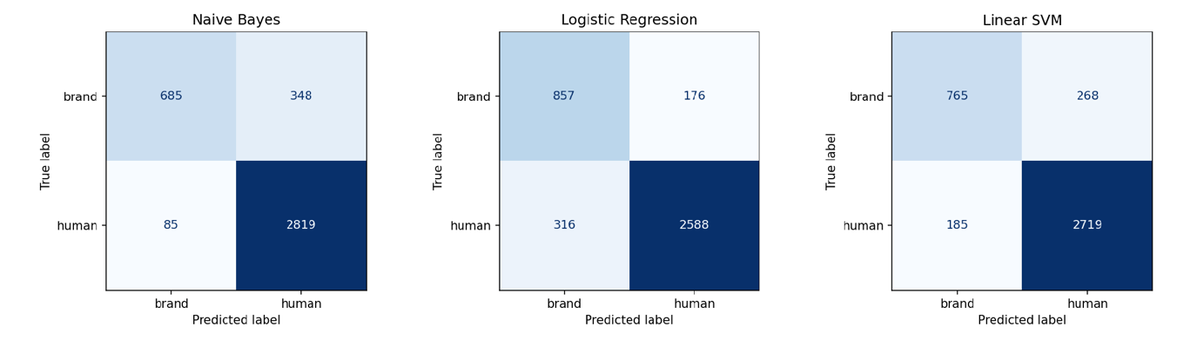
Figure 1. Confusion matrices of the three classifiers on the test set.
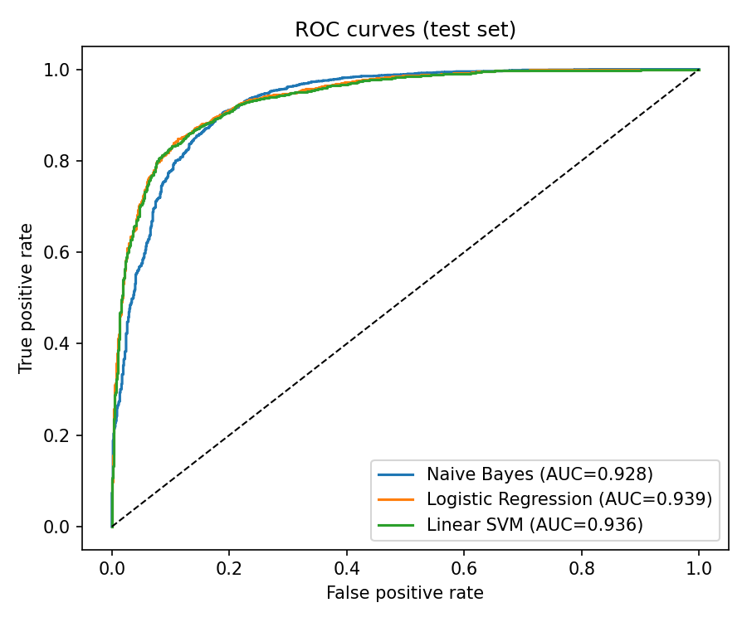
Figure 2. ROC curves of the three classifiers on the test set.

What the models learned
Figure 3 shows the words with the largest logistic regression weights. Words in profile descriptions such as "news", "official", "community", "station" and "service", and tweets about weather updates, point strongly to brand accounts. Words describing a person, such as "love", "lover", "writer", "author", "photographer" and "blogger", point to human accounts. These patterns match intuition: organisations describe what they provide, while people describe who they are and what they like. This supports the conclusion that text is the most informative view of a profile, which is examined further in Task 4.
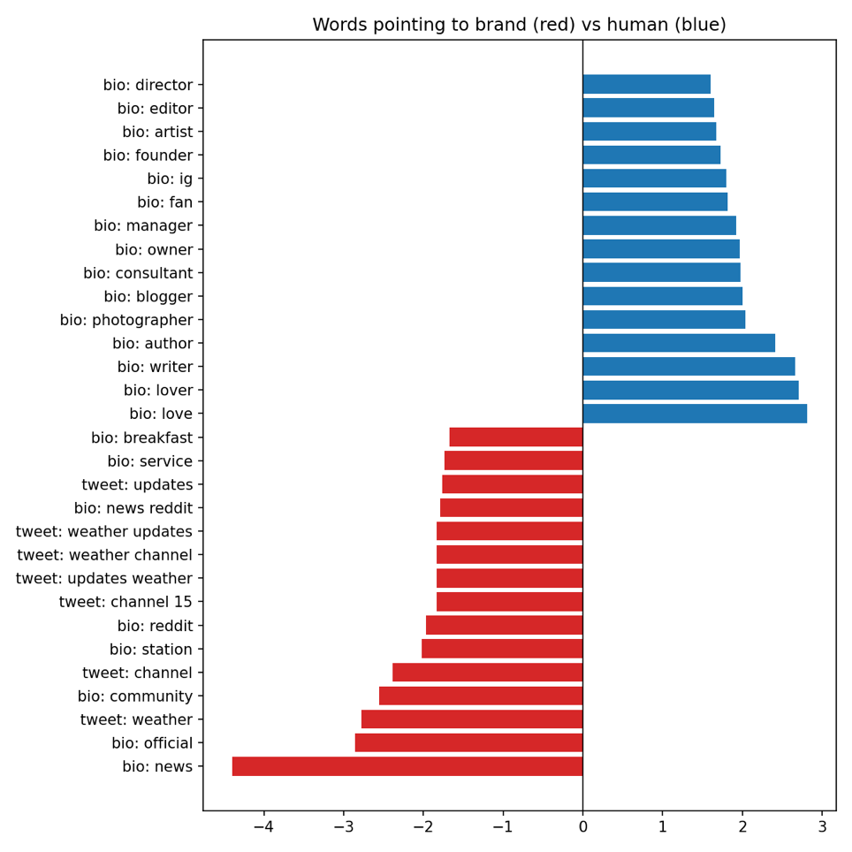
Figure 3. Words most strongly associated with brand (red) and human (blue) profiles.

Detecting mislabelled profiles
To find likely mislabels, every labelled account (not only the trusted ones) was scored by models that had never seen it. The 17,678 labelled accounts were divided into five folds. For each fold, the three classifiers were trained on the trusted accounts in the other four folds and then predicted the probability that each account in the held-out fold is human. This out-of-fold approach matters: a model that had trained on an account would simply repeat its recorded label.
An account was flagged as a likely mislabel when two conditions held. First, the three models on average were at least 80% confident that the recorded label is wrong. Second, none of the three models supported the recorded label. Requiring agreement between three different kinds of model reduces the chance that one model's weakness produces a false flag.

