Southeast University

Department Of Computer Science & Engineering

**Project Name :** Employee Management system

**Course Title:** Web and Internet Programming

**Course Code:** CSE471.1

**Submitted By:** Abid Hasan Chowdhury  
 Id: 2019100000018  
   
 Chelsea Rifat Oaishi  
 Id:2019100000005

Zahid Hasan

Id:2019100000015

Project Proposal

**Scenario of our application :**

Employee Management system is an application that enables users to create and store Employee Records. This application will allow admin to add new employees. The admin can view the list of employee details. The admin can edit and delete employee information. The admin can assign projects and check projects status .Database should store all personal details of employees such as name, email, birthday, gender, contact number, nid number, address, salary, degree, photo etc. In order to login as an employee, the user has to fill up the login form. The employee can submit the assigned projects, view and update their owns profile.

**Business process diagram:**

**Admin:**

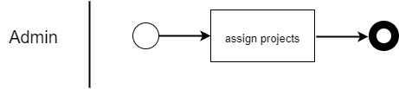

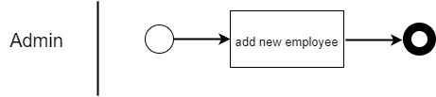

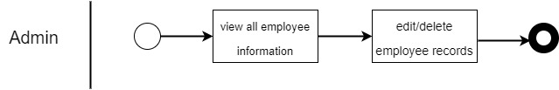

**Employee:**

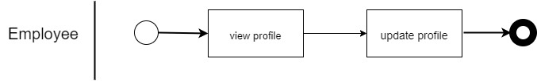

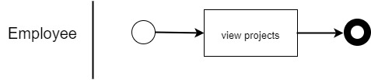

**Stakeholder :**

Internal Stakeholder

1. employees
2. Admin or managers

**Activity diagram:**

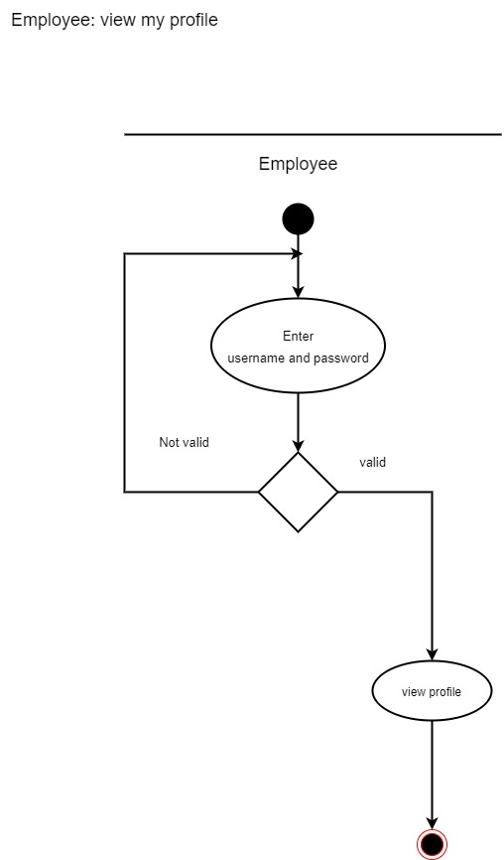

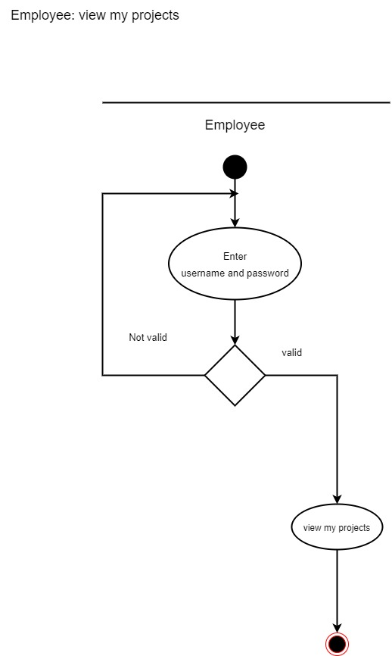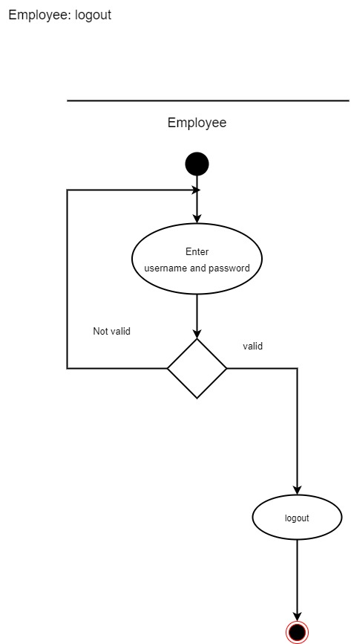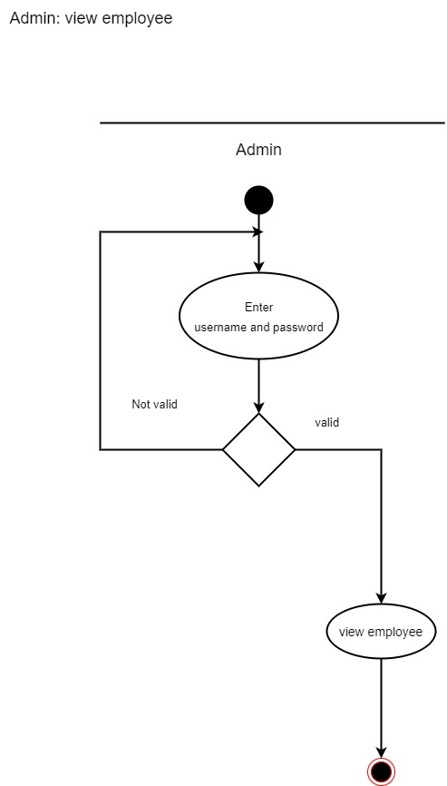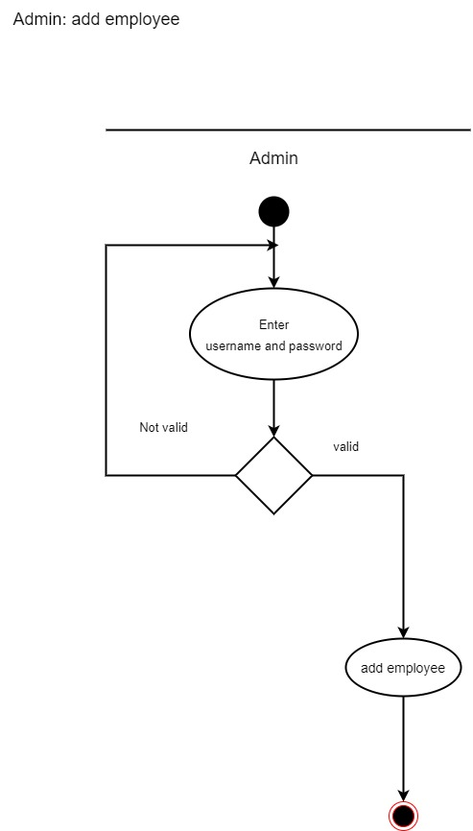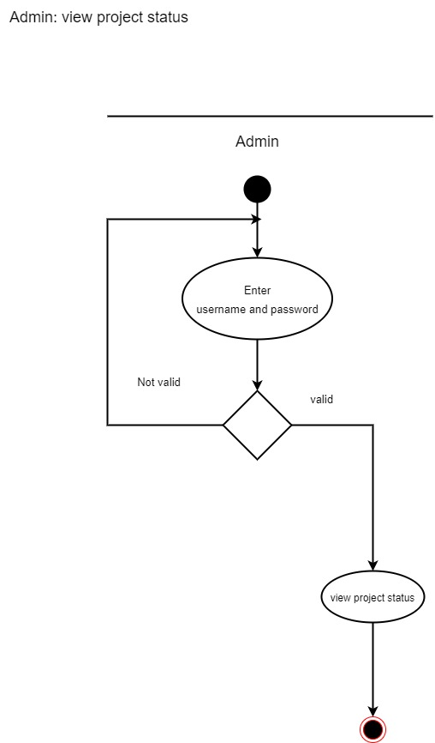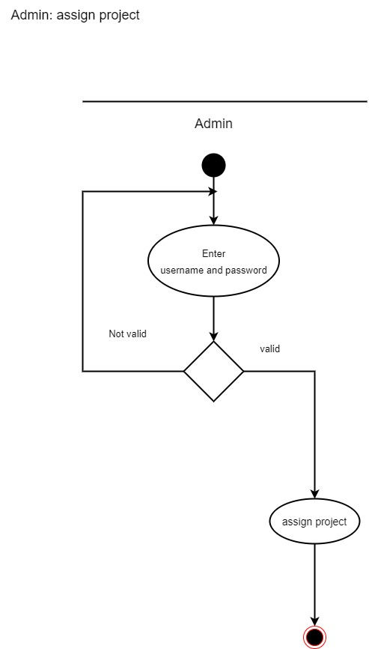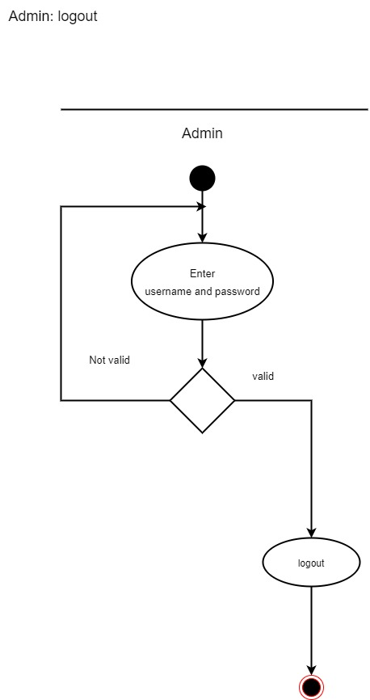

**ER diagram :**

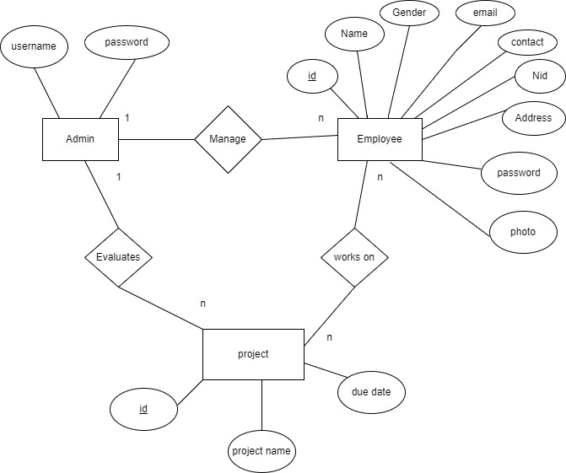

**Class diagram :**

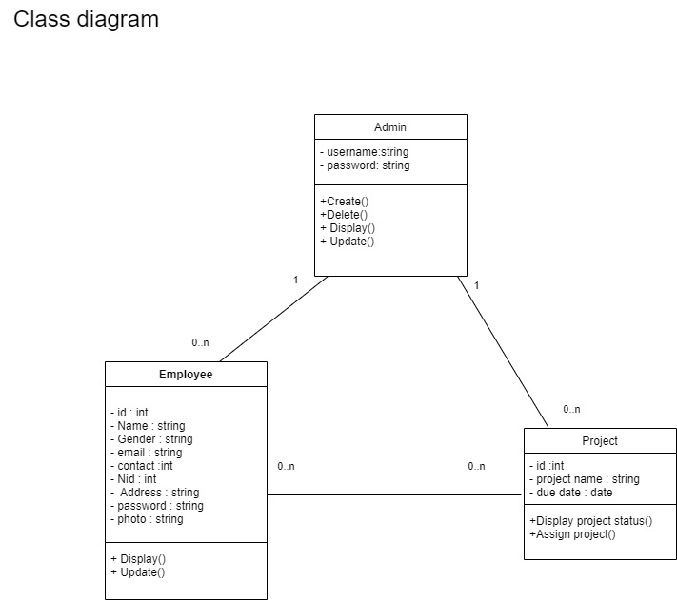

**GUI (Graphical user interface** ) :

**Admin Login:**

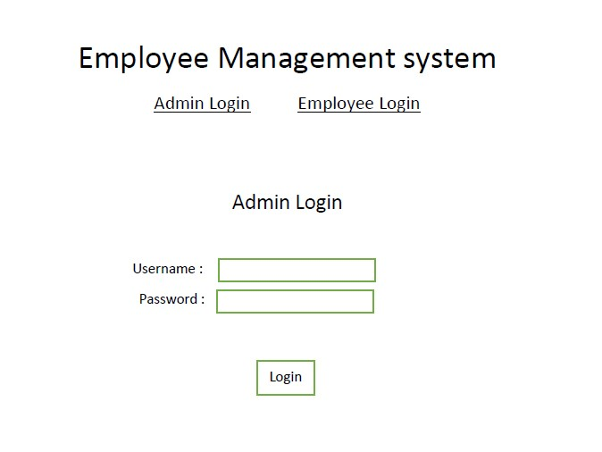

**Employee Login:**

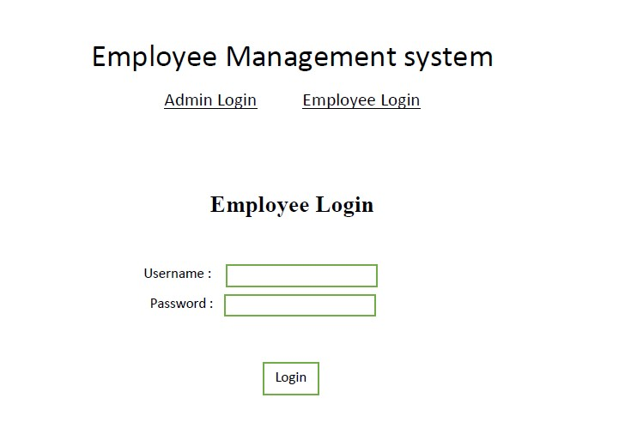

**Admin Page :**

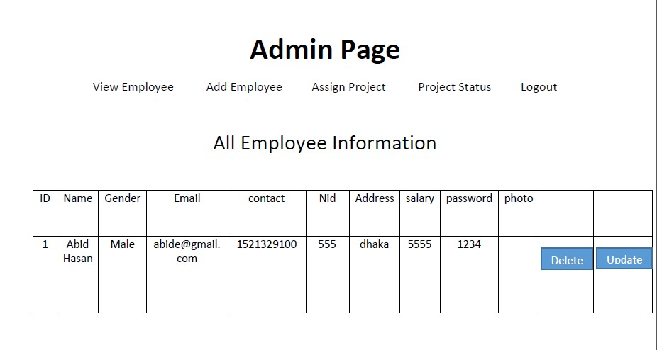

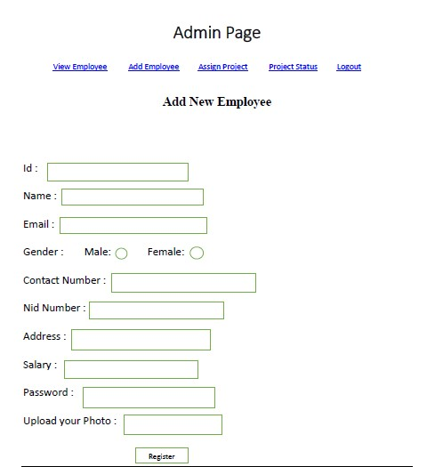

**Employee page:**

