Ministerul Educaţiei al Republicii Moldova

Universitatea Tehnică a Moldovei

ATI

RAPORT

Lucrarea de laborator nr.7
la Programarea în Windows

A efectuat:
st. gr. TI-154 Suruceanu Valentin

A verificat:
conf.univ.dr. Lisnic Inga

Chişinău - 2017

Lucrarea de laborator nr.7

Tema: Implementarea laboratoarelor 1-6 în C#

Scopul lucrării
De a studia metodele şi principiile de lucru al limbajului C#
Sarcină
1. De realizat laboratoarele 1-6 în C#.

Noţiuni principale din teorie:
C# (pronounced "C sharp") is a programming language that is designed for building a variety of applications that run on the .NET Framework. C# is simple, powerful, type-safe, and object-oriented. The many innovations in C# enable rapid application development while retaining the expressiveness and elegance of C-style languages.

Typing
C# supports strongly typed implicit variable declarations with the keyword var, and implicitly typed arrays with the keyword new[] followed by a collection initializer.C# supports a strict Boolean data type, bool. Statements that take conditions, such as while and if, require an expression of a type that implements the true operator, such as the Boolean type. While C++ also has a Boolean type, it can be freely converted to and from integers, and expressions such as if(a) require only that a is convertible to bool, allowing a to be an int, or a pointer. C# disallows this "integer meaning true or false" approach, on the grounds that forcing programmers to use expressions that return exactly bool can prevent certain types of programming mistakes such as if (a = b) (use of assignment = instead of equality ==, which while not an error in C or C++, will be caught by the compiler anyway).C# is more type safe than C++. The only implicit conversions by default are those that are considered safe, such as widening of integers. This is enforced at compile-time, during JIT, and, in some cases, at runtime. No implicit conversions occur between Booleans and integers, nor between enumeration members and integers (except for literal 0, which can be implicitly converted to any enumerated type). Any user-defined conversion must be explicitly marked as explicit or implicit, unlike C++ copy constructors and conversion operators, which are both implicit by default.The C# language does not allow for global variables or functions. All methods and members must be declared within classes. Static members of public classes can substitute for global variables and functions.

Methods and functions
Like C++, and unlike Java, C# programmers must use the keyword virtual to allow methods to be overridden by subclasses.Extension methods in C# allow programmers to use static methods as if they were methods from a class's method table, allowing programmers to add methods to an object that they feel should exist on that object and its derivatives.The type dynamic allows for run-time method binding, allowing for JavaScript-like method calls and run-time object composition.C# has support for strongly-typed function pointers via the keyword delegate. Like the Qt framework's pseudo-C++ signal and slot, C# has semantics specifically surrounding publish-subscribe style events, though C# uses delegates to do so.

Namespace
A C# namespace provides the same level of code isolation as a Java package or a C++ namespace, with very similar rules and features to a package.

Listingul programului:(din laboratorul 1, secvențe principale)
namespace PW_Labs_Csharp
{
public partial class Form_lab1 : Form
{
public Form_lab1()
{
InitializeComponent();
}

private void Form_lab1_Load(object sender, EventArgs e)
{
SoundPlayer simpleSound = new SoundPlayer(Properties.Resources.musical002);
simpleSound.Play();
text_label.Text = "Lucrarea de laborator al studentului Coroletchi Octavian grupa TI-154";
//text_label.Left = 200;
}
}
}
Listingul programului:(din laboratorul 2, secvențe principale)

namespace PW_Labs_Csharp
{
public partial class Form_lab2 : Form
{
public Form_lab2()
{
InitializeComponent();
Image image = PW_Labs_Csharp.Properties.Resources.Bmp_file_Icon_256;
pb1.Image = image;
pb1.Width = image.Width;
pb1.Height = image.Height;
pb1.CreateGraphics();
}
private void pictureBox1_Click(object sender, EventArgs e)
{

}

private void label1_Click(object sender, EventArgs e)
{

}
int i = 0;
bool reverse = false;
private void draw_panel_Paint(object sender, PaintEventArgs e)
{
Pen blueP = new Pen(Color.Blue);
SolidBrush blueB = new SolidBrush(Color.Blue);
SolidBrush redB = new SolidBrush(Color.Red);
SolidBrush crimsonB = new SolidBrush(Color.DarkMagenta);
Graphics dc = CreateGraphics();
dc.DrawLine(blueP, new Point(200, 225), new Point(950, 225));
dc.DrawLine(blueP, new Point(950, 225), new Point(950, 300));
dc.DrawLine(blueP, new Point(200, 300), new Point(950, 300));
dc.DrawLine(blueP, new Point(200, 225), new Point(200, 300));
dc.FillEllipse(blueB, 200, 350, 750, 100);
dc.FillRectangle(redB, 200, 460, 750, 100);
dc.DrawRectangle(blueP, 200, 460, 750, 100);
e.Graphics.FillEllipse(crimsonB, i, 0, 50, 50);
}

private void timer1_Tick(object sender, EventArgs e)
{
if(reverse ==false)
i+=10;
else if(reverse == true)
i-=10;
if(i==(970))
reverse = true;
else if(i==0)
reverse = false;
Invalidate(true);
}

}
}
Listingul programului:(din laboratorul 3, secvențe principale)

namespace PW_Labs_Csharp
{
public partial class Form_lab3 : Form
{
public Form_lab3()
{
InitializeComponent();
}
private void Form_lab3_Load(object sender, EventArgs e)
{

}

private void label1_Click(object sender, EventArgs e)
{

}

private void panel1_Paint(object sender, PaintEventArgs e)
{
Point[] points = new Point[] { new Point { X = 150, Y = 300 }, new Point { X = 250, Y = 0 }, new Point { X = 400, Y = 1300 }, new Point { X = 500, Y = 200 } };
SolidBrush myBrush = new SolidBrush(Color.MediumAquamarine);
e.Graphics.DrawBezier(new Pen(Color.Magenta), points[0], points[1], points[2], points[3]);
//e.Graphics.DrawLine(new Pen(Color.Magenta), new Point(points[0].X + 500, points[0].Y), new Point(points[0].X + 500, points[0].Y));
for (double t = 0; t < 1; t = t + 0.0001)
{
int x = Convert.ToInt32(Math.Pow((1 - t), 3) * points[0].X + 3 * t * Math.Pow((1 - t), 2) * points[1].X + 3 * t * t * (1 - t) * points[2].X + t * t * t * points[3].X);
int y = Convert.ToInt32(Math.Pow((1 - t), 3) * points[0].Y + 3 * t * Math.Pow((1 - t), 2) * points[1].Y + 3 * t * t * (1 - t) * points[2].Y + t * t * t * points[3].Y);
e.Graphics.FillRectangle(myBrush, x + 500, y, 1, 1);
}
}
}
}
Listingul programului:(din laboratorul 4, secvențe principale)

namespace PW_Labs_Csharp
{
public partial class Form_lab4 : Form
{
public Form_lab4()
{
InitializeComponent();
}
int i = 0;
int x = 0;
int y = 0;
int angle = 0;
bool reverse = false;
float scale_x = 1;

private void draw_panel_Paint(object sender, PaintEventArgs e)
{
e.Graphics.FillEllipse(new SolidBrush(Color.Red), 0 + i, 0, 50, 50);

}

private void timer1_Tick(object sender, EventArgs e)
{
if (reverse == false)
i += 10;
else if (reverse == true)
i -= 10;
if (i > (this.Width - 150))
reverse = true;
else if (i == 0)
reverse = false;
Invalidate(true);
}

private void Form1_KeyDown(object sender, KeyEventArgs e)
{
if (e.KeyCode == Keys.Right)
x += 15;
if (e.KeyCode == Keys.Left)
x -= 15;
if (e.KeyCode == Keys.Up)
y -= 15;
if (e.KeyCode == Keys.Down)
y += 15;
if (e.KeyCode == Keys.CapsLock)
angle += 10;
if (e.KeyCode == Keys.ShiftKey)
angle -= 10;
}

private void Form_lab4_Load(object sender, EventArgs e)
{
panel1.BackColor = Color.FromArgb(0, 0, 0, 0);

}

private void panel1_Paint(object sender, PaintEventArgs e)
{
Image image = PW_Labs_Csharp.Properties.Resources.Bmp_file_Icon_256;
Graphics dc = CreateGraphics();
RectangleF rect = new RectangleF(25 + x, 25 + y, this.Width, this.Height);
Rectangle srect = new Rectangle(0, 0, 1200, 800);
dc.TranslateTransform((float)(x + image.Width / 2), (float)(y + image.Height / 2));
dc.RotateTransform(angle);
dc.TranslateTransform(-(float)(x + image.Width / 2), -(float)(y + image.Height / 2));
dc.DrawImage(image, rect, srect, GraphicsUnit.Pixel);
Pen blueP = new Pen(Color.Blue);
SolidBrush blueB = new SolidBrush(Color.Blue);
SolidBrush redB = new SolidBrush(Color.Red);
SolidBrush crimsonB = new SolidBrush(Color.DarkMagenta);
}

}
}
Listingul programului:(din laboratorul 5, secvențe principale)

namespace PW_Labs_Csharp
{
public partial class Form_lab5 : Form
{
public Form_lab5()
{
InitializeComponent();
}
private void Form_lab5_Load(object sender, EventArgs e)
{

}

private void label1_Click(object sender, EventArgs e)
{

}

private Point[] points = new Point[] { new Point { X = 150, Y = 600 }, new Point { X = 450, Y = 0 }, new Point { X = 600, Y = 1000 }, new Point { X = 1000, Y = 200 } };
int x = 0, y = 0;
private void panel1_Paint(object sender, PaintEventArgs e)
{

SolidBrush myBrush = new SolidBrush(Color.MediumAquamarine);
e.Graphics.DrawBezier(new Pen(Color.Magenta, 3), points[0], points[1], points[2], points[3]);
Image image = PW_Labs_Csharp.Properties.Resources.Bmp_file_Icon_256;
e.Graphics.DrawImage(image, x, y);
}

private void panel1_MouseDown(object sender, MouseEventArgs e)
{

}

private void panel1_MouseClick(object sender, MouseEventArgs e)
{

}

private void panel1_MouseMove(object sender, MouseEventArgs e)
{
if (e.Button == MouseButtons.Left)
{
points[1].X = Cursor.Position.X;
points[1].Y = Cursor.Position.Y;
Refresh();
}
if (e.Button == MouseButtons.Right)
{
x = Cursor.Position.X - 250;
y = Cursor.Position.Y - 250;
Refresh();
}
}
}
}

Listingul programului:(din laboratorul 6, secvențe principale)

namespace PW_Labs_Csharp
{
public partial class Form_lab6 : Form
{
public Form_lab6()
{
InitializeComponent();
}
private void Form_lab6_Load(object sender, EventArgs e)
{

}

private void label1_Click(object sender, EventArgs e)
{

}

double x = 0, y = 0;
double startX = 570, startY = 441;
//Seconds
double sec_endX = 570, sec_endY = 180;
double const_sec_endX = 570, const_sec_endY = 180;
//Minutes
double min_endX = 570, min_endY = 195;
double const_min_endX = 570, const_min_endY = 195;
//Hours
double h_endX = 570, h_endY = 270;
double const_h_endX = 570, const_h_endY = 270;
double deg90InRad = 3.14159265358979324 / 30;
void Rotate_Sec(double deg90InRad)
{
x = sec_endX;
y = sec_endY;
x -= startX;
y -= startY;
sec_endX = (x * Math.Cos(deg90InRad)) - (y * Math.Sin(deg90InRad));
sec_endY = (x * Math.Sin(deg90InRad)) + (y * Math.Cos(deg90InRad));
sec_endX += startX;
sec_endY += startY;
}

void Rotate_Min(double deg90InRad)
{
x = min_endX;
y = min_endY;
x -= startX;
y -= startY;
min_endX = (x * Math.Cos(deg90InRad)) - (y * Math.Sin(deg90InRad));
min_endY = (x * Math.Sin(deg90InRad)) + (y * Math.Cos(deg90InRad));
min_endX += startX;
min_endY += startY;
}
void Rotate_Hour(double deg90InRad)
{
x = h_endX;
y = h_endY;
x -= startX;
y -= startY;
h_endX = (x * Math.Cos(deg90InRad)) - (y * Math.Sin(deg90InRad));
h_endY = (x * Math.Sin(deg90InRad)) + (y * Math.Cos(deg90InRad));
h_endX += startX;
h_endY += startY;
}
private void panel1_Paint(object sender, PaintEventArgs e)
{

SolidBrush myBrush = new SolidBrush(Color.MediumAquamarine);
Image image = PW_Labs_Csharp.Properties.Resources.clock;
RectangleF rect = new RectangleF(271, 140, 596, 600);
e.Graphics.DrawImage(image, rect);
//Seconds Line--------------------------------------
float temp;
temp = DateTime.Now.Second;
while (temp > 0)
{
Rotate_Sec(deg90InRad);
temp--;
}
e.Graphics.DrawLine(new Pen(Color.Blue, 1), (float)startX, (float)startY, (float)sec_endX, (float)sec_endY);
sec_endX = const_sec_endX;
sec_endY = const_sec_endY;

//Minute Line---------------------------------------------
temp = DateTime.Now.Minute;
while (temp > 0)
{
Rotate_Min(deg90InRad);
temp--;
}
temp = DateTime.Now.Second;
Rotate_Min(deg90InRad * ((temp * 100 / 60) / 100));
e.Graphics.DrawLine(new Pen(Color.Black, 3), (float)startX, (float)startY, (float)min_endX, (float)min_endY);
min_endX = const_min_endX;
min_endY = const_min_endY;

//Hour Line----------------------------------------
temp = DateTime.Now.Hour;
if (temp > 12) temp = temp - 12;
while (temp > 0)
{
Rotate_Hour(deg90InRad * 5);
temp--;
}
temp = DateTime.Now.Minute;
Rotate_Hour(deg90InRad * 5 * ((temp * 100 / 60) / 100));
e.Graphics.DrawLine(new Pen(Color.Black, 6), (float)startX, (float)startY, (float)h_endX, (float)h_endY);
h_endX = const_h_endX;
h_endY = const_h_endY;
}

private void timer1_Tick(object sender, EventArgs e)
{

label1.Text = DateTime.Now.ToString("HH:mm:ss");

panel1.Refresh();

}
}
}

Rezultatele programului:

(Fereastra principală)
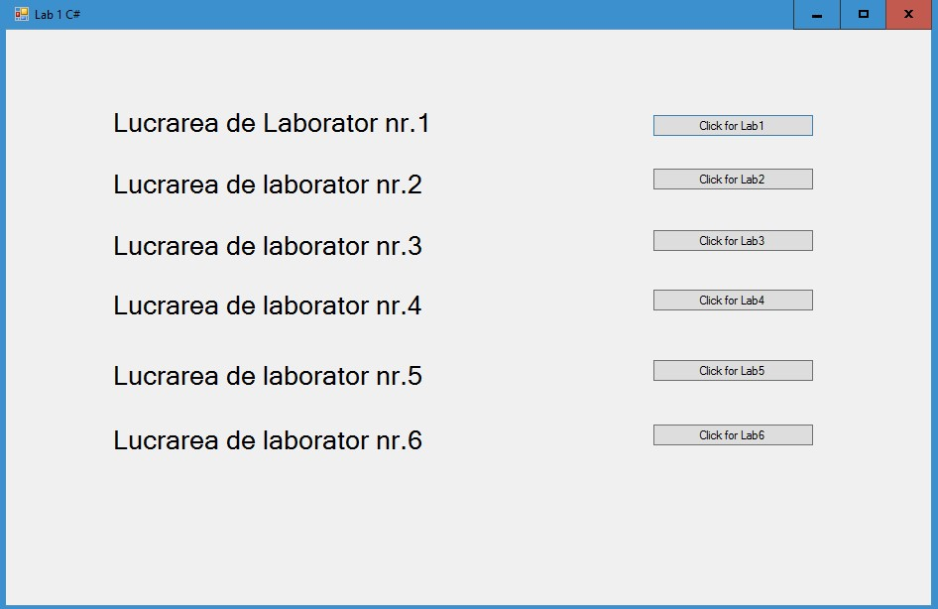

(Afișarea textului centrat, laboratorul 1)
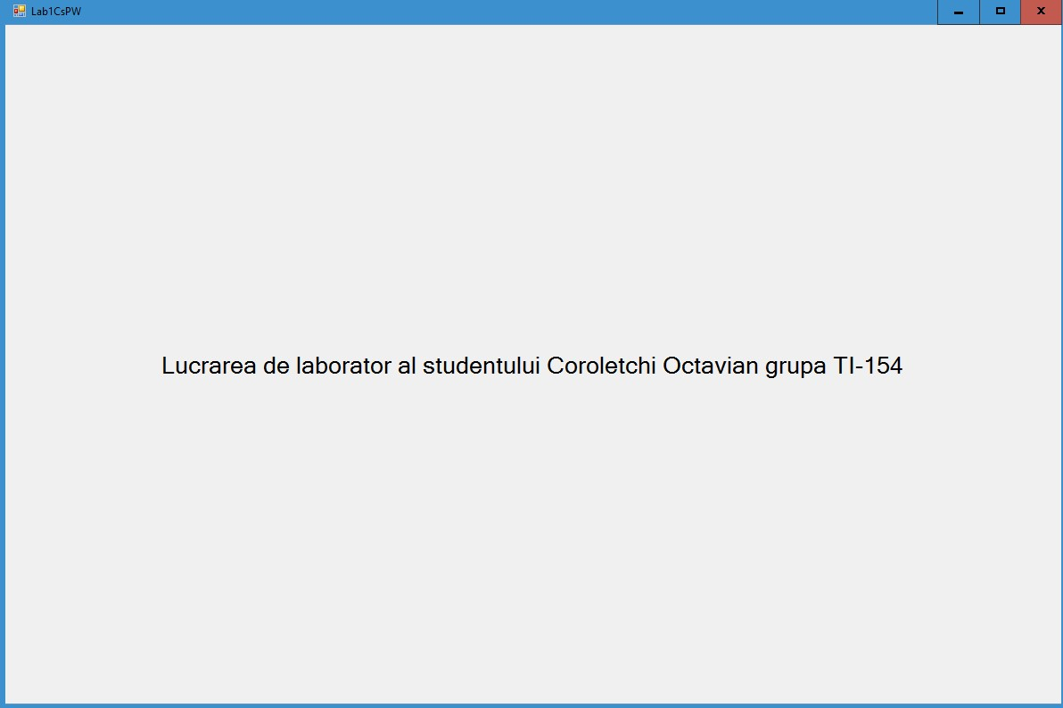

(Folosirea diferitor forme de desenare, laboratorul 2)
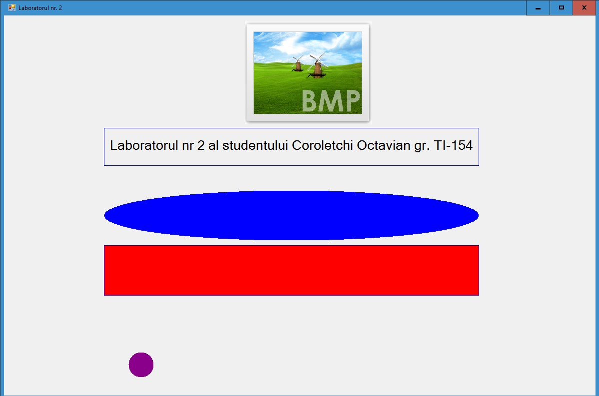

(Curbele Bezier, laboratorul 3)
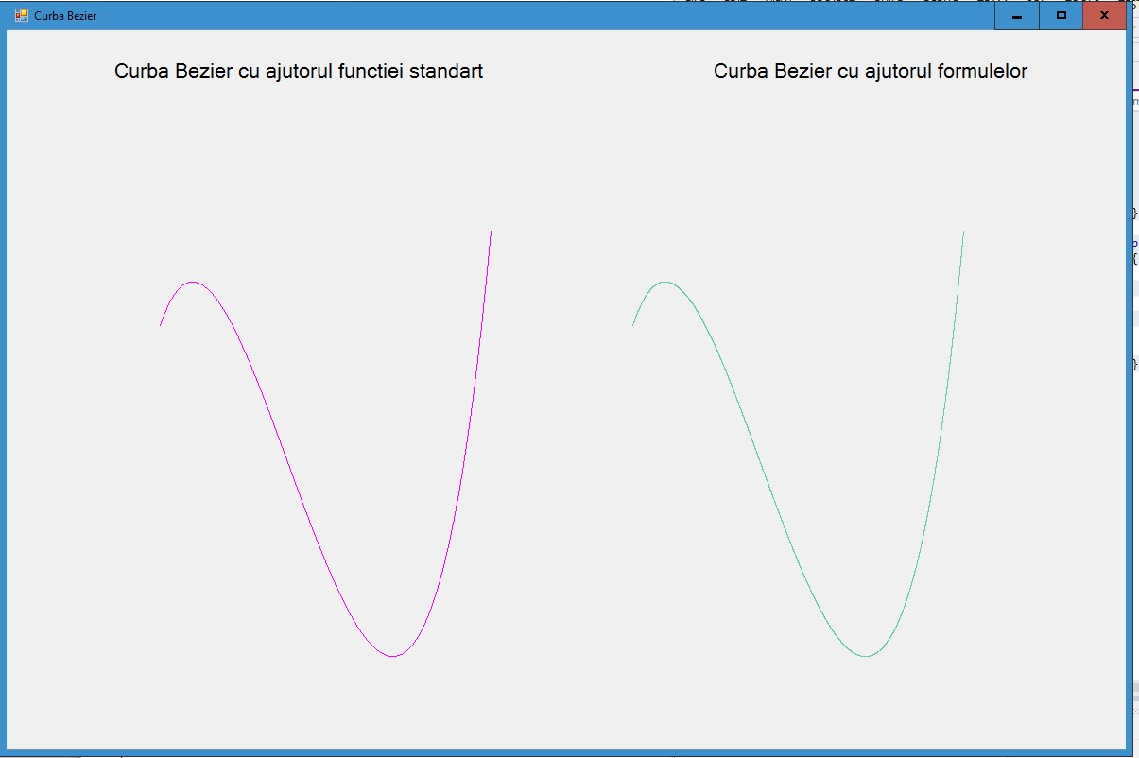

(Folosirea tastaturii, laboratorul 4)
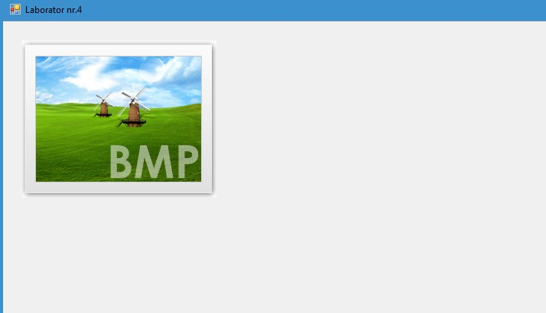
(Folosirea mouse-ului, laboratorul 5)
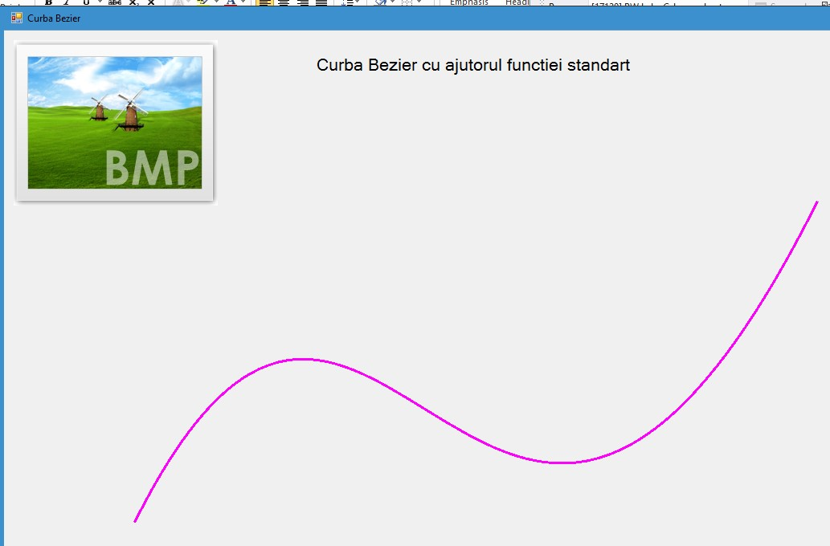
(Ceasul din laboratorul 6)
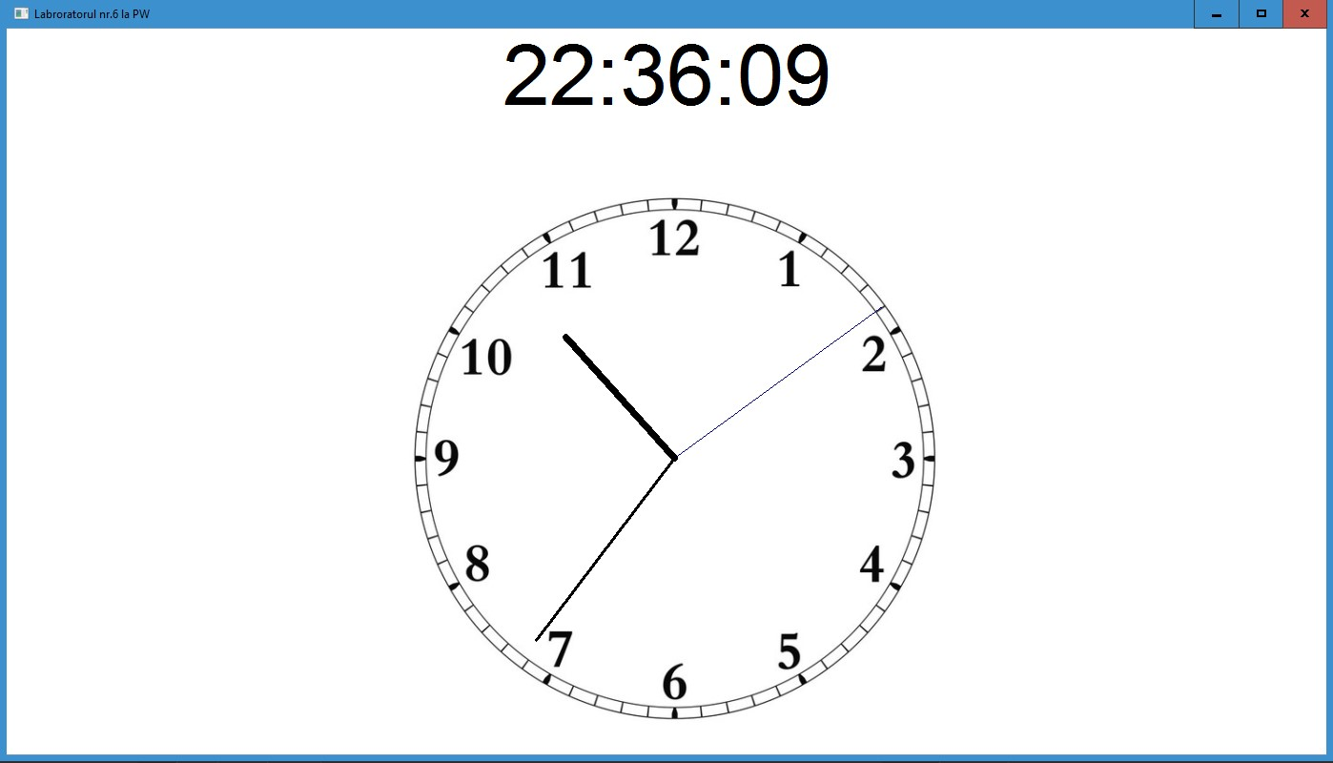
Concluzie
În concluzie, am observat posibilitățile cu care pot fi efectuate unele lucruri din programare windows în C/C++, în C# cu mult mai ușor. Visual Studio oferă instrumente performante cu care se pot efectua ușor modificări în fereastra utilizatorului, si amenajarea oricărui detaliu. În C/C++, am descoperit cum este executat un program la un nivel inferior, observînd cele mai mici detalii. În C#, majoritatea lucrurilor sunt automatizate.

