SignalR
Real-time communication

Emrah Okic (Author) – IB150132
Dzemal Bijedic, Fakultet Informacijskih Tehnologija
Bosnia and Hercegovina, Mostar
emrah.okic@edu.fit.ba

Introduction

In the past two decades, one of the biggest issues facing online sites that handle a lot of social feeds is, real time feeds. The HTTP protocol is still the most used communication protocol in the world however, it cannot handle real time communication as it relies on a the three-way-handshake protocol. This causes HTTP to be less desirable for real time notification and feed systems as it is desirable for such activities to be propagated to all users once a new activity has been registered. To solve such issues SignalR was created by Microsoft in 2013 using the Apache 2.0 open source license. This paper will discuss ease of use, scalability, use cases and socket.io (SignalR’s competitor).

Ease of Use

Multi language support

When SignalR is implemented on an API, one of the major benefits is that it can work with almost any language out there. The main implementation of SignalR can be done through either C# or Visual Basic, in both scenarios it is extremely well supported and extremely easy to setup. This is also extremely important as it also supports every major browser out there (chrome, firefox, safari, edge, even internet explorer).

Ease of implementation

Thanks to the amazing support SignalR has, it is extremely easy to set it up, for this paper we will be using C# to show this.
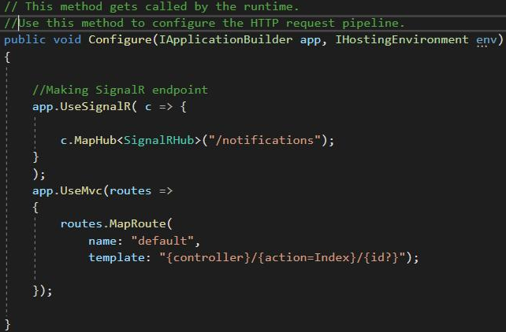
Figure 1 Configuring end point
Using the following code as an example, we can configure the end point for SignalR hub.
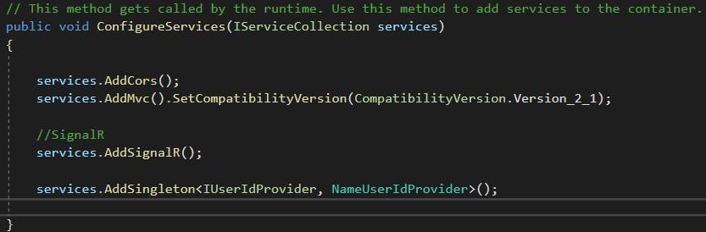
Figure 2 Configuring SignalR

Add SignalR service to IServiceCollection that can be used with dependency injection.
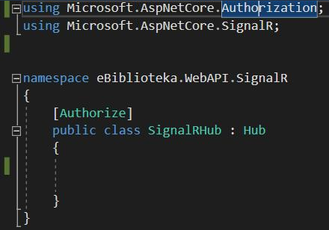
Figure 3 Creating SignalR hub class

The Hub class is already created by SignalR’s service, therefor this derived class may remain empty but still usable, however, you cannot send notifications to specific users. A hub is a class that serves as a high-level pipeline that handles client-server communication.[1]

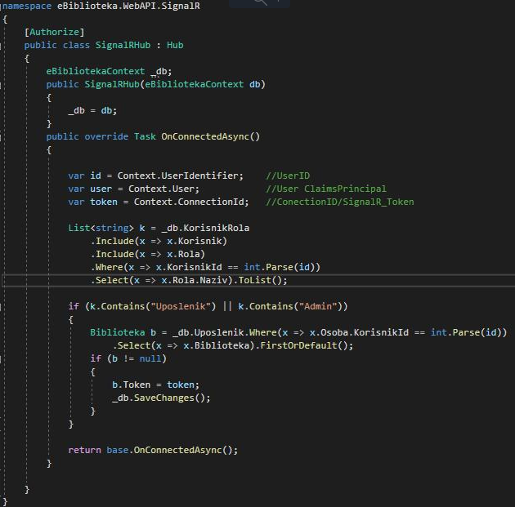
Figure 4 Overriding function on connect

Adding the ability to save connection id on the database so later it becomes possible and easy to send a notification to one specific user. This function gets called on each successful connection to the hub.

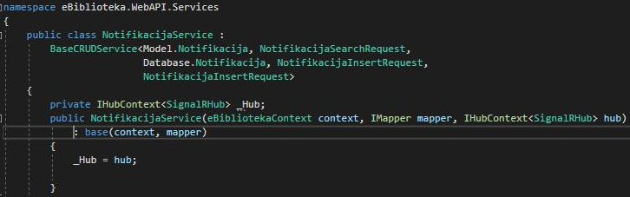
Figure 5 Using hub services

Need to get hub from dependency inject IHubContext interface created by SignalR to send messages. This is already SignalR’s implemented service so, we can use their functions, such as:
- Clients
  - All
  - AllExcept
  - Client (string connection_id)
  - Cleints (list<string> connection_id)
  - User (string user_id)
  - Users (list<string> user_id)
- Groups
  - Add to group
  - Remove from group
Figure 6 Using IHubContext interface

The following is a simple example of using the service where we send a notification to a specific user with the connection id saved on the database. “SendNotification” is the method name on the client side, while “Model” is the actual notification that is being sent to said client.

With just this small amount of code, you will have a running real-time communication application. And thanks to SignalR being a framework and not a server (like SocketIO covered later in this paper) it operates as a higher-level API and handles a lot of the workload for us.

scalability

When businesses grow, they always face the problem of scalability, thanks to websockets (covered in the sub section below) such issues are close to completely eliminated. Thanks to implementations such as load balancing and cloud services (AWS and Google Cloud) most of the issues are solved. There is a small issue however, when you have a lot of instances SignalR is tracking all of them which could cause issues.
SignalR can dynamically switch between different types of real-time communication protocols such as:
- Websocket
- Event Source
- Forever Frame
- Long Polling
To solve this issue, there are two options: Redis for SignalR or Azure SignalR Service. This document will cover Redis for SignalR.

Redis for SignalR

Combining Redis, docker and load balancers easily solves all the issues related to scaling.
The first step would be to create a docker image. It is important remember that Redis works on the 6379 port as you will need this while mapping the port forwarding. The next important step is to get the latest Microsoft.AspNetCore.SignalR.Redis nuget package, at the time of this document that latest version is 2.4.1.
With this setup, rather than SignalR communicating with every instance it is now using Redis. This is very beneficial as SignalR will always try to default to Websockets, this protocol (unlike HTTP) only requires the receiver to confirm and then it opens a bi-directional connection. This eliminates the need to constantly confirm requests while allowing both client and server to communicate at the same time. But, once the amount of users increase it becomes a burden for SignalR to support all of those connections and that is why having Redis handle all of those connections becomes an amazingly good solution.
This easy and simple approach only works if the system is running using websockets. If the system is running anything other than websockets (namely long polling) you must configure the load balancer to support sticky sessions. This allows the client to connect to the same server behind the load balancer each time it makes a request.

Azure

Azure SignalR Service simplifies the process of adding real-time web functionality to applications over HTTP. This real-time functionality allows the service to push content updates to connected clients, such as a single page web or mobile application. As a result, clients are updated without the need to poll the server or submit new HTTP requests for updates.[6]

Azure has native SignalR development support as well as a built-in dashboard for performance and connection monitoring. One of the biggest advantages of using Azure is scalability and ease of implementation.

Using Azure SignalR is as simple as adding a new nuget packate to the project, namely: Microsoft.Azure.WebJobs.Extensions.SignalRService. Thanks to this it is possible to simply use the EventHubTriggerAttribute to pull data from IoT Hubs.

Most projects are migrating to this solution due to ease of scaling as it can handle a lot of concurrent connections. When your application starts to grow and has thousands of users hammering the web application, it is possible thanks to Azure SignalR to separate SignalR’s traffic so that all those thousands of users still use only one instance of your web application but Azure SignalR would handle the thousands of different instances requested (which communicates with the web application). This removes the need to manager a Redis cluster due to Azure SignalR already handling this for you, this also applies when it fails to use websockets and has to use long polling, Azure SignalR handles sticky sessions for you.

Use cases

The reason SignalR has become so popular is the many use cases it is applied in. At first it was only used for simple chat applications which required real time communication. Later it evolved into IoT devices and the need for those devices to talk to each other in real time and relay information in real time.
And in the past few years the implementation of SignalR using IoT devices has been picking up traction. According to Microsoft, Azure SignalR Service is an Azure managed PaaS service to simplify the development, deployment, and management of real-time web application using SignalR, with Azure supported SLA, scaling, performance, and security. The service provides API/SDK/CLI/UI, and the rich set of code samples, templates, and demo applications, this is one of the most used services in combination with SignalR for IoT purposes.
One of the better examples of SignalR’s use case is in the airlines industry, where real time communication between the Tower and aircrafts is imperative. SignalR allows this and due to the increasing amount of flights in our modern age, its ease of scalability makes it an excellent choice for such a field where lives are at stake. It would allow the Tower to monitor aircraft states in real time while at the same time being able to notify all of them simultaneously to avoid catastrophic scenarios.

SocketIO

SockeIO is a famous alternative to SignalR however, unlike SignalR it relies on node.js and javascript. Similar to SignalR, SocketIO also works with load balancers but, one of the major differences is that SocketIO only supports websockets, which means that in the case of a failure it will not be able to switch to something like Event Source or Forever Frame. SocketIO’s performance is in fact extremely good if it is possible to guarantee that websockets will always work and it is used in most scenarios. It also however has a higher degree of complexity unlike SignalR which provides a higher-level API that works out of the box and handles things for you.
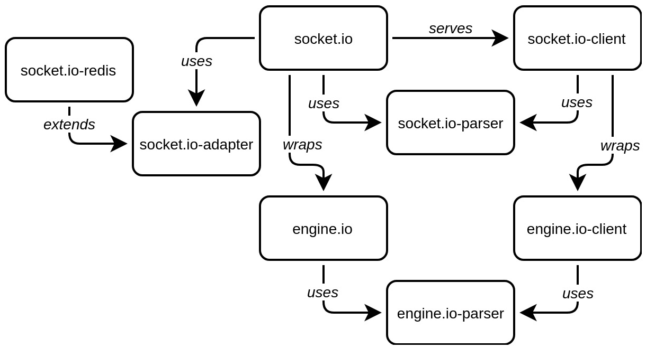
Figure 7 SocketIO implementation

The way SocketIO works is by first establishing a long polling (namely XHR-polling) connection then immediately upgrading it to the best connection possible (namely websockets).

However, problems come when working at scale. If you want to build a CRM-like app that enables communications between businesses. Socket.IO is built on asynchronous networking libraries and will cause load on your server. Maintaining connections to users as well as sending and receiving messages adds strain, and if clients start sending significant amounts of data via Socket.IO, it streams data in chunks, freeing up resources when the data chunk is transmitted. So, when your application attracts more users and your server reaches its maximum load you will need to split connections over multiple servers or risk losing important information.
Unfortunately, this is not as simple as adding another server. Sockets are an open connection between a server and a client. The server only knows about the clients who have connected directly with it and not those connected to other servers

To solve this problem, you need to have a pub/sub store (e.g. Redis). This store will solve the aforementioned problem by notifying all the servers that they need to send the message when someone joins the chat. Unfortunately, this means an additional database to maintain which will most likely require its server.

At first glance this might seem similar to how SignalR scales out (as both, in this example, use Redis) but, thanks to SignalR being a higher-level API, simply adding the SignalR.Redis nuget package and adding one line of code solves the whole issue (as shown in Figure 8). This greatly simplifies the complexity and implementation required as SignalR handles mostly everything for you.
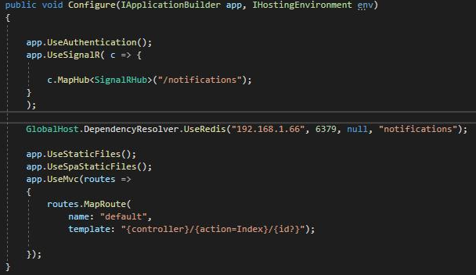
Figure 8 Adding scalability in code

References

- Microsoft ASP.NET Core SignalR Documentation
- SignalR Programming in Microsoft ASP.NET by Jose M.Aguilar.
- Pro ASP.NET SignalR, Real-Time communication in .NET with SignalR 2.0 by Keyvan Nayyeri and Darren White.
- Real-Time Web Application Development with ASP.NET Core, SignalR, Docket and Azure by Rami Vemula.
- SignalR Scaleout with Redis Backplane.
- Microsoft Azure SignalR Documentation.

