

**What is WordPress?**

WordPress is a web-software where you can create your website or blog. Nowadays WordPress is the one of the most popular blogging platforms used by many businesses on the internet. WordPress, has become an essential part of the internet. There are over 70 million website powered by WordPress. Many famous blogs, news outlets, music sites use etc. sites are using WordPress.

Here’s some popular Website using WordPress:

[**TechCrunch**](https://techcrunch.com/)

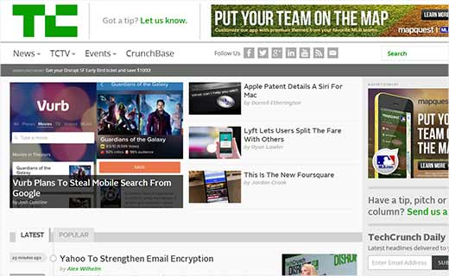

[**The New Yorker**](http://www.newyorker.com/)

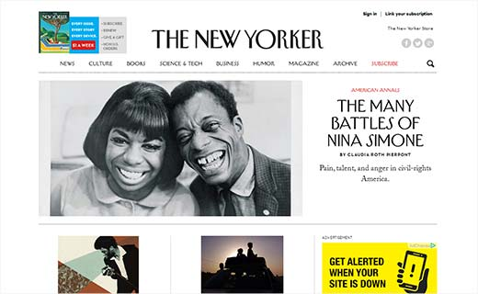

[**BBC America**](http://www.bbcamerica.com/)



[**MTV News**](http://www.mtv.com/news/)



**Why use WordPress?**

* WordPress is completely free. It’s a free project and there are hundreds of volunteers constantly working to improve the code for WordPress in order to make it simple for users.
* There are thousands of plugins, widgets to build a custom website by your own choice.
* WordPress is user friendly. Rather than hiring a web professional to change something in your website, you can easily manage and update your content on your own.
* It’s not just a blogging tool, it’s also a highly flexible content management system that enables you to build and manage your full feature website and control them with the help of a web-browser.

**Why learn WordPress?**

* WordPress is easy to learn and you can build your own website without the knowledge of HTML, CSS, PHP etc.
* You can install WordPress software in your web-server in about 5 minutes, once installed, it enables you to use a simple web based editor to create web pages, without the knowledge of coding.
* If you know how to use the basic formatting tools in a programme like Microsoft Word, you can edit your site easily.

**How can I start using WordPress?**

WordPress is free. WordPress can be downloaded for self-hosted installations from WordPress.org or it can also be used as a hosted service via WordPress.com.

**WordPress.com vs WordPress.org**

1. The one major difference between WordPress.com and WordPress.org is who’s actually

hosting the website. With WordPress.org, user hosts their own blog or website. They can

download and install WordPress blogging platform and install it on their own web server.

WordPress.com, on the other hand, takes care of all of the hosting. Users don’t have to

download software or manage a web server.

2. WordPress.com has a limited number of plugins and themes and doesn’t allow users to use any other plugins and themes. But in WordPress.org user can upload and use any kind of plugins or themes they want.

3. User can monetize your blog or website and place advertisement on their own to earn

money from their website in WordPress.org. But WordPress.com place their own advertisement in user’s websites and doesn’t give users any control over it.

4. By using WordPress.org user can have unlimited storage depending on hosting company.

But in WordPress.com the space is limited (3GB for free).

5. User can add custom analytics in their website in WordPress.org. But in WordPress.com users are restricted to their analytics. They can’t use custom analytics software because they cannot add custom codes.

6. User can modify and customize their own HTML/CSS/PHP code in WordPress.org.

But WordPress.com doesn’t allow any custom codes.

7. Managing an ecommerce site isn’t allowed in WordPress.com. But as WordPress.org is

independent, user can run any ecommerce site they want.

8. Affiliate marketing is monitored and strictly forbidden in WordPress.com. But in

WordPress.org it’s allowed.

9. WordPress.com is hosted by themselves and assure users to host their site on a fast and

reliable server. But WordPress.com is hosted by different hosting companies and reliability

depends on the quality of those companies.

10. WordPress.com takes care of the security of the website to prevent hack or comment spam,

where in WordPress.com users have to do that on their own.

**WordPress.com or WordPress.org— Which is Better for you?**

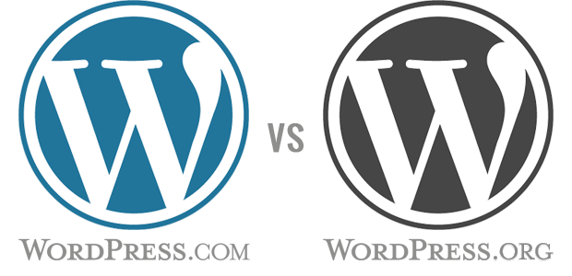

If you are a personal blogger who do not care about making money from their sites, then go with WordPress.com. If you are a blogger trying to make blogging into a career, then you want to use self-hosted WordPress.org.

Often people will say, self-hosted WordPress will cost you money. For a small enough site, it is actually cheaper. And if your site is bigger then you’ll earn enough money from those sites to maintain hosting of your sites. With WordPress.org you can customize your site using different plugins, widgets, themes while WordPress.com has a certain limitation about using themes and plugins.

Let’s say you use WordPress.com, buy their custom domain ($18 per year), pay for ad-free option ($30 per year), and get custom design upgrade ($30 per year). That total is $78, and you are still not in full control.

For WordPress.org, you can get a .com domain for $12 from Godaddy. Your total would come to $36/per year. And you will have full control over everything.