Emran Mahmud Chowdhury 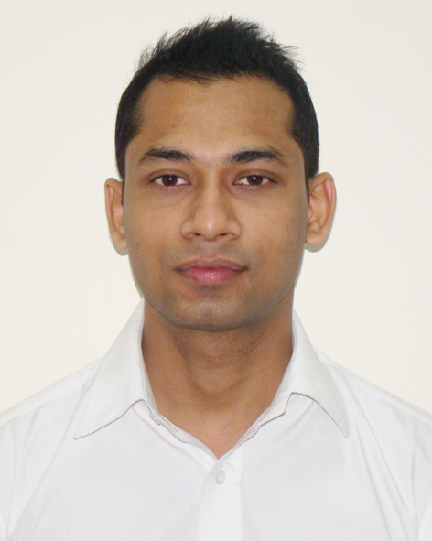

tiashiit904@gmail.com
01768009215

Objective
To work in a competitive environment that effectively utilizes my analytical, interpersonal and organizational skills to conceive and achieve solutions. The solutions which help the organization in not only meeting its targets, but also allowing it to grow, thereby, enhancing my own skills as an individual and as a key player in the organization's development.

Summary
- Extensive hands on experience of designing, developing and deploying n-tier based applications.
- Experienced in cross platform mobile apps development with React Native and Redux.
- Experienced in creating highly reusable user component with React.
- Experienced in front end development with Angular and TypeScript.
- Experienced in ionic for mobile apps development.
- Experienced in Back End API development with Node Js, Express.
- Strong Knowledge in PHP , JavaScript.
- Strong Knowledge in MySQL, Frebase, MongoDB.
- Experienced in SCSS, Bootstrap, Angular Material.
- Experienced in Git Source Control System
- Currently working as Sr. React Native Engineer at BJ IT LIMITED.
- Ability to take full ownership of a project to ensure on time delivery.
- Ability to adapt existing web application functionality into a mobile application or build up from scratch.
- A team player with excellent communication and interpersonal skills who has the ability to work independently under pressure.
- M.Sc in 2010 from the University of Dhaka. Graduated in 2009 from Eastern University.

List of Technology Expert
React Native, React, Redux, Angular, Ionic, PHP, Node.js, MySQL, PostgreSQL, MongoDB, Sequelize.js, JSON Web Token (JWT), Firebase, JQuery, JSON, CSS,SASS, Bootstrap, Material Design etc.

Experiences
BJ IT LIMITED
Sr. React Engineer
(September 2018 – cont.)
Fiber @ Home Ltd.
Sr.Programmer
(July 2015 – August 2018)
Dhaka CentrenicIT Ltd.
Sr.Programmer
(March 2013 – June 2015)
Digital Network Communications Ltd.
Sr.Programmer
(April 2011 – February 2013)
Algorithm, ERP Solution
System Analyst (Part Time)
(January 2010 – December 2010)

Projects
Discover JAPAN (A project on world Olympic 2020)

Role:
- App developer , Web client developer

Tools:
React, React-Native, Redux ,Saga

Crypto currency Wallet

Role:
- App Developer

Tools:
- React-Native, Redux, Coinmarketcap API.

E-Restaurant management Solution
Role:
- Full Stack Developer

Tools:
- Angular, Ionic , PHP, MySQL etc.

ECHO SMS
Role:
- Full Stack Developer

Tools:
- Ionic 3 ,Node js,Mysql

Operations & Maintenance System for Field Operation
Role:
- Full Stack Developer

Tools:
- ReactJS,Node.js , Express ,MySQL ,MySQL,MongoDB
Management Information System (MIS)
Role:
- Sr. Programmer

Tools:
- PHP ,MySQL, Express, Angular , JWT

E-Commerce Web Application Portal
Role:
- System Architect Design, Web Design , Developer ,Quality Assurance

Tools:
- PHP,Backbone.js,AJAX,HTML5,CSS3, MySQL

Training Project Management System
Role:
- Sr. Programmer
- Application Architect

Tools:
- PHP,Backbone.js,AJAX,HTML5,CSS3, Mysql

Virtual Marketplace
Role:
- Sr. Programmer
- Application Architect

Tools:
- PHP,AJAX,HTML5,CSS3, Mysql

Training Support System
Role:
- Sr. Programmer
- Application Architect
Tools:
- PHP,AJAX,HTML5,CSS3, Mysql
Framework:
CODEIGNITER

Expert Micro credit System for Swanirvar Bangladesh
Role:
- Programmer
- Application Architect
Tools:
PHP, JavaScript, MySQL

Karmikallan System for Swanirvar Bangladesh
Role:
- Programmer
- Application Architect
Tools:
- PHP,AJAX, MySQL

Education
Institute of Information Technology, University of Dhaka
M.Sc. Information Technology
CGPA: 3.41 (Out of 4.0)
Year: 2010
Eastern University

B.Sc. Computer Science & Engineering
CGPA: 3.78 (Out of 4.0)
Year: 2009
B.C.I.C College, Dhaka
Higher Secondary School Certificate (HSC)
CGPA: 4.10 (Out of 5.0)
Year: 2003
B.C.I.C College, Dhaka
Secondary School Certificate (SSC)
CGPA: 4.38 (Out of 5.0)
Year: 2001

Distinctions
Have achieved “Magna Cam Laude” award from Eastern University

Interests
Reading books, watching movies.

References
References can be provided on request.



EMRAN MAHMUD CHOWDHURY

