Assumption of the Ordinary Least Squares Model

To this point in the readings, assumptions necessary to use ordinary least squares (OLS) have been briefly mentioned, but not formalized. In this reading assignment, the assumptions will be formalized. The importance of the assumptions made to derive and statistically use OLS cannot be over emphasized. Knowledge of the assumptions provides you the necessary knowledge of how to properly use OLS.

Traits of the OLS Estimator

Five traits of the OLS estimator have been discussed in the previous reading assignments. These traits are summarized here.

1) The OLS estimator is computationally feasible. As shown in the derivation reading assignments, the OLS estimator is derived using calculus and algebra. In the matrix derivation, an easy to implement equation was obtained. This equation has been implemented in numerous computer programs. The ease of use of the OLS estimator, because of the numerous programs has also lead to the abuse of OLS. By example, it has been shown; OLS estimates for a small number of observations can be obtained by hand. Again, providing evidence, OLS estimates are computationally feasible.

2) The OLS objective function penalizes large errors more than small errors. This trait arises because of the objective of OLS to minimize the sum of squared residuals. Consider the following three residuals, 2, 4, and 8. Each residual is twice as large as the preceding residual. That is, 4 is twice as large as 2 and 8 is twice as large as 4. When the residual is squared, the penalties (squared values) are 4, 16, and 64 in the OLS objective function. This trait places a larger weight on the objective function when the estimated y-value is far away from the actual value than when the estimated y-value is close to the actual value. This is desirable trait in most cases, that is penalize us more as we get farther away. However, this trait may also be undesirable. What if the x-value associated with the residual value of 8 is a true outlier, maybe caused by a data problem? In this case, it may not be desirable to place the additional weight on the residual. By placing the additional weight, we are hurting our estimates for the parameter values.

3) OLS estimator provides unique estimates for a given sample. Because of this trait, for a given set of dependent and independent variables, one will also obtain the same estimates using OLS.

4) The OLS objective function ensures the residuals that are equal in magnitude are given equal weight. Consider the two residuals –4 and 4. In both of these observations, the estimated y-value is equal distance from the observed y-value, 4 units. It just happens you overestimated y in the first case and underestimated y in the second case. By squaring the residuals, both values are 16 in the objective function. Therefore, both residuals contribute (have equal weight) the same to the sum of the squared residuals.
5) The OLS estimator was derived using only two assumptions: 1) the equation to be estimated is linear in parameters, and 2) the FOC’s can be solved. Because the OLS estimator requires so few assumptions to be derived, it is a powerful econometric technique. This also subjects OLS to abuse.

Keep in mind linear parameter means the equation to be estimated is linear in the unknown parameters and not the independent variables, the x’s. Recall, all the following equations are linear in parameters, ’s, but are not linear in the x’s

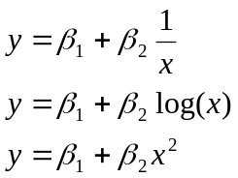.

The following equations are not linear in the parameters, ’s.

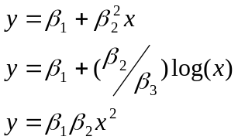

See previous readings for further explanation of the importance differences here.

Without the ability to solve the FOC, we would not be able to find the OLS estimates. In short, this assumption allowed the inverse of the X’X matrix to be calculated. These assumptions, although not very restrictive, both become important in the remainder of this reading assignment.

Three other desirable properties of the OLS estimator can be derived with additional assumptions. These three properties are 1) unbiased estimator, 2) Gauss Markov Theorem, and 3) the ability to perform statistical tests. We will return to these properties after presenting the five assumptions made when performing and using OLS.

Five Assumptions of the OLS Estimator

In this section, five assumptions that necessary to derive and use the OLS estimator are presented. The next section will summarize the need for each assumption in the derivation and use of the OLS estimator. You will need to know and understand these five assumptions and their use. Several of the assumptions have already been discussed, but here they are formalized.

Assumption A - Linear in Parameters

This assumption has been discussed in both the simple linear and multiple regression derivations and presented above as a trait. Specifically, the assumption is

the dependent variable y can be calculated as a linear function of a specific set of independent variables plus an error term.

Numerous examples of linear in parameters have been presented including in the previous traits section. The equation must be linear in parameters, but does not have to be linear in the x’s. As will be discussed in the model specification reading assignment, the interpretation of the β’s depends on the functional form.

Assumption B - Random Sample of n Observations

This assumption is composed of three related sub-assumptions. Two of these sub-assumptions have been previously discussed; the third is a partially new assumption to our discussion.

Assumption B1. The sample consists of n-paired observations that are drawn randomly from the population. Throughout our econometric discussion, it has been assumed a dependent variable, y, is associated with a set of the independent variables, x’s. This is often written 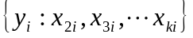. Recall, x₁ is the variable associated with the intercept.

Assumption B2. The number of observations is greater than the number of parameters to be estimated, usually written n > k. As discussed earlier, if n = k, the number of observations (equations) will equal the number of unknowns. In this case, OLS is not necessary, algebraic procedures can be used to derive the estimates. If n < k, the number of observations is less than the number of unknowns. In this case, neither algebra nor OLS provide unique estimates.

Assumption B3. The independent variables (x’s) are nonstochastic, whose values are fixed. This assumption means there is a unilateral causal relationship between dependent variable, y, and the independent variables, x’s. Variations in the x’s cause variations (changes) in the y’s; the x’s cause y. On the other hand, variations in the dependent variable do not cause changes in the independent variables. Variations in y do not result in variations in the x’s; y does not cause x. The assumption also indicates that the y’s are random, because of the error terms being random and not because of randomness of the x’s. This can be shown by examining the general equation in matrix form, Y = X + U. In this equation, the X’s and the ’s are nonstochastic (fixed in our previous discussions), but U is a vector of random error terms. With Y being a linear combination of a nonstochastic component and a random component, Y must also be random; Y is random because of the random component.

Assumption B-3 is a specific statement of the assumption we made earlier of the x’s being fixed.

Assumption C – Zero Conditional Mean

The mean of the error terms has an expected value of zero given values for the independent variables. In mathematical notation, this assumption is correctly written as 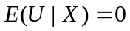. A shorthand notation is often employed and will be used in this class of the following 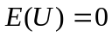. Here, E is the expectation operator, U the matrix of error terms, and X the matrix of independent variables. This assumption states the distribution each error term, u_{i}, is drawn from has a mean of zero and is independent of the x’s. The last statement indicates there is no relationship between the error terms and the independent variables.

Assumption D – No Perfect Collinearity

The assumption of no perfect collinearity states that there is no exact linear relationship among the independent variables. This assumption implies two aspects of the data on the independent variables. First, none of the independent variables, other than the variable associated with the intercept term (recall x₁=1 regardless of the observation), can be a constant. Variation in the x’s is necessary. In general, the more variation in the independent variables the better the OLS estimates well be in terms of identifying the impacts of the different independent variables on the dependent variable.

If you have three independent variables, an exact linear relationship could be represented as follows 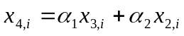. This equation states if you know the value for x_{3,i} and x_{2,i} the value for x_{4,i} is also known. For example, let x_{3,i} = 3, x_{2,i} = 2, and ₁ = 4 and ₂ = .5. Using these numbers, a value for x_{4,i} can be found as follows x_{4,i} = 4 * 3 + .5 * 2 = 13. This assumption does not allow for these types of linear relationships. In this example x_{4,i} is not independent of x_{3,i} and x_{2,i}. The value for x_{4,i} is dependent on the values for x_{3,i} and x_{2.i}. The assumption is the relationship cannot be perfect as in this example. A relationship that is close, but not exact does not violate this assumption. As we will see later, close relationships, however, do cause problems in using OLS.

Assumption E - Homoskedasticity

The error terms all have the same variance and are not correlated with each other. In statistical jargon, the error terms are independent and identically distributed (iid). This assumption means the error terms associated with different observations are not related to each other. Mathematically, this assumption is written as:

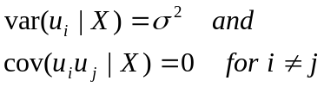

where var represents the variance, cov the covariance, ² is the variance, u the error terms, and X the independent variables. This assumption is more commonly written:

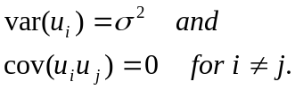

Need / Use of the Five Assumptions

In this section, the importance and need for each of the five assumptions is discussed. The discussion continuously adds additional assumptions from these we have made to derive the OLS estimator. Each additional assumption allows statements to be made concerning the OLS estimator. At the same time additional assumptions make the OLS estimator less general.

Derivation of the OLS Estimator

The need for assumptions in the problem setup and derivation has been previously discussed. Only a brief recap is presented. Assumptions A, B1, B2, and D are necessary for the OLS problem setup and derivation. Assumption A states the original model to be estimated must be linear in parameters. Paired observations and the number of observations being greater than k is again part of the original problem set up. This forces the use of an estimator other than algebra. Finally, no perfect collinearity allows the first order conditions to be solved. More on this assumption in a upcoming reading assignment.

Unbiased Estimator of the Parameters, 

One of the desirable properties of an estimator discussed earlier was the estimator should be an unbiased estimator of the true parameter values. Because the original problem has a random error term associated with the equation to be estimated, the dependent variable is a random number. Any estimator, which uses the dependent variable to estimate the parameter values, will be a random number because the dependent variable is a random number. Unbiased property is a property of the estimator and not a particular sample. Estimates from a particular sample are just fixed numbers. It makes no sense to discuss unbiased estimates of a particular sample. Rather it means the procedure to obtain the estimates is unbiased, when the procedure is viewed as being applied across all possible samples.

If assumptions B-3, unilateral causation, and C, E(U) = 0, are added to the assumptions necessary to derive the OLS estimator, it can be shown the OLS estimator is an unbiased estimator of the true population parameters. Mathematically, unbiasedness of the OLS estimators is:

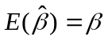.

By adding the two assumptions B-3 and C, the assumptions being made are stronger than for the derivation of OLS. However, these two assumptions are intuitively pleasing. Unilateral causation is stating the independent variable is caused by the dependent variables. Assumption C states the mean of the error associated with our equation is zero. KEY POINT: Under fairly unrestrictive and intuitively pleasing assumptions the OLS estimator is unbiased.

Proof of Unbiased Property of the OLS Estimator. Using the equation for the OLS estimator and substituting in for Y, Y = Xβ + U, one obtains:

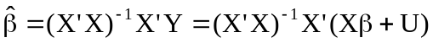

where the capital letters denote matrices. Using the distributive property of matrix algebra and the definitions of inverses and identity matrices, one obtains:

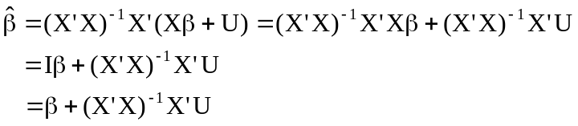.

Taking the expectation of both sides of the equation, recall the assumption of the expected value of the error term is zero was added in this section, leads to the following:

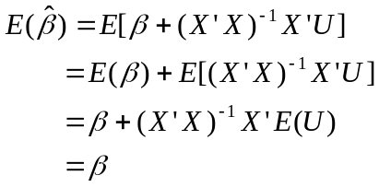.

The expectation operator can be distributed through an additive equation and a fixed value can be moved to the outside of the expectation operator. The second assumption added was unilateral causation, which means the independent variables, the X’s, are fixed.

We have proved the expected value of the OLS estimator is equal to the true value; therefore, the estimator is unbiased. Note, we have used the assumptions necessary to solve for the OLS estimator and the assumption of the mean of the error term distribution is zero, E(U) = 0. That is, we used assumptions A - D.

Assumptions A – E

If we add in the assumption of homoskedasticity, the error terms all have the same variance and are not correlated with each other, three very important aspects of the OLS estimator can be given. These points are: 1) Gauss-Markov Theorem and extensions; 2) unbiased estimator for the variance of ²; and 3) variance for the 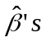. These three points cement the importance of the OLS estimator and provide the background necessary for statistical inference and tests (subject of the next reading assignment).

Gauss-Markov Theorem. Because of the Gauss-Markov Theorem, OLS is one of the strongest and most used estimators for unknown parameters. The Gauss-Markov Theorem is

Given the assumptions A – E, the OLS estimator is the Best Linear Unbiased Estimator (BLUE).

Components of this theorem need further explanation. The first component is the linear component. This component is concerned with the estimator and not the original equation to be estimated. To stress, Assumption A is concerned with the original equation being linear in parameters. The Gauss-Markov theorem is concerned with estimators and the use of Assumptions A – E. Within the theorem, linear refers to a class of estimators that are linear in Y. To clarify, consider the OLS estimator 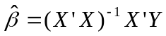. The dependent variable, Y enters this equation linearly. Notice it is a constant (X’X)⁻¹ X’ multiplied by the vector Y. There are no squared terms or inverses associated with the vector, Y. This is the meaning of linear is that in the estimator, Y enters the equation linearly. The theorem states that out of the class of estimators that are linear in Y, OLS is the “Best” where “Best” refers to the smallest variance of the estimated coefficients.

Earlier, one of the desirable properties of estimators was that the estimator has minimum variance. The Gauss-Markov theorem is a very strong statement. The theorem states that any unbiased estimator you can derive, which is linear in Y, will have a larger variance than the OLS estimator.

Combining the unbiased property with the Gauss-Markov theorem, the OLS estimator has two desirable properties that were discussed in the general problem set-up, unbiasedness and efficiency (within the class of unbiased and linear in Y estimators). This theorem provides a very strong reason to use OLS. It is unbiased and has minimum variance within the class of unbiased and linear in Y estimators. OLS estimator has the minimum mean squared error among unbiased linear in Y estimators. Recall, mean squared error considers both biasness and variance. Because in the class of estimators being considered, the biased component is zero and the variance is at a minimum, the OLS will have the minimum mean squared error in this class of estimators.

Gauss-Markov Extension. If it is assumed the error terms are distributed normally,
u_{i} ~ N(0, ²), then the OLS estimator is the Best Unbiased Estimator (BUE). By adding in the addition assumption of normality of the error terms, a stronger statement concerning the variance of the estimated parameters can be given. BUE is a very strong statement. This statement is concerned with all unbiased estimators and not just those estimators that are linear in Y. OLS will have a minimum variance among all unbiased estimators.

Note, the Gauss-Markov Theorem and its extension do not imply that OLS has the minimum variance among all potential estimators. Estimators that are not unbiased may have a smaller variance. The Gauss-Markov theorem implies nothing about the variance of these biased estimators. Further, nothing can be stated about the mean squared error property discussed earlier between the biased and unbiased estimators.

Proof of the Gauss-Markov Theorem and its extension requires mathematical concepts that are beyond this class; therefore, the proof is not presented.

Unbiased Estimator of . Assumption E states the error terms have the same variance. An estimator of the variance of the error terms is necessary. The variance of the error term is also the variance of the Y’s net of the influence of the X’s. Recall, the Y’s are random because the U’s are random.

The simple formula for calculating the variance of a random number is:

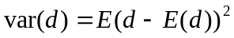

where E is the expectation operator. Usually, in statistics a sample is taken, which modifies the variance formula to:

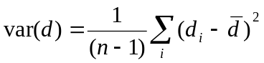

where n-1 is the degrees and freedom (note only the variance is being estimated) and 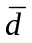is the mean of the observations. Applying the assumption that the expected value of the error terms is zero to the general variance formula for the error terms the following is:

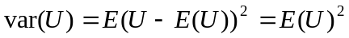.

The true error terms by definition are not observed. We do, however, have estimates of the true error terms, the residuals, 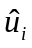. Because the residuals are based on a sample, a modified form of equation (1) is used to estimate the variance of the error terms. This equation is modified for the degrees of freedom. Recall, k parameters are being estimated, so the degrees of freedom becomes n – k. In scalar form, an unbiased estimator of the variance of the error term is:

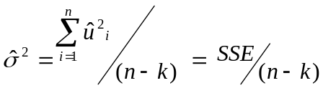

or in matrix form

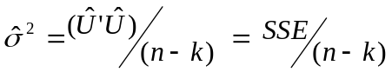.

Note the 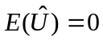, from the algebraic property the sum of the residuals equal zero. The estimator of the variance of the error term given by calculating the variance of the residuals with the degrees of freedom modified because k parameters are being estimated. Because the true error terms are not observed, the residuals are used. The sum of squared errors and the degrees of freedom are scalars, therefore, 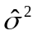 is a scalar.

The proof of the unbiasedness of the variance estimator and the actual derivation requires mathematical concepts that are beyond this class. The above discussion provides an intuitive feel for the estimation of the variance.

Variance / Covariance Matrix for 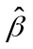

The OLS estimator, , is an estimator of the “true” parameter values, . Recall, estimators have a distribution associated with them, because they are a function of observed dependent variables, Y, which are random numbers. The dependent variables are random, because of the random error term. Random variables have a distribution associated with them. Having a distribution implies a variance. Therefore, a formula for the variance of the ’s is necessary.
Variances of the estimated parameters, , are given by:

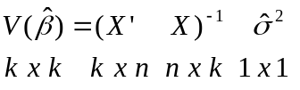

where is an estimate of the variance of the error term (see previous section) with the dimensions of the matrices are given under each matrix. Clarification of this variance matrix is necessary. This matrix is correctly called the variance / covariance matrix. The dimension of the matrix is k x 1. There are k parameter estimates 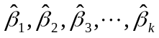. Each estimate will have a variance associated with it. This gives k variances, one for each 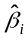. X is a n x k matrix, therefore, X’ is a k x n matrix. With these dimensions, X’X results in a k x k matrix. From the previous section, is scalar, therefore, 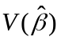 is a k x k matrix.

The variance / covariance matrix is:

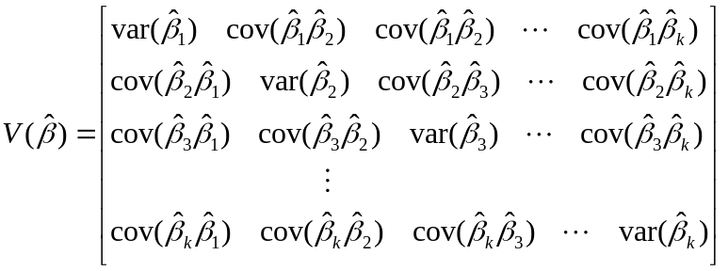

where var denotes variance and cov denotes covariance. In this matrix, row i and column i are associated with . The diagonal elements of the matrix are the variances of the estimated parameters. Nondiagonal elements are the covariances between the estimated parameters. The matrix is symmetric, 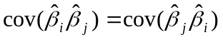.

In this class, we will only be concerned with the diagonal elements of the variance / covariance matrix, . The covariances become important in extensions of the OLS estimator that are not covered in this class.

Derivation of the Variance / Covariance Matrix. To this point, we have assumed the variance / covariance matrix of the estimated parameters is given by the equation 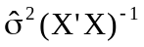. This matrix is often called the covariance matrix. This is because the variance of is equal to the covariance between 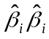. The covariance between a random variable and itself is the variance of that variable. The variance / covariance between any two random variables is:

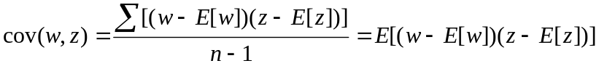

where w and z are two random variables and E is the expectation operator. The covariance of can be written in matrix form as:

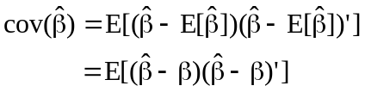

where the unbiased property has been used, 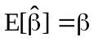.

In proving the OLS estimator is unbiased, we showed the OLS estimator could be written as:

.

To proceed, we need the property of matrix transpose, which states in over case the following:

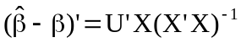.

Substituting these results into the covariance equation we obtain:

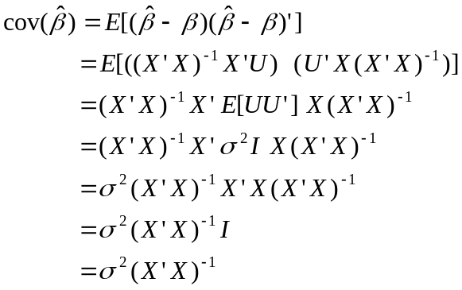
Here, we have used the assumption of fixed X’s to move the expectation operator through the equation. Note in matrix form 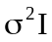 is the homoskedasticity assumption. That is, each error term (each observation) has the same variance, where the dimension of I is n x n and 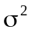is a scalar. We used assumptions A - E. Because we do not know the true variance, , we replace the true variance with an estimated variance, 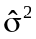.
Concluding Remarks

This reading assignment has formalized the assumptions necessary to derive and use the OLS estimator. You will not need to know the proofs. You will, however, have to know the assumptions and how they are used. The Gauss-Markov Theorem and its extension must be commitment to memory. As the discussion continued in this reading assignment, additional assumptions where added. Each additional assumption added restrictions to the model, but allowed stronger statements to be made concerning OLS or different variances to be calculated. The reminder of the econometrics portion of the class is concerned with using the OLS estimator in economic applications.

Terms / Concepts

Five Assumptions of the OLS Estimator
Gauss-Markov Theorem
BLUE
BUE
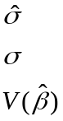
Why is OLS so powerful?
Why is OLS so widely used?

