**CVAVR Installation**

CVAVR is a **C cross-compiler**, **Integrated Development Environment (IDE)**, and **Automatic Program Generator** for the Atmel AVR series of microcontrollers. It’s a freeware, developed by HP InfoTech and is suitable for small projects.

For advance and larger programs, Atmel Studio is used, which is developed by Atmel and is freely available.

For installation of CVAVR in Windows, follow these steps-

**1)** Open the folder **CVAVR-v3.2**. Double click on **CodeVisionAVR.msi .**

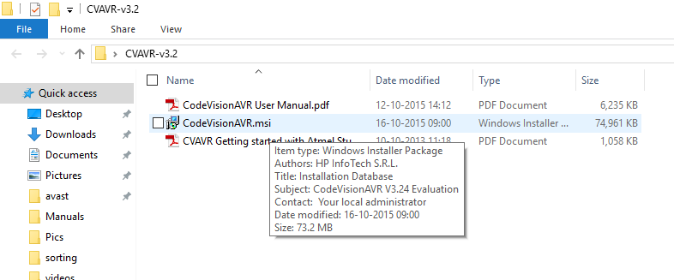

**2)** A window will pop-up. Click on next.

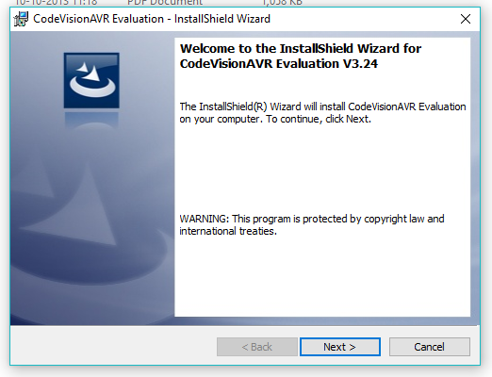

**3)** Another pop-up window will open. Check the radio button and click on next.

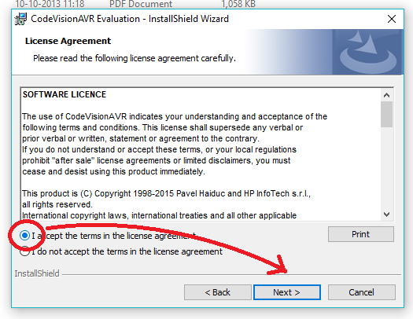

**4)** Another pop-up window will open. Click on next.

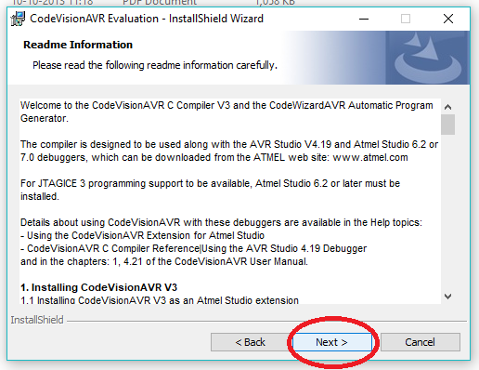

**5)** Another pop-up window will open. Here you can choose the directory where you want to install the software. By default it is **C:\cvavreval**, but it can be changed to desired location by clicking on **Change** button.

Click on next after directory change is over.

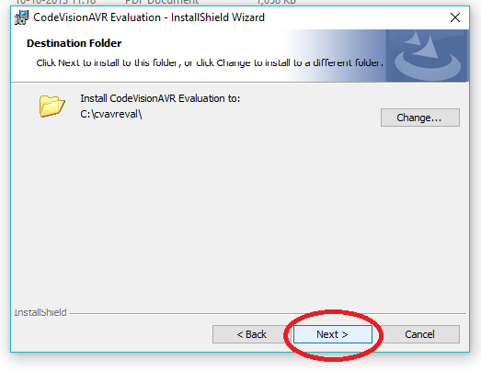

Hit the **Install** button in next window.

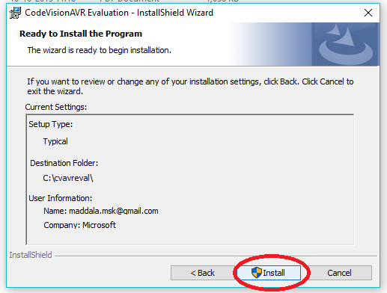

**6)** A window may pop-up during installation. Click on next.

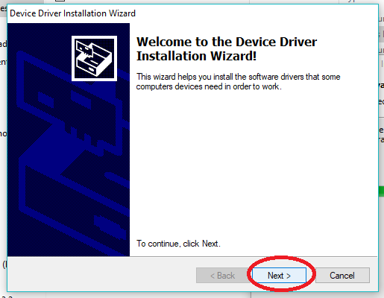

**7)** Once the installation is finished, click on finish.

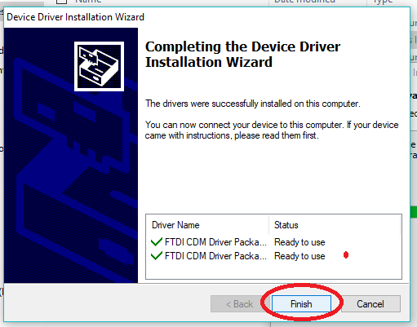

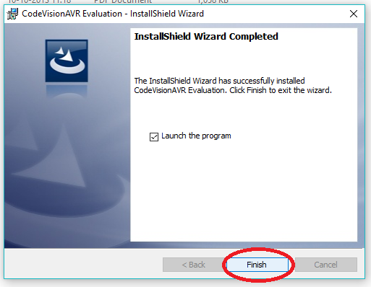

**VOILA! The installation of CVAVR is successful.**

Now go to **Start a Project** **in CVAVR** documentation.