Group 34 User Manual
Contents
Account Management:
Register an Account………………………………………………………………………….……………….... 2
Log in to Account .......................................................................................................... 4
Sign out of Account……………………………………………………………………………………....…..... 5
Changing Username...................................................................................................... 7
Changing Password....................................................................................................... 8
Changing Profile Picture................................................................................................. 9
Navigation
Dashboard .................................................................................................................. 10
Return to Dashboard.................................................................................................... 10
Course Management
Search and Filter Courses……………………………..…………………………………………………….. 11
Course Bookmarking…………………………………………………………………………………………... 14
Course Completion……..………………………………………………………………...…………………… 16
Gamification
Achievement Badges…………………………………………………………………………………………... 18
Streaks……………………………………………………………………………………………………………… 19
Leaderboard………………………………………………………………………………………………………. 22
Equipping profile borders……….……………………………………………………………………………. 24
Friends Management
Adding Friends…………………………………………………………………………………………………… 25
Removing Friends………………………………………………………………………………………………. 26

Account Management -
Register an Account:
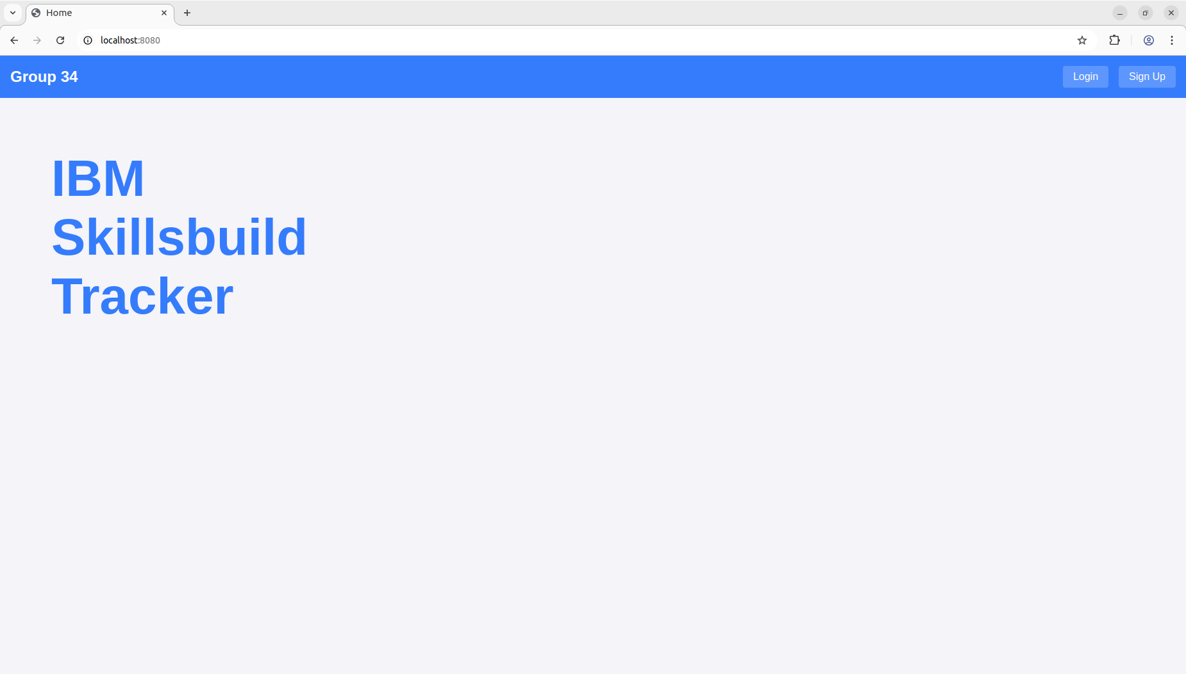
- Click on the sign up button on the top right of your screen.

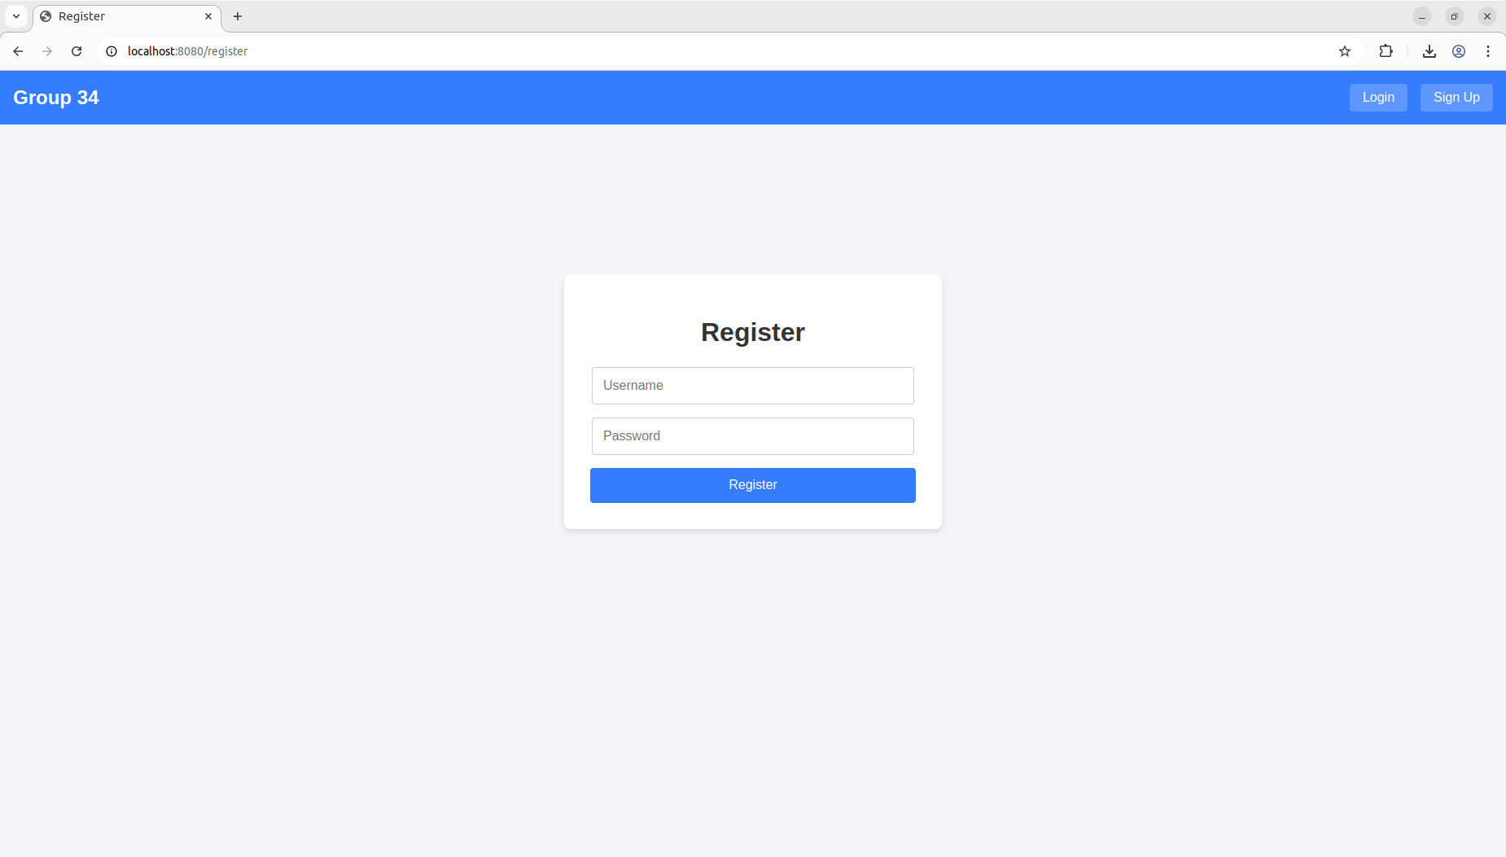
- Enter a unique Username and a password into respective fields. Password must be at least 8 characters, contain a capital, number and punctuation otherwise error will be shown.

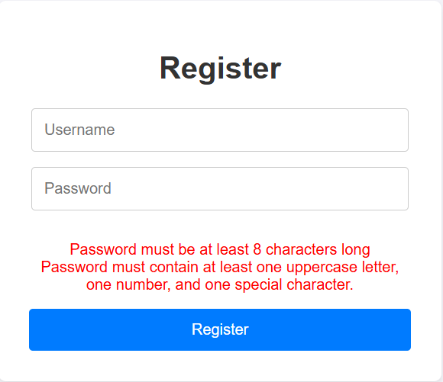
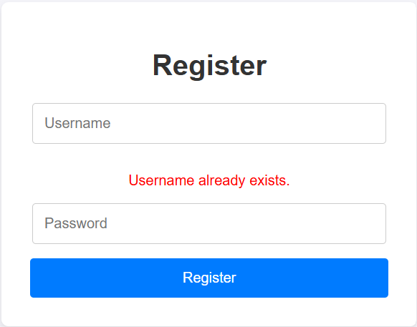
Error message for invalid password (Only relevant error is shown) (Left)
Error message for invalid username (Right)

- Click on the Register button to create an account.

Login to account:
- Click on the login button on the top right of your screen.

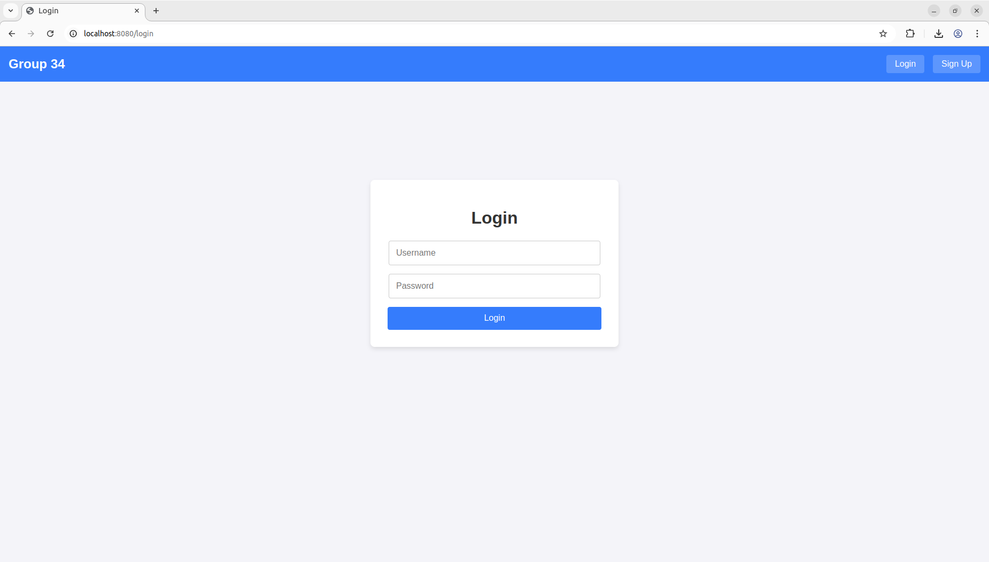
- Enter your username and password into the respective fields ensuring they are correct.
- Click on the login button to sign in.

Sign out of Account:
On any page, click the logout button on the top right of the screen to sign out.

Profile Management:
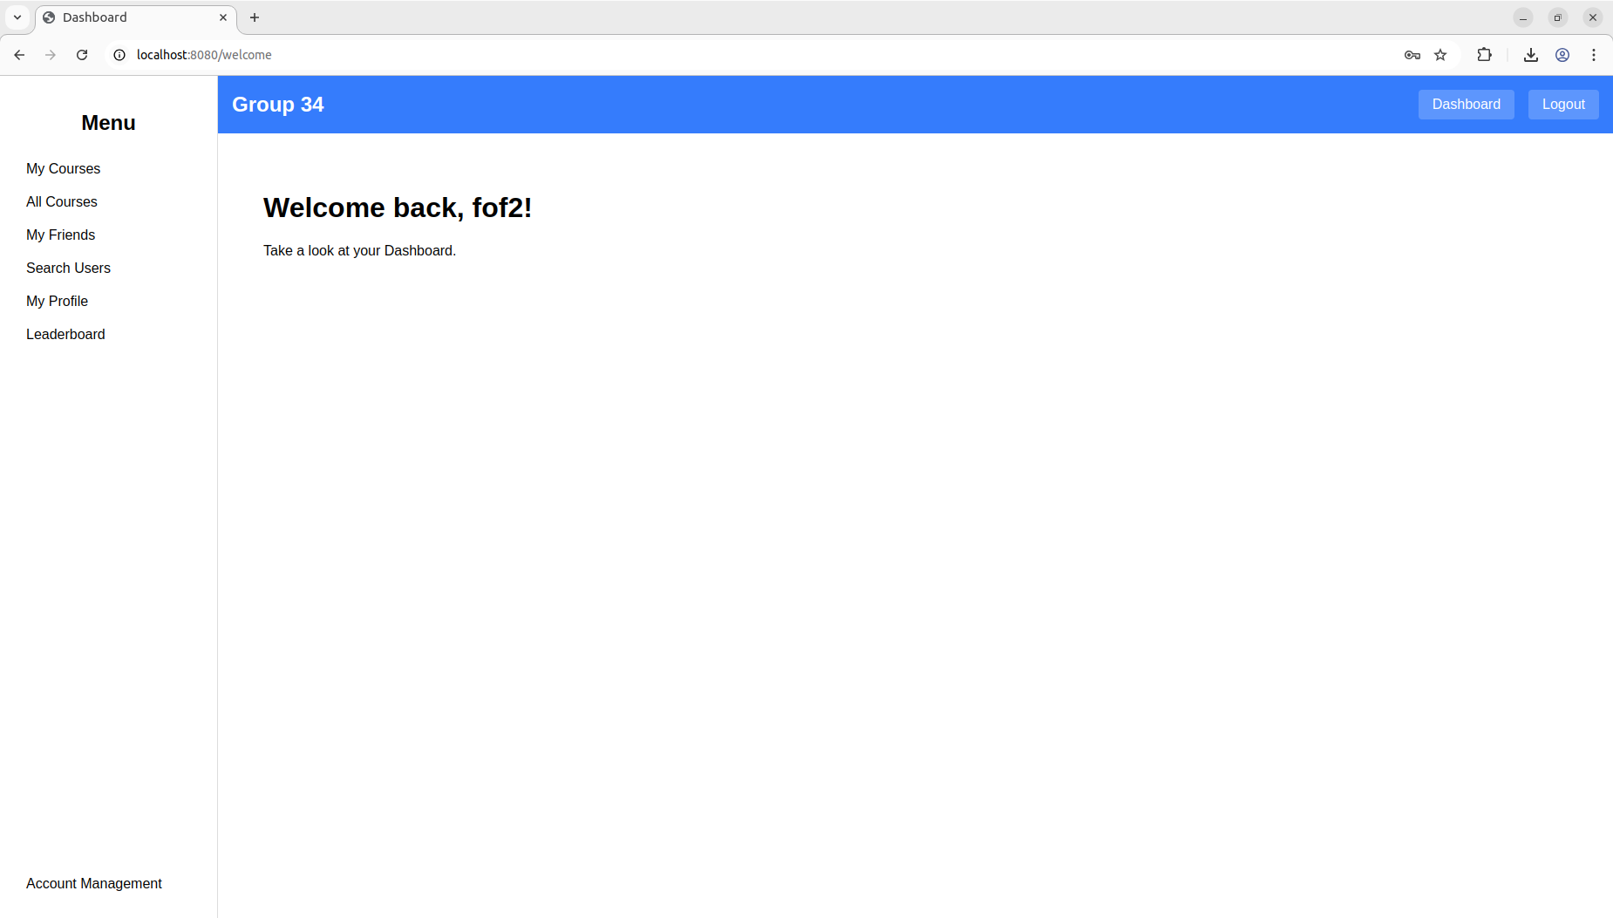
- To Open profile management, click Account management on the bottom left of the sidebar.

Changing Username –
- Enter a unique username into the new username input box.
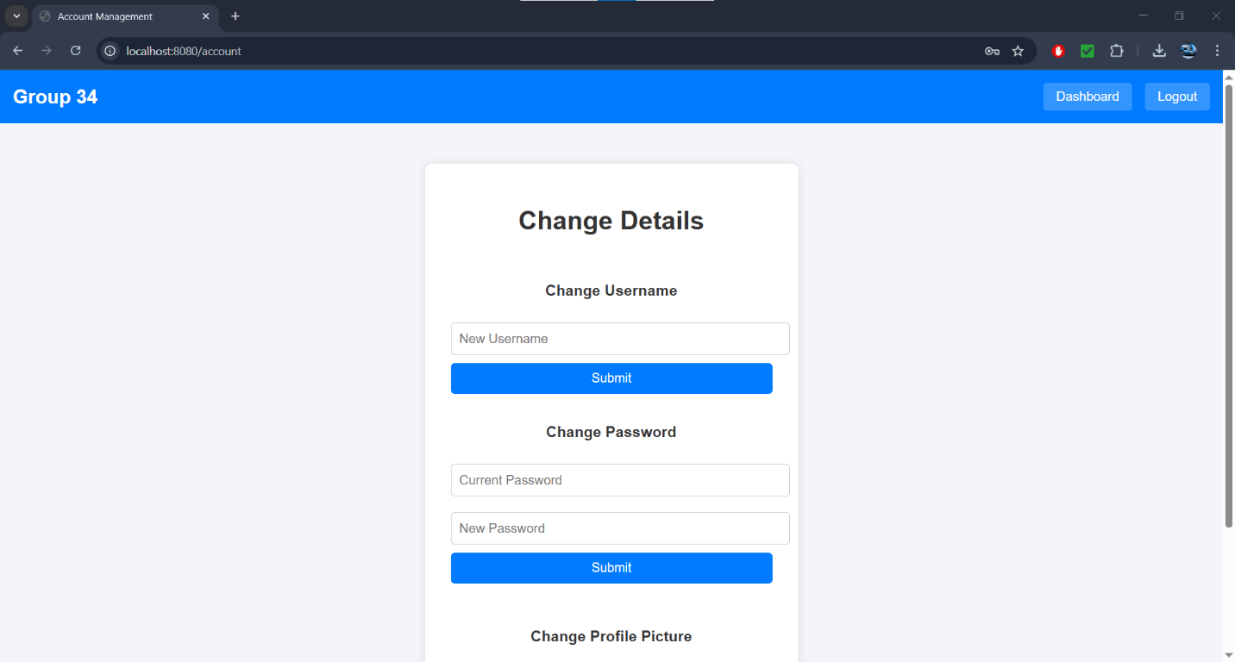

- Click submit to successfully change username (As long as username provided is not already taken)

Changing Password –
- Enter current password and new password into respective fields.
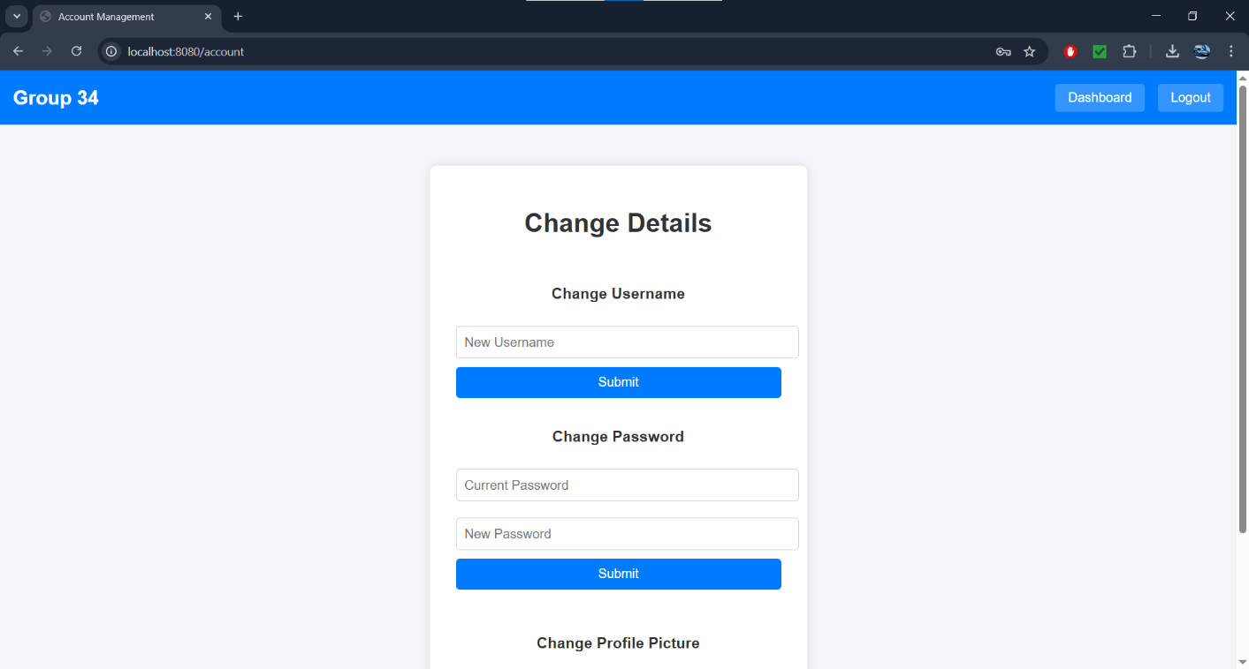

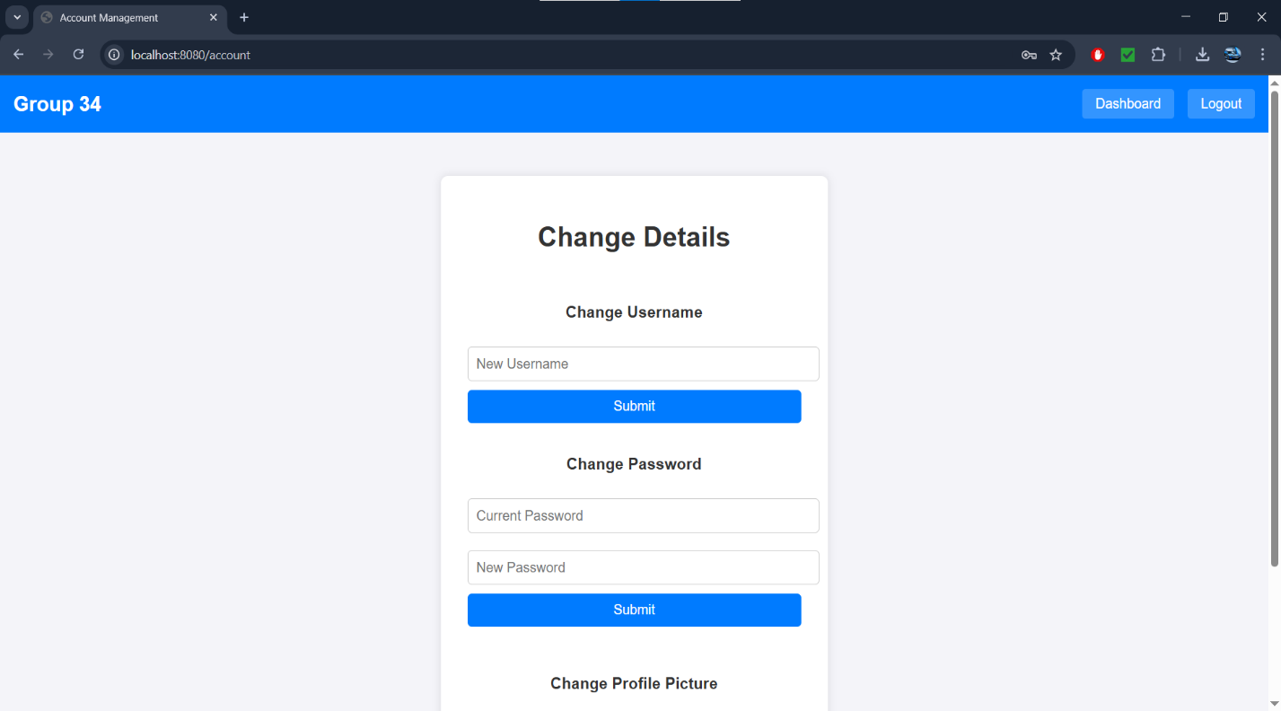
- Click submit to change password (ensuring old password is correct and new password is valid)
Changing Profile Picture –
- Click on Choose file and select an image from your computer.
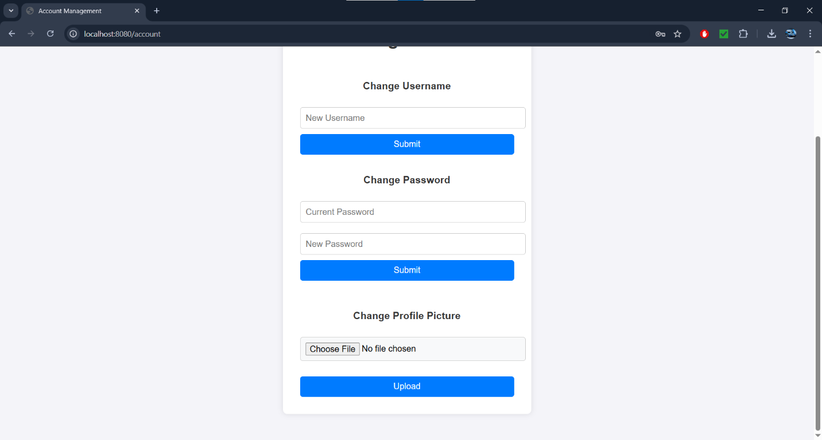
- Once a picture is selected, click upload to apply the picture.

Navigation –
Dashboard:
- To navigate to different pages, click on a link in the sidebar to travel to the page.
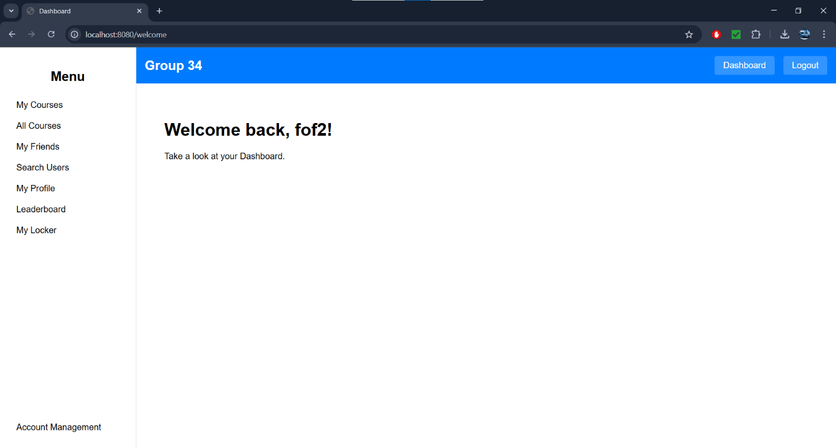
Return to Dashboard:
- To navigate back to the dashboard, click dashboard in the navbar from any page.

Course Management –
Search and Filter courses:
- On the dashboard find and click the “All Courses” button on the left hand menu.
- User should be redirected to a page where all available courses are displayed.
- User can then use the text boxes (Shown in image below) to filter for courses based on Keyword or Category.
  - Keyword relates to the Course title whereas Category links to course type (e.g. computer science, mathematics, etc)
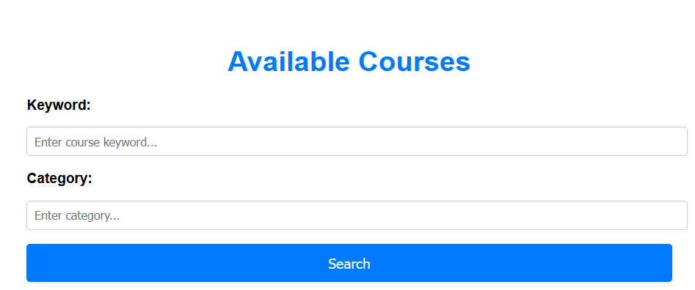

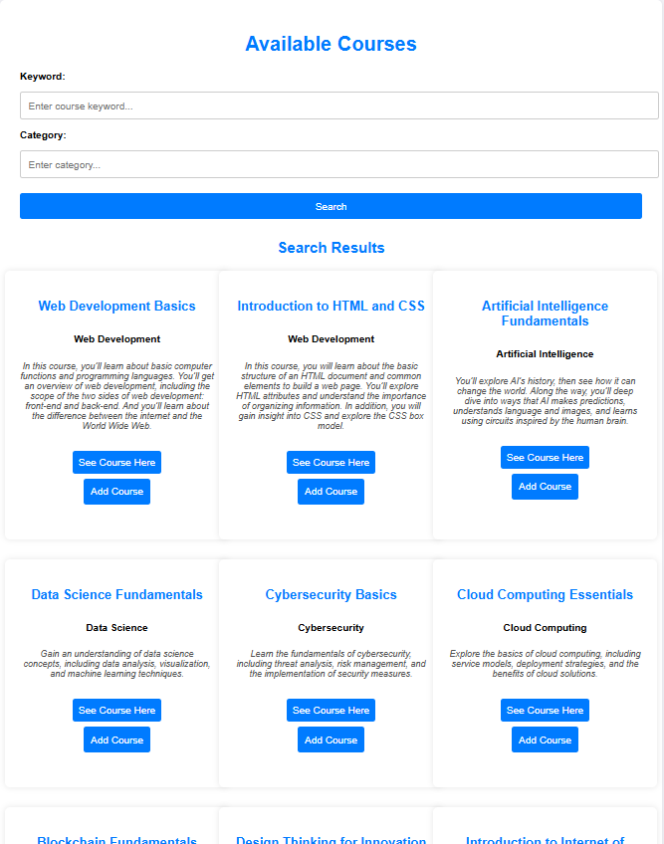
- As can be seen in the image below if nothing is entered to either field then all courses will be displayed.

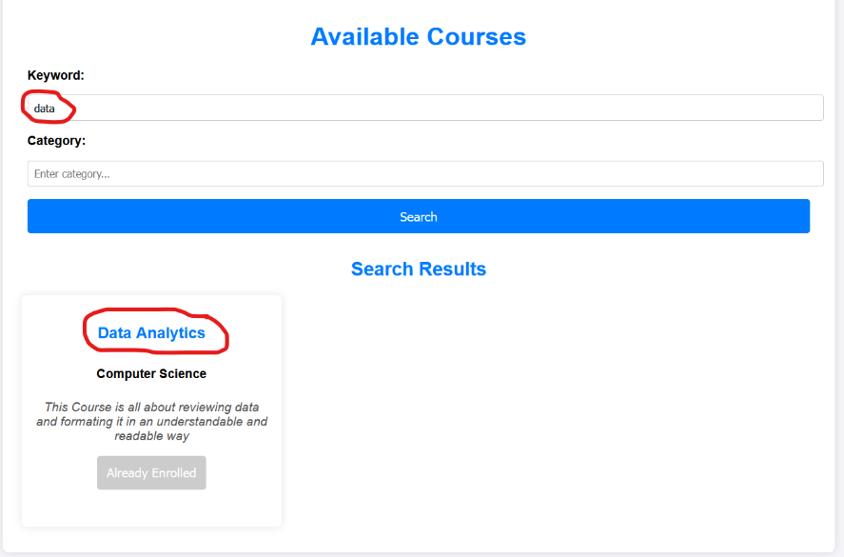
- User can then enter data into either the “Keyword:” field or the “Category:” field which shows courses fitting those descriptions (Which will be shown in the next 2 images. The fields are not case sensitive
This image shows the user entering “data” into the “keyword” field. The program then displays courses which contain that word “data”.

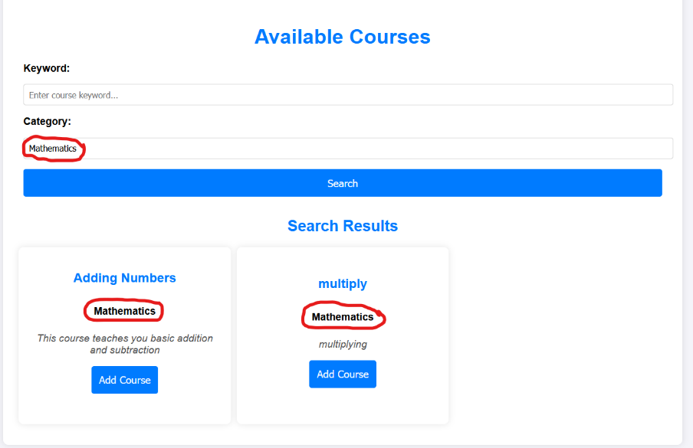
This image shows the user entering “Mathematics” into the “Category” field. The program then displays courses which are in the “Mathematics” category. A red circle highlighting the data entered and the outcome has been edited in for the sake of showing what has been entered and the expected outcome.

Course Bookmarking:
- On the Dashboard find ‘All Courses Section on the left-hand menu
- Click the button to see all courses available
- When courses are shown, you can click the ‘Add Course’ button on a course
- When pressed the button will be greyed out and will now be ‘Already Enrolled’ and can no longer be pressed
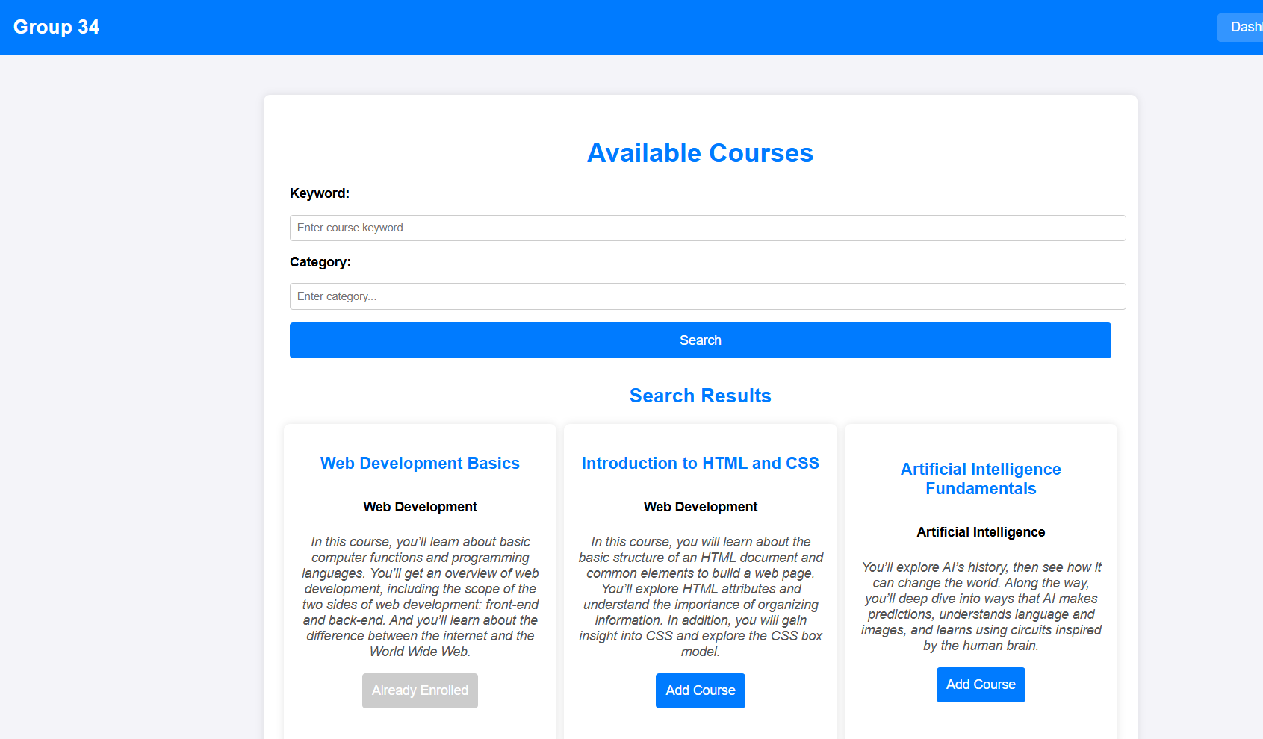

- The user can now navigate back to the ‘Dashboard Page’ and view their added courses in the ‘My Courses’ section
- The user can now click the ‘My Courses’ button on the left-menu to view courses they added
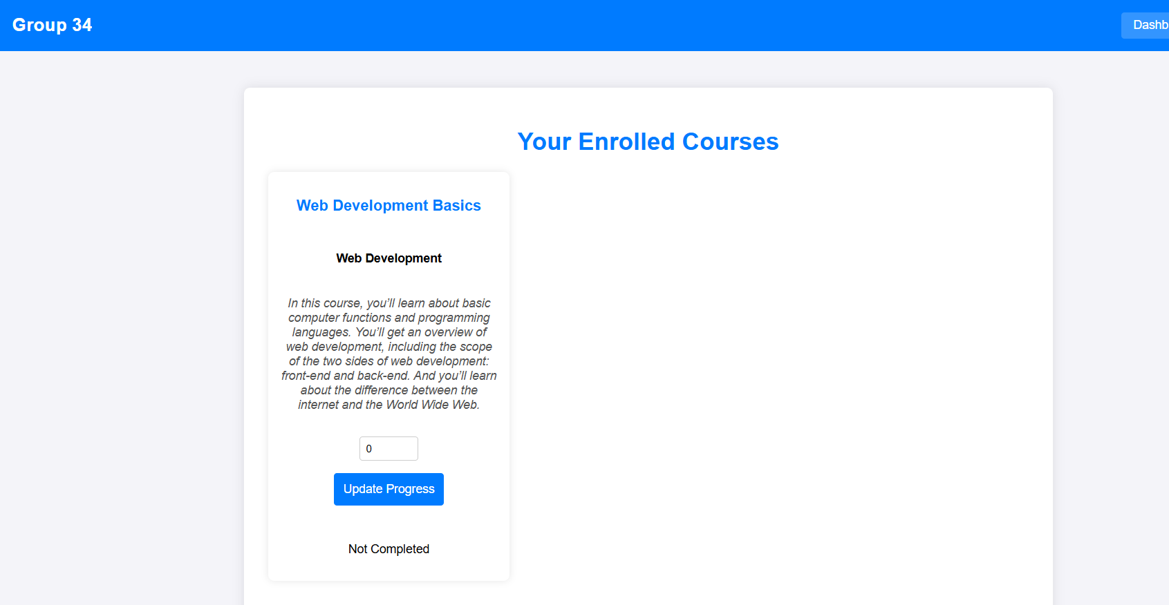
- The user can now see courses they have added which they can manipulate

Course Completion:
Users can manually update their course progress for each enrolled course.
- Navigate to "My Courses."
- Enter a progress value (whole number) between 1 and 100.
  - Allowed: Whole numbers (e.g., 10, 50, 75, 100).
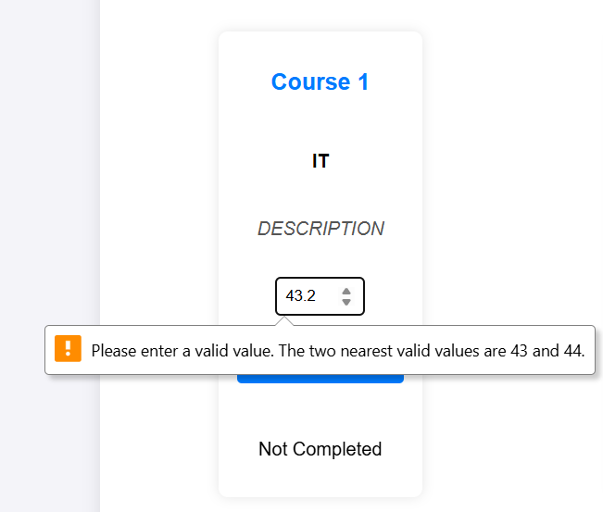
  - Not allowed: Decimal numbers (e.g., 99.5), letters, or symbols.

- Click "Update Progress" to save the changes.

A course is only considered "Completed" when progress reaches 100%.
Progress Value | Completion Status
1 - 99 | Not Completed
100 | Completed

- When progress reaches 100%, the page automatically refreshes to reflect the update.
- The database is updated in real-time.
- The UI will display the course as Completed.
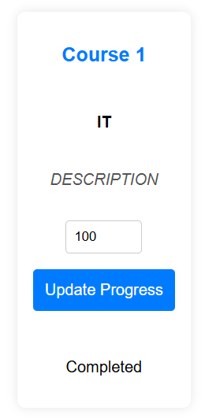

If progress is mistakenly set to 100%, it can be corrected by updating the value to a lower number:
- Enter a progress value below 100 (e.g., 80, 50, 10).
- Click "Update Progress."
- The system updates:
  - Database: The completed field changes back to "Not Completed."
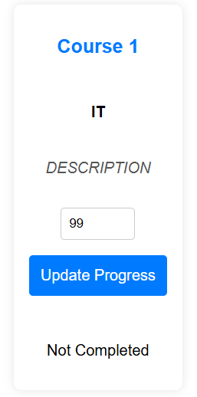
  - UI: The completion status is removed.

Gamification –
Achievement Badges:
Achievement badges are awarded based on course completion milestones and learning streaks.
Every completed course earns 100 points and increases the course completion count. Badges are unlocked at these milestones:
Course Completion Badges
Badge Name | Requirement
First Steps | Complete 1 course
Explorer | Complete 5 courses
Expert Learner | Complete 10 courses
Master of SkillsBuild | Complete 20 courses
Full Completionist | Complete all courses
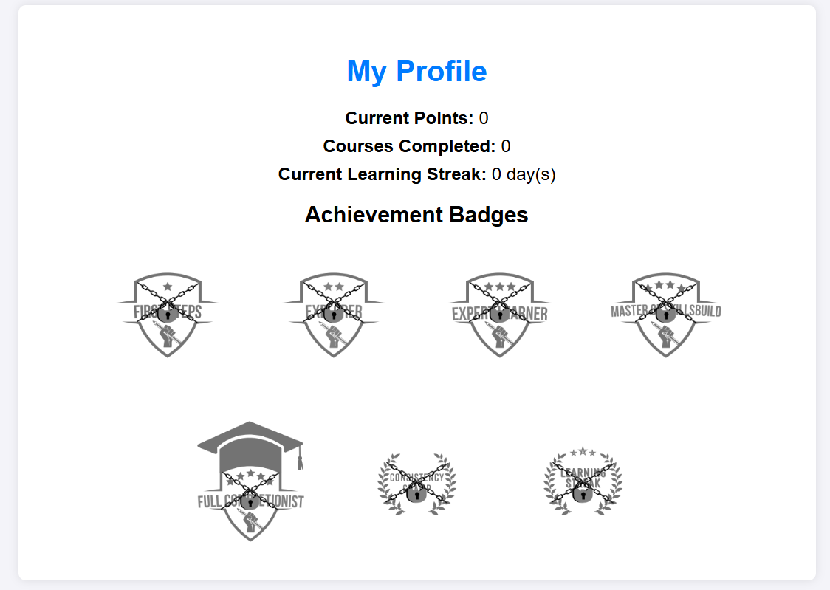
The figure above shows a profile with all badges locked.
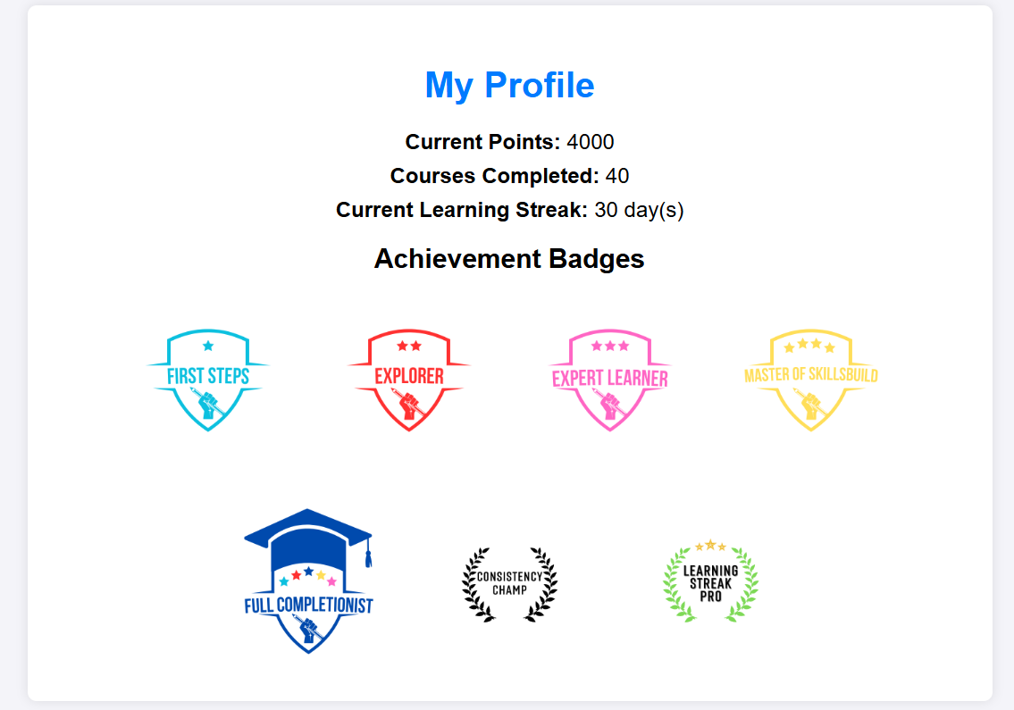
The figure above shows a profile with all badges unlocked.

Streaks:
A learning streak is maintained by completing at least one course per day. If a day is missed, the streak resets. These badges reward consistency:
Streak Badges
Badge Name | Requirement
Consistency Champ | Maintain a 7-day streak
Learning Streak Pro | Maintain a 30-day streak

Tracking Your Streak & Badges
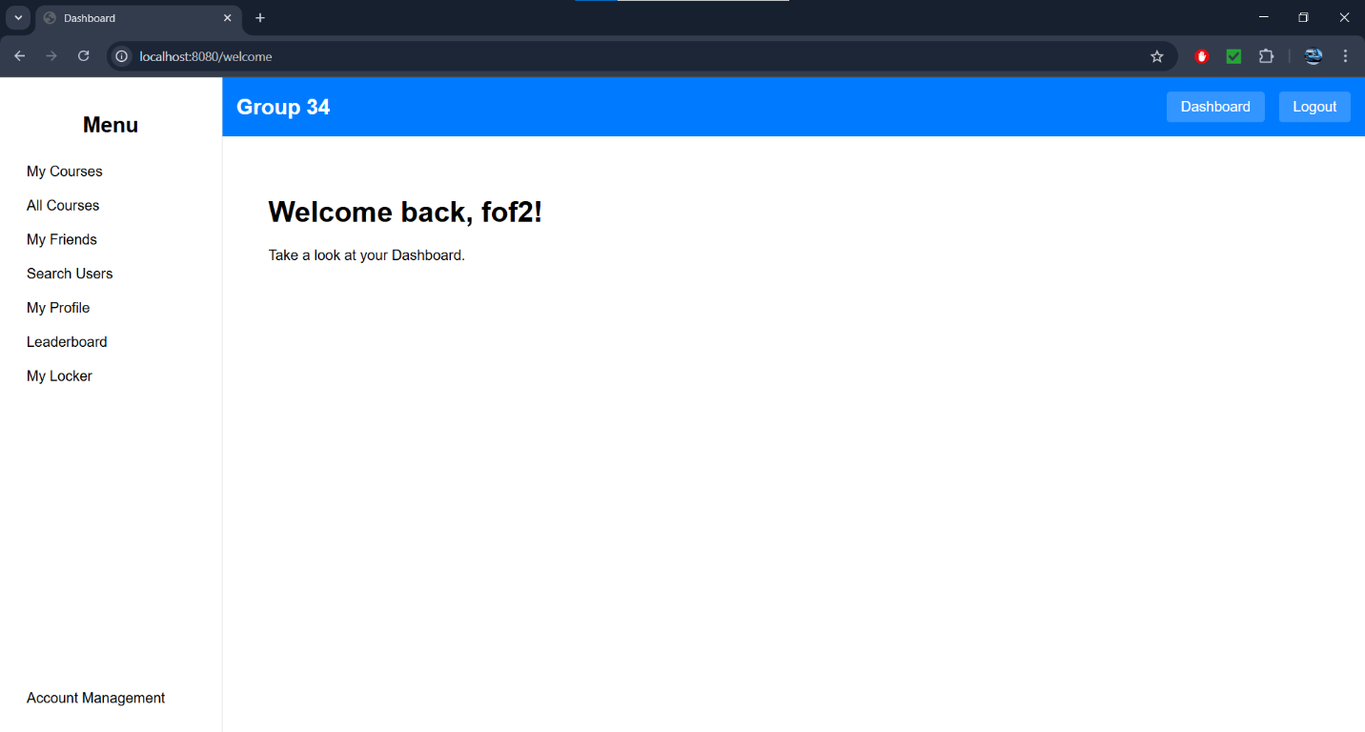
Users can track their streaks and unlocked badges on the "My Profile" page.

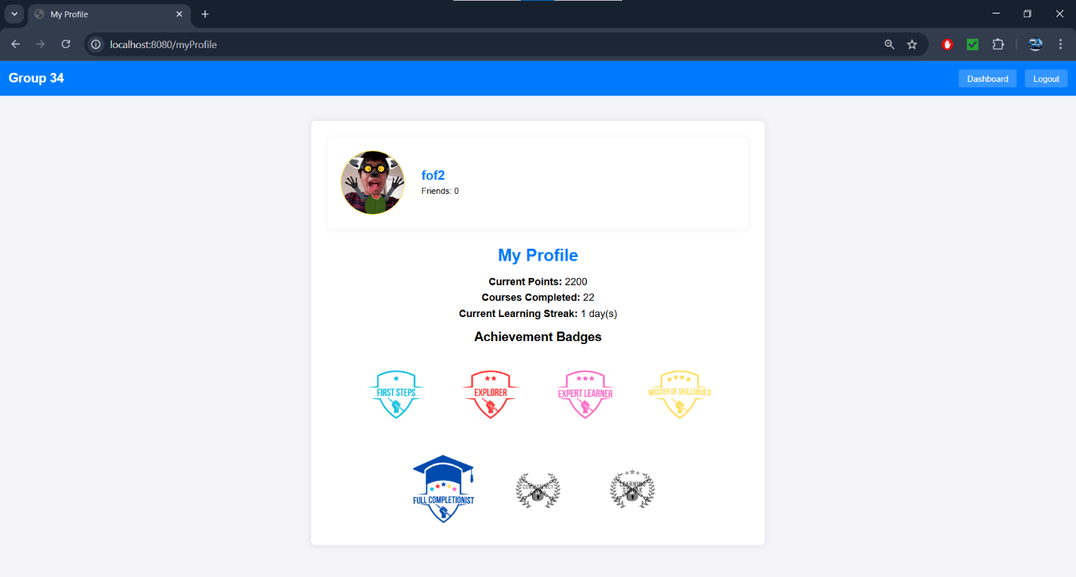
- The streak counter updates automatically as the user updates their progress in a course.

- If a badge is unlocked, a pop-up notification appears as shown below:
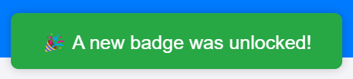.
- Hovering over locked badges displays unlock requirements.
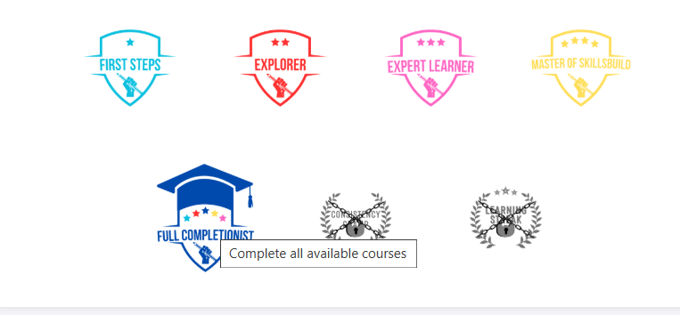
(Mouse can not be seen in screenshot but it is on top of Full Completionist badge)

Leaderboard:
- To view the global leaderboard, click on the leaderboard button in the sidebar.

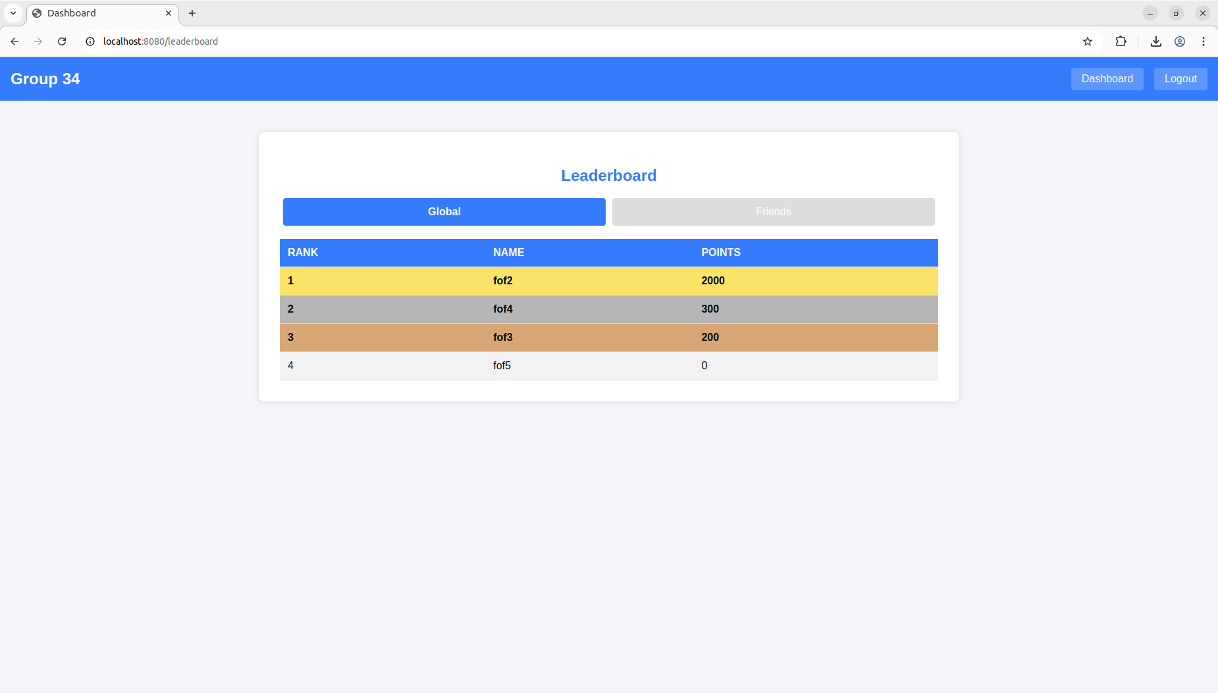
- To view the friends leaderboard, click on the friends tab above the leaderboard.
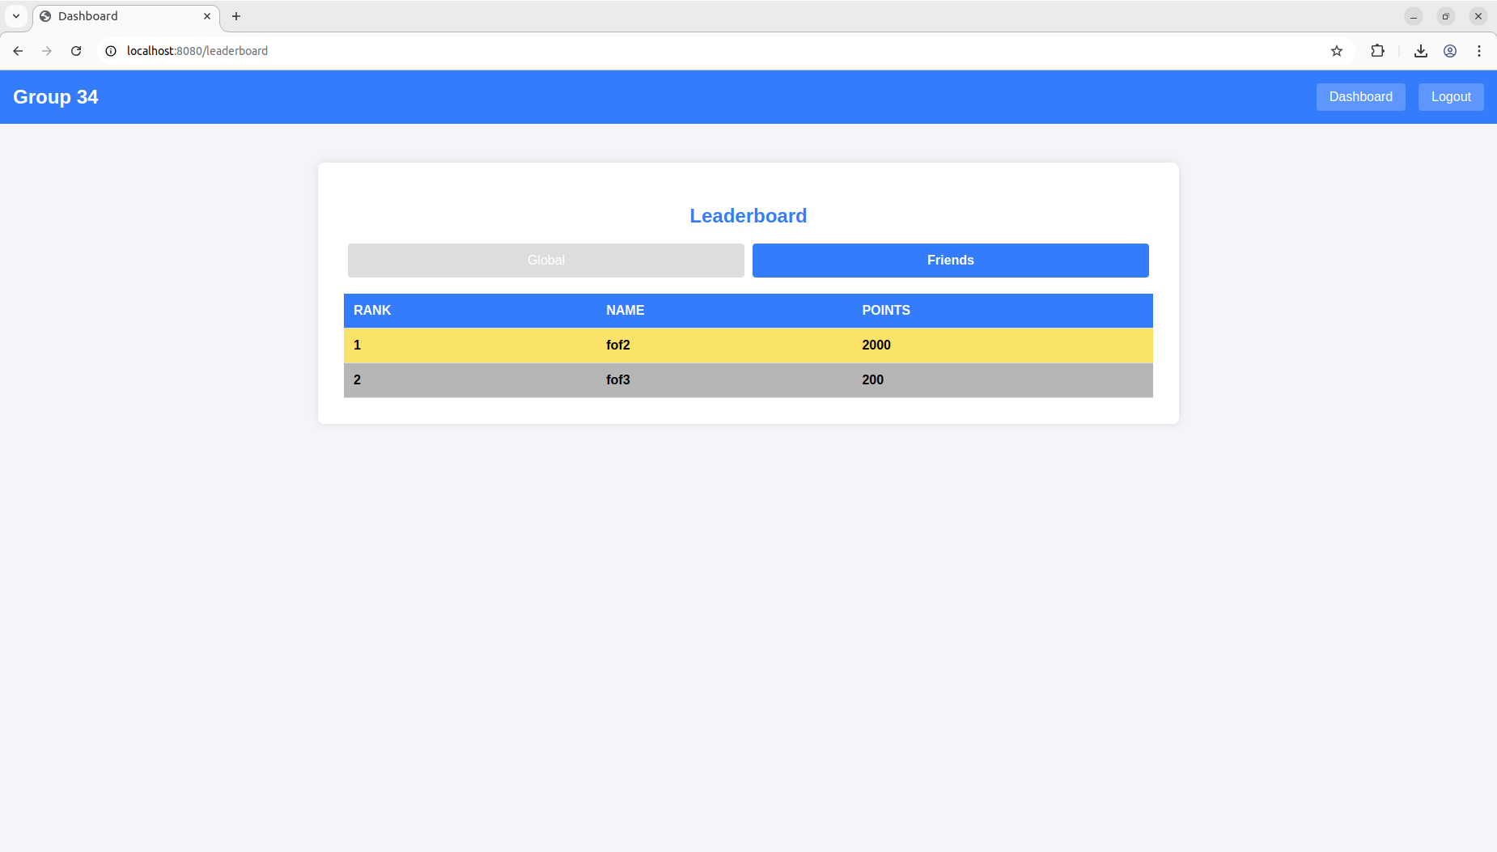
- To view the global leaderboard again, click on the global tab.

Equipping Profile Borders:
- Borders are equipped using the “Locker” page on the dashboard. This page unlocks after a course is completed.

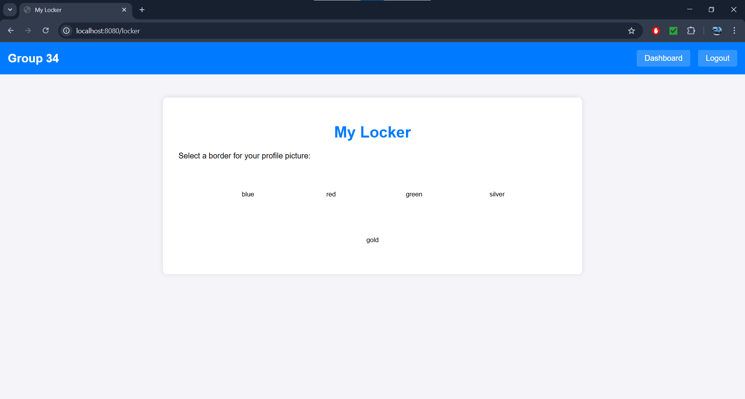

- To equip a border, click on a colour. Silver is unlocked after 20 courses are completed. Gold is unlocked after all courses are completed.

- Once equipped, the border can be seen on the My profile page. (The gold border is equipped below).

Friends Management –
Adding Friends:
- On the dashboard press the ‘My Friends’ button to see your current friends or press the ‘Search Users’ button to view all users
- If ‘My Friends’ button was pressed, the user will see a screen which will either show a message telling the user they have no friends or a list of their friends as well as a button which redirects the user to the search user’s function.
- When on the ‘Find Users’ page the user can search for a user using the search function by entering a user’s name or a fragment of their name then pressing search
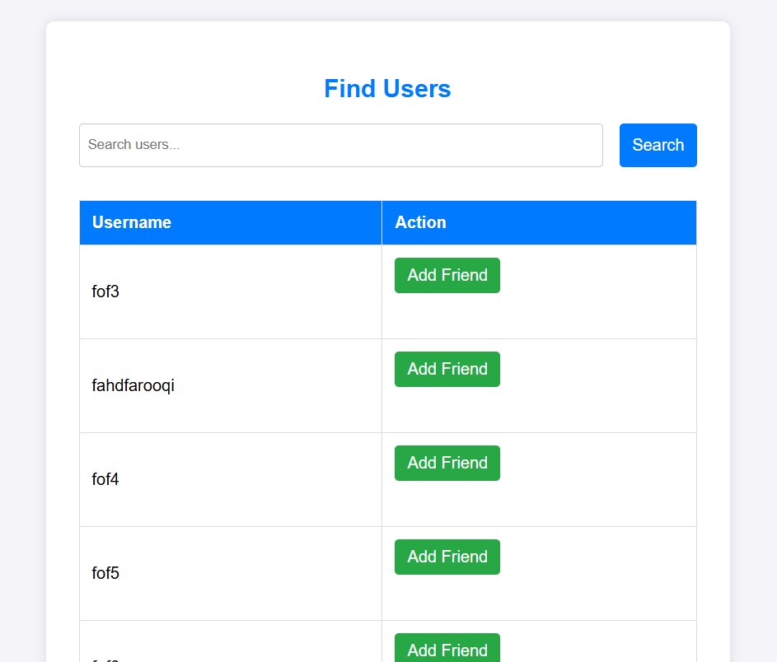
- When a user finds another user, they want to friend they can press the green ‘Add Friend’ button to send a friend request to that user.

- After a friend request is sent, the user will be redirected to their ‘My Friends’ page.
- If a user returns to the ‘Find Users’ page they will see that the user they sent a request to now has a red ‘Pending’ button next to their name that cannot be clicked, this will remain here until the other user accepts the request.
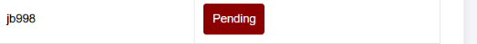

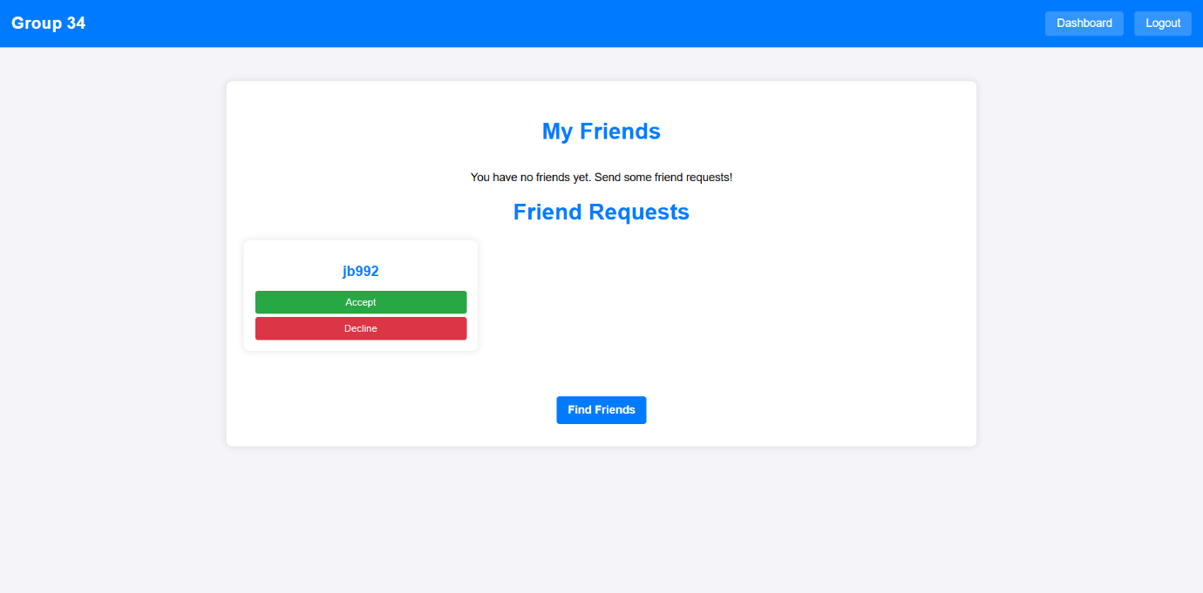
- Once a request is accepted, both users can now see each other in their friends list.
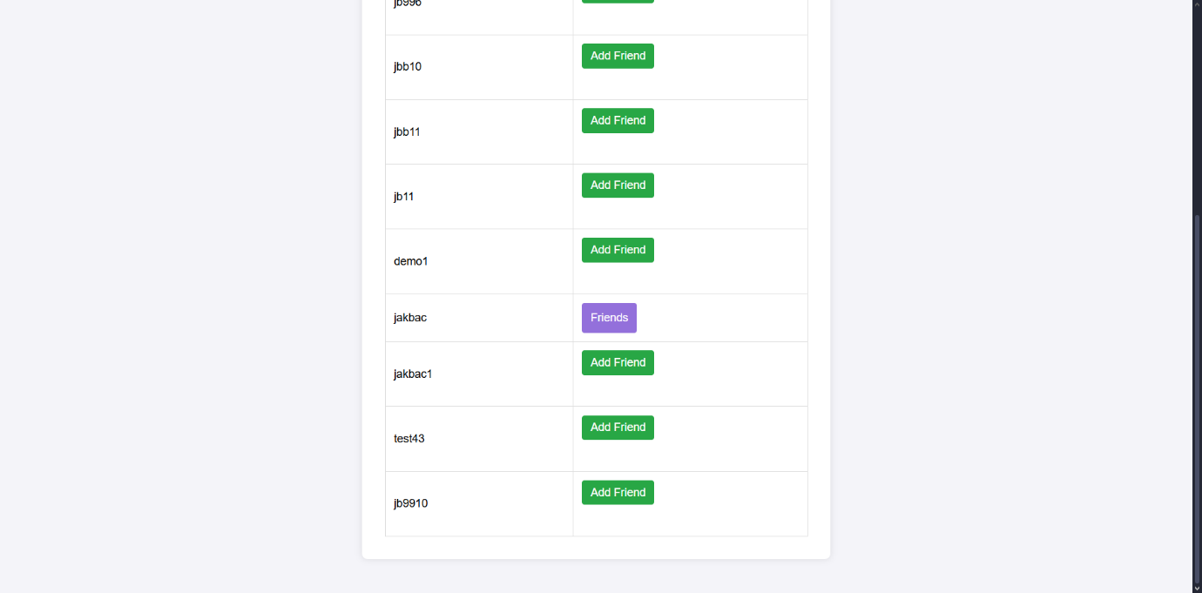
- This will also update on the ‘Search Users’ page since if a user returns to that user, they will see a purple ‘Friends’ button that cannot be clicked which indicates that the user is friends with that person

Removing Friends:
If a user wishes to no longer be friends with a user, they can press the red ‘Unfriend’ button on the ‘My Friends’ page which in turn will remove that person from their friend list as well as the friend list of the other user, as a result, that person will no longer appear as a friend in other features.
