

GAZIANTEP UNIVERSITY

DEVELOPMENT OF ULTRASONIC DISTANCE AND LEVEL MEASUREMENT SYSTEM USING ARM BASED MICROCONTROLLER

EEE 499 GRADUATION PROJECT

IN

ELECTRICAL & ELECTRONICS ENGINEERING

BY

EMRE CAN KIZILATEŞ

JANUARY 2022

ABSTRACT

DEVELOPMENT OF ULTRASONIC DISTANCE AND LEVEL MEASUREMENT SYSTEM USING ARM BASED MICROCONTROLLER

KIZILATEŞ,EMRE CAN
GRADUATION PROJECT IN ELECTRICAL AND ELECTRONICS ENGINEERING
SUPERVISOR:Prof.Dr.Ergun Erçelebi
January 2022, 17 pages

Nowadays,we have some difficulties in obtaining the distance and level that we want to measure.Even though,measuring tape is an easy option, but this kind of tool will have limitation of manual error.Before this, engineers have produced a range finder module have many disadvantages like limitation for distance,different results for different obstacles,and need calibration for every time before starts using it .Manual distance measuring is always done at the expense of human error. Precise and fix measurement of low range distance between 2 centimeters to 4 meters with the accuracy of at least 0.1 cm.this project mainly focused on utializing the ultrasonic waves at 40khz by using ultrasonic sensor transducers and measure the level and distance that we want to find. In general This report discusses end to end design of system in hardware and sofware.

Keywords:Ultrasounds,ultrasonic sensor,distance measuring,

ACKNOWLEDGEMENTS
First and foremost,i thank my supervisor prof.Ergun Erçelebi for giving me an opportunity to do this project under his patient guidance.i will be forever grateful to him for his reviews,suggestions and encouragement,which has benefitted immensely both this project and me personally
I would also like to extend a warm thanks to my friend; FATİH KOCA for his efforts and wisdom at timer application in msp430.
Finally I would like to acknowledge my perents that have supported me throughout the year.
TABLE OF CONTENTS
Page
ABSTRACT.................................................................................................................................................ii
ACKNOWLEDGEMENT..........................................................................................................................iii
LIST OF FIGURES....................................................................................................................................vi
LIST OF TABLES......................................................................................................................................vi
LIST OF TABLES......................................................................................................................................ix
1.INTRODUCTION.............................................................................................................................1
- COMPONENTS……..........………………………………………………………………..……........2
  - Hc-sr04-Ultrasonic sensor........................………………………………………………................……………………2
  - Msp430g2553 Microcontroller……………………………………………………………………………...........3
- HARDWARE………………………………………………………………........................................4
  - Hardware design schematic……………………………………………………………................4
3.1.1.Connection diagram...............................................................................................................4
3.1.2.Hardware pins and functions..................................................................................................5
- SOFTWARE…………………………………………………………………………..………...........5
4.1.Timer_A application........................................................................................................................5
4.2.Timer_A modes................................................................................................................................6
4.2.1.Up mode....................................................................................................................................6
4.2.2.Continuous mode......................................................................................................................7
4.3.Capture-compare blocks..................................................................................................................7
4.3.1.Capture mode..............................................................................................................................8
4.4.Output modes.................................................................................................................................8
5.TEST RESULTS…………………………………………………………………………………...……9
5.1.Measuring range………………………………………………………………………………………..9
5.2.Frequency...............................................................................................................................................10 5.3.Accuracy................................................................................................................................................11
5.4.Temperature...........................................................................................................................................12
6.CONCLUSIONS......................................................................................................................................12
REFERENCES...........................................................................................................................................14
APPENDICES
A) COST ANALYSIS.................................................................................................................................15
B) PROJECT CODES…………………………………………………………………………................15
C) GANTT CHART……………………………………………………………………………………...17

LIST OF FIGURES
Page
Figure .2.1 Ultrasonic sensor.........................................................................................................................2

Figure. 2.2.Msp430g2-et pinouts...................................................................................................................3

Figure.3.1.Connection diagram......................................................................................................................4

Figure.4.1.Up mode graph................................... …………………………………………………….……7

Figure.4.2.Continuous mode graph……………………………..…………………………………………..7

Figure.4.3.Capture block diagram……………………………………..…..................……….……………8

Figure.5.1.Measuring range test css output……………………............……………………….……...…..10

Figure.5.2.Frequency test css output.....………………………………………………………..…….……10

LIST OF TABLES
Page
Table 4.4.Timer_A output mode .....………………………………………………………........................9

Table5.3.Accuracy test results…........……………………………………………………..……………...11

- INTRODUCTION
An ultrasonic sensor includes a transducers that can emits high frequency-40khz-inaudible acoustic waves in one direction when the transducer elements vibrates.If the waves strike and bounce off an object,the transducer receives the echoed signal.The sensor then determines its distance or level from the object or liquid based on the length of time time between the initial sound burst and the echo’s return.Ultrasonic sensor requires fairly accurate timing circuitry,so acoustic sensor really requires a proccessor like an msp launchpad to drive it.Ultrasonic sensor hc-sr04 should be a first choice for detecting clear objects,obstacles,liquids and dense of materials of any surface type and irregular shaped surfaces.This makes it a perfect choices to measuring desired distance and level

2. COMPONENTS

2.1. HC-SR04-ULTRASONIIC SENSOR
Ultrasonic sensor work on a principle,which evaluate attributes of a target by interpreting the echoes from radio and sound waves respetively.Ultrasonic sensors generate high frequency sound waves and evaluate the echo which is received back the sensor.Sensors calculate the time interval between sending the signal and receiving the echo to determine the distance to an object.As shown in figure.2.1 the hc-sr04 has four pinouts:Vcc,Gnd,Trıg and Echo.when the trıg pin is excited with 10us pulse,the transmitter emits eight bursts pulses at 40khz.The on board signal processing filters the signal received by the receiver and one time programmable controller on the sensor calculates the transit time and sends out logic high on the echo pin for a duration proportional to the distance.Half the round trip distance thus obtained gives us the distance from the sensor to the subject

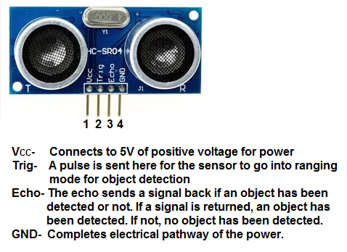
FIGURE.2.1.

2.2.Msp430g2et-g2553-microcontroller
Msp430 microcontroller is is an inexpensive and easy-to-use evaluation modulev(EVM) for the MSP430G2xx entry-level series of microcontrollers (MCUs). It contains almost everything needed to start developing on the ultra-low-power MSP430™ microcontroller platform, including an onboard debug probe for programming, debugging and energy measurements. The board also features a push button and three LEDs for creating a simple user interface. The MSP430G2553 16-bit MCU has 16KB of flash, 512 bytes of RAM, up to 16-MHz CPU speed, an 8-channel 10-bit ADC, capacitive-touch enabled I/Os, a universal serial communication interface, and more.In this project microcontroller will be used for generating 10us pulses which has 40khz frequency and calculate the time between each echo pulse reflected back to the sensor and determines the distance between object to sensor by using serial clock line pin which controlled by timer application in our launchpad and pulse width modulation technique which also used for trigger the sensor to give ultrasonic waves.

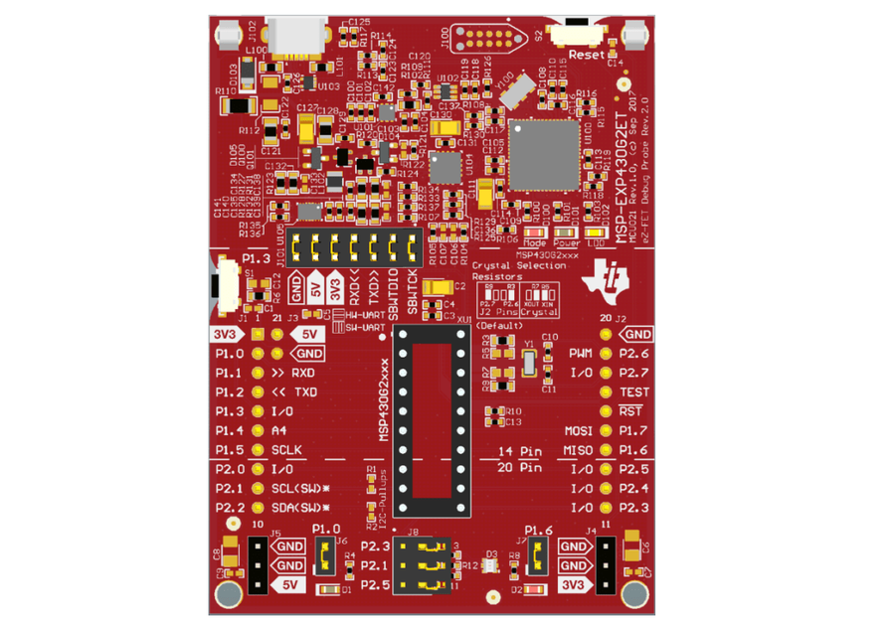

FIGURE.2.2.

3. HARDWARE

3.1. HARDWARE DESIGN SCHEMATIC
In hardware side of this project mainly has been focused on the electrical connections of the components and making the suitable design in realistic contraints in power consumption and desired frquency, measurement range.

3.1.1.CONNECTION DIAGRAM

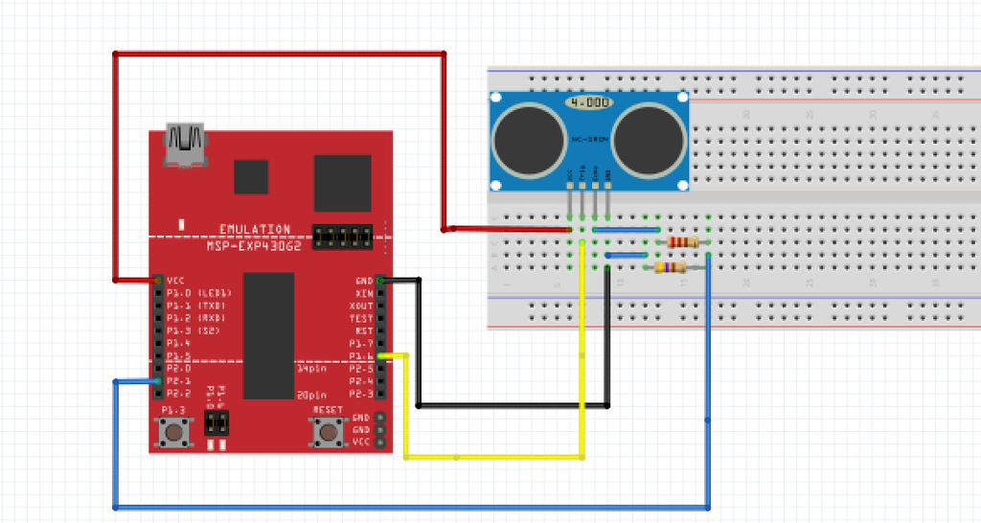
FIGURE.3.1.
It has been shown in figure.3.1 vcc,gnd,p1.6 pin and p2.1 are used in microcontroller. Sensor Vcc is connected to 5V on the MSP430 Launchpad Sensor Ground to GND on the MSP430 Launchpad Sensor Trigger to P1.6(MISO) on the MSP430 Launchpad Sensor Echo to P2.1(SCL) on the MSP430 Launchpad.Echo pin is needed to implemeted in voltage divider because voltage level should be reduced from 5V to 3.3V to use utialize echo pin properly. (470/(470+220))*5v =3.3V.

3.1.2.HARDWARE PINS AND FUNCTIONS
Pin1.6-Master in slave output- pin was used in this circuit for trigger the sensor by giving 10us pulses.This process has been done by utializing the pulse width modulation in compare mode of timer application which has been discussed in software section.
Pin2.1-Serial clock line-was used in this project for calculate the duration in echo pulse -which directly proportional to the distance-and find the distance by divide the duration over 58. according to datasheet of the hc-sr04.(ıt can be found in datasheets section)

4.SOFTWARE
In this section will be discussed about desired outcome,software codes of the project and timer application of the launchpad and why it was used in our program that will be discussed in detail.

4.1.TIMER_A APPLICATION
Timer_A is a 16-bit timer/counter with three capture/compare registers. Timer_A can support multiplecapture/compares, PWM outputs, and interval timing. Timer_A also has extensive interrupt capabilities.
Interrupts may be generated from the counter on overflow conditions and from each of thecapture/compare registers.
Timer_A features include:
• Asynchronous 16-bit timer/counter with four operating modes
• Selectable and configurable clock source
• Two or three configurable capture/compare registers
• Configurable outputs with PWM capability
• Asynchronous input and output latching
• Interrupt vector register for fast decoding of all Timer_A interrupts

In previous sections timer_a has been talked about triggering the sensor with 10us pulses with using pulse width modulation.Timer_a was used in capture compare mode to determine the pulse width modulation and that triggered the sensor by that process ıt can be utialized the sensor and make the connection and command between launchpad and sensor for desired operation in specific frequency 1Mhz and measurement range which is defined as 2cm up to 4m. capture mode and capture interupts for measuring echo timestamps in p2.1. was used to record the time event and measurements.

4.2.TIMER_A MODES
Timer_A supports 4 modes of operation:
- Stop Mode: In this mode the Timer is Halted.
- Up Mode: Timer repeatedly counts from Zero to value stored in Capture/Compare Register 0 (TACCR0).
- Continuous: Timer repeatedly counts from Zero to 0xFFFF, which is maximum value for 16-bit TAR.
- Up/Down Mode: Timer repeatedly counts from Zero up to the value in TACCR0 and back down to zero.

Mainly up and continuous mode has been used to operate capture and compare in timer_a application this two modes will be discussed i n detail

4.2.1.UP MODE
The up mode is used if the timer period must be different from 0FFFFh(65535 in decimal 1111111111111111 in binary) counts. The timer repeatedly counts up to the value of compare register TACCR0, which defines the period.

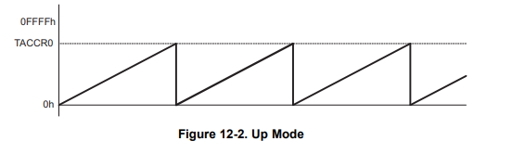
FIGURE.4.1.
4.2.2.CONTINUOUS MODE
In the continuous mode, the timer repeatedly counts up to 0FFFFh(65535 in decimal 1111111111111111 in binary ) and restarts from zero.

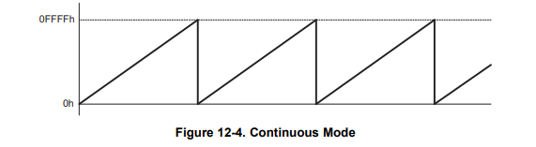
FIGURE.4.2.

4.3.CAPTURE COMPARE BLOCKS
Two or three identical capture/compare blocks, TACCRx, are present in Timer_A. Any of the blocks may be used to capture the timer data, or to generate time intervals. Capture Mode The capture mode is selected when CAP = 1.

4.3.1.CAPTURE MODE
Capture mode has been used to record time events. It can be used for speed computations or time measurements. The capture inputs CCIxA and CCIxB are connected to external pins or internal signals and are selected with the CCISx bits. The CMx bits select the capture edge of the input signal as rising, falling, or both. A capture occurs on the selected edge of the input signal. If a capture occurs;The timer value is copied into the TACCRx register The interrupt flag CCIFG is set The input signal level can be read at any time via the CCI bit. MSP430x2xx family devices may have different signals connected to CCIxA and CCIxB. See the device-specific data sheet for the connections of these signals. The capture signal can be asynchronous to the timer clock and cause a race condition. Setting the SCS bit will synchronize the capture with the next timer clock. Setting the SCS bit to synchronize the capture signal with the timer clock is recommended.

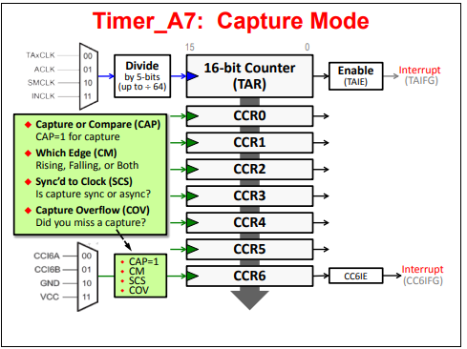

FIGURE.4.3.

4.4.OUTPUT MODES
When the pin is used as an output, its value is determined by the OUT bit-field in its control register. The exact details for this are TA0.1 = TA0CCTL1.OUT. (Sometimes you’ll just see this OUT bit abbreviated as OUT1.) Besides routing the CCR OUT signal to a pin, it can also be used by other MSP430 peripherals. For example, on some devices the A/D converter could be triggered by the timer directly.

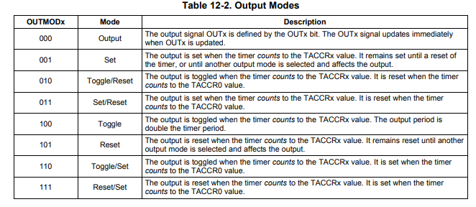
TABLE.4.4.

5.TEST RESULTS
The project 0980 has some specific contraint values in design and our purpose was made the circuit design between given specific orders.According to last results of the project electrical parameters and other values is given below.

5.1.MEASURING RANGE
In this project our measuring range shoıld in between 2 centimeters and 4 meters.The circuit has been tested and stated measuring range range in datasheet of ultrasonic sensor was verified.
When any obtacles has been putted in front of the senor ıt was detect only between 2cm to 4 cm as in figure5.1.
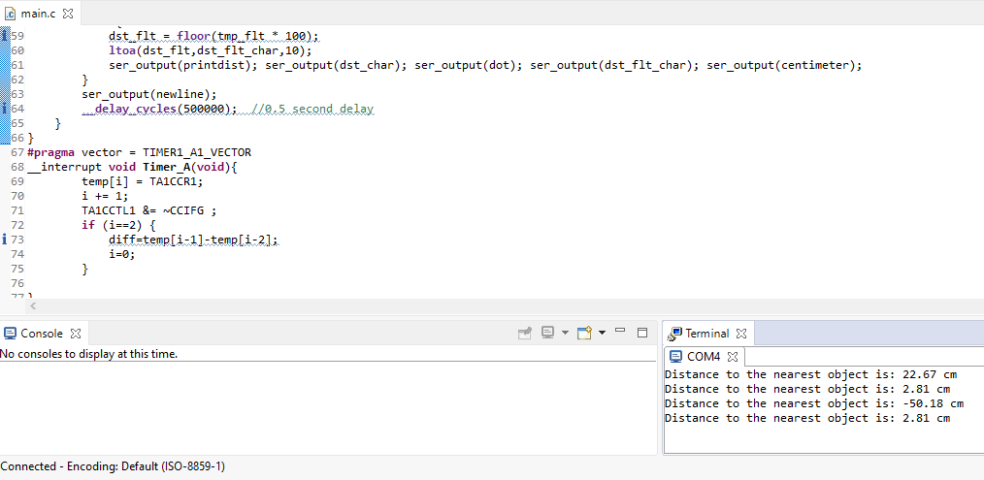

FIGURE.5.1.

5.2.FREQUENCY
In project criterian states about frequency that 1Mhz in our project test this value was tested and if there is any change in frequency that will be measuring diffrence or non valid outputs .1Mhz value has been specified for calculating and measuring centimeters range distances.
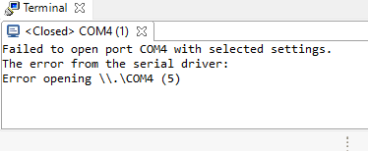
FIGURE.5.2.

5.3.ACCURACY
This test was utiliazed by using ruler and sensor in presentation time and also some results has been outcome .
SENSOR VALUE | ACTUAL VALUE
From D1 to D2 in our department building | From D1 to D2 in our department building
2.79 cm | 2.83 cm

TABLE.5.3

5.4.TEMPERATURE
This test has been done in fridge and radiator, after the test there is no specific change in serial monitor, temperature values was -24 celcius in fridge and +49 celcius in radiator.

6.CONCLUSION
Ultrasonic sensors are non-intrusive in that they do not require physical contact with their target, and can detect certain clear or shiny targets otherwise obscured to some vision-based sensors. Therefore, range finders may need to be recalibrated to make accurate measurements in a new environment. Temperature variations and air currents can create invisible boundaries that will reflect ultrasonic waves, so care must be taken to avoid these. For the transmitted wave to echo back to the receiver, the target surface must be perpendicular to the transmitter. Round objects are therefore most easily sensed since they always show some perpendicular face. When targeting a flat object, care must be taken to ensure that its angle with respect to the sensor does not exceed a particular range.
Ultrasonic sensors typically have a “dead zone” immediately in front of them in which objects cannot be detected because they deflect the wave back before the receiver is operational. (This is because reverberations from the transmitter force the receiver to pause a moment before beginning to listen for the echo). Some materials are more absorbent than others, and these will reflect less ultrasound. This complicates using the attenuation method to measure the distance of arbitrary objects.
The project 0980 has been prepared by arm based microconntroller and ultrasonic sensor.It gives us a chance to measure any distance without physical contact with very high accuracy.In real life this technology can be used in any area which basically needs the same manners in our project and also used in several areas like car parking sensors and security systems in public buildings and shopping centers.

REFERENCES
www.erpublication.org
www.aml.ece.iisc.ac.in
https://www.ti.com/lit/ug/slau144j/
https://cdn.sparkfun.com/datasheets/Sensors/Proximity/HCSR04.pdf
www.ocfreaks.com
www.software-dl.ti.com
www.ti.com/msp430g2553
Max/MSP ile MIDI Programlama Serdar Çelik page 34-46,98-101

APPENDICES

A-)COST LIST
HC-SR04 SENSOR | 5 TL
MSP430G2553 | 251 TL
MALE-MALE FEMALE-MALE JUMPER CABLES | 5 TL
RESISTORS(220,470 OHMS) | 5 TL
ELECTRONIC BREADBOARD | 11 TL
OVERALL | 277 TL

B-)PROJECT CODES
#include <msp430.h>
#include <stdlib.h>
#include <stdio.h>
#include <string.h>
#include <math.h>
char printdist[] = "Distance to the nearest object is: ";
char centimeter[] = " cm";
char dot[] = ".";
char zerro[] = "0";
char newline[] = " \r\n";
volatile int temp[2];
volatile float diff;
volatile unsigned int i=0;
int dst_int;
int dst_flt;
float tmp_flt;
char dst_char[5];
char dst_flt_char[5];
volatile float distance;
void ser_output(char *str);
void main(void)
{
WDTCTL = WDTPW | WDTHOLD; // stop watchdog timer
BCSCTL1= CALBC1_1MHZ;
DCOCTL = CALDCO_1MHZ;
P1DIR = BIT6;
P2SEL = BIT1;
P1SEL = BIT1|BIT2|BIT6;
P1SEL2 = BIT1|BIT2;
UCA0CTL1 |= UCSWRST+UCSSEL_2;
UCA0BR0 = 52;
UCA0BR1 = 0;
UCA0MCTL = UCBRS_0;
UCA0CTL1 &= ~UCSWRST;
TA0CTL = TASSEL_2|MC_1 ;
TA0CCR0 = 0xFFFF;
TA0CCR1 = 0x000A;
TA0CCTL1 = OUTMOD_7;
TA1CTL = TASSEL_2|MC_2 ;
TA1CCTL1 = CAP | CCIE | CCIS_0 | CM_3 | SCS ;
_enable_interrupts();
while(1){
distance = diff/58;
dst_int = floor(distance);
tmp_flt = distance - dst_int;
ltoa(dst_int, dst_char,10);
if (tmp_flt < 0.01) {
dst_flt = floor(tmp_flt * 1000);
ltoa(dst_flt,dst_flt_char,10);
ser_output(printdist); ser_output(dst_char); ser_output(dot); ser_output(zerro); ser_output(zerro); ser_output(dst_flt_char); ser_output(centimeter);
}
else if (tmp_flt < 0.1) {
dst_flt = floor(tmp_flt * 100);
ltoa(dst_flt,dst_flt_char,10);
ser_output(printdist); ser_output(dst_char); ser_output(dot); ser_output(zerro); ser_output(dst_flt_char); ser_output(centimeter);
}
else {
dst_flt = floor(tmp_flt * 100);
ltoa(dst_flt,dst_flt_char,10);
ser_output(printdist); ser_output(dst_char); ser_output(dot); ser_output(dst_flt_char); ser_output(centimeter);
}
ser_output(newline);
__delay_cycles(500000); //0.5 second delay
}
}
#pragma vector = TIMER1_A1_VECTOR
__interrupt void Timer_A(void){
temp[i] = TA1CCR1;
i += 1;
TA1CCTL1 &= ~CCIFG ;
if (i==2) {
diff=temp[i-1]-temp[i-2];
i=0;
}
}
void ser_output(char *str){
while(*str != 0) {
while (!(IFG2&UCA0TXIFG));
UCA0TXBUF = *str++;
}
}

C-)GANTT CHART
