REPORT OF DEEP LEARNING PROJECT

Emre Akbaş - 1185181532

Selami Göktuğ Koyuncu - 52174638152

Detection of Pneumonia with Deep Learnıng

1) PROBLEM

The importance of healthy and accurate diagnosis is increasing day by day as the population is constantly growing and the demand for health services is increasing with it. In the field of medical imaging, timely and accurate detection of serious diseases such as pneumonia has become increasingly important. Fast and accurate disease detection is necessary to intervene in time and prevent such diseases that endanger human life. The project, which is based on this problem in general, focuses on the rapid and accurate detection of pneumonia. We started to develop this project by researching artificial intelligence and deep learning. In particular, thanks to cnn, one of the deep learning methods, we created a model that classifies x-ray images as diseased and non-diseased images. Thus, we accelerated disease diagnosis and at the same time, we made disease diagnoses and treatment applications more efficient with accurate diagnoses in the field of health.

2) Explanation of The Neural Network Model

**Convolutional neural network** (**CNN**) is a regularized type of feed-forward neural network that learns feature engineering by itself via filters (or kernel) optimization. Vanishing gradients and exploding gradients, seen during backpropagation in earlier neural networks, are prevented by using regularized weights over fewer connections. For example, for *each* neuron in the fully-connected layer, 10,000 weights would be required for processing an image sized 100 × 100 pixels. However, applying cascaded *convolution* (or cross-correlation) kernels, only 25 neurons are required to process 5x5-sized tiles. Higher-layer features are extracted from wider context windows, compared to lower-layer features.

Feed-forward neural networks are usually fully connected networks, that is, each neuron in one layer is connected to all neurons in the next layer. The "full connectivity" of these networks makes them prone to overfitting data. Typical ways of regularization, or preventing overfitting, include: penalizing parameters during training (such as weight decay) or trimming connectivity (skipped connections, dropout, etc.) Robust datasets also increase the probability that CNNs will learn the generalized principles that characterize a given dataset rather than the biases of a poorly-populated set.

CNNs use relatively little pre-processing compared to other image classification algorithms. This means that the network learns to optimize the filters (or kernels) through automated learning, whereas in traditional algorithms these filters are hand-engineered. This independence from prior knowledge and human intervention in feature extraction is a major advantage.

A convolutional neural network consists of an input layer, hidden layers and an output layer. In a convolutional neural network, the hidden layers include one or more layers that perform convolutions. Typically this includes a layer that performs a dot product of the convolution kernel with the layer's input matrix. This product is usually the Frobenius inner product, and its activation function is commonly ReLU. As the convolution kernel slides along the input matrix for the layer, the convolution operation generates a feature map, which in turn contributes to the input of the next layer. This is followed by other layers such as pooling layers, fully connected layers, and normalization layers. Here it should be noted how close a convolutional neural network is to a matched filter.

3) DESCRIPTION OF OUR DATASET

The dataset is organized into 3 folders (train, test, val) and contains subfolders for each image category (Pneumonia/Normal). There are 5,863 X-Ray images (JPEG) and 2 categories (Pneumonia/Normal).

For the analysis of chest x-ray images, all chest radiographs were initially screened for quality control by removing all low quality or unreadable scans. The diagnoses for the images were then graded by two expert physicians before being cleared for training the AI system. In order to account for any grading errors, the evaluation set was also checked by a third expert.

metin, ekran görüntüsü, dikdörtgen, tasarım içeren bir resim

Açıklama otomatik olarak oluşturuldu

**Some Datas From Our Data Set :**

**1) Normal Datas :**

röntgen filmi, tıbbi görüntüleme, radyoloji, radyografi içeren bir resim

Açıklama otomatik olarak oluşturulduröntgen filmi, tıbbi görüntüleme, radyografi, radyoloji içeren bir resim

Açıklama otomatik olarak oluşturuldu

**2) Pneumonia Datas :**

röntgen filmi, tıbbi görüntüleme, radyoloji, radyografi içeren bir resim

Açıklama otomatik olarak oluşturulduröntgen filmi, tıbbi görüntüleme, radyoloji, radyografi içeren bir resim

Açıklama otomatik olarak oluşturuldu

4) RESULTS

Finally, as we see in the result of our project, we have achieved an accuracy rate of 92 percent. In this way, we have shown how convenient and usable artificial intelligence is in the field of health, diagnosis of diseases, correct treatment, etc.

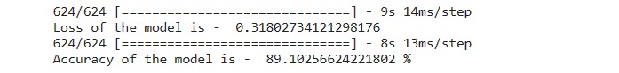

1) Training And Validation Accuracy And Loss :

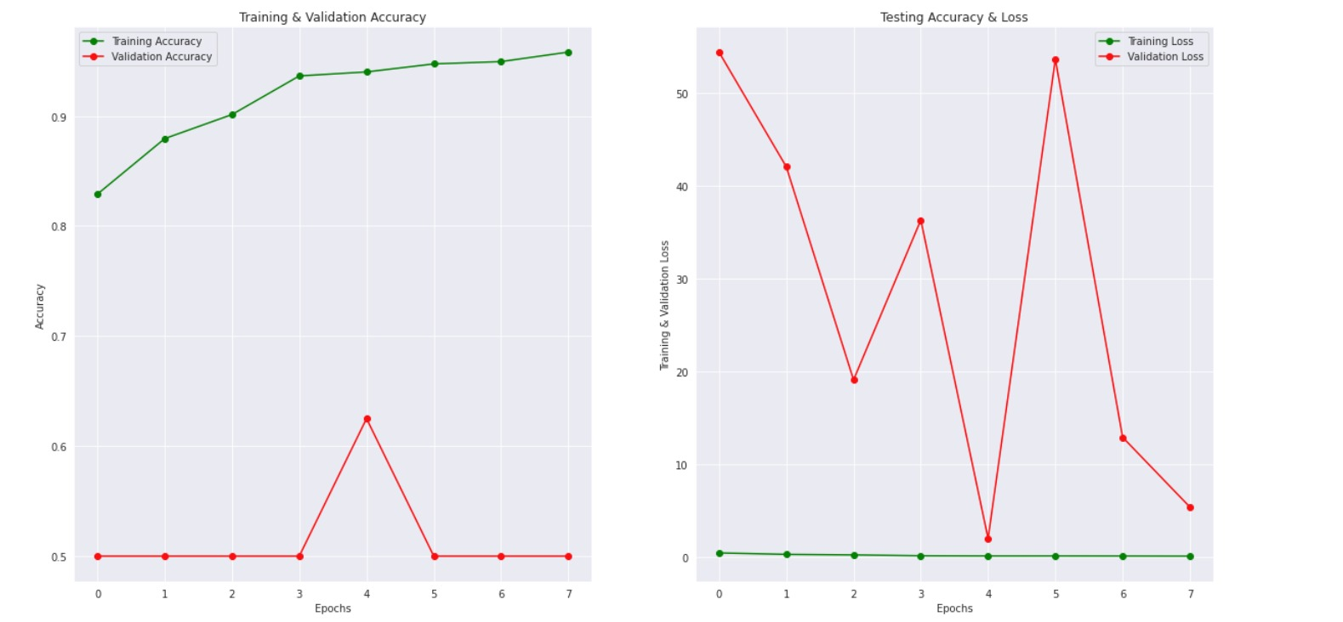

2) Metrics :

ekran görüntüsü, metin, dikdörtgen, tasarım içeren bir resim

Açıklama otomatik olarak oluşturuldu

3) Testing :

Correctly Predicted Class :

metin, ekran görüntüsü, taslak, siyah beyaz içeren bir resim

Açıklama otomatik olarak oluşturuldu

Uncorrectly Predicted Class :

metin, ekran görüntüsü, röntgen filmi, skeleton içeren bir resim

Açıklama otomatik olarak oluşturuldu

4) Our Model :

metin, sayı, numara, yazı tipi, makbuz içeren bir resim

Açıklama otomatik olarak oluşturuldu

5) Precision, Recall, f-1 Score :

metin, makbuz, yazı tipi, beyaz içeren bir resim

Açıklama otomatik olarak oluşturuldu

6) Augmentation :



5) DISCUSSION

Discussion section encompasses the evaluation of results and provides a critical analysis of the study in general. In this section, the following points can be addressed:

Model Performance: Are the results obtained by the model satisfactory? Can the model reliably diagnose pneumonia?

Dataset: Is the dataset used sufficient? How effective was the data imbalance, and have the applied data augmentation techniques addressed this issue?

Generalizability of the Model: Can the model demonstrate similar performance on different datasets or real-world applications? What can be done to enhance the model's generalizability?

Limitations and Future Work: What are the limitations of this study? What can be done to improve the performance of this model in the future? Can performance be enhanced using different data augmentation techniques, different model architectures, or larger datasets?

These discussion points facilitate a thorough evaluation of your study and provide guidance for future research. It's important to identify the strengths and weaknesses of the model's performance to emphasize areas for improvement in future studies. Additionally, in this section, the potential clinical applications of the study and its implications can also be discussed.

- Our answers for these questions :

Model Performance: The model achieved high accuracy in diagnosing pneumonia. Both training and validation accuracies were at high levels, and similar performance was obtained on the test dataset. This indicates that the model can be reliably used for pneumonia diagnosis.

Dataset: The dataset used was sufficient for training the model for pneumonia diagnosis. However, there was a data imbalance issue between the normal and pneumonia classes, which could potentially affect the model's performance negatively. To address this, data augmentation techniques were applied to augment the normal class. This helped in training the model in a more balanced way and improved its performance.

Generalizability of the Model: The model can potentially demonstrate similar performance on different datasets or real-world applications. However, further testing is required to assess its generalizability. Additionally, to enhance the model's generalizability, a larger dataset or transfer learning techniques could be employed.

Limitations and Future Work: Limitations of this study may include the size and diversity of the dataset used. Furthermore, using a larger dataset or experimenting with different model architectures could further improve the model's performance. In future work, the application of the model in clinical settings and its performance on real-world patient populations could also be investigated.