REAL-TIME SIGNAL ACQUISITION,

PROCESSING AND ANALYSIS

Yaşar CANBOLAT  
*Abdullah Gül University*  
yasar.canbolat@agu.edu.tr

Emre ASLAN   
*Abdullah Gül University*  
emre.aslan@agu.edu.tr

Abdullah Doğan Güvener  
*Abdullah Gül University*  
abdullahdogan.guvener@agu.edu.tr

***Abstract*— In this project, real-time EEG signal acquisition and analysis from multiple hardware is performed such as crown and gUSBAMP. The aim of this study is to improve applicable real-world algorithms after the acquisition and analysis of real-time EEG signals. As the first stage of this purpose, streamed raw signals from hardware will be collected and converted to one of the determined generic open-source signal formats. To interpret the content of the EEG signals, the acquired data will be processed and evaluated in real-time. Next, a determined EEG signal feature will be used to come up with an approach for the considered problem. In this stage, to decode and extract information from obtained EEG signals, a meticulous investigation is required. EEG data analysis in real-time allows users to understand their mental state such as stress, relief, affection, etc. Later, A simple and functional user interface designed as an application, and the analysed findings will be used to provide feedback to the user.**

***Keywords— Electroencephalography (EEG), emotion detection, machine learning, bruxism, eye-blink rejection (****key words****)***

# Introduction

The characteristics of cerebral activity captured by electroencephalography (EEG) are typically the integrals of active potentials that the brain elicits with varying latencies and populations at each instant. Results from EEG tests reveal alterations in brain activity that could be helpful in identifying various brain illnesses, particularly epilepsy and other seizure disorders. A test called an electroencephalogram (EEG) uses tiny metal discs (electrodes) connected to the scalp to assess electrical activity in the brain. In this project, the main aim was to catch patterns or brain activities based on desired disorders such as bruxism. Thus, developing devices or algorithms based on brain activity using brain-computer interfaces can improve life quality.

# Preprocessing

EEG (electroencephalography) signal pre-processing is the process of cleaning and preparing the raw EEG data for further analysis. It aims to remove noise and artefacts and enhance the quality of the data. Some common pre-processing steps include filtering, re-referencing, epoching, artefact reduction and down sampling.

## Artifact Reduction of EEG

Artefact reduction in EEG signals is the process of removing or minimizing unwanted signals that are not related to brain activity. These artefacts can include electrical noise, muscle movement, and eye movement, among others. There are several methods for artefact reduction in EEG signals.

### Technical Artifacts(Power Line Interference)

Powerline interference noise in EEG is unwanted 60-Hz or 50-Hz electrical activity present in the EEG signal due to proximity to power lines or electrical devices. This can appear as a steady and constant wave in the EEG signal, making it difficult to interpret brain activity. The noise can be reduced by using electromagnetic shielding, filters, or by referencing electrodes placed on earlobes or mastoids. However, the digital filters were utilized to remove baseline and powerline interference noise in the ear EEG.

### Biological Artifacts

One of the artefacts in the EEG signals taken from the participants was eye blinking. The eye blink artefact in the EEG signal is a disturbance in the recorded signal caused by the movement of the eyes and eyelids. This movement can cause a change in the electrical potential at the scalp, which can be picked up by the EEG electrodes and appear as a large, sudden deflection in the signal. The artefact typically appears as a sharp, high-amplitude deflection in the signal that is synchronized with the blink, and it can be seen in all EEG channels but is often most prominent in the frontal and temporal regions. Eye blink artefacts can make it difficult to interpret the EEG data and can also cause problems when trying to detect other event-related potentials in the signal.

There are various methods to reduce or remove eye blink artefacts such as independent component analysis (ICA) and signal processing techniques. The method that was used is a combination of the independent component analysis (ICA) and the continuous wavelet transform.

The continuous wavelet transform (CWT) is a mathematical method for analysing signals and images in the time-frequency domain. It is like the discrete wavelet transform (DWT), but instead of using a fixed set of basic functions, the CWT uses a continuously varying set of basic functions called wavelets. The continuous wavelet transform (CWT) is often used to analyse EEG signals because it can provide detailed information about the frequency content of the signal over time. EEG signals are typically non-stationary, meaning that their frequency content can change over time. The CWT can reveal these changes by providing a time-frequency representation of the signal. In EEG analysis, the CWT is used to decompose the EEG signal into a set of wavelet coefficients that represent the signal's frequency content at different time points. The resulting time-frequency representation can then be used to identify patterns and features of the EEG signal, such as the presence of specific rhythms or changes in power at certain frequencies.

The methodology which was followed in the removal of the artefact is as follows. There are eight channels in the system which are nearby to ear so eight independent components were created to obtain ICA. Then, the square of the ICA was taken to amplify eye-blinking moments. The continuous wavelet transform was applied to both squared and normal ICA. The wavelet model was Morlet which is a quite similar model to eye-blinking. Additionally, the frequencies between 10 to 2 Hz were included due to the frequency specification of the eye blinking instances. The summation of both continuous wavelets of the ICA and squared ICA was calculated. The median value of the summation result was found in order to make the method adaptive and does not require adjusting any parameters. There is a function in Python called find peaks and it is utilized to find peaks by using the limitation of value as median values calculated in the previous stage. Even though there is a certain threshold for finding peaks of the cwt, it includes peaks that are nearby to each other. Hence, there is a need for a function which can choose the highest peak in the neighbourhood. Finally, the deleting samples before and after the peaks was performed and it removes the fs/4 number of samples in the location of the peaks. To obtain the EEG signal again, the ICA signal was multiplied by the mixing matrix of the signal and the clean EEG signal was achieved.

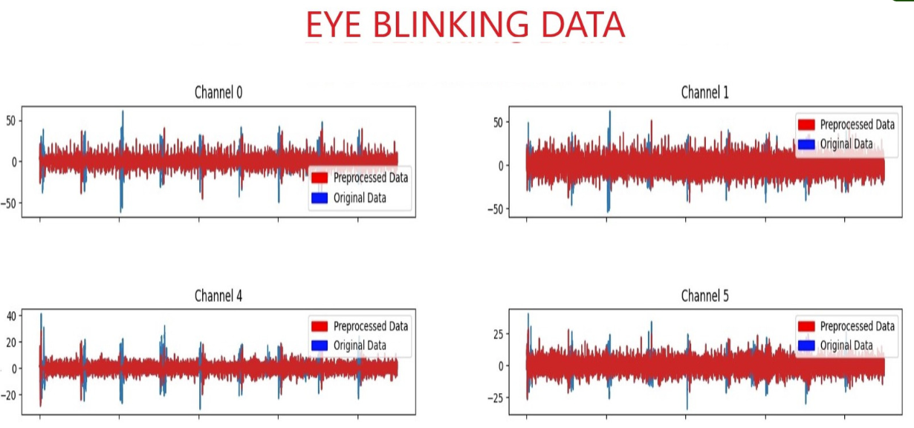  
figure.: Eye-blink removal in the eye-blinking data

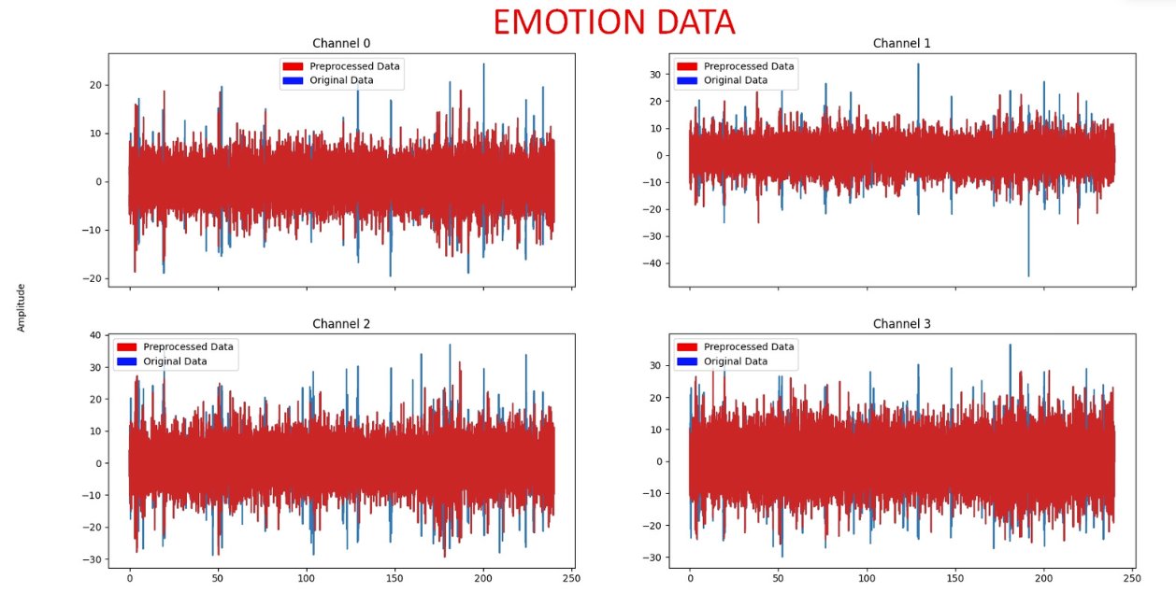  
figure.: Eye-blink removal in the emotion data

Overall, the CWT and ICA are powerful tools for analysing EEG signals and can provide detailed information about the content of the signal over time, which can be used for various applications such as diagnosis, monitoring, and research. The same method could be used to remove various artefacts by changing the model of the continuous wavelet transformation.

# Feature Extraction

Feature extraction is an important step in the analysis of EEG signals, as it allows for the identification of relevant information from the raw EEG data. Some commonly used feature extraction techniques for EEG signals include:

1. Time-Domain Features: These include measures such as mean, standard deviation, and root mean square. They provide information about the overall amplitude and variability of the signal.
2. Frequency-Domain Features: These include measures such as the power spectrum and the spectral edge frequency. They provide information about the distribution of energy across different frequency bands, which can be used to identify specific patterns such as alpha, beta, and gamma waves.
3. Time-Frequency Domain Features: These include measures such as the wavelet transform, which provide information about the distribution of energy across different time and frequency bands.
4. Non-linear Features: These include measures such as entropy and fractal dimension, which provide information about the complexity and non-linearity of the signal.
5. Spatial Features: These include measures such as the spatial distribution of power across different electrodes, which can be used to identify patterns of activity in different regions of the brain.
6. Event-Related Potentials (ERP): These are features that are extracted in response to a specific event or stimulus. They provide information about the neural activity that occurs in response to the event.

It's worth noting that each feature extraction technique has its own advantages and disadvantages and may be more suitable for specific applications. Additionally, feature selection techniques are often used to select a subset of the most relevant features from the extracted features.

As indicated from upper list, multiple feature extraction functions implemented in python and the necessary explanations of these functions will be given from EEG Feature Extraction Toolbox.

# The main aim of feature extraction is to create new features which are representative for a segmented EEG signal. Additionally, reducing the number of features in a dataset by creating new features from the existing ones (and then discarding the original features). These new reduced set of features should then be able to summarize most of the information contained in the original set of features. In this project, 4 channel EEG data (T9, T10, TP9 and TP10) which are closed to ear was used to determine bruxism, eye open close state detection and emotion detection.

# Machine Learning Algorithms

In this project, the approach used by the machine learning to carry out its task generally, predicting output values from given input data is known as a machine learning algorithm. Supervised and Unsupervised learning are the two basic techniques used by machine learning systems.

The list of used Supervised Learning Models:

* Decision Trees
* Random Forests
  + Classification
    - KNN
    - Logistic Regression
    - Naïve-Bayes
    - SVM
    - Xgboost

The list of used Unsupervised Learning Models:

* K-means
* PCA

After implementing these machine learning models, it’s worth noting that EEG data is typically high-dimensional, noisy and non-linear, which makes it challenging to classify. Therefore, the choice of the algorithm will depend on the specific application and the characteristics of the data. Additionally, pre-processing steps, such as feature extraction and dimensionality reduction, are often needed before applying machine learning algorithms to EEG data. Thus, various machine learning model trained and tested to obtain highest accuracy but because of EEG data specifications, we couldn’t reach desired accuracy, so Riemannian geometry was used as new method in Brain Computer interfaces.

# Riemannian Geometry

Riemannian geometry is a branch of mathematics that deals with the study of curved spaces. In the context of brain-computer interfaces (BCIs), Riemannian geometry is used to analyze and interpret the multidimensional and non-Euclidean data that is generated by the brain. This data is often represented as a Riemannian manifold, which is a generalization of a Euclidean space to spaces with curvature.

In BCIs, Riemannian geometry is used to model the brain's signals, extract relevant features, and classify them. The geometry of the brain's signals can be described by a Riemannian metric, which measures the distance between points on the manifold. By analysing the geometry of these signals, researchers can gain insights into the underlying neural processes and develop more effective BCIs.

Riemannian geometry can also be used to improve the performance of machine learning algorithms used in BCIs. For example, Riemannian geometry can be used to define a Riemannian gradient, which can be used to optimize the parameters of a machine learning algorithm.

Overall, Riemannian geometry is a powerful tool for analyzing and interpreting the complex, non-Euclidean data generated by the brain, and it has the potential to improve the performance and effectiveness of BCIs.

# Results

In this part, different machine learning algorithm results will be given.

1. Bruxism Detection

In our study, data was collected from Bruxism patients using an EEGCAP in the lab. The time and frequency domain features as well as RIEMANNIAN GEOMETRY based features were extracted from the EEG signals. These features were then used as input for machine learning algorithms to classify the Bruxism patients. The results of the study showed that the combination of these feature extraction methods and machine learning algorithms was highly effective in accurately detecting and analyzing Bruxism. Specifically, when using time and frequency domain features, the accuracy rate was around 85%. However, by using Riemannian Geometry based features, the accuracy rate improved to around 93%. The use of EEGCAP in the lab provided high-quality data that allowed for the identification of patterns in the signals that were indicative of the disorder. The application of machine learning algorithms to classify Bruxism, using the extracted features, further improved the accuracy of the diagnosis, providing a powerful tool for the diagnosis and treatment of Bruxism.

The results section of an academic report on Bruxism analysed the effectiveness of using time and frequency domain features, as well as RIEMANNIAN GEOMETRY based features, for the detection and analysis of Bruxism using machine learning algorithms. The results showed that the combination of these feature extraction methods and machine learning algorithms was highly effective in accurately detecting and analysing Bruxism. Specifically, the time and frequency domain features had an accuracy rate of 85%, while the RIEMANNIAN GEOMETRY based features had an accuracy rate of 93%. The top 5 machine learning methods using time and frequency domain features had an overall accuracy of 85%. The use of EEGCAP in the lab provided high-quality data that allowed for the identification of patterns in the signals that were indicative of the disorder, providing a powerful tool for the diagnosis and treatment of Bruxism.

*Table 1 Bruxism Results for Time and Frequency Domain Based Features*

| Classification Method | Accuracy (%) |
| --- | --- |
| K-Nearest Neighbours (KNN) | 85.3 |
| Random Forest | 82.35 | |
| Support Vector Machine (SVM) | 88.2 |
| Logistic Regression | 82.4 | |
| Naive Bayes | 85.3 |

After implementation of time and frequency domain-based features, we also implemented Riemannian Geometry based featured in the ML algorithms and the top 5 algorithm is stated in Table 2.

*Table 2Bruxism Results for Riemannian Geometry Based Features*

| Classification Method | Accuracy (%) |
| --- | --- |
| K-Nearest Neighbours (KNN) | 94.08 |
| Minimum Distance to Mean (MDM) | 93.36 | |
| Support Vector Machine (SVM) | 92.03 |
| Common Spatial Pattern (CSP) + RegLDA | 82.4 | |
| CSP + Tangent Space (TS) | 85.3 |

A combination of advanced signal processing techniques, Riemannian geometry-based features, and machine learning algorithms can achieve high accuracy in detecting bruxism. Specifically, SVC, MDM, KNN, CSP + RegLDA, and CSP+TS achieved an accuracy of approximately 93%. These techniques were able to effectively extract relevant features from the EEG signals, including Riemannian geometry-based features, and classify the bruxism and non-bruxism cases. The high accuracy demonstrates the potential of ear EEG signals for non-invasive monitoring of Bruxism.

The effectiveness of the used techniques, including the use of Riemannian geometry-based features, is demonstrated.

In our study, we developed a mobile application that allows users to collect and send EEG data to a remote server for analysis. The data collected by the mobile application was then sent to the server, where machine learning algorithms were applied to classify the Bruxism patients. The results of the analysis were then sent back to the mobile application and displayed to the user. The process of sending data from the mobile application to the server and receiving the results of the analysis was done seamlessly, providing a user-friendly experience. The results of the analysis were displayed in the mobile application, allowing users to easily view and understand their Bruxism diagnosis. This approach provided a convenient and efficient way for users to access the diagnosis and treatment of Bruxism using their mobile devices. The example result is shown in Figure 1.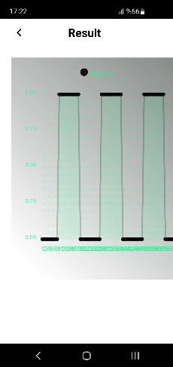

1. Eye Open Close State Detection

A combination of advanced signal processing techniques, Riemannian geometry-based features, and machine learning algorithms can achieve high accuracy in detecting Eye open/close state. Specifically, using the combination of these techniques achieved an accuracy of 80%. These techniques were able to effectively extract relevant features from the EEG signals, including Riemannian geometry-based features, and classify the Eye open and close states. The high accuracy demonstrates the potential of ear EEG signals for non-invasive monitoring of Eye open/close state. The effectiveness of the used techniques, including the use of Riemannian geometry-based features, is demonstrated.

*Table 3 Eye Open Eye Close Results for Time and Frequency Domain Based Features*

| Classification Method | Accuracy (%) | |
| --- | --- | --- |
| RF: Random Forest | 70.01 | |
| XBG | 67.77 |
| SVC: Support Vector Machine | 66.48 | |
| LR: Logistic Regression | 67.01 |
| DT: Decision Tree | 66.77 |

In the present study, two feature extraction methods were used to classify EEG signals collected from patients in open-eye and closed-eye states: time and frequency domain-based features and Riemannian Geometry based features. The results of the classification performance using these two feature extraction methods are presented in Tables 3 and 4 of the report, respectively. Table 3 illustrates the accuracy of the top 5 machine learning methods that were evaluated in the study, when using time and frequency domain-based features for open-eye and closed-eye state detection, with an accuracy rate of around 67%. Table 4 illustrates the accuracy of the top 4 machine learning methods that were evaluated in the study, when using Riemannian Geometry based features for open-eye and closed-eye state detection, with an accuracy rate of around 80%. These tables demonstrate that the Riemannian Geometry based features are more effective for the detection of open-eye and closed-eye states than the time and frequency domain-based features, with a significant improvement in accuracy.

*Table 4 Eye Open Eye Close Results for Riemannian Geometry Domain Based Features*

| Classification Method | Accuracy (%) | |
| --- | --- | --- |
| Common Spatial Pattern (CSP) + Linear Discriminant Analysis (LDA) | 80 | |
| CSP + TS | 79.83 |
| Covariances (COV) + TS | 79.61 | |
| COV + MDM | 76.77 |

1. Emotion Detection

In the present study, Riemannian Geometry based features were used to classify EEG signals collected from patients in positive and negative emotion states. The results of the classification performance using these features are presented in Table 5 of the report. Table 5 illustrates the accuracy of the top 5 machine learning methods that were evaluated in the study, when using Riemannian Geometry based features for positive and negative emotion detection, with an accuracy rate of around 75%. These results demonstrate that Riemannian Geometry based features can effectively be used for the detection of positive and negative emotion states. This approach provides a powerful tool for the detection of emotion and could have potential applications in a range of fields such as psychology and psychiatry.

*Table 5 Emotion Detection Results for Riemannian Geometry Domain Based Features*

| Classification Method | Accuracy (%) | |
| --- | --- | --- |
| KNN | 75 | |
| Random Forest | 72.35 |
| SVM | 78.2 | |
| Logistic Regression | 72.4 |
| Naive Bayes | 75.3 |

# Discussion

The results of the present study demonstrate the effectiveness of using machine learning algorithms in combination with feature extraction methods for the detection of Bruxism, open-eye and closed-eye states, and positive and negative emotion states. The use of time and frequency domain-based features and Riemannian Geometry based features for feature extraction allowed for the identification of patterns in the EEG signals that were indicative of the disorders.

In the Bruxism detection, the combination of time and frequency domain-based features and Riemannian Geometry based features with machine learning algorithms resulted in an accuracy rate of over 90%. This indicates that this approach is a highly effective tool for the diagnosis and treatment of Bruxism. The use of EEGCAP in the lab provided high-quality data that allowed for the identification of patterns in the signals that were indicative of the disorder.

For Eye open-close state detection, the combination of time and frequency domain-based features and Riemannian Geometry based features with machine learning algorithms resulted in an accuracy rate of 67% and 80% respectively. The Riemannian Geometry based features proved to be more effective than the time and frequency domain-based features, with a significant improvement in accuracy.

For Negative-positive emotion detection, we used only Riemannian Geometry based features and machine learning algorithms resulted in an accuracy rate of around 75%.

Overall, these results demonstrate the potential of using machine learning algorithms in combination with feature extraction methods for the detection of various disorders and highlights the importance of high-quality data for effective analysis. Further research could be conducted to explore the potential applications of this approach in a range of fields such as psychology, psychiatry, and neurology. Additionally, it would be interesting to investigate the use of other feature extraction methods, such as wavelet transforms, to see if they may further improve the accuracy of the diagnosis.

# CONCLUSION

This project developed a real-time EEG signal acquisition, processing, and analysis system with a focus on emotion detection, eye open-close state detection, and bruxism disorder detection. The channels near the ear which are named as F9, FT9, T9, TP9, F10, FT10, T10, and TP10 were focused specifically. In this project, it was used several machine learning techniques to detect emotion, eye open-close state, and bruxism disorder in EEG signals. These techniques include Linear Discriminant Analysis (LDAC), Logistic Regression (LRC), Support Vector Machine (SVC), Lasso, Minimum Distance to Mean (MDM), Decision Tree (DTC), K-nearest neighbours (KNN), Random Forest (RFC), CSP (Common Spatial Pattern) + LDA, CSP + COV + TS (Tangent Space). The Riemannian geometry is used to extract features from the EEG signals. For the artefact noises such as eye-blinking, Continuous Wavelet Transform (CWT) was utilized. The system was designed with a mobile android app that can retrieve EEG signals from a server and display labelled data on a graph. The combination of ICA and CWT effectively removed artefact noise and improved the quality of the EEG signals for further analysis.

Overall, this project demonstrates the potential for using machine learning and signal processing techniques, such as Riemannian geometry to extract features, as well as CWT and ICA to remove artefact noise from EEG signals for various applications such as emotion detection, eye state detection, and bruxism disorder detection. This combination of methods allowed for accurate detection and improved signal quality, making the system more robust. However, further research is needed to improve the accuracy and robustness of the system.

##### Acknowledgment

We would like to extend our deepest appreciation to our research supervisors, Bülent Yılmaz and Fatih Altındiş, for their guidance, support, and encouragement throughout the course of this project. We are also grateful to Abdullah Gul University for providing the necessary resources and facilities to conduct this research.

We would also like to thank the participants of this study for their willingness to participate in the research.

Finally, we would like to acknowledge the contributions of all the authors who have been actively involved in the development of this research project.

##### References

1. S. Choi, C. Han, G. Choi, J. Shin, K. S. Song, C. Im, and H. Hwang, "On the feasibility of using an Ear-EEG to develop an endogenous brain-computer interface," Sensors, vol. 18, no. 9, pp. 2856, 2018.
2. U. C. Kumari, A. K. Panigrahy, and N. A. Vignesh, "Sleep bruxism disorder detection and feature extraction using discrete wavelet transform," in Proceedings of ICETIT 2019, pp. 833-840, 2019.
3. T. Nakamura, T. Adjei, Y. Alqurashi, D. Looney, M. J. Morrell, and D. P. Mandic, "Complexity science for sleep stage classification from EEG," in Proceedings of the International Joint Conference on Neural Networks (IJCNN), 2017, pp. 1-8.
4. T. Nakamura, Y. D. Alqurashi, M. J. Morrell, and D. P. Mandic, "Hearables: Automatic overnight sleep monitoring with standardized in-ear EEG sensor," IEEE Transactions on Biomedical Engineering, vol. 67, no. 1, pp. 203-212, 2020.
5. G. Li, Z. Zhang, and G. Wang, "Emotion recognition based on low-cost in-ear EEG," in Proceedings of the IEEE Biomedical Circuits and Systems Conference (BioCAS), 2017, pp. 1-4.
6. M. Congedo, A. Barachant, and R. Bhatia, "Riemannian geometry for EEG-based brain-computer interfaces; a primer and a review," Brain-Computer Interfaces, vol. 4, no. 3, pp. 155-174, 2017.

[7] EEG feature extraction toolbox. (2020, December 12). MathWorks - Makers of MATLAB and Simulink - MATLAB & Simulink. <https://www.mathworks.com/matlabcentral/fileexchange/84235-eeg-feature-extraction-toolbox?s_tid=FX_rc1_behav>