Department of Electric & Electronic Engineering,
Boğaziçi University

Catch the Square If You Can

Emre AVARA
M.Turan ERTÜRK

Project Advior : Professor Şenol MUTLU

28.05.2019

Table of Contents

1 INTRODUCTION 3
2 PROBLEM STATEMENT 3
3 RELATED BACKGROUND 3
4 DESIGN 3
5 RESULTS 6
6 CONCLUSION 6
A READ ME 7

INTRODUCTION

In this project we designed a game. In the following pages of this project report you will find the definition of the game we designed, the method we use to realize the project (i.e. the components that we designed as VHDL code, the pin configuration of the board ) the algorithm and the objectives of the project are included.

PROBLEM STATEMENT

Square objects float down from the top of the 640x480 screen. We have a basket at the bottom of the screen, we need to catch the falling squares down. We’ll earn points for every square object we have managed to capture. The problem that we encountered was the borders of the screen, optimization of the falling speed of the square and the movement speed of the basket.

RELATED BACKGROUND

In the game we chose the shapes as squares and smooth polygons. Because we had to set limits on the horizontal and vertical axes. We have adjusted the horizontal and vertical sequencing so that we have printed the shapes we want on the black screen in the colors we choose.

DESIGN
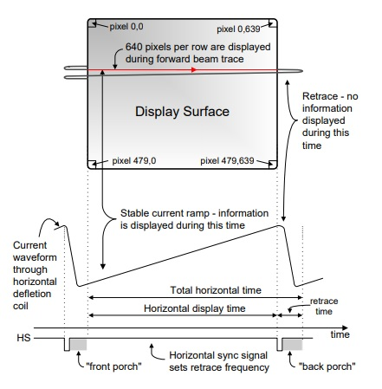
In this project, at first we started to create a horizontal and vertical synchronization generator which synchronize the output and the VGA screen. We used the VGA output to generate 640x480 pixels screen resolution. We used 7 pins of the VGA controller such as Ground, VCC, R, G, B, Vsync, Hsync. The Vsync and hsynch pins would be the VGA control for the monitor that scans the screen at 25MHz starting from top left corner. Certain pixels are spared for different purposes on the VGA controller and were not visible on monitor. So the algorithm to change colour and but a stationary block on the screen pixel adjustments were made.

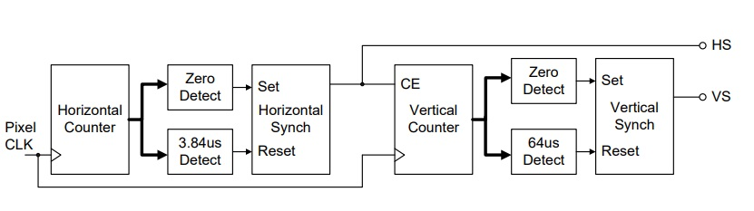
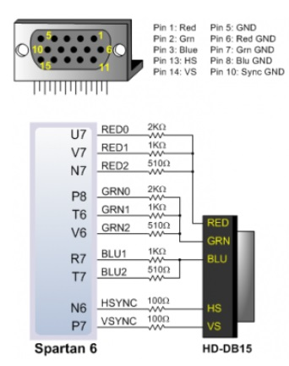

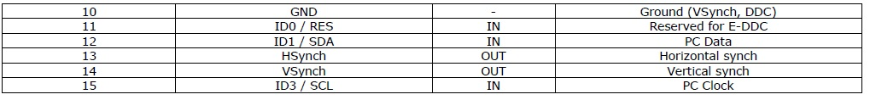
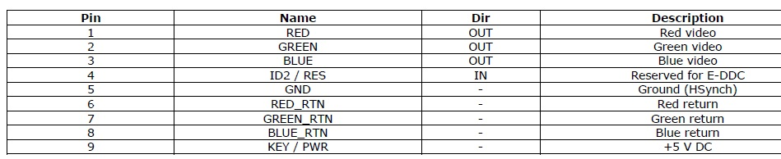
Then we created our shapes using colour generator. We determined the limits of our shapes and coloured them using colour generator. It has 8 bits ( 3 bits for red, 3 bits for green and 2 bits for blue from most significant to least significant, respectively). The high (1) means that colour is painted and low (0) means it is not.

We started by creating our shapes. We have created a component called color generator. We have determined the starting positions in the horizontal and vertical axes. We have allowed the square object to float downwards.For the movements we created 3 frequency divider (4,1M,3M divider).
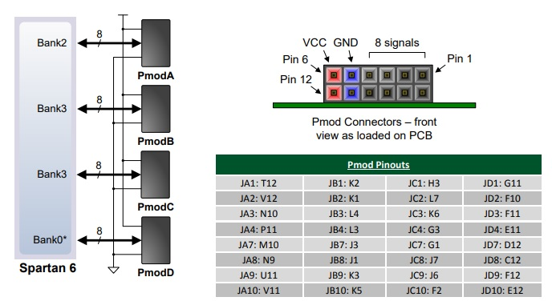
We wrote the necessary steps to move our basket left and right. We used Up/Down counter for the movements of the basket on the horizontal axis. We used the joystick for the movement of the basket. We connected the joystick to the Pmod pins of the NEXYS 3 board. We used the “JA and JD” pins for the digital input.

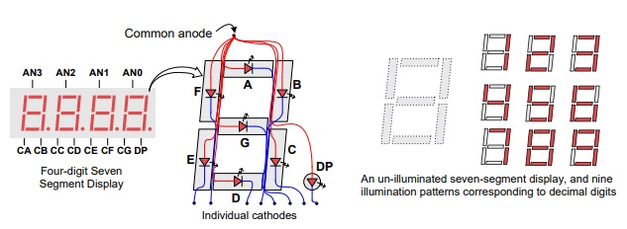
When the falling square is caught by the basket, we created a new square falling from random point. If the square is caught which means that the square object come down by the time the lower end of it contact with the upper end of the basket., the player gets 1 point and there is no penalty for missing. We displayed the score on the 7-segment LCD display of the NEXYS 3 board. The pin configurations are as in the figure on the right.

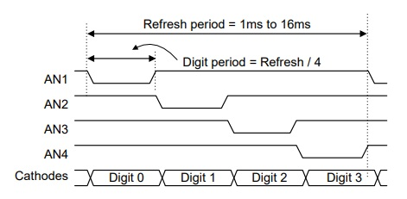
For the display we used the code that is given on the moodle (nexys 3 sseg driver). It works as shown below. In every cycle it shows only 1 digit however it is working on 60 Hz frequency our eyes can’t realize.

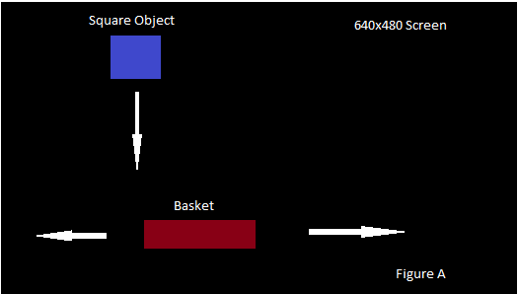
In our main vhd file, we have completed our project by combining all components. The general structure of our project is as shown below.
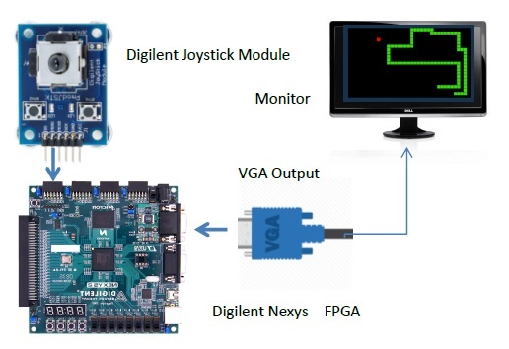

RESULTS

As we started the project, we thought that the game we were going to do should not be just for taking notes. We thought that we should think about how to use it in the most efficient way, so we thought about the areas of usage. A child playing this game can learn what a square and rectangle look like, and learn the red, blue and black color and counting with fun. We started our work to make this game and we finally created our game. We achieved what we aimed in our project proposal.

CONCLUSION

The purpose of this project is to make a game. The game had to be of an entertaining and teaching nature. The task in the game is to capture the square objects floating from above with the user-controlled basket below. For each object captured, points will be earned. A child playing this game will be able to learn what a square is by seeing the shape of falling square objects. By seeing the rectangle basket below and recognize the rectangle. We have added a scoreboard to the game, so that the children playing can recognize the numbers. We learned and gained experience on how to use Nexys3 board. We gained experience on VHDL coding. We really enjoyed too much.

APPENDIX

READ ME

To play this game you need NEXYS 3 board, joystick, a buzzer and screen. To start the game plug in all the cables as mentioned above. Then program the NEXYS 3 board. The game will be displayed on the screen. Use joystick to move the basket. The aim of the game is to catch the squares as possible as you can. You will get extra one 1 for each square that you caught.

