**Database**

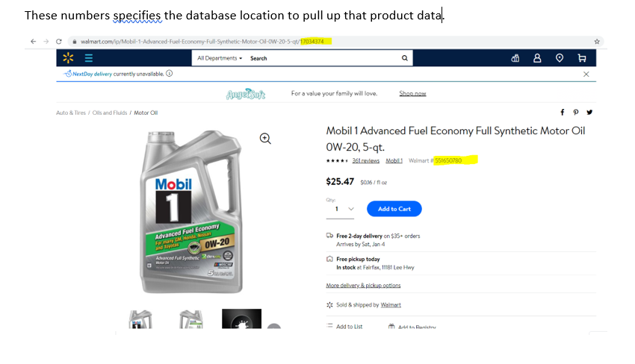

SQL

Types of the database products

1. MSACCESS – Front End and Back End Database
2. SQL SERVER – Back End Database
3. ORACLE – Back End Database
4. SYBASE – Back End Database
5. DB2- Back End Database

Search what is indexing?

Cloud

Production database ?

QUERY1 - Example of a query from database for learning a salary of an employee ankur

* Select salary
* From employees
* Where name = ankur;

Result

**Salary: $1000**

QUERY 2

Select Name, Salary, SSN

From Employees

Where Employee= #103;

Result

**Name: Ankur**

**Salary: $1000**

**SSN: 123-45-6789**

QUERY 3

Select Employee#, Name, Salary, SSN

From Employees

Where Employee= #103; (it can be some other category that’s unique to that employee such as phone number)

Result

**Employee= #103**

**Name: Ankur**

**Salary: $1000**

**SSN: 123-45-6789**

QUERY 4

Select * (star * means all the information available on that table)

From Employees

Where “Phone Number 123 456 7890” or “Employee #103”

(any unique category can be selected)

Result

**Employee= #103**

**Name: Ankur**

**Salary: $1000**

**SSN: 123-45-6789**

**Date of Birth: 01/01/1985**

QUERY 5

All the information about a tire such as price, quantity, delivery date, free pick up date, tire size etc…

Select * (star * means all the information available on that table for this tire. Even though its one tire but we want all the information about that tire . That’s why we use *)

From Auto & Tire

Where Product Number: 565093947;

Result

All the information about that product.

QUERY 6

Select *

From Employees;

Result

**Employee#**

**Name**

**Salary:**

**SSN:**

These information for all the employees will be retrieved

**OPEN SQL COMMAND LINE**

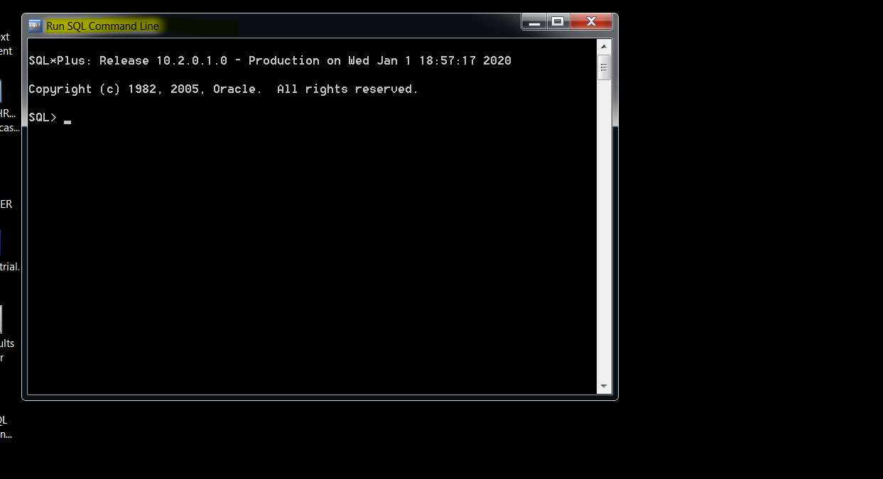

First connect to the database

Type connect hr/hr

Press enter.

It will be connected.

Here hr is username and hr is password

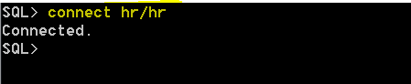

{ Select table_name from user_tables; } is your query

Press enter.

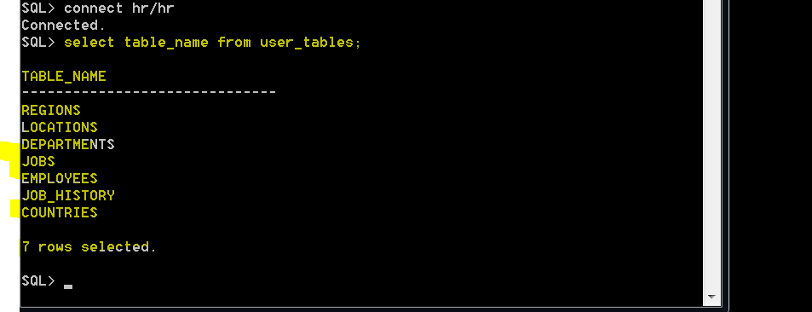

Table names are listed.

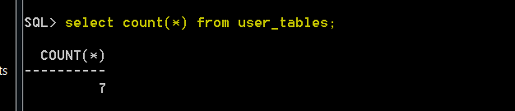

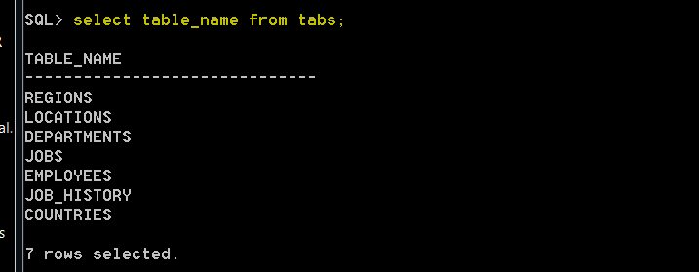

User_tables is same as tabs

They both will bring the same thing

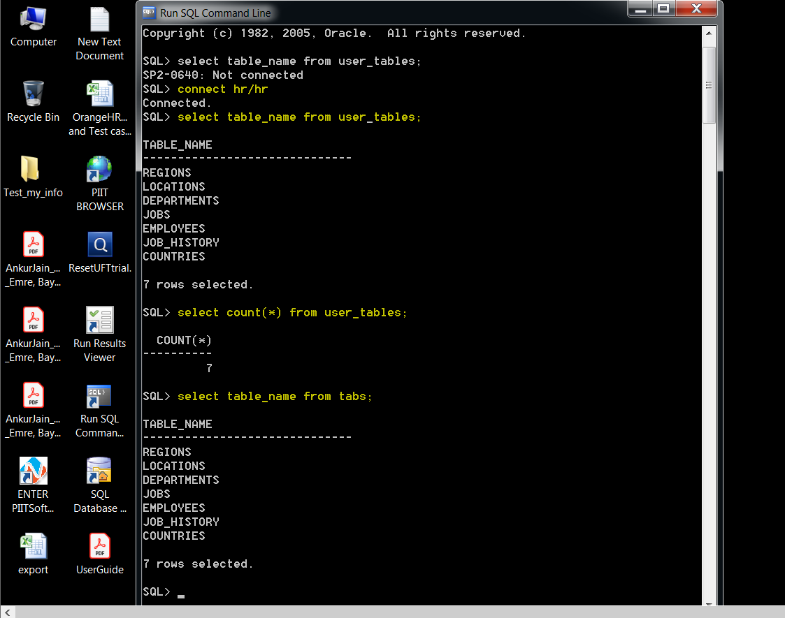

Select * from employees;

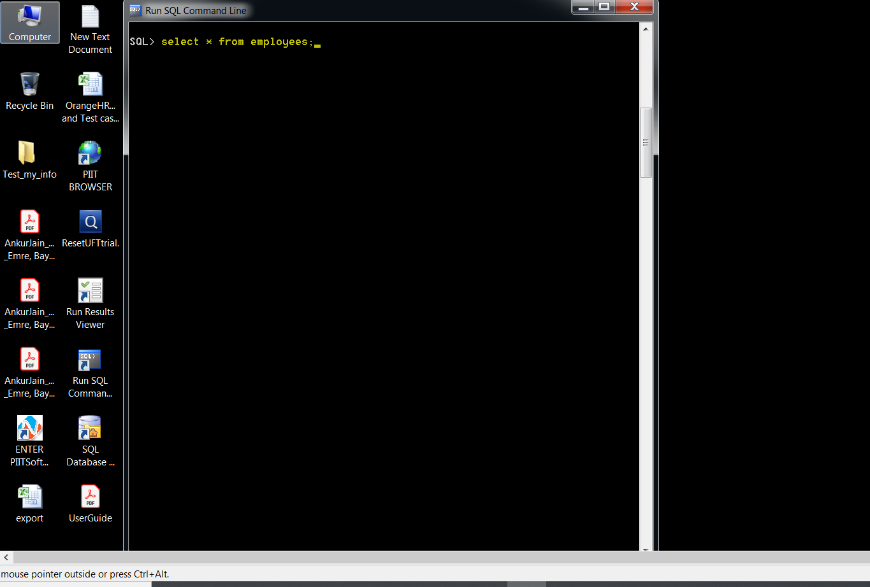

Will bring all the information about all the employees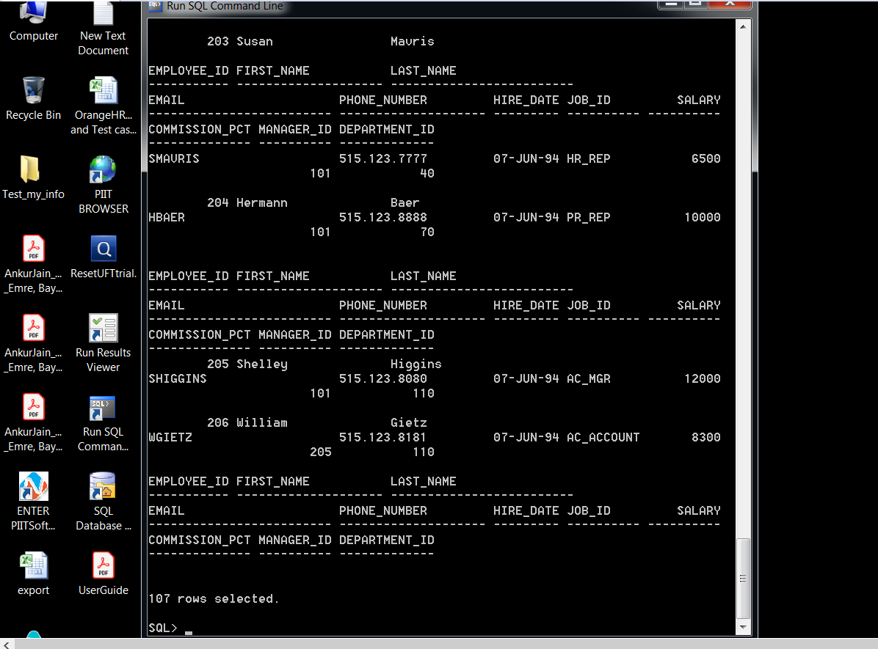

SQL Config: Right click on the top and click on properties

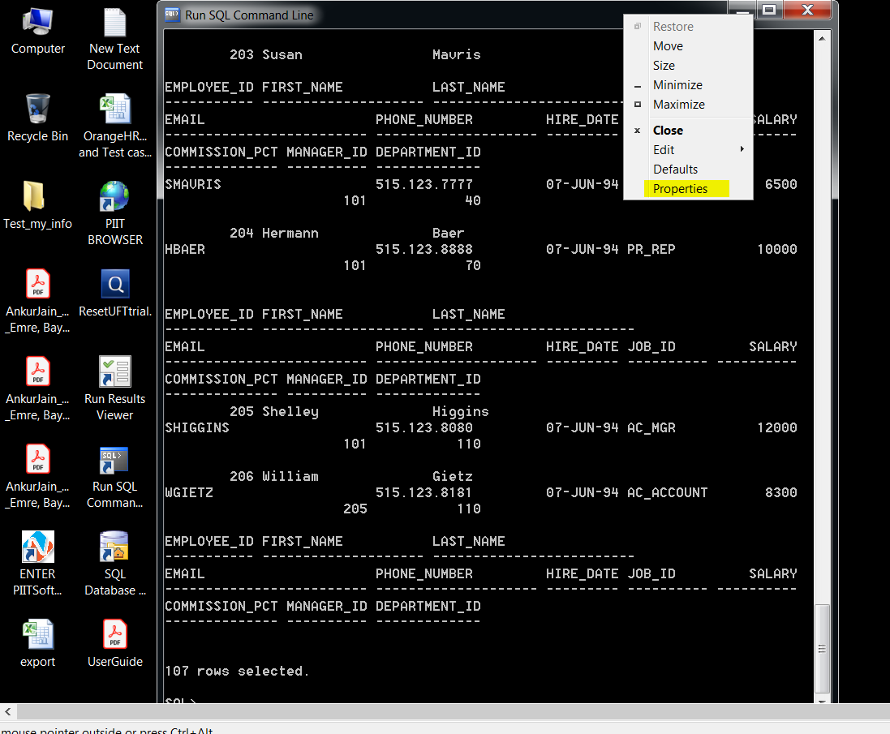

Click on Font and select 12x16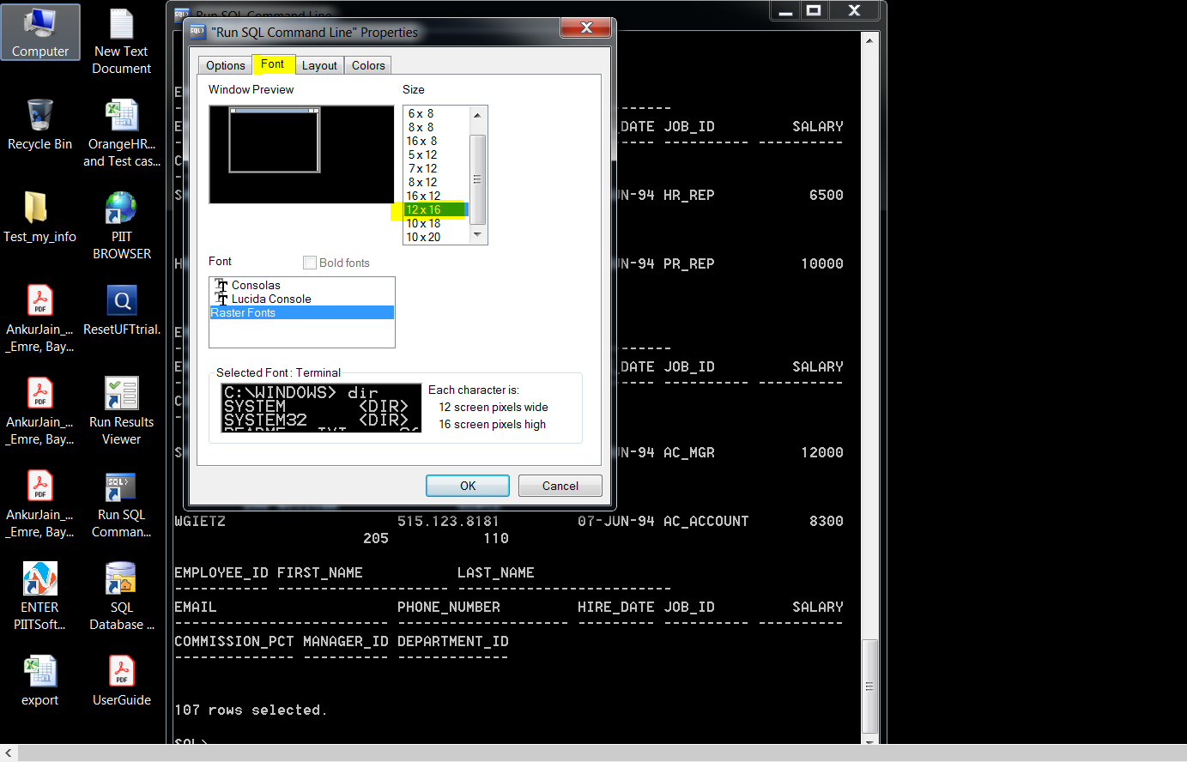

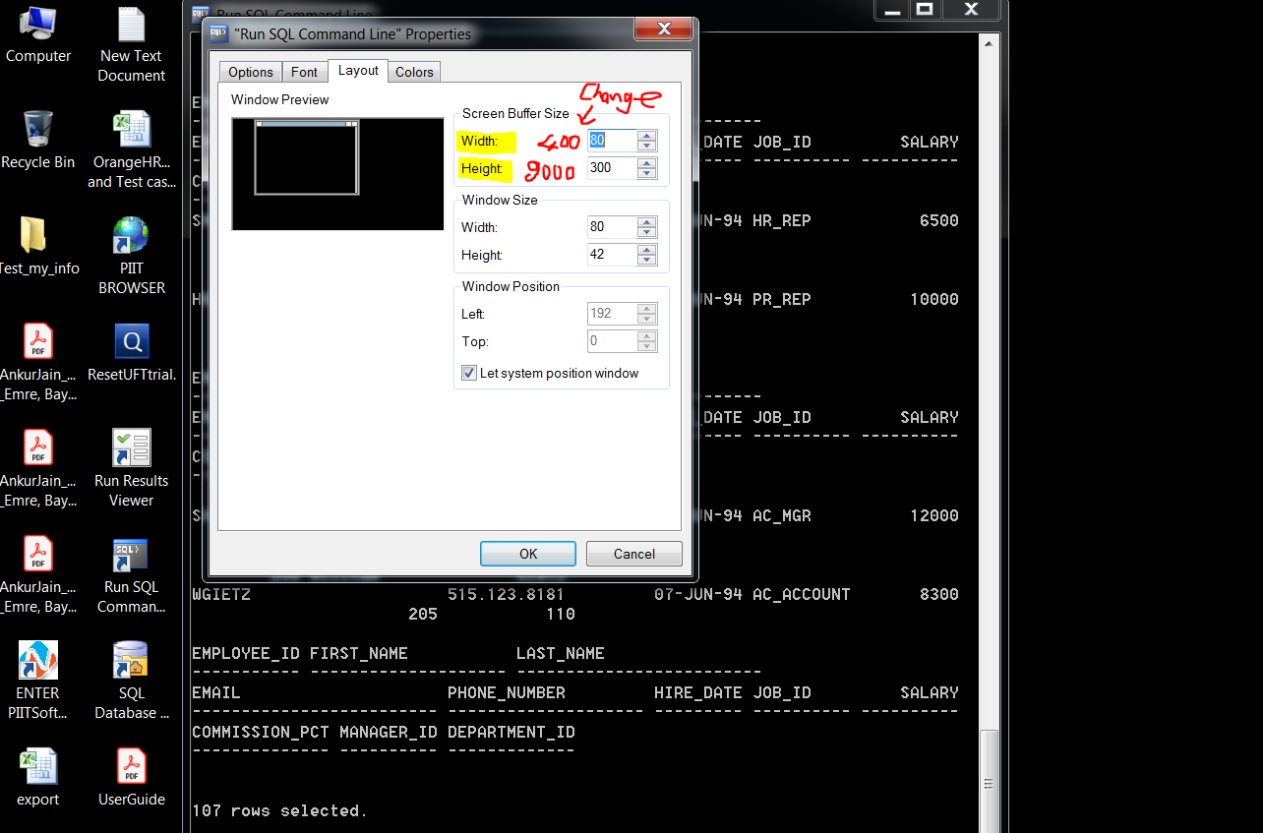

Change it to width:400, Height:9000

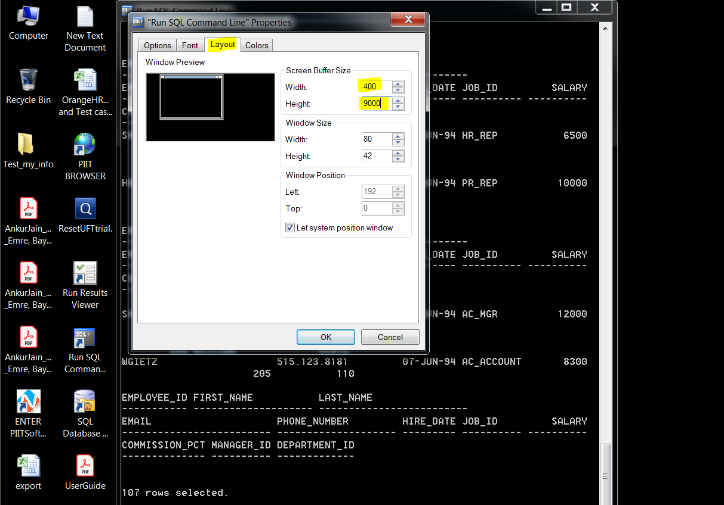

Then it becomes

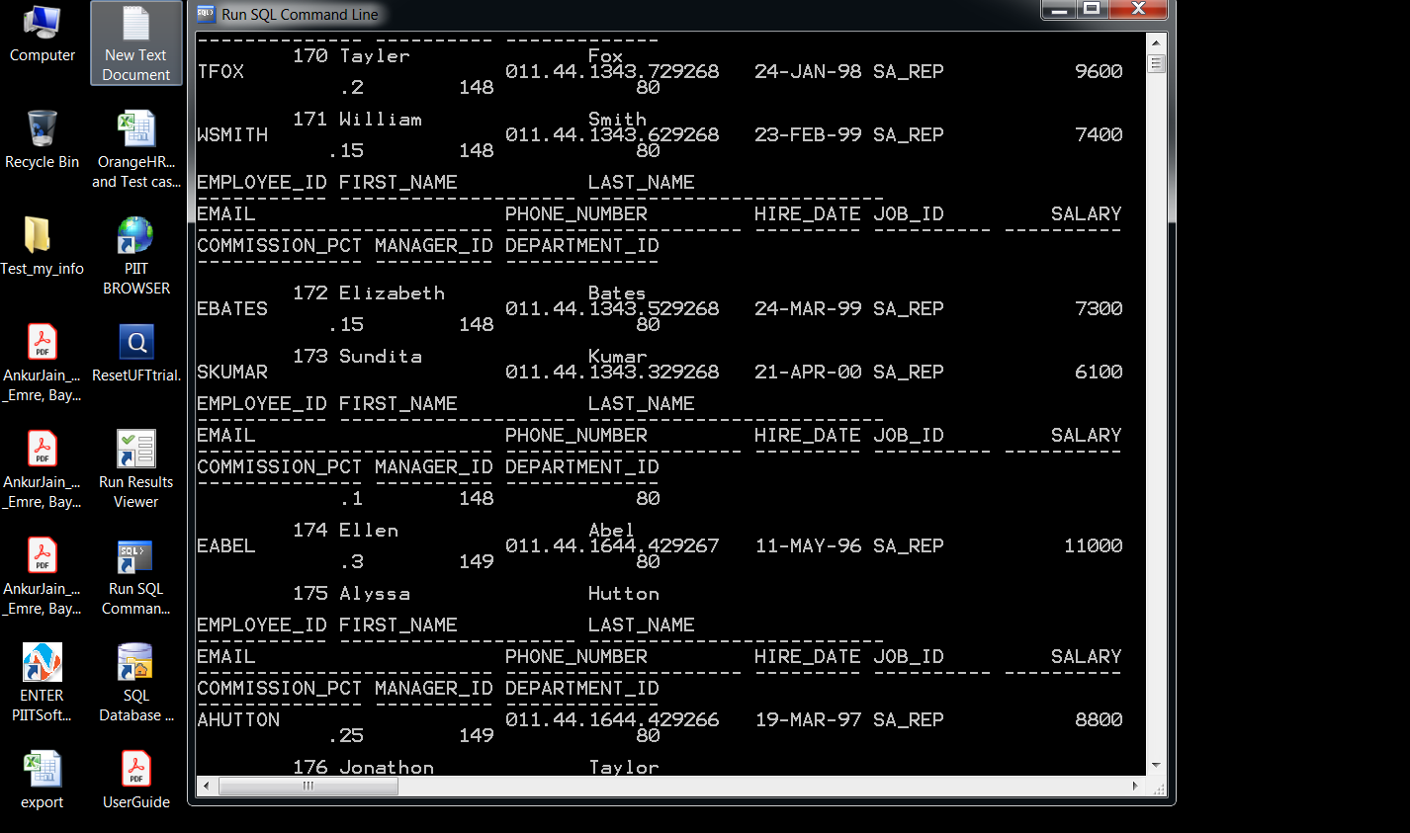

Then

Set linesize 400;

Set pagesize 400;

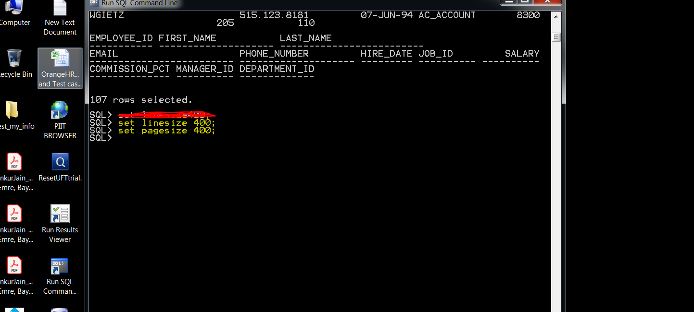

Enter query select * from employees;

Then it becomes 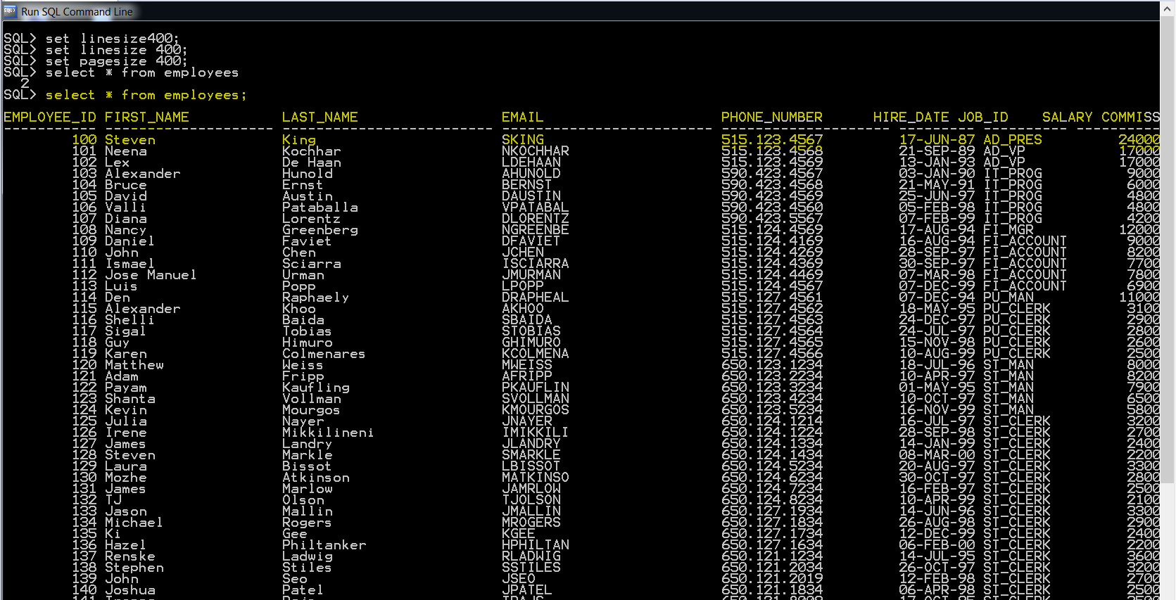

Easier to read from results

To save what you write command to save a word document

Spool c://sqllab01012020.doc

Then open computer c: drive you will see the document sqllab01012020 saved thereHowever that document will be empty first once you off the SQL command line then document will include details of your saved commands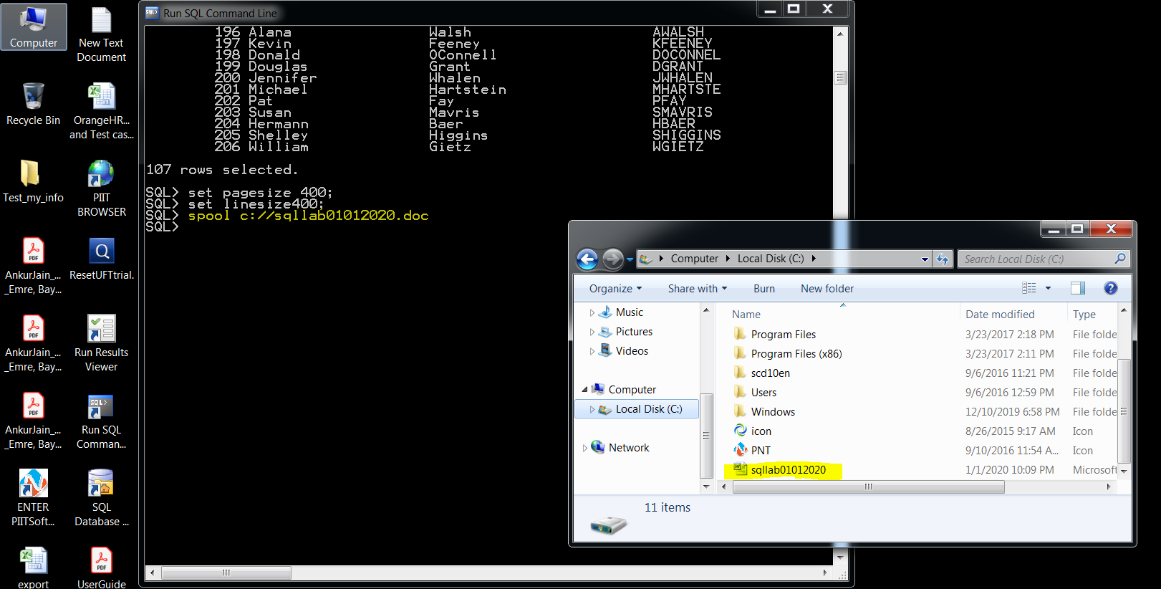

Type edit

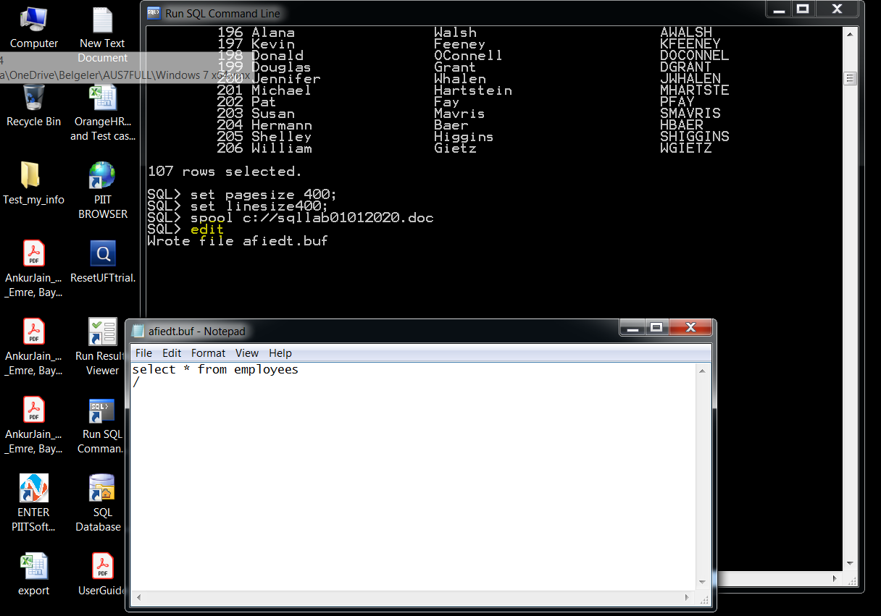

Ed is a short cut for edit

So you can use ed instead of edit

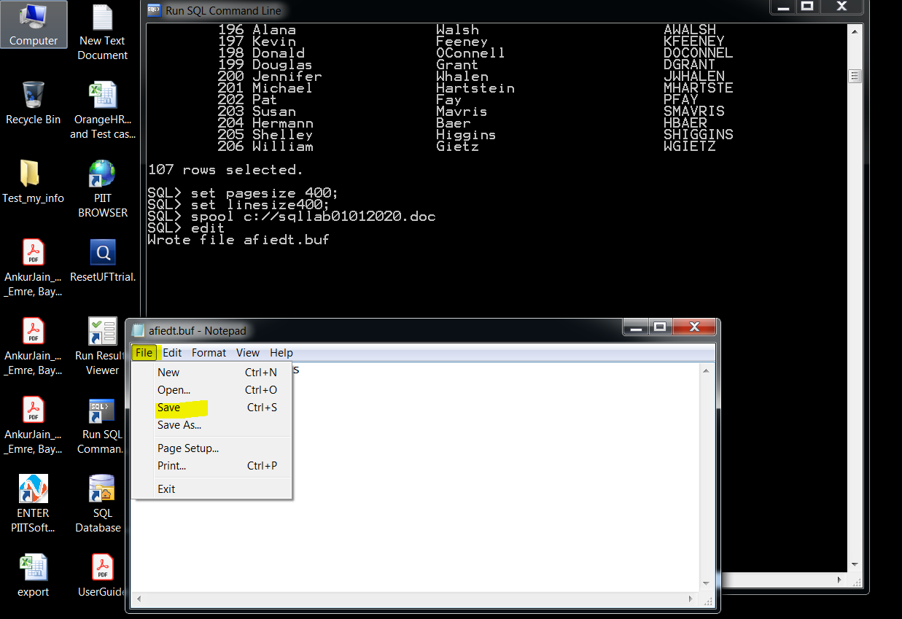

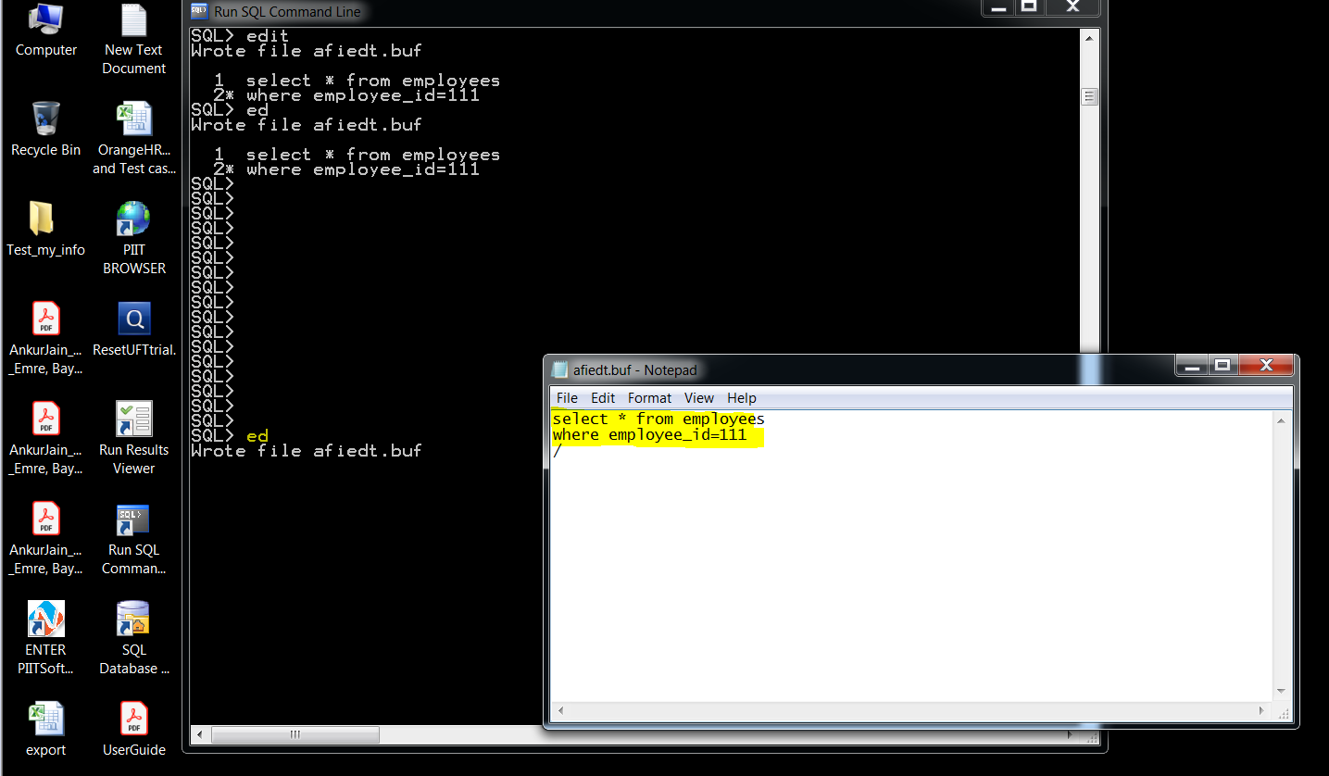

File and save then close

Then type / press enter

When you enter /

It went to database and brought employee 111 information

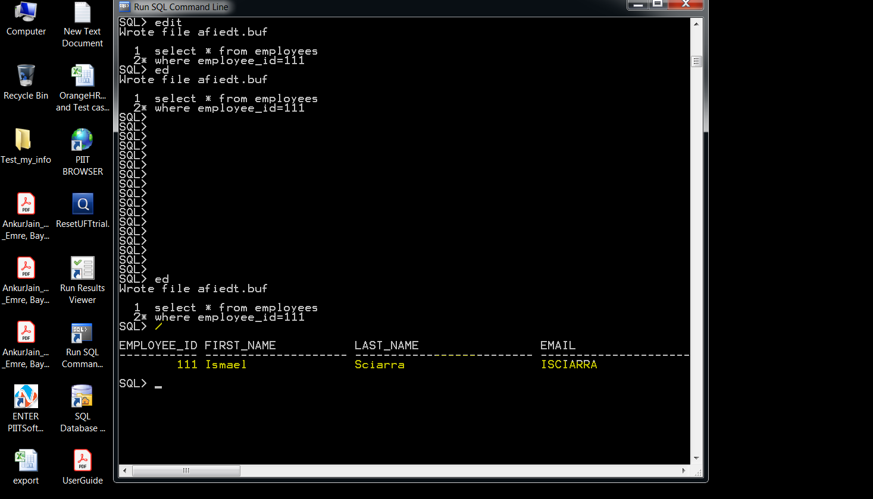

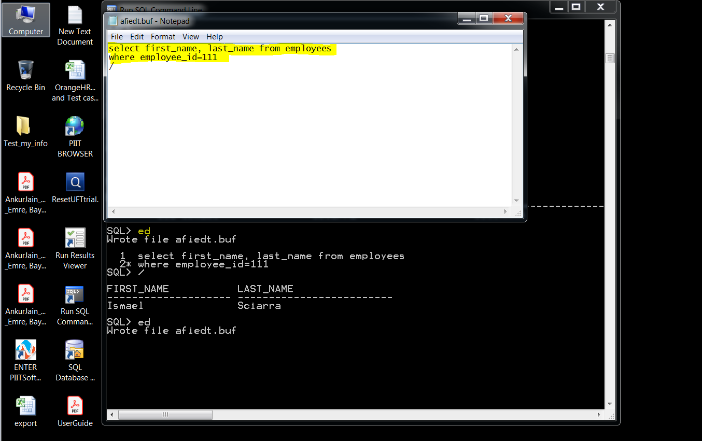

Click on file save it then close it

Enter / to SQL command line

It will go to data base and bring first name and last name

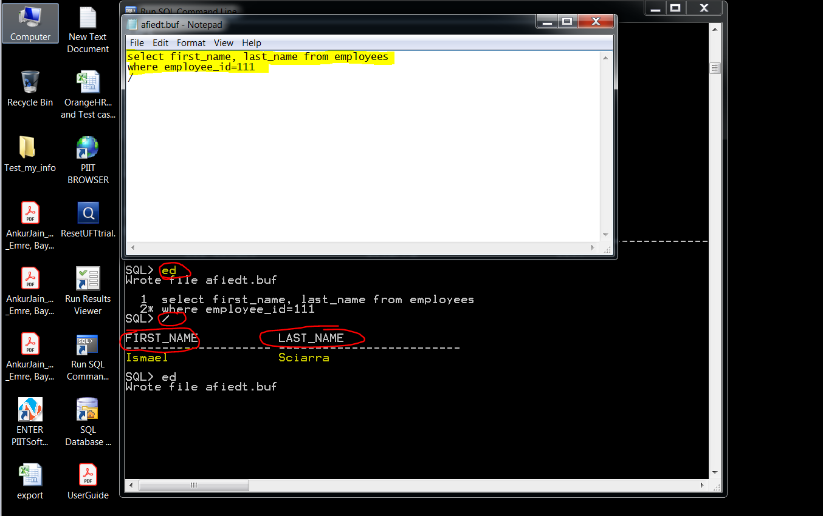

---

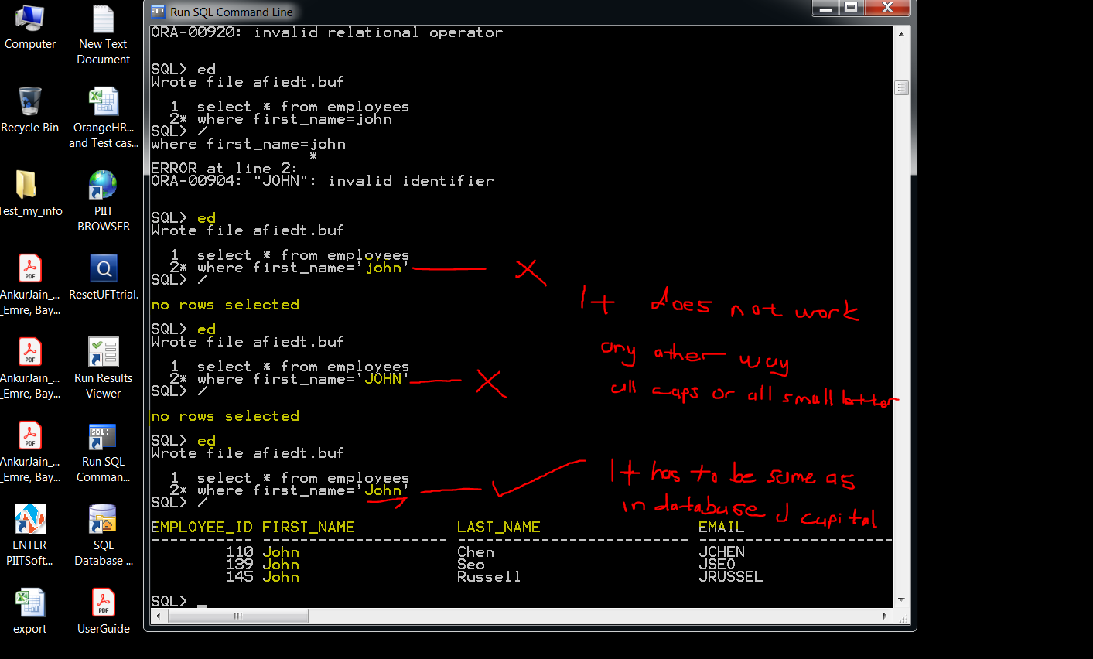

As you see it has to be typed the same way it was enter to database

name and last name. First letter is capital than rest is lower case letters.

you can use a different command to still find the data even tho you don’t type in the same name

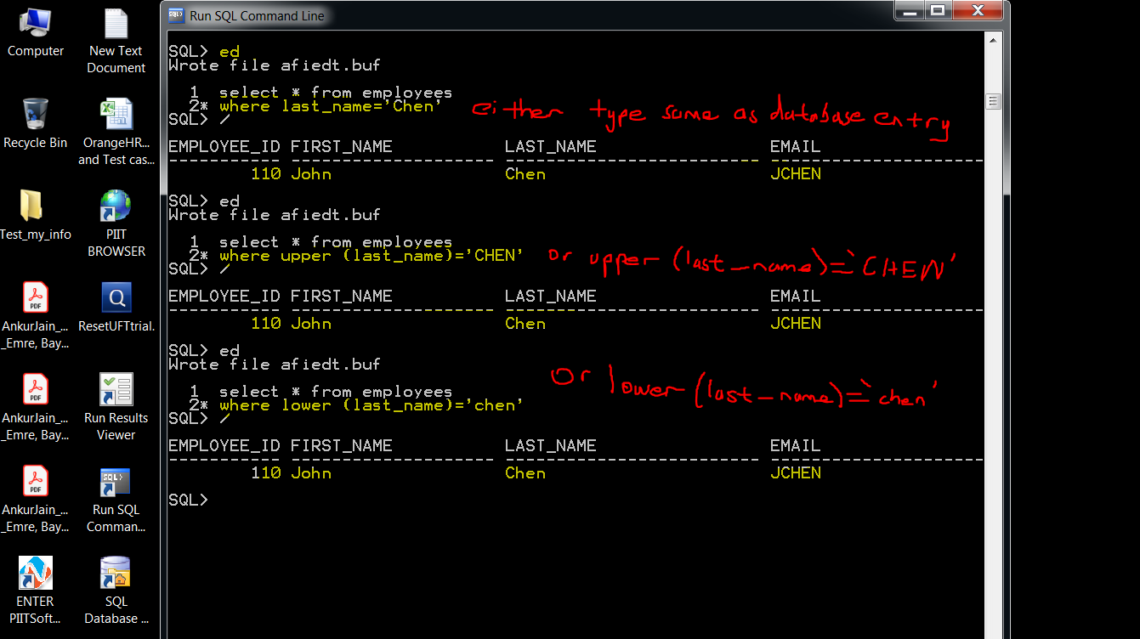

It is case sensitive

That’s why we used upper and lower command to find these employees regardless of case sensitivity.

where upper (last_name)=’CHEN’

Or

where lower (last_name)=’chen’

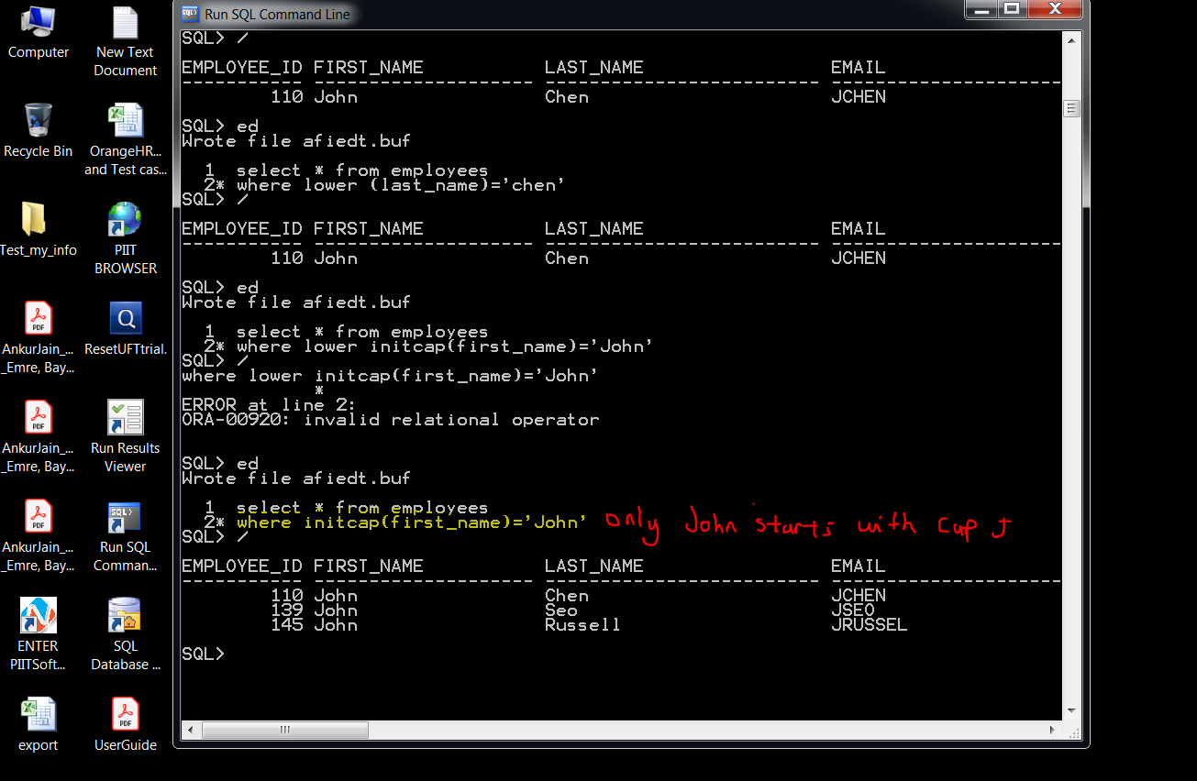

Order by first_name

Alphabetic order for firstname

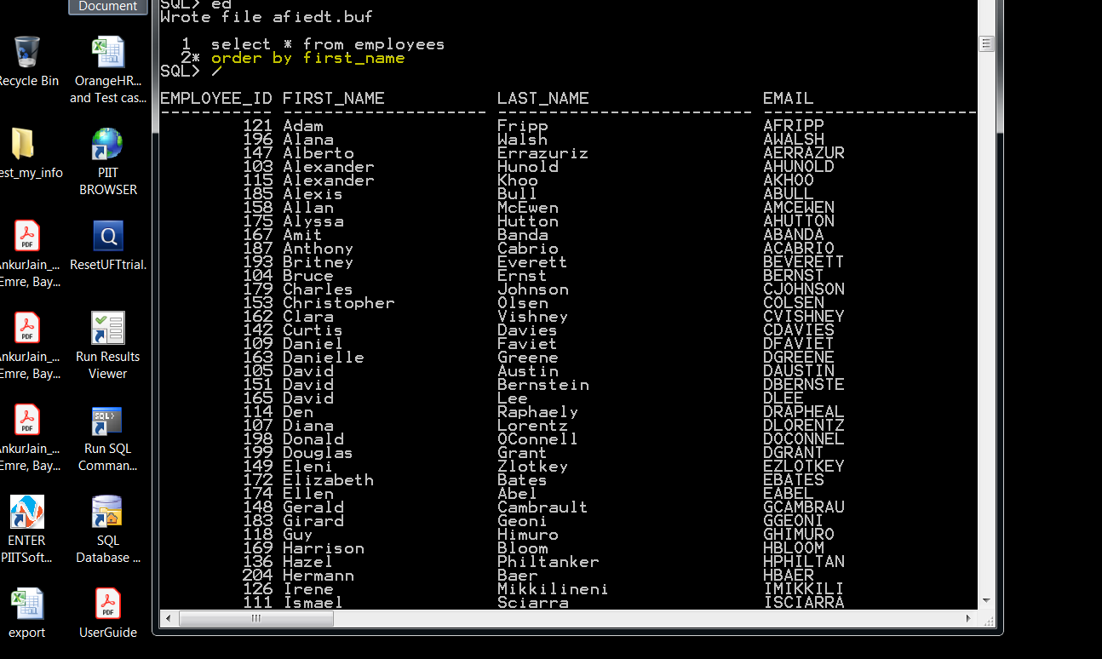

Order by last_name

Alphabetic order for lastname

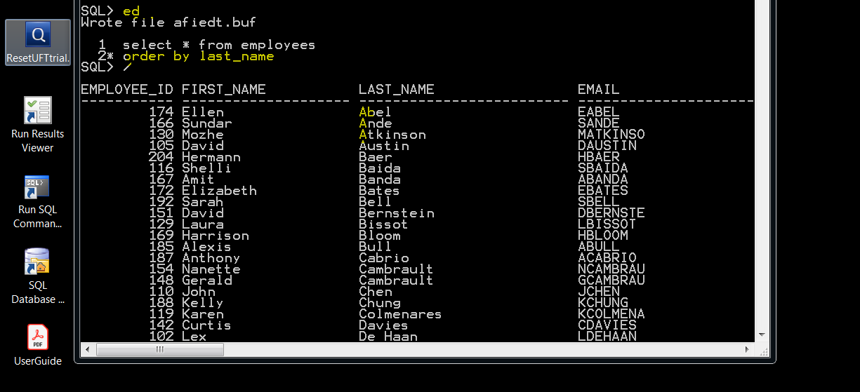

**USING (and) COMMAND**

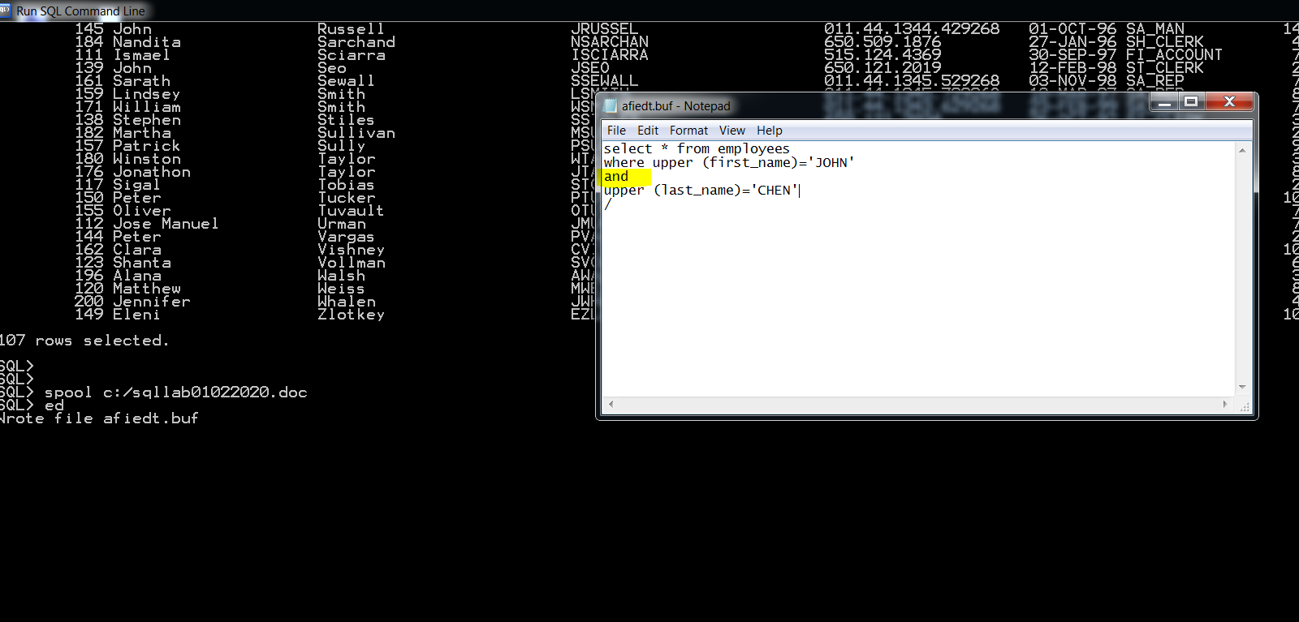

Basically, query is for employees with name john AND last name chen.

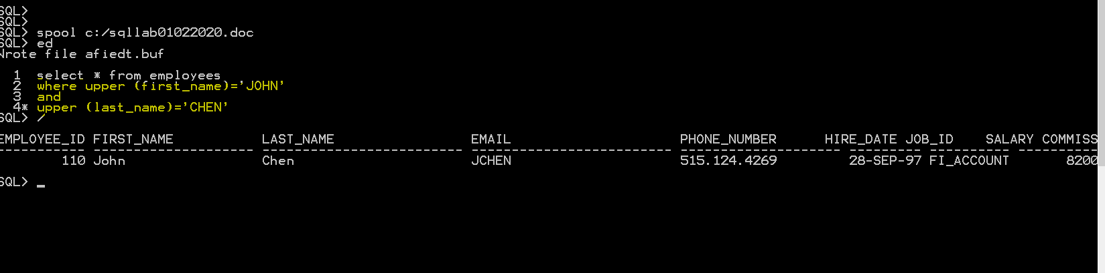

We are searching employee john bull but there is no such an employee

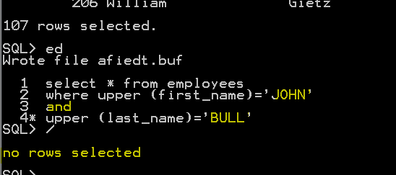

So it says no rows selected

**USING (OR) COMMAND**

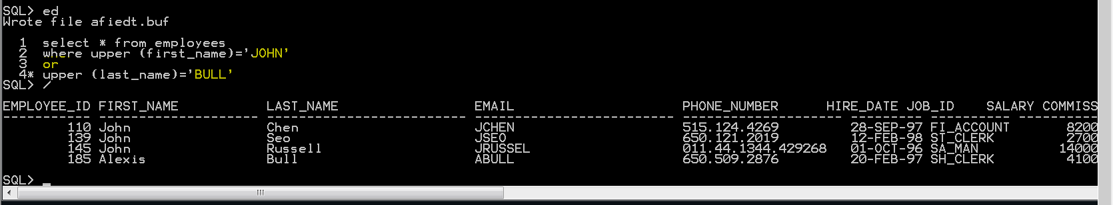

Basically, we search employees with name john or last name bull

So, query gave us all the matching employees

**USING (LIKE) COMMAND**

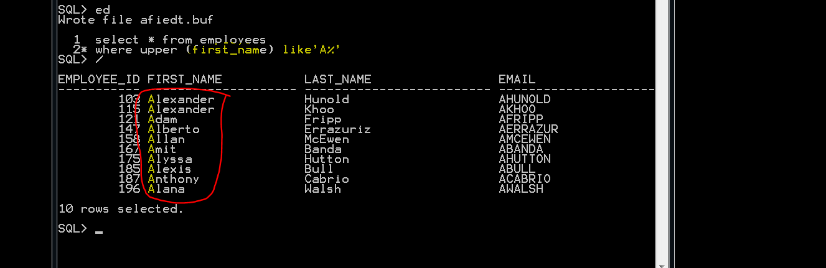

**With like command we used in first_name**

**Brought us all the first names with A**

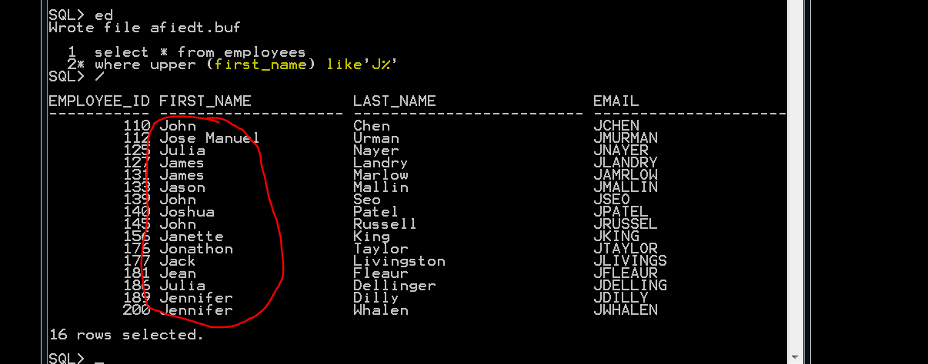

**Brought us all the first names with J**

**WRITE A QUERY TO RETRIEVE EMPLOYEE NAMES, SALARY AND COMMISSION**

**ANSWER**

**Select first_name, last_name, salary, commission_pct from employees;**

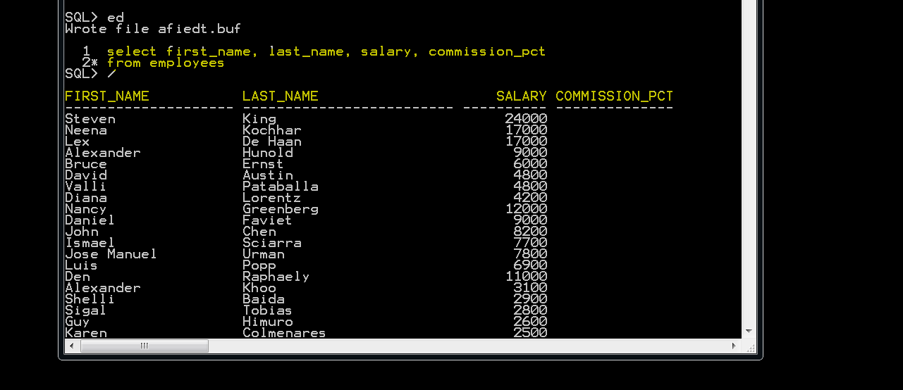

**WRITE A QUERY TO FIND EMPLOYEES WITH COMMISSIONS ( USING IS NULL or IS NOT NULL COMMAND)**

**Select first_name, last_name, commissions_pct from employees**

**Where commissions_pct is not null**

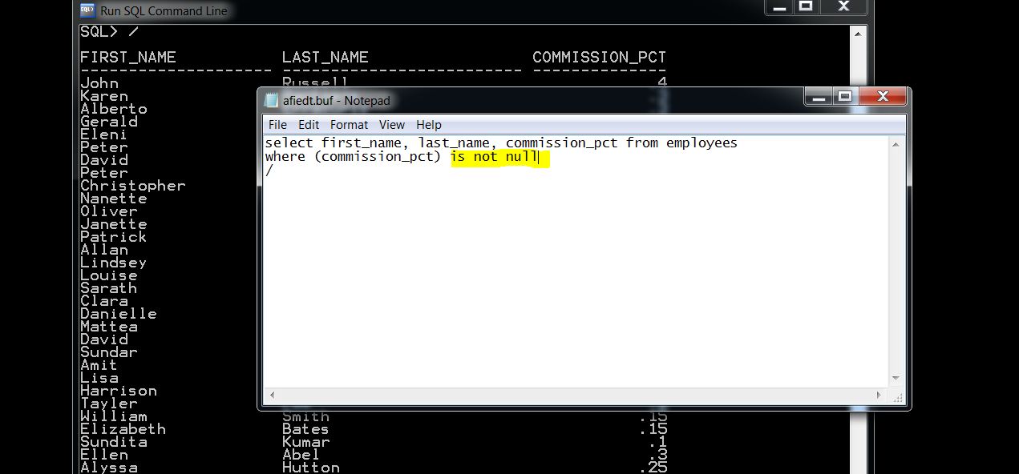

**Or you can use greater than > or smaller than < signs**

**Select first_name, last_name, commissions_pct from employees**

**Where commissions_pct > (0)**

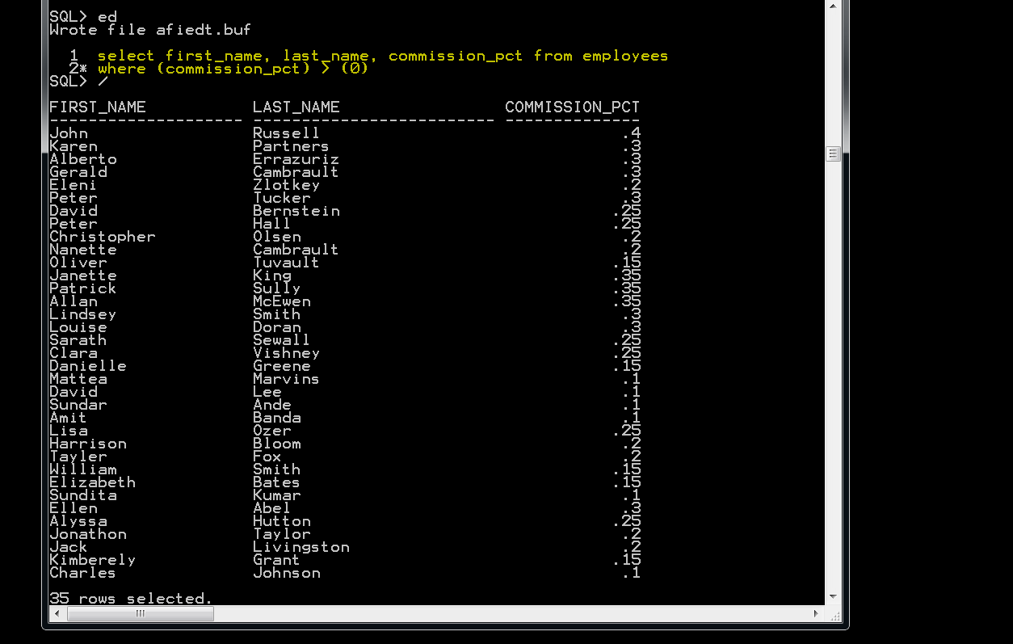

**To find employees with no commission (IS NULL)**

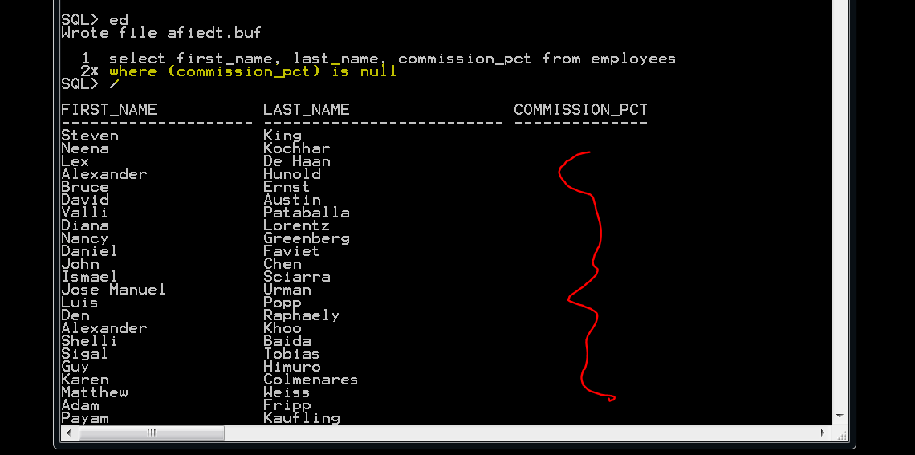

**Query find employees with more than average salary**

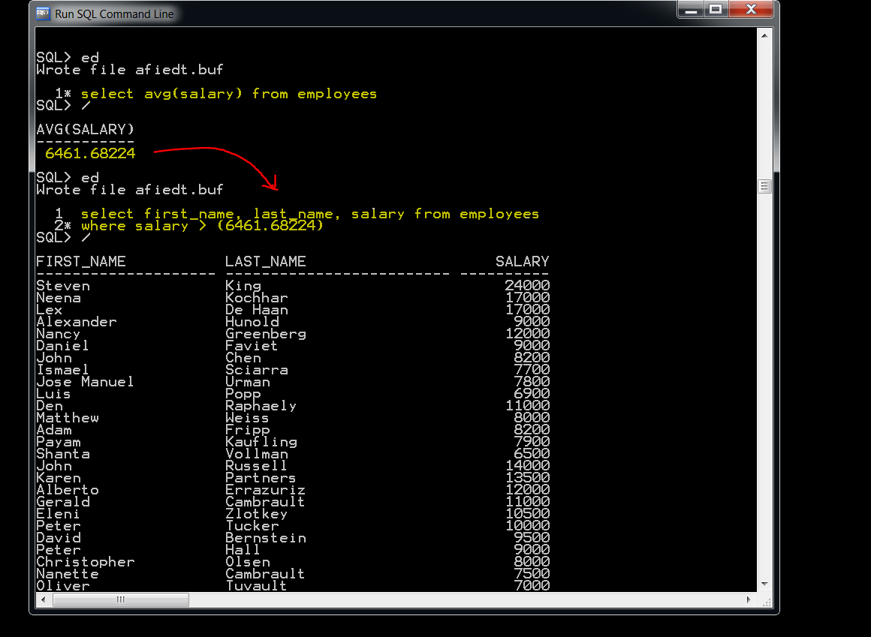

**IN ORDER TO FIND THE SAME RESULST IN ONE LINE OF QUERY**

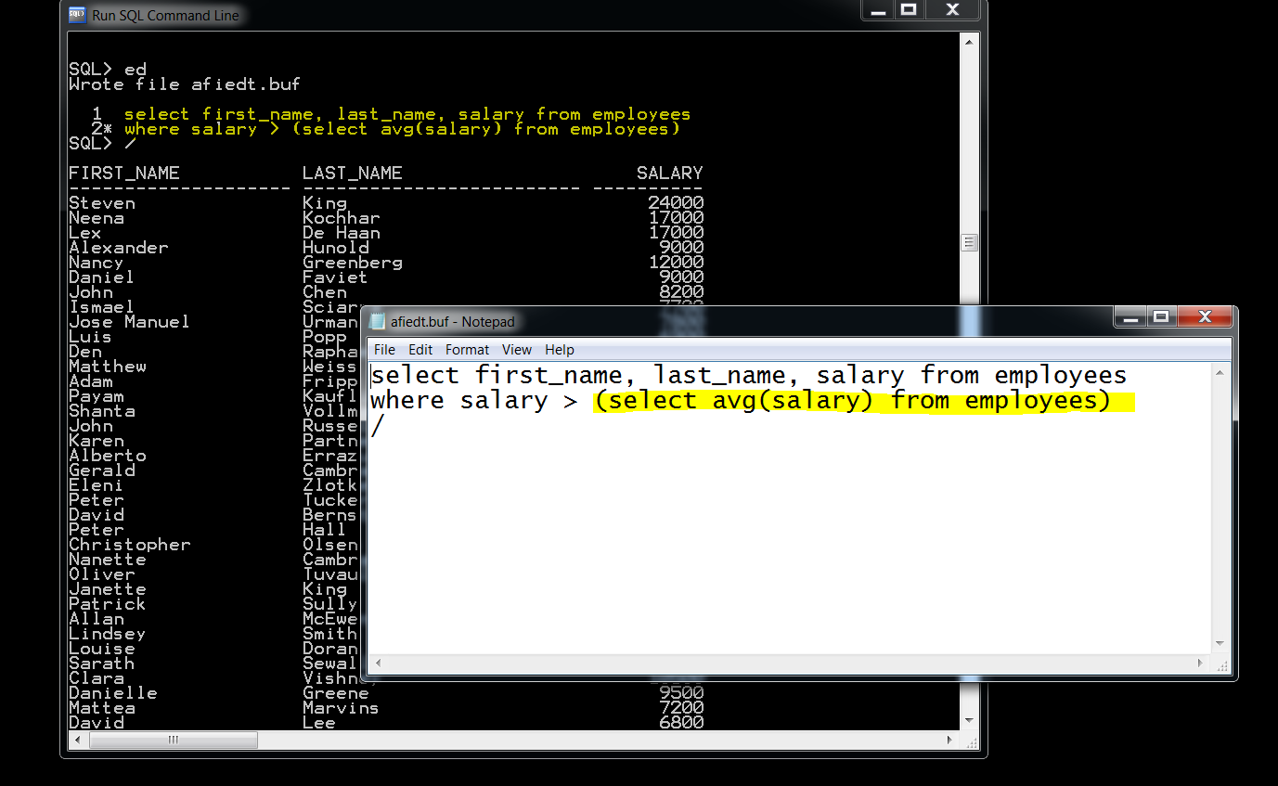

**Query**

**Find out people with the salary same as peter tucker**

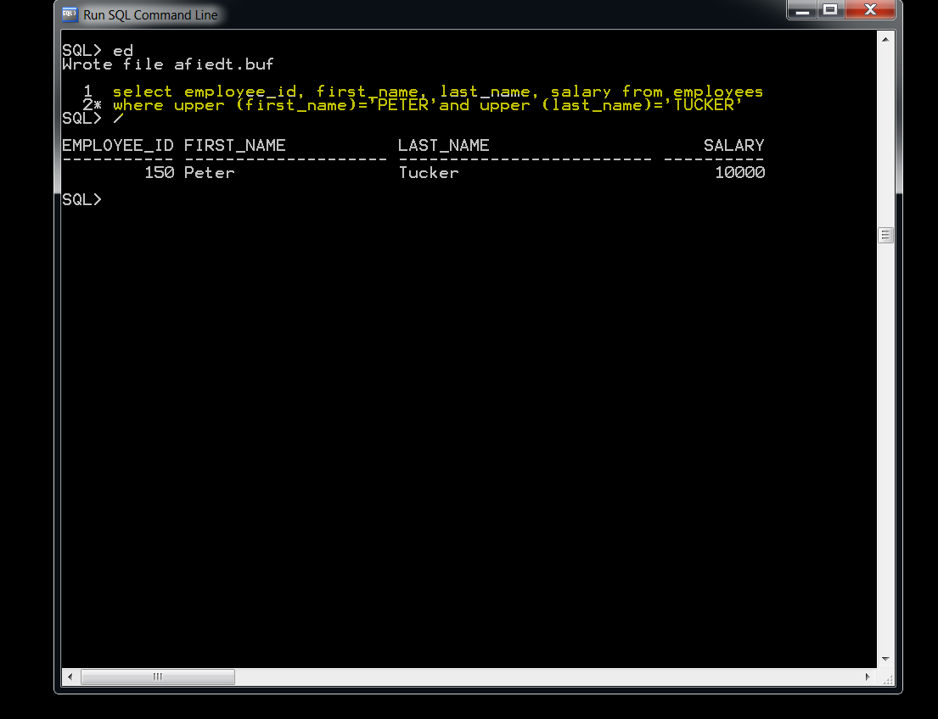**1w**

**We found out peter makes 10000**

**Now we can find people with 10000 salary**

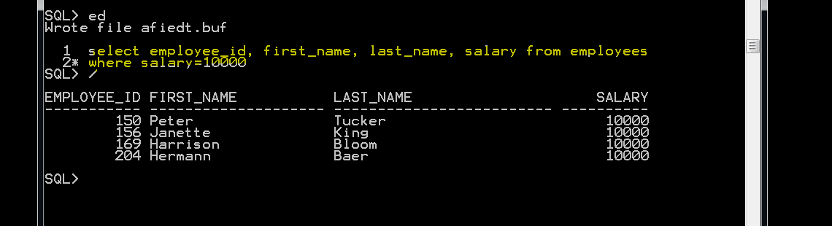

**To make it shorter**

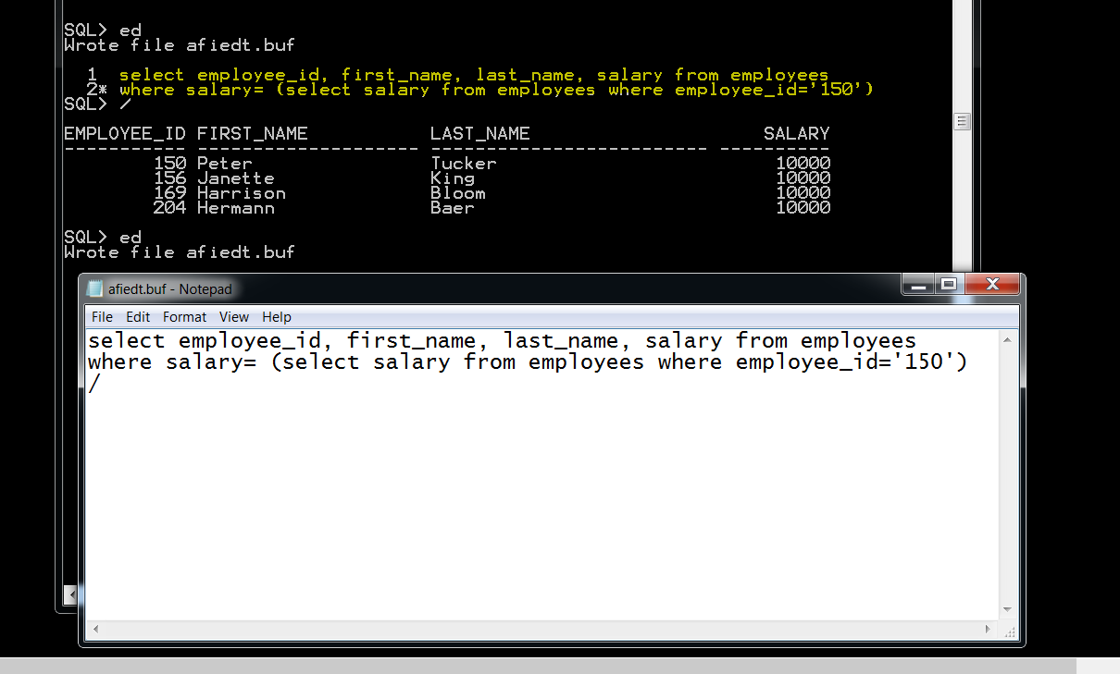

**Or we can find the same info with first name and last name**

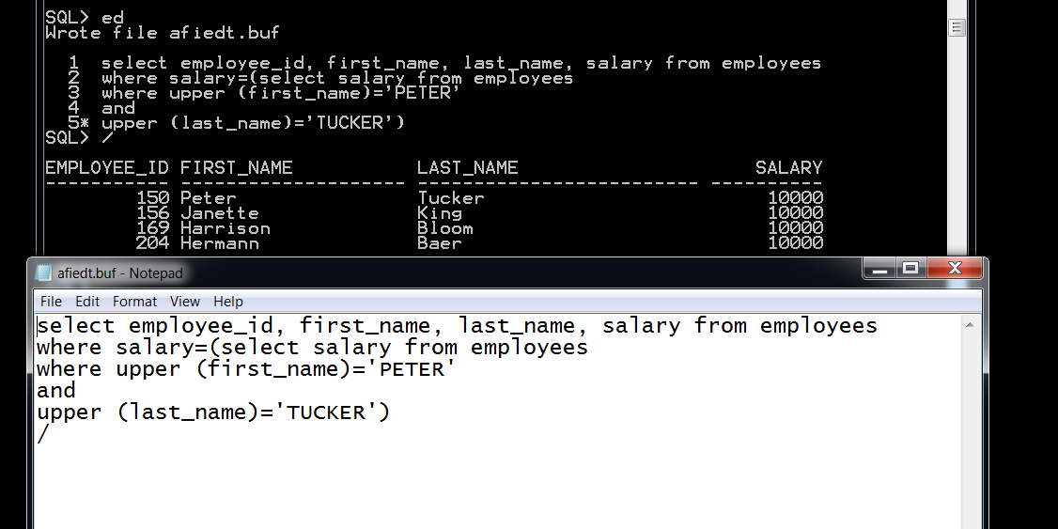

**Query = Find the employee with maximum salary**

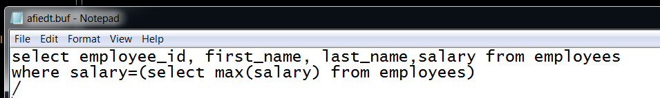

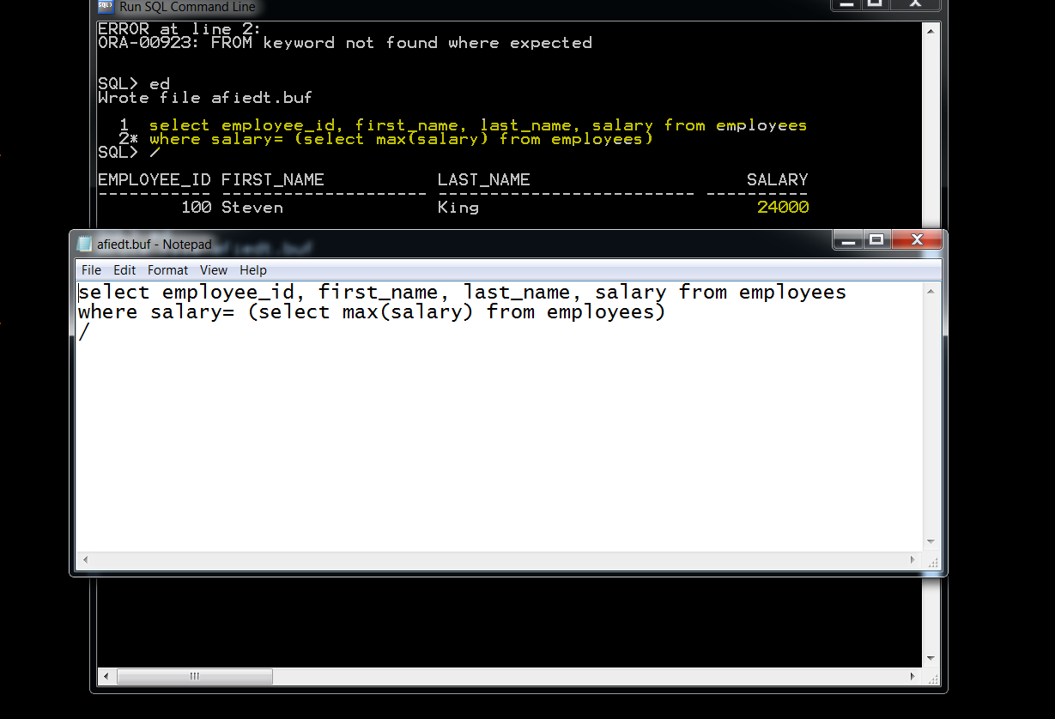

**Query = Retrieve first 10 records from a table**

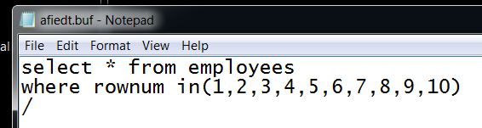

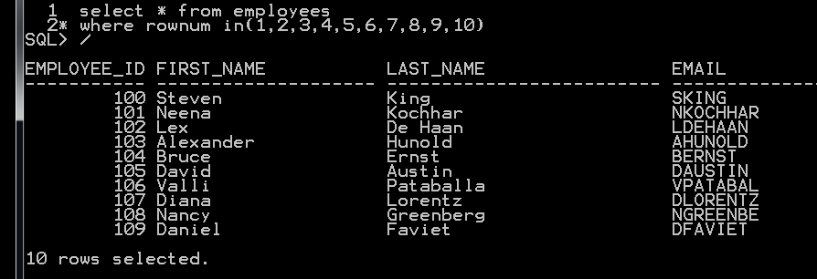

**Same thing can be done with this command**

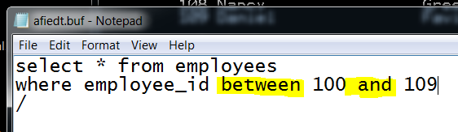

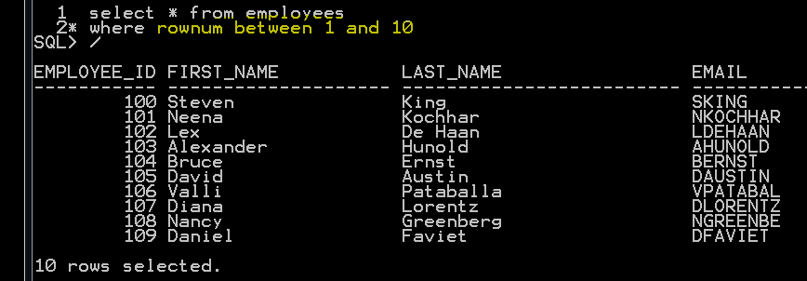

**Same thing can be done with this command**

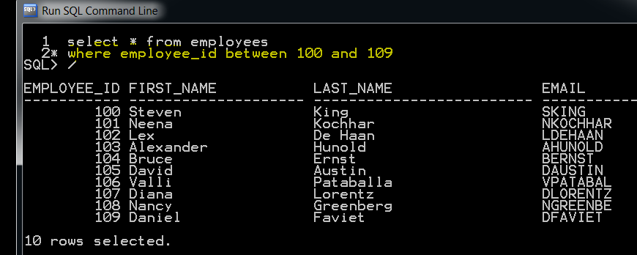

**Same thing can be done with this command**

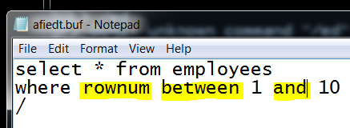



**Same thing can be done with this command**

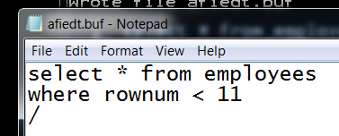

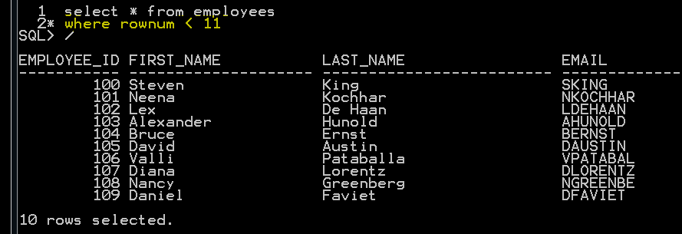

**Same thing can be done with this command**

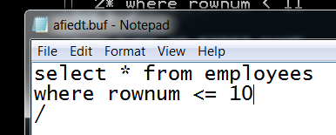

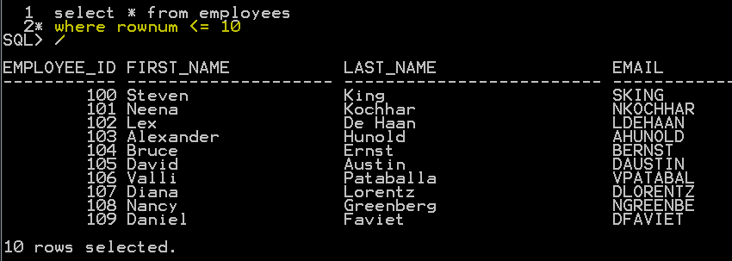

**QUERY= Find out row number 11 to 20 from our table**

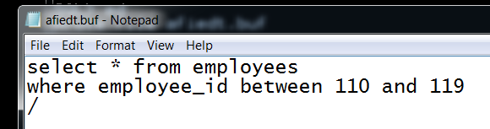

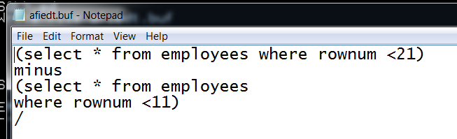

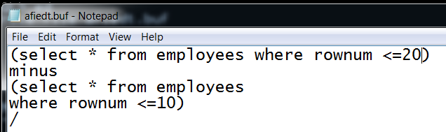

**An experienced professional with a wealth of knowledge and tangible skills on manual and automation testing tools and techniques.**

**Throughout my time in the engineering field I have**

**demonstrated great success in managing diverse projects while applying technical standards,**

**principles, theories, concepts and techniques to solve difficult problems.**