**MySQL**

**To Practice JDBC, we need to have:**

1. **SQL editor**
2. **Server to host our database[Localhost:3306]**

**Download the mysql jar file**

<https://dev.mysql.com/downloads/windows/installer/>

This installer comes with mySQL server and editor together and more

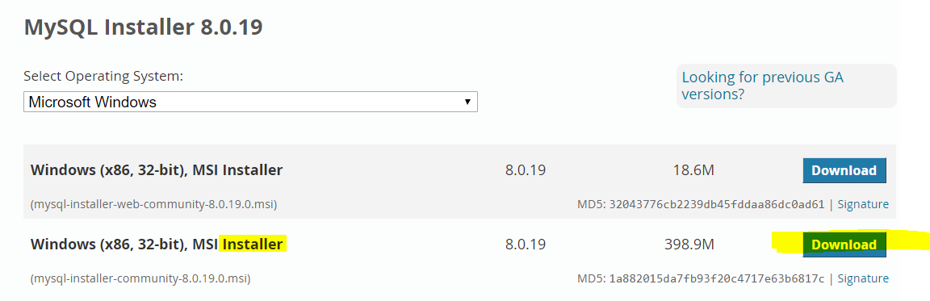

**Select both 🡪** 

**Select Developer Default🡪** 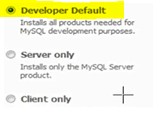

**Let it install all 🡪** 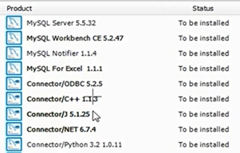

**Set the Localport = 3306**

**Set both username/password=root 🡪**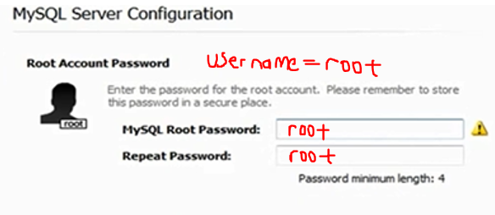

**Open the Workbench and double click on localhost:3306, enter password=root**

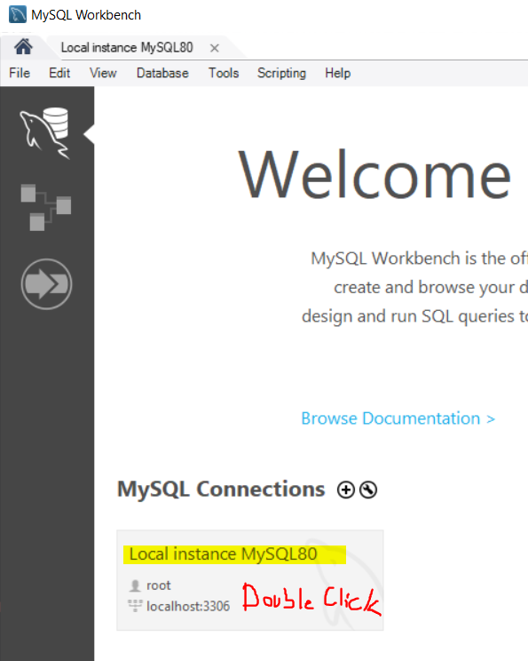

Click Schemas to see the databases. I created employeeportal earlier.

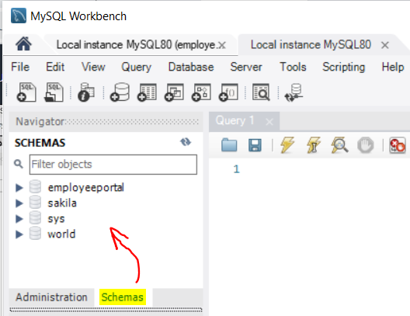**🡪** 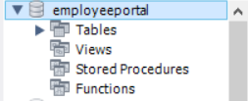

**Create Another DataBase,Table then Insert Values 🡪**

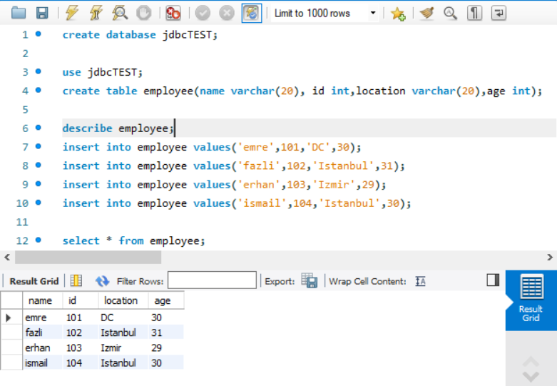

**JDBC CONNECTION**

**First add jar file to the project in eclipse🡪** 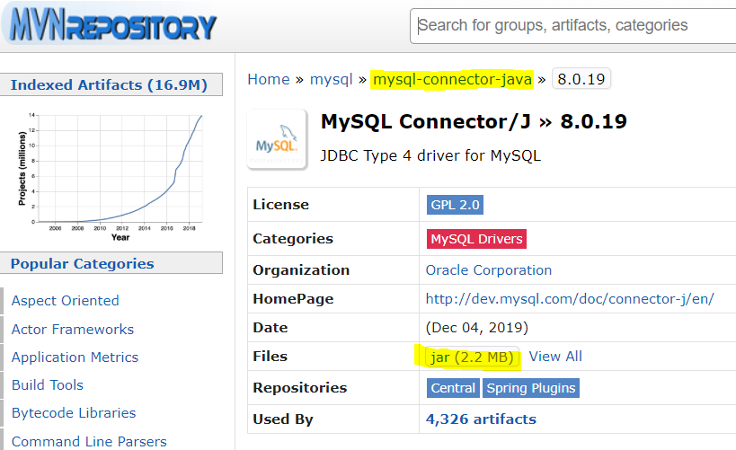

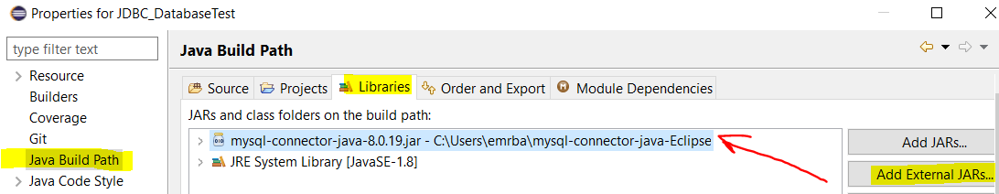

**How to Retrieve data from the database using Eclipse**

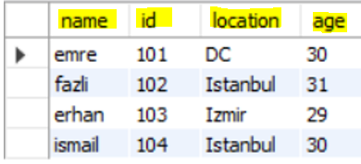

**Connection argument to pass: basically 3 Strings**

**1-“jdbc:mysql://HostName:PortNumber/DataBaseName”,**

**2-”username”,**

**3-”password”**

"jdbc:mysql://localhost:3306/jdbcTEST", "root","root"

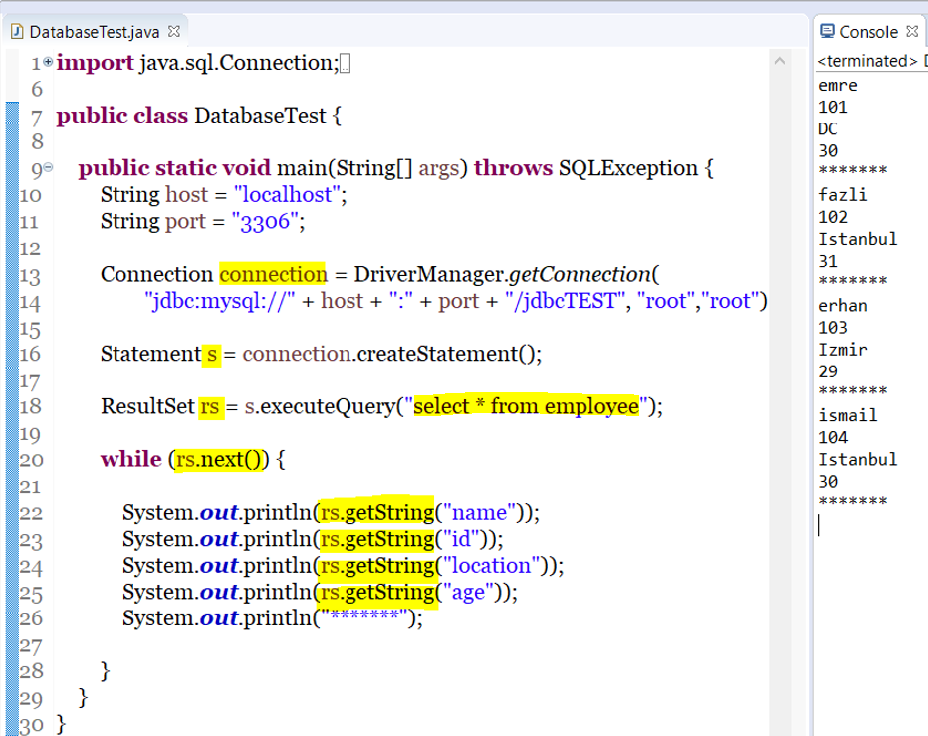

**From here we can use these values with Selenium**

**Such as 🡪 driver.findElement(By.xpath(“xpath”)).sendkeys(rs.getString(“name”));**

**driver.findElement(By.xpath(“xpath”)).sendkeys(rs.getString(“id”));**