**GIT/GITHUB**

Github is source (version) control system

**How to download**



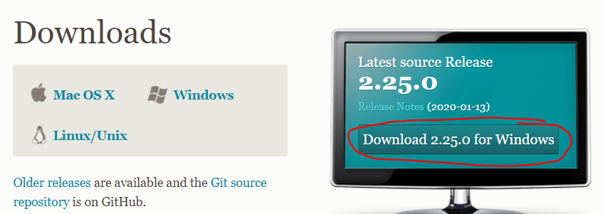

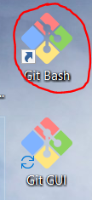

Type “git config –list” then enter

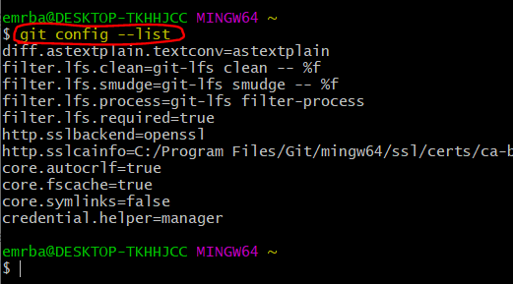

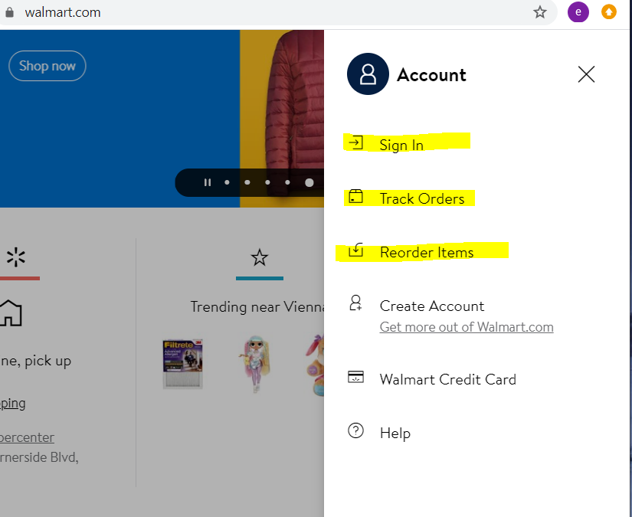

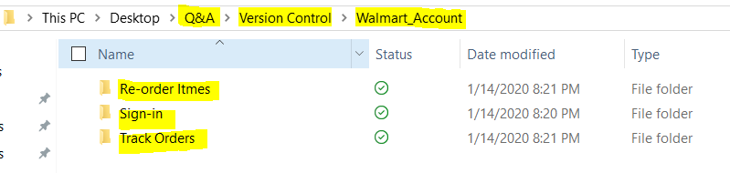

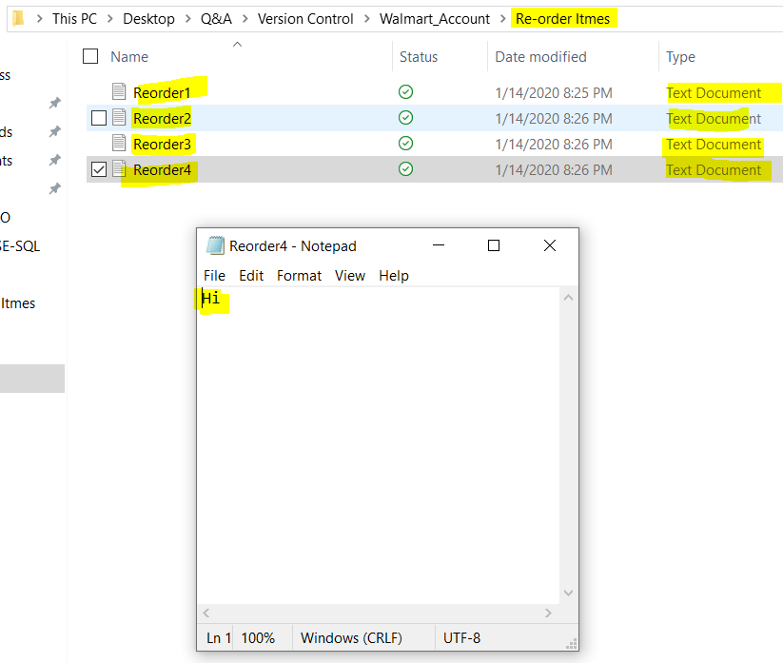

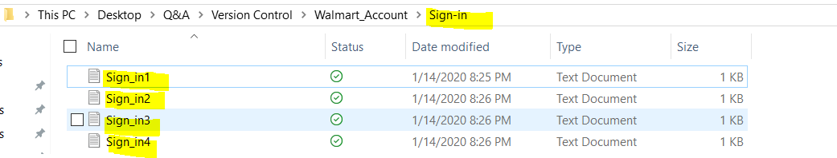

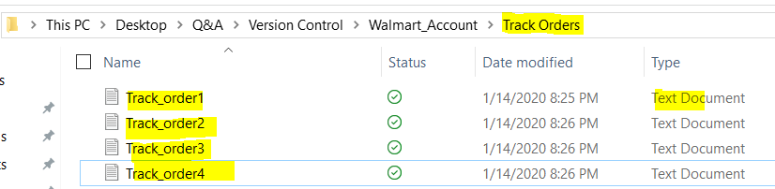

Go to Walmart Account folder inside version control folder

Right click and select git bash here

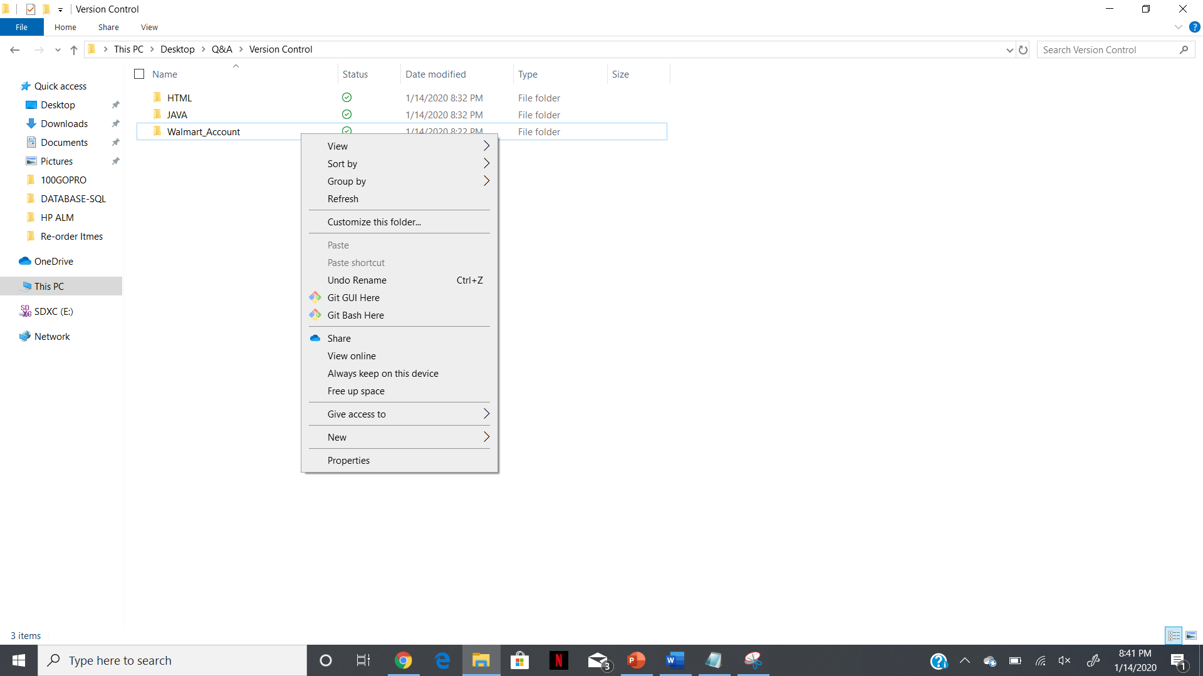

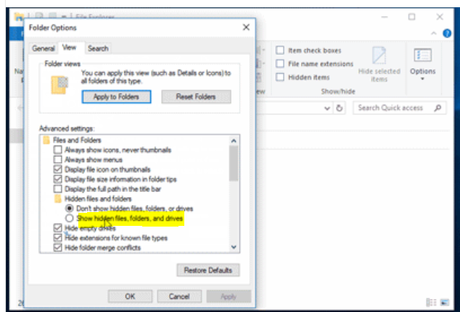

“git init” enter

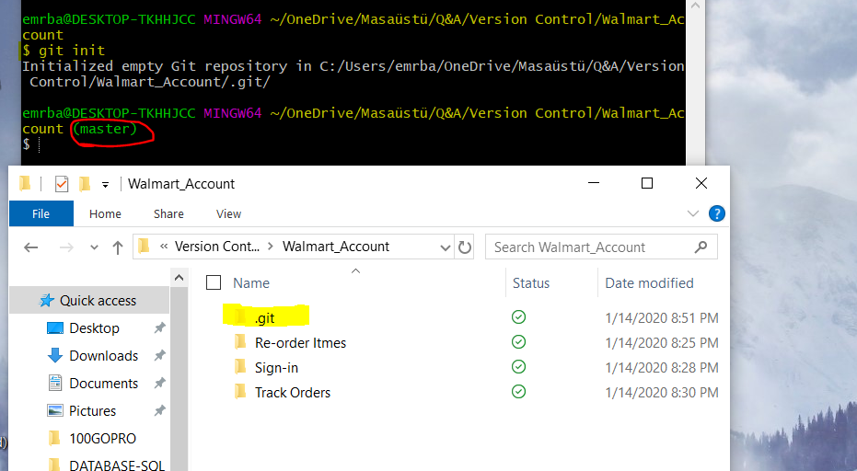

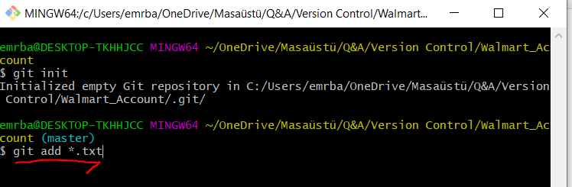

**Do this git setup in your work so you save all the work you do.**

**Basically, we added all the txt files by “git add*.txt”**

**Then “git status” showed us all the added txt files**

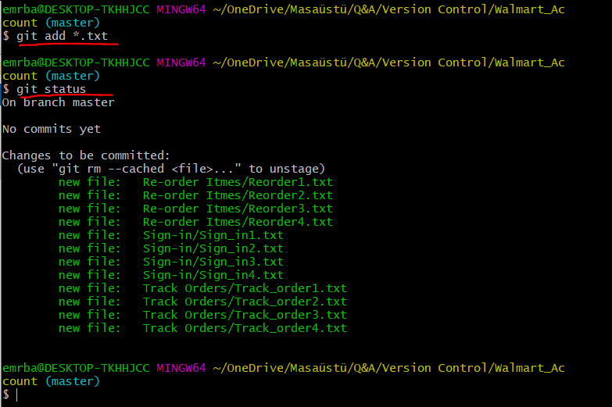

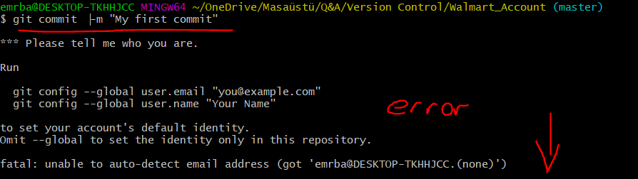

**Define the email with git config –global user.email “palyanco@gmail.com”**

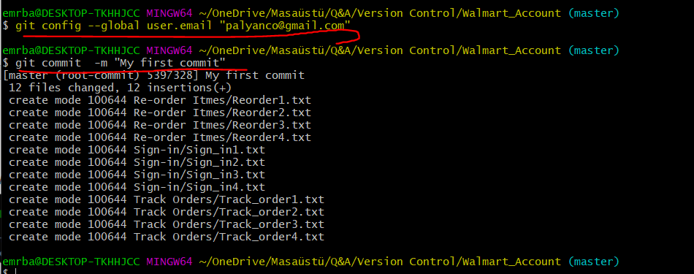

**Check the status again**

**Nothing to commit that means everything already committed**

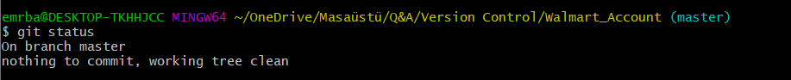

**So now I went to re order folder and changed the text documents basically changing the codes, scripts**

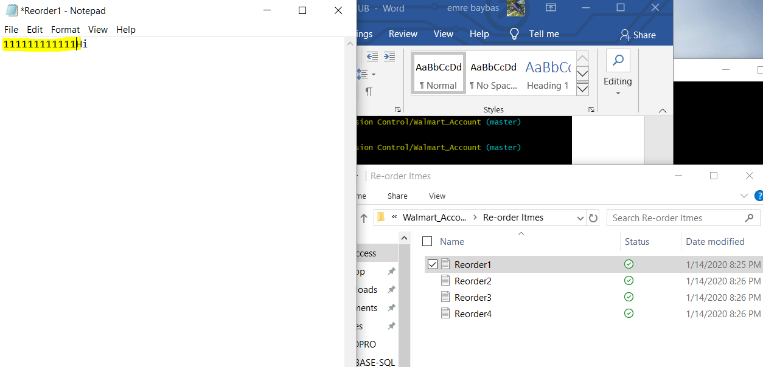

**To all 4 txt files we made changes**

**Then, go to git bash and enter git status again**

**It will show you what had been modified**

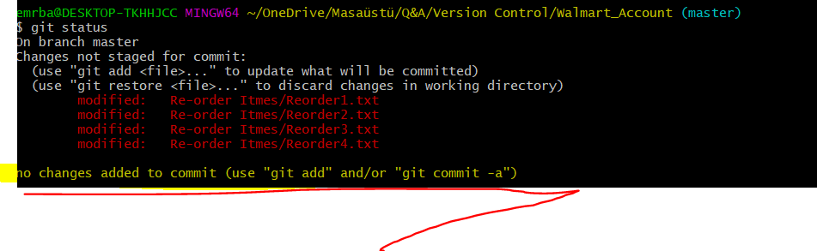

**This is what we follow always**

**GIT FILE STATUS LIFE CYCLE**

**Working directory (Walmart account) 🡪 Add🡪 Staging Area 🡪 Commit 🡪 Git Local Repository 🡪 push to Github**

**So now go add *.txt to add to staging area**

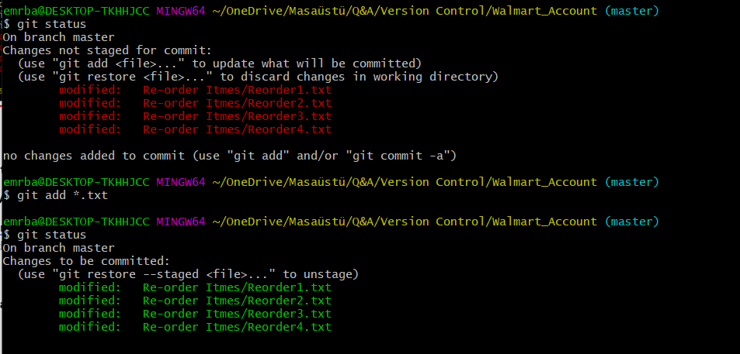

**Now we will commit again as second commit**

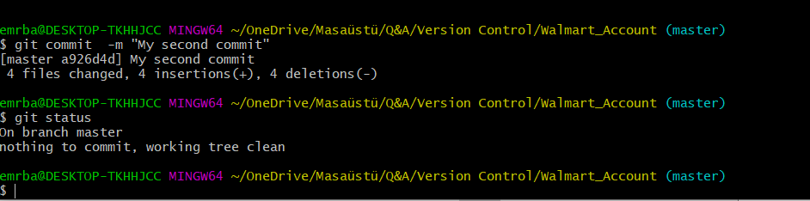

**Github.com**

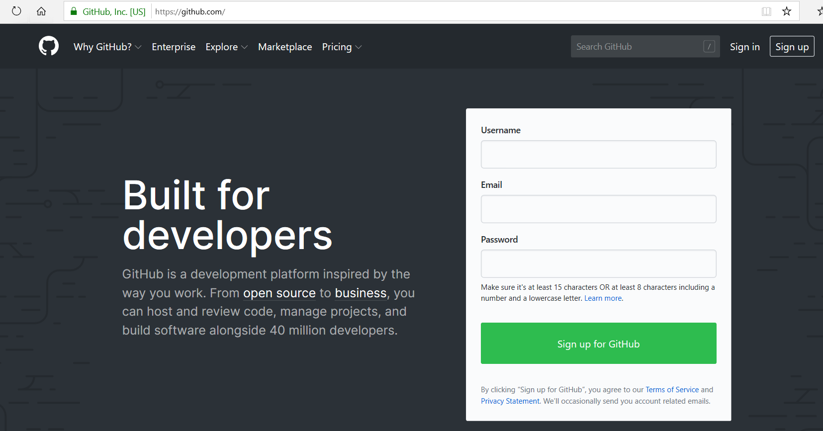

**Sign up, create an account**

**Create a repository**

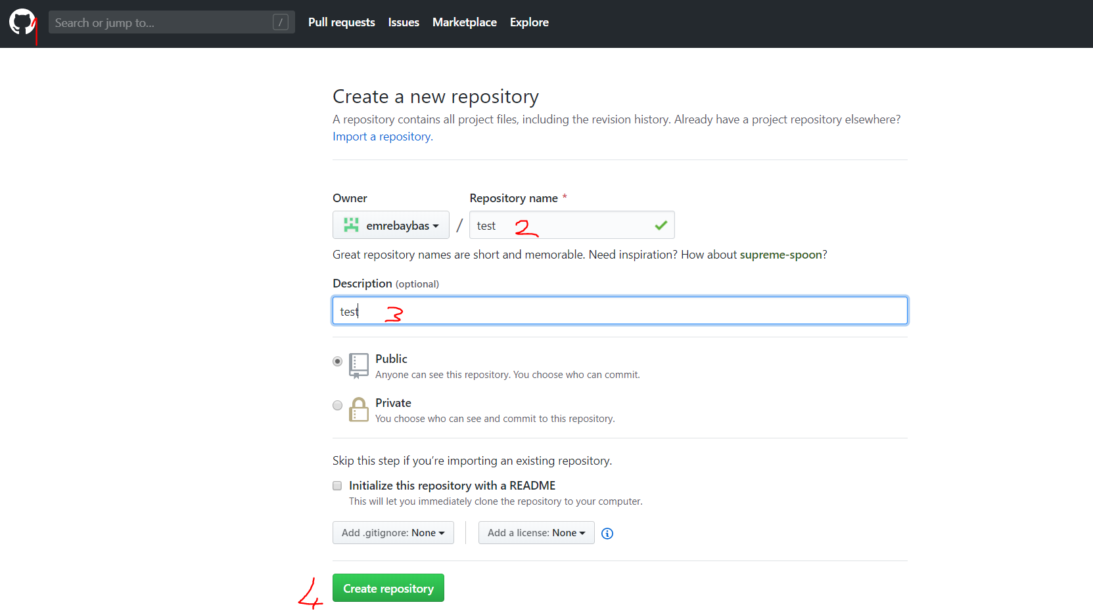

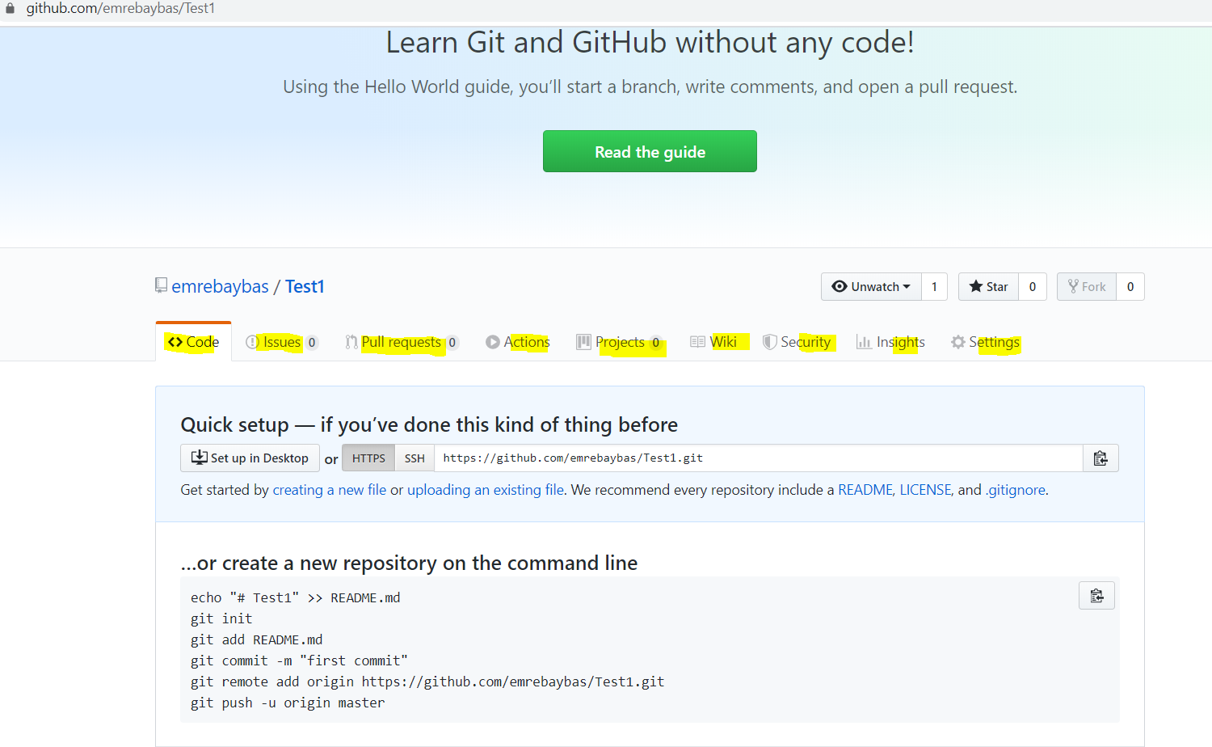

**Copy this command and enter to git “git remote add origin https://...............”**

**Then “git push -u origin master”**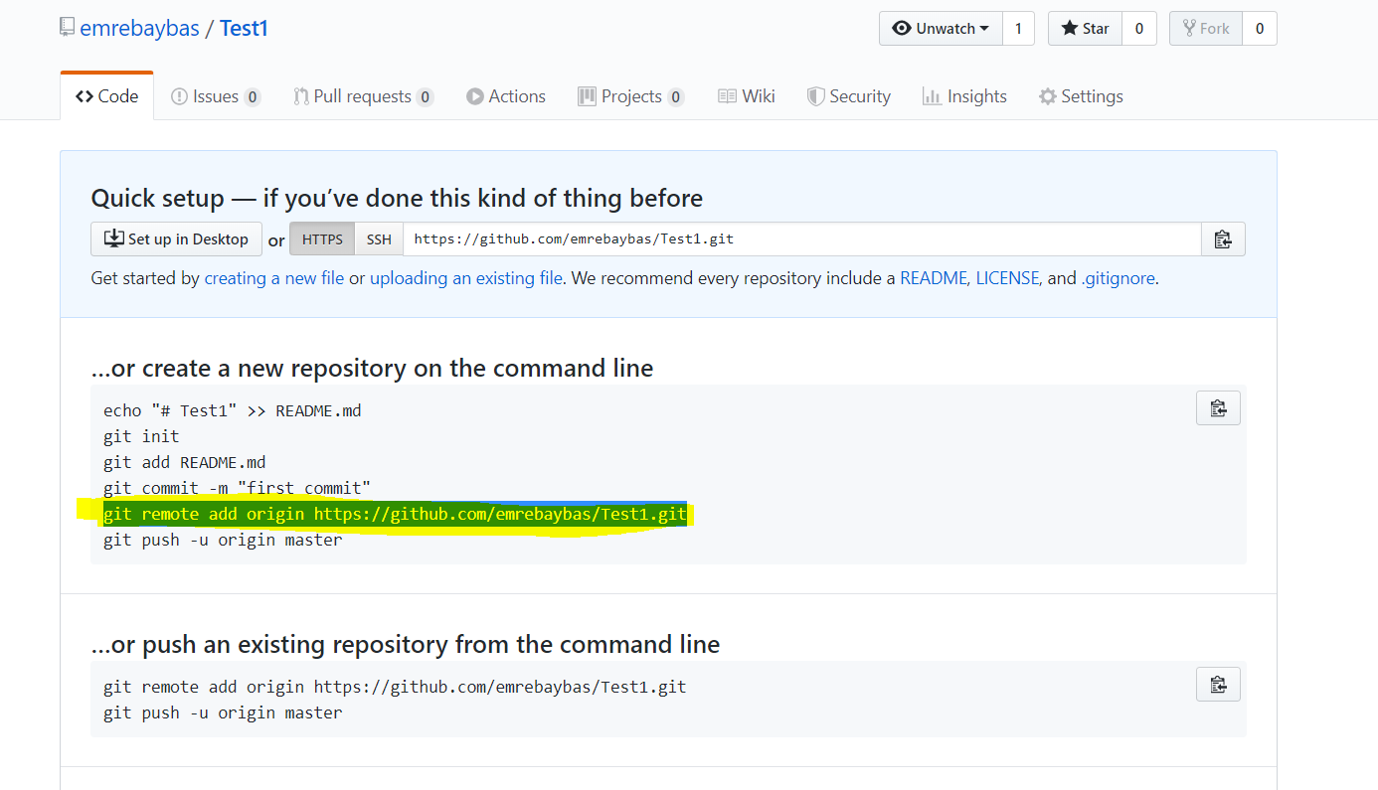

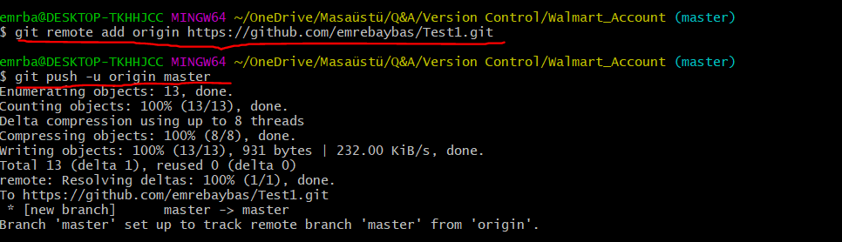

**After this click on repository name in this case “Test1”**

**You will see all the files**

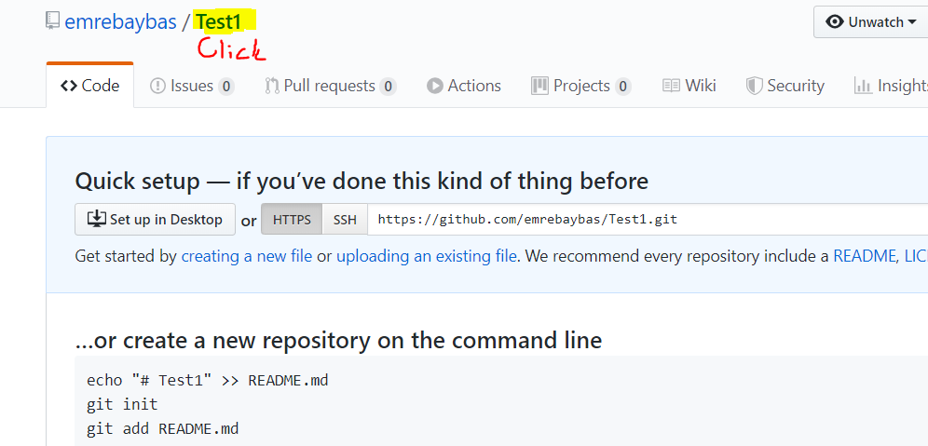

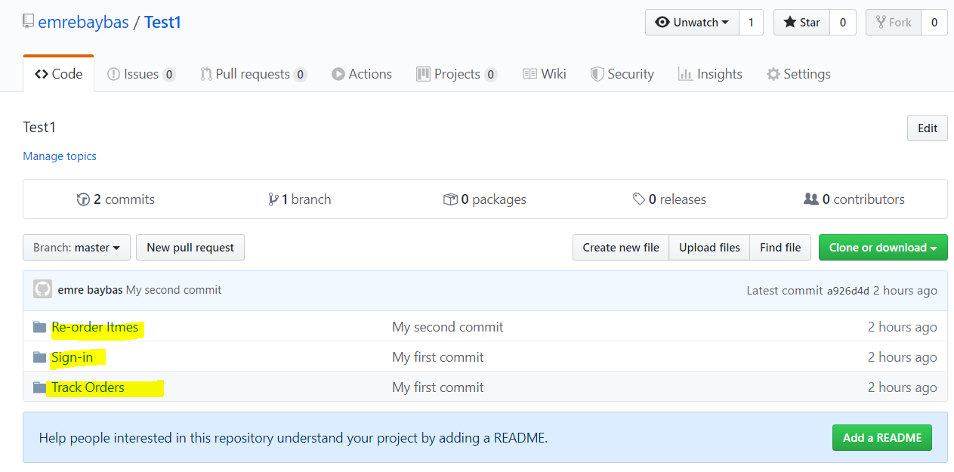

**PROCESS**

**Jira – Task Ticket**

* **Hello world in JAVA**
* **Coding in JAVA/HTML**
* **Copy/paste in text document and**
* **Push it to GitHub**

**Create an account with JIRA**

**Then create a project**

