# CSE 222 HOMEWORK #5

**Emre BAYRAM 141044019**

**TABLE OF CONTENTS**

1. REQUIREMENTS 2
   1. OVERALL DESCRIPTION 2
   2. REQUIREMENT DEFINITIONS 2
2. Analysis and Solutions Approach 3
3. Class Diagrams 4
4. Tests 5
5. Result…………………………………………………………………………………………………….8

### 

### **Requirements**

## Overall Description

### **Part1**

### Implementing Honoi Tower Problem with iterative thinking.

### 

### **Part2**

### Implementing the remove procedure from LinkListRec. This remove method removes all duplicated elements in the linkedlist

### 

### **Part3**

### Implementing 3 recursive method . First method is “intersection of List” this method returns Intersection of 2 list while your are creating object that you have used , Second method is “Union Of List ” this method returns a new List of Union of 2 list in the same way you created object. Third method is “is Subset” this method returns true or false whether list1 is subset of list2 is true otherwise false.

## Requirement Definitions

* + 1. 2 list when using part3 class
    2. When returning a List used ArrayList data structure.

**2. Analysis and Solutions Approach**

**PART 1**

I was solved before Honoi tower problem using recursive thinking. I examined again this solution then do some research on the Internet and play the game. Then I develop some algorithms and apply them.

**PART 2**

Before implementing remove method , wrote a small Linked List data Structure as in course book. Then I examined the normal remove method and I wrote algorithm for remove all duplications and apply to code.

**PART 3**

I did some research about these methods on Internet about what is expecting from me and I develop algorithm after that apply it I wrote wrapper method for every method.

**3. Class Diagrams**

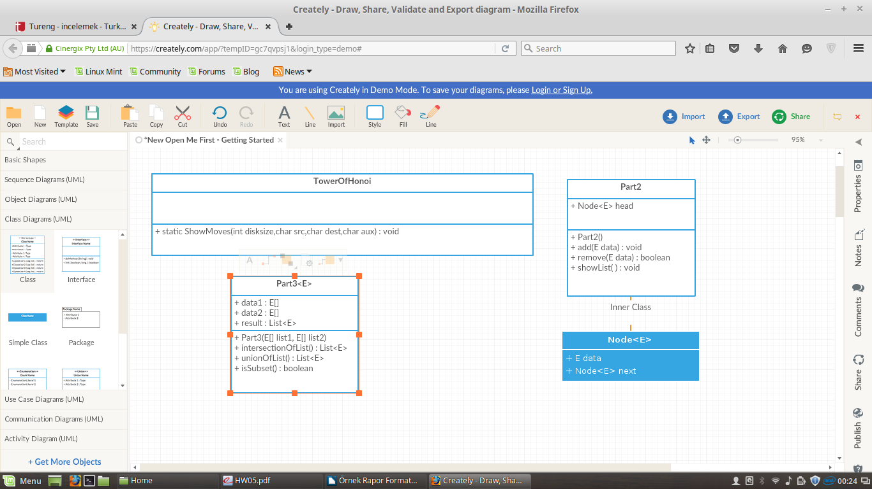

**Figure 1 Class Diagram**

**4. Tests**

**Tower Of Honoi**

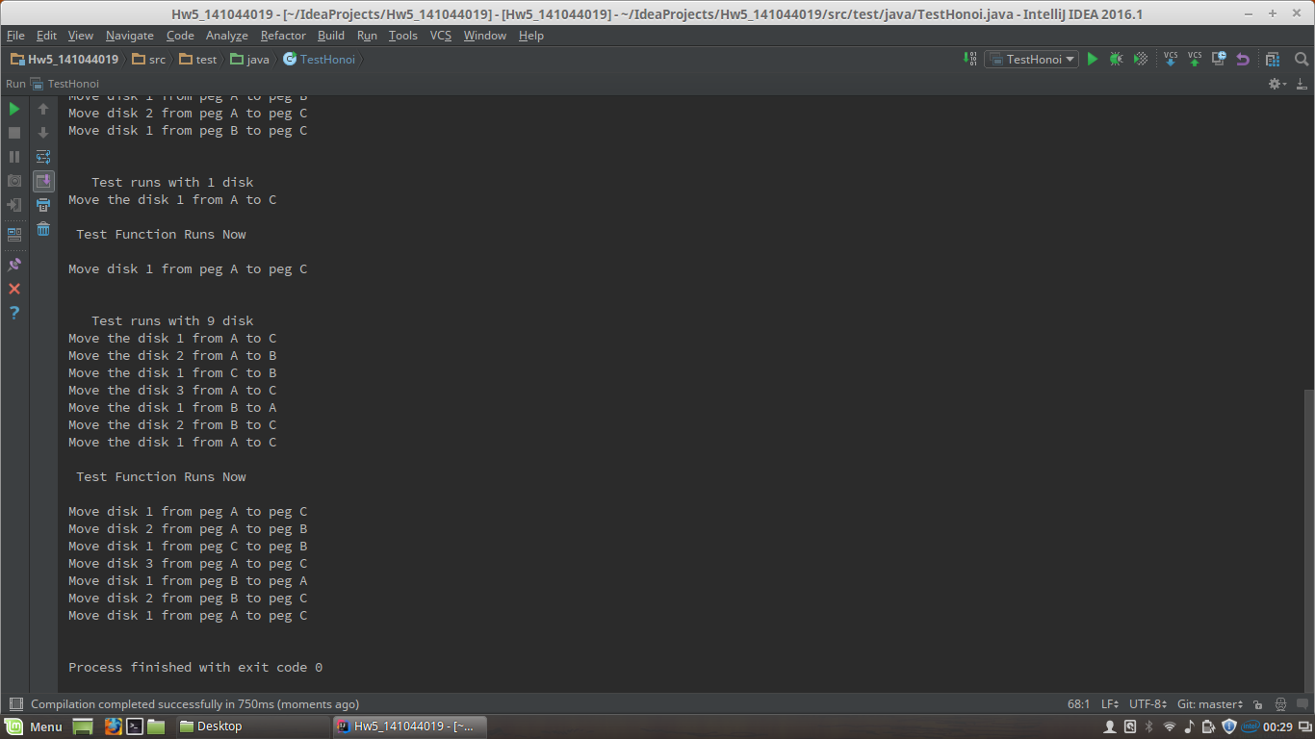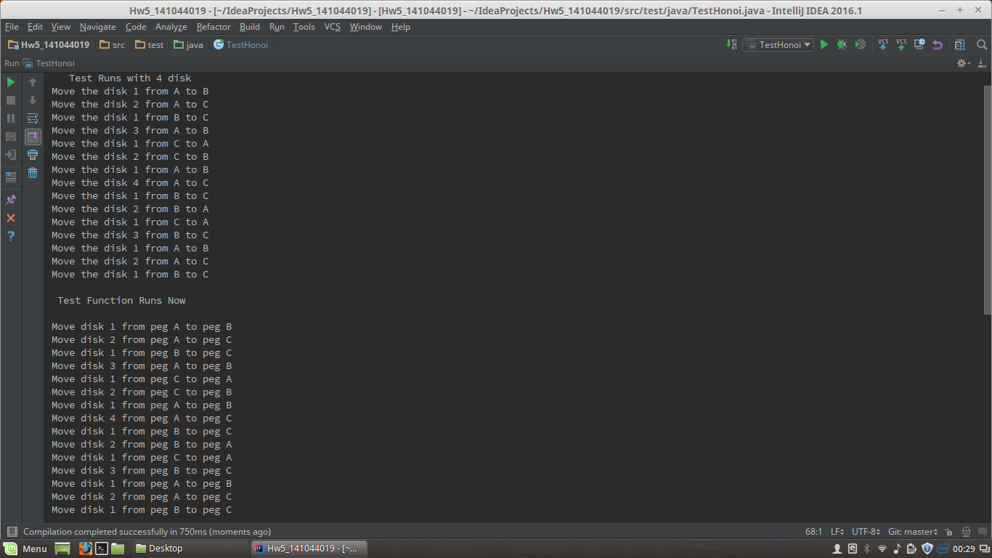

Exactly Same as solution.

Part 2

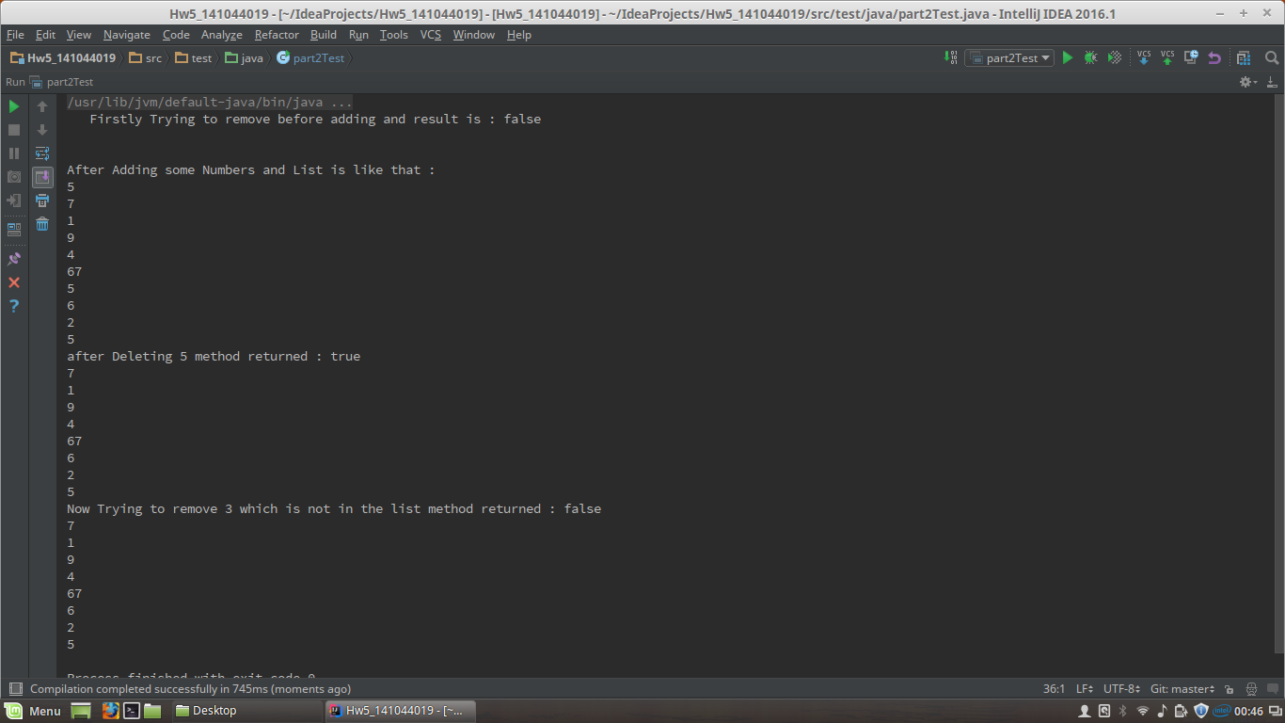

Every case is true.

Part 3

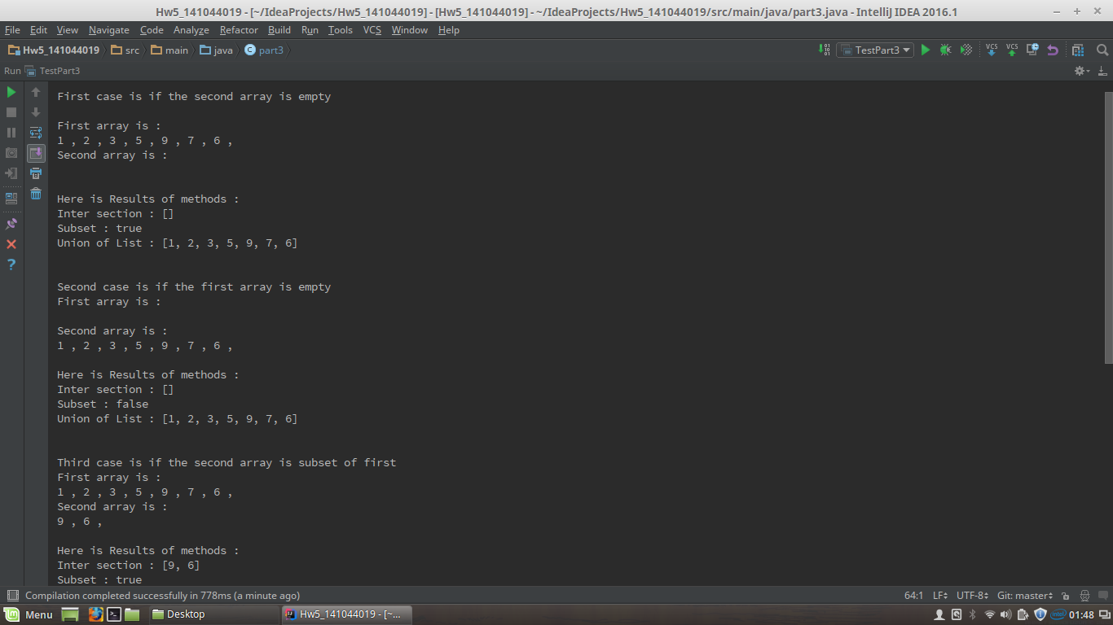

Every Case is demonstrated with true result all 3 methods work OK.

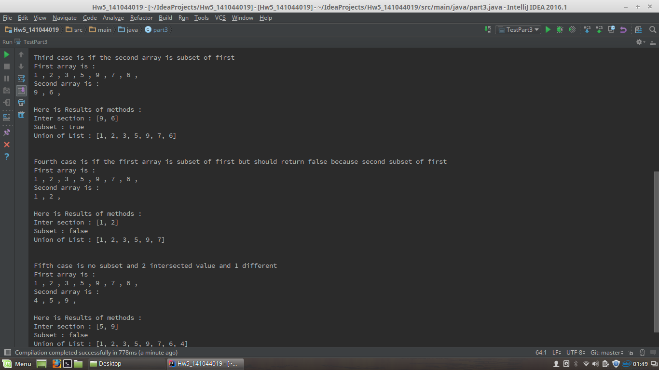

**5.Result**

As a result, I have challenged writing iterative Honoi Tower problem and Part. Other Parts are not difficult for me.