**BIL 101 HOMEWORK 1**

**EMRE**

**BAYRAM**

**141044019**

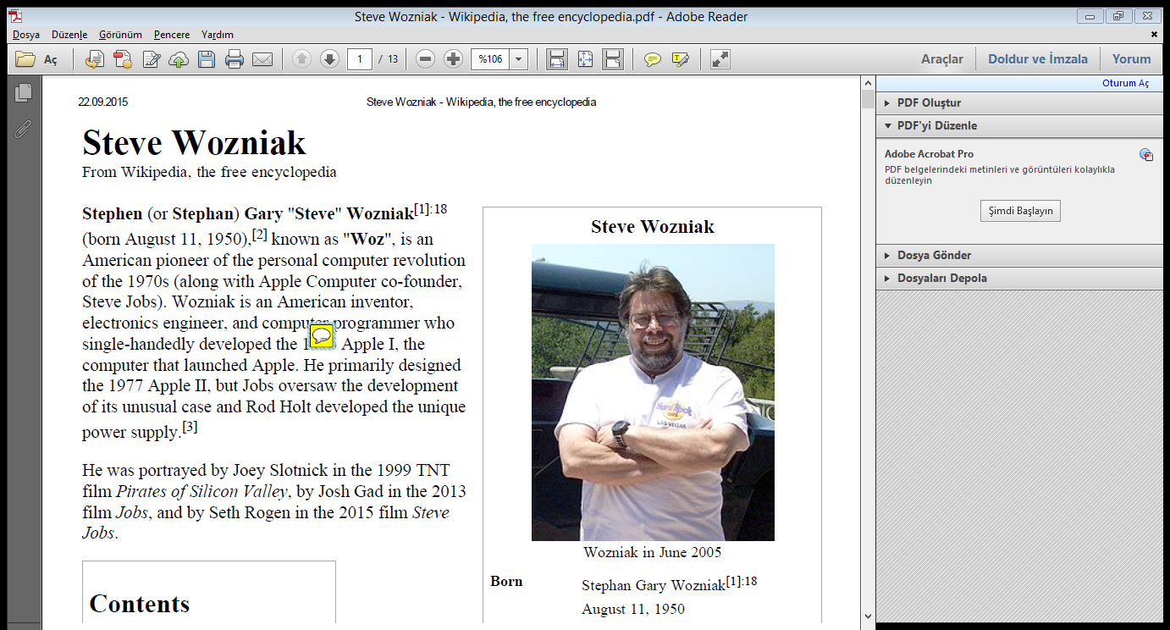 **STEVE WOZNIAK**

Steve Wozniak was born on 11 August 1950, in California. His full name is Stephan Gary Wozniak and his Nickname is “The Woz”. He is computer scientist and inventor. His father is engineer at Lockheed Martin, too. He known as co-founder of Apple Company. Many people can see that his skills are good at electronics in early ages. Then his study life was went on University of California at Berkeley. Steve Wozniak and Steve Jobs the founder of Apple Inc. are met in here, University of California. This two friend have mutual relationship between them. Steve Wozniak quitted his work in Hewlett-Packard.

**APPLE ADVENTURE**

**Figure 1: Steve Wozniak in June 2005**

After quitting from Hewlett-Packard, Two Steve started working out of family garage and Jobs’ bedroom. Steve Wozniak was good at producing and inventing and other Steve was good at marketing. After few time later, they founded Apple Inc. and Wozniak invented Apple I computers. Apple I was builted and designed most of parts in Jobs’ bedroom and garage. On February 7, 1981, Wozniak got injured when the private plane piloting crashed while taking off from the Santa Cruz Sky Park. After this accident he didn’t start working in Apple immediately and he start thinking leaving from Apple but he returned. He was enjoying engineering inventing something, not management or marketing and after their company getting bigger growing fast. He felt no longer needing in company within many engineer. He leaved company.

**AFTER APPLE**

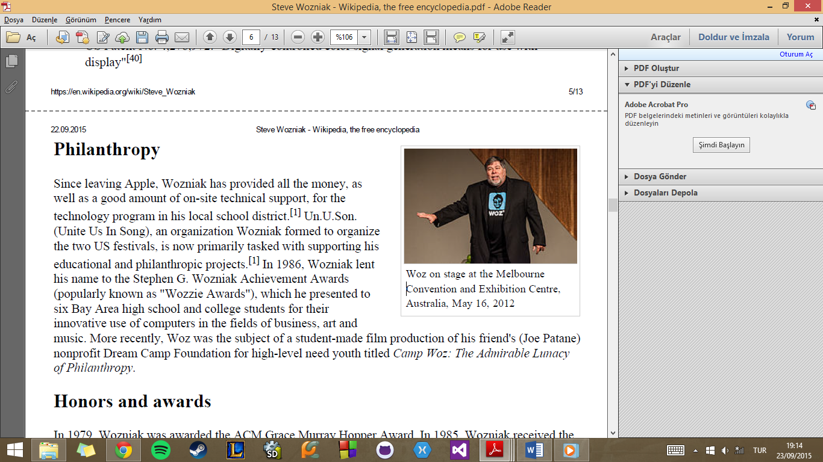 Wozniak thought computer classes in elementary schools. Because he knows that how could teachers effect on students’ lives. So that he did. And then in 2001 he founded Wheels of Zeus (WoZ), in this company he aimed to develop inventing new electronics with ambitious engineers like him especially wireless GPS technology. This company closed in 2006. After that he found one more technology company in 2006. This company attended technology competition named FIRST. After that he started to give many speeches and attend many exhibition and University conferences. At last He started to give classes in Sydney, Australia at University of Technology.

**SOME CONTURBUTIONS**

First of all, he and Jobs create Apple Inc. with this company they gave very important development to technology. When they were creating the Apple computers, he invented PAL colour display method. And here is some patents;

1. Controller for magnetic disks recorders etc.
2. Video display on Microcomputers
3. Digitally controlled color signal generation means for use with display

But I think his lessons, speeches and conferences to new engineers and people who interested in technology, is more important he gave morale to new generations as you see in figure 1.

**Figure 2 : Woz on stage at the Melbourne Convention and Exhibition Centre,Australia, May 16, 2012**

**References**

1. <https://en.wikipedia.org/wiki/Steve_Wozniak>
2. <https://tr.wikipedia.org/wiki/Steve_Wozniak>
3. <http://www.biography.com/people/stevewozniak9537334>
4. Jobs Film