Machine Learning Midterm Project Report
Breast Cancer Wisconsin and Wine Classification
GitHub: https://github.com/emrebeyaziit/machine-learning-midterm
Video: https://youtu.be/4J05ROaqaso

1. Loading the Datasets
For this project, I used the Breast Cancer Wisconsin and Wine datasets from scikit-learn. Breast Cancer has 569 samples, 30 features and two classes (0 = malignant, 1 = benign). Wine has 178 samples, 13 features and three classes (0, 1 and 2). I kept the original labels and did not include the target column in the input features.

2. Dataset Quality Checks
I checked missing values, duplicates and feature types before modeling. Both datasets have numerical features and no missing values. I also used IQR and boxplots to look for possible outliers. I did not automatically delete unusual samples because they might still be useful data.

3. Exploratory Data Analysis
I checked descriptive statistics, class distributions, correlations and boxplots. The Breast Cancer features include several related measurements, while Wine includes chemical measurements with different ranges. These plots helped me understand why scaling might matter.

Breast Cancer — EDA figures
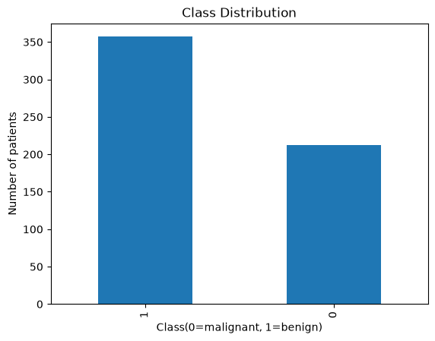
Breast Cancer: Class distribution
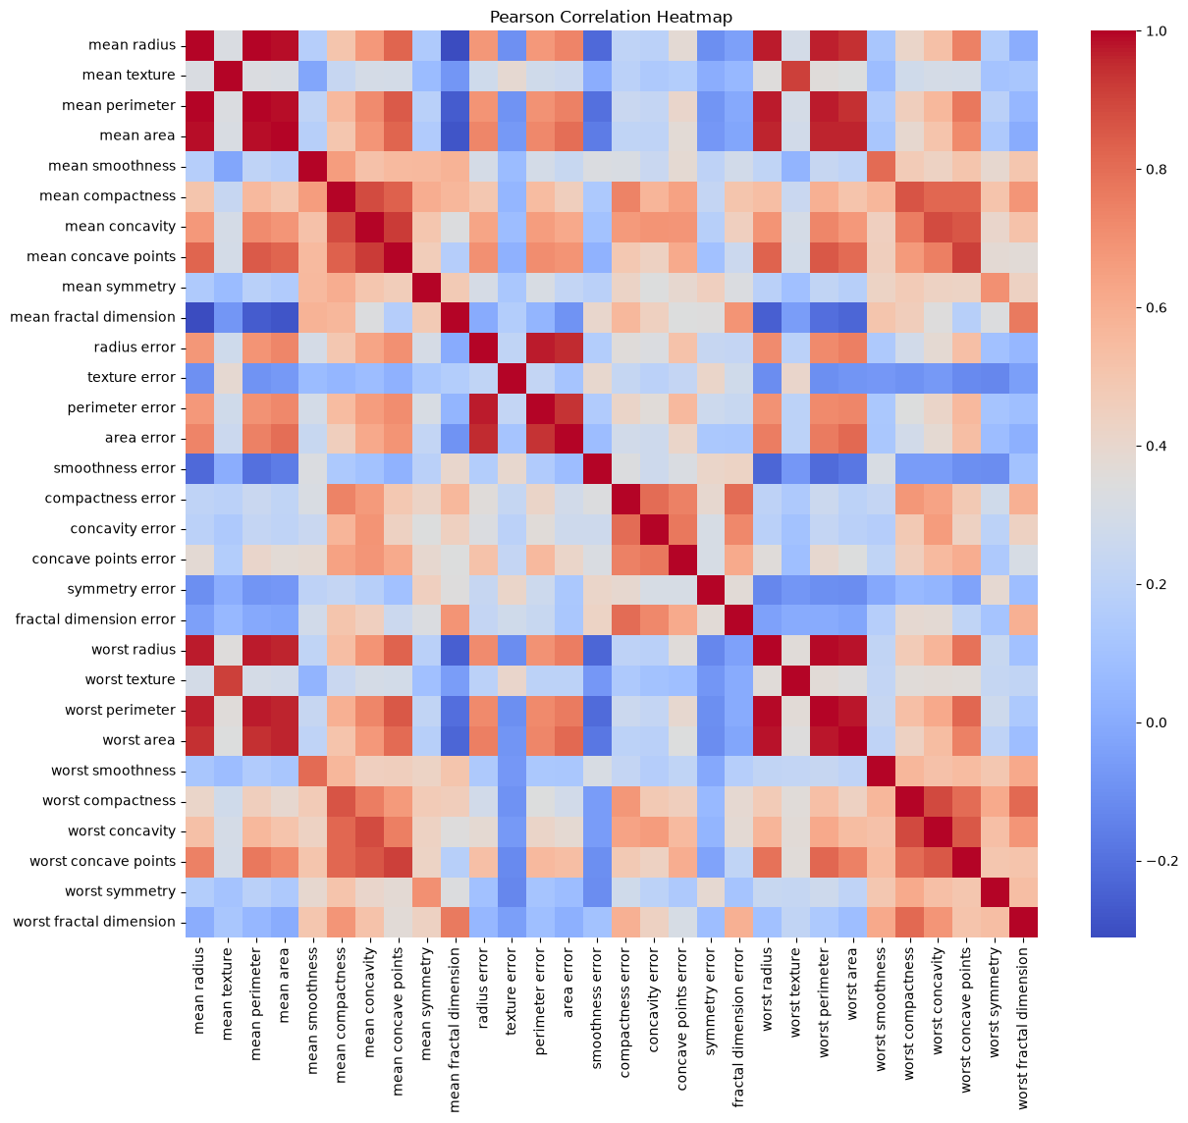
Breast Cancer: Feature correlation heatmap
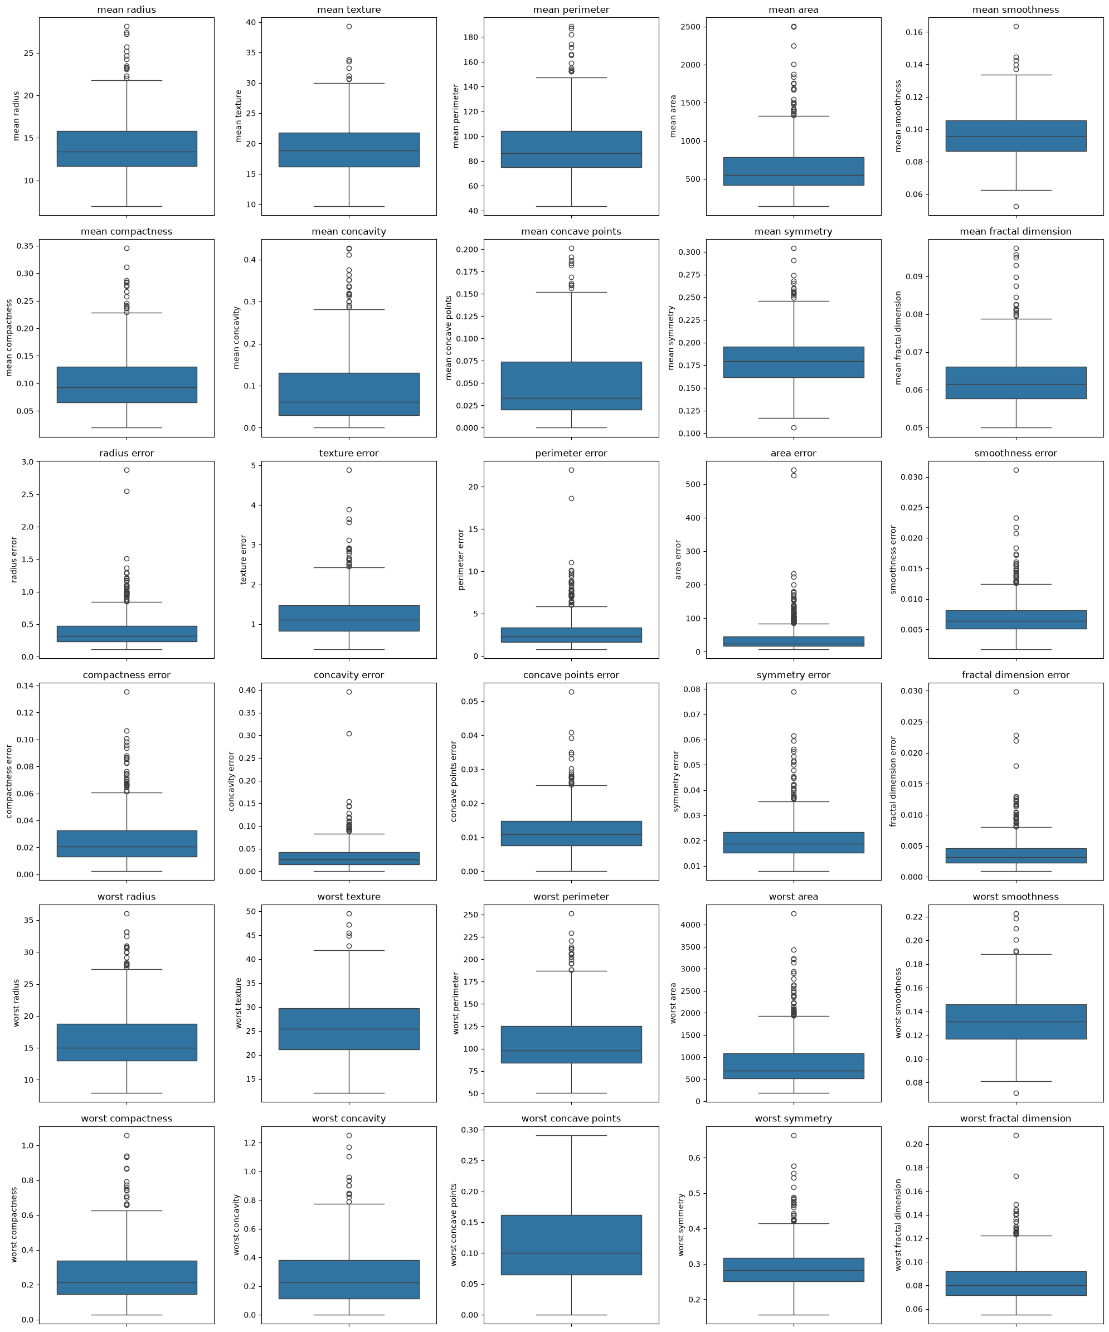
Breast Cancer: Boxplots covering the features

Wine — EDA figures
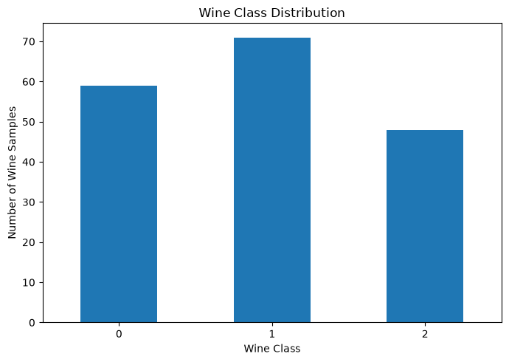
Wine: Class distribution
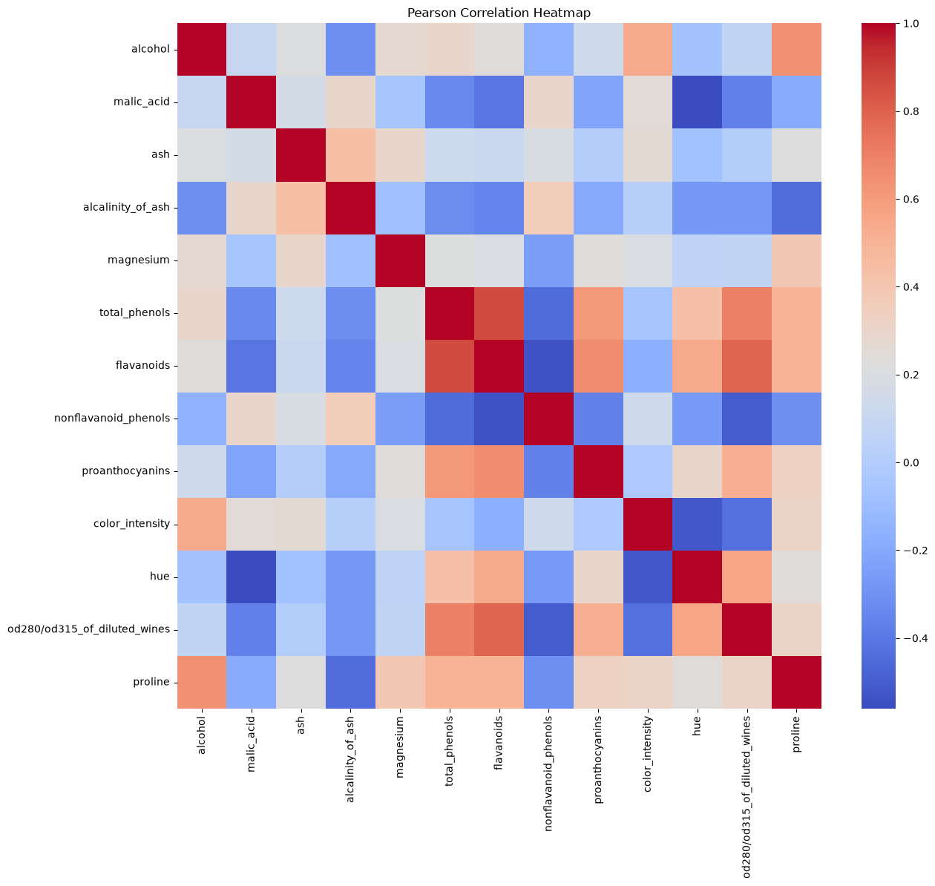
Wine: Feature correlation heatmap
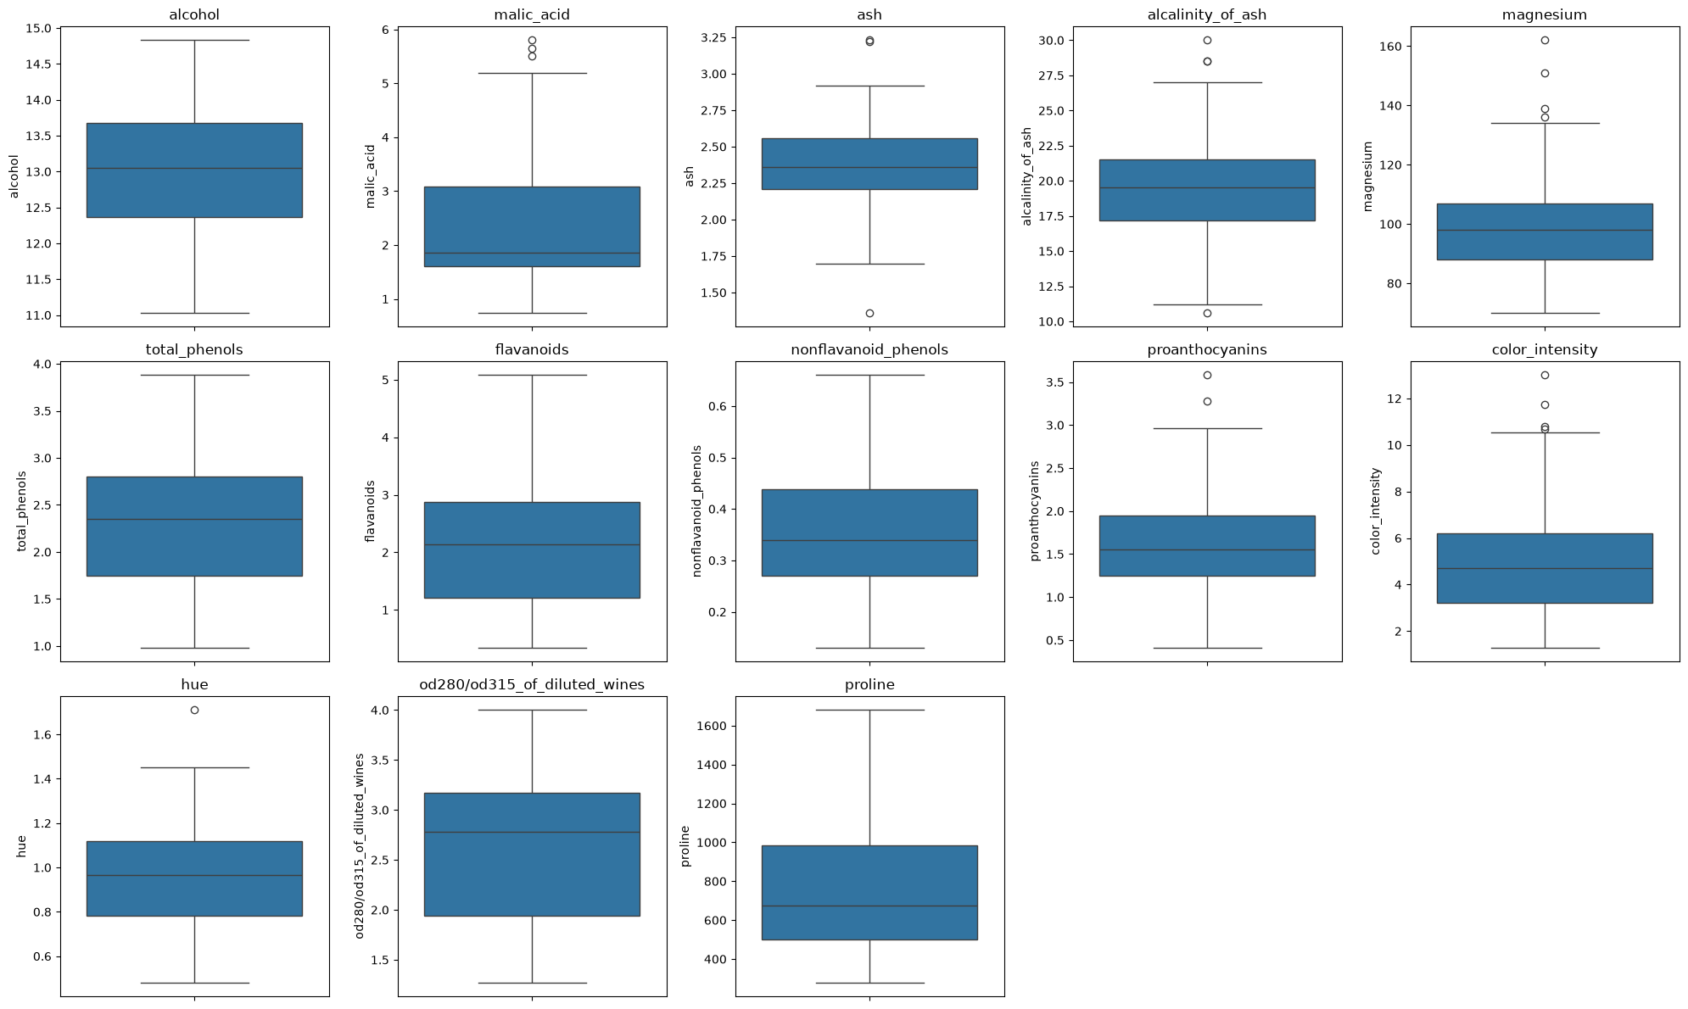
Wine: Boxplots covering the features

4. Splitting the Datasets
I reserved the same stratified 20% test set once using random_state=42. I then used seeds 42, 52 and 62 to create training and validation splits from the remaining data. The final proportions are about 70% training, 10% validation and 20% testing. I kept the test data separate until final evaluation.

5. Preprocessing and Scaling
I compared the original feature values with StandardScaler results. For each seed, I fitted the scaler only on the training split and applied it to validation and test data. This avoids using validation or test information when calculating the scaling values.

6. Classification Models
I trained Decision Tree, KNN and Gaussian Naive Bayes with scaled and unscaled features. I tested different tree depths and KNN neighbor counts. There were 66 classifier fits per dataset, giving 132 classifier fits in total.

7. Validation Metrics
I compared accuracy, macro precision, macro recall, macro F1 and ROC-AUC on validation data. I selected the best configuration using mean validation macro F1 over three seeds, not the final test score.

8. Model Comparison and Selection

Breast Cancer — all 22 configurations
The best validation configuration was bc_knn_scaled_k7. Mean validation F1 was 0.968, with a standard deviation of 0.030.
Configuration | Val. accuracy | Val. F1 | F1 std. | Val. AUC
bc_dt_scaled_d10 | 0.924 | 0.919 | 0.011 | 0.927
bc_dt_scaled_d2 | 0.918 | 0.912 | 0.024 | 0.922
bc_dt_scaled_d3 | 0.924 | 0.918 | 0.030 | 0.941
bc_dt_scaled_d5 | 0.924 | 0.919 | 0.023 | 0.930
bc_dt_scaled_dNone | 0.924 | 0.919 | 0.011 | 0.927
bc_dt_unscaled_d10 | 0.924 | 0.919 | 0.011 | 0.927
bc_dt_unscaled_d2 | 0.918 | 0.912 | 0.024 | 0.922
bc_dt_unscaled_d3 | 0.924 | 0.918 | 0.030 | 0.941
bc_dt_unscaled_d5 | 0.924 | 0.919 | 0.023 | 0.930
bc_dt_unscaled_dNone | 0.924 | 0.919 | 0.011 | 0.927
bc_gnb_scaled_default | 0.930 | 0.925 | 0.020 | 0.976
bc_gnb_unscaled_default | 0.942 | 0.937 | 0.023 | 0.980
bc_knn_scaled_k1 | 0.942 | 0.937 | 0.021 | 0.934
bc_knn_scaled_k11 | 0.965 | 0.961 | 0.039 | 0.994
bc_knn_scaled_k3 | 0.959 | 0.955 | 0.023 | 0.979
bc_knn_scaled_k5 | 0.959 | 0.955 | 0.023 | 0.979
bc_knn_scaled_k7 | 0.971 | 0.968 | 0.030 | 0.978
bc_knn_unscaled_k1 | 0.889 | 0.879 | 0.057 | 0.876
bc_knn_unscaled_k11 | 0.924 | 0.916 | 0.011 | 0.961
bc_knn_unscaled_k3 | 0.901 | 0.891 | 0.045 | 0.930
bc_knn_unscaled_k5 | 0.918 | 0.911 | 0.030 | 0.948
bc_knn_unscaled_k7 | 0.912 | 0.904 | 0.001 | 0.958
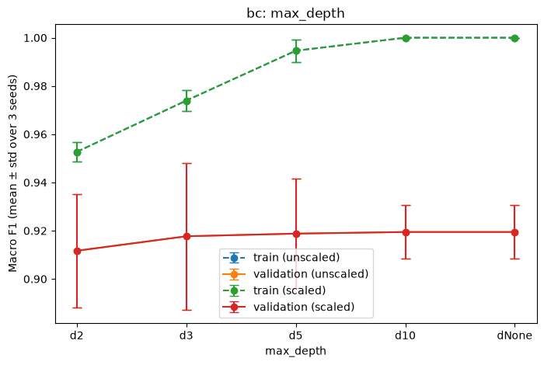
Breast Cancer: Decision Tree depth comparison
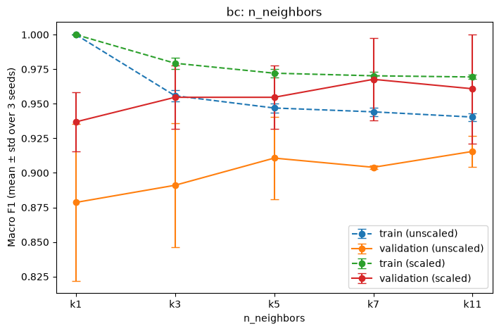
Breast Cancer: KNN neighbor comparison

Wine — all 22 configurations
The best validation configuration was wine_knn_scaled_k5. Mean validation F1 was 0.981, with a standard deviation of 0.032.
Configuration | Val. accuracy | Val. F1 | F1 std. | Val. AUC
wine_dt_scaled_d10 | 0.944 | 0.946 | 0.055 | 0.955
wine_dt_scaled_d2 | 0.852 | 0.848 | 0.036 | 0.905
wine_dt_scaled_d3 | 0.944 | 0.946 | 0.055 | 0.961
wine_dt_scaled_d5 | 0.944 | 0.946 | 0.055 | 0.955
wine_dt_scaled_dNone | 0.944 | 0.946 | 0.055 | 0.955
wine_dt_unscaled_d10 | 0.944 | 0.946 | 0.055 | 0.955
wine_dt_unscaled_d2 | 0.852 | 0.848 | 0.036 | 0.905
wine_dt_unscaled_d3 | 0.944 | 0.946 | 0.055 | 0.961
wine_dt_unscaled_d5 | 0.944 | 0.946 | 0.055 | 0.955
wine_dt_unscaled_dNone | 0.944 | 0.946 | 0.055 | 0.955
wine_gnb_scaled_default | 0.963 | 0.964 | 0.031 | 1.000
wine_gnb_unscaled_default | 0.963 | 0.964 | 0.031 | 1.000
wine_knn_scaled_k1 | 0.963 | 0.966 | 0.030 | 0.975
wine_knn_scaled_k11 | 0.981 | 0.981 | 0.032 | 1.000
wine_knn_scaled_k3 | 0.944 | 0.946 | 0.056 | 1.000
wine_knn_scaled_k5 | 0.981 | 0.981 | 0.032 | 1.000
wine_knn_scaled_k7 | 0.981 | 0.981 | 0.032 | 1.000
wine_knn_unscaled_k1 | 0.704 | 0.671 | 0.023 | 0.765
wine_knn_unscaled_k11 | 0.630 | 0.600 | 0.001 | 0.822
wine_knn_unscaled_k3 | 0.667 | 0.646 | 0.043 | 0.833
wine_knn_unscaled_k5 | 0.704 | 0.667 | 0.040 | 0.864
wine_knn_unscaled_k7 | 0.667 | 0.636 | 0.032 | 0.846
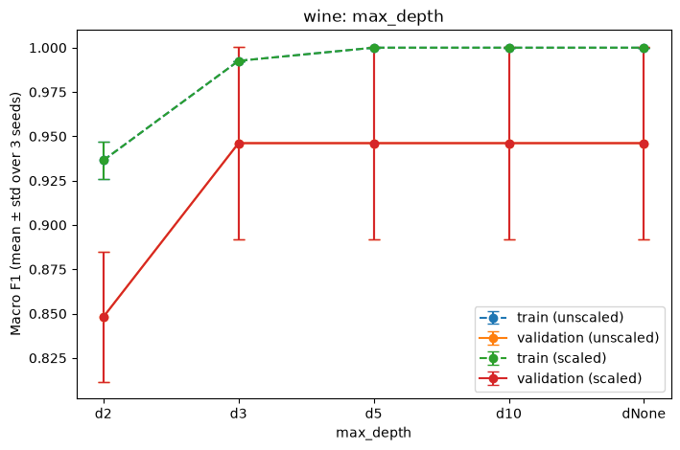
Wine: Decision Tree depth comparison
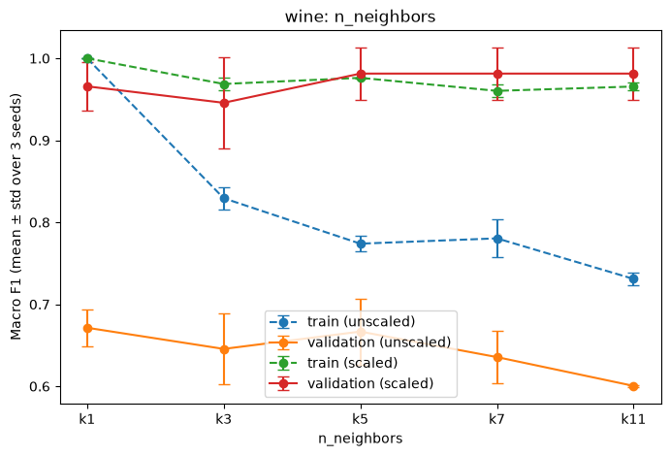
Wine: KNN neighbor comparison

9. Final Test Evaluation

Breast Cancer — seed 42
Selected model: bc_knn_scaled_k7. Test accuracy: 0.974; macro precision: 0.980; macro recall: 0.964; macro F1: 0.971; ROC-AUC: 0.989.
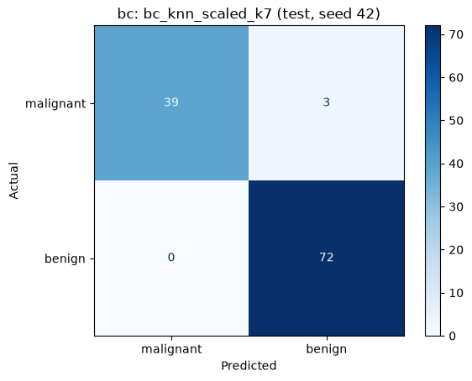
Breast Cancer: final confusion matrix
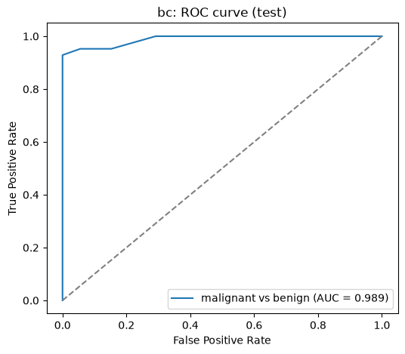
Breast Cancer: final ROC curve

Wine — seed 42
Selected model: wine_knn_scaled_k11. Test accuracy: 1.000; macro precision: 1.000; macro recall: 1.000; macro F1: 1.000; ROC-AUC: 1.000.
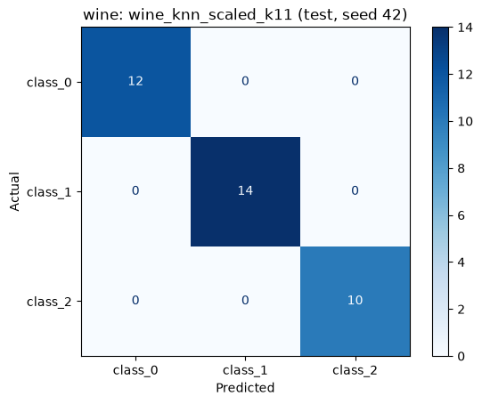
Wine: final confusion matrix
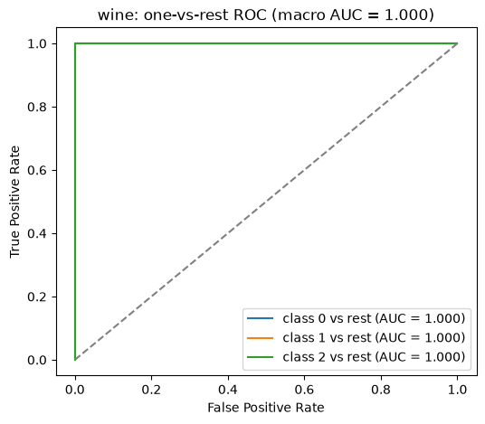
Wine: final ROC curve
In Breast Cancer, the confusion matrix was [[39, 3], [0, 72]]. Three malignant samples were predicted as benign. For the malignant class, precision was 1.000 and recall was 0.929. In Wine, the confusion matrix was [[12, 0, 0], [0, 14, 0], [0, 0, 10]], so all 36 test samples were classified correctly.

10. K-Means Clustering
I used K-Means without training on class labels: two clusters for Breast Cancer and three for Wine. I compared scaled and unscaled data using ARI and silhouette. There were 12 K-Means fits in total.

Breast Cancer — clustering summary
Representation | Val. ARI mean | ARI std. | Silhouette mean
scaled | 0.581 | 0.142 | 0.312
unscaled | 0.504 | 0.106 | 0.677
Test ARI: unscaled = 0.558, scaled = 0.735.
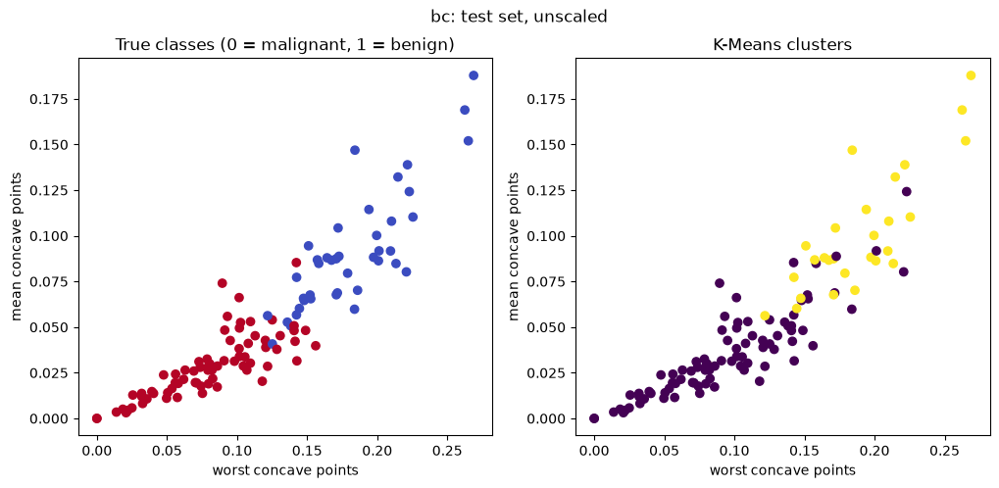
Breast Cancer: K-Means unscaled, true classes versus clusters
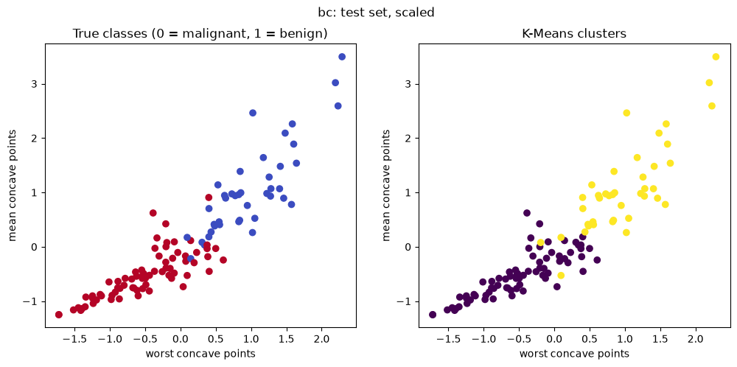
Breast Cancer: K-Means scaled, true classes versus clusters

Wine — clustering summary
Representation | Val. ARI mean | ARI std. | Silhouette mean
scaled | 1.000 | 0.000 | 0.275
unscaled | 0.361 | 0.068 | 0.577
Test ARI: unscaled = 0.373, scaled = 0.909.
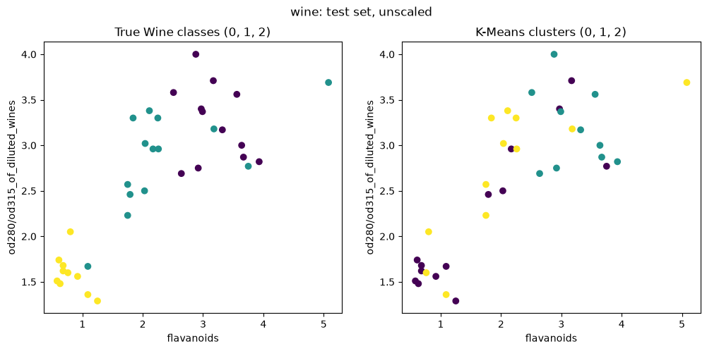
Wine: K-Means unscaled, true classes versus clusters
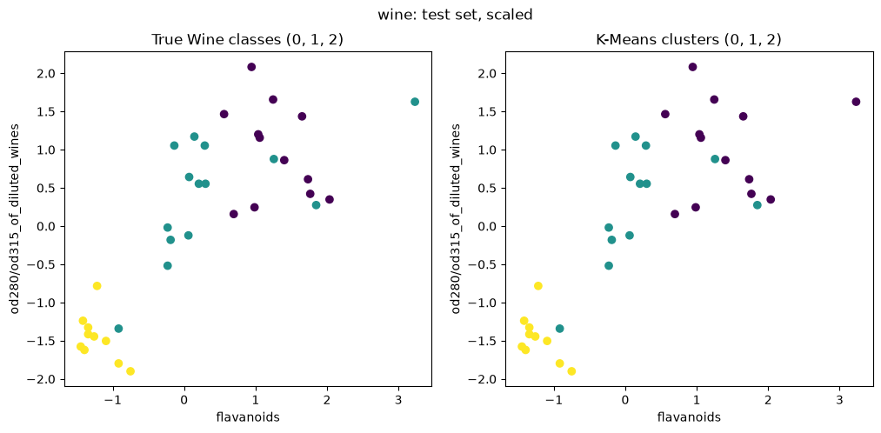
Wine: K-Means scaled, true classes versus clusters
Scaling improved test ARI for both datasets, especially Wine. Cluster numbers are not the same thing as class labels, so I used ARI to compare the grouping with the real labels.

11. Comparing the Two Datasets
1. Scaled KNN was selected for both datasets: k=7 for Breast Cancer and k=11 for Wine.
2. Scaling mattered for distance-based methods. Wine K-Means test ARI increased from 0.373 to 0.909 after scaling.
3. Changing tree depth or neighbor count did not always improve validation performance.
4. Breast Cancer had three incorrect test predictions; Wine had none on its 36-sample test set.
5. Scaled K-Means test ARI was about 0.735 for Breast Cancer and 0.909 for Wine.
6. If I continued the project, I would test more train/validation splits to see how stable the results are.

12. Conclusions and Project Links
Overall, KNN gave the best validation performance on both datasets. Scaling was important for KNN and K-Means. The Wine test result was perfect on this particular test set, but that does not guarantee the same result on new data.
The executed notebooks, full run tables and CSV exports contain the detailed outputs. This report shows the main results and the required comparison figures.
Repository: https://github.com/emrebeyaziit/machine-learning-midterm
Video walkthrough: https://youtu.be/4J05ROaqaso
AI/tool-use details are documented separately in AI_DISCLOSURE.md. Please check that the disclosure accurately reflects the work and the instructor’s permission.

