**COMPUTER NETWORK ASSİGNMENT**

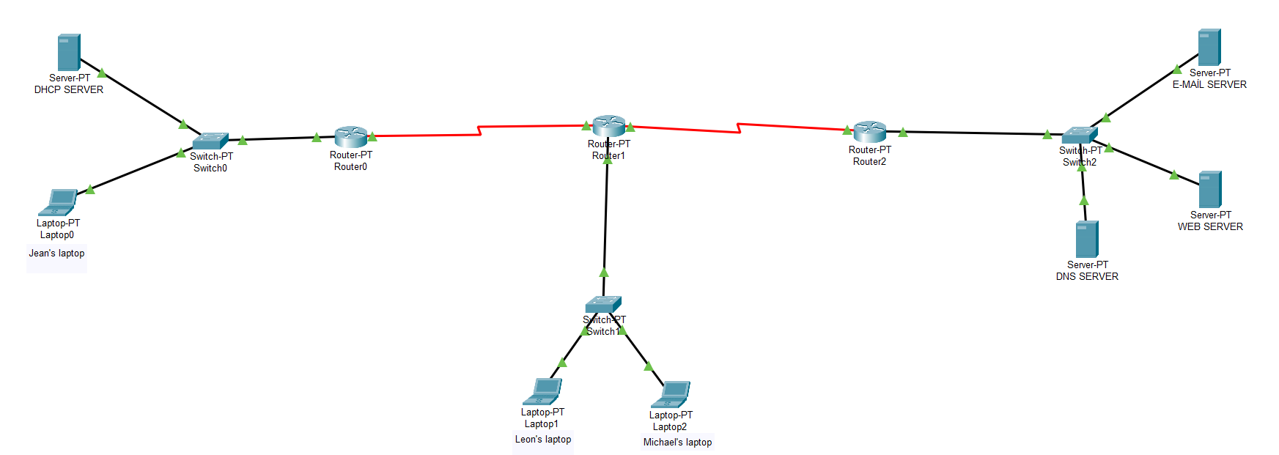Finished network topology:

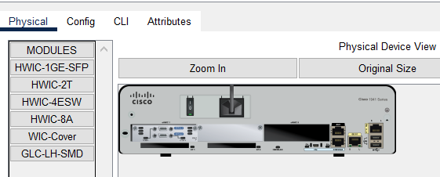Step-by-step designing of the topology:

1. First, I have put HWIC-2T on the routers in order to open their serial mode and use serial cable.

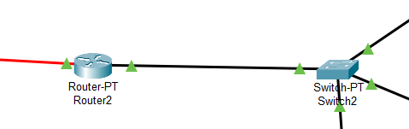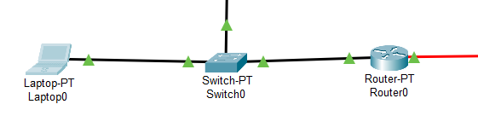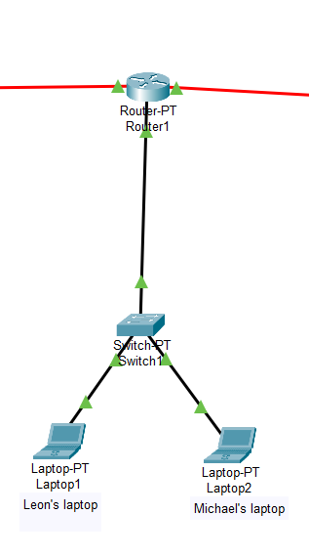

2-Secondly I connect the laptops to the switches and do the same thing for the routers with cables.

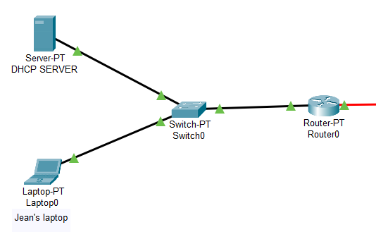

3-After those steps, finally I connect the servers which DHCP, WEB, E-MAİL and DNS.

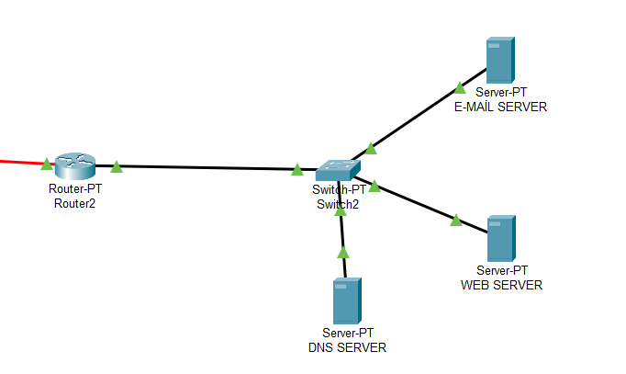

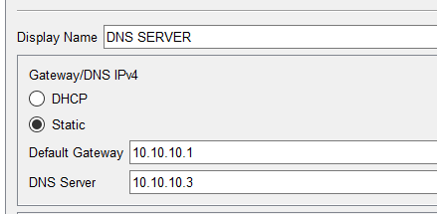DNS SERVER PROCEDURES:

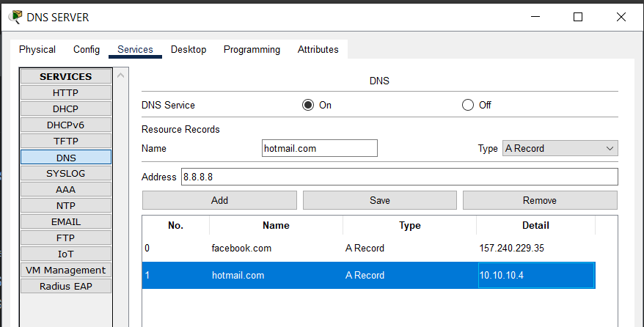Config settings

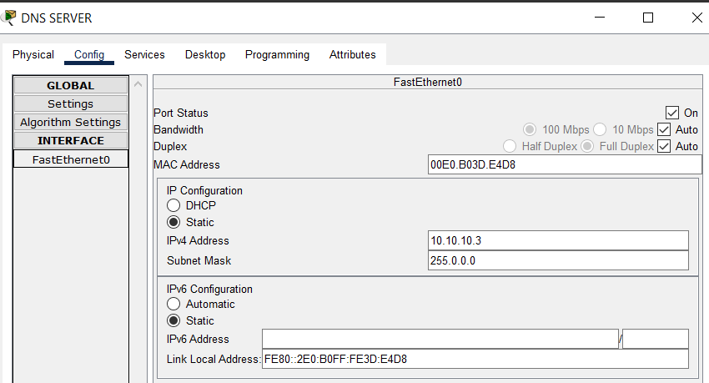DNS server settings

IPV settings

WEB SERVER SETTİNGS:

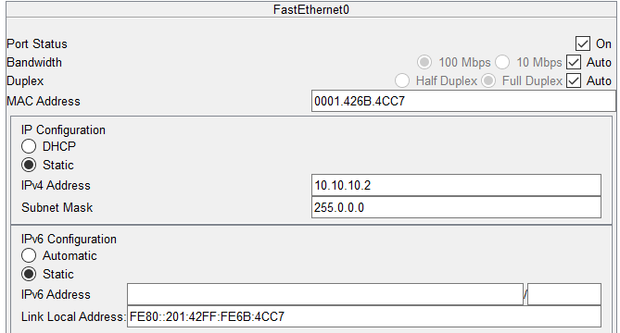Config

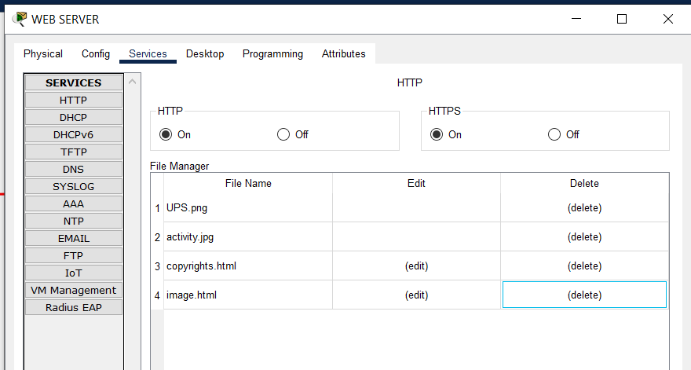

HTTP settings

E-MAİL SERVER SETTİNGS:

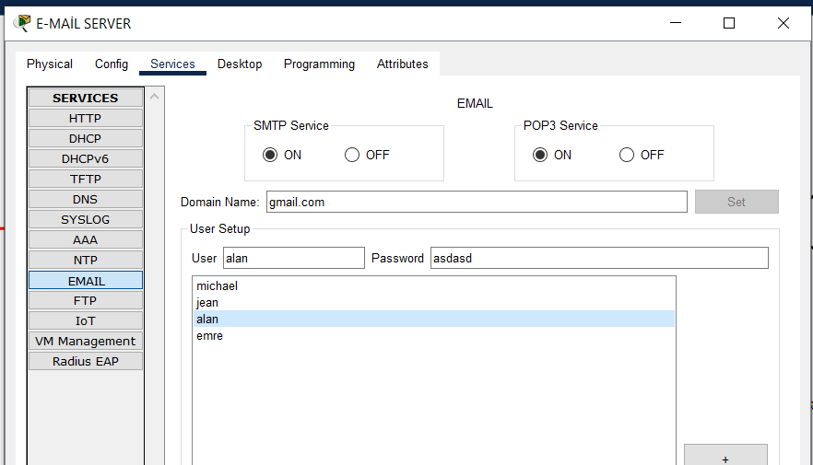

E-MAİL SMTP AND POP3 SETTİNGS

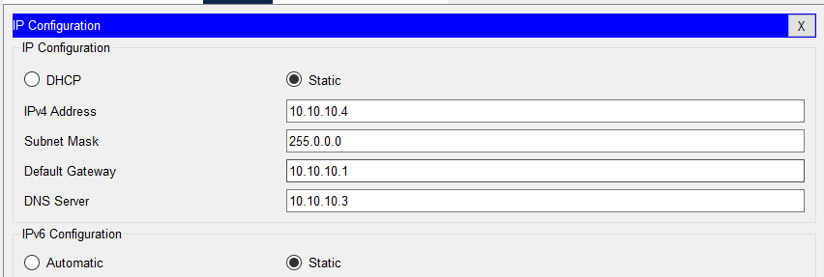

IP configuration

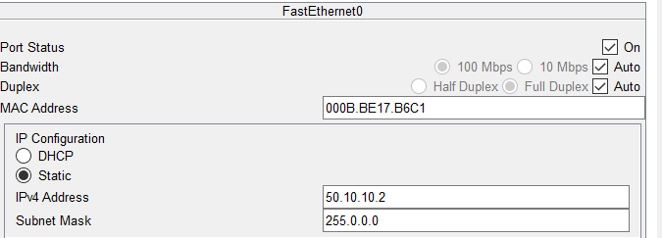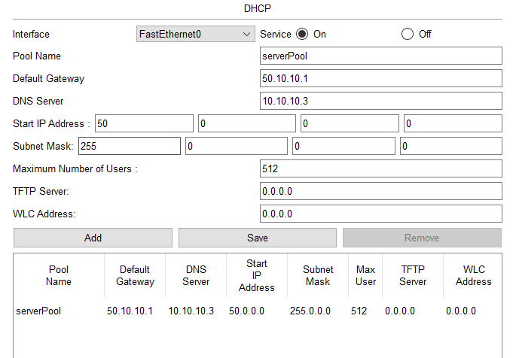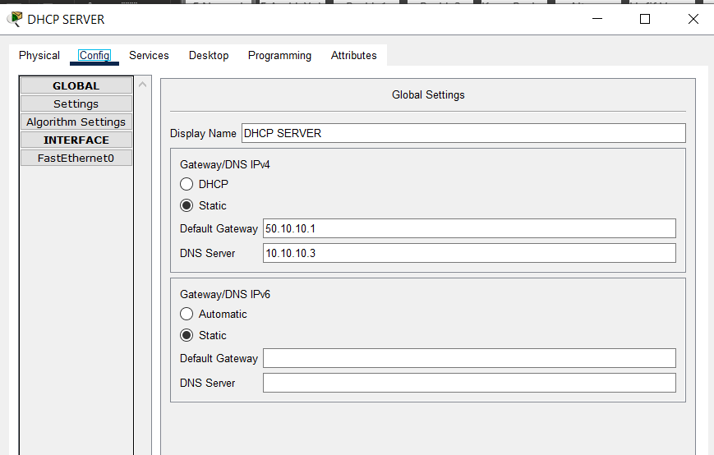DHCP SERVER SETTİNGS:

DHCP settings

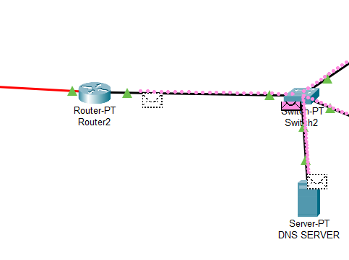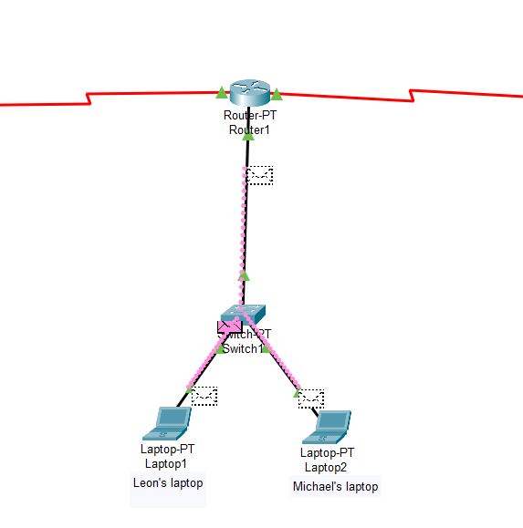**PİCTURES OF SİMULATİONS**

