**1.)**

We have the expression that follows.

$$a⋅x≡1(mod n)$$

The remainder of dividing a⋅x by 𝑛 must be precisely 1. If there is no common divisor between $a$ and 𝑛 it means 𝑔𝑐𝑑(𝑎,𝑛) = 1 , the equation always gives a solution. But if 𝑔𝑐𝑑(𝑎,𝑛) $≠$ 1, there is no solution for this equation.

Understand the necessary steps mathematically and did research on the relevant equation.

$$a⋅x+b⋅y=gcd(a,b)$$

We can write $a=bq+r$, we observe that

$$gcd(a,b)=gcd(b,r)$$

Also we can write this equation

$$b⋅x_{1}+r⋅y_{1}=gcd(b,r)$$

Also we know that $a-bq=r$

$$b⋅x_{1}+(a-bq)⋅y_{1}=gcd(a,b)$$

$$a⋅y_{1}+b⋅(x_{1}-q⋅y_{1})=gcd(a,b)$$

Thanks to this equation, we can start our coding process.

$$x=y_{1}$$

$$y=x_{1}-q⋅y_{1}$$

I used a recursive function in my code, the reason for this comes from the basic logic of the Extended Euclidean Algorithm and continues until r = 0. When r = 0, The operation of the function ends and this returns $gcd$ and the coefficients $x,y.$

$$a=bq+r$$

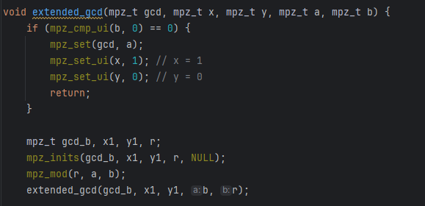

When $gcd(a,n) = 1$

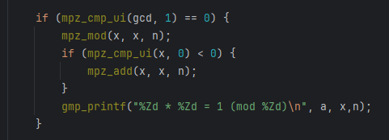

**Outputs:**

$$gcd(a,n) = 1$$

mpz_set_str(a, "5045454564566456445621560000000101", 10);  
mpz_set_str(n, "7897856245645645650000004564560454564564563411456001", 10);

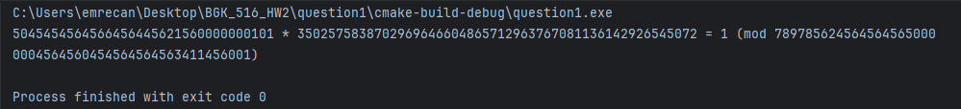

$$gcd(a,n) ≠ 1$$

mpz_set_str(a, "3500000000000000000000000000", 10);  
mpz_set_str(n,"7000000000000000000000000000000000000000000000000000000",10;

$$0 < a < n$$



mpz_set_str(a, "454545242087778", 10);  
mpz_set_str(n, "4520402402", 10);

$$2.a)$$



**Closure:**

$$a,b∈Z⟹a-b∈Z$$

$$5-3=2$$

$$-4-6=-10$$

$$0-7=-7$$

**Identity element:**

$$a-e=a if and only if e=0$$

$$e-a≠a$$

$$0-4=-4≠4$$

**Inverse element**

$$a-b=e$$

**Associativity**

$$(a-b)-c≠a-(b-c)$$

$$\left(7-4\right)-2=3-2=1$$

$$7-\left(4-2\right)=7-2=5$$

$$2.b)$$

**Closure:**

$$12+8 mod 20=20 mod20=0,$$

$$7+13 mod 20=20 mod20=0,$$

$$17+5 mod 20=22 mod 20=2,$$

**Identity element:**

**Inverse element**

$$a+b mod 20=0$$

$$a=\left(20-b\right) mod 20$$

$$2+18 mod 20=20 mod 20=0$$

$$16+4 mod 20=20 mod 20=0$$

**Associativity**

$$\left(a+b\right)+c mod 20=a+\left(b+c\right) mod 20$$

$$\left(7+8\right)+3 mod 20=15+3 mod 20=18$$

$$7+\left(8+3\right) mod 20=7+11 mod 20=18$$

$$2.c)$$

**Closure:**

$$7⋅6 mod 15=42 mod 15=12$$

$$10⋅2 mod 15=20 mod 15=5$$

$$14⋅9 mod 15=126 mod 15=6$$

**Identity element:**

$$a⋅e mod 15=a$$

$$7⋅1 mod 15=7$$

$$11⋅1 mod 15=11$$

**Inverse element**

$$a⋅b mod 15=1$$

**Associativity**

$$\left(a⋅b\right)⋅c mod 15=a⋅\left(b⋅c\right) mod 15$$

$$2.d)$$

**Closure:**

$$\frac{5}{3}⋅\frac{3}{17}=\frac{5}{17}=\frac{5}{17}$$

$$-\frac{4}{6}⋅\frac{3}{8}=-\frac{12}{48}=-\frac{1}{4}$$

$$\frac{11}{6}⋅\frac{12}{22}=\frac{2}{2}=1$$

**Identity element:**

$$a⋅e =a$$

$$\frac{5}{3}⋅1=\frac{5}{3}$$

$$-\frac{6}{7}⋅1=-\frac{6}{7}$$

$$1⋅1=1$$

**Inverse element**

$$a⋅b =1$$

$$\frac{5}{3}⋅\frac{3}{5}=1$$

$$-\frac{4}{6}⋅-\frac{6}{4}=1$$

**Associativity**

$$\left(a⋅b\right)⋅c=a⋅\left(b⋅c\right)$$

$$\frac{5}{3}⋅\left(\frac{3}{17}⋅\frac{8}{9}\right)= \left(\frac{5}{3}⋅\frac{3}{17}\right)⋅\frac{8}{9}$$

$$3.)$$

In fact, this question is exactly the same as the question in Homework-3, the only difference of the question in Homework-3 is that it asks us to print the x and y values, so the only difference between the 1st question in Homework-3 and this question in my codes is that only the x and y values ​​are not written.

I wanted to understand the necessary steps mathematically and did research on the relevant equation.

$$a⋅x+b⋅y=gcd(a,b)$$

We can write $a=bq+r$. Here, the algorithm is called again with 𝑏 and 𝑟 instead of 𝑎 and 𝑏. This is based on the following mathematical expression

$$gcd(a,b)=gcd(b,r)$$

Also we can write this equation

$$b⋅x_{1}+r⋅y_{1}=gcd(b,r)$$

Also we know that $a-bq=r$

$$b⋅x_{1}+(a-bq)⋅y_{1}=gcd(a,b)$$

$$a⋅y_{1}+b⋅(x_{1}-q⋅y_{1})=gcd(a,b)$$

Thanks to this equation, we can start our coding process.

$$x=y_{1}$$

$$y=x_{1}-q⋅y_{1}$$

I used a recursive function in my code, the reason for this comes from the basic logic of the Extended Euclidean Algorithm and continues until r = 0. When r = 0, The operation of the function ends and this returns $gcd$ and the coefficients $x,y.$

$$a=bq+r$$

**Outputs:**

mpz_set_str(a, "1045", 10);  
mpz_set_str(b, "771", 10);

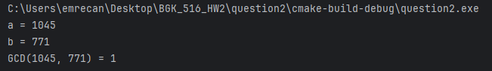

mpz_set_str(a, "9999999999999999999", 10);  
mpz_set_str(b, "33333333", 10);

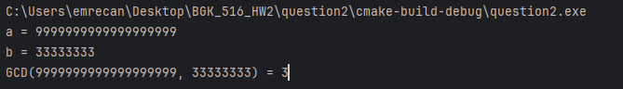

mpz_set_str(a, "11", 10);  
mpz_set_str(b, "0", 10);

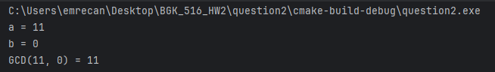

mpz_set_str(a, "0", 10);  
mpz_set_str(b, "11", 10);

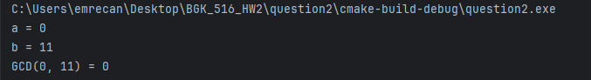

mpz_set_str(a, "0", 10);  
mpz_set_str(b, "11", 10);

