

**Department of Computer Engineering**

**CSE5041 Database Design & Development  
Project Report**

eFashion Portal

|  |  |  |
| --- | --- | --- |
|  | **ID** | **Name & Surname** |
| **Students :** | **1900005485** | **Emrecan Üzüm** |
|  | **1900005511** | **Nurettin Berke Demirel** |

* **INTRODUCTION**
* **PROJECT DESCRIPTION**

E-fashion database stores information about a fashion company's products, product sales history (or sold) and fashion shows. Datas are stored in two different part. The part with products and fashionshow information.

**1-) Products**

• The products are divided into 4 within themselves. These are upperbody, lowerbody, accessory and shoes. There is a table where the properties of each product are kept. Each product has a sales(or sold) table. After the product is added to the sales table (after the “insert to sale table” procedure runs), the trigger is activated and the quantity decreases from the table where the product's informations are kept.

• 3 of these 4 product tables (loweroutfit, upperoutfit, shoes) are divided into 2 main tables (outfit and shoes). These 2 separate tables take the combineid defined in the accessory table and combine all products (combining 4 different products).

• In the product information sections, there is a unique ID for each product, a lower table with sales and product addition information, and information that changes according to the product, such as type, combineID, color. The product sales table and adding procedures store the ID and soldID of the product that will make changes.

**2-) Fashion Shows**

• The second part of the database consists of models and designers. Models and designers come together to create a fashion show (the model and designer give their IDs as foreign keys to the fashion show, thus forming the fashion show).

• Contact information, email and passwords of models and designers to log into the system are stored in the database. In addition, data such as the name and date of the past fashion shows are kept under the fashionshow table.

* **ENTITY RELATIONAL MODEL**
* **ENHANCED ER DIAGRAM**

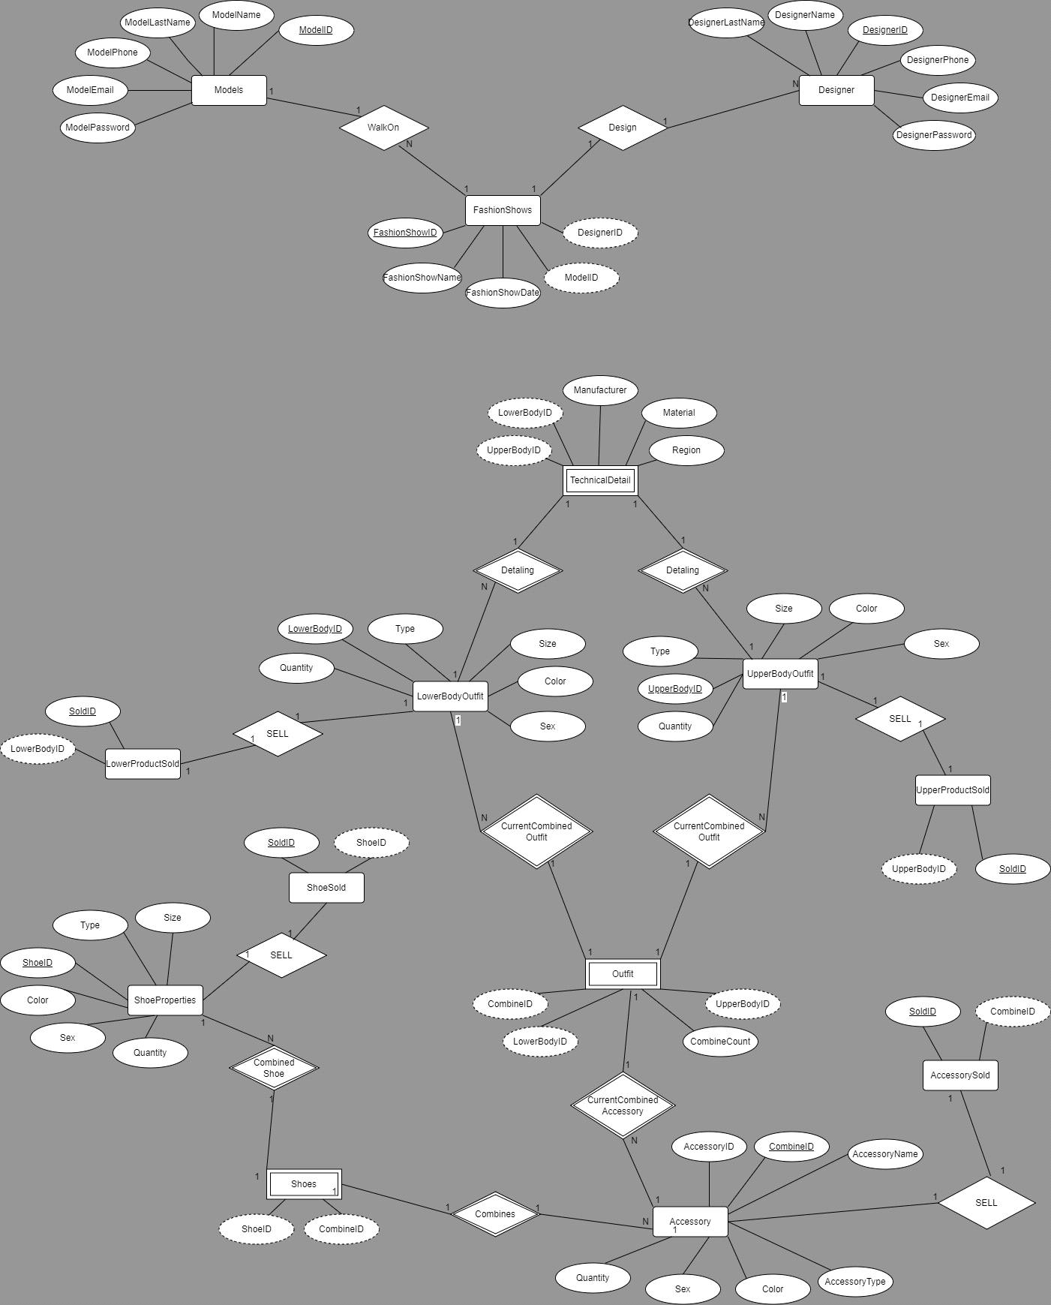

* **RELATIONAL SCHEMA & MAPPING**
* **Mapping a regular entity**

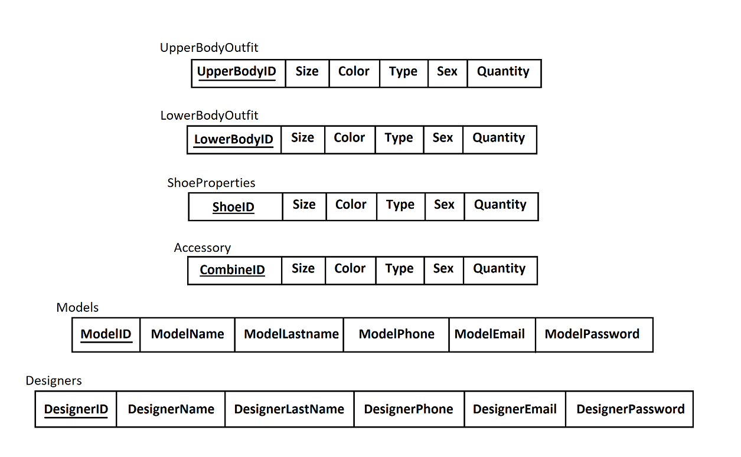

* **Mapping Multivalued Attribute**

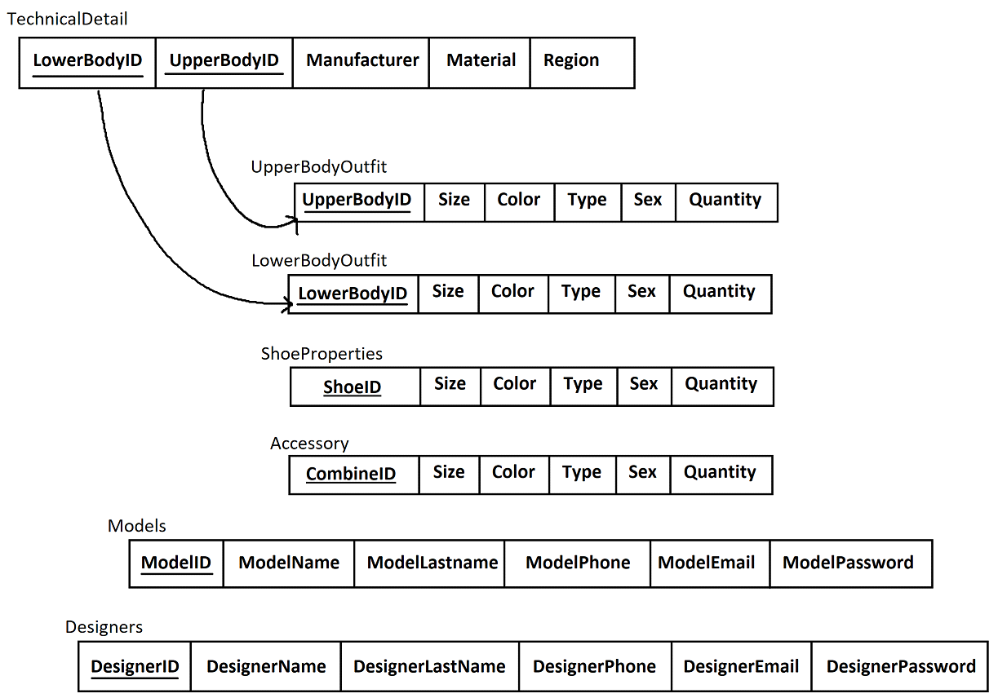

* **Mapping Weak Entities**

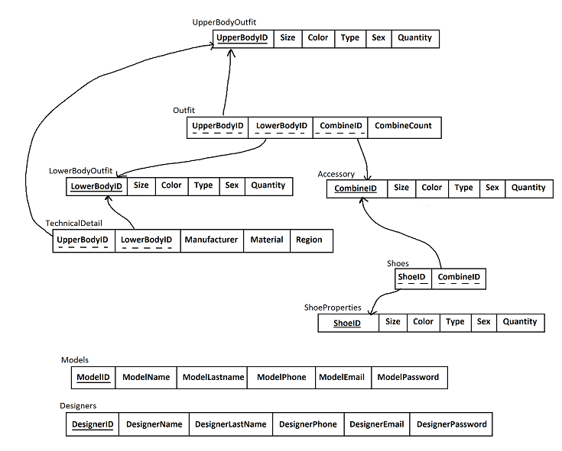

* **Mapping Binary Relationships**

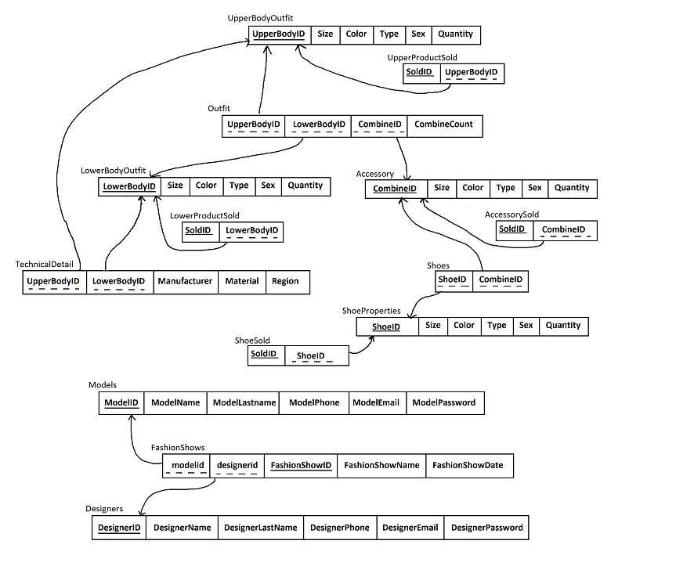

* **NORMALIZATION**
* **FUNCTIONAL DEPENDENCIES**

F = {FD1: UpperBodyID , Type => UpperBodyId,Size, Color, Sex, Type, Quantity

FD2: SoldID, UpperBodyID => SoldID, UpperBodyID

FD3: LowerBodyID , Type => LowerBodyID , Size, Color, Sex, Type, Quantity

FD4: SoldID, LowerBodyID => SoldID, LowerBodyID

FD5: ShoeID => Size, Color, Sex, Type, Quantity

FD6: SoldID, ShoeID => SoldID, ShoeID

FD7: ShoeID => Size, Color, Sex, Type, Quantity

FD8: CombineD => AccessoryID,AccessoryName,Size, Color, Sex, Accessory Type, Quantity

FD9: SoldID, CombineID =>SoldID,CombineID

FD10: UpperBodyID, LowerBodyID => Manufacturer, Material, Region

FD11:CombineID,LowerBodyID,UpperBodyID => CombineCount

FD12:ModelID=>ModelName,ModelLastname,ModelPhone,ModelEmail,ModelPassword

FD13:DesignerID=>DesignerlName, DesignerLName, DesignerPhone, DesignerEmail, DesignerPassword

FD14:DesignerID,FashionShowID,ModelID=>FashionShowName,FashionShowDate

* **UNNORMALISED FORM**

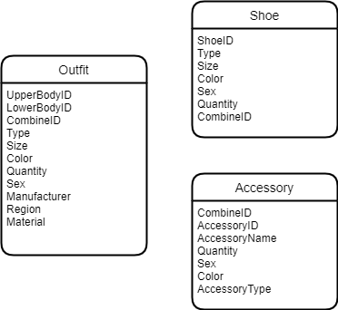

* **FIRST NORMAL FORM**

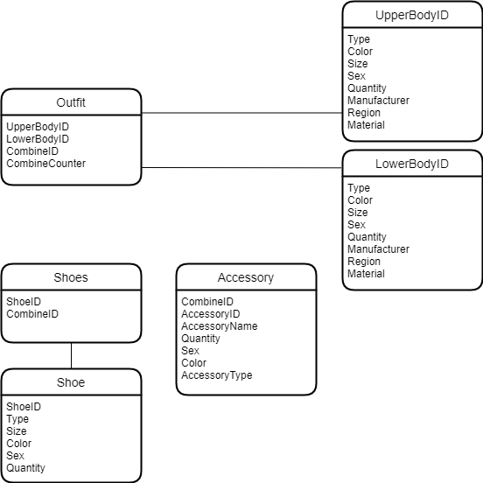

* **SECOND NORMAL FORM**

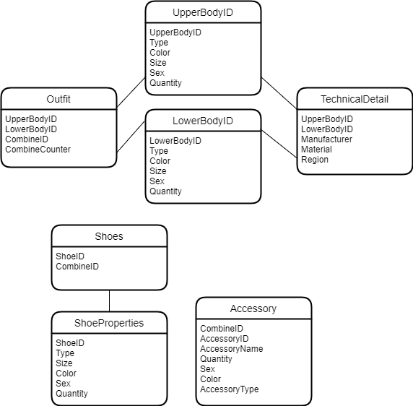

* **THIRD NORMAL FORM**

